BIO-4015B (Spring 2021)
Summative Practical
Group B.

Student number: ..............................

--------------------------------------------------------------------------------------------------------------
INTRODUCTION
--------------------------------------------------------------------------------------------------------------

Theoretical preparations before starting to work on the given tasks

- Revise the lectures on ‘VISION’ and ‘NERVE SIGNALLING’
- Study the lecture on ‘HEARING’ (Self study)
as well as the corresponding parts of textbooks on physiology
- Attend the introduction lecture
- Students are allocated to two groups: A and B
- Read and follow the instructions on Blackboard and within the form

Practical preparation for using the ‘Practical Workbook’

- GoTo Blackboard: Course BIO-4015B
- Summative Assessment
- Coursework 2020-21_Reaction Time Practical
”BIO-4015B_Practical_2021_Workbook_Group A”
“BIO-4015B_Practical_2021_Workbook_Group B”

- Download the workbook (Word format) and use this form for generating your report
- Fill in the student number on page 1
- Use a standard font for filling text boxes (‘e.g. Arial/11-12 pt)
- Use the preset boxes for adding:
Results/Calculations
Figures
Discussion/Write-up
In case of “mishaps” just download the empty file again

- Calculations can be done by any adequate/available method (Excel, SPSS, Prism/Graphpad)

- Submission of the finished report should be done as ONE single document
- Follow the instructions for the submission by Blackboard
- Use the following name:
‘Studentnumber_BIO-4015B_Practical_Group A (or B)’

--------------------------------------------------------------------------------------------------------------
Practical on Reaction Times
--------------------------------------------------------------------------------------------------------------

- General comments on ‘Reaction Times’ and the idea of the practical
Reaction time defines the time span between a signal and an output reaction. In the practical we/You measure reaction times upon different stimuli and different output reactions.
- Reaction times will be measured/calculated for two different types of signals:
  - Visual/Ocular signals or
  - Acoustic signals
- Induced reactions will be either
  - pressing a button with your thumb or
  - catching a ruler with your fingers
- Reaction times are measured for both hands (left and right) and experimental data are given in the form.

Left/right hand preference: The preferred dominant hand is self-certified by the test persons and indicated in the workbook

Statistical analyses:
- The Null hypothesis states for these experiments:
“There is no difference between reaction times of both hands”
- In order to test this hypothesis, the results of the measurements should be analysed by using statistical methods (t-test) to calculate the probability of the “Null-hypothesis”.

- Reaction times upon an acoustic stimulus (Sound detection; Hearing)

Data collection (Demonstration in Introduction sessions):
- For measuring acoustic reaction times, a computer-based system is used: ‘BioPAC’.
- The proband is using headphones and ‘click’ sounds are heard in different “click” sound patterns, either random (0.1-10 seconds) or constant (3 seconds).
- Upon hearing the clicks the proband has to press a button with his thumb. In separate experiments either the left or the right thumb is used
- The reaction times are collected by the BIOPAC program and given as ‘seconds’.
- Data were collected and are prefilled in the tables (see below)

- Four series of experiments are done by each test-person:
- Click sounds at random time intervals and 10 reaction times with the left hand are collected
- Click sounds at random time intervals and 10 reaction times with the right hand are collected
- Click sounds at constant time intervals and 10 reaction times with the left hand are collected
- Click sounds at constant time intervals and 10 reaction times with the right hand are collected

C. Reaction times upon a ‘visual stimulus’ (Ocular test; Vision)

Data collection (Done before):
- For measuring visual reaction times, a simple ‘Ruler-catching test’ was performed
- The principal experiments was described in the introduction sessions (see there)
- The ruler was dropped after random periods of time (“that’s the fun bit ....”) and
the test person catches the ruler as fast as possible after its release
- The distance ‘D’ is then measured at a constant position resembling the top of the hand (measurement: ‘cm’). The reaction time has to be calculated from the distance of the ruler travelled.
- This experiment is repeated 10 times with the left and 10 times with right hand
- The readings for the distance ‘D’ (in cm) were noted and filled in the tables given.

Calculation of reaction time:
- The measurements are taken as the ‘distance’ the ruler migrated
- Therefore, reaction times can be calculated by using the following formula:
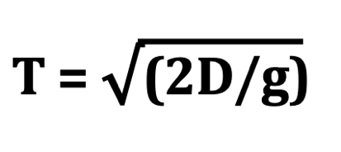
T: time
D: distance the ruler travelled
g: Standard gravitational acceleration (g = 9.8 m/sec²)

----------------------------------------------------------------------------------------------------------------
Statistical analyses
----------------------------------------------------------------------------------------------------------------
Use a statistical test (t-test) to analyse the data and test the Null hypothesis

- Use a statistical test for the comparison of data and testing of the null-hypothesis. A t-test is usually adequate. Reasons/Limitations of using this test should be discussed in Part 1e (see below)
- Any program for statistical calculations could be used: Excel, SPSS, Prism/Graphpad.)
- Compare the following test results by statistical methods as indicated also in the data tables (see below)

Auditory tests
- Reaction times of left and right hands in auditory test at random signals
- Reaction times of left and right hands in auditory test at constant signals
- Compare results of random vs. constant sound patterns from the same hands

Ocular/Visual tests
- Reaction times of left and right hands in visual test (Random ruler test)

- Fill in your results in the corresponding tables of the form

- In any case use adequate numbers of decimals

Part 1: Data analysis I
Calculations and statistical analyses of given data sets

Data Group B Testperson: “Betty B.”
Self-declaration: The person stated to be RIGHT-handed

- The following data are collected from a real person and should be analysed.
- The distance of the ruler travelled until caught is given and the reaction time has to be calculated by using the formula given below.
- Calculations/Results should be filled in the provided tables
- Calculate Mean, Stdev and SEM (Standard error of mean)
- The significance of the difference should be tested by “2-sample, 2-tailed t-tests”
- For convenience, use the tables for including calculations and results

1a. Data: OCULAR/Visual Test

Left hand  Trial number | Distance traveled by ruler  (D, in cm) | Reaction time (T)  (T, in sec) |  | Right hand  Trial number | Distance traveled by ruler  (D, in cm) | Reaction time (T)  (T, in sec)
1 | 15.4 | 0.1773 |  | 1 | 10.4 | 0.1457
2 | 16.3 | 0.1824 |  | 2 | 9.9 | 0.1421
3 | 11.9 | 0.1558 |  | 3 | 11.9 | 0.1558
4 | 14.2 | 0.1702 |  | 4 | 14.4 | 0.1714
5 | 51.2 | 0.3232 |  | 5 | 14.1 | 0.1696
6 | 15.6 | 0.1784 |  | 6 | 8.9 | 0.1348
7 | 13.8 | 0.1678 |  | 7 | 10.4 | 0.1457
8 | 15.9 | 0.1801 |  | 8 | 12.2 | 0.1578
9 | 17.3 | 0.1879 |  | 9 | 13.1 | 0.1635
10 | 14.9 | 0.1744 |  | 10 | 10.1 | 0.1436
 | Mean | 0.189765 |  |  | Mean | 0.153005
 | STDEV | 0.04773 |  |  | STDEV | 0.012489
 | SEM | 0.015094 |  |  | SEM | 0.003949
0.001571329

t test (Auditory test) of reaction times p-value =
(Left vs Right hand)
1b. Data: Auditory test: RANDOM time intervals

Trial  number | Left hand Reaction time (sec) |  | Trial number | Right hand Reaction time (sec)
1 | 0.157 |  | 1 | 0.198
2 | 0.172 |  | 2 | 0.211
3 | 0.183 |  | 3 | 0.192
4 | 0.205 |  | 4 | 0.225
5 | 0.167 |  | 5 | 0.197
6 | 0.191 |  | 6 | 0.207
7 | 0.201 | Missed reaction > | 7 | (missed)
8 | 0.159 |  | 8 | 0.223
9 | 0.213 |  | 9 | 0.19
10 | 0.144 |  | 10 | 0.172
Mean | 0.1792 |  | Mean | 0.1815
STDEV | 0.02304 |  | STDEV | 0.016808
SEM | 0.007286 |  | SEM | 0.005315

t test (Auditory test) p-value =
0.940732

(Left vs Right hand)

1c. Data: Auditory test: CONSTANT time intervals

Trial  number | Left hand Reaction time (sec) |  | Trial number | Right hand Reaction time (sec)
1 | 0.139 |  | 1 | 0.155
2 | 0.172 |  | 2 | 0.199
3 | 0.213 |  | 3 | 0.124
4 | 0.166 |  | 4 | 0.153
5 | 0.168 |  | 5 | 0.151
6 | 0.189 |  | 6 | 0.163
7 | 0.229 |  | 7 | 0.141
8 | 0.165 |  | 8 | 0.122
9 | 0.188 |  | 9 | 0.197
10 | 0.219 |  | 10 | 0.133
Mean | 0.1848 |  | Mean | 0.1538
STDEV | 0.028354 |  | STDEV | 0.026873
SEM | 0.008966 |  | SEM | 0.008498
0.036613

t test (Auditory test) p-value =
(Left vs Right hand)
1d. Test: Auditory test: Comparison of Reaction times
‘Constant’ versus ‘Random’ signal patterns

Random sound pattern Random sound pattern

 | Left hand Reaction time (sec) |  | Trial number | Right hand Reaction time (sec)
Mean | 0.1792 |  | Mean | 0.1815
SEM | 0.007286 |  | SEM | 0.005315

Constant sound pattern Constant sound pattern
 | Left hand Reaction time (sec) |  | Trial number | Right hand Reaction time (sec)
Mean | 0.1848 |  | Mean | 0.1538
SEM | 0.008966 |  | SEM | 0.008498

LEFT HAND RIGHT HAND
t test (Auditory test) t test (Auditory test)
(Random vs Constant) (Random vs Constant)
0.299637991
p-value = p-value
0.480418

There were no changes made to all datasets

e. Statistics: Rationale of using t-tests for statistical testing

T-test is a type of inferential statistic that is used to determine if there exist a significant difference between the means of two related groups or variables of data. It is used as a hypothesis testing tool especially the statistical significance of an attribute or parameter in a population. The statistical method is mostly used when comparing data sets that follow a normal distribution and may have unknown variances. However, this test only applies to a randomly distributed population and that the scale applied in measurement should follow a continuous or ordinal scale.

Part 2: Data Analysis II
Graphical representation of data

Figure 2a: Visual reaction times of left and right hand

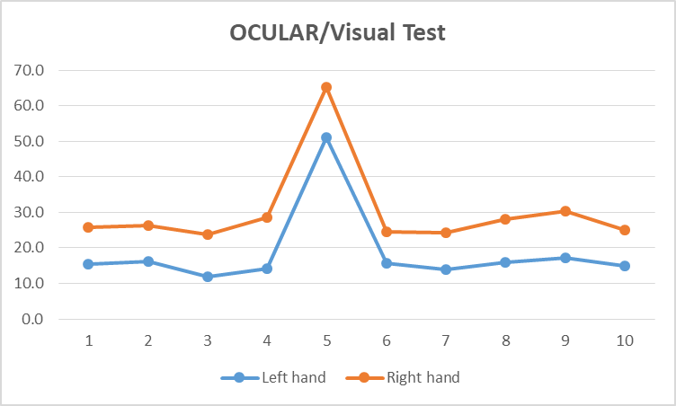
The graph 2a (i) above illustrates the reaction times of the left hand and right hand. There is a greater statistical difference between the reaction times of the left hand and right hand as described by the data above. The p-value is lower than 0.05 meaning we reject the null hypothesis. A p-value less than 0.05 typically indicates strong evidence against the null hypothesis, as there is less than a 5% probability the null is correct.

Figure 2b: Reaction times of left and right hand upon different sound patterns
(Constant and Random patterns)

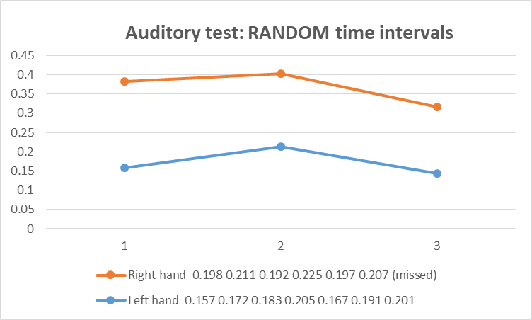
The graph 2a (ii) above illustrates the reaction times of the left hand and right hand of the auditory test. There is statistical difference between the reaction times of the left hand and right hand as described by the data above. The p-value is less than 0.05 meaning we reject the null hypothesis. A p-value higher than 0.05 (> 0.05) is not statistically significant and indicates strong evidence for the null hypothesis.

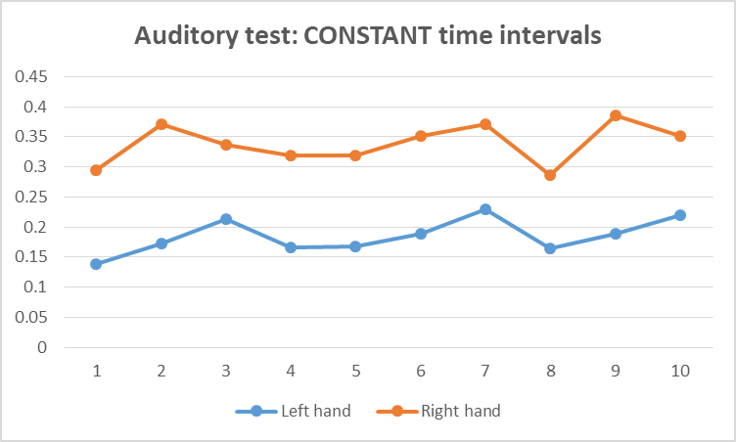
The graph 2a (iii) above illustrates the reaction times of the left hand and right hand of the auditory test at constant time intervals. There is no statistical difference between the reaction times of the left hand and right hand as described by the data above. The p-value is higher than 0.05 meaning we fail to reject the null hypothesis. A p-value less than 0.05 typically indicates strong evidence against the null hypothesis, as there is less than a 5% probability the null is correct.

Part 3: Summary of experiments and results
Discussion of experiments

Introduction:
The experiment is about determining the reaction times using Visual/Ocular signals or Acoustic signals as induced by the reactions which includes pressing a button with your thumb or catching a ruler with your fingers. Reaction time defines the time span between a signal and an output reaction. The reaction times are measured for both hands (left and right) and experimental data tabulated as shown in the above tables in part 1.
The experiment seeks to test the hypothesis on whether there is significant difference between reaction times of both hands or not by conducting a t-test statistic.

Materials and Methods
Requirements/ Materials
- Ruler
- Timer or clock
Method
- The ruler is dropped after random periods of time and the test person catches the ruler as fast as possible after its release.
- The visual reaction is measured concurrently as the ruler catching test is conducted.
- During this process the distance ‘D’ is then measured using a ruler at a constant position resembling the top of the hand and recorded.
- The reaction time has to be calculated from the distance of the ruler travelled.
- This experiment is repeated 10 times with the left and 10 times with right hand and the readings for the distance ‘D’ (in cm) recorded and filled in the tables given.
- Two sets of tests are performed i.e. randomly and at constant positions and repeated 10 times.
- Calculation of reaction time are then calculated using the following formular and recorded in the tables provided;
Analysis
The results obtained are then subjected to statistical analysis to determine its correlation using the t-test to compare the means.
Results
Below is a summary of the data obtained with the descriptive statistics done to compare the Visual reaction times of left and right hand
Left hand |  | Right hand
Mean | 18.65 | Mean | 11.54
Standard Error | 3.647259245 | Standard Error | 0.596881
Median | 15.5 | Median | 11.15
Mode | #N/A | Mode | 10.4
Standard Deviation | 11.53364643 | Standard Deviation | 1.887503
Sample Variance | 133.025 | Sample Variance | 3.562667
Kurtosis | 9.549195491 | Kurtosis | -1.25321
Skewness | 3.06203632 | Skewness | 0.320998
Range | 39.3 | Range | 5.5
Minimum | 11.9 | Minimum | 8.9
Maximum | 51.2 | Maximum | 14.4
Sum | 186.5 | Sum | 115.4
Count | 10 | Count | 10

Correlation analysis using Excel showed the following output

 | Left hand | Right hand
Left hand | 1 | 0.463384
Right hand | 0.463384 | 1

Conclusion
Based on the above findings, it can be concluded that the test statistic is using the left hand is statistically significant whereas using the right hand confirms that it is not significant at all. This is a positive correlation coefficient since all the values calculated are positive. It indicates that an increase in the first variable would correspond to an increase in the second variable, thus implying a direct relationship between the variables.

Discussion

Discussion/Question A: Auditory tests and L/R preference
Based on the results obtained from the statistical test conducted above, there is a significant correlation between the reaction times measured in the auditory tests (Biopac) and the assumption of the proband’s preferred hand. The correlation coefficient was as illustrated in the table below;
 | Left hand | Right hand
Left hand | 1 | 0.463384
Right hand | 0.463384 | 1
The correlation coefficients were all positive thus confirming that their existed correlation between the reaction times. A correlation coefficient of positive one (+1) showed strong correlation especially when comparison was made when a left hand and second hand was used concurrently for the same test, whereas, the +0.463384 showed medium correlation especially when one hand is used either right for both or left for both.
Based on the findings it can be concluded that there exists a correlation between the reaction times and the preference of the left or right hand used.

Discussion/Question B: Auditory tests and sound patterns
A random versus constant intervals in the auditory reaction times when subjected to correlation statistic produced the following output.
Auditory test: CONSTANT time intervals
 | Left hand | Right hand
Left hand | 1
Right hand | -0.25525 | 1
Auditory test: CONSTANT time intervals
 | Left hand | Right hand
Left hand | 1
Right hand | -0.27449 | 1
The correlation coefficients were all positive for similar hands used either all left hand or all negative hand tests thus confirming that their existed correlation between the reaction times. However, correlation coefficients were all negative for alternate hands used either when left and hand were used for same test together meaning there was no correlation for the test. A correlation coefficient of positive one (+1) showed strong correlation especially when comparison was made when a left hand and second hand was used concurrently for the same test, whereas, -0.25525 and -0.27449 showed no correlation especially when one hand is used either right for both or left for both.
The results therefore confirms that there is no correlation between the auditory tests and sound patterns.

Discussion/Question C: Visual tests and L/R preference
Based on the results obtained from the statistical test conducted above, there is a significant correlation between the reaction times measured in the Visual tests (Biopac) and the assumption of the proband’s preferred hand. When the visual and auditory reaction time results of the participants in the study were examined it was found that when either left or right hands were used there was a strong correlation hence statistically significant to justify a correlation. On the other hand, when both hands i.e. right and left were used concurrently, there was no correlation. However, similar results were observed with the auditory tests where there was a string correlation when both left or right hands were used.

Discussion/Question D: Reaction times in visual and acoustic tests
A comparison of the results obtained from both experiments show some level of similarity in the outputs generated. The results indicated that there is a significant correlation between the reaction times measured in the Visual tests (Biopac) and the assumption of the proband’s preferred hand. When the visual and auditory reaction time results of the participants in the study were examined it was found that when either left or right hands were used there was a strong correlation hence statistically significant to justify a correlation.
However, correlation coefficients were all negative for alternate hands used either when left and hand were used for same test together meaning there was no correlation for the test. The two tests show some level of concurrence in the statistical analysis when correlation analysis was conducted hence we reject the null hypothesis.

------------------------------------------------------------------------------------------------
MARKING
------------------------------------------------------------------------------------------------

Part | Tasks |  | Max. marks | Marks given
Part 1  Max. 30 | 1a. Data | Correct calculations:  Visual reaction times | 6
Part 1  Max. 30 | 1b. Data | Correct calculations  Acoustic reaction times (Random) | 6
Part 1  Max. 30 | 1c. Data | Correct calculations  Acoustic reaction times (Constant) | 6
Part 1  Max. 30 | 1d. Test | Correct calculations  Acoustic reaction times Comparison Patterns | 8
Part 1  Max. 30 | 1e. Statistic | Rationale of statistical method | 4
Part 2  Max. 30 | Fig. 2a | Graph of visual reaction times | 8
Part 2  Max. 30 | Fig. 2a | Figure legend | 5
Part 2  Max. 30 | Fig. 2b | Graphs of acoustic reaction times | 12
Part 2  Max. 30 | Fig. 2b | Figure legends | 5
Part 3  Max. 40 | Write-up | Introduction | 2
Part 3  Max. 40 | Write-up | Materials and Methods | 3
Part 3  Max. 40 | Write-up | Brief description of numerical results | 3
Part 3  Max. 40 | Write-up | Discussion A | 8
Part 3  Max. 40 | Write-up | Discussion B | 8
Part 3  Max. 40 | Write-up | Discussion C | 8
Part 3  Max. 40 | Write-up | Discussion D | 8
 |  | TOTAL MARKS POSSIBLE | (100)

