Name
Wilfrid Laurier University

Department of Geography and Environmental Studies

GG101 Introduction to Physical Geography

Lab 6: Environmental Change with a focus on Climate
Instructor
Date

Tasks and Questions

Historical Record

Figure 1 in the Lab 6 background reading shows the global mean annual temperature record from 1880 to 2019 presented as departures from 1951-80 mean. Figure 3 shows the change in Canada over the period 1948 to 2019 expressed as departures over the period 1961-90. Figure 3 was from the Climate Trends and Variations Bulletin (Annual Report 2019) published by Environment Canada. The graph below has been generated from that same data and adjusted so the baseline period is also 1951-80. The years plotted are 1950 to 2019. The annual values are shown in grey, the red line is a 5-year running average and the blue line is a linear trend fit over the period 1970 to 2019.
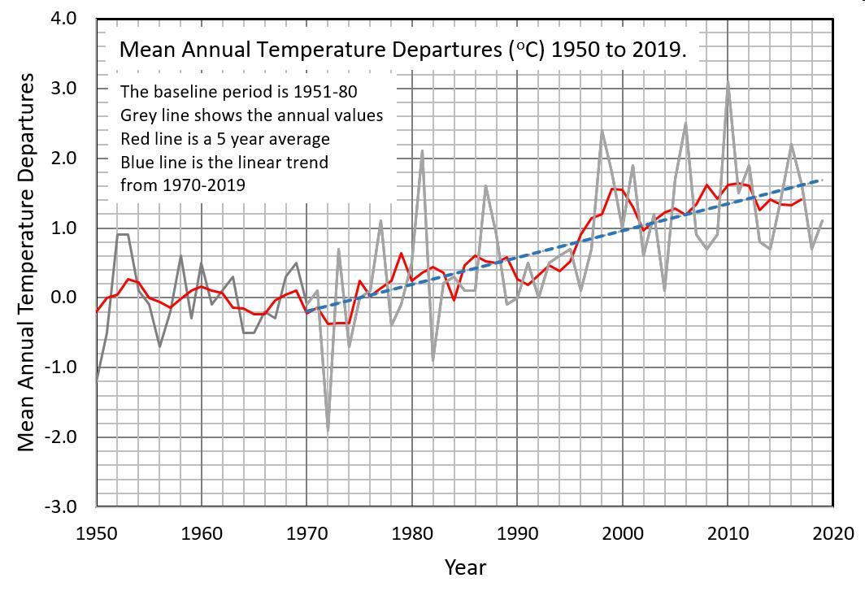

Task 1

Compare Figure 1 from the background reading with the graph above. From Figure 1, consider the period only from 1950 to 2019. Both records show that temperatures in the 1950s and 1960s were largely unchanged (flat). By the mid-1970 the temperatures began to increase.
Question 1 (2 marks)

For the period from 1970 to 2019.

- Estimate the magnitude of the temperature change that occurred globally and in Canada, present your estimates as numeric values over that interval.
By +1.7⁰ in Canada and + 1⁰ globally.

- Comment on the year to year variability (variation) in the two records, which record has more variability.
The graph in figure 1 has the highest variability. The diagram above only shows a gradual rise in temperature observable from 1970 to 2019 but no significant changes in comparisons with consecutive years.

Spatial Pattern over the Period 2000-2019

In the Climate Atlas of Canada, a base period of 1976 to 2005 is used to capture ‘current conditions’. Go to the GISS global mapping site described on pages 2, 3, and 4 in the background reading. Set the Data Sources using the parameters shown in the background reading (they are the default data sources). The Map Type will be Anomalies. For the Base, Period use 1976 to 2005. For the Time Interval use 2000 to 2019 (20-year time interval). We will examine mapping output that shows the spatial variation in global temperature over the period 2002 to 2019 (relative to 1976 to 2005).

For the Mean Period use:

- Annual (Dec-Nov) 0.36

- NH Winter (Dec-Feb) 0.34

- NH Spring (Mar-May) 0.37

- NH Summer (Jun-Aug) 0.34

- NH Fall (Sep-Nov) 0.42

Task 2 (5 marks)

Examine the five maps you have created that show the spatial distributions of the changes in mean Annual, Winter, Spring, Summer, and Fall temperatures over the period 2000 to 2019. Complete Table 1 by identifying the global areas that are experiencing the most substantial warming and cooling for the selected periods. You may identify global areas in a number of ways, such as latitudinal zone (e.g., high latitude land areas of North America), the segment of a continent (e.g., northeastern Africa), country (e.g., Chile and Peru), or segment of an ocean (e.g., the Arctic Ocean north of Siberia).
Question 2 (1 mark)

What season has shown the most significant change in temperature over the period 2000 to 2019?
The NH Fall season.

Question 3 (1 mark

Overall, what latitudinal zone has experienced the greatest warming since 2000?

Areas of latitude 75-90

Table 1. Spatial patterns in warming and cooling over the period 2000 to 2019.


Time |  | Global Locations
Period |  | Areas of Highest Warming |  | Areas Cooling

Annual Around latitude 75-90 Around latitude -75 to -60

Winter Around latitude 75-90 Around latitude -75 to -60

Spring Around latitude 75 Around latitude -60

Summer Around Latitude 75 Around latitude -60

Fall Latitude 75-90 Latitude -60 to -45

Task 3

The data in the maps from GISS show us the magnitude and spatial pattern of warming that has occurred over the last 20 years. We will use results from a General Circulation Model (GCM) from the same organization to examine the distribution of changes to mean annual temperature that would occur if the concentration of greenhouse gases in the atmosphere increased to the equivalent of 520 ppm CO₂ and a new planetary energy balance were to be established. The CGM is called ROCKE-3D and the URL is in the background document. Examine the global pattern of surface temperature change that is projected under a scenario of a doubling of CO₂ (2X CO2) as compared to pre-industrial CO₂ levels. Repeat the process for a four-times CO₂ (4X CO2) scenario. For these two maps use the Variable called surface temperature.

Question 4 (1 mark)

What is the average warming that would occur for the globe as a whole for the two scenarios?

2X CO2: An increase of between 1.5° and 4.5°

4X CO2: An increase of 3.0°- 8.5°

Task 4

We will now use the ROCKE-3D model to examine how a series of variables may change as we move to a higher CO2 world. For these analyses we will use two time periods, they are the Pre-Industrial and the 4X CO2 time frame. We will examine three Variables, they are:

- Sea ice fraction (%):

- Planetary albedo (%):
- Cloud cover (%)

For each of these variables examine the results from the pre-industrial model and the 4X CO2 model.

Question 5 (3 marks)

Describe the overall changes (global) that occur when we compare the pre-industrial to the 4X CO2 model for these three variables.
The sea ice fraction decreases as we move from the pre-industrial to the 4X CO2 level timeframe. This may be since as carbon (IV) oxide increases, global warming increases and melts the ice. The planetary albedo is also decreasing and this reduces the sun’s reflectivity and global warming increases. The cloud cover is also reducing due to the increase in sunray penetration caused by increasing global warming.
Question 6 (1 mark)

Why is a loss of sea ice in Polar Regions associated with a lower albedo in the same regions?
The polar region has snow in addition to sea ice. Since snow in Polar Regions has high albedo, it reflects light and insulates sea ice from radiation and this maintains coolness in these regions.

Task 5 (5 marks)

In this section, we will look at climate changes at the local scale that are projected for the Toronto area under two different scenarios. Go to the Climate Atlas of Canada interactive mapping website. In the Climate Atlas interactive map, examine the Annual, Winter, Spring, Summer, and Fall mean temperatures for the Toronto location. Record the average values for each of the above variables for

1976-2005, and for the projected periods 2021-2050 and 2051-2080 under the Less Climate Change and More Climate Change scenarios. Enter the data into Table 2
Table 2. Average temperature values for Toronto, with projected average temperatures under the Less

and More Climate Change scenarios.


2021-2050 2051-2080

Variable 1976-2005
Less More Less More

Annual 8.41⁰ 11.02⁰ 19.43⁰ 15⁰ 24.4⁰

Winter -16⁰ -10⁰ -8⁰ -5⁰ -3⁰

Spring 2.4⁰ 8.4⁰ 9.7⁰ 13.6⁰ 14.9⁰

Summer 23⁰ 26.83⁰ 31.3⁰ 30⁰ 34.2⁰

Fall 10⁰ 16⁰ 17.3⁰ 22.1⁰ 24⁰

Examine the graphing output for the above variables for the two scenarios (low and high amounts of climate change). The high amount of climate change corresponds to a high emission scenario, this is similar to the pathway that we are currently following. The magnitude of change for each of the above variables is larger for the higher emission case. Figure 11.27 in your textbook shows the global projections of mean temperature change for these same two scenarios, they are called RCP8.5 and RCP4.5 for the high and low emissions cases. Refer to the graphs from the Climate Atlas that you have just examined and Figure 11.27.

Question 7 (2 marks)

Compare the projected temperature changes for the Toronto area that will occur under the two scenarios. Comment on the seasonal pattern and the difference between the two scenarios.
The projected temperatures are higher for the high emission projections than the low emissions scenario. This means that if the current levels of greenhouse emissions are maintained, the effects of global warming will still occur but at a smaller impact than if the emissions increase. In the modern-day world, there are increasing levels of emissions and this high impact scenario may be the future.

Question 8 (4 marks)

Return to the Climate Atlas mapping site, zoom down to the Toronto area. Several variables are listed under the Heading "Hot Weather". Using the higher emission scenario for the two projected periods examine the variables: (i) Very Hot Days, (ii) Tropical Nights, (iii) Number of Heat Waves, and (iv) Average Length of Heat Waves. What do the projections show? Using the resources available from the Climate Atlas site comment on why these projected changes are of particular concern for urban areas in Canada.
The projections show that the number of hot days, tropical nights increase, days with heat waves, and their number increases. These variables occur as a result of increasing global temperatures that in this case are caused by global warming. Since global warming is caused by greenhouse gas emissions from industrial areas, patterns from these variables are important in raising awareness against pollution.

