Write some most important questions on Ms word from the Book Chapter 12.

SOLUTION

Chapter 12, Problem 1E
Aggregate demand represents total spending in an economy at all alternative price levels. It is the sum total spending in economy by government, business and individual consumers. Aggregate demand curve is the summation of different individual demand curves.

Chapter 12, problem 2E
Aggregate demands curve slope downwards because of following effects:
Wealth effects: individuals and businesses own assets in the form of money, stock and bonds, fixed and other financial assets. The quantity of goods that can be exchanged with these assets is the purchasing price of these assets. When the general price level increases, the purchasing power of wealth becomes less reducing the aggregate spending of the people. When the price level falls, more products can be purchased with the assets or wealth increasing the purchasing power of the individual causing an increase in the aggregate spending.

For example: when the stock market crumble, the value of the financial assets decrease decreasing the purchasing power of the stocks and finally decreasing the wealth. This decrease in wealth decreases the consumption of the individual.

Chapter 12, Problem 3E
Increase in foreign income has positive effect on the aggregate demand and aggregate expenditure. When the foreign income increases then the people’s demand will be more domestic and also foreign goods, leading, to an increase in imports. This demand from foreign countries makes an increase in the demand for goods in the domestic country shifting the aggregate demand curve towards its rights.

In the figure, X axis represents the aggregate expenditure and Y axis represents the price level. When the foreign income rise the aggregate demands increase thus aggregate demand curve shifts to right.

Chapter 12, Problem 4E
When the prices of the foreign goods decreases in relation to the domestic prices, then domestic goods becomes expensive as compared to the foreign goods, and domestic net exports decreases. Thus, aggregate demands decreases and aggregate demand curve will shift towards its left.

Chapter 12, problem 5E
Aggregate supply curve represents the amount of real GDP produced at different price levels. The aggregate supply curve analyses how the amount of all goods and services produced in the economy changes as the price level changes. In other words, the aggregate supply curve is summation of individual supply curve of all goods and services in the economy.

The individual supply curve is based on the change in price of a particular good in relation to change in price of the other goods. The supply curve of the individual goods like pizza is dependent on the price of that good and the relative price of other goods. As the price of pizza rises relative to price of other goods. Sellers are willing to produce more pizza for sale. If the price of pizza goes down in relative to prices of other goods, sellers will produce less.

Whereas the aggregate supply curve does not depend on the price of the related goods for the supply of output, but it is mainly dependent on the profits received by the producers.

Chapter 12, problem 6E
a)
Various determinants that cause the supply curve to shift are:

Non-price determinants:

1. Resource prices: when the price of the output changes the cost of production does not change immediately. When the cost of resources such as land, labour and capital falls, then there is rightward shift in the aggregate supply curve. Thus films are willing to produce more output at given price level. When the cost of resources go up the profit falls and the films are willing to produce less and hence the aggregate supply curve shifts to left. Example during the period of prosperity and growth, firms are able to make more profits thus, they expand production and aggregate supply shift to right.

2. Technology: technology and innovations allow the business to increase the productivity with the same resources and hence the aggregate supply increases and the aggregate supply curve shifts to right. Example-with the help of personal computers a secretary is able to write 50 letters in a day where earlier he or she was able to write only 20 letters by hand.

3. Expectations: if there is expectation of the higher future prices and profits in business, it causes the wages to go up. In the future if prices do not go up, the higher real wages causes the profits and production to reduce and aggregate supply curve shift to left. Conversely anticipated per worker become a cause aggregate supply to increase. Example- if firm pays on average 100$ per worker and anticipated future higher prices and profits, raises the pay to 120$ per worker. But in future if prices do not rise thus the real wages causes further lower production and profits hence aggregate supply curve shifts to left and vice versa.

4. Economic growth: with the changes in technology, quantity and quality of resources the short and long run aggregate supply curve shift to right thus indicating the increase in aggregate supply and potential real GDP

b)
X axis represent the real GDP, Y axis represent the price level. The aggregate supply curve shifts with changes in resources prices, technology and expectations. When aggregate supply increases, the curve shifts to right, like the shifts from ASO to AS1, so that at every price level more is being produced. When the aggregate supply falls, curve shifts to left, like the shift from ASO to AS2, so that at every price level, less is being produced.
Chapter 12, problem 7E

a)
The upward sloping supply aggregate curve occurs when the price level rises to induce further increase in output. The curve gets steeper as real GDP increases. Since the closer the economy comes to the capacity level of output, less output will rise in response to higher prices as more and more firms reach their maximum level of output in short run.

b)
In the long run the aggregate supply curve is a vertical line at the potential level of real GDP which indicates there is no relationship between the price level changes and real GDP

Curve is the extension of short run AS curve. In the short run when the price level rises to induce further increase in output. The AS curve gets steeper as real GDP increases, since the closer the economy comes to capacity level of output and more firm’s reach their maximum level of output in short run. From this point where maximum capacity is reached the curve gets steeper and slowly becomes vertical and takes the shape of long run AS curve.

Chapter 12, problem 8E
X axis represent the level of real GDP in economy, Y axis represent the price level. AD is the aggregate demand curve; AD is the aggregate supply curve. The initial equilibrium is maintained at P0 and Y0.

When the aggregate demand decreases, aggregate demands curve shifts from AD to AD1. The price level decreases from P0 to P1 and real GDP decreases from Y0 to Y1. Thus, there is contraction in the economy and the price level and output of economy falls.

b)
In the short run the aggregate supply does not change and AS curve can lie to right of long run AS curve. LRAS represents the potential level of real GDP in the short run if the unemployment rate falls below natural rate unemployment. The long run AS curve shifts, as technology changes and new supplies of resources are obtained. The output change as result of change in aggregate demand is a short run phenomenon. Later the price level adjusts and outputs returns to potential level.

Chapter 12, problem 9E
X axis represent the real GDP of Japan, Y axis represent the price level.
When foreign income GDP falls than the foreign spending falls. This reduces the spending on imports by the foreign country.

Thus, a fall in income of US reduces its spending on imports decreasing the exports of. This reduced export of shift the AD curve towards its left decreasing the price level from to P1 and GDP from YO to Y1

b)
If the price level in fall, than the goods becomes more expensive as compared to. This decreases the exports of, which finally decreases the aggregate demand.
When the demand in reduces due to fall in price level of aggregate demand curve shift to left from AD to AD1. Real GDP falls from YO to Y1 and price level reduces from PO to P1.

c)
When the labor receives large wage increase in then the cost of production increases, which shift the AS curve towards its left to form AS1. This increases the price level from P1 and reduces the output from YO to Y1.

d)
The expectation of future prices to go up increases the wages of labor. Thus, the price level goes up and supply goes down. The aggregate supply curve shift from AS to A1 and the price level increases from P0 to P1. The real GDP decreases from Y0 to Y1.

Chapter 12, problem 11 E
X axis represent the real GDP and Y axis represents the price level. AD and AS represents initial aggregate demand and aggregate supply curves.

Initially aggregate demand and supply equilibrium is maintained at real GDP Y0 and price level P0. When the aggregate demand increases from AD to AD1 and aggregate supply curve increases from AS to AS1 then the equilibrium points shifts from point E to point M. price level more or less remains constant at P0 and real GDP increases from Y0 to Y1.

X axis represent the real GDP and Y axis represent the price level, AD and AS represent initial aggregate demand and aggregate supply curves.

When the aggregate demand increases and the aggregate supply decreases. AD curve shifts from to AD1 and aggregate supply curve shifts from ASo to AS0. The initial equilibrium is maintained at point E with the price level PO and real GDP at YO. With a shift in the AS curve towards its left and AD cure towards its right the equilibrium shifts up to point N, where the price level rises to P1 and real GDP is constant at YO.

X axis represents the real GDP and Y axis represents the price level AD and AS represents initial aggregate demand and aggregate supply curves.

When the aggregate demand and aggregate supply both decreases, AD curve shifts from to AD1 and AS curve shift from ASo to AS1. The initial equilibrium points shift from point E to point N where the price level remains the same at point PO and real GDP deceases from Point Y0 to point Y1.

Chapter 12, problem 13 E
In the diagram, X represents the real GDP and Y represents the price level. AD and AS represent the initial aggregate demand and supply curves. Initially economy is in equilibrium at point E with the price level P0 and real GDP Y0

When the aggregate demand curve shifted to AD1 due to increase in aggregate demand and if aggregate supply curve shift from AS to AS1 with equal magnitude downwards due to increase in supply, new equilibrium point is formed at F. AT new equilibrium point, the price level remains constant at point PO but the real GDP increases from Y0 to Y1

Chapter 12, problem 14E
In the diagram X axis represent the real GDP and Y axis represent the price level. AD and AS represent the initial aggregate demand and supply curves respectively. AD1 represent the new aggregate demand curve; AS1 represents the new aggregate supply curve.

Initially economy is in equilibrium at point E with the price level P0 and real GDP Y0

When there is an increase in aggregate demand making a shift in the AD curve towards its right forming a new AD curve at AD1 the price level and real GDP also increases, but if the increased prices increases the cost of inputs than the AS curve will shift towards its left forming A S2. A new equilibrium is formed at the intersection of AD2 and AS2 where the real GDP remains constant at Y0, but the price level increases to P1.

Chapter 12, problem 15 E

a)
In the diagram X axis represent the real GDP and Y axis represent the price level. AD and AS represent the initial aggregate demand and supply curves. Initially economy is in equilibrium at point E with the price level P0 and real GDP Y0.

When consumers expect recession in future, they decrease their aggregate demand and thus the aggregate demand curve AD shift from AD to AD1. Now the new equilibrium shifts from point E to point F. at point F the price level is P1 and the real GDP is Y1. Thus, expectation of future recession by consumers reduces the price level and the real GDP.

b)
In the diagram X axis represent the real GDP and Y axis represent the price level AD and AS represent the initial aggregate demand and supply curves. Initially economy is in equilibrium at point E with the price level P0 and real GDP Y0.

When the foreign income rises, the aggregate demand in the economy increases which shifts the AD curve from AD to AD1. Now the new equilibrium point is maintained at point F where the price level is P1 and the real GDP is Y1. Thus when the foreign income raises the price level and real GDP also rises.

c)
In the diagram X axis represents the real GDP and Y axis represents the price level. AD and AS represents the initial aggregate demand and supply curves. Initially economy is in equilibrium at point E wth the price level P0 and real GDP Y0.

With a decrease in the foreign price level, the domestic goods becomes more expensive reducing the exports or demand for the domestic goods, this shifts the demand curve towards its left form AD1. A new equilibrium is formed at the intersection of AD1 and AS curve at F. The new equilibrium is formed at the intersection of AD1 and AS curve at F. the new equilibrium reduces the price to PI and real GDP to Y1

d)
In the diagram, X represents the real GDP and Y axis represents the price level. AD and AS represent the initial aggregate demand and supply curves. Initially economy is in equilibrium at point E with the price level PO and real GDP Y0.

When the government spending increases, the aggregate demand in the economy increases which shifts the AD curve form AD to AD1. Now the new equilibrium point is maintained at point F where the price level is P1 and real GDP is Y1. Thus, an increase in government spending increases the price level and real GDP.

Chapter 12, problem 16 E
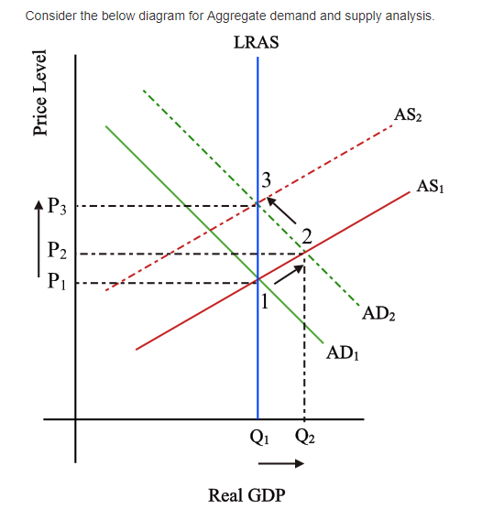

The economy is initially at equilibrium at point 1 with the price P1 and the real GDP of Q1. This is at a point where aggregate demand and aggregate supply intersect. With an increase in aggregate demand, the AS curve shift from AS1 ¬¬¬to AS¬¬2. This shifts the equilibrium to point 2 with an increased price level and real GDP of P¬2 and Q2 respectively. In the long run, all the other costs respond to this increase in prices result in fall in aggregate supply. This shifts the aggregate supply curve from AS1 to AS2. This shift the equilibrium to point 3 where price is P2 and real GDP is back to Q1.

Now considering the given instance, boom years are short run period. This is the point at which the price level increases from point 1 to point 2 in the above figure. As there is an increase in the real GDP during the period, the statement is true.

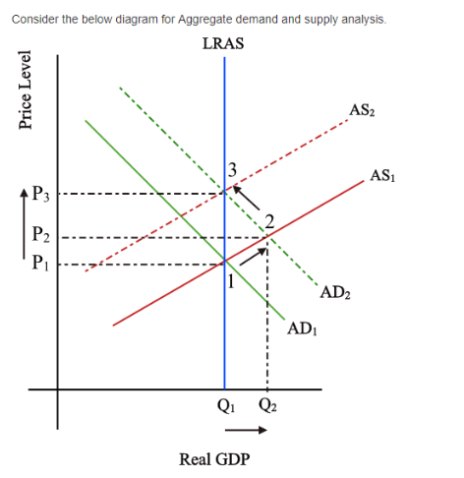

The economy is initially at equilibrium at point 1 with price P1 ¬and real GDP of Q1. This is at a point where aggregate demand and aggregate supply intersect. With an increase in aggregate demand, the AS curve shift from AS1 to AS2. This shifts the equilibrium to point 2 with an increased price level and real GDP of P2 and Q2 respectively. In the long run, all the other costs respond to this increase in prices result in fall in aggregate supply. This shifts the aggregate supply curve from AS1 to AS2. This shift the equilibrium to point 3 where price is P3 and real GDP is back to Q1.

Now considering our present situation of rising oil prices, this is the short run period that results in the shift in the equilibrium from point 1 to point 2. Due to the increased prices, other cost responds, resulting in a fall in aggregate supply. Observe the situation of the economy at point 3 where prices are high at P3 with the same real GDP of Q1. Hence from the aggregate demand and supply analysis, understand that the increased prices influenced the other cost resulted in a fall in aggregate supply and decline in real GDP.

