An investor can choose from a very large number of mutual funds. Each mutual fund has its own mix of different types of investments. The data in BestFunds3 present the one year return for the 10 best small cap growth, mid cap growth, and large cap growth funds, according to the U. S. News & World Report. (Data extracted from money. usnews. com/ mutual funds.) Analyze the data and determine whether any differences exist in the one year return between small cap growth, mid cap growth, and large cap growth funds. (Use the 0.05 level of significance.)

SOLUTION

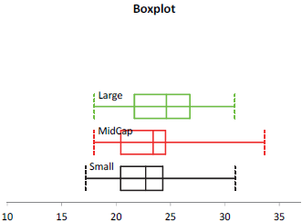

The boxplot shows that the one-year return for the 10 best mid-cap growth funds is right-skewed. The normality assumption needed for the following Levene test for difference in variances and one-way ANOVA F test for difference in means is violated. Since the sample size is small, the conclusions you arrive at could be misleading.

H₀: σ₁² = σ₂² = σ₃² The population variances are the same.
H₁: At least one σ_{j}² is different.

PHstat output of the Levene test:
ANOVA
Source of Variation | SS | df |  | MS |  | F | P-value |  |  |  | F crit
Between Groups | 1.1257 | 2 |  | 0.5628 |  | 0.0745 | 0.9284 |  |  | 3.3541
Within Groups | 203.9983 | 27 |  | 7.5555
Total | 205.1240 | 29
 |  |  |  | Level of significance |  |  |  |  |  |  | 0.05

Decision: Since p-value > 0.05, do not reject H₀. There is not enough evidence to conclude that the three population variances are different. Hence, the equal variance assumption for the ANOVA test for the difference in three means is not violated.

Populations: 1 = small cap, 2 = mid cap, 3 = large cap
H₀: μ₁ = μ₂ = μ₃ H₁: At least one μ_{j} is different
PHStat output:
ANOVA
Source of Variation | SS | df |  | MS |  | F |  | P-value |  |  |  | F crit
Between Groups | 14.1922 | 2 |  | 7.0961 |  | 0.4100 |  | 0.6677 |  |  |  | 3.3541
Within Groups | 467.3073 | 27 |  | 17.3077
Total | 481.4995 | 29
 |  |  |  | Level of significance |  |  |  |  |  |  |  | 0.05

Decision: Since the p-value = 0.6677 is larger than 0.05, do not reject H₀. There is insufficient evidence to conclude that differences exist in the one-year return between small cap growth, mid-cap growth, and large cap growth funds.

