The manufacturer of Boston and Vermont asphalt shingles provides its customers with a 20 year warranty on most of its products. To determine whether a shingle will last as long as the warranty period, the manufacturer conducts accelerated life testing. Accelerated life testing exposes the shingle to the stresses it would be subject to in a lifetime of normal use in a laboratory setting via an experiment that takes only a few minutes to conduct. In this test, a shingle is repeatedly scraped with a brush for a short period of time, and the shingle granules removed by the brushing are weighed (in grams). Shingles that experience low amounts of granule loss are expected to last longer in normal use than shingles that experience high amounts of granule loss. In this situation, a shingle should experience no more than 0.8 grams of granule loss if it is expected to last the length of the warranty period. The file Granule contains a sample of 170 measurements made on the company’s Boston shingles and 140 measurements made on Vermont shingles. Completely analyze the differences in the granule loss of the Boston and Vermont shingles, using α = 0.05.

SOLUTION

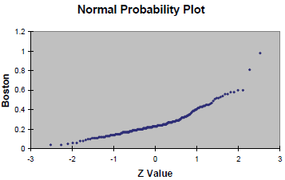

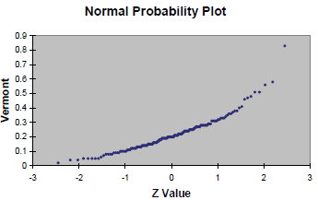

The normal probability plots suggest that the two populations are not normally distributed so an F test is inappropriate for testing the difference in two variances. The sample variances for Boston and Vermont shingles are 0.0203 and 0.015, respectively, which are not very different. It appears that a pooled-variance t test is appropriate for testing the difference in means.

H₀: μ_{B} = μ_{V} Mean granule loss of Boston and Vermont shingles are the same.
H₁: μ_{B} ≠ μ_{V} Mean granule loss of Boston and Vermont shingles are different.

Excel output:
t-Test: Two-Sample Assuming Equal Variances
 |  |  | Boston | Vermont
 | Mean |  | 0.264059 | 0.218
 | Variance |  | 0.020273 | 0.015055
 | Observations |  | 170 | 140
 | Pooled Variance |  | 0.017918
 | Hypothesized Mean Difference |  | 0
 | Df |  | 308
 | t Stat |  | 3.014921
 | P(T<=t) one-tail |  | 0.001392
 | t Critical one-tail |  | 1.649817
 | P(T<=t) two-tail |  | 0.002784
 | t Critical two-tail |  | 1.967696

Since the p-value = 0.0028 is less than the 5% level of significance, reject H₀. There is sufficient evidence to conclude that there is a difference in the mean granule loss of Boston and Vermont shingles.

