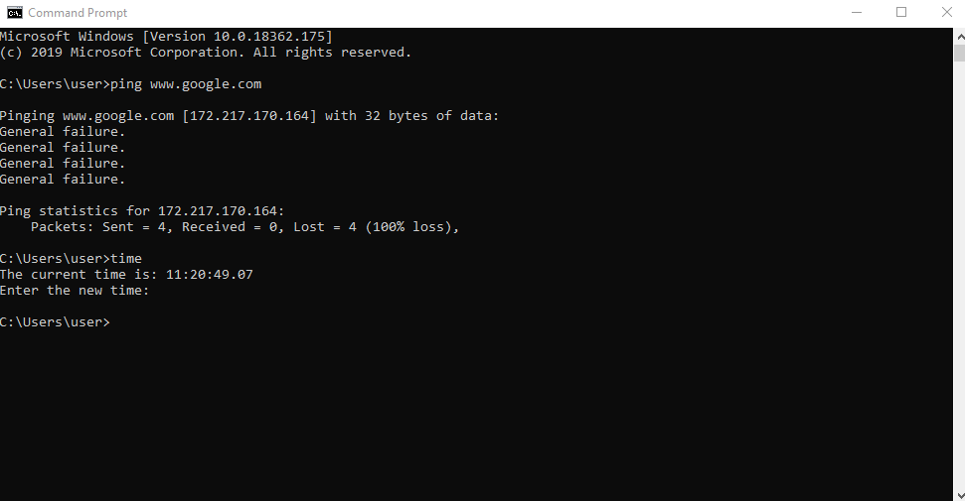
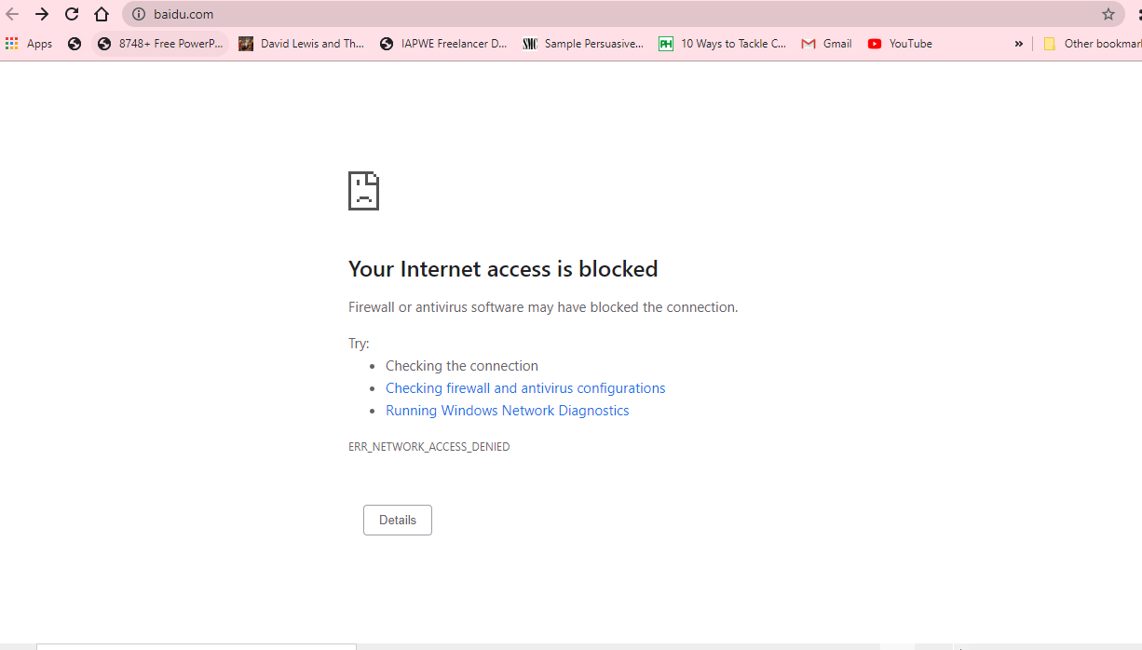
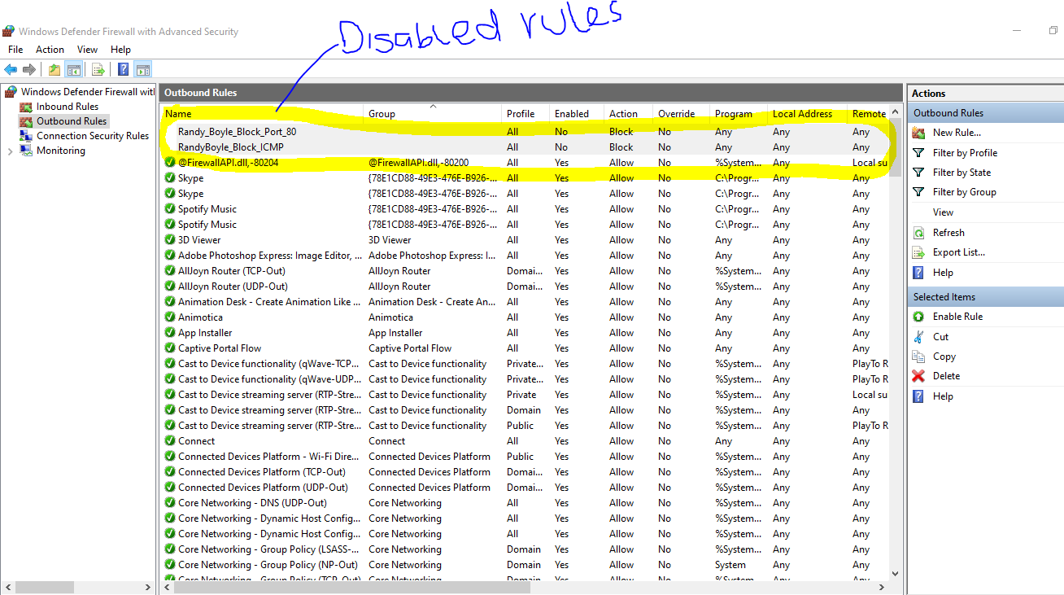

Blocking ICMP and Protection
Stallings and Brown (2017) assert that firewalls offer an efficient means of protecting a local network or system from security threats. They say that firewalls allow access to the outside world using wide area networks and the internet (Stallings & Brown, 2017). Indeed, blocking all ICMP traffic can project one from different security threats, including hacking activities. Given that ICMP ensure threats-free network connections and access, blocking ICMP traffic can help protect individuals against threats. Often, ICMP configure firewalls to block the outbound pings, people remain secure because only fixed-sized ICMP packets can pass through these firewalls. In addition, Boyle and Panko (2015) propose that though there are several attacks that static packet filtering might fail to stop, ICMP can stop numerous attacks very effectively. Also, blocking all ICMP traffic can considerably decrease the availability of discoverable data about a network and system. In some occasions, Boyle and Panko (2015) suggest that blocking certain ICMP types is preferred. Since ICMP is also a troubleshooting tool and error-reporting technique, blocking the ICMP traffic on a network is essential. Thus, creating a rule to block all ICMP traffic will assist and protect me from using ping command to send ICMP packets.
Port 80 Rule Enabled
I could still access some websites with my port 80 rule enabled. With the second rule of blocking all outgoing Port 80 traffic, it relates to the web traffic, also known as http. If I create and enable this rule, it implies that all the outgoing traffic is blocked. I can utilize a Web browser to verify this rule is effective. But, secure traffic, websites with https, will be accessible. Like the other protocols, Port 80 ensures vital projections, including reducing someone’s vulnerability or internet security threats from various attacks. Closing this port does not also decrease the risk to individuals who accidently visit different websites using http. Often, people get a redirect to https and remain protected from different types attacks. Similarly, keeping Port 80 enabled in attempts to serve a redirect allows individuals to receive the right version of different sites – usually with https versions. However, there are several situations beyond one’s control, which can briefly land them on the http version of websites, including manually writing domain names.
Allowing Port 443
I might want to allow incoming (not outgoing) Port 443 and block incoming Port 80 as https is more secure on port 443 than on 80. Often, it is important to know the difference. Often, http is largely unsecured on Port 80. The information that passes through 443 is also encrypted or protected using secure sockets. Compared to Port 80, one is more secure using Port 443. Besides, using https is also vital in reducing attacks from hackers through recognizing open ports and then hindering access with firewalls. It is also logical to access, pass, and transact using https sites in protecting one’s self from malicious attacks, including guarding personal data, customer details, business information, and passwords from unauthorized third-party individuals. With newer and emerging security threats today, it is advisable to use everything in one’s arsenal to prevent and obstruct cybercriminals. Thus, taking advantage of port 443 can appear as a simple solution, but it has unmatched benefits compared to port 80. Besides, the encryption over this port is also vital in protecting one’s communication and backing up information, ensuring robust actions in case of any disaster (Boyle & Panko, 2015).
Another advantage that port 443 has over port 80 is that information is transferred over a connection that is more and highly resistant to hackers and interruption. Further, one’s identity of a server, which connects remotely, can also be authentic with a lot of assurance. Similarly, once a connection has been established, sites using https displays signs like padlocks, unbroken keys, and others in the windows, which informs about secure connections. For this reason, Port 443 is most preferred than Port 80. Nowadays, cybercriminals attempt to invade and steal information that passes through and between different servers. If a website lacks an SSL certificate, which is only possible through port 443, suggests that the site operates through http rather than https. But, if https is unavailable, sites can load on secured connections through Port 80, which can be hard for criminals to intercept and steal information. As such, Port 443 offers security to information when shared across different servers. It locks data until it reaches its destination (Boyle & Panko, 2015).
If Malware Can Rename Itself
Yes, in efforts to pass through firewalls, a malware can rename itself. However, doing so is often dependent on firewalls type and the malware’s particular functionality. Similarly, it does necessarily suggest that the malware can make through firewalls. For instance, when a firewall is meant to block Port 20, users or malware can often tunnel the port session using different ports.

