AACS1573 Introduction to Data Science
MARKING CRITERIA
Your written assignment and presentation will be assessed against the following criteria.
ASSIGNMENT RUBRICS (CLO3)
No.
Criteria
Evaluation/Marks
Mark Achieved
0
– Nothing
Presented/
Plagiarized
2
– Developing
4
–
Approaching
Expectation
6
– Complete
8
– Excellent
10
– Beyond
Expectation
1
.
Logic and
Organisation
Does

not
develop
ideas
cogently,
uneven and
ineffective
overall
organisation,
unclear
introduction
and conclusion
Still
developingideas
cogently, uneven
and

ineffective
overall
organisation,
unclear
introduction and
conclusion
Develops unified

and
coherent

ideas
within
paragraphs with
generally
adequate
transitions; clear
overall
organisation
relating

most
ideas together
good

with
introduction and
conclusion
Develops

ideas
cogently organises
them logically with
paragraphs

and
them
connects

with
effective
transitions Clear

and
specific
introduction and
conclusion
Strongly Developed
cogently

ideas
them
organise
with
logically

paragraphs
and

connect them with
effective transitions
Clear and specific

and
introduction
conclusion n
High innovative
idea
cogently
organised and
logically
sequenced with
clear and
a
specific
conclusion.
2
.
Conceptual
Understanding
Does

not
respond
using course
content
using
Respond

appropriate and
sufficient course
content
Responds using
appropriate and
sufficient course
content
Respond

clearly
and
effectively
using appropriate
sufficient
and
Good Response in
using course content
and resources in
explaining
your

Highly effective

in
response
using
course
content
and
course
content
outside
and

sources
understanding of the
topic

to
sources
explain

the
understanding
3
.
Evidence
Does not
present data
Presents
accurately some
of the necessary
data
Presents clearly
and accurately
most of the
necessary data
Presents

clearly
and accurately all
of the necessary
data
Good Sequence and
Logical

thinking
behind Presenting
data
Most suitable
content
explaining the
end to end
points and with
clarity
4
.
Relevance of
Content
Irrelevant
content
Partially relevant
content

is
mentioned
Good relevant

content
is
mentioned
Right appropriate
Content is
mentioned
Right content with
clear logic content is
mentioned
Highly effective
content
explaining the
clear

logic
behind the topic
AACS1573 Introduction To Data Science
No.
Criteria
Evaluation/Marks
Mark Achieved
0
– Nothing
2
– Developing
4
–
6
– Complete
8
– Excellent
10
– Beyond
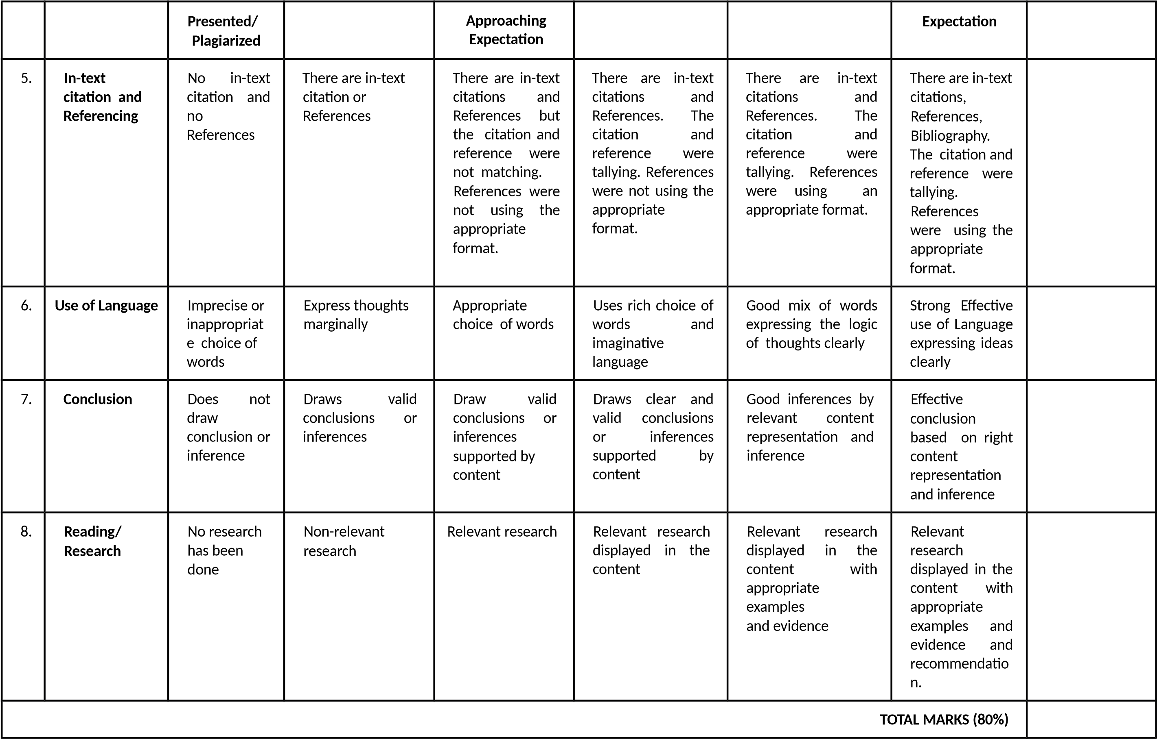
PRESENTATION RUBRICS (CLO2)
AACS1573 Introduction To Data Science

No
Evaluation
Categories
0
- No
submission
1
– Weak
/Unsatisfactory
2
– Developing
/Needs Improvement
3
- Satisfactory
4
- Very Good
5
– Exceptional
/Excellent
Mark
Achieved
1
.
INTRODUCTION
How well did the
speaker set the
scene
Did not
appear/atte
nd the
presentation
Lack of interest
and enthusiasm.
The presented
topic was not
introduced and
explained.
Individuals were
not introduced.
Shows a bit of
interest

and
enthusiasm.
The presented topic
was introduced but
vague and
irrelevant.
Introduced self but
not the members.
Seems interested,
but could be
more informed
on

the
introduction.
All members
were addressed,
including self.

and
Interested
enthusiastic

the
about

presentation. The
introduction has
been laid out
properly and to
the point.
All members
were addressed,
including self.
Eager about the
presentation.
Exceptional
introduction which
the

includes
summary.
All members were
addressed,
including self.
2
.
CONTENTS
Was the objective
identified? Was
the presentation
adapted to a wide
range of
audiences? Was it
well organized?
No clear
statement
offered.
Scope too broad
or too narrow;
lacks depth; AND
uses too much
technical
language/ jargon.

clear
No
information
sequence; very
difficult to follow.
Incomplete or
unfocused.
Scope too broad or
too narrow OR
lacks depth OR
uses too much
technical
language/ jargon.
Evidence of some
organization

but
not in an optimal
order; difficult to
follow.
Reasonably clear.
Reasonable scope
and depth; lapse
into detail that
may
not be
accessible to the
audience. Ideas
presented

in
logical sequence;
reasonably easy
to follow.
and

Clear
Good
concise.
scope & depth
without losing
the audience in
technical detail; a
learning

good
experience.
Presented
in

logical
&interesting
ways; easy to
follow but not
oversimplified.
Clear, concise.
Engaging, and
thought-provoking.
Exceptional scope
& depth; a true
learning
experience;
exceeds
expectations.
Exceptional
organization
because the topic
is complex.
Assignment Page 6
AACS1573 Introduction To Data Science

The
opinion
clearly
expressed.
Opinion strongly
expressed
and
supported.
4
.
CONCLUSIONS
CONFIDENCE
(
reading
materials)
How
well did the
author conclude,
summarize and
recommend?
No

apparent
conclusions; no
discussion

of
implications.
Conclusions

are
restatements
of

previous
statements.
Brings

closure

some
with
synthesis

but
does not address
implications.
Synthesizes the
brings
work;

closure; allude to
broader
implications.
Synthesizes; brings
closure;

conveys
real implications;
suggest

new
perspectives.
TOTAL MARKS (20%)
MARKING CALCULATION
A. ASSIGNMENT RUBRICS (80%)
B. PRESENTATION RUBRICS (20%)
TOTAL A + B (100%)
CONVERT TO 50%

Table Content
Task
Pages
Introduction
1.0
1.1 Definition of Data Science
1.2 Significance of Data Science
10
2.0
Case Study
1
0
3.0
Data Science Process
3.1 Identify Data Source
3.2 Data / Feature Selection
3.3 Data Cleansing
3.5 Data Analysis
1
1
1
1
-1
3
1
3
-1
4
14-16
4.0
Result and Discussion
16
5.0
Conclusion
1
7
6.0
References
1
7
Appendix
1
8

Introduction
Data science is the field of study which combines the scientific method, math and statistics, specialized programming, advanced analytics, and artificial intelligence to extract the meaningful business insight buried from the data. Banks utilize the data from customer previous history, trends, loyalty and communication by using data science. Nowadays, many banks are utilizing the power of data science to perform the important tasks like fraud detection and Customer Segmentation . Hence, investing in data science technology can add value to your business.
The using of data science in the banking sector is more than a tendency. Banks are using the data science to compete with their competition. Bank companies needed the data to develop insights and make data-driven decisions. Banks are able to make smarter decisions, focus their resources efficiently and improve performance by the helping of data science. Data science is playing some of the major role in banking industry. Here are some of the data science application which is risk modeling, fraud detection, customer lifetime value, customer segmentation, recommendation engines, real-time predictive analytics.

Case study
In this study, fraud detection by using data science in the bank industry is discussed. Fraud transaction are increasing heavily every year and it has cause the company losing billions amount of money. In the past businesses are using rudimentary analytics and business rules to look for anomalies to create alerts from separate data sets. With the current fraud detection system and the advancements in machine learning, it has made the companies easier to detect frauds and irregularities in transactional patterns. Proactive fraud detection in banking is crucial for the bank companies for providing the security to customers and employees. The sooner the bank detect the fraud, the less money they will loses. By implementing the fraud detection able the banks to achieve necessary protection and avoid significant loses.
There are some key steps of fraud detection. The first step is Obtaining the data samplings for model estimation and preliminary testing. The second step is model estimation and the third step is testing stage and deployment. Since each of the dataset is different, each of them needs individual training and development by data scientist. Transforming in-depth theoretical knowledge into practical applications requires expertise in data mining techniques such as association, clustering, prediction and classification. As an example, when some unusually high transactions occur, the bank’s fraud prevention system will put the money on hold until the account holder confirms the deal.

3.1 Identifying Data Source
Nowadays, with the evolved of the technology, big data systems are helping all the bank to better understand the human behavior and predict for conclusions. Big data systems are able to help the bank industry to identify for the fraud transaction accurately. There are multiple places that people can get the datasets such as Kaggle, Google Public Datasets or UCI Machine Learning Repository. In this assignment, we are using the data sets from PaySim simulator n bank in order to produce a synthetic datasets that resembles the regular operation of transaction and injects the fraudulent behavior to test the performance of fraud detection method. PaySim simulator in bank will help aggragated data from private dataset to generate a synthetic dataset https://www.kaggle.com/ntnu-testimon/paysim1. Usually in the real-life application the source of the datasets is coming from the bank manager. Bank Manager will provide the data such as customer details and customer’s behaviour.

3.2 Data/Feature Selection
Figure 1 shows the data of synthetic financial datasets for fraud detection
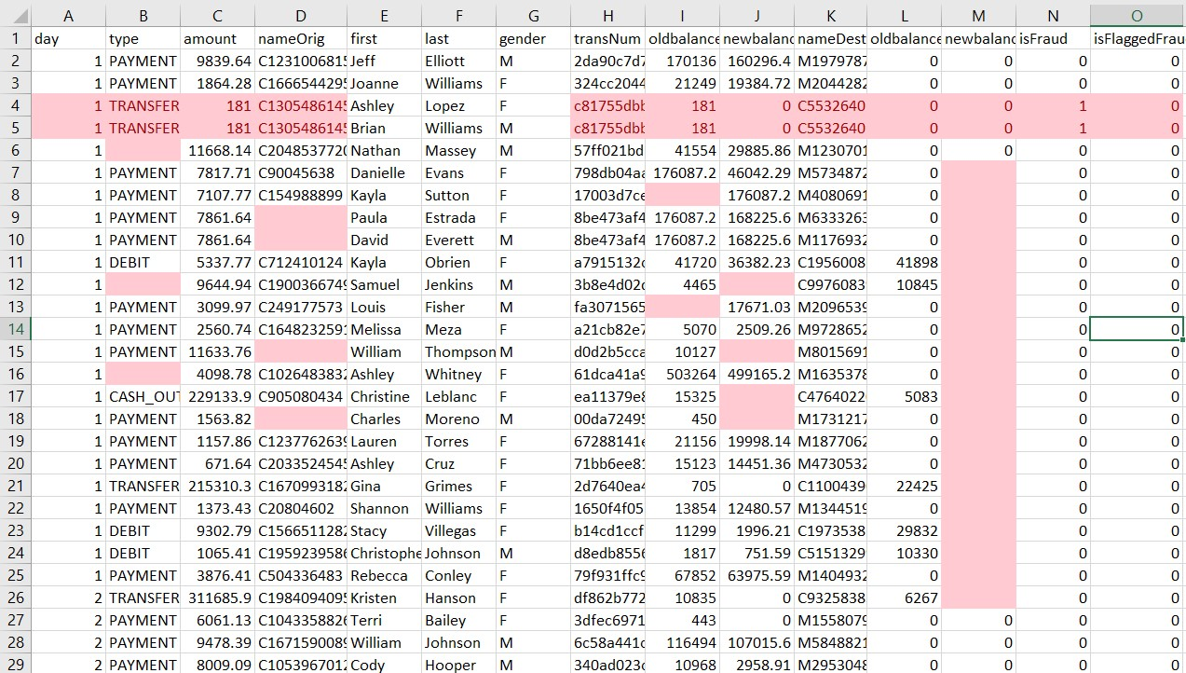

Figure 1: Synthetic financial datasets for fraud detection before data selection
Figure 1 shows the Synthetic financial datasets for fraud detection before data selection. Figure 2 shows the Synthetic financial datasets for fraud detection after data selection. The dataset consists of 99 customer and 15 features. The feature are sort in to three categories .First is customer behavior feature such as day, and type of transaction. The second category is customer Information feature such as amount, nameOrig , first, last, gender. The third Category is the customer’s transaction information such as transNum, oldbalance, newbalance, nameDest, oldbalanceOrig, newbalanceOrig. In the datasets of the study which is shown in figure 1 contain 15 columns and 100 rows of data. There are multiple of data type which is day, type, amount, nameOrig,first, last, gender, transNum, oldbalance, newbalance, nameDest, oldbalanceOrig, newbalanceOrig, isFraud, isFlaggedFraud. This datasets help people to get know of customer behavior when processing the transaction.
Day is mean unit of time in real world and day 1 means 1 day of time in real world . Type is mean type of transaction such as debit, payment, cash-in, cash-out and transaction. Amount means that amount of the transaction. NameOrig means that customer who started the transaction. First,last and gender means the first name, last name and the gender of the customer. oldbalanceOrig means that initial balance of the bank account before the transaction. newbalanceOrig means that the new balance of the bank account after the transaction. nameDest means that customer who is the recipient of the transaction. oldbalanceDest means that initial balance recipient after the transaction. newbalanceDest means the new balance recipient after the transaction. Data type isFraud means the transactions made by the fraudulent agents inside the simulation. In this specific dataset the fraudulent behavior of the agents aims to profit by taking control or customers accounts and try to empty the funds by transferring to another account and then cashing out of the system. While isFlaggedFraud means the business model aims to control massive transfers from one account to another and flags illegal attempts. An illegal attempt in this dataset is an attempt to transfer more than 200.000 in a single transaction.

Data after data selection
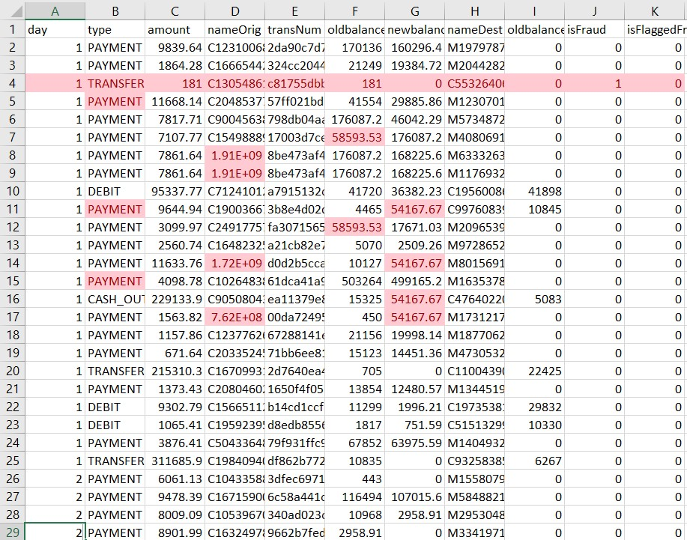

Figure 2: Synthetic financial datasets for fraud detection after data selection
Data Before data selection contain few data such as day, type, amount, nameOrig,first, last, gender, transNum, oldbalance, newbalance, nameDest, oldbalanceOrig, newbalanceOrig, isFraud, isFlaggedFraud. After the data selection the data such as first name, last name and gender is being taken out. The reason these data is being taken out is because these data type are not suitable for this project. As a general rule, you would be expected to preserve anonymised data only. Personal data should be deleted as soon as possible because it will against the legal requirement for keeping the personal data.

3.3 Data cleansing
Figure 3 shows the Synthetic financial datasets for fraud detection before data cleansing while the Figure 4 shows the Synthetic financial datasets for fraud detection after data cleansing.

Figure 3: Synthetic financial datasets for fraud detection before data cleansing
Figure 4: Synthetic financial datasets for fraud detection after data cleansing Data nameOrig before the data cleansing is using the wrong format, as an example of the wrong format 1912850431 and 1716932897. nameOrig data supposed to start with a alphabet C then with the number, as an example of the correct format,C1912850431 and C1716932897. Hence, we clean the data by fixing the error of the nameOrig data by adding a C infront of the number.
Next, there’s some missing value in the oldbalanceOrig and newbalanceOrig Data. This problem is being solve by calculate and filling the mean average value of the data in to the missing column. The reason of using mean value to fill these column is because there are only a few data are missing from the datasets. There’s also a lot of missing data in the newbalanceDest.
Hence, we clean the data by delete the whole column from the datasets.
Next, the there’s also some missing value in the type data. The missing value of the type data is fill by the most frequent data. In addition, there’s duplicate data in the datasets above. The duplicate data is being remove from the datasets and only one of the data is remain in the datasets.

3.5 DATA analysis
Data analysis is a necessity for making well-informed and efficient decisions. Data analysis is being used in this study to help the bank to find the fraud and predict the fraud transaction with the datasets provided in the figure 4. Figure 5 shows a pie chart is used to display frequency of the type of transaction of 99 transaction. Figure 6 shows a line chart is used to display the total amount of different of type of payment of 99 transaction. Figure 7 shows a histogram chart is used to display the total amount of transaction of 4 day.
PAYMENT;
57.14
%
TRANSFER;
24.49
%
DEBIT; 9.18%
CASH_OUT; 9.18%
frequency of type of transaction
PAYMENT
TRANSFER
DEBIT
CASH_OUT

Figure 5: frequency of the type of transaction of 99 transaction
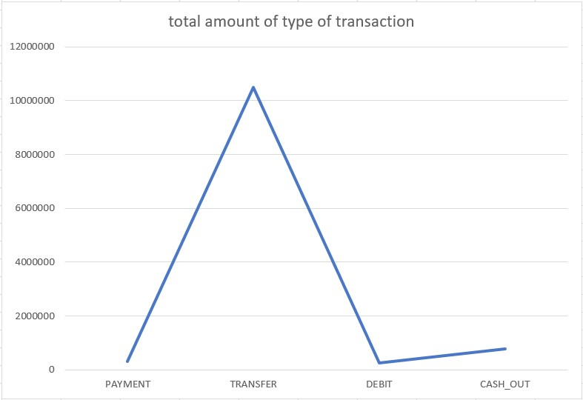

Figure 6: the total amount of different of type of payment of 99 transaction
Day 1
Day 2
Day 3
Day 4
0
2000000
4000000
6000000
8000000
10000000
12000000
Total amount of transaction of 4 day
Figure 7: the total amount of transaction of 4 day

4 Result and Discussion
The result of the pie chart shows that PAYMENT is the type of payment method that is frequently used by the customer following by TRANSFER transaction method. Next, number of customer using the DEBIT and CASH_OUT payment method are the same. This result of pie chart shows that customers favorite transaction method is using PAYMENT transaction method following by TRANSFER, DEBIT, CASH_OUT transaction method.
The result of the line graph shows that TRANSFER transaction method involves the most of the money compare to other transaction method following by CASH_OUT, PAYMENT, DEBIT transaction method. The result of the line graph shows that TRANSFER transaction method is the transaction method that the customer using when transfer large amount of money and it also shows that customer more willing to use this transaction method when transfer large amount of money following by CASH_OUT, TRANSFER, DEBIT transaction method.
The result of the histogram graph shows that Day 4 involve the most transaction amount compare to the other day such as Day 1, Day 2 and Day 3. It shows that there are a lot of customers are transferring big amount of money in Day 4 then followed by Day 1, Day 3 and Day 2.

CONCLUCISON
As a conclusion, large amount of customer transaction data are being generated and recorded by using data science. Data science able to help the company to extract the data and provide more insight to the management. With the insight provided it make it easier for the bank to identify the new trends and the behavior of the customer and these data are able to help. Even though it have a lot of good advantage but it also have a lot of disadvantage which is high costs. To understand the pattern of the fraud and detect fraud, a team of data scientists are needed to design and continually update the system. With the involvement of massive amounts of data, businesses are also required to invest in data storage and management as well. Next, it is difficult to collect good data. A great deal of good data are needed in order to build a machine learning model with long-term functionality.
However, from the output of the chart we can understand, we are not able to achieve the objective which is Fraud detection. The reason of this is because fraud detection aren’t able to achieve without the machine learning. Fraud detection and Machine Learning becomes possible due to the ability of Machine Learning algorithms to learn from the historical fraud patterns and recognize them in the future transaction. So the fraud detection objective is not achieve.

6 Refrences
Medium,Guru99 2021,What is Data Analysis? Research | Types | Methods | Techniques,viewed
10 February 2021, Available at: <https://www.guru99.com/what-is-data-
analysis.html#:~:text=Data%20analysis%20is%20defined%20as,based%20upon%20the%20data %20analysis.>
2021 Kaggle Inc,Students&#39; Academic Performance Dataset,viewed 12 February
2021,Available at:< https://www.kaggle.com/ntnu-testimon/paysim1>
Craig Stedman,2005 - 2021,DEFINITION data analytics (DA),TechTarget, viewed 12 February
2021, Available at: <https://searchdatamanagement.techtarget.com/definition/dataanalytics?
_gl=1*t6qvxf*_ga*MTIxMzQ5NTM0OC4xNjA3NDQxNTI2*_ga_RRBYR9CGB9*MTYxMz
MwMjIxNS4xLjAuMTYxMzMwMjIxNS4w&amp;_ga=2.229203418.751049824.16133022161213495348.1607441526>
Available at:<https://wso2.com/whitepapers/fraud-detection-and-prevention-a-data-analyticsapproach/>

