ACCT 365 DATABASE ASSIGNMENT

OBJECTIVE
The primary objective of this assignment is to teach you how to create tables in Microsoft Access. By completing this assignment, you will also gain Database Management System (DBMS) skills required to set up table structures and field properties and to establish table relationships. You will also gain familiarity with DBMS concepts such as (1) primary and foreign keys, (2) one-to-many and many-to-many relationships, (3) a relationship table (i.e., a linking entity), (4) referential integrity, and (5) an Entity-Relationship (E-R) diagram.

COMPANY BACKGROUND
Almost a year ago Tom Waren, owner of Waren Distributing, was approached about an idea for a new business venture by his twin sister Jill. Jill had been considering starting a video shopping network show to distribute various products to retail customers. Jill wanted Tom to sell his products to her new business Waren Unlimited at cost and in exchange Tom would receive a 20% share of Waren Unlimited profits after one year. Jill started operations in July without Tom's participation, but he decided to join with Jill in September. Several cable television stations have broadcast the program, which demonstrates name brand products and flashes a 1-800 number that viewers can dial to order items. Waren Unlimited's product pricing is very competitive as inventories are purchased in very large quantities directly from Waren Distributing and a number of other manufacturers/distributors. Also, overhead is minimal in comparison to retail outlets.
This is a critical time in Waren Unlimited's growth. National cable network time has recently been purchased and decisions need to be made on how to best use the expensive national air-time. You have been asked to develop some relational database tables Waren Unlimited can use to collect data on operating activities. The data will be used to formulate future business plans.

PARTIAL E-R DIAGRAM
On the following page you will find selected entities and relationships for Waren Unlimited. A complete database would consist of customer payment records, inventory purchases, etc. and would involve complete interactions between all aspects of the database. However, these few tables shown below will provide a representative exposure to relational databases and provide you with the understanding of how to create and use tables. The attributes (or fields) required in the tables shown below are as follows:
Customer = (Customer#, Customer Name, Address, City, State, Zip, Age, Sex, Occupation)
Item = (Stock#, Supplier#, Description, Unit Cost, Sales Price, QOH, Air Time)
Order = (PO#, Customer#, Salesperson ID, Date)
Order-Item = (PO#, Stock#, Quantity)
Salesperson = (Salesperson ID, Salesperson Name, Commission Rate)
Supplier = (Supplier#, Supplier Name, Address, City, State, Zip)
M
*
M
Supplier
Item
Order
Customer
Salespers
on
Order-
Item
M
1
1
M
*
M
1
M
M
1
1
*Many-to-Many relationships are not allowed by Access and require a relationship (or linking entity) table which results in the Order-Item Table. The table titled “Order-Item” is necessary because inventory items have a many-to-many relationship with purchase orders. This means that any particular inventory item can be purchased by several customers while any one customer may purchase several different items. Therefore, the individual items included in each order are identified in the table “Order-Item”. To work in Access, you will not and cannot have a many-to-many relationship between the Item and Order tables. Instead, this is turned into a One-to-Many relationship between Item and Order-Item and One-to-Many between Order and Order-Item tables. (So you will have a total of FIVE lines.)
The underline indicates the table’s primary key and the dashed underline designate a foreign key. Note that in the case of a concatenated key such as “PO#, Stock#” the primary key may also serve as a foreign key. The primary key is the unique identifier for each item in the table. The foreign keys are derived from the relationships between the entities. The rule followed is: the primary key of the "one" is placed in the table of the "many” as the foreign key. Why? Consider the supplier – item relationship. Say the supplier Hills Office
Supply supplies 30 items. If the item code were put in the supplier table, the row depicting Hills Office Supply would be quite long – it would need 30 places for a list of items it supplies. That’s not efficient, especially if some suppliers might just supply a couple of items and another supplier might provide a hundred. However, if you put the foreign key in the ‘many’ table, i.e, the Items table, each item in the table would require one spot for the supplier that supplies that particular item. So putting the foreign key in the ‘many’ table is the simple, efficient, logical way to do it.

CREATING TABLES (3 points)
First you will create four of the six tables indicated above, including setting a primary key(s) for each. Then you will establish the relationships between the tables (which will automatically establish the foreign keys.)

To Create The Tables
- Download Waren_Unlimited_1.accdb from Blackboard and save it onto your computer or your flash drive. Do not open and work on the file directly in Blackboard. I will not be sympathetic when you then cannot save your work.
- Open the file by either double clicking it or start Access 2013, then File-Open as you would in Word, and open the file that you saved on your computer or flash drive.
- You will see two tables on the left-hand side. Double-click on tbl_customer. The computer opens the table in “datasheet view”, where you are viewing the contents of the table. Tbl_customer contains no data, i.e., no customer names, addresses, or other information. Under the HOME TAB, click on the architect triangle on the top left (above the word “view”) to get the ‘design view’, where you see the structure of the table. How many fields does the table have? (9) How many of these are text? (8) What is the field size of age? (Click on age, look below for the field properties. It’s an Integer.) If you wanted to input data, you would click on the icon that looks like a spreadsheet which is under the home tab, top left, exactly where the architect’s triangle used to be. Clicking on this grid-looking icon takes you back to the datasheet view. Close the customer table; do not forget how to toggle between design view and datasheet view.
- Click on Create, which is a tab on top of the ribbon, then Table Design (to create a table in design view). Enter the field names and data types as shown below in XX-Item (IMPORTANT!! THE “XX” refers to YOUR INITIALS! So my table name would be BJ-Item, yours would be your initials rather than the BJ). Field Name and Data Type go on the top half of the screen; Field Properties are entered on the bottom half of the screen. Note that field properties will change as you click on different fields. Adjust the field properties as indicated below.

XX-Item FIELD NAME DATA TYPE FIELD PROPERTIES
XX-Stock# Short Text Field size 5
XX-Supplier#. Short Text Field size 7
XX-Description Short Text Field size 25
XX-Unit Cost Currency
XX-Sales Price Currency
XX-QOH Number Integer
XX-Air Time Number Integer
- Identify the primary key. To set the primary key, put the cursor on the row for XX-Stock#, right click and click on ‘primary key’. Another way to do it would be to put the cursor on Stock#, click on the Design tab above and then click on the Primary Key icon, top left.
- Close the table; it will ask you if you want to save it. Click on Yes and name it XX-Item.
- Click on Create, Table Design for XX-Order. Enter table design (see below). Repeat for XX-OrderItem and XX-Salesperson.
- Remember to always use your initials in place of XX and to indicate the primary key. If you forget to indicate the primary key, Access will remind you as you exit that you should have one. If that happens, cancel the exit and set the primary key. Do not let Access add the primary key because it will add a new data item which you do not want or need. (If this happens, go to design view of the table, put cursor on row with new primary key added by Access and delete it.)
XX-Order
FIELD NAME
DATA TYPE
FIELD PROPERTIES
XX-PO#
Short Text
Field size 7
XX-Customer#
Short Text
Field size 5
XX-Salesperson ID
Short Text
Field size 15
XX-Date
Date/Time
XX-Order-Item
FIELD NAME
DATA TYPE
FIELD PROPERTIES
XX-PO#
Short Text
Field size 7
XX-Stock#
Short Text
Field size 5
XX-Quantity
Number
Integer
- Notice this table has a composite primary key (i.e., the primary key involves more than one attribute/field). Click on one field, then hold down the Control (Ctrl) key and click on the second field. Both lines should be highlighted (the light blue box on the left will be darker blue). When both are highlighted, click Design tab and Primary Key on the ribbon. After setting the primary key, close and save the table.
XX-Salesperson
FIELD NAME
DATA TYPE
FIELD PROPERTIES
XX-Salesperson ID
Short Text
Field size 15
XX-Salesperson Name
Short Text
Field size 30
XX-Commission Rate
Number
Field size is Double
Format is Percent
Decimal places is auto
- After entering and saving the above tables, go back and make the following modifications.
- Open the customer table (double click on it), go to design view (Home tab, architect’s triangle). The gender field size should be set to one. Under Default Value enter "F" since most customers are female. Under Validation Rule enter =F or M, indicating Male or Female. Under Validation Text enter the following text: Must enter "F" for female or "M" for male. Validation text is the message the user sees if he/she does not enter data correctly per the validation rule. Test this to make sure it works. (Click on datasheet view, top left, then enter something other than F, f, M, or m in the gender column.)
- Fix the Field Properties on the following three data items to include an “input mask” (i.e., a pre-specified format for the data). In table design view, on top half highlight the data item. Then down in Field Properties, input mask line, click on expression builder (a box with 3 periods) that appears at the right when you click on this line. This will give you the wizard choices. Adjust the input masks as follows:
Salesperson ID in the Order table should be Social Security Number type.
Date in the Order table should be short date type.
Salesperson ID in the Salesperson table should be Social Security Number type.

ESTABLISHING RELATIONSHIPS BETWEEN TABLES (2 points)
- Before you begin setting up your relations make absolutely sure you have set up both the PO# and Stock# as the (composite) primary key in the Order-Item table. Close all tables.
- Click Database Tools tab, then Relationships. Add each of your six tables by left clicking on the table on the left side and dragging it to the middle screen. If you accidentally add one twice, just right click on it and ‘hide table’.
- Arrange the tables so they appear in the same place on the page that they are in the data model on page 2 above. (No technical reason for this; it’s to assist in my grading and your line-drawing).
- Establish relationships between tables based on the E-R Diagram (data model) depicted in section
III. Establish the relationship between two tables by clicking on a field in one table and dragging and dropping it the related field in the other table. For example, drag from the Customer# field in the Customer table to the Customer# field in the Order table. Do not drag from the Customer# field in the Customer table to the PO# in the Order table. This is not a key-to-key thing. The two data items being linked must be conceptually the same thing.
An Edit Relationships dialog box will appear when you release the mouse button. Verify the table relationships in the Edit Relationships dialog box and the relationship type (one-to-many). Click on "Enforce Referential Integrity" “Cascade Update” options, then Create. Referential integrity is the way Access enforces minimum cardinality rules. So in this example, you wouldn’t be able to add an order for a customer unless that customer was in the database (i.e., in the customer table). After all five relationships are established, close the Relationships window. If you need to edit or delete a relationship, put the cursor precisely on the relationship line and right click.
If you get an error message like this, you didn’t set a primary key in a table.
If you get the error message below, it means the field types you are trying to link are not the same type. Maybe one is a number and one is a text, or one is a date one is a text, or maybe they are both numbers but they are not the same type of numbers.
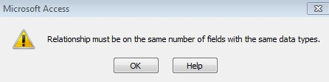
If you do not get 1 to infinity, you just get a line between the two tables with no cardinality indicators, you forgot to click the ‘enforce referential integrity’ box (and cascade update).
Fix the error back in the table/design view, and come back and set the relationship. Close the relationships window.
VI. GETTING DATA INTO YOUR TABLES.
1. Importing Data from a Microsoft Excel Spreadsheet (1 pt)
- You will import data from Excel to the tbl_Customer table. Look at the file ‘tbl_Customer.xls’ using excel. The Customers datasheet has 21 rows of data, column headers, and contains CustomerID, Name, Address, City, State, Zip, Age, Gender, and Occupation.
- Close the Excel file and close the tbl_customer table in Access. Under ‘external data’ tab, in the
‘import and link’ section of the ribbon, click on the Excel icon. In the dialog box that pops up, browse for your excel tbl_customers.xlsx file, click on ‘append a copy of the records to the table’ and in the drop-down box select the tbl_customer table. OK. Show worksheets radio box should be checked and tbl_customer should be highlighted (if your excel file had several worksheets in it, this is where you would select the worksheet you want to import. Yours only has one.) Next. Next. Import to table: tbl_customer. Finish. Close.
- Open tbl_customer and verify that 20 records have been imported.
2. Entering data directly (1 pt)
- Enter the following data into the salesperson table (simply type the three lines of data into the table, in datasheet view):
tbl_Salesperson
Salesperson ID Salesperson Name Commission Rate
519-23-5909 Goldberg, Carla 2.00%
401-93-8888 Holcomb, Sandra 1.50% 234-34-5212 Johns, Michael 3.50%
- Close the table.

COPY TO WORD
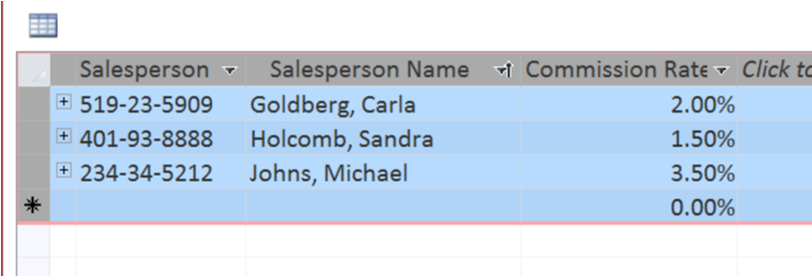
- Click Here to highlight the whole Salesperson table. Copy (control C or right click, Copy) and past into a new word document. Save it; name doesn’t matter as long as you can find it.
- Repeat and copy the contents of the Customer table into same Word document, below the Salesperson table.
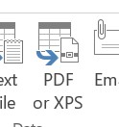
- Go to the ER diagram (Database Tools tab, click on Relationships). If your relationships look like the diagram below, they are correct. After you check it, click on PDF to make a PDF report. It doesn’t matter what you name it as long as you can find it to upload to Blackboard.
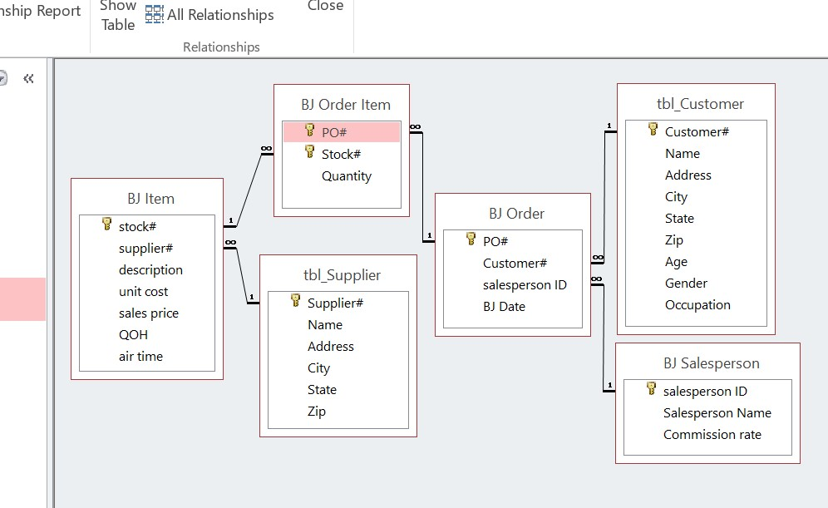

TURN-IN
- Upload your Access file to Blackboard.
- Upload your Word Document showing the contents of the two tables (Salesperson and Customer) • Upload the PDF file showing the relationships.
Note: You cannot email database files to my Outlook (bjones) account, because Outlook sees them as potential virus files and strips them off the email. Two implications: (1) Get them done on time; you can’t email them to me once Blackboard stops accepting them. They won’t be accepted late! (2) If you need me to look at your file, you must come to my office with your file on a flash drive or with your laptop.
Powered by TCPDF (www.tcpdf.org)

