BRE418 Real Estate Development
Coursework constitutes 50% of your final grade, comprising the following components:

- Term Project (Group Work)
  - Presentation : 10%
  - Final Report : 15%
- Term Paper (Individual Work) : 25%

(a) Term Project (25%)

You and your group members (with 5 to 8 persons) will use this assignment to undertake a feasibility study for a redevelopment project. Through this practical project, you are expected to develop a greater understanding of the underlying principles, concepts and processes of property development in the contexts of Hong Kong.

The subject site is located at 53-59 and 61-63 Pilkem Street, Jordan, Kowloon. It has a site area of approximately 550 square meters. Currently, it is occupied by an array of composite buildings of 6 storeys, which have been used for shops and residential uses. According to the Tsim Sha Tsui Outline Zoning Planning (S/K1/28), the subject site falls within a “Residential
(Group A)” zone.

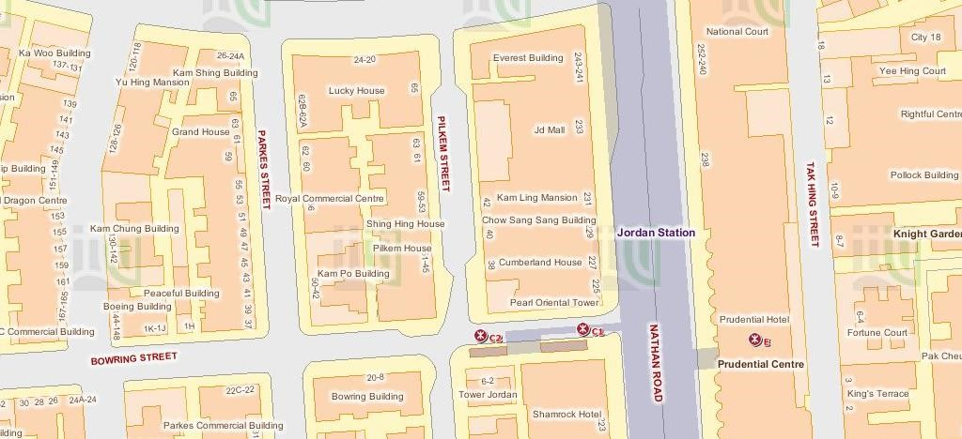
Figure 1 Location of the Subject Site

The Subject
Site

Assuming that the subject site is under a single ownership and its lease conditions are virtually unrestricted, your client is interested in redeveloping this site into a hotel or an office development with retail shops at the lower levels. To facilitate his decision making on redevelopment, he invites you and your group members to conduct a feasibility study. In your report, you need to offer your professional advices on the following issues:

- Market Analysis. The real estate market in Hong Kong has experienced a rapid growth over the past several years. However, the recent week outlook for local retails sales and economic development may hinder the demand for street level stores and office premises in the years to come. Based on your market research, you need to provide an analysis on the vacancy rates of these two types of premises, their price and rental levels as well as the conditions of their future supply in the nearby areas. Moreover, you need to identify both the opportunities and the key market risks for the proposed redevelopment project.

- Planning application. Within a Residential (Group A) Zone, hotel/office development requires planning permission from the Town Planning Board. You are required to provide a brief account which provides the development justifications/planning gains of your proposed development scheme and explains the key procedures involving in the planning application for the proposed development under Section 16 of the Town Planning Ordinance.

- Development Scheme Formulation. In your proposed development scheme, you need to show the key development parameters, including office grade, site coverage, plot ratio, building height, no. of storeys, total gross floor area, and so on. In formulating your development scheme, you should take into account the site conditions as well as those development restrictions imposed by the Outline Zoning Plan and the Building (Planning) Regulations.

- Land Value Assessment. You need to provide a residual valuation assessing the open market value of the subject site (as at 15 March 2020) based on your development scheme. The assessment will be conducted based on the assumption that the subject site is vacant (cleared of structures).

Project Presentation and Final Report Submission:

Each group will give a presentation (20-30 minutes) on their final report respectively. Moreover, each group is required to submit a final report of no more than 20 pages (include all tables, figures and pictures, but exclude the covering sheet showing your identity and the page containing the list of references). The report must be type-written on A-4 papers. Font size must not be smaller than 12.

All report submission in hard copy will be submitted to the collection box at ZS 7/F of BRE Department. The submission due date is 14 May 2020.
(b) Term Paper (25%)

Your term paper should focus on one of the following questions:

Question 1

In what way the adjustments in mortgage rules could affect housing markets have remained highly controversially. In October 2019, the Hong Kong SAR Government announced relaxing mortgage restrictions on first-home buyers. According to the policy address delivered by the Chief Executive, for those first-home buyers who are qualified, the lending cap to borrow up to 90 per cent of the property’s value would be increased from HK$4 million to HK$8 million. Meanwhile, the cap on the value of domestic properties eligible for mortgages of up to 80 per cent would be raised from HK$6 million to HK$10 million. Some people opine that these new measures will not significantly influence housing prices as they only help those first-home buyers who have sufficient income to support a property but do not have adequate money to make a down payment. One the other hand, some people argue that such measures will drive up property prices and lead buyers to take on high risk in a downward market. In your term paper, you are required to critically examine these different views and explain why you agree or disagree with them.

Question 2

The “rail plus property (R+P)” development model has been widely adopted by many cities as an urban development strategy to enhance land use efficiency. However, in practice, this model has countered increasing objections due to its negative impact (e.g. the construction of walled buildings etc.) on local communities. In this term paper, you are required to critically analyze, with local examples, the key success factors behind the R+P model as well as the possible limitations and pitfalls of this model in Hong Kong (or your city).

Term Paper Submission:

Your term paper submission must not exceed five A-4 pages (include all tables, figures and pictures, but exclude the covering sheet showing your identity and the page containing the list of references). Your submission must be type-written, using a font size of no less than 12 pt, and leaving a margin of at least one inch on all four sides.
All term paper submissions (in hard copy) will be submitted to the collection box at ZS 7/F of BRE Department. The submission due date is 14 May 2020.

Assessment Criteria (Written Submission)
Your written submission will be graded based upon the following assessment criteria:
Assessment  Criteria/Outcomes | Grade:
Assessment  Criteria/Outcomes | F | D/D+ | C/C+ | B/B+ | A/A+
Comprehension | Unsatisfactory in the accuracy and coverage of the key concepts and issues | Demonstrate some superficial coverage of the key issues but is obviously lopsided or inaccurate | Demonstrate and adequate understanding of the key issues, but some noticeable  missing gaps | Demonstrate a balanced and accurate coverage of the key issues | Demonstrate an  accurate, convincing, comprehensively, and impressive understanding of the key issues
Evaluation | Incapable of accurately appraising the importance, strengths and limitation of the relevant theories | Demonstrate obvious weakness in appraising the importance, strengths and limitations of the relevant theories | Meet general expectation in accurately appraising the importance, strengths and limitation of the relevant theories | Meet most expectation in accurately appraising the importance, strengths and limitation of the relevant theories | Exceed expectation in accurately appraising the importance, strengths and limitation of the relevant theories
Critical Thinking | Incapable of providing solutions in unfamiliar scenarios and/or responding to questions | Provide trivial and superficial answers that are directly or mostly adopted from references without analysis | Meet general expectation in providing solutions in unfamiliar scenarios and/or responding to  questions | Meet most expectation in providing solutions in unfamiliar scenarios and/or responding to questions | Exceed expectation in providing solutions in unfamiliar scenarios and/or responding to questions
Problem solving & Application | Incapable of applying the theoretical knowledge in actual circumstances and/or solving practical real estate development issues | Fail to meet expectation in applying the theoretical knowledge in actual circumstances and/or solving practical real estate development issues | Meet general expectation in applying the theoretical knowledge in actual circumstances and/or solving practical real estate development issues | Meet most expectation in applying the theoretical knowledge in actual circumstances and/or solving practical real estate development issues | Exceed expectation in applying the theoretical knowledge in actual circumstances and/or solving practical real estate development issues
Communication | Incapable of communication and presenting  ideas in a clear manner | Contain some major and obvious errors in communication | Meet general expectation in communication and presenting ideas in a clear  and articulate manner | Exceed expectation in communication and presenting ideas in a clear  and articulate manner | An error-free piece of work in terms of communication and a highly pleasant piece of work for reading
Spelling and  Grammar | Full of spelling mistakes. Full of grammatical mistakes. | Many spelling mistakes.  Many grammatical mistakes. | Clear evidence of not using spell check. Clear evidence of grammatical mistakes. | Very Few spelling mistakes. Grammatical mistakes can be found, often due to weak English foundation. | No spelling mistakes. Few, if any, grammatical mistakes.

Assessment Criteria (Oral Presentation)
Your oral presentation will be graded based upon the following assessment criteria.
Your tutor will assess your team’s performance in every presentation. Your individual grade from the presentation will be moderated by the lecturer/tutor if your individual performance is found to be substantially different from your team performance.

Assessment  Criteria/Outcomes |  |  | Grade:
Assessment  Criteria/Outcomes | F | D/D+ | C/C+ | B/B+ | A/A+
Comprehension | Incapable of accurately identifying and describing the key issues. | Barely meet most expectation in accurately identifying and describing the key issues. | Generally capable of accurately identifying and describing the key issues. | Meet most expectation in accurately identifying and describing the key issues. | Exceed expectation in accurately identifying and describing the key issues.
Participation | Do not participate in the personation and stay quiet in most circumstances; do not pay attention to questions and comments. | Do not actively participate in the personation and stay quiet in most circumstances. | Participate in the presentation and respond to questions and comments. | Participate very actively in presentation and responding to questions and comments. | Participate very actively in presentation and often taking the lead in responding to questions and comments.
Communication | Incapable of communicating and presenting ideas in a clear  and articulate manner | Barely meet expectation in communicating and presenting ideas in a clear and articulate manner. | Meet expectation in communicating and presenting ideas in a clear  and articulate manner | Meet most expectation in communicating and presenting ideas in a clear and articulate manner. | Exceed expectation in communicating and presenting ideas in a clear and articulate manner

Plagiarism and Referencing
Sources of information must be clearly referenced. Plagiarized assignment will be awarded
an “F” grade and the students concerned may be subject to disciplinary action. More information and guidelines about plagiarism and how to avoid it are available at https://www.polyu.edu.hk/ogur/academic-integrity.

Powered by TCPDF (www.tcpdf.org)

