With Apple being one of the most iconic brands in the consumer electronics market, its financial results throughout the COVID-19 period can be seen as controversial (Statista, 2021). On the one hand, its recent sales increase could be seen as a highly positive result after the major decline in global sales throughout 2020. On the other hand, it is not clear whether this single spike in revenues will be sustainable considering the slowdown of many economies including the most critical Chinese market (Canon and Jasper, 2021). The following SWOT analysis explores the current strengths, weaknesses, opportunities, and threats of Apple.

Figure 1: Apple SWOT Analysis 2020
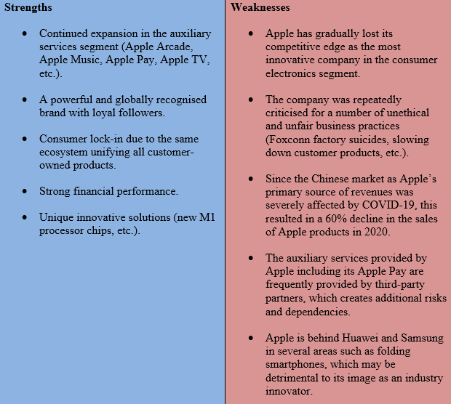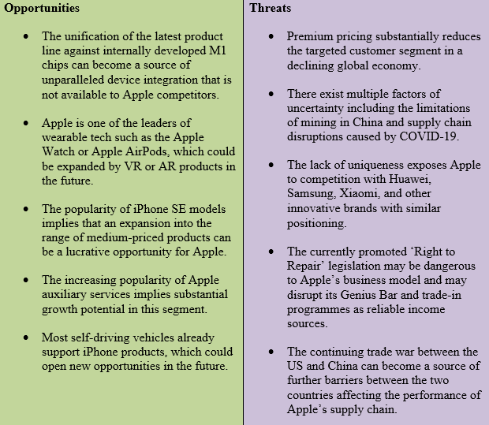
Based on: DiPietro (2018, n.p.); Schneider (2019, p.539); Spinello (2019, p.118); Stamm and Needleman (2020, n.p.)

The findings of the analysis suggest that the studied brand still has a solid competitive position but should monitor a number of threats such as the loss of its innovative edge and potential disruptions across its supply chain (Canon and Jasper, 2021).

You can also check Unilever’s and Tesco’s SWOT analyses on our website.

References
Canon, G. and Jasper, J. (2021) “Apple sales rise to $90bn amid Covid buying surge”, [online] Available at: https://www.theguardian.com/technology/2021/apr/28/apple-quarterly-earnings-covid-sales [Accessed on 9 July 2021].
DiPietro, B. (2018) “Crisis of the Week: Battery Issue Drains Apple’s Reputation”, [online] Available at: https://www.wsj.com/articles/crisis-of-the-week-battery-issue-drains-apples-reputation-1516101013 [Accessed on 9 July 2021].
Schneider, G. (2019) Microeconomic Principles and Problems: A Pluralist Introduction, London: Routledge.
Spinello, R. (2019) Business Ethics: Contemporary Issues and Cases, London: SAGE.
Stamm, S. and Needleman, S. (2020) “Everybody vs. the App Store: Why Companies Are Taking Issue with Apple’s Growing Revenue Engine”, [online] Available at: https://www.wsj.com/articles/everybody-vs-the-app-store-why-companies-are-taking-issue-with-apples-growing-revenue-engine-11601129781 [Accessed on 9 July 2021].
Statista (2021) “Apple's net income worldwide from 1st quarter 2005 to 1st quarter 2021(in billion U.S. dollars)”, [online] Available at: https://www.statista.com/statistics/263427/apples-net-income-since-first-quarter-2005/ [Accessed on 9 July 2021].

