Data analytics and visualization with tableau
TABLE OF CONTENTS
- EXECUTIVE SUMMARY..........................................................................................................2
  - Issue..................................................................................................................................2
  - Anticipated Outcomes.......................................................................................................2
  - Recommendation..............................................................................................................3
  - Justification.......................................................................................................................3
- BUSINESS CASE ANALYSIS TEAM..........................................................................................4
- PROBLEM DEFINITION...........................................................................................................4
  - Problem Statement............................................................................................................4
  - Organizational Impact.......................................................................................................5
  - Technology Migration.......................................................................................................5
- PROJECT OVERVIEW..............................................................................................................6
  - Project Description............................................................................................................6
  - Goals and Objectives........................................................................................................7
  - Project Performance..........................................................................................................7
  - Project Assumptions..........................................................................................................8
  - Project Constraints............................................................................................................8
  - Major Project Milestones..................................................................................................8
- STRATEGIC ALIGNMENT........................................................................................................9
- COST BENEFIT ANALYSIS......................................................................................................9
- ALTERNATIVES ANALYSIS....................................................................................................10
- APPROVALS..........................................................................................................................11

Executive Summary
This business case outlines how the data analytics and visualization with tableau project will address current business concerns, the benefits of the project, and recommendations and justification of the project. The business case also discusses detailed project goals, performance measures, assumptions, constraints, and alternative options

1.1 Issue
For a long time now businesses, like the health sector have had issues in making decisions and through the proper interpretation of data. In the coming year’s business will produce twice as much as they produce now. Being able to use and access this data helps them realize huge opportunities. These opportunities need to be turned into reality, through analyzing these data to solve problems. I have outlined this business case through the data analytics and visualization with tableau project to help businesses to make powerful reports and dashboards that will assist them in decision making and reacting skillfully to their business data, applying predicative analytics to help improve decision making and help see and understand their dat

1.1 Anticipated Outcomes
If Data analytics and visualization with tableau is adopted by a business, it will be the beginning of better control use of company data. The company will hire an analyst who will be able to make effective visualizations that will harness the brain’s innate perceptual and cognitive tendencies to convey conclusions clearly and directly. The tableau will enable employees to design and present “data stories” that will use these visualizations, capitalizing on business-tested methods and design principles.

1.1. Recommendation
At first, various options were looked at to help in seeing and analyzing company data. Compared to tableau, none of the methods found could meet Walter Enterprise data’s level of interpretation and amount. This is why management went on with tableau. We believe that Data analysis and visualization will only be achieved through it.
For this to succeed, the company will need to employ data analytics and train other employees on how to work with this software as it coincides with other IT systems and will ensure efficient and effective seeing and understanding of data.

1.1. Justification
Migration from tabular method to tableau will ensure data understanding hence efficiency in the company. Tableau will ensure;
- Visualization will help predict the future make better decisions altogether.
- Data of huge volume will be spotted effortlessly and swiftly
- Data visualization will express data in a universal way
- It will be easier to share ideas.
- Data visualization will enable management make adjustments to the company ensure better results
- It offers scalability
- It eases interpretation.

2. BUSINESS CASE ANALYSIS TEAM

To ensure this project goes through, we will need a strong and efficient team. The subsequent individuals contain the business case analysis team. They are responsible for the analysis and creation Data analytics and visualization with tableau Project business case.

Role Job Description Name(s)/Title(s)
Ensures on overall Mr. Andrew Drub. VP
Executive Sponsor accountability of the project operations
Will monitor and maintaining Ms. Tara Jones computer networks together Mr. Shrewder Miller

Technology Support
with networks during the Mr. Wittrock Quince project,
Will assist project sponsor, Ms. Sunshine Kane, Ms. Vera technology support, the Moore’s, Mr. Chin Chong, Mr.
Process Administration manager and the software Silver Stone, Ms. Naima support team with duties. Vaidya and Mr. Tim Wash. Overall responsibility to Ms. Diana Bees. ensure the success of
Project Manager initiation, planning, execution
monitoring and closure of the project.
Provides software support for Mr. John Jerry
Software Support the project through software
configuration control

3. PROBLEM DEFINITION

3.1. Problem Statement
The Data analytics and visualization with tableau will affect Wayne’s Enterprise in several ways. The following provides an explanation of how the company’s, tools, processes, and roles and responsibilities will be affected as a result of the tableau implementation.
Tools- The use of toolbars and spreadsheets will be completely wiped out and the tableau incorporated into the company or data organization
Process- Tableau analyzes data in a logical and easy manner; hence the IT department won’t be in charge of writing reports and managing changes as all these will be done by the tableau software.
Roles and Responsibilities- Managers will not need to write reports and manage change anymore. Roles will change as analysts who worked using spreadsheets will be replaced as they train on use of the tableau.
Hardware/Software- The company will need to purchase the tableau software hence increased budgeting.

1.1. Technology Migration
In order for Wayne enterprise to effectively move from spreadsheets a way of data collection and keeping, al lot of processes will be affected, these will include;
- Day to day operations
- Administration
- Technology used
These changes will have to occur in a systematic manner to ensure proper and efficient transition.
Phase I - The Company will have to purchase the tableaus tools that it will require for a swift transition to be tested and verified by IT experts.
Phase II - After verification, the IT experts will have to create a back-up system to ensure maximum security and preventive measure in case of a security breech.
Phase III - All company data will be incorporated into the new system and archive all data from the company mainframe
Phase IV- All relevant employees will be trained on how to use the new software while recruitment of analysts goes on.
Phase V – All systems will be set in motion for the new system change.

4. PROJECT OVERVIEW
Tableau visualization and analytics products aim to help business managers, analysts and executives see the relationships between different data points, regardless of users' technical skill levels. Tableau provides reporting, dash boarding and scorecards, BI search, ad hoc analysis and queries, online analytical processing, data discovery, spreadsheet integration, and other data analytics and analysis functions.

4.1. Project Description
Data analytics and visualization with tableau project aims at replacing Wayne Enterprises information systems with a more elaborate and efficient software, that will ensure quick access of data in a usable format.

1.1. Goals and Objectives
The data analytics and visualization with tableau project directly supports several of the corporate goals and objectives established by Wayne Enterprise. The following table lists the business goals and objectives that the Data analytics and visualization with tableau Project supports and how it supports them:
Business Description
Goal/Objective
Timely and Tableau makes data analysis and interpretation fast and easy. accurate reporting
Reduced work- Time, effort and resource need earlier on will reduce hence employees load will focus on other projects.
Reduce overhead The need for several employees will reduce hence a reduction in the costs company’s overhead costs.
Leverage the It makes leverage of power easy, optimizes performance of query and the power of database connection of database views.
1.1. Project Performance
Below is a chat that shows the expected performance of the tableau software;

Project performance
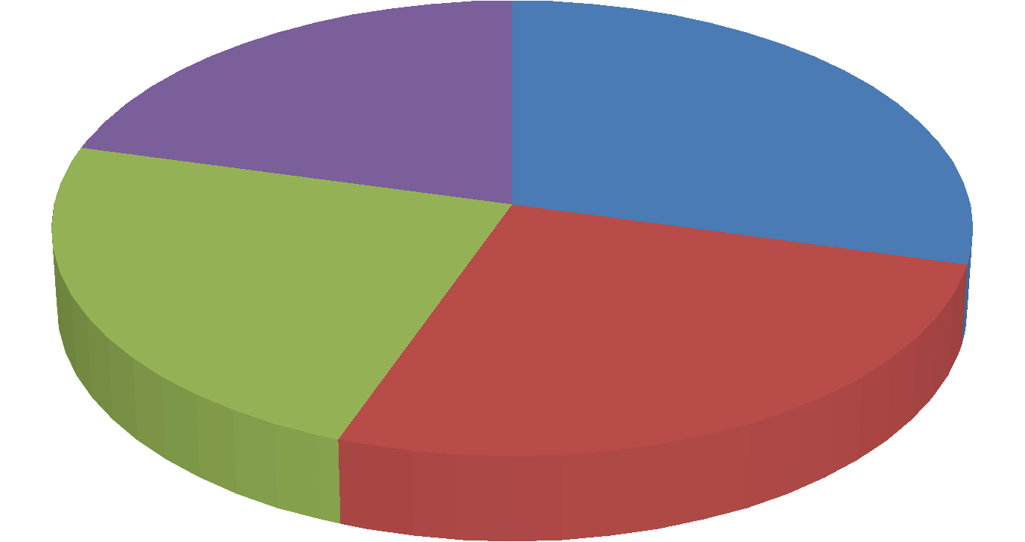
1
st Qtr
2
nd Qtr
3
rd Qtr
4
th Qtr
Below is a simplified data from the chart;

1st Quarter This software will improve the duration of reports being pulled, analyzed and presented to stakeholders by 29%
2nd Quarter The software will ensure proper and efficient decision making by 26%
3rd Quarter Decrease in cost and staff requirements as system maintenance will reduce by 24%
4th Quarter Data accountability and security will increase by 21%

1.1. Project Assumptions
The following assumptions apply to the Data analytics and visualization with tableau Project. As project planning begins and more assumptions are identified, they will be added
consequently.
- The software will be bought on time for verification and testing.
- Funding will be available for the training and recruitment of new employees.
- Enough support from the executive donor and the management.
- The managers and executives will accept the new technology.

4.2. Project Constraints
The following constraints apply to the Data analytics and visualization with tableau Project. As project organization begins and more restraints are acknowledged, they will be
added accordingly.
- Few IT experts in the company that will oversee the implementation process.
- Difficulties in replacing the old technology with a new one to executives and
managers minds.
- Lack of enough funding for the project.
- No employee awareness before the initiation.

4.3. Major Project Milestones
The following are the major project milestones identified at this time. As the project planning moves forward and the schedule is developed, the milestones and their target completion dates will be modified, adjusted, and finalized as necessary to establish the baseline schedule.
Milestones
Target Date
Project initiation
8/15/2017
Project planning and review
8/20/2017
Phase I
9/10/2017
Phase II
9/17/2017
Phase III
9/30/2017
Phase IV
10/10/2017
Phase V
10/20/2017
Project close out
/
1/2017
11

5. STRATEGIC ALIGNMENT
The Data analytics and visualization with tableau Project is in direct support of several of Wayne Enterprise’s Strategic Plans. By directly supporting these strategic plans, this project will improve our company’s reputation and increase business.
Plan Goals/Objectives Relationship to Project
2002 Wayne Enterprise Plan By 2020, the company will Use of tableau is a step to the for information revolutionize its information development of information management management sector using management in the company.
technological developments available.
2007 Wayne Enterprise Plan Improve data analysis. Tableau will ensure fast and for information Reports to stakeholders every efficient interpretation of data management first Monday of the month. so as to meet the monthly
report deadline.

6. COST BENEFIT ANALYSIS
The following table captures the cost and savings actions associated with the WP Project, descriptions of these actions, and the costs or savings associated with them through the first year. At the bottom of the chart is the net savings for the first year of the project.
First year

Action Description costs (-
Type indicates
Action
anticipated
savings)
Purchase of the Tableau cost This purchase will fall under $350,000,000
software. investments
Licensing cost This will be an expense $150,000

Installation of software cost This will be an investment $100,000 and employee training
Reduction of employees savings This will be savings $ 700,000 IT employees will no savings Savings as the number of employees $200,000 longer write reports will reduce
Software Maintenance cost Constant maintenance is an expense $ 4000 Timely and accurate savings Will save on money and time $8000 company reports

7. ALTERNATIVES ANALYSIS
If this project is not approved the following can be alternatives to help solve the problem the company is currently facing, they include;
- Addition of employees in the information management department to ensure swift
and accurate access and understanding of data.
- Giving more time to managers to pull and compile data into reports.

8. APPROVALS
The signatures of the people below indicate an understanding in the purpose and content of this document by those signing it. By signing this document you indicate that you approve of the proposed project outlined in this business case and that the next steps may be taken to create a formal project in accordance with the details outlined in this.
Name
Title
Signature
Date
Mr. Walter Jack
President and COO
Mrs. Emily Jack
Executive VP
References
Kim, D. H. (2015). A Case Study of Producing Infographics Using Tableau Public. Journal of
Korea Spatial Information Society, 23(2), 21-29. doi:10.12672/ksis.2015.23.2.021
Kułlacka, A. (2014). Tableau Calculus for Basic Fuzzy Logic BL. Information Processing and
Management of Uncertainty in Knowledge-Based Systems, 325-334. doi:10.1007/978-3-
319-08795-5_34
McDaniel, S., & McDaniel, E. (2013). Advanced Data Management in Tableau—Calculated
Fields, Functions, and Parameters. Rapid Graphs with Tableau 8, 175-192.
doi:10.1007/978-1-4302-6736-2_10
McDaniel, S., & McDaniel, E. (2013). Managing Data Is Critical for Great Results—Data Items and Data Management in Tableau. Rapid Graphs with Tableau 8, 145-174.
doi:10.1007/978-1-4302-6736-2_9
Tableau. (n.d.). Encyclopedia of Operations Research and Management Science, 821-821.
doi:10.1007/1-4020-0611-x_1033

