Efficiency wage differential: a case study for TESCO express

Table of Contents
Introduction 1
Review of Literature 4
Efficiency wage models in the traditional trade theory 5
Data Description 9
Methodology 10
Explaining wage differentials 21
Gender pay gaps 22
Comparison of retail wage with Living wage 25
Union and non-union wage different 26
The employer size effect 27
Bonus as a trend in Pay System 28
Case Study: Tesco Express 32
Observed intra industry wage differentials ( TESCO) 35
Conclusion 36
REFERENCES 40

This page left intentionally blank

Introduction

Economists who have made detailed comparative studies of wage rates within an industry or between industries in the same labour market area are struck by the haphazard variations in such rates of many intra industry differentials in wages. Actual wage facts seem contrary to what one might expect according to conventional wage theory. Demand and supply do not eliminate gross "inequities" or gross irrationality. Perfect competition seems to be the exception rather than the rule. Movement in response to varying rates does not take place even in the same locality. One of the most significant facts about wage rates is their variation for the same job in the same labour market. Instead of a single rate for the same work, there is usually a band or zone of rates ranging from the lowest to the highest-paying employer in a community.

Relative wages plays a vital role in employee and employer wage bargaining. Workers do compare their wages with other workers of the same firm and other firms of the industries. Comparison can be made with same designation, roles with same job description, competitor in the industry and required skills for the job. According to different scholar which will be discussed later the wage differentials within and between organisations can have important effects on firms performance and turnover. Related argument for high wage differential is if employee do get higher wages than productivity will increase because employee will give more effort to his job, will not look forward to move to other job and as a result employee turnover will come down. According to Rosen’s (1981) tournament theory if wages is settled with productivity then those who are more productive will earn more wages. Opposite relationship with wages and performance is also found by several authors including Akerlof and Yellen (1990), Levine (1991) who argues that if the wage is regarded more unfair than individual effort is reduced.

The presence and persistence of substantial wage differentials between industries is a major empirical regulatory. Wage differential can result from the functioning of a competitive labour market, reflecting compensating differences in human capital accumulation. They may also reveal institutional influences that determine contractual arrangements between employers and workers, often reflected in the presence or absence of a union. Finally they may be consequences of efficiency wages being paid in some industries that are employers can increase their profits by paying their workers’ wages that are above their market value.

Several economists have run through the gamut of standard theory for the explanation of large wage differentials that are observed in the industries. For example, Murphy and Topel(1987), Krueger and Summers(1988), and Gibbons and Katz(1989) attempt to measure the degree to which wage differentials arise from ability.

Author of this paper has worked as a seasonal employee for different retailer (non-food) like ASDA, TESCO and food retailer like McDonald’s and has observed that wage differential exists though they are operating in the same business (retail). Apparently author tried to find out does this wage differential has got any impact on the business itself like performance or turnover. This paper examines the magnitude of wage differentials for equally skilled workers. Author focuses on the role of industry affiliation in explaining relative wages. Findings suggest that a worker's industry exerts a substantial impact on his wage even after controlling for human capital variables and a variety of job characteristics. We are led to conclude that there are important variations in wages which cannot be explained by standard competitive theories. These findings complement demonstrations of important relationships between firm size and wages (e.g. Brown and Medoff (1985)) and of large intra-industry wage differences (e.g. Dunlop (1957) and Groshen (1986)) in suggesting the importance of developing and testing alternative models of wage determination even in non-union settings. Author focuses on efficiency wage theories as an explanation for the setting of wages. Any economic theory that explains why wages deviate from their standard competitive level must in a tautologies sense explain why firms find it profitable to pay non-competitive wages. In this sense, any explanation of non-competitive wages must have an efficiency wage element. That is, it must postulate that over some range profits are an increasing function of the wage rate offered. In some cases, the efficiency wage theory is a triviality. For example, firms may find it unprofitable to violate minimum wage laws because of the fines that will be imposed. Or it may be necessary to pay supra-competitive wages to unionized workers in order to avoid strikes. Our principal interest is however in "pure" efficiency wage models in which firms can find it profitable to raise wages even when they will not be punished by some outside party for failing to do so. The limited evidence that is available suggests that high paying industries may benefit by reducing turnover as suggested by efficiency wage theories.

A wage differential in UK retail sector is mainly about the location and differences in human capital characteristics. There are wage differentials due to firm size, location, unionization effects and gender gap.

Taking into account of all the sources mentioned above this paper will try to find out wage differential in retail sector and its impact on business performance and employee turnover.

Review of Literature

Efficiency wages hypotheses (in various forms) have been used to explain why non-union firms might find it profitable to offer wages above market-clearing levels. While paying high wages entails direct costs, this practice may result in benefits such as high worker effort, low turnover, or a large supply of labour to the firm. One motivation for this literature is to explain involuntary unemployment: if the efficiency wage framework is valid, then firms may not lower wages even in the face of excess supplies of labour (Stiglitz,I987). An additional motivation of this literature appears to be the empirical observation that interim or inter-industry wage differentials remain even after most possible economic determinants of these differentials have been controlled (Krueger and Summers, I988). Further, these differentials appear to lower quits and raise the length of queues of job seekers attempting to gain entry. They suggest the existence of rents associated with efficiency wages (Katz and Summers, I 989).

A distinct and complimentary explanations regarding direct relationship between wages and productivity have been analysed in the literature (Katz, 1986). Economic gains to an employer of high wage policies have long been stressed by labour economists are based on the potential benefits of the firm of higher wages: increased effort level and reduced shirking by employees; lower turnover costs; a higher quality labour force; and improved morale, more easily facilitated teamwork, and greater feelings of loyalty by workers to the organisation. (Dunlop 1985; Reynolds 1978)

Non-competitive wage premiums are offered to worker who is related to union or collective bargaining. To maintain industrial peace some firm may pay higher wages that are not related with unions (Foulkes, 1980; Freeman and Medoff, 1984). A closely related efficiency wage model of the impact of the threat of collective bargaining on wages was developed by Dickens (1986).

Efficiency wage models in the traditional trade theory

Three variant model known as fair wages, shirking and adverse selection models of efficiency wages hypothesis have been integrated in trade theory.

Fair wages: The intuitionally created wage rigidity model appeared
Through the models of Brecher (1974), followed by Krugman (1995) and Davis ( 1998a). Trade effects of both the economy with wage rigidity(European economy) and wage flexibility ( American economy) with low skilled abundant countries are discussed in these models. In view of Krugman (1995) due to wage rigidity income and domestic demand decreases which magnifies the initial fall in employment caused by imports of low skilled intensive products. Countries which economy has got rigid wages will be affected negatively by trading low skilled abundant countries. A labour market institution characteristic is determined by the tradition of a specific society. Institution refers to a broader world where not only the formal norms like unions, minimum wages differs but also the other informal norms such as fair wages also differ. It differs from the explicit ‘’fairness’’ modelling principles which share the underlying notion of ‘’fair’’ labels for wages.

This study is a direct contradiction to the earlier study of Kreickmeir and Nelson (2006) model of wage rigidity where works of a country has got different attitude towards the differential of wages depending on skilled and non-skilled workers. A rise in skill premium and unemployment is induces with more unaffected flexible wages by neither global nor sector specific global change. Davis (1998 b) does not agree with this postulates.

According to Agell and Lundborg(1995) ‘’ fairness’’ is the comparison of wages paid to the worker in return of another production factor. A lower relative wage is distributed when the price of the labour intensive price falls. For those employees to whom ’’fairness ‘’ matters their effort falls and for the productivity of the economy unemployment rises. An important implication for this postulate is if any trade policy lifts the ‘’fairness’’ then it can decrease the negative effect of trade in the economy.

Albert and Meckl(2001) states that for the persistence of stable wage differential across sectors ‘’fair wages’’ are necessary. For a small open economy or trade with two countries this establishment of a link between unemployment and wage differentials leads to some interesting implications. The country with small economy if exports high wage goods then employment rises. Expansion of foreign direct Investment increases labour demand and increase employment but if that sector is also high wage sector then the demand for labour falls and as a result unemployment rises. In the case of two country trade the country exports high wage goods experience a rise of unemployment. The rate of unemployment moves in opposite direction for high wage goods exporter and low wage goods exporter.

Wage differentials do exist within the same sector also. Egger and Kreickmeier (2009) aim to capture firm heterogeneity by saying that firm might have specific wage system on the basis of productivity. The open economy benefits from two aspects, first due to higher number of varieties trade induced output increases and second by introducing transportation costs which influence firm to survive with lower productivity and affects employee wages. As a result trade is found to increase output and hence increase the wage differentials.
In a nutshell ‘’fairness’’ model shows the way of higher wage and higher unemployment after opening to trade.

Shirking: This model report more optimistic results. In this case opening to trade increase employment, even though through different channels or in the worst case, the employment level is unaltered relative to autarky.(Matusz,1994,1996,1998; Hoon, 2001,Altenburg and Brenken,2008)

In an economy with Shapiri-Stiglitz efficiency wages the trade magnified division of labour induced by intra-industry trade on employment and wages.(Matusz,1996). In a monopolistically competitive market, the economy comprises of a region which yields intermediary goods with increasing returns to scale and a perfectly competitive sector of final goods, assembled from the intermediary goods. It opens intra industry trade with an identical country in all respects excepts for labour endowment alters the autarky equilibrium due to the increase number of potential organisation enters into the market and increase labour and productivity and ultimately lifts the no shirking constraints. If we hold the number of firms as constant, productivity and wages increase in both economies. Employment expands up to a limit where the new equilibrium is reached due to the higher number of firms. Matusz(1998) shows that in a similar imperfect condition and efficiency wages the elasticity of substitution between goods is a crucial determinant of the effects of trade on employment. Trade contribute as an important factor to increase employment when firms hold substantial monopoly power. Calibrating his model the author has seen that unemployment rises at least one percent and sometimes double when there is no trade. For the same level of employment by increasing the real consumption of wage, trade increases welfare by reducing shirks and creating jobs. ( Matusz, 1996, Hoon, 2001). They assume that effort is zero for a worker who shirks and constant who does not. Altenburg and Brenken( 2008) find this assumption restrictive or an unchanged difference between the welfare of an employed and unemployed worker.

Adverse Selection

Different model describes the gain and or loses of trade due to imperfect information. Trading economies suffer from adverse the selection in the recruiting process. It is possible for both parties where someone get poor employee with poor productivity to suffer loss from relative trade autarky. And the world economy remains below its efficiency level.If the adverse selection process can be eliminated through the screening technology of any party than it is possible to find efficiency. In a nutshell wage rigidity of the labour market has identified the sources for gain or loss to trade of the labour economy. It is also obvious that efficiency wages might bring some ambiguity in terms of labour market outcomes under trade.

Empirical evidence

There is no evidence that efficiency wages has a direct contribution to the labour market. In most cases efficiency wages have been taken into account in the specification of the wage equation, together with other factors.( Milner and Wright, 1998)

There is a question whether country’s characteristics or prevailing industry structure plays a role in wage setting. It has been found that for the same country and occupation or same industry of different countries controlling various individual firm characteristics co efficient of relative wages is 0.6 to 0.9 ( Kantz and Summers, 1989)

An organisation do have different goals and objectives and there is no single measure which can cope firm performance (Venkatraman and Ramanujam,1986).According to efficiency wage theory high wage attracts pools of talent and thus increase efficiency and reduce shirking (Milkovich and Newman , 2004). Efficiency can be increased by hiring better employees or motivating present employees to work. Higher wages are related with lower shirking. (Capelli and Chauvin,1991). The longitudinal study of Tsai and Wang(2005) suggest that the firm which pay higher wages achieve higher productivity by improving workforce. Organisation which pays
higher wages do believe that they will be able to attract workforce with high quality. It is expected that pay differentials should enhance organisations productivity.

In any case it is important to acknowledge the role of wages upon employee turnover in the labour market. For instance one of the mechanisms that may generate efficiency wages (Akerlof and Yellen,1986)involves the reduction in turnover costs achieved by increasing pay. Shaw and Gupta(2007)showed that employee turnover is differently affected by pay differential. Those who performs well their turnover patterns differs from those who performs low or average. Turnover rates vary according to the position of employee in the establishment i,e good performers who are at the top of the pay structure shows low turnover whereas low or average performers who are placed in middle or low position resign themselves very often.

Data Description

The Office for National Statistics (ONS) Annual Survey of Hours and Earnings, Tesco’s annual review and data used by PayScale , a salary research organisation who offer comprehensive data for industries, occupations and locations. Tesco’s pay slip and internal data. Author of this paper has got access to all the relevant information regarding pay of these three retailers. Author will match the relevant data regarding pay and will conclude with relating this data with performance and turnover.

Methodology

This reports relates to the Annual Survey of Hours and Earnings (ASHE) conducted by Office of National Statistics (ONS) ASHE covers whole UK employee jobs regardless of levels, distribution and make up of earnings and paid hours for employees in all industries and occupation.

ASHE collects information from the employers based on one percent sample of jobs on the HM Revenue and customs Pay As You Earn (PAYE) register.

ASHE collect information of those employees who worked for the establishment for at least one year, whose pay period was not affected by absence. They do not collect data of those whose earning was reduced for sickness. Those who works as a seasonal employee is not covered as well.

ASHE data accuracy is subject to various sources of error known as sampling and non -sampling error. We have identified the percentile band within which the wage falls for each occupation in the dataset and interpolate the exact percentage of employees that fall either side of the threshold. It is then a simple calculation to obtain actual pay rates for that group.

The two dependable variables Firm’s performance and turnover are considered in the literature of compensation ( Shaw, Gupta and Delery,2002). We used annual report of the organisation to get return on assets (ROA) which is also used by pay differential literature( Brown, Sturman and Simmering, 2003; Henderson and Fredrickson, 2001; Kepes, Delery and Gupta 2009). We calculate operationalized turnover rate as the number of individuals left an establishment divided by the total number of employees in the establishment ( Shaw et al, 2005)

As it described earlier, The existence of wage dispersion is one of the most essential predictions of EWM. However, it must be described that neither the competitive style nor most of the EWMs can explain the factor that organizations utilizing different technology are available together in the same industry. In this sensation, EWMs are able to explain only the way of life of interindustrial salary differentials, but not intraindustry salary submission. Therefore, some external rumours is needed to be able to generate intraindustry submission. A solution used in the fictional performs to obtain heterogeneity among organizations has been to believe that one part of manufacturing has a flexible supply to the industry but a set provide to the company. Furthermore, we may consider that there are scientific issues that generate intraindustrial heterogeneity, i.e., we will observe some product difference even if we are very careful in our medical assessment of the industry. EWMs also calculate a company between salary top quality and company functions, where the weblink between both places of factors varies based on the styles. In this sensation, EWMs provide formalization for explanations found previously in the fictional performs about the effect of commercial features on salary submission. Consider for example Lester’s tracking rumours and Stigler’s examining rumours, described in Area. In the rest of it we will focus on these links between EWMs and company functions and the predictions of EWMs with regards to organization's salary activities. The healthy style predictions that the performance salary for workers who are in excess supply should be continuous, that different salary contracts should are available for workers applied under long- vs. short-term contracts, and finally that we should observe a predominance of continuous long-term profession contracts (Rodgers, 1975 and Pleasure and Tight, 1978)
The shirking style predictions higher incomes in organizations where tracking costs are excellent and/or where the cost of worker malfeasance is excellent. In the same way the earnings style predictions higher salaries in organizations where earnings is more costly. In turn, there are different concepts that web link these performance salary costs with company functions that can be calculated.
Shirking/monitoring costs have been considered to be higher in large organizations. Given that the development process is more interdependent in large organizations, any breakdown, economic downturn, or commercial incident will be more costly. Furthermore, higher incomes be protecting tracking business time, which has a higher opportunity cost in large organizations. In addition, shirking may also be associated with the financial commitment endowment, in the sensation that it will be costly for organizations that use costly financial commitment gadgets (in the extreme shirking could be associated with stunning the gadgets or taking details or products).
Turnover costs have also been appropriate to the sizing the company. The rumours is that hiring and training costs are higher in large organizations, due to their more suggested manufacturing methods. In this case, if organizations talk about at least part of such costs they will have an inspiration to reduce revenues. Testing costs are also higher in large organizations. Weiss and Landau (1984) come up with a screening style in which incomes figure out the performance of a organization's best workers and the number of applicants. In this set up, they show that incomes and company sizing are positively associated, a result that is inspired by the fact that large organizations need more workers. In Garen’s (1985) style large companies have a more costly of acquiring details about workers. Those modifications in the Some caveats need to be made to previous times explanations. In particular, large and capital intensive organizations should decide on a technology that prevents the devastation from shirking or that makes tracking easy. However, considering the sum of explanations just described, we determine that
EWMs make a supposition that higher incomes should be expected in large organizations with excellent capital investments and excellent income. Furthermore, the sociological style predictions that organizations will usually pay excellent or low incomes to all careers.

Segmentation is a topic properly appropriate to salary differentials, because one of the main explanations of the segmented perform industry (SLM) school is that the neoclassical style does not provide an sufficient information of the submission of incomes and income. SLM idea statements that modifications in incomes can be described by the adscription of the workers to different segments of the perform industry. Moreover, most of the medical tests on segmentation have tried to validate the rumours that wage setting systems differ across perform industry, and there is rationing of main or official industry projects. Therefore, the way of life of salary differentials across perform industry has been one of the medical tests for segmentation. However, in order to affiliate segmentation to interindustrial salary differentials, we should declare that some industries
belong to the main (or formal) industry while others are part of the extra (or informal).EWMs have tried to provide a explanation for the way of life of dual perform market segments of the type postulated by Doeringer and Piore (1971). The rumours is that the main industry is made up of performance salary organizations while the wage-productivity regards is inadequate or non-existent for extra industry organizations.
In the LDCs’ situation, it also has been suggested that a key difference between official and casual areas is the way of life in the former of a salary performance relationship. However this is a more doubtful announcement, given the predominance of self-employed within the informal sector. The analysis of the segmentation rumours goes far beyond the purpose of this paper. Also details limitations prevent us from a further discussion of this factor, since most of our data excludes casual activities and we generally focus the analysis on the salary modifications among workers. However large salary differentials be successful in the Chilean economy even after not such as casual industry workers from the analysis.
Screening process between small and big organizations generate a valuable relationship between company size and incomes. Both styles seem to be strengthened by the author’s reviews.
The choosing styles calculate a relationship amongst financial commitment, income, and incomes. This regards could be extended to other EWMs under the canonical way of system [5]. The instinct is that any malfeasance that contains underutilization of financial commitment and forgone manufacturing, such as a higher quantity of giving up and shirking, or lower choosing, will be more costly in organizations with excellent capitulator percentages, higher income and a large workers (Lang, 1988, p. 3).In most EWMs workers are engaged with their own salary and their opportunity cost, measured by a normal salary and the lack of profession quantity. Under the sociological style, workers are also engaged with their relative incomes inside the company and their own previous incomes, since these relative incomes effect their knowing of being pretty managed. Both the collaboration risk style and the sociological style calculate higher salary premia in areas with excellent rents which, as in Dickens (1986), we can believe represent monopoly rents or profits to set financial commitment opportunities. However, while in the first style worker pressure happens from the risk of unionization, in the sociological style worker pressure happens from a mood effect that impacts performance.

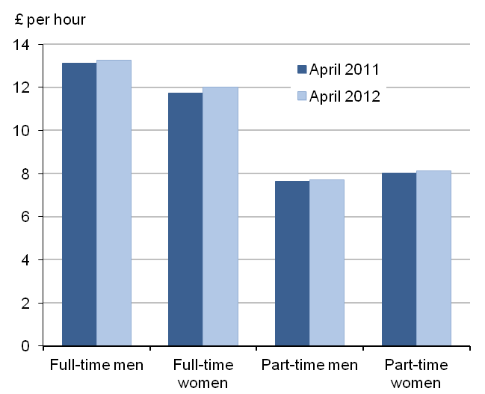

Fig:1 | Median gross hourly earnings (excluding overtime); UK, April 2011 and 2012
 | Table for fig1
 |  |  |  |  | £ per hour
 |  |  | Full-time | Part time | All
 | April 2011 | Men | 13.12 | 7.64 | 12.41
 |  | Women | 11.75 | 8.03 | 9.90
 |  | All | 12.56 | 7.99 | 11.07
 | April 2012 | Men | 13.27 | 7.72 | 12.50
 |  | Women | 12.00 | 8.12 | 10.04
 |  | All | 12.76 | 8.01 | 11.21
 | Change % | Men | 1.1 | 1.0 | 0.7
 |  | Women | 2.2 | 1.2 | 1.4
 |  | All | 1.6 | 0.2 | 1.2
 | Source: Annual survey of Hours and earning (ASHE),office for national statistics
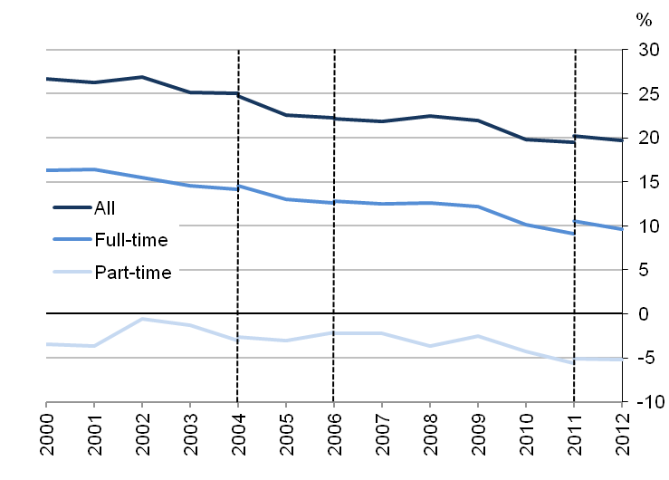

 | Fig 2: Median gross hourly earnings (excluding overtime) with gender pay differences; UK, April 2011 and 2012
 |  |  | Table for Fig2 |  |  | £ per hour
 |  |  |  | Men | Women | Pay gap %
 | April 2011 | Full-time |  | 13.12 | 11.75 | 10.5
 |  | Part-time |  | 7.64 | 8.03 | -5.1
 |  | All |  | 12.41 | 9.90 | 20.2
 | April 2012 | Full-time |  | 13.27 | 12.00 | 9.6
 |  | Part-time |  | 7.72 | 8.12 | -5.2
 |  | All |  | 12.50 | 10.04 | 19.7

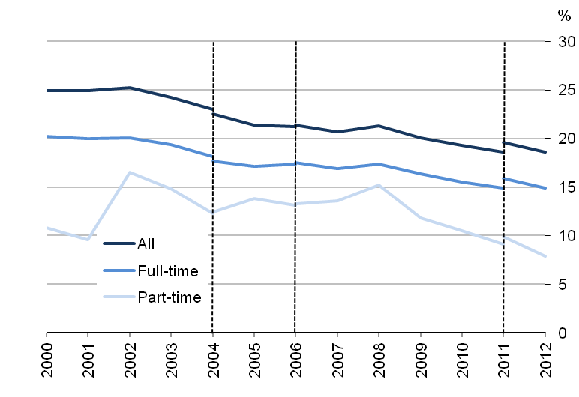

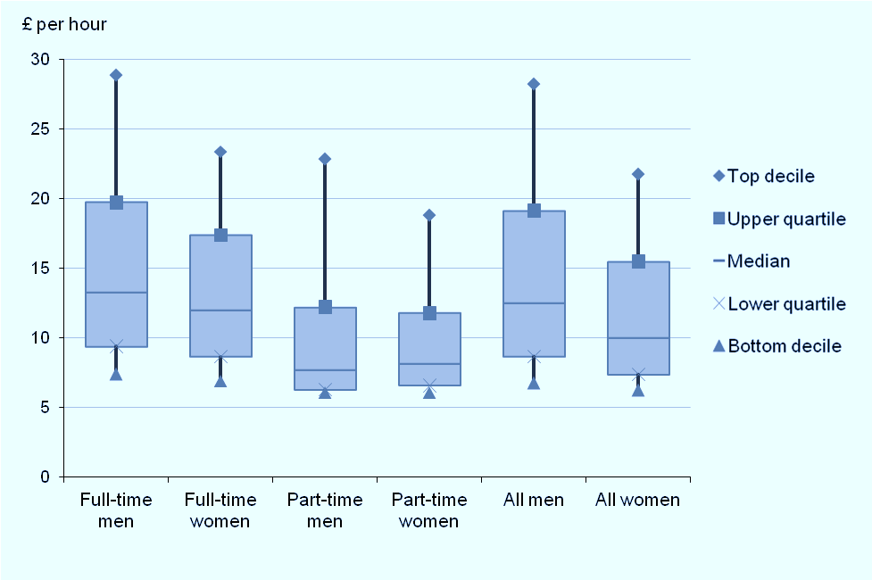

 | Fig: 3 Gender pay difference by distribution of gross hourly earnings (excluding overtime); UK, April 2012
 | Table for Fig3
 |  |  |  |  | %
 |  |  | Full-time | Part-time | All
 | Bottom decile |  | 6.2 | 0.0 | 7.3
 | Median |  | 9.6 | -5.2 | 19.7
 | Top decile |  | 19.0 | 17.6 | 22.9

Table 4: | Distribution of gross hourly earnings (excluding overtime); UK, April 2012
 |  |  |  |  | £ per hour
 |  |  | Full-time | Part-time | All
 | Men | 10% earned less than | 7.38 | 6.08 | 6.75
 |  | 50% earned less than | 13.27 | 7.72 | 12.50
 |  | 10% earned more than | 28.85 | 22.83 | 28.23
 | Women | 10% earned less than | 6.92 | 6.08 | 6.25
 |  | 50% earned less than | 12.00 | 8.12 | 10.04
 |  | 10% earned more than | 23.37 | 18.81 | 21.75
 | All | 10% earned less than | 7.16 | 6.08 | 6.44
 |  | 50% earned less than | 12.76 | 8.01 | 11.21
 |  | 10% earned more than | 26.56 | 19.71 | 24.95

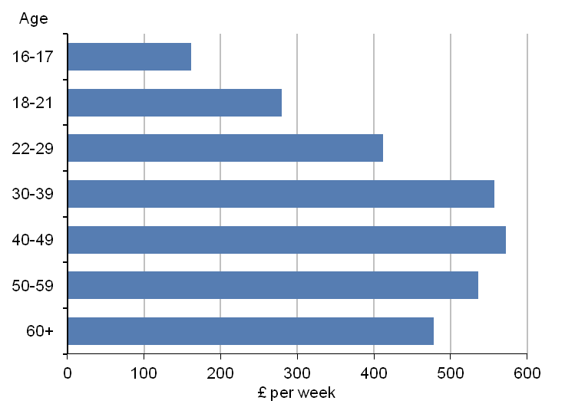
Fig 5: Gender pay gap by age
Table5 for gender pay gap by age
 |  |  |  |  |  |  | £ per week
 | Age group | Men | % change from 2011 | Women | % change from 2011 | All | % change from 2011
 | 16-17 | 166.7 | -0.5 | 121.1 | -18.9 | 161.4 | -0.5
 | 18-21 | 295.9 | 3.8 | 266.1 | 2.5 | 279.6 | 2.1
 | 22-29 | 420.2 | 1.6 | 402.5 | 2.3 | 412.0 | 2.0
 | 30-39 | 574.9 | 0.0 | 526.8 | 2.5 | 557.2 | 1.2
 | 40-49 | 622.3 | 0.9 | 484.5 | 3.3 | 572.6 | 2.2
 | 50-59 | 598.4 | 1.5 | 446.1 | 0.6 | 536.1 | 1.0
 | 60+ | 509.2 | 2.1 | 407.4 | 2.9 | 477.8 | 2.4

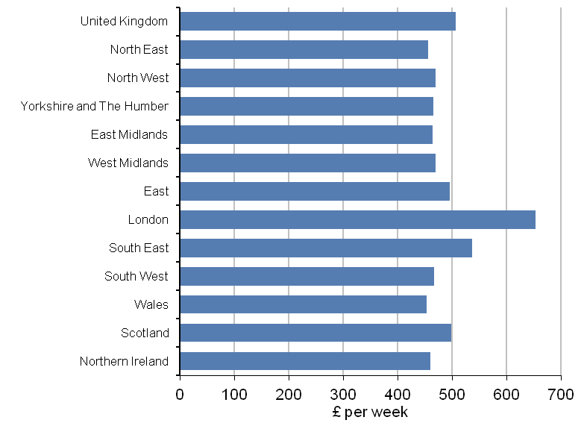

Fig6: Median gross weekly earning by workplace region

Table6for fig 6
 |  |  |  |  |  |  | £ per week
 | Region | Men | % change from 2011 | Women | % change from 2011 | All | % change from 2011
 | United Kingdom | 545.8 | 1.4 | 448.6 | 1.9 | 505.9 | 1.5
 | North East | 490.3 | 0.7 | 407.0 | -0.5 | 455.1 | 1.3
 | North West | 505.8 | 1.4 | 420.3 | 1.9 | 469.9 | 2.3
 | Yorkshire and The Humber | 501.7 | 0.7 | 412.0 | 2.3 | 464.7 | 0.9
 | East Midlands | 508.3 | 2.1 | 402.5 | 2.1 | 464.4 | 1.3
 | West Midlands | 508.1 | 1.3 | 409.0 | 1.7 | 469.2 | 1.0
 | East | 538.7 | 1.1 | 425.9 | 1.0 | 495.2 | 1.2
 | London | 707.4 | 0.1 | 591.6 | 1.9 | 652.8 | 0.7
 | South East | 588.6 | 0.9 | 461.8 | 2.3 | 536.6 | 1.4
 | South West | 506.8 | -0.3 | 411.8 | 2.3 | 467.0 | 1.2
 | Wales | 482.4 | 0.0 | 403.9 | 1.4 | 452.6 | 0.3
 | Scotland | 533.1 | 3.0 | 438.1 | 0.6 | 497.6 | 2.6
 | Northern Ireland | 478.9 | 3.7 | 440.0 | 5.3 | 459.5 | 3.3

Explaining wage differentials

According to Krugman(2002) the wage differential exists because of social norms which is created combined by economic and culture, politics, globalization and technology is plausible. There is a belief that in each place there is a charismatic leader who should be paid more. This leader can be establishment by itself who believes that those who are working under this establishment should be paid more and this way they are showing that they are leader of the industry to attract workforce.
The greater tolerance of this inequality could be linked with individual fragmentation towards job. No more we are working for a great Britain all together as a collective endeavour as it was( Antcliff et al,2005). The decline of collective industrial relation could be a factor for this wage differentials because it enables more flexibility in rewards where individual are influenced to be responsible for their own achievement and losses.(Lemiux et al, 2007)

Gender pay gaps

In most cases, retail industry does pay less to women than man. There is gender discrimination in retail though it is difficult to observe in labour market data. UK has low perceptions of gender discrimination and there is evidence that the pay gap could be for the choice of job pattern rather than discrimination. The pay differential shows in most cases for women who are not counted for statistical data of wages due to sickness or unpaid leave. Because women do take 39 weeks holiday during giving birth and some other cases like while growing up kids they do work as a seasonal employee.
Most recently 400 workers has filed a case against ASDA for equal job evaluation which will be a major test case. If this case become successful than supermarkets have to pay millions of pounds back pay to store staff particularly women. This claim against ASDA is a major case to evaluate equal opportunity in the private sector. They are being pursued by the group of employment lawyers who won a battle of one billion pond landmark ruling from supreme court against Birmingham City Council who employed low paid women.

If this pay discrepancy found then other supermarket like Tesco, Sainsbury’s, Morrison, Marks and Spencer could face similar claims. In this particular situation women staffs who works for Asda stores claims that they should be valued equally like those other staff who are working in distribution centre (mostly male dominated) and they should get equal pay. If they can win this battle company has to pay them differences from six year back in earnings.
Asda employs 172,000 staff and operates their own distribution centre. Michael Newman who is the legal firm representative has claimed they could win this case. If they can win this case than other supermarket may face same claim though some of them operates their distribution centre by themselves and some of them operated by third party. Staff of those distribution centres is recruited in a mix process where some staff are recruited by the company itself and some are recruited by agency. Morrison does recruit three quarter of their staff for distribution centre whilst Tesco do recruit most of them. Some of the Sainsbury’s distribution centre’s staff are recruited via agency to get rid of any types of legal complain regarding wages. Some do claim that warehouse job is not same as like shop floor colleague because they do work unsocial working hours, additional skills and uncomfortable conditions. But shop floor colleagues claim that warehouse colleagues do take stuff off from shelves, put them in a pallet and stick it on a lorry whilst shop floor colleague do exactly the opposite same thing, they take pallet out of the lorry, unstack them from pallet and put them on the shelf.

Part -timer’s wage inequality

According to Gallie et al(1998) part time staff do possess low skill, has got limited opportunity to improve their skill and have less career prospective. Apparently there is no such evidence why part time worker is low skilled than a full time worker though both of them do same job.
There are two broad interpretations about part time workers skill . First one is job designing for part time staff is done in such a way that it needs low skill and low pay. This is especially designed for women who cannot work full time because of family responsibility and for students who has to study beside work. The second point is about human attitude towards job, individual attributes towards job (McGinnity and McManus,2007). Employers design part time job that fits the characteristics where low skill and low effort is needed.
However, Duncan Gallie and Ying Zhou suggests that in general the rising skills of part timers have not been reflected in their pay position. Retailer do recruit part time staff rather than full time to save money because part time staff are low paid comparing to full time staff and they do get less holiday hours.

Comparison of retail wage with Living wage

The UK living wage is an hourly rate calculated on the basic cost of living in UK. Living wage is compiled from ONS data by Markit for KPMG. According to them 810,000 sales and retail assistants are the highest absolute number of sun living wage earners. Dataset is broken down into four digit standard occupation classification (SOC) for UK aggregates.
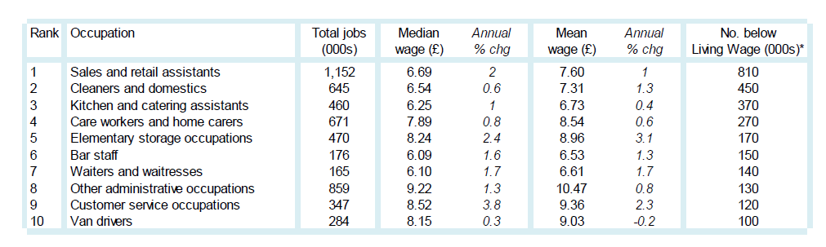

Table 5 : Top 10 occupations by number below living wage

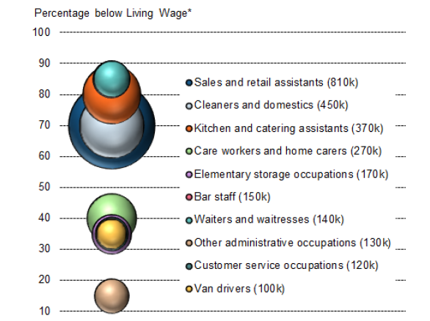

Fig: Top 10 occupations by number below living wage

Union and non-union wage different

Compared to market forces, union decline is seen as a modest source of rising inequality ( Autor et. Al. 2008). Union effects on non-union workers may be imposed in many ways. As a precaution to avert the threat of union non-union employers may rise wages.(Leicht 1989). Western and rosenfeld(2011) argue that union can play a vital role for the betterment of the economy as well as employee. In the early 70’s each of every third male was more organised and they raised their voices for equity not only for union members but for all. The erosion of moral economy and its underlying distributional norm had started after declining union leadership. As a result wage differential in the non-union sector has risen.
By analysing current population Survey( CPS) it is obtained that one fifth of wage inequality among men and none in women has increased. The effect of union decline when we compare the link between unionization and non-unionization wage differential. During the time period of 1973-2007 wage differentials for men has increased from .25 to .35, whilst for women it has increased from .20 to .30. Increasing inequality has raised the wage for the top level and fallen for the bottom level. After the declining of unionization highest paid workers wage has propelled like rocket ( Lemieux 2008)
Researcher has found that union do help to increase wages only for the blue collar worker who is less educated. Collective bargaining raise the wage within establishment and industry. Freeman (1980) found that union reduces the differentials of wages between educational and occupational groups.
Wages are the main focus on unionization. When union workers do raise their wage then employers may find to get unemployed people to recruit in the non- union sector. Spillover of workers on non-union sector causes wage to fall. For example we can say the two big unions of UK is USDAW and GMB. Usdaw was pushing Tesco to equalize its worker pay for different types of stores. And as a result In 2013 Tesco finalize their new pay system where every employee regardless of store size gets same pay.

The employer size effect

There is large evidence that large employers do pay more than the small employer and even when they belongs to same union status.(Lester, 1967; Masters 1969; Antos 1981). The wage gain associated with moving from a small organisation to a large organisation is similar to moving from an employer with union to an employer with no union attached to it.
Both neoclassic and institutional labour economists has offered why larger employer pay more than small employers. A size differential in labour quality and working condition is focused by neo-classicist while product market power and union avoidance are taken into point by institutionalism.
Large organisation do recruit people with higher quality and skills. According to Oi (1983) large firms employ higher quality people to save the cost of monitoring a given quantity of labour service. Oi has made an strong assumption that large institution can take a decision in an hour time whilst not affecting the numbers of workers output which had to be monitored in that one hour. Larger workplace may pay higher wages because of undesirable working condition like greater reliance on rules, less freedom of action and scheduling(Master,1969), more impersonal work atmosphere and longer commuting (Scherer 1976)

Bonus as a trend in Pay System

Purpose
The purpose of the discretionary bonus scheme is to reward both hourly paid and salaried colleagues throughout the business for the hard work and loyalty they have given to Asda throughout the year in helping to achieve the Company's set profit targets

Key Points

- This policy is applicable to Retail hourly paid and salaried colleagues only.

- The discretionary bonus year starts on the 1st January and ends on the 31st December.

- The bonus rules are subject to change and any changes will be communicated.
Target
The size of the colleague’s bonus will depend on the store’s cash profit performance versus the store plan.
- If the store’s plan bonus profit is -1% of plan sales then 30% of bonus is payable.
- If the store hits its store plan bonus profit then 80% of bonus is payable.
- If the store’s plan bonus profit is + 1% of plan sales then 100% bonus is payable.
- If the store’s plan bonus profit is +1.5% of plan sales then the maximum bonus of 125% is payable

Holiday Pay
Holiday pay is another form of wage where employee is entitled for a paid day off. Holiday pay is calculated as the higher of either basic hourly rate of employees contracted hours or average hourly rate of pay for hours worked by an employee in the 12 weeks immediately before holiday.
Rate of holiday pay may increase or decrease throughout the holiday year depending on premium hours worked by employee and contractual basic hourly rate during the 12 weeks prior to holiday. Holiday rate will never be less than contractual rate of pay

Store Cash Profit Target | % of Bonus Payable | Full Time Hourly Paid Colleague
Store plan bonus profit  +1.5% of plan sales | 125 % | £500
Store plan bonus profit +1% of plan sales | 100% | £400
Store plan bonus profit | 80% | £320
Store plan bonus profit -1% of plan sales | 30% | £120

Eligibility

Who is  Eligible? | All hourly paid colleagues (including colleagues on Supported Placement  Schemes) who have at least 6 months continuous service at the end of the  bonus year.  Seasonal colleagues with 6 months service will receive a prorated bonus  based on their average weekly hours.
Who isn’t  Eligible? | Hourly paid colleagues who have resigned, are working their notice, been  given notice to leave or are on suspension when the bonus is paid.  Hourly paid colleagues with less than 6 months’ service at the end of the  bonus year.  Hourly paid colleagues who are AWOL at the time the bonus is paid and  are subsequently dismissed for misconduct, gross misconduct or for being  AWOL (or would have been dismissed for such reason but for their  resignation).
Attendance | Bonus is calculated on the number of hours that an hourly paid colleague  has worked and been paid for during the bonus year.  Any time taken off from work (including certain flexible working schemes  e.g. a career break) will reduce the average weekly number of hours a  colleague will have worked in the bonus year and reduce the amount of  bonus received.

Case Study: Tesco Express

Background: Reviewing the pay structure in express.
Since 2010 Tesco, Usdaw and Express store colleagues had been reviewing the express pay structure, including the bonus scheme.
A working group was formed to look specifically at this issue. To make sure they had a balanced view all store roles, including managers were represented.
In 2011 they ran an online survey for Express colleagues to see how their employee felt about the Express pay structure and Bonus Scheme. The outcomes of the surveys was that whilst some colleagues wanted to maintain bonus, others wanted to move to the guaranteed, higher rates of pay and premiums that are paid in the other Tesco formats.
The working group also conducted focus groups to gain direct feedback from store colleagues, reviewed viewpoint results, the bonus trend and Key performance indicators over the past several years.
As the review progressed, it highlighted a number of business challenger which equally needed to be considered by the working group.
Having considered all the facts, information, feedback, discussion and future business challenges, the working group came to the unanimous conclusion that aligning the pay structure in express to all other store formats across the business was the right thing to do for colleagues and would support future growth, job creation and the continued success of the express format.
Why Tesco aligned Express Pay and Premiums to other store formats?
The working group heard compelling arguments from Express colleagues questioning the fairness of both the lower hourly rates of pay and the Bonus Measures. The review also highlighted-
- Colleagues had become frustrated and disengaged with the Mystery Shoppers targets which can result in a loss of bonus for things such as not smiling or not making eye contact with every customer. The stock loss bonus can also be affected when cages of stock are not delivered nor perhaps are misdirected, leading to time spending challenging results. Colleagues in store are working incredibly hard but they say they feel demoralised disheartened and discouraged by what they see as fundamentally unfair Bonus measures.
- Express viewpoint results regarding pay have been consistently lower than other store formats for a number of years
- There is significant lack of understanding about how the stock loss and Mystery Shopper Bonus works or what colleagues are required to do to achieve it, which defeats the objective of bonus schemes.
- Colleagues are not able to include any Bonus earnings when they apply for loans or mortgages, or Tesco’s own benefits such as child care vouchers or new cycle to work scheme.
- Inconsistent take home pay impacts colleagues who receive support through working tax credits or housing benefits.
- Mystery shopper has been replaced by customer viewpoint which they feel much better way to measure customers shopping experience. Without mystery shopper it was more likely that harder, fixed financial measure would need to be introduced so that the bonus scheme still can operate. The working group believed that it would led to even more dissatisfaction amongst colleagues.
- Colleague told they were often feeling torn between trying to achieve’ I don’t queue’, ‘ I can get what I want’ and ‘ the colleagues are great’ measures, because these all have a bearing on the level of bonus they can achieve and this is frustrating for colleagues.
- The nature of the bonus measures has led to behaviour that hold them back to stores for example cctv camera being checked to identify who has failed mystery shoppers.
The review also uncovered a number of business concerns:
- The Express pay structure and bonus scheme had become a barrier to movement between formats as Customers assistant, Team Leaders and managers in the other formats are less willing to move to work in an express store when their pay and premium will be different.
- This situation made it hard for Tesco to offer opportunities to colleagues and maximize their internal vacancies in both their existing and new express stores when colleagues are unwilling to transfer because of the current differences in pay and premiums

Observed intra industry wage differentials ( TESCO)
Hourly Rates of Pay
Position in Store | What colleague receive now | From 30 June | What does this mean for a full time colleague working 36.5 hours
Customer Assistant (Starter) | £6.42 | £6.91 | An increase of £983 per annum
Customer Assistant(Established) | £6.76 | £7.28 | An increase of £983 per annum
Team Leader (Starter) | £7.92 | £8.50 | An increase of £1,167 per annum
Team Leader  ( Established) | £8.33 | £8.95 | An increase of £1,167 per annum

Improved Premiums
Night Premium | What colleague receive now | From 30 June
Night Premium 1  (applicable between 2200-0000 hrs) | Not paid | Time + 1.47
Night Premium 2  (applicable between 0000-0600 hrs) | Time + 1.44 | Time + 2.18

SUNDAYS
Joining Dates | What colleague Receive Now | From 30 June
If colleague joined Tesco before 5 July 1999 | Time +£1 | Double Time
If colleague joined on or after 5 July 1999 | Time +£1 | Time + Half

Bank Holidays
Joining Dates | What colleague Receive Now | From 30 June
If colleague joined Tesco before 4 September 2000 | Time +£2(Excluding Boxing Day and New Years Day | Double Time
If colleague joined on or after 4September2000 | Time +£2(Excluding Boxing Day and New Years Day | Time + Half

Overtime(applicable for hours worked in excess of 36.5 hrs. per week)
Joining Dates | What colleague Receive Now | From 30 June
If colleague joined Tesco from April 2005 onwards | Single Time | Single Time
Between April 2004 and March 2005 | Single Time | Time +£1.25
Between April 2003 and March 2004 | Single Time | Time + £1.75
Between April 2002 and March 2003 | Single Time | Time + £2.15
Joined Tesco before 2002 | Single Time | Time +Half

Conclusion

The effects of our outcomes can be considered from two viewpoints. First, in favours to be accepted or being rejected that our analysis provides for different concepts of salary differentials, and in particular for the discussion between aggressive vs. performance salary concepts. Second, with regards to what we have discovered about the salary framework.
The basic forecast of performance salary designs is the lifestyle of salary differentials; in this feeling our outcomes assistance such designs. However, the scientific analysis always has restrictions and ours is no exemption. The evaluation of the design of salary differentials provides more information for giving answers to the question of whether such differentials signify merely a mathematical trend. The analysis on the design of salary differentials shows that they are relatively constant across efforts and professions.
Moreover, salary differentials are considerably associated with the characteristics of companies and sectors. The outcomes display that great paying sectors have higher investment strength, are more successful, have experienced higher growth with regards to investment, and have larger average dimension companies. Additionally, focus seems to highly impact the salaries of red receiver employees.
A number of these outcomes cause serious complications for a aggressive speculation. Intra establishment salary differentials are constant across time, such as times that involved important changes in financial guidelines. Therefore, aggressive details in accordance with the short-run immobility of or transitory demand bumps should have a minimal part or no part at all in describing such differentials. The great connection of salary differentials across professions is a discussion against the unmeasured capability description, since it is unlikely that employees in different professions within a company or industry have identical amounts of unmeasured capability.
A significant correlation between salaries and investment strength should be noticed if high-ability technologies are investment intense and if the evaluation did not effectively control for employee capability. The value of earnings recommends the lifestyle of rent-sharing procedures that are more challenging to Reconcile with an aggressive description. The outcomes display that modern companies pay salaries considerably higher that what seems to be the opportunity cost of employees. The distribution of wages is not only great in the high-skilled professions (where unmeasured capability should be greater) but also in the semi- and inexperienced professions. Wages are highly associated between occupations that are not supporting in manufacturing, and salaries for different professions display an identical progress across time.
The addition of this proof creates very implausible the discussion that the salary differentials seen in financial system react to the effect of unmeasured employee factors. The outcomes recommend, on the opposite, that sectors and companies do in fact pay different salaries to identical employees.
In the case of Tesco the justifications have been based on the existence of unions and the existence of indexation. Our analysis indicates that it is challenging to feature to such aspects the chronic design of salary differentials that we notice for the whole interval. In the past segments we have recommended several justifications for why this is so; here let us only remember that the impact of unions and the guidelines of indexation have modified considerably during the interval protected by our analysis, yet the wage differentials have stayed constant.
In brief, the lifestyle of salary differentials and the balance of their design are more reliable with EWMs that estimate such actions. The evaluation of the design of salary differentials also provides a test for the forecasts of different EWMs. However it is challenging to discriminate among different EWMs. The significance of dimension and investment strength in salary dedication is aspects that are consistent with shirking and revenues designs. The problem with these results is that substitute details can also be provided. In particular, the discussion that unmeasured capability is associated with technology creates it very challenging to differentiate among substitute theories. The great connection across professions presents a task to shirking or tracking designs because companies should pay great salaries only to the professions where such costs are particularly great. The most reliable outcomes are acquired for normative or sociological designs that estimate a design of great connections across all professions inside a company. The proof of rent-sharing procedures even when partnership power is poor is also reliable with this design. Also, rent-sharing arguments could be along with other EWMs. Overall, the proof on salary differentials seems better described by a mixture of designs that include both financial and sociological justifications in order to describe the chronic design of such differentials. In this sense, our outcomes validate the results that have been acquired for the US economy: firms tend to pay higher salaries to some professions, due to revenues, effort elicitation, employment or other reasons, but simultaneously they also face value restrictions that lead them to pay high wages to all the other professions. One of the main forecasts of the EWMs is that salaries will are generally difficult. Therefore, if performance salary concerns are appropriate to the economy—as this research has tried to prove—a design of difficult salaries financial system should also be expected.

REFERENCES

Ajila, C. & Abiola, A., 2004. Influence of Rewards on Workers Performance in an Organization. , 8(1), pp.7–12.
Altonji, J.G., 1986. Efficiency Wage Theories: A Partial Evaluation
Available at: http://www.jstor.org/stable/3585172?origin=crossref.
S. et al., 2013. Living Wage Research for KPMG Structural Analysis of Hourly Wages and Current Trends in Household Finances.
Anon, 2013a. A Direct Test of the Efficiency Wage Model Using UK Micro-Data ,Vol . 43 , No . 4 ( Oct ., 1991 ), pp . 529-548 Published by : Oxford University Press A DIRECT. , 43(4), pp.529–548.
Anon, 2004. Assessing the Productivity of the UK Retail Sector Oxford Institute of Retail Management. , (April).
Anon, 2011. Employee attitudes to pay.
Anon, 2008. Global Wage Report 2008 / 09 Minimum wages and collective bargaining Towards policy coherence,
Anon, 2013b. Interindustry wage differentials and efficiency wages : some Canadian evidence. , 27(1), pp.81–100.
Anon, 2007. STUDIES ON WAGE DIFFERENTIALS AND LABOUR,
Anon, 2013c. Union-non-union individual level organizational effects. , 9(2), pp.109–124.
Anon, 2014. Wage Differentials between Temporary and Permanent Workers in Italy.
Anon, 2013d. Wage Gaps Large and Small Author ( s ): Barry T . Hirsch. , 74(4), pp.914–933.
Anon, 2005. Working papers.
Author, V. et al., 2004. Labor Market Reforms and Changes in Wage Inequality in the United Kingdom and the United States,
Awards, G.G. et al., 2014. Interim results for the 28 weeks to 28 September 2013. , (November 2013), pp.1–41.
Barth, E., 2009. Performance Pay and Within-Firm Wage Inequality.
Belfield, R. & Marsden, D., 2005. Intra-establishment Pay Inequality and Performance Effects in Comparative Perspective. , (June).
Blackwell, A., 1997. Efficiency Wage Theory.
Bloom, M., 1999. the Performance Effects of Pay Dispersion on Individuals and Organizations. Academy of Management Journal, 42(1), pp.25–40. Available at: http://amj.aom.org/cgi/doi/10.2307/256872.
Blundell, R. & Crawford, C., 2013. What can wages and employment tell us about the UK ’ s productivity puzzle ? 1. , pp.1–32.
Booth, S. & Hamer, K., 2007. Labour turnover in the retail industry: Predicting the role of individual, organisational and environmental factors. International Journal of Retail & Distribution Management, 35(4), pp.289–307. Available at: http://www.emeraldinsight.com/10.1108/09590550710736210 [Accessed May 12, 2014].
Bozio, A. & Ifs, P.J., 2009. 9 . Public sector pay and pensions. , pp.213–237.
Braakmann, N., 2008a. Intra-firm wage inequality and firm performance – First evidence from German linked by Working Paper Series in Economics Intra-firm wage inequality and firm performance – First evidence from German linked employer-employee-data. , (77).
Braakmann, N., 2008b. Intra-firm wage inequality and firm performance – First evidence from German linked employer-employee-data. , (StataCorp 2005), pp.1–24.
Brown, C. & Medoff, J., 2013. The Employer Size-Wage Effect James Medoff. , 97(5), pp.1027–1059.
Caju, D. et al., Wo r k i n g Pa p e r S e r i e s Inter-industry wage differentials in EU countries what do time varying data add to the picture ? WO R K I N G PA P E R S E R I E S N O 118 2 / A P R I L 2010 INTER-INDUSTRY WAGE DIFFERENTIALS IN EU COUNTRIES WHAT DO CROSS.
Card, D., Lemieux, T. & Riddell, W.C., 2003. Some parts of this paper are taken from our forthcoming chapter in the.
Cardoso, A.R., 2000. WAGE DIFFERENTIALS ACROSS FIRMS : AN APPLICATION OF MULTILEVEL MODELLING. , 354(August 1999), pp.343–354.
Carneiro, A., 2007. Establishment Turnover and the Evolution of Wage Inequality.
Carter, T.J., 2013. Implications of Empirical Efficiency Wage Models. , 65(3), pp.594–602.
Case, A. & Ab, B., 2008. The impact of employee empowerment on service quality and customer satisfaction in service organizations.
Cataldi, A. & La, R., Part-time Work , Wages and Productivity : Evidence from Matched Panel Data. , pp.1–29.
Chen, P. & Edin, P., 2013. EFFICIENCY WAGES AND INDUSTRY WAGE DIFFERENTIALS : A COMPARISON ACROSS METHODS OF PAY. , 84(4), pp.617–631.
Chevalier, A., 2003. Wage policy , employee turnover and productivity. , (May).
Coats, D. & Introduction, C., The National Minimum Wage . Retrospect and Prospect.
Commitment, C. & Society, E., 2011. HP people.
December, N., 2007. Report for December 2007 Innovation in the UK Retail Sector. , (December).
Dumond, J.M., Hirsch, B.T. & Macpherson, D. a., 1999. Wage Differentials Across Labor Markets and Workers: Does Cost of Living Matter? Economic Inquiry, 37(4), pp.577–598. Available at: http://doi.wiley.com/10.1111/j.1465-7295.1999.tb01449.x.
Economist, D.E., Fran, B.Y. & Rycx, O.I.S., 2002. Inter-industry wage differentials: evidence from belgium in a cross-national perspective**. , (5), pp.555–568.
Epstein, G.S. & Ward, M.E., 2006. Perceived income, promotion and incentive effects. International Journal of Manpower, 27(2), pp.104–125. Available at: http://www.emeraldinsight.com/10.1108/01437720610666164 [Accessed May 12, 2014].
Feinberg-danieli, G. & Lonti, Z., 2005. The Union and Non-Union Wage Differential in the New Zealand Public Service. , (June), pp.27–37.
Gambin, L. et al., 2012. Sector Skills Insights : Retail Sector Skills Insights : Retail. , (July).
Gardner, D.G., Dyne, L. & Pierce, J.L., 2004. The effects of pay level on organization-based self-esteem and performance: A field study. Journal of Occupational and Organizational Psychology, 77(3), pp.307–322. Available at: http://doi.wiley.com/10.1348/0963179041752646.
Gartenberg, C., 2013. Pay Harmony : Peer Comparison and Executive Compensation Pay Harmony : Peer Comparison and Executive Compensation.
Gittleman, M., 1999. Working Paper No . 288. , (288).
Global, T. & Capital, H., 2008. Adaptable Workforce.
Guthrie, J.P., 2000. Alternative Pay Practices and Employee Turnover:: An Organization Economics Perspective. Group & Organization Management, 25(4), pp.419–439. Available at: http://gom.sagepub.com/cgi/doi/10.1177/1059601100254006 [Accessed May 12, 2014].
Haas, A., Spatial Wage Differentials *. , pp.1–37.
Heiwege, J., 2013. Sectoral Shifts and Interindustry Wage Differentials. , 10(1), pp.55–84.
Hendricks, W.E. & Kahn, L.M., 2013. EFFICIENCY WAGES , MONOPOLY UNIONS AND EFFICIENT BARGAINING *. , 101(408), pp.1149–1162.
Huang, A.T. et al., 2013. Empirical Tests of Efficiency Wage Models Empirical Tests of Efficiency Wage Models. , 65(257), pp.125–143.
Huang, I.-C., Lin, H.-C. & Chuang, C.-H., 2006. Constructing factors related to worker retention. International Journal of Manpower, 27(5), pp.491–508. Available at: http://www.emeraldinsight.com/10.1108/01437720610683976 [Accessed May 12, 2014].
Industrial, S. et al., 2013. Labor Market Institutions and Wage Inequality Author ( s ): Winfried Koeniger , Marco Leonardi and Luca Nunziata Published by : Cornell University , School of Industrial & Labor Relations content in a trusted digital archive . We use information technolog. , 60(3), pp.340–356.
Irene, B. et al., 2009. THE IMPACT OF TRAINING AND DEVELOPMENT ON WORKER PERFORMANCE AND PRODUCTIVITY IN PUBLIC SECTOR ORGANIZATIONS : A CASE STUDY OF GHANA PORTS AND HARBOURS AUTHORITY COMMONWEALTH EXECUTIVE MASTERS OF.
Johansen, K. & Strmt, B., 2013a. Efficiency Wages , Interfirm Comparison , and Unemployment. , 68(2), pp.387–402.
Johansen, K. & Strmt, B., 2013b. Efficiency Wages , Interfirm Comparison , and Unemployment. , 68(2), pp.387–402.
King, J., Executive, C. & Tyler, D., 2013. Interim Results Wednesday 13 th November 2013. , (November), pp.1–21.
Korean, T.H.E. & Review, E., 2010. WAGE DIFFERENTIAL BY EMPLOYMENT TYPE AND CONTRACT LENGTH * MINSEONG KIM ** ⋅ SUNGHYUN RYU *** I . INTRODUCTION. , 26(1), pp.157–176.
Krueger, B.Y.A.B. & Summers, L.H., 2013. Efficiency Wages and the Inter-Industry Wage Structure Author ( s ): Alan B . Krueger and Lawrence H . Summers Published by : The Econometric Society Stable URL : http://www.jstor.org/stable/1911072 . EFFICIENCY WAGES AND THE INTER-INDUSTRY WAGE who accep. , 56(2), pp.259–293.
Lallemand, T., Plasman, R. & Rycx, F., Intra-firm Wage Dispersion and Firm Performance : A Review and Empirical Tests on Belgian Data 1. , pp.1–27.
Lane, J.I., Salmon, L.A. & Spletzer, J.R., 2007. Establishment wage differentials. , (April).
Lee, N., Sissons, P. & Jones, K., 2013. Wage inequality and employment polarisation in British cities. , (May), pp.1–74.
Lester, R.A., 2013. WAGE DIVERSITY AND ITS THEORETICAL IMPLICATIONS I. , 28(3), pp.152–159.
Machin, S., 2008. Big ideas Rising wage inequality. , pp.8–10.
Macleod, W.B. et al., 2013. Labor Turnover and the Natural Rate of Unemployment : Efficiency Wage versus Frictional Unemployment.
Macleod, W.B. & Malcomson, J.M., 2013. Wages Costs , and Efficiency Cycles. , (37).
Mansour, M., 2000. HR Practices Impact on Firm Performance : An Empirical Study.
Marsden, D., 1999. Pay Inequalities and Economic Performance Project report.
Martins, P.S., 2003. Firm wage differentials in a competitive industry: some matched-panel evidence. International Journal of Manpower, 24(4), pp.336–346. Available at: http://www.emeraldinsight.com/10.1108/01437720310485889 [Accessed May 12, 2014].
Martins, P.S., 2008. Worker churning and firms’ wage policies. International Journal of Manpower, 29(1), pp.48–63. Available at: http://www.emeraldinsight.com/10.1108/01437720810862001 [Accessed May 12, 2014].
Mendes, R.V., 1980. Gender wage differentials and occupational distribution Gender wage differentials and occupational distribution. , pp.27–41.
Min, H., 2007. Examining sources of warehouse employee turnover. International Journal of Physical Distribution & Logistics Management, 37(5), pp.375–388. Available at: http://www.emeraldinsight.com/10.1108/09600030710758437 [Accessed May 12, 2014].
Munasinghe, L., 2013. Wage Growth and the Theory of Turnover. , 18(2).
Name, A., Bovill, D. & Statistics, N., 2014. Patterns of Pay : Estimates from the Annual Survey of Hours and Earnings , UK , 1997 to 2013. , (February), pp.1–35.
Neill, J.E.O. & Neill, D.M.O., 2005. No Title.
Neumuller, S., 2012. Inter-industry Wage Differentials Revisited : Wage Volatility and the Option Value of Mobility.
New, T.H.E. & Pay, O.N., THE NEW CLOSED SHOP : THE COST WHO ’ S DECIDING OF PAY ON PAY ? AN ANALYSIS OF PAY INEQUALITY.
Nicklisch, A., 2006. Fairness and Social Comparison : An experimental study of the Co-Employment of Permanent and Temporary Wage Differentials , Fairness and Social Comparison : An experimental study of the Co-Employment of Permanent and Temporary Agency Workers.
Obloj, T. & Sengul, M., 2012. Incentive Life-cycles: Learning and the Division of Value in Firms. Administrative Science Quarterly, 57(2), pp.305–347.
Available at: http://asq.sagepub.com/lookup/doi/10.1177/0001839212453833 [Accessed May 6, 2014].
Offers, P.W. & Scoones, D., 2014. Promotion , Turnover , and Preemptive Wage Offers. , 83(4), pp.771–791.
Osburn, J., 2000. to the primary mission of the firm have the greatest differential. , (February).
Outlook, L.M., 2013. Autumn 2013.
Paper, B., 2012. Wholesale and Retail : Sector Skills Assessment 2012. , (November).
Poggi, A., 2014. Within-Establishment Wage Inequality and Satisfaction. , (2013).
Poggi, A., 2010. Within-establishment wage inequality and satisfaction. , pp.1–10.
Potential, H., 2012. Ret ai l ’ s Hi dde n Po te n ti a l. , (November).
Premia, W., African, S. & Market, L., 2000. WORKING PAPERS Wage Premia and Wage Differentials in the South African Labour Market. , (00), pp.0–25.
Quarterly, T., 2013. An Interplant Test of the Efficiency Wage Hypothesis Author ( s ): Peter Cappelli and Keith Chauvin Source : The Quarterly Journal of Economics , Vol . 106 , No . 3 ( Aug ., 1991 ), pp . 769-787. , 106(3), pp.769–787.
Reilly, K.T. & Zanchi, L., 2003. Industry wage differentials: how many, big and significant are they?, Available at: http://www.emeraldinsight.com/10.1108/01437720310485906 [Accessed May 12, 2014].
Retail, I., 2008. by Kelly Sakai , Kenneth Matos and Ellen Galinsky Families and Work Institute Funding from the Alfred P . Sloan Foundation and the Ford Foundation.
Rhodes, C., 2013. The retail industry.
Romaguera, P., 1991a. Wage Differentials and Efficiency Wage Models. , (March).
Romaguera, P., 1991b. Wage Differentials and Efficiency Wage Models. , (March).
Scale, T.H.E. et al., WORKING FOR POVERTY THE SCALE OF THE PROBLEM OF LOW PAY AND WORKING.
Schmitt, J., 2013. Why Does the Minimum Wage Have No Discernible Effect on Employment ? , (February).
Siebert, W.S. & Chevalier, A., 2006. Labour Turnover and Labour Productivity in a Retail Organization. , (2322).
Smith, B.J., Current Issues Note 36 Patterns of low pay.
Split, J., Jobs Split.
Stavrevska, V., 2011. The efficiency wages perspective to wage rigidity in the open economy: a survey. International Journal of Manpower, 32(3), pp.273–299. Available at: http://www.emeraldinsight.com/10.1108/01437721111136769 [Accessed May 12, 2014].
Street, B. & Ec, L., 2013. Asda Income Tracker. , (October).
Structures, W. & Markets, A., 2007. Chapter Ten. , pp.1–5.
Suleman, F., 2006. Firms ’ wage policies : new evidence from Portuguese linked employer - employee data. , (1), pp.1–14.
Sulis, G., 2011. What can monopsony explain of the gender wage differential in Italy? International Journal of Manpower, 32(4), pp.446–470. Available at: http://www.emeraldinsight.com/10.1108/01437721111148559 [Accessed May 12, 2014].
Systems, S.P.A.Y., Act/emp.
Takahashi, K., 2006. Effects of wage and promotion incentives on the motivation levels of Japanese employees. Career Development International, 11(3), pp.193–203. Available at: http://www.emeraldinsight.com/10.1108/13620430610661722 [Accessed May 12, 2014].
Theories, E.W., Author, P.E., Source, L.F.K., Annual, N.M., Press, C., et al., 2013. Theories : E ficiency Wage A Partial. , 1(1986), pp.235–276.
Theories, E.W., Author, P.E., Source, L.F.K., Annual, N.M. & Url, S., 2013. Theories : E ficiency Wage A Partial. , 1(1986), pp.235–276.
Tsai, K.-H., Chou, C. & Chen, M.-Y., 2008. Does matching pay policy with innovation strategy really improve firm performance?: An examination of technology-based service firms. Personnel Review, 37(3), pp.300–316. Available at: http://www.emeraldinsight.com/10.1108/00483480810862288 [Accessed May 12, 2014].
Tuttle, M., 2013. Employee Turnover : A Meta-Analysis and Review with Implications for Research. , 11(1), pp.55–70.
Ussher, K., LONDON RISING : THE CASE FOR A LONDON MINIMUM.
Wage, N.M., 2014. Interim Government Evidence for the Low Pay Commission’s 2014 Report. , (October 2013).
Wage, W. & Barth, E., 2008. Manpower Human Resources Lab Performance Pay and Inequality. , (April).
Western, B. & Rosenfeld, J., 2011. Unions, Norms, and the Rise in U.S. Wage Inequality. American Sociological Review, 76(4), pp.513–537. Available at: http://asr.sagepub.com/cgi/doi/10.1177/0003122411414817 [Accessed May 9, 2014].
Wicks-lim, J., 2005. ANALYZING THE RIPPLE EFFECTS OF MINIMUM AND PREVAILING. , (September).
Yim, F.H. et al., 2005. Critical success factors in the personal selling process: An empirical investigation of Ecuadorian salespeople in the banking industry. Journal of Strategic Marketing, 3(2), pp.1–16. Available at: http://www.citeulike.org/group/12110/article/9637069 [Accessed November 9, 2013].
Yoon, H., 2013. Reexamining the Pay Differentials-Organizational Outcomes Relationship in Korea : , 19(1).

