Impact on Capital Markets of the European Project of a Financial Transaction Tax Paris-Dauphine Doctoral school ED 543 economic
SUMMARY
- Dissertation Summary
- Chapter I: “The Effect of the EU Financial Transaction Tax on Implied
Volatility”.
- Chapter II: “Study of the Effect of the EU Financial Transaction Tax on the Corporate Cost of Capital and the Corporate Bond Market”.
- Chapter III: “Study of the Effect of the EU Financial Transaction Tax on Stock Markets, Corporate Value and Volumes of Securities on the Primary Market”. 5. Article published in “Applied Economics” on Aug 21, 2017: “Study of the Effect of a Financial Transaction Tax on the Corporate Cost of Capital”.
Summary of the Dissertation of Jean-Pierre FRAICHOT
Impact of the Financial Transactions Tax upon Capital Markets

The purpose of the dissertation is the study of the consequences of the proposed taxation of financial transactions by the European Union, in its current form. This plan would create a tax that would be a hybrid between the classic TOBIN tax on foreign exchange markets and the concept of “Standard Transaction Excise Tax” (STET) introduced by STIGLITZ and SUMMERS, based upon an original idea by KEYNES, and concerning the securities market. This new European STET consists in taxing financial transactions concluded within the European Union, or by financial institutions domiciled within the Union. The respective rates of this tax would range from .1% and .01% for cash and derivative instruments, and the basis would be the nominal value of the contracts. As the subject is extremely vast, we limit ourselves to the study of stock and bonds markets. After a presentation of the literature, and the approach chosen for this dissertation, we will set forth in a third section the main results of the dissertation. The final section is dedicated to the general conclusion of the dissertation.

Section 1: Literature
There exists an extensive literature (see enclosed References) concerning the effects of a STET upon financial markets, in particular with regard to the potential impact upon (i) the cost of capital for businesses, (ii) volatility, and (iii) liquidity. The various studies are either theoretical works, in limited number, dealing with general equilibrium models (e.g. [21]), or empirical surveys of the impact of past experiments with the implementation of STET-type taxes in various countries (United Kingdom, Sweden, Japan) ([4], [5], [14], [19], [25], [27], [30], [33], [36], [39]). We will conclude this brief review of the literature by a critical analysis that will allow us to define our own approach.

1.1 Effect On Cost of Capital
Concerning this first point, there exists a consensus on the effect of the increase in the cost of capital for businesses. The (mostly empirical) available studies generally find a negative impact in the middle term (with a horizon of a few years) upon the prices of financial instruments (mostly stocks).
- Empirical Studies: In the context of the introduction of a STET in Sweden, WESTERHOLM [39], then UMLAUF [36] find a significantly negative impact for the introduction of a STET upon the prices of stocks. UMLAUF shows that the Swedish stock index fell by 2.2% on the day the 1% tax was implemented and .8% on the day that tax was raised to 2%.
WESTERHOLM concludes that cutting the tax by 1% would lead to a 7.5% increase in that index, while a complete repeal of the tax would lead to 9.7% increase.
Transposing these results to the case of the United Kingdom, SAPORTA and KAHN [33], through their analysis of the historical stock prices from 1969 to 1996, find similar results and conclude that a 1% drop in the “STAMP DUTY TAX” would lead to a 6.24% increase in the general stock index. HAWKINS and MACCRAE [15] analyze the potential repeal of that tax and find an increase ranging from 6.75 and 12.25%, depending on the assumptions made on the impact of the tax repeal on the transaction volumes.
- Theoretical Studies: A study by LENDVAI, RACIBORSKI, VOGEL for the Economic Studies Department of the European Commission [21], based on a general equilibrium model, concluded to a .09% impact on the cost of capital.

1.2 Effect On Volatility

There exists in fact no consensus on the impact of the introduction of a STET on financial market volatility. A detailed survey of the very abundant literature on the topic by WANG and YAU [38], evidences two groups of studies, each arriving at different conclusions. A first group of studies finds no significant effect, while a second group finds an increase in volatility.

1.3 Effect On Liquidity

There again we have two kinds of studies, likewise listed at [38]. The first group of studies finds that the liquidity of securities markets would be negatively affected by the introduction of the tax, particularly as to the volumes exchanged on the markets, and more particularly where there exists the option to transfer transactions toward another market that would not be subject to the STET, as was the case for the Swedish market. The second group of studies finds such impact to be negligible, or impossible to prove.

1.4 Critical Analysis of Extant Literature

The approach generally followed by the relevant literature is that of an empirical ex-post facto analysis of the volatility actually recorded on the markets following historical experiments of implementation of STET-type taxes in various countries.

- Surprisingly, les effects of a STET-type tax have never been considered via the standpoint of the markets of options on financial securities, while these markets by definition are markets where one trades the anticipated volatility of financial securities, which are the underlying assets of the relevant option contracts. The anticipation of the impact on these financial markets of the introduction of a Financial Transaction Tax (FTT) would answer the question of the impact of the tax on volatility. Likewise, the analysis of the impact on the costs of capital does not take into account to this day the credit derivatives markets. This shortcoming is explained, in our opinion, by the fact that most implementations of STET-type taxes have been implemented at a time (until roughly the 1990s) when the stock and credit derivatives markets did not yet exist.

- Finally, the link between the potential impact of the FTT on volatility and the cost capital has been discussed, to our knowledge, only in the empirical studies cited above, and never from the standpoint of theoretical modeling. This second shortcoming can be explained largely by the fact that markets arbitrage (“Capital Structure Arbitrage”) between credit derivatives and stock derivatives, such as “Credit Defaults Swaps” (CDS) or “Collateralized Debt Obligations” (CDO) have only been developed very recently, since the early 2000s. Further, these markets have almost disappeared, or at least have stagnated, between 2008 and 2015following the financial crisis triggered by LEHMAN BROTHERS bankruptcy.

Section 2. Our Approach

2.1 Impact of The FTT On Option Markets

Given the points raised above, the approach chosen in Chapter I shall consist in a study first of the impact of the FTT on option markets, from the angle of the potential change in behavior of the market makers following the introduction of an FTT.

Very quickly the concept of the liquidity of the relevant option market appears critical, because it will determine the magnitude of the repercussion of a raise in the transaction costs on the prices posted by the market makers.

Within this context, it is fundamental to analyze the formation of option prices from the angle of insurance markets, to determine whether the offer and demand of options will be sensitive to the modification of the “buy-sell” spreads on the volatility. Nowadays, the analysis of the “buy-sell” spreads is indeed fundamental in the determination of option prices. For a “market practitioner”, there is an immediate reaction to the proposed FTT. It is an additional transaction cost that will necessarily affect the “implicit” volatility determined by market makers. Research concerning the options and credit derivative markets, and the transaction cost analysis techniques, have developed since the early1980s. These techniques have aimed at improve the profitability of operators similar to market makers by considering the stochastic optimization of their profit or utility function, through the resolution of Hamilton Jacobi Bellman (HJB) equations. The generalization of algorithmic trading linked to the increased power of computers and flash trading, as well as fairly recent theoretical advances (2007-2008), have allowed simple asymptotic solutions to this optimization issue based on the volatility and liquidity of financial markets.

2.2 Taking into Account the Interaction Between the Effects of The FFT On Volatility and Those On Capital Costs

Following the critical analysis of the literature, the last two chapters are dedicated to the study of the interaction between the modifications of the volatility and capital costs, as a consequence of the introduction of the FTT.

We discuss from the onset a structural approach linking by Capital Structure Arbitrage (CSE) the respective markets of (i) des stock derivatives, (ii) credit derivatives and (iii) stock and bond markets. Contrary to the conclusions of the extant literature, the effects of homogenous taxation are going to depend on the micro-economic characteristics (balance sheet, initial volatility, credit rating) specific to the business. Thus the impact of a general measure such as the introduction of the FTT may depend on specific structural characteristics at the micro-economic level.

We will in particular discuss the effects triggered by the taxation level of the business. The tax deductibility of interest paid to bondholders introduces a dissymmetry between the behavior of stocks and that of bonds. Bond prices are not sensitive to differences of corporate tax rates on profits. On the contrary, corporate value, as well as shareholder equity, will depend on that tax rate. Likewise, the greater liquidity of the stock market compared to the market for corporate bonds suggests a different treatment of the effects on bonds and stocks.

We therefore divide the issue into two distinct chapters dealing with capital costs:

- Chapter II focuses on the analysis of bond indebtedness, and the consequences on the primary bond market of the introduction of the FTT. These consequences are directly translated into marginal corporate cost of capital.
Chapter II is the keystone of our approach, because it is where we discuss the potential propagation by CSE of the effects of the FTT to credit and bond markets.

- In Chapter III we discuss the general structure of the capital of the business, and the possible reaction of the business in terms of optimal adjustment of its financial structure to the introduction of the FTT. We study in particular the maximization of the corporate value and the allocation of financing between the issuance of stocks and bonds. We then review the final impact on the theoretical stock price and actual volatility, before reaching our conclusion.

Section 3 : Main Results

3.1. Volatility

We review in Chapter I the concept of implicit volatility of a stock. This volatility is derived from the observation of the European-type option market on that stock. At an instant t, by considering the given price of the underlying stock, and setting the value of parameters such as the risk-free interest rate or the dividends, we determine, by reversing the BLACK-SCHOLES formula, a volatility value that corresponds to the option value observed on the market for a given exercise price.

The use of this concept allows us to consider the fact that volatility is in itself measurable and determined via a rational equilibrium on the market. The recent development of new products on the stock derivatives markets have incidentally allowed the introduction for the most liquid underlying assets (indices and certain very liquid stocks) of volatility indices (VIX or VSTOXX) based on the value of implicit volatility.

By application of well-known rules on the hedge of stock portfolios, taking into account the additional transaction cost involved by the FTT will lead to a widening of the buy-sell spread of stock options, and therefore to a widening of the buy-sell spread on the volatility. From a quantitative standpoint, this effect will be an increasing function of the rate of the transaction tax, of the frequency of the adjustment of the hedge of the option portfolio, and the effective liquidity of option markets. We determine an adjustment frequency that depends in fact on the relative variation relative of the underlying asset, and we use the work BOYLE and VORST [8] to formalize this impact when volatility is constant. Our approach allows us to complete the literature by taking into account, on the one hand, the initial costs of constitution of the hedge portfolio and on the other hand, the potential costs of delivery at term by considering a stochastic volatility. In this case, we conclude that there exists no “closed” formula to calculate this impact, and that it is appropriate to perform Monte Carlo simulations to obtain a quantitative estimate.

By using insurance theory, on show that this widening of the buy-sell spread has no incidence on the demand for options. Economic agents on the markets will deem that the introduction of the tax is equivalent to an increase in volatility risk. By considering the asymmetry between sellers and buyers of options, we conclude that the FTT will entail an increase in the “middle” price of options held to term. Therefore, an increase in the “middle” value of volatility will follow.

Where option markets are not very liquid, and in particular in the case of a market of “pure insurance”, where market makers are faced with agents who seek to hold options to term, we show that such increase is permanent.

In the case of stocks with a very liquid associated option market, we use the asymptotic approximation of the Hamilton Jacobi Bellman (HJB) equations [2] to prove that there is, in this type of situation, a very weak, even negligible, impact, on the implicit volatility of the relevant stocks. We consider both market makers with a risk-neutral utility function and those that incorporate risk aversion. We show that the competition constraint between both types of agents, leads risk-adverse agents to consider an un aversion coefficient that is exactly the gamma of the option(s) used to construct the synthetic stock. We then deduce, after taking into account the depth of the market, the impact volatility, which is less than the “tick” in sufficiently liquid markets.

3.2 Liquidity

We show that, if the liquidity of option markets is sufficient, the implementation of the FTT will further increase such liquidity. This phenomenon is due to the massive substitution of transactions on synthetic or derivative products in place of transactions on stocks on the spot market.

- By applying Merton’s model, we note that the agents who hold stock on the long term will not decrease their stock demand, even in case of a widening in the buy-sell spread on stocks. This widening of the spread is analyzed as per insurance contract theory, as previously stated, and the tax increase is equivalent to a risk increase, which has no impact on demand. Therefore, to estimate the liquidity, one must estimate the intensity of arrival orders? (ordres d’arrivée?), which are issues by other economic agents, such as the market makers.

The market to be considered is the complete market, made of cash transactions on the stock and transactions on derivative products of “delta-one” type, in particular the synthetic stock, (constructed from a buy “call” position and a sell “put” position, and which is also a future?). We show that, if the position on a synthetic stock is held for a short period and is to carried to term, the impact of the FTT will be .02% on the spread.

- We further show that, in the hypothesis of a symmetry of the curves volatility around the money?, by exercise price, the agents who take directional positions on the increase and decrease of the price of the underlying stock will be able to enter into contracts that minimize the impact of the tax. These “pseudo-synthetic” contracts are made of call type option purchases and put type option sales at modified exercise prices. Their payment at term reproduces a tax-free payment provided the relative variation relative of the price of the stock is over .4% of the nominal amount of the transaction, and a zero payment if the variation is less than .4%.

Therefore, the increase in the FTT will induce a massive substitution between cash and synthetic stocks, and more generally “delta-one” type derivative products. The liquidity of the market with regard to the latter will improve considerably. In sum, if the ex-ante incidence of the tax is indeed .02% of the nominal value of the stock over the quotation interval of the synthetic stock, the ex-post impact will be less give the increase in liquidity.

- The market makers will always maintain, if not increase, the volume of their purchase and sale on the option markets. They use algorithmic trading techniques (flash-trading) that allow them to gain an advantage, in terms of price, compared to the other actors. Indeed, their order execution speed leads to a faster process of price discovery that allows them to have access to information that is not yet available to the other participants. They then benefit by priority of real jumps in middle prices, which range in fact from .03% to .05% on the cash and synthetic stock.

Furthermore, the MIFID II regulation, implemented in 2018, introduces a minimum tick for cash stocks. This measure was designed by the regulator to manage the competition between the various exchanges to offer the best liquidity and attract transactions. The implementation of that regulation will in fact increase the attraction of delta-one type derivative products.

In sum, in stock markets, where algorithmic flash-trading is dominant, and which have a very liquid associated option market (the best example being the Apple stock in the United States), the impact of the FTT will be negligible on the liquidity of the total market comprised of the stock and synthetic stock.

- For other markets, the conclusion is less certain and must be determined on a caser-by-case basis. In the extreme case of a market where there are no speculators on stocks and where the positions taken are long term investments, the demand for stocks will not be sensitive to the introduction of the tax, because the stock market is one of pure insurance. Further, volumes will increase in the long term because of the adjustment of the structure of businesses, and altogether liquidity will increase.

3.3 Cost of Capital

3.3.1 Chapter II

Chapter II considers the arbitrage between stock derivatives and credit derivatives, and finds a significant effect of the FTT on the latter market, which leads to a substantial increase in the cost of financing for businesses. We study first the theoretical impact of the FFT, before then performing a simulation on the values of 6 businesses.

A. Theoretical Impact On The Cost of Capital

The explanation for the significant increase in the cost of financing for businesses resides in the fact that business that issue bonds on the primary market must offer to subscribers some insurance against the credit risk born by the latter. By way of an arbitrage between credit derivatives and stock derivatives, we show that such coverage is equivalent to the purchase of an American-type put option on the stock. In case of bankruptcy, the bondholder covers its loss by selling the stock, which then has a value close to zero. We take into account the hypothesis where the bankruptcy happens when the value of the assets falls beneath an amount stated as a fraction of the principal of the debt. The trajectory of the value of the assets is supposed to follow a process of geometrical stochastic diffusion, whose volatility is derived from the volatility of the price of the stock.

The market for put-type options is generally rather illiquid, in particular for long maturities and options out of the money (with a very low exercise price.) These options are preferred in this type of arbitrage for cost reasons. Further, since businesses borrow, we will take into account the purchase value of the put with a market maker. The latter will increase, as we saw above, the sale price of the option to recoup the coverage costs of its option portfolio until its term.

In this model, we then see that the credit risk, or credit spread, is a growing function of the volatility of assets, which itself depends on the volatility of the stock price. While the price of the issued bond includes the cost of credit insurance, this is equivalent to considering an arbitrage model between stocks and bonds from the same business.

For the sake of simplicity, we will consider an arbitrage model between credit derivatives and stock derivatives, which is broadly used in trading floors, and was introduced by JP MORGAN in the early 2000s, the CreditGrades® model.

This model yields directly, for any business with a given balance sheet structure, the link between the probability of default by this entity and the volatility of the stock price. This model is widely used by market operators to calculate the theoretical spread of credit derivatives with a certain level of volatility of the stock price. When so used, it allows an arbitrage between credit derivatives and stock derivatives, in particular the arbitrage previously described, which uses put-style. We apply this model to a sample of 6 European businesses, which comprises three manufacturing concerns and three financial institutions. We consider the structure of their balance sheets as it is known as of 09/30/2016. First we calibrate the CreditGrades® model on the credit spreads and the volatilities of the stocks of these businesses. We then perform a simulation of the impact of the introduction of the FTT on the issuance price of bonds by these businesses on the primary market.
We consider successively maturities of 5, 10, 15 and 20 years for these bonds.

The amplitude of the increase of the credit spreads on the CDS markets appears much greater (several percentage points per year) than that generally stated by the European Commission (.09%) [21]. This increase then propagates by arbitrage to the markets for business bonds, and leads to significant price drops on the secondary bond markets. The amplitude is such that, for example for ARCELOR MITTAL (-80% for 20 year bonds), that the FTT would induce insurmountable competition distortions with competing businesses located in emerging countries. This simulation reminds us that the effects of the FTT will be felt well beyond the world of finance, and affect businesses whose principal competitors are outside the European Union and thus not subject to this tax.

B. Calibration of Our Models And Analysis Of The Concrete Cases of 6

European Companies

We use two models, dealing respectively with perpetual debt and fixed maturity debt, to estimate the impact on the price of the debt and the theoretical price of the stock, for a sample of 6 European businesses selected for the purposes of Chapter II.

We note that the behavior of these businesses tends towards having a fixed capital structure rather than an optimal capital structure. The drops in the theoretical bond and stock prices are significant. One can measure them both on the short term, as soon as the FTT is introduced, and on the long term, once the businesses have renewed their debt inventory. The short term effect is comprised between -3% and -10% of the stock value. The long term effect is comprised between -1% and -8% of the stock value. The average credit spread increase, for the average duration of the debt, is comprised between .5% and 2.5%.

3.3.2 Chapter III

Chapter III deals with the structure of the capital of these businesses and the impact of the FTT on that structure. We review in particular the impact of the FTT on the theoretical value of the stock of the business, as well as the intrinsic value of the latter.

We model the structure of the business and that of its capital based on the models introduced during the mid-1990s by LELAND and TOFT following the work of MODIGLIANI and MILLER.
Unlike these authors, however, we consider, in the line of the CreditGrades® model, an exogenous determination of the bankruptcy of the business, which happens whenever the value of the assets falls beneath predetermined level. This trigger threshold is set as a fraction of the principal amount of the debt incurred by the business.

We consider that there may exist two main types of capital structures:

- The first follows a fixed capital structure, i.e. a debt level whose principal is a fixed fraction of the value of the assets.

- The second considers an optimal capital structure. Due to the tax deductibility of paid interest, we show in this manner that there exists an optimal debt threshold that maximizes the value of the company for the shareholder.

We will first study the differential theoretical impact on the theoretical value of stock depending on the capital structure and the corporate tax rate, before reviewing the induced consequences of the drop in the value of the stock, in particular in the context of regulations such as CRD IV.

A. Differential Theoretical Impact On Theoretical Value of The Stock

1. Impact Depending On Capital Structure

a. We first consider businesses that wish to keep a fixed capital structure, i.e. that choose to set their debt level at a constant fraction of asset value.

We show that businesses that finance themselves exclusively through issuance perpetual debt, in particular junior debt, preferred stock or participation securities?, will experience during the introduction of the FTT a drop in the value of their debt inventory, as well as a drop in the value of their preferred stock. They will also experience a drop in corporate value. These businesses will however witness at first an increase in the theoretical value of their stock. But later bond issuances will lead to a drop in the price of the stock.

The amplitude of this effect increases with the leverage of the business, credit spread and volatility. This effect is always negative whatever the other parameters, such as dividend level, interest rate or tax rate on profits.

With regard to businesses that finance themselves exclusively through the issuance of fixed and intermediate (5 to 15 years) maturity debt, we show that the impact of the increase of the FTT will generally be negative on the theoretical value of the stock, as well the theoretical value of the debt and the value of the business. This impact on the debt will affect not only the existing debt inventory, but also the new bond issuances of intermediate maturity (up to 15 years). The amplitude of this impact is again an increasing function, respectively?, of the leverage of the business, the credit spread and of the volatility.

The notable exceptions will concern, in particular, the businesses that issue “junk bonds” and are close to bankruptcy, so that the introduction of the FTT would create, in such cases, a selection bias in favor of businesses in poor health to the detriment of those that are more “virtuous”.

Generally, one can find an envelope? of parameters? on the dividends paid by the business and the interest rate such as the impact of the FTT is negative for the businesses that issue intermediate maturity debt (up to 15 or 20 years). We observe that such is the case, in particular, for all of the companies that comprise the French index CAC40.

b. We then consider businesses that seek to determine an optimal level of indebtedness (and thus leverage) tending to maximize the corporate value.

We show that the introduction of the FTT will tend to decrease the optimal level of indebtedness for businesses. Following the introduction of the FTT, the latter will tend, in order to adapt, to repay the existing debt inventory through stock issuances on the market. For businesses that finance themselves exclusively through issuances de debt with fixed and intermediate (5 to 15 years) maturity, we show that the impact of the increase of the FTT will be generally negative on the theoretical value of the stock, as well as the theoretical value of the debt and the corporate value.
We calculate that these stock issuances will happen with an issuance price inferior to that prevailing before the introduction of the tax, thus leading to a drop of the theoretical price of the stock by way of the classic dilution effect.

We also show that, like those businesses striving for a fixed capital structure, businesses that exclusively finance themselves through the issuance of debt with fixed and intermediate (5 to 15 years) maturity, will generally notice a negative impact on the theoretical value of their stock, as well as the theoretical value of the debt and the corporate value.

The amplitude of this impact is also a growing? function respectively? of the leverage of the business, the credit spread, and the volatility and maturity of the debt.

2. Theoretical Impact Depending On Corporate Tax Rate – Consequences In Terms of Economic Policy

We simulate the impact of the FTT according to various values of the corporate tax rates applicable in the European Union, from 15% (Ireland) to 35% (France).

We show that businesses that finance themselves with perpetual debt, preferred stock or participation securities? will see a drop in the theoretical value of the stock, which will be all the greater if the tax rate is low.

Conversely, we show that, in the case where businesses finance themselves by issuing fixed intermediate maturity debt, the negative impact on the stock price decreases with the tax rate.

These conclusions suggest that the introduction of the tax at the same time in all of the countries of the European Union will create competitive distortions as to the financing of businesses due to the divergence of the tax rates and the diversity of the means of financing. The harmonization of corporate tax rates within the European Union therefore seems to be an indispensable precondition to any implementation of a financial transaction tax.

B. Impact Of The Induced Drop In The Theoretical Value Of The Stock

- Long Term Increase in Stock Volumes: In fixed capital structures, we observe that, by combining drops in primary stock and bond markets, businesses have to issue more securities for the same financing needs.

In optimal capital structures, we saw that the introduction of the FTT tends to decrease the resort to leverage by businesses, which then issue more stock.

In sum, the FTT will tend, in the long term, to increase the issuance of stock on the primary market, which, all things being equal, should lead to an increase in the volume of circulating securities? and a greater liquidity.

- Conflict with CRD IV (Basel III) Regulations On Capital Increase for Financial Institutions

The implementation of the FTT will have a contrary effect to the rules introduced by Regulation CRD IV, which is the transposition at the European level of the Basel III Directive of the Bank for International Settlements. Indeed, these rules mandate that European banks and financial institutions have sufficient available capital in view of their assets.

As a practical matter, in order to comply with these ratios, European banks are currently engaged in a process of issuance of securities that are equivalent to quasi-reserves, and which consist either in perpetual debt, or in fixed maturity debt of intermediate duration. These securities, designated by the acronym COCO (Contingent Convertible Obligations), are convertible into reserves whenever the value of reserves falls beneath a critical threshold, expressed as a function of the value des assets of the financial institution. One recognizes a process that is very close to our own analytic framework, which for its part adopts a threshold based on the value of the assets.

Our analytic framework is applicable by considering the value of the stock instead of the asset value, and an adequate recovery rate.

The CRD IV regulations can then in fact be construed as a fixed capital structure, which falls within our analysis.

We then find that the increase in volatility due to the introduction of an FTT will have an opposite effect to that sought by the regulations: the introduction of the FTT will entail a decrease in the value of the issued debt, which will lead the banks to issue more COCOs, and thus induce a drop in the value of the reserves.

This is therefore contrary to the stated regulatory goal of an increase in the value of the reserves.

Section 4: General Conclusion

We have striven to evaluate the impact of the proposed Financial Transaction Tax in the European Union (FTT) through an approach focused on the option markets on stocks, where volatility is the subject of implied quotations.

We have shown that, in the hypothesis where option markets on stocks are liquid enough, the transaction cost entailed by the FTT will not increase the volatility. Conversely, option markets that are rather illiquid will witness a significant increase in their volatility, which can moreover be calculated through standard and recognized models linked the transaction costs to the implied volatility.

With regard to the liquidity, we have shown that the liquidity of the market comprised of stocks and their derivatives, such synthetic stocks or futures, would not be affected for stocks whose associated option markets are sufficiently liquid, due to the tax differential between “cash”? products and derivatives, and of the availability of an arbitrage between those two types of assets. Moreover, we have proven that the conjunction of the implementation of the FTT and the MIFID II regulation, which mandates minimum values for quotation units (“ticks”), should considerably soften the potential impact of the FTT on the less liquid markets. Further, we have found a long term increase in the volumes of stocks issued by businesses that would adjust their optimal balance sheet structure by issuing more stock and less debt. Such increase would favor the liquidity of stock markets.

Following these results, we have found an increase in the implied volatility of options on stock used in arbitrage operations between options on stock and credit derivatives (Credit Default Swap-CDS). This increase is explained by the fact that, for the considered maturities, the option markets are very illiquid. As a consequence, the greater volatility increasing the probability de default by businesses, we have concluded that the introduction of the FTT would lead to an increase in credit spreads for bond issuances by European Union companies. The amplitude of this increase was estimated at levels that are multiple times those found by other authors using general equilibrium theoretical models, in particular the work conducted for the European Commission.

We have studied the impact of the FTT both on stocks and bonds, as well as on corporate values. We have generally found a destruction of value, a decrease in debt and a drop in the theoretical prices of stocks, leading to significant increases in the cost of capital. In the specific case of the implantation of Regulation CRD IV in Europe, we have proven that the introduction of the FTT had an effect that was contrary to that sought by CRD IV, by making it in particular more difficult to comply with the minimal capital rules mandated by this new regulation.

Miscellaneous:

- Publications: An abstract from Chapters I and II was published in the review “Applied Economics” in August 2017 (see enclosed PDF of the publication). This work was also presented at the Econometry Symposium of BOCHUM, organized by Bochum University (Germany) on April 21 and 22, 2017.

- Dissertation Pre-Defense: The Dissertation Pre-Defense took place on June 22, 2017 before
Professors Martine CARRE-TALLON, René AID (both from Paris-Dauphine) and Mathieu ROSENBAUM (Polytechnique-CREST), who was the rapporteur. The conclusion was favorable to the continuation of the dissertation and a defense in several months, subject to the finalization of Chapter III. It recommended substantial and significant modifications on form. It suggested to develop the exposition, in particular in Chapter I, and to implement in Chapter III a quantitative comparison with the results from the literature.

Citations
- Almgren, R, Chriss, N. (2000). Optimal Execution of Portfolio Transaction. Goldman Sachs Asset Management.
- Avellaneda, M. Stoikov, S. (2008). High Frequency Trading in a limit Order Book. Quantitative Finance, Vol. 8, No. 3, 217-224.
- Altman, E. (1968). Financial Ratios, Discriminant Analysis and the Prediction of Corporate Bankruptcy. The Journal of Finance, Vol. 23: 589-609.
- Amihud Y., Mendelson H. Liquidity, Asset prices and Financial Policy. Financial Analysts Journal, Vol. 47, No. 6 (nov. - Dec., 1991), pp 56-66
- Anthony, J.,Bijlsma M.,Elbourne A., Lever M., Zwart G. Financial Transaction Tax: review and assessment. CPB Netherlands Bureau For Economic Policy Analysis. CPB Discussion Paper — 202.
- Black, F. and Scholes, M. (1973). The Pricing of Options and Corporate Liabilities. The Journal of Political Economy, Vol. 81(3): 637 - 654.
- Black, F. and Cox, J. (1976). Valuing Corporate Securities: Some Effects of Bond Indenture Provisions. The Journal of Finance, Vol. 31: 351-367.
- Boyle, P., Vorst, T. (1992). Option Replication in Discrete Time with Transaction Costs. The Journal of Finance, Vol. 47: 271-293.
- Duffie, D. and Singleton, K. (1999). Modeling Term Structures of Defaultable Bonds. The Review of Financial Studies, Vol. 12: 687-720.
- Finkelstein, V. (2013). Assessing Default Probabilities from Equity Markets. Presentation, Credit Risk Summit, New-York.
- Finkelstein, V., Lardy, JP. , Pan, G., Ta,T., Tierney, J. (2002). Credit Grades technical Document. RiskMetrics Group, Inc, Deutsche Bank.
- Finkelstein, V. and Lardy, J.-P. (1999). Assessing Default Probabilities from Equity Markets.
Simple Closed-Form Solution. Presentation, ICBI Global Derivatives Risk Management, Juan les Pins, France.
- Habbermeier, K. and Kirilenko., A. Securities Transaction Taxs and Financial Markets.IMF Staff papers. Vol. 50, Special issue 2003 International Monetary Fund.
- Hakkio, C., Should we throw sand in the gears of financial markets?. Economic review,. 1994, issue Q II, No v. 79, no. 2, 17-30
- Hawkins, M. and McCrae, J., Stamp Duty on Share Transactions: Is There A Case For Change?. Institute For Fiscal Studies. June 2002.
- Ho,T. and Macris,R. (1984). Dealer bid-ask quotes and transaction prices: an empirical study of some AMEX options. The Journal of Finance, Vol. 39: 23-45.
- Ho,T. and Stoll,H. (1980). On dealer markets under competition. The Journal of Finance, Vol. 35: 259-267.
- Jarrow, R. and Turnbull, S. (1995). Pricing Derivatives on Financial Securities Subject to Credit Risk. The Journal of Finance, Vol. 50: 53-85.
- Kupiec, P. Noise Traders, Excess Volatility, and a Securities Transaction Tax. of Financial Services Research. June 1996, Volume 10, Issue 2, 115?129
- Lardy, J.-P. (2001). A Simple Closed-Form Formula to Price Credit. Presentation, Risk, Paris.
- Lendvai J., Raciborski R., Vogel L., Securities Transaction Taxs: Macroeconomic Implications in a General Equilibrium Model European Economy: Economic Papers 450. March 2012.
- Leland, H. (1985). Option Pricing and Replication with Transaction Costs. The Journal of Finance, Vol. 40: 1283-1301.
- Leland, H. (1994). Corporate Debt Value, Bond Covenants, and Optimal Capital Structure. The Journal of Finance, Vol. 49: 1213-1252.
- Leland, H. (1994). Optimal Capital Structure, Endogenous Bankruptcy, and the Term Structure of Credit Spreads. Finance working paper no.240. Haas School of Business, University of California, Berkeley, USA.
- Leland, H. and Toft, K. (1996). Optimal Capital Structure, Endogenous Bankruptcy, and the Term Structure of Credit Spreads. The Journal of Finance, Vol. 51: 1283-1301.
- Leland, H. (2007). Comments on hedging errors with Leland’s option model in the presence of transaction costs”. Haas School of Business, University of California, Berkeley, USA.
- Matheson, T. Taxing Financial Transactions: Issues and Evidence. IMF Staff papers. Vol. 50, Special issue 2003 International Monetary Fund.
- Modigliani, F. and Miller, M. (1958). The Cost of Capital, Corporation Finance, and The Theory of Investment”. American Economic Review, Vol 48: 433-443
- Musiela, M. and Rutkowski, M. (1998), Martingales Methods in Financial Modeling. 2nd edition, Springer Verlag, Berlin.
- Stamp Duty: Its impact and the benefits of its abolition. Prepared for ABI, City of London Corporation, IMA and London Stock Exchange. Oxera. May 2007.
- What could be the economic impact of the proposed financial transaction tax? A comprehensive assessment of the potential macroeconomic impact. Oxera. May 6th, 2014.
- Rubinstein, M. and Reiner, C. (1991). Breaking Down the Barriers. Risk pp 28-35.
- Saporta, V. and Kan, K. Stamp Duty on Share Transactions: Is There a case for Change? Institute of Economics - Academia Sinica. 1997.
- Taleb, N. (2001). Fooled by Randomness: The Hidden Role of Chance in Life and in the
Markets. Random House.
- Schwert, G. and Seguin, P. Securities Transaction Taxs: An Overview of Costs, benefits and
Unresolved Questions. Financial Analysts Journal. September-October 1993.
- Umlauf. S. Transaction Taxs and the Behavior of the Swedish Stock Market. Journal of
Financial Economics, 1993, Vol. 33, issue 2, pages 227-240.
- Vasicek, O. KMV (Kealhofer, McQuown and Vasicek). (2012). Structural Models in Credit
Valuation. NYU Stern.
- Wang, G. and Yau, J. (2012). Would a Financial Transaction Tax Affect Financial Market Activity? Insights from Futures Markets Policy Analysis, No.702.
- Westerholm. J., The Impact of Transaction Costs on Turnover, Asset prices and Volatility:
The Cases of Sweden and Finland’s Security Transaction Tax Reductions. LTA. 2/03. P.213-241

References
Amihud, Y. and Mendelson, H. (1986). Asset pricing and the bid-ask spread. Journal of financial Economics, 17(2):223–249.
Anthony, J., Bijlsma, M., Elbourne, A., Lever, M., and Zwart, G. (2012). Financial transaction tax: review and assessment. CPB Netherlands Bureau For Economic Policy Analysis. CPB Discussion Paper.
Avellaneda, M. and Stoikov, S. (2008). High-frequency trading in a limit order book. Quantitative Finance, 8(3):217–224.
Bessembinder, H. (2002). Trading costs and return volatility: evidence from exchange listings. Working paper.
Bjursell, C. J., Wang, G. H., and Yau, J. (2006). Transaction tax and market quality of us futures markets: An ex-ante analysisi. Journal of future markets, 26.
Boyle, P. P. and Vorst, T. (1992). Option replication in discrete time with transaction costs. The Journal of Finance, 47(1):271–293.
Brennan, M. J. and Subrahmanyam, A. (1996). Market microstructure and asset pricing: On the compensation for illiquidity in stock returns. Journal of financial economics, 41(3):441–464.
Campbell, J. Y. and Froot, K. A. (1994). International experiences with securities transaction taxes. In The internationalization of equity markets, pages 277–308. University of Chicago Press.
Capelle-Blancard, G. and Havrylchyk, O. (2016). The impact of the french securities transaction tax on market liquidity and volatility. International Review of Financial Analysis, 47:166–178.
Colliard, J.-E. and Hoffmann, P. (2017). Financial transaction taxes, market composition, and liquidity. The Journal of Finance, 72(6):2685–2716.
Habermeier, K. and Kirilenko, A. A. (2003). Securities transaction taxes and financial markets. IMF Staff Papers, Special Issue International Monetary Fund, 50(1):165–180.
Hakkio, C. S. et al. (1994). Should we throw sand in the gears of financial markets? Economic Review, 79:17–30.
Hau, H. (2006). The role of transaction costs for financial volatility: Evidence from the paris bourse. Journal of the European Economic Association, 4(4):862–890.
Hawkins, M. and McCrae, J. (2002). Stamp duty on share transactions: is there a case for change? Institute For Fiscal Studies.
Jones, C. M. and Seguin, P. J. (1997). Transaction costs and price volatility: evidence from commission deregulation. The American Economic Review, 87(4):728–737.
Keynes, J. (1936). The General Theory of Employment, Interest and Money. Harcourt Brace.
Kupiec, P. (June 1996). Noise traders, excess volatility, and a securities transaction tax. Journal of Financial Services Reseach, 10(2):115–129.
Leland, H. (1985). Option pricing and replication with transaction costs. The Journal of Finance, 40:1283–1301.
Lendvai J., Raciborski R., V. L. (2012). Securities transaction taxes: Macroeconomic implications in a general equilibrium model. European Economy: Economic Papers, (450).
Lo, A. W., Mamaysky, H., and Wang, J. (2004). Asset prices and trading volume under fixed transactions costs. Journal of Political Economy, 112(5):1054–1090.
Matheson, M. T. (2003). Taxing financial transactions: Issues and evidence, volume 3, Special Issue. IMF Staff Papers, International Monetary Fund.
Modigliani, F. and Miller, M. H. (1958). The cost of capital, corporation finance and the theory of investment. The American economic review, 48(3):261–297.
Mulherin, J. H. (1990). Regulation, trading volume and stock market volatility. Revue ´economique, pages 923–937.
Roll, R. (1989). Price volatility, international market links, and their implications for regulatory policies. In Regulatory Reform of Stock and Futures Markets, pages 113–148. Springer.
Saporta, V. and Kan, K. (1997). The effects of stamp duty on the level and volatility of equity prices.
Schwert, G. W. and Seguin, P. J. (1993). Securities transaction taxes: an overview of costs, benefits and unresolved questions. Financial Analysts Journal, 49(5):27–35.
Song, F. M. and Zhang, J. (2005). Securities transaction tax and market volatility. The Economic Journal, 115(506):1103–1120.
Stiglitz, J. E. (1989). Using tax policy to curb speculative short-term trading. Journal of financial services research, 3(2-3):101–115.
Summers, L. H. and Summers, V. P. (1989). When financial markets work too well: a cautious case for a securities transactions tax. Journal of financial services research, 3(2-3):261–286.
Tobin, J. (1978). A proposal for international monetary reform. Eastern economic journal, 4(3/4):153–159.
Umlauf, S. R. (1993). Transaction taxes and the behavior of the swedish stock market. Journal of Financial Economics, 33(2):227–240.
Westerholm, P. (2003). The impact of transaction costs on turnover, asset prices and volatility: the cases of sweden’s and finland’s security transaction tax reductions. Liiketaloudellinen Aikakauskirja, pages 213–241.
Chapter I: The Effect of the EU Financial Transaction Tax on The Implied Volatility ∗
Jean Pierre Fraichot†
LEDa, U. Paris Dauphine, PSL Research University
November 10, 2018

Abstract
We use a new approach for assessing the impact of the European Union (EU) Financial Transaction Tax (FTT) on the stock market volatility. We measure the effect of such tax directly from the equity option market implied volatility. We review the existing literature about the market-maker’s behavior in presence of transaction costs. We complete it and build up a quantitative framework to measure this impact in presence of non constant volatility. After calibration of local volatility, we conduct Monte-Carlo simulations for a sample of five corporate companies and assess the quantitative effect of such tax on the volatility. We then review the possible impact of the equity option market liquidity. We find that, in equity option markets where option buyers are mainly hedgers, and market-makers are structurally short, the FTT will generate a volatility increase. It will increase too the volatility bid-ask. The effect will be maximal in deeply illiquid option markets where a) The market maker in order to facilitate the transaction acts as a principal b) all option positions are carried until their maturity, as they cannot be unwound in the market, by finding opposite interests. In particular, option buyers will face a significant increase of the option prices and the implied volatility. Those results will be used in Chapter II, in the case of put option buyers.
For liquid option markets, we study a theoretical option market fulfilling several conditions on existing liquidity prevailing before the introduction of the FTT. We consider that on this market, risk adverse market-makers compete with risk neutral agents acting as informed traders, and derive a constraint on the risk aversion coefficient in their utility function. We assume that the market of the underlying cash equity and Single Stock Futures allows for limit orders. We try to estimate the impact of the FTT on respectively the option mid-price and the bid-ask spread.
The impact on the option mid-price is solely related to the additional hedging costs that the FTT will generate on the rebalancing of the hedging portfolio. This effect is due to the asymmetry between option buyers and option sellers, and the fact that option buyers benefit of a convexity effect explained by the positive value of their Gamma’s position.
The impact on the bid-ask spread depends upon both the hedging costs (factor 1) and the FTT reduced rate of 0.01 percent (factor 2) which is levied on the notional value of the option contracts.
We find that if the option market-depth is sufficient, such that the time horizon of the market-maker is one trading day, the real impact of the FTT related additional hedging costs

∗
I thank Martine Carr´e-Tallon, Ren´e A¨ıd and participants to Doctorants Workshop (Paris Dauphine, June 2016) for useful comments.
†
Address: Universit´e Paris-Dauphine, PSL Research University, LEDa, Place du Mar´echal de Lattre de Tassigny,
75775 Paris Cedex 16, France. E-mail: fraichot@yahoo.com
(factor 1) on the market-maker ’s mid price of the option will be a fraction of 1 bp of the notional value. This will happen for option contracts on Futures or for cash equity options which can be hedged with Single Stock Futures or Delta-One products. By inversion of the Black-Scholes formula, the magnitude of the impact will be beyond the second decimal in terms of implied volatility. For cash equity options hedged with cash equities, it will be slightly more, but the magnitude will still be comparable to the tick size for such options.
This results imply that, for such markets, we can expect no significant impact on the implied volatility. Even more, it is possible that market-makers tend to absorb this increase when it is within one tick of quotation.
Going further and relaxing the conditions under which the transaction cost impact of the FTT would be within 1 b.p, we found that the option market liquidity will command the magnitude of the impact on the volatility mi-price. Results suggest an inverse relationship between the impact of the FTT and the option market liquidity prevailing at the time the FTT is introduced
We further examine the impact of the FTT on the liquidity of option markets. We find that the FTT impact of the hedging costs (factor 1) linked to the rebalancing of the portfolio, on the bid-ask spread is insignificant for options on Futures, or cash equities which can be hedged with Single Stock Futures or Futures. For options hedged with cash equities, the impact (factor 1) is about a few basis points for options whose maturities is less than 3 months, and within one tick for options whose maturity is beyond 3 months.
We assume that the volume of transactions on the most liquid equity option and derivatives markets should increase significantly because of the distortion between the taxation of cash and derivatives instruments, built in the FTT provisions. Such distortion should benefit to delta one products, such as synthetic securities, single stock futures, equity swaps and CFDs. All trading agents, not interested into the physical ownership of the cash equity share should cluster as Delta one derivatives users.
Consequently, the liquidity of the already most liquid option markets, as well as other Delta one products should improve as the volume traded will increase. The markets will tend to record a very significant development of such products. This should in turn allow the hedging of cash equities with Single Stock Futures and lead to an impact on the bid-ask spread within one tick of quotation. Finally, the expansion of the option market liquidity should help the option market-maker to reduce its time horizon and further decrease the bid-ask spread (factor 1).
On the FTT added bid-ask spread (factor 2) the numerical initial impact of 2 b.p of the notional value for synthetic stocks and other Delta-one derivatives, should be offset partially by a flight to derivatives, improving the liquidity, the traditional reaction of monopolistic competitive markets to the introduction of excise taxes, and improvements in the management of marketmaking business.
Keywords: Tax reform, options, volatility, liquidity, credit spread
JEL Classifications: G02,G11,G12,H22,H39

Introduction
In 1972, the Bretton-Woods agreement was terminated. As a consequence, the convertibility of the US dollar currency into gold, as well as the pegging of world currencies to the Dollar, came to an end. Following this decision, foreign currencies were allowed to float freely one against an other, creating for the first time in history, volatility on the foreign exchange markets. Observing what was deemed at the time ”excessive speculation”, James Tobin introduced the concept of a Tax on foreign exchange transactions to curb excessive speculation on Foreign Exchange markets (Tobin, 1978). The idea behind the proposal of such tax was that a transaction tax may reduce speculative trading and excess market volatility. This idea was not new, as this concept was initially introduced on the securities markets by Keynes (1936), who proposed a securities transaction tax during the Great Depression. Stiglitz (1989), then reconsidered the concept of a tax on securities transactions in order to curb excessive speculation. He advocated that a reasonable standard transaction excise tax (STET) levied on all securities transactions was preferable to a capital gain tax. His argument was that such tax while curbing the activity of noise traders, should not discourage arbitrageurs and long term investors, which are useful to the economy. The promoters of both the Tobin tax and the STET were assuming, when proposing such tax, a positive relationship between shortterm speculation and excess market volatility. They considered a categorization of the market participants into two distinct groups. Long term investors are attracted by the potential changes in the values of corporate firms. They do no trade frequently and are not responsible for shortterm market moves. Conversely, short run traders or ”noise traders” aim to benefit from short run market move or changes in the trend of the market. The volumes of transactions initiated by such economic agents is in general largely superior to the volumes generated by long term investors. Thus, their behavior is likely to be the cause of excess market volatility. Consequently, the market structure appears essential to explain the impact of a transaction Tax on market volatility. This is why, in the literature, various studies have focused on the respective importance of agents such as long term investors, speculators or noise traders as well as the agents providing liquidity to the market (”the market-makers”) to assess the final impact of such transaction tax.
Following the financial crisis of 2007-2008, financial regulations has been overhauled and reviewed in order to avoid the repetition in the future of such scenario. Economic policies have naturally turned towards the idea of imposing financial transaction taxes (FTTs), in the vein of what was proposed by Keynes, Tobin and Stiglitz. For instance, in the USA, the Obama administration proposed in the 2012 federal budget to levy a 0.02 percent of the notional of each future transaction to be paid by each party of the transaction. In Europe, France and Italy did implement a FTT at the respective rates of 0.3 percent and 0.2 percent applied only to the values of overnight cash transactions on equities, and charged only to non financial institutions. The European Union (EU) has also considered various FTT projects. A first proposal for a bank transaction tax was rejected by the EU in 2010. This was followed in 2011, by a new proposal for a new tax plan based upon a Tobin tax for foreign exchange and a specific FTT for securities. The new taxation scheme was supposed to take effect in 2014, and had the backing of France, Germany, Italy and the Netherlands. It was firmly opposed by the United Kingdom. Since then, this project is still in discussion.
The purpose of the dissertation is the study of the consequences of the proposed taxation of financial transactions by the European Union, in its current form. This plan would create a tax that would be a hybrid between the classic Tobin tax on foreign exchange markets and the concept of ”Standard Transaction Excise Tax” (STET) introduced by Stiglitz and Summers and Summers (1989), based upon an original idea by Keynes, and concerning the securities market. This new European STET consists in taxing financial transactions concluded within the European Union, or by financial institutions domiciled within the Union. The respective rates of this tax would range from .1 percent and .01 percent for cash and derivative instruments, and would be charged to each party of the transaction. The basis of the tax would be the notional value of the contracts. As the subject is extremely vast, we limit ourselves to the study of stock and bonds markets.
There exists an extensive literature (see enclosed References) concerning the effects of a STET upon financial markets, in particular with regard to the potential impact upon (i) the cost of capital for businesses, (ii) volatility, and (iii) liquidity. The various studies are either theoretical works, in limited number, dealing with general equilibrium models (e.g. Keynes (1936)), or empirical surveys of the impact of past experiments with the implementation of STET-type taxes in various countries (United Kingdom, Sweden, Japan) (For instance see Anthony et al. (2012), Bjursell et al. (2006), Bessembinder (2002)). This is also discussed in Campbell and Froot (1994), Habermeier and Kirilenko (2003), Hakkio et al. (1994), Hau (2006), Hawkins and McCrae (2002), Jones and Seguin (1997)),Umlauf (1993) and Westerholm (2003)). We will conclude this brief review of the literature by a critical analysis that will allow us to define our own approach.
There exists in fact no consensus on the impact of the introduction of a STET on financial market volatility, for both theoretical and empirical studies. A survey of existing literature for both types of work, evidences that various authors conclude that the introduction of the FTT could increase, decrease or leave unchanged the asset price volatility. Putting together those elements, the results are inconclusive.
Among theoretical studies of this potential impact, Kupiec (1996), finds that a transaction tax in a general equilibrium framework has ambiguous effects on asset price volatility. Risky assets record a reduction in their price volatility as well as a drop in their price, whereas the volatility of the returns of such assets increases with the tax. The author concludes that there are several possible scenarios depending upon various other factors. The FTT introduction could increase, decrease of leave unchanged the asset price volatility.
Song and Zhang (2005) focus on the so called ”noise traders” in a general equilibrium model, and evidence that other players in the market such as long term investors or even arbitrageurs could be discouraged by the introduction of the tax. They argue that the net effect on asset price volatility of the tax depends on the change of trader composition resulting from the implementation of the tax. This ”trader composition effect” would coexist with the consequences of a possible reduction in trading volumes and decrease in market liquidity. The final effect would result from the respective relative magnitudes of these two effects as well as their interaction.
Among empirical studies on the subject, a detailed survey evidences two groups of studies, each arriving at different conclusions. A first group of studies finds no significant effect either increasing or decreasing of the introduction of a FTT on asset price volatility. The second group of works is itself split into two subgroups which find either an increase or a decrease in volatility.
In the first group: Roll (1989) has evidenced on a study following the October 1987 crash, that there no significant evidence of a negative impact of transaction taxes on asset price volatility. Mulherin (1990), on the period ranging from 1897 to 1987 has concluded that the implementation of a transaction tax does not necessarily reduces asset price volatility. Umlauf (1993) in the case of the introduction of a FTT in Sweden found no significant difference in market volatility between the different tax regimes which prevailed in Sweden, as the tax was introduced for the first time in 1984 at a 1 percent rate, and then increased at 2 percent in 1986. Saporta and Kan (1997) in the case of the case of the introduction of a ”Stamp Duty” in the UK in 1994 make the interesting remark that the same stocks traded outside the UK as ”American Deposit Receipts” (ADR) record a lower volatility than the same stocks traded in the U.K. However, they finally conclude that there is no significant effect of the Stamp Duty Tax on volatility. More recently following the introduction in 2012 of a F.T.T in France applying only to non intra-day cash equity transactions performed by non financial investors, Capelle-Blancard and Havrylchyk (2016) concludes to no significant effect of this tax on the French stock market volatility.
Some other studies have focused on the impact of deregulation and the suppression of financial transaction taxes on implied volatility. Jones and Seguin (1997) did review the impact of the suppression of the minimal brokerage commissions in the US stock market 1975, which can be likened to a one-time reduction of a transaction tax. They found a fall in the volatility after this minimum fee was suppressed on the NYSE. However, this volatility decrease occurred also on the NASDAQ market which was not subject to this minimum brokerage fee.
In the second group, some studies rely on the relationship between transaction costs and volatility to conclude on the possible impact of the FTT. In the US, Bessembinder (2002) found that volatility was reduced for stocks that had moved from NASDAQ to NYSE where transaction costs were lower. On the French stock market, Hau (2006) found a positive relationship between transaction costs and price volatility. He observed an increase in the cost of trading stocks due to an increase in the tick size.
Surprisingly, the effects of a STET-type tax have never been considered via the standpoint of the markets of options on financial securities, while these markets by definition are markets where one trades the anticipated volatility of financial securities, which are the underlying assets of the relevant option contracts. The anticipation of the impact on these financial markets of the introduction of a Financial Transaction Tax (FTT) would answer the question of the impact of the tax on volatility. Likewise, the analysis of the impact on the costs of capital does not take into account to this day the credit derivatives markets. This shortcoming is explained, in our opinion, by the fact that most implementations of STET-type taxes have been implemented at a time (until roughly the 1990s) when the stock and credit derivatives markets did not yet exist.
As explained before, we focus here, on the particular case of the European Financial Transaction Tax (FTT). This FTT is in fact a standard transaction excise Tax (STET) that would apply certain rates to the notional value of all transactions related to securities and derivatives. This STET would apply to all Financial transactions taking place in the European Union (EU) or performed by financial institutions domiciled in the EU.
We try a new approach for measuring the volatility impact of the FTT, through the effect on the behavior of option market-makers. Market-makers agents are the ones providing liquidity to the option equity markets. The prices they quote embed an hypothesis on the market volatility which can be derived using Black-Scholes option pricing framework. Therefore the concept of volatility can be considered not only from an ”ex-post” approach using the past returns of a given security, but also using the concept of implied or traded volatility derived directly from the option market We aim to estimate the possible impact of the FTT on such volatility.
In a first part, we explore the existing literature about the impact of transaction costs on volatility. We complete it to accommodate all transaction costs on the complete life cycle of an option. We review the consequences of a non constant volatility and assess the impact through Monte -Carlo simulations.
We then focus on the role of the option’s market liquidity and assess the final impact of the FTT implementation depending upon liquidity. We find a positive increase in the case of non liquid option markets consisting solely of economic agents looking for hedging, and where market-makers are constantly short of options. On the other hand, we evidence two theoretical highly liquid option markets on both futures and cash equity. We then conduct numerical simulations showing an impact of the FTT on the option mid- price which is within a fraction of the ”effective” ticksize.This strongly suggests that option market makers could absorb the impact of the FTT on volatility.
Consequently, the paper is organized as follows. Section1 is devoted to measuring the effect on implied volatility of increased transaction costs, considering the hedging behavior of a standard option market’s-maker. Section 2, considers the effect of liquidity on the final impact of those increased transaction costs on the prices quoted by the market-makers. Section 3, considers quantitative simulations of this impact in highly liquid option markets. Section 4 concludes.

1 Transaction Costs and Option Implied Volatility: the Theory

1.1 Replication and Cost of Hedging in The Presence of Transaction Costs When The Volatility is Constant
We consider here the particular role of option broker-dealers also called market-makers in the determination of transaction prices on various types of equity option markets.
A market-maker, on one hand, acts as a broker (an ”agent”) on behalf of its clients to find directly an opposite interest at the best price quoted in the market. On the other hand, if it cannot find opposite interests for its clients in the market, it can act for its own account, and act as a ”principal” party by stepping into the market. In this latter case, it will derive facilitation revenues in exchange for him to carry an inventory and bear specific costs such as market-risk (opportunity cost) as well as funding costs. The market risk, is due to the presence of a long or short position with potential losses in case of adverse market moves. In order to mitigate this risk, the market-maker will have to enter into hedging transactions, for the time it will carry on the position, and will be subject to transaction costs.
Market-makers are organized under the regime of monopolistic competition, as they offer the same kind of product, are generally ”price-makers” and there are very few barriers for entering and leaving the business. In this regime, when there is a large number of firms, the profit tends toward zero and their price is such that they are just ”breakeven”.
In this context, the FTT or any other STET is, by definition, an additional transaction cost. According to Leland (1985) and Boyle and Vorst (1992), option market-makers have to bump the volatility of the options they are selling, to accommodate for the expected costs of future hedging transactions. Before the introduction of the FTT, these costs consist mainly of the bid-ask spread between the purchase and the sales price of a given security. They have an impact on the cost of the option because option portfolios are (delta) hedged against the share price variations, using a replicating portfolio consisting of shares and cash. This hedge is adjusted frequently, as the share price movements affect the number of shares to be either sold or purchased.
The FTT is an additional transaction cost which widens the bid-ask spread on the underlying equity. The periodic hedging adjustment of the replication portfolio exposes the market-maker to the cascading effects of the FTT levied on shares transactions and therefore generate significant expenses. Furthermore, the FTT provisions include a taxation of stock lending and borrowing operations, repurchase agreements and reverse repurchase agreements which are necessary to fund the replicating portfolio. This disposition affects mainly cash equity options.
Because of the specific provisions of the FTT, we can expect that for index options, the impact will be significantly less. This is due to the fact that, in the case of index options, the replicating portfolio consists of cash and index futures contracts whose ”round-trip” FTT tax rate is 0.02 percent of the notional amount, instead of 0.4 percent for cash instruments, if we had both FTT taxes on transactions and funding. Furthermore, the funding of non-hedged futures positions does not require repurchase or reverse repurchase agreements. It consists of funding initial margins and margin calls which represents only a fraction of the amount to fund for cash derivatives.
Leland (1985) finds an impact of transaction costs linked directly to the frequency of re-hedging of option replications portfolios. The original Leland work considers an asymptotic case, where the re-hedging frequency tends to be infinite. Leland computes an asymptotic limit rule, giving the volatility to get the same pay-off as in the ideal Black-Scholes world, in this asymptotic case. However, since the original work of Leland, additional research done by Elie and L´epinette (2015) has proven that in order to get this asymptotic results the transaction costs have to satisfy a specific condition. Nevertheless, market practitioners use the Leland rule which can be considered as a proxy giving a benchmark for the impact of transaction costs, when the re-hedging frequency is finite. Furthermore, if we consider the Variance swap markets and the fact that such instruments can be replicated with option portfolios instead of shares, we can prove that the Leland condition still holds for finite readjustments (cf. infra ).
According to Leland, the volatility necessary to offset transaction costs has to be increased to a new value σ⁰ such that:
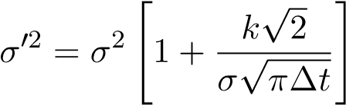 (1)
k designates the round trip transaction cost expressed in percentage of the underlying asset value. σ designates the volatility in the absence of transaction costs; σ⁰ designates the modified volatility. ∆t designates the frequency of re-hedging the option’s replication portfolio.
Boyle and Vorst (1992) find a different rule based on a threshold for the variation of the underlying asset. The replication portfolio is rebalanced every time the relative variation of the underlying asset, since the last re-hedging, is over a given threshold ν. The new volatility σ⁰ is such that:
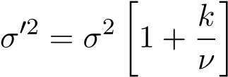 (2)
One can note immediately that the correction does not depend of the option’s time to maturity.
The ∆s rule can made consistant with a ∆t rule by considering the specific following threshold:
√
∆s = σ ∆t
Besides the fact that the ∆t rule is asymptotically incorrect without specific conditions on the transaction costs, authors such as Taleb (2005), find that the ∆s rule is more efficient than the ∆t rule.
Especially, it proves to be more conservative from a risk perspective and allows for better preservation of the market-maker’s capital and its impact on volatility is higher than for the ∆s.
For a given level of volatility, this multiplier is constant. For instance assuming a volatility level of 40 percent per year the multiplier ratio between a daily re-hedging frequency and a 2 percent based re-hedging strategy amounts to 1.56.
The variables to consider are either the frequency of re-hedging(Leland, 1985) or the underlying asset variation threshold(Boyle and Vorst, 1992) triggering the rebalancing of the delta hedging portfolio. Both formulas consider the level of volatility as the other input. Assuming that the FTT generates an additional 0.2 percent roundtrip transaction cost on both sales and purchases of the underlying cash equity, the application of both formulas gives the results displayed in Table 1 below in terms of volatility increase.
This volatility increase is computed under the assumption that the option position sold by the market-maker will be held until the option maturity. As a result, this effect as computed below, is the maximum possible effect of the FTT that a market-maker will transmit to the market by an increase in the volatility of an option sold onto the market.
Table 1 shows the increase in the implied volatility, solely for the replication costs, for a marketmaker selling an option on a cash equity, it will have to carry until maturity. Conversely, a market-maker buying an option on cash equity and carrying the position until maturity, will have to decrease the volatility it will quote, by the same amount, to accommodate for the expected hedging costs.
For index options, where we can assume a 0.02 percent roundtrip transaction cost, the magnitude of the impact will be 10 times lower as both the Leland and Boyle and Vorst formulas retain a volatility impact that is itself proportional to the rate of the roundtrip cost (Table 1).
Table 1: Volatility Increase for a 3 year Short (cash) Call Equity Option Position
Depending Upon the Re-hedging Rules (Initial Volatility: 40 percent; S=K)
Hedging Rule | No Repo Tax | Repo Tax | Index Options
∆s = 0.01 | 7.33 | 13.67 | 0.73
∆s = 0.02 | 3.82 | 7.33 | 0.38
∆s = σ^{p}(∆t) | 4.26 | 8.15 | 0.43
∆t = 1/252; Daily | 2.46 | 4.78 | 0.25
∆t = 1/(2 ∗ 252); Twice a day | 3.44 | 6.62 | 0.34

1.2 Total Costs Including Initial and Settlement Costs When The Volatility is Constant
The original works from Leland, as well as Boyle and Vorst just consider the hedging costs attached to the rebalancing of the hedging portfolio. However, in the context of a FTT transaction, the market-maker will incur additional costs at trade inception. It will incur costs at option settlement, as well. A corrected formula to accommodate for the costs incurred at trade inception was proposed by Leland et al. (2007). However, we need to consider, in addition, all the costs borne by the marketmaker at delivery, in case the position is carried out till option maturity. Furthermore, we have to take into account the dynamic aspects of market-making, especially that only the inventory portion of the flow orders has to bear costs of replication. Also, we have to consider that only a portion of the option book is to be carried upon delivery.
We make the assumption that before selling a new option, the market-maker owns a hedged equity portfolio as well an unhedged equity portfolio. Its market risk is within its trading limits. This allows the market maker to benefit from ”proprietary” directional positions it can take on both volatility and stock price level.
When new trades arrive, the market-maker generally nets together matching orders of opposite interests, and chose either to hedge or non hedge the positions for which it acts as a principal.
We consider the case of a market-maker selling a call option.
- At trade inception, the number δ of shares that the market-maker selling a call option has to buy is: 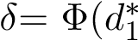), where Φ() designates the cumulative distribution of a standard gaussian random variable.
It will therefore incur a cost of 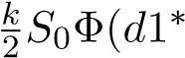) which is stated in Leland et al. (2007), where S₀ is the spot value of the stock.
This cost will be quite different between option on equity futures or forward (k = 0.02 percent) and option on cash stocks (k = 0.2 percent without funding; k = 0.4 percent if we consider the funding) .
It will have to be weighed by the quantity of options which need effectively a replication portfolio to be hedged. In the Flow order addressed by the market-maker, this one can match and net purchase and sales orders from the market. Thus only a portion of the flow quoted by the market is going to need a replication portfolio.
- At trade settlement, in case the call option is in the money, this market-maker will sell the stock before tax at the strike price K and will receive (1 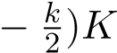 after the FTT. It will buy the stock at a price before tax of S_{T} and (1 +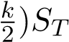 after paying the FTT.
In our business model this settlement cost will only apply to the options for which the broker dealer entered into the market and acted as a principal. The settlement costs will only apply for those trades which represent a fraction IF(t) of the total Flow orders.
- On the stock sale, the additional cost is, according to Black-Scholes framework [ 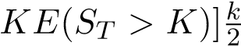which writes:
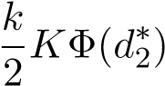
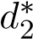 designates the quantity d₂ using the modified volatility σ∗.
- On the stock purchase, the additional cost is:
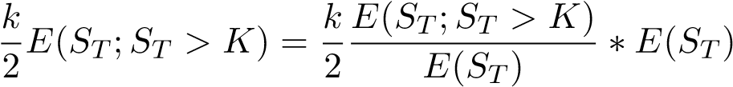
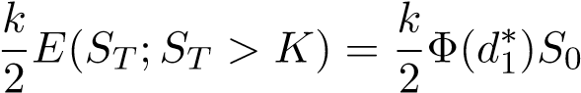
According to the definition of Φ(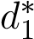), where 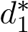 designates the quantity d₁ using the modified volatility σ∗.
As a consequence, to consider the full impact of the FTT on the expected transaction costs incurred by the market-maker selling a call option, and carrying this position till option’s maturity, we have to consider the following additional cost:
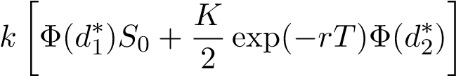
with r the risk free interest rate.
This cost translates into an additional volatility ”bump” that the market maker will apply. The total additional cost to consider for trade inception and settlements costs writes then:
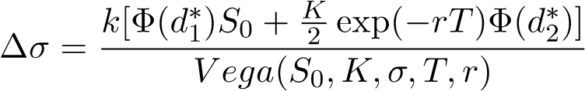 (3)
One can remark that the volatility bump will depend upon both the probability of exercise for the European option (measured by Φ(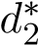 )) and the option maturity. It will be higher for ”In The Money” options and options with a shorter maturity.
By considering the call put-parity relationship, this volatility ”bump” will also apply to the put volatility.
Because those additional costs are applying to the hedging portfolio, which is considered the same way in both Leland and Boyle and Vorst work, this additional cost is the same in both frameworks.
Finally, we obtain the full impact of transaction costs and FTT, by adding the effects from Table 1 and Table 2 for a cash equity option, and Table 1 and Table 3 for a future equity option.
Table 2: Additional Impact of Initial Hedging and Terminal Settlement Costs on Implied Volatility in percentage, Depending Upon Option Strike and Maturity in Fractional Years for a Cash Equity Option;S=100; σ = 0.40
 | Moneyness defined as strike divided by spot
Maturity | 0.8 | 0.9 | 1.0 | 1.1 | 1.2
0.08 | 34.36 | 6.65 | 2.65 | 1.52 | 1.05
0.25 | 5.15 | 2.53 | 1.55 | 1.10 | 0.8
0.5 | 2.46 | 1.56 | 1.12 | 0.86 | 0.70
1 | 1.39 | 1.03 | 0.81 | 0.67 | 0.58
2 | 0.88 | 0.71 | 0.60 | 0.52 | 0.46
3 | 0.70 | 0.59 | 0.51 | 0.45 | 0.41
4 | 0.60 | 0.52 | 0.46 | 0.41 | 0.38
5 | 0.55 | 0.48 | 0.43 | 0.39 | 0.36
Table 3: Additional Impact of Initial Hedging and Terminal Settlement Costs on Implied Volatility in percentage, Depending Upon Options’ Strike and Maturity in Fractional Years for a Future Index Option. S=100; σ = 0.25
 | Moneyness defined as strike divided by spot
Maturity | 0.8 | 0.9 | 1.0 | 1.1 | 1.2
0.08 | 0.35 | 0.67 | 0.26 | 0.15 | 0.10
0.25 | 5.15 | 0.25 | 0.16 | 0.11 | 0.08
0.5 | 0.25 | 0.16 | 1.12 | 0.86 | 0.70
1 | 0.14 | 0.10 | 0.08 | 0.07 | 0.06
2 | 0.09 | 0.07 | 0.06 | 0.05 | 0.05
3 | 0.07 | 0.06 | 0.05 | 0.05 | 0.04
4 | 0.06 | 0.05 | 0.05 | 0.04 | 0.04
5 | 0.05 | 0.05 | 0.04 | 0.04 | 0.04

1.3 The Impact of Transaction Costs on Implied Volatility when The Volatility is itself Not Constant
The original papers from Leland or Boyle and Vorst do consider a constant volatility. They do not consider either put or call spread positions. In the real world, volatility is itself stochastic and market makers have to hedge against it, sometimes using put or call spread positions.
In fact, the only way to hedge against the volatility risk is to take an opposite position on an instrument depending upon the volatility (in short, an option or an other instrument based on options such as a Variance or a volatility swap) of the same underlying instrument.
Because we make the assumption that the option market can be illiquid, we have to consider that, in that case, it might be impossible for the market-maker to hedge against the volatility by entering into an opposite position on an other option.Therefore, the market maker is going to be exposed to the risk of holding an option hedged with a replication portfolio consisting only of cash and shares.
Such situation carries the risk of having a realized stock variance higher than the variance for which it sold the option. This risk, related to what market practitioners call ”Dollar Gamma”, is path dependent and cannot be estimated with a closed formula. Instead, the best practice consists in measuring this hedging risk through a ”Monte-Carlo” simulation of the possible paths followed by the underlying asset.
We need to be able to consider that the variance (and therefore the volatility) is itself non constant. Therefore, we have to consider a model of both volatility and underlying equity. Such models are very well known today.
One possible candidate is the ”Heston Model” which retains a stochastic volatility following a random path correlated with the level of the underlying asset, as follows:
Such model in order to give positive values for the variance has to respect a few constraints, ’apriori’ on its parameters known as the ”Feller” conditions. It can be calibrated in the market, as it is possible to use ”Heston based” closed formulas for the option prices to be compared to market prices. However, such model calibration is very sensitive to the market data. It is not unusual to then calibrate Heston models which do not satisfy the Feller-conditions. This is not very practical in Monte-Carlo simulations, and several methods of correction can be used. For all those reasons, we will explore an other route.
An other approach is to consider a modified Black-Scholes model where the concept of (local) volatility is used. The local volatility is itself a deterministic function of both underlying asset level and residual maturity of the option. It can be calibrated through a Partial Differential Equation (PDE), by using the market prices of options with different strike prices and maturities. It is possible to estimate using the existing market data. Estimations of such models are available through various software vendors, and especially on Bloomberg terminals.
1.3.1 Dollar Gamma, Path Dependency and Monte-Carlo Simulation of the Marketmaker’s Hedging Program When Volatility is not Constant
We consider know a sample of 5 corporate companies. For each stock, we use the existing market data on the corresponding option prices for various strikes, and maturities, as of September 30, 2016. We calibrate a local volatility surface to available market data. Such process is standard and available through Bloomberg terminals.
We then build up a specific dedicated library in Visual Basic and Excel allowing to replicate the Delta neutral hedging program followed by the option market-maker.
This is done through a Monte-Carlo simulation of the path followed by the underlying equity price using the calibrated local volatility surface. We estimate the impact of the FTT by applying for each business day of the simulated path the additional hedging costs due to the FTT, when purchasing or selling shares. We suppose at this stage that the underlying stock path is not affected by the FTT. We compute then the profit and loss of a market-maker selling a european call option and deduct the additional impact of transaction costs due to the implementation of the FTT.
This corresponds to a calculation based on a daily frequency of re-hedging and a ∆t rule. We then derive the corresponding impact to a ∆s rule, by applying a coefficient computed as described above (cf paragraph 1.1). We are assuming that the FTT will apply on a roundtrip basis on repurchase agreements as well as purchase and sales of securities. Both parties will pay their FTT due but will not charge it to their counterpart. This results into an increase in the roundtrip transaction costs which amounts, for our market-maker to 0.4 percent of the notional value of the trade.
Finally, we compute the necessary increase in the volatility level to offset the expected transaction costs by dividing the amount of additional transaction costs by the option vega at trade inception.
Under these assumptions, we find that taking into account a non constant volatility leads to a significant increase of the FTT’s impact on the implied volatility quoted by the option marketmaker. This increase can amount to several additional points of implied volatility as evidenced when comparing Table 4 to Table 5.
Table 4: Volatility Increase for a Short (cash) Equity Option Position 3 years when Volatility Is not Constant)
Company | ATM Level | ∆t Daily/Vol | ∆s/Vol 0.02 | ∆s/Vol 0.01
Michelin | 23.05 | 6.75 | 10.48 | 20.07
Alsthom | 26.12 | 6.09 | 9.454 | 18.12
Arcelor | 39.05 | 6.29 | 9.77 | 18.71
Axa | 28.44 | 5.56 | 8.63 | 16.54
Commerzbank | 38.19 | 5.28 | 8.21 | 15.73
Those values are to be compared to the ones computed under the assumption that the volatility is constant.
Table 5: Volatility Increase for a Short (cash) Equity Option Position 3 years when Volatility Is Constant)
Company | ATM Level | ∆t Daily/Vol | ∆s/Vol 0.02 | ∆s/Vol 0.01
Michelin | 23.05 | 4.6 | 4.22 | 7.875
Alsthom | 26.12 | 4.65 | 4.79 | 8.92
Arcelor | 39.05 | 4.78 | 7.16 | 13.34
Axa | 28.44 | 4.68 | 5.21 | 9.71
Commerzbank | 38.19 | 4.77 | 7.00 | 13.05
1.3.2 Call and Put Spreads. Application to Delta Neutral Hedging Rule
In option market’s real life, market-makers, instead of holding a position till maturity, in case they do not find an offsetting trade, will hedge their option positions with available options, regardless of the strike. Generally speaking, this is the case for ”Out of the Money” (OTM) equity options which are not very liquid, and are hedged with ”At The Money” (ATM) options which are more abundant. Consequently, it is interesting to measure the impact of the FTT in such configurations. As we saw before, the calculation of the FTT full impact has to consider a non constant volatility and is based on Monte-Carlo simulations as it is path-dependent.
Table 6 shows the impact of the FTT in terms of Volatility for an OTM equity option which is statically hedged with an ATM option. The ratio between the number of OTM options and ATM options is such that the overall Call-spread position is Delta neutral at inception(δ=0).
We can see, in the particular case of Michelin, that the FTT’s impact increases with the distance of the OTM option to the Money. Put more simply, the FTT’s impact increases with the difference between the option strike and the spot value. Practically, we can see also that the FTT’s impact is lessened for OTM options whose strike is in a range of up to 200 percent of the spot price.
Table 6: Volatility Increase for a Call Spread Position on an Equity Option Position
3 years depending Upon The Moneyness (Constant Volatility): The Case of Michelin Stock as of 30/09/2016)
Moneyness | Vol Impact
250 | 2.8
200 | 2.6
140 | 2.5
120 | 2.0
Remark: Going forward, we will consider in the next sections, for simplicity sake that the volatility is constant. This will allow us to avoid the additional consideration of volatility randomness in our quantitative estimations.
1.3.3 Impact of the FTT on Expected Realized Variance
We consider now the variance which is the square of the volatility. We focus on the expected realized variance, under the risk neutral mesure induced by the random process followed by the stock. We can extend to the expected realized variance the Leland results which stand for the implied volatility. We consider only the cost of hedging of a Variance swap.
In fact, we have the following proposal, which also proves that the Leland calculation for fixed re-hedging period still holds. Finally, this formulation allows to consider a formulation which is not dependant upon the Dollar-Gamma thanks to the properties of variance swaps.
Proposition Impact of Transaction Costs on Expected Realized Variance
Hypothesis
- We consider a Variance swap whose expected realized variance and strike price is K_{V ar} = σ² under the classic Black-Scholes assumption of zero transaction costs.
- We consider there is a roundtrip transaction cost affecting both purchases and sales of shareswhose rate k is expressed as a percentage of the share value.
Conclusion (i) in order to achieve the same pay-off the strike price of the variance swap has to be adjusted to:
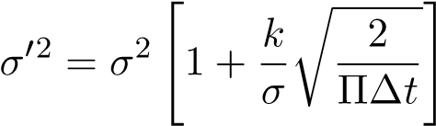 (4)
One can see immediately this is identical to the Leland formula discussed previously.
Proof
We consider a variance swap whose pay-off is:
NV ar(σR2 − KV ar)
where N_{V ar} designates a currency amount. The Variance Swap pays a multiple of the difference between the realized variance (σ_{R}² )and the strike price (K_{V ar}). The maturity of the swap is T. It is expressed usually in business day units.
It is well known(see for instance Allen et al. (2006)) that such Variance Swap can be replicated with a weighted option portfolio. Such replication, is for instance, the basis for the computation of exchange traded variance swaps such as VIX (in the USA) or VSTOXX (in Europe).
We see that the hedging of such portfolio come down to a delta hedging as the Variance swap is insensitive to the Dollar Gamma effect by construction.
We take the same notations as in Allen et al. (2006), p.87. We omit the factor 100 which is just introduced as a unit measure, we see that if the rehedging occurs a t + ∆t, then a quantity of
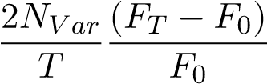
shares has to be bought in the market in order to stay delta-neutral.
We can consider for simplification’s sake, that ∆t = 1 business day. In that case the quantity 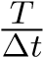 is an integer.
If we consider that this re-hedging process has to be done exactly 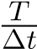, we have then the expectation of costs associated with such readjustment on the life span of the variance swaps, which writes.
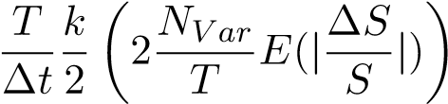 (5)
After simplification, since: we find that those costs equal: 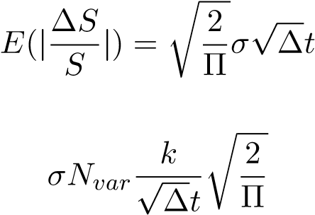
We find that in order to cover the expectation of such costs, the strike price of the Var swap, which is the market price of the underlying stock variance expectation. has to be adjusted. The new Variance strike price is then:
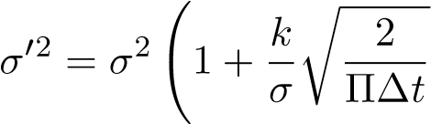!
This proves the proposition.

2 The FTT Impact Depending Upon Market Structure and Liquidity

2.1 Theory
2.1.1 Low Liquidity Equity Option Markets and Risk Neutral Market-Makers
We consider here equity option markets with a low liquidity. Generally, such markets rely heavily upon a ”human” market-maker network. Those markets can be opposed to ”auction exchange based” markets ruled by ”automatic robot trading”, where the liquidity is generally higher. In this latter case, this liquidity is generally due to the presence of ”speculators” or noise traders. We do not make any further assumptions on the possibility of placing ”limit orders” on the underlying equity at the difference of next paragraphs 2.1.2 and 2.1.3.
Let us assume that the FTT generates an additional cost of carrying one unit of inventory until maturity (”frozen inventory”) is x_{t} which can be computed according either to Leland or Boyle and Vorst rules if we assume a constant volatility. This inventory is considered as outside the proprietary positions that the market-maker might have as an informed trader.
The market-maker which carries a short inventory of q_{t} units, will quote aggressively on the buy side, in order to offset the transaction costs attached to this inventory. It quotes a bid price b_{t} and an asking price a_{t}. The mid price (or equivalently the reservation price) is then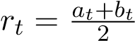. It will bump its bid-reservation price for each unit and will quote b_{t} = r_{t} + q_{t}x_{t} for each unit of its inventory.
Consequently the quotation interval will become [b_{t} + q_{t}x_{t},a_{t}].
In other words, the market-maker will purchase insurance against being short by buying options at a competitive price up to b_{t} + x_{t}. It will give immediately q_{t}x_{t} to the market in exchange for offsetting immediately its inventory and the expected risk attached to it which is also q_{t}x_{t}.
The new mid-price r_{t}⁰ will be:
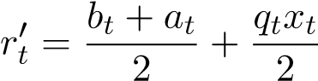
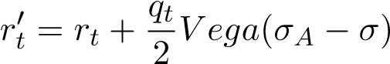
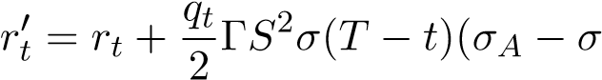) (6)
where Γ and Vega are the corresponding greeks attached to the option. σ_{A} is the modified volatility which offset the additional transaction costs.
We consider an option market where the market-makers are the main sellers against the rest of the market, and carry at all times, a short inventory, (q_{t} > 0). If we further assume that the ”pattern” of [q_{t}, 0 < t < T], the path followed by the inventory is not affected by the FTT, (or at least that q_{t} will not decrease), then because all other quantities in the above equation are positive, there will be an increase in the reservation price. This will correspond to an increase in the volatility mid-price.
As discussed in Appendix A, this will be the case when the market on the demand side consists only of hedgers that we define as economic agents looking for insurance.
Equally important, is the fact that, in case the inventory is frozen or options are kept till maturity, the impact on both bid and ask prices will be the maximum impact computed according to either Boyle and Vorst rule.
As a conclusion, we can consider that in such markets, the introduction of the FTT will tend to increase the mid price of equity options and will lead to an increase in the volatility mid price. This effect will be the highest in option markets where the market-makers are facing hedgers and are the only option sellers.
2.1.2 Highly Liquid Equity Option Markets with Risk Neutral Market-makers: A Rule of Thumb
We consider know a liquid option market where it possible to place limit orders. We consider an agent which faces the flow of incoming orders. It adjusts the intensity λδ of the incoming orders which are executed by adjusting its bid-ask spread which equals 2 δ.
Such agent derives its revenue first from agency business, or acting as a principal without carrying an inventory. On its inventory, then it can also act as an ”informed” trader taking directional positions on the future evolution of underlying equity prices and volatility.
This agent, in fact uses the flow of incoming orders to build up a directional position while minimizing its transaction costs. On its inventory, it will have a risk neutral approach. We will denominate this agent as a risk neutral market maker, even though it acts too as an informed trader.
We designate by δª the distance between the asking price and the reservation price. δ^{b} is the distance between the reservation price and the bid-price. We further assume that:
δª = δ^{b} = δ
We will further explicit in paragraph 2.1.3, the relationship between λ and δ which depends upon the micro-structure characteristics of the market considered.
We assume that the market-maker knows, based on its knowledge of equity option market depth that it will take a reasonable time ∆t to unwind its position by finding an opposite interest in the market.
We can define ∆t as a ”stopping” time such that ∆t = (τ − t₀) with:
τ = inf [t;Z_{t} = x]
where:
Z_{t} designates the number of trades executed with intensity λ(δ) on the time interval [0,t], and x is the size of the order which is quoted by the market maker.
In other words, τ is the first hitting time of x by the Poisson process of executed trades whose intensity parameter is λ(δ). We have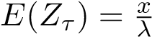.
A good ”rule of thumb” for the market-maker is to compute its total effective cost TC(∆t) as a fraction of the option cost TC(t,T) which corresponds to the case where the option is held till maturity. This is computed by averaging (”amortizing”) the total inventory cost on the time needed to unwind it into the market. This writes:
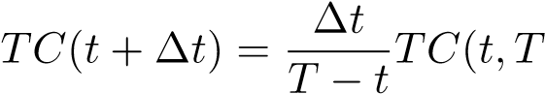) (7)
This results is quite intuitive. However, it can be shown that this assumption has some ground. Proof: Justification of the Rule of Thumb
- We assume the current hypothesis of the Black-Scholes framework about the underlying asset S following a geometric brownian process with a given volatility σ that we will suppose constant for simplicity’s sake.
We consider a ”small” time interval ∆t which corresponds to the time needed to unwind the position in the market. For the calculation’s simplicity sake, we will consider that this time interval is the same as the time interval defining the frequency of re-hedging ∆t⁰. We will then review the general case where ∆t⁰. and ∆t have different values.
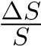 follows a gaussian distribution 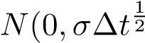). This yields immediately:
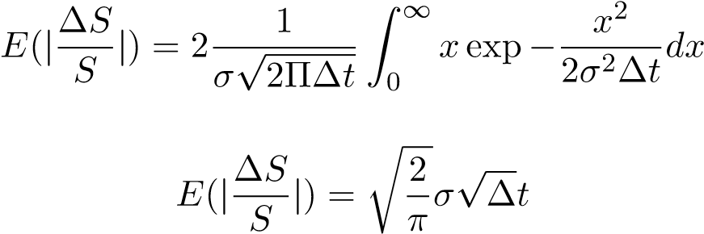
(8)
and
(9)
- We consider know the delta hedging process for call option C on a time interval ∆t.
  - The call option is replicated by a portfolio comprised of shares and cash.
The cash portion writes Q = C − (^{∂C}_{∂s} )S and the shares to be bought are ^{∂C}_{∂s} S
Consequently the replicating portfolio P writes P = Q+(^{∂C}_{∂s} )S and consequently the hedging strategy is self financed.
The computation is quite standard.
Following Leland (1985), we show that the total transaction costs :
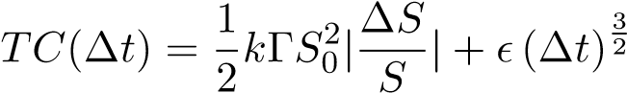 (10)
where designates a usual residual small infinite function andis the order of ∆t to consider.
  - The total increase in the volatility to offset the cascading costs , according to Leland, is such that the new volatility σ⁰ writes:
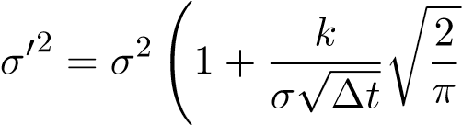!
Focusing on small values of σ⁰ − σ we can write:
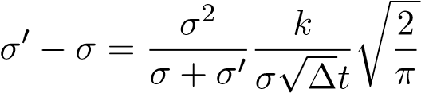
This simplifies into:
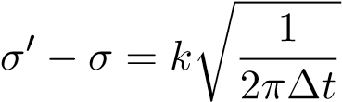
Immediately this yields because TC(t,T) = Vega (σ⁰ − σ ) and Vega=σΓS²(T − t)
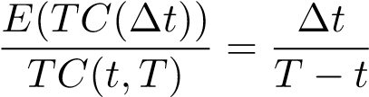
- We consider now that we have a time interval ∆t⁰ for unwinding the option position in the market, whereas the frequency of re-hedging is ∆t. From the discussion above, it comes that
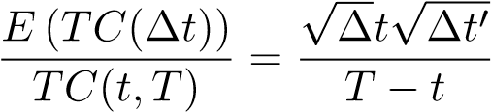
.
Obviously, if ∆t > ∆t⁰ , the market-maker will unwind its position before having to adjust its hedging portfolio. In such case, it will only have to bear the transaction costs linked to
the FTT at trade inception.
√ √ √
Consequently, we can consider that a practical value would be ∆t⁰ = λ ∆t with λ <= 1
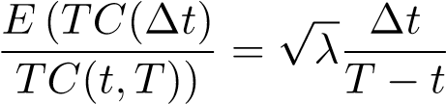
d: Boyle and Vorst framework We consider now the Boyle and Vorst framework. Focusing on small values of σ⁰ − σ we can write:
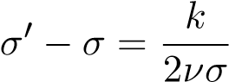
We then use the expression of Vega as a function of Γ to derive the fraction:
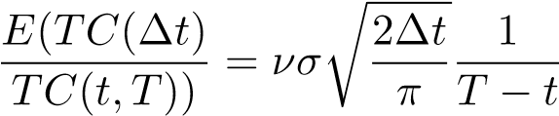
where ν in percents is the threshold triggering the rebalancing of the hedging portfolio.
This can be compared to the time based rebalancing.
This demonstrates the ”Rule of Thumb”.
Remark:
In assessing the ”Rule of Thumb” we have made the explicit assumption that the error made by considering that the quantity ΓS² (known as ”Dollar Gamma”), on the time interval ∆t was acceptable.
This assumption is valid for liquid ”option markets” where this time interval is of the same magnitude as the time commanding the frequency of re-hedging (even inferior for highly liquid markets).
2.1.3 The Hamilton Jacobi Bellman Framework for Risk Adverse Market-Makers in Highly Liquid Markets
We consider again the maximization of a risk adverse market-maker trading a given security whose utility function is defined as follows:
U(w,s,q,t) = E_{t}[−exp(−γ(x + qS_{T} ))]
where x designates the original capital of the market-maker.
and γ is the market-maker’s risk aversion coefficient (γ tending toward zero meaning the marketmaker tends to be ”risk neutral”). We note q the number of units in the market-maker’s inventory, and T is the time horizon on which the market-maker considers its maximization program.
We consider additional assumptions and definitions.
Assumptions
- The liquidity of the market is sufficient enough to allow the ocurence of ”limit” orders. Thatmeans it is possible, for the market-maker to set up buy or sell orders at a predetermined price called ”the limit”. The liquidity in the market is such that the market will not move beyond the limit price without having the trade executed.
- dS_{t} = σ W_{t} where W_{t} is a standard Wiener process and σ is the constant volatility. Consequently this is not a standard log-normal volatility.
- Trading intensity is defined as the Poisson process intensity λ(δ) at which a ”limit” order will be executed as a function of its distance δ to the mid-price quoted by the market-maker.
The frequency of market-orders is considered constant. In this model and in ”real life”, the closer the ’limit’ order is to the mid-price, the better is the chance to have this order executed.
- The distribution of the size of market-orders obeys a power law such that:
dPQ(x) = K1x−(1+α)
where K₁ is a constant.
∆p = K₂ ln(Q)
where ∆p is the absolute price change following a market order of size Q.
The market-maker’s behavior in such markets can be described by the Hamilton Jacobi Bellman equation (HJB) (see Ho and Stoll (1980)).
The HJB equation tries to maximize the utility function by finding the optimal values δª and δ^{b} which designate the respective distances of the asking and bid prices to the reservation price.
Those values are commanding directly:
- The execution intensity process λ₍δª) at which the sell orders are executed.
- The execution intensity process λ₍δ^{b}) at which the buy orders are executed.
Those values of λ are linked to the micro-structure parameters:
λ(δ) = ΛP(∆p > δ)
= ΛP(ln(Q) > Kδ)
= ΛP(Q > exp(Kδ))
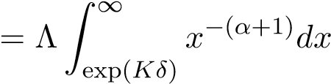
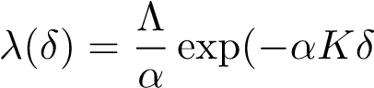) (11)
According to Ho and Stoll, for instance, this leads to the resolution of the following Hamilton-Jacobi Bellman equation (using for simplicity sake, from now on, the notations of Avellaneda and Stoikov (2008))
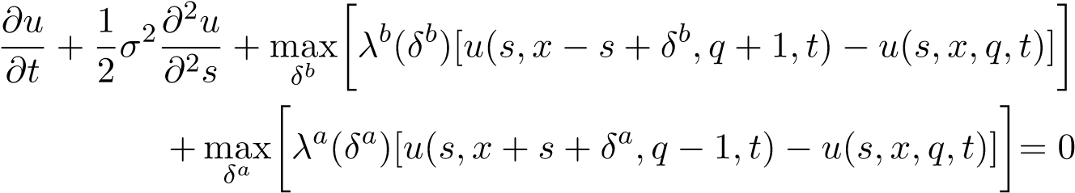 (12)
u(s,x,q,T) = −exp(−γ(x + qs))
Resolution
The HJB equation is usually simplified by using an ansatz θ(s,q,t) such that:
u(s,x,q,t) = −exp(−γx)exp(−γθ(s,q,t))
This leads to a PDE in θ as follows:
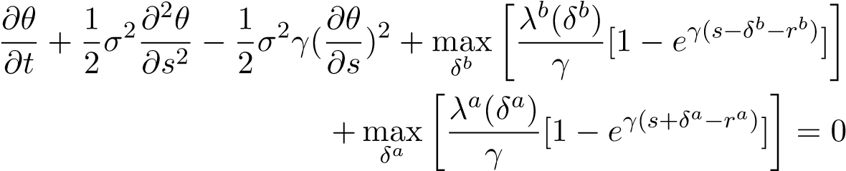 (13)
θ(s,q,T) = qs
The solutions for rª and r^{b} are directly linked to θ: Reservation prices are explained by the level of inventory q ( The convention being q < 0 if the market-maker is short).
r^{b}(s,q,t) = θ(s,q + 1,t) − θ(s,q,t) | (14)
rª(s,q,t) = θ(s,q,t) − θ(s,q − 1,t) | (15)
Those reservation prices give then a reservation price which is the average of the two.
Once the bid-ask reservation prices are determined, the first order condition provides the following relationships for the optimal distances δª and δ^{b} as follows:
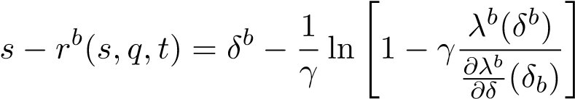 (16)
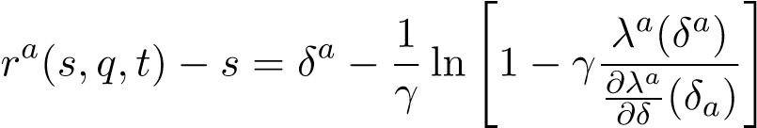 (17)
Equations (8) and (9) are quite important as they can be used to assess the possible reaction to the FTT. First, one can notice that despite the framework is set-up for risk adverse market-makers, this framework can be applied by considering that risk neutral market makers are representing the ”limit” case, when γ tends toward zero.
Considering small values of γ and using well known properties of the logarithm function, we get the following equations for risk neutral market-makers.
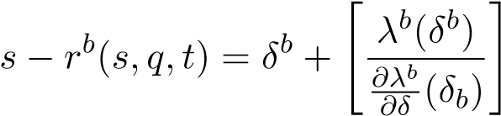 (18)
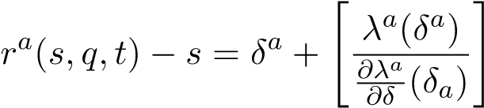 (19)
2.1.4 The Asymptotic Approximation of the Hamilton Jacobi Bellman for Highly Liquid Option Markets
Let’s consider now, highly liquid markets which are generally based on ”auction exchange ” based and animated by automated ”robot” trading, especially ”high frequency” trading. Such markets are opposed to the broker based markets discussed above which are ”human based”. They are characterized by a very high liquidity. This allows the presence of high frequency traders as well as the possibility of placing ”limit” orders in the market. Those markets can be of any kind, for instance we will consider equity markets or equity option markets.
In such markets, the intensity of arrivals can be considered as symmetric. This means that if we assume that δ is the distance of the quote to the reservation mid-price, we have:
λª(δ) = λ^{b}(δ) (20)
Especially, if δ = 0 we see that 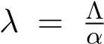 and that all trades are executed at the mid-price S. According to the results established by Avellaneda and Stoikov (2008), it is possible to have a simple asymptotic expression of the prices quoted by the market-maker. The solution of the marketmaker’s optimisation program at time t for the horizon T, is as follows, in terms of bid-ask spread and reservation (mid) price.
Reservation price is given by:
r(s,t) = s − qγσ² (T − t)  Bid-ask spread at time t is: | (21)
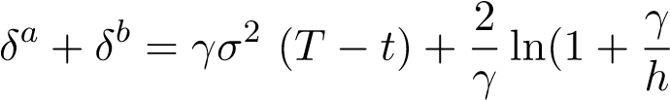) (22)
whith h = Kα and σ²(T − t) is the cost incurred by the market-maker, if it carries the position until maturity. Clearly this is an opportunity cost, as the market-maker is exposed to the market risk without having the opportunity to unwind its position.
Finally 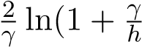) measures the price impact of the market-maker’s quote on the market.
It can be seen then immediately that the corresponding impact for a risk neutral market-maker is
2
h by considering that γ tends toward zero.

2.2 Upper Bound for the Market’s-Maker Risk Aversion Coefficient in a Competitive Highly Liquid Option Market
Through these two equations we can assess the impact of the introduction of the FTT on the prices quoted by market-makers in order to derive any possible effect on the implied volatility.
Applying the HJB framework directly to the option prices would prove difficult as we will have to deal with the volatility of the call or the put considered as an asset.
However, we can turn around this difficulty by considering the synthetic stock which is a combination of a call and a put with the same strike and maturity. It is well known that this synthetic security is itself a single stock future on the underlying equity whose maturity is the option’s maturity. We consider that the volatility of the synthetic stock can be approximated by the volatility of the cash stock (cf Appendix B).
This framework would be suitable for highly liquid option markets, such there exists already significant volumes on the synthetic security, and consequently on the corresponding options. The option markets for Apple or Microsoft, appears as good candidate. Such stocks enjoy the privilege of having dedicated exchange traded variance swap markets which cannot be possible without a highly liquid market.
Assumption: We can try to calibrate the ”HJB” equation, using the ”boundary condition” that the HJB solution must respect in case the (’frozen”) inventory is held until maturity. In that case, we can compare the results to the Leland or Boyle and Vorst calculations. The idea behind this comparison is that in such markets, risk adverse market-makers will have to compete with risk neutral players, such as other types of ”flash traders” as well as ”informed traders”. Those last ones are generally taking directional positions on the expected direction of the market, for the stock. Practically, to stay in business, risk adverse market-makers will face the general constraint that the increase in their bid-ask spread following the introduction of the FTT, is not more than the one quoted by risk neutral market-makers. Thus, despite the fact that the asymptotic approximation of HJB for a Risk-adverse market maker supposes a monopolistic competition with one representative market-maker, we will admit that there could be other ”market-making agents” following a risk neutral strategy and competing for business with the risk adverse market-makers.
As explained above, we consider the synthetic stock which is a combination of a call and a put with the same strike and maturity. It is well know that this synthetic security has the same pay-off as a single stock future on the underlying equity whose maturity is the option’s maturity. Recall that we proxy the volatility of the synthetic stock by the volatility of the cash stock.
From the bid-ask spread formulation we get: δª + δ^{b} = γσ² (T − t)
If σ_{A}^{N} is the normal volatility of the underlying asset after transaction costs, we proxy the corresponding log-normal volatility by:
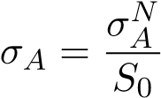
(T − t) designates the time horizon on which the market-maker maximizes its expected utility.
We designate by ∆ the quantity δª + δ^{b}.
We use the following notation for Vega. V ega(S₀,K,σ,T,t) = ϑ((S₀,K,σ,T,t)
The competitiveness constraint imposes that the bid-ask spread for risk adverse market-makers will not increase more than the bid-ask spread of risk neutral market makers. Moreover, we know that according to HJB, the increase in the synthetic stock spread writes:
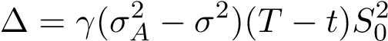 (23)
On the other hand, Boyle and Vorst or Leland analysis retain a ”volatility bump” for the call and the put so a consequent bump on the synthetic security bid-ask spread which writes:
∆ = 2ϑ(S₀,K,σ T,t)(σ_{A} − σ) (24)
we know from Black-Scholes framework that
) (25)
Because of the competitive condition, both risk neutral and risk adverse market-makers must quote the same bid-ask interval on the synthetic stock. We further assume that they consider the same market impact. Consequently, we have the following relationship.
(26)
Where k designates the effective tax rate, which is 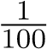 for cash instruments and 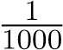 for derivatives such as Single Stock Futures.
If we further assume that the natural ”time horizon” in such markets is the day ∆_{t} = (T − t) and also that the re-hedging frequency is daily. Equation above simplifies into:
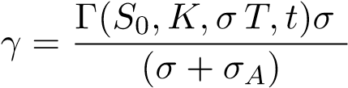 (27)
According to equation 2 (Boyle and Vorst), we have:
σ_{A} = (1 + µ)σ (28)
with
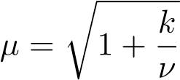
where ν designate the threshold for applying the ν based ∆_{s} ν rule of hedging. so, we find finally:
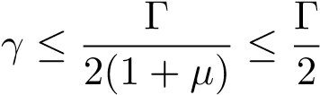
Interpretation
Therefore, we find a very interesting proposition regarding the maximization of the risk adverse option market-maker’s utility function.
Proposition 1: Consider that:
- A Risk adverse option market-maker operating on an option market accepting limit orders.
- Quoting on specific strikes and maturities, as well as on the synthetic stock for a given underlyingasset,
- Subject to competition with risk neutral market makers, and quoting the same bid-ask spread.
(iii) This market-maker maximizes the following utility function v(x,s,q,t) = E_{t}[−exp(−γ(x + qT))],where γ designates its risk aversion coefficient.
- The asymptotic estimation of HJB from Avellaneda and Stoikov (2008) is valid in the optionmarket considered.
Then the risk aversion γ coefficient to consider in the market-maker’s utility function, depends upon the option traded, and has an upper bound which is :
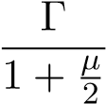
where Γ designates the Greek ”Gamma” of the corresponding option computed according to the Black-Scholes formula and µ is defined according to equation (28).
Corollary: Consider additionally that:
- The risk adverse market-maker is subject to the constraint of having the same market-impactreaction than the risk neutral players
Then the risk aversion γ coefficient to consider in the market-maker’s utility function is:
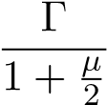
where Γ designates the Greek ”Gamma” of the corresponding option computed according to BlackScholes formula and µ is defined according to equation (28).
The proof is immediate considering equation above.
Remark:
We could consider now a ”theoretical” risk adverse market-maker trading a composite book built with synthetic securities, cash equity options, single stock futures, and other delta one products. This market-maker will trade mainly the synthetic or the future aiming to minimize its inventory and maximizing its profit. This will ensure the same for the equity option portion of its business.
This market-maker will have an adaptive risk aversion coefficient equal to the Γ of ”the option”. This option, chosen within the most liquid (”At the Money”) will have to get the same maturity as the future or the synthetic. Its horizon will be reduced to ∆_{t}.
Under these conditions, it results from the two propositions above, that in terms of impact of transaction costs, the ”Rule of Thumb” will yield the same results than an asymptotic approximation of the HJB equation for such trader, where the horizon considered will consist of ∆_{t}. This new horizon ∆_{t} will be chosen as a time which on one hand allows to unwind the inventory, and on the other hand registers a sufficient high volumes of trades, such that the HJB asymptotic approximation can be considered. On highly liquid markets such the ones we considered (AAPL, MSFT), starting with ∆_{t} as 1 trading day seems for us a reasonable assumption.
Furthermore, on highly liquid markets we will consider that the equity options on single stocks can be hedged with Single Stock Futures or other delta one products subject to a lower FTT rate. It is possible to show that market-makers will face the same order flow than before the introduction of the FTT, if we consider the combined market consisting of the reunion of cash and delta one products.
Proposition:
- We consider a highly liquid cash equity markets whose associated Option market is highly liquid;
- The market share of the market-maker on the combined market consisting of both cash andderivatives is not affected by the implementation of the FTT.
then
- There is a large substitution occurring between Cash and Delta One transactions
- The Volumes Traded on the combined market consisting of cash and Delta one products andaddressed by the market-makers will stay the same.
Proof:
-We consider that there exists an initial allocation of transactions between the two types of agents and the two types of products such that the equilibrium on both cash and delta one products can be summarized as follows, in terms of quantities held:
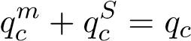 (29)
qDm + qDS = qD (30)
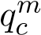 and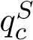designate respectively the initial allocation of cash quantities held by the market-makers
and the other agents. q_{c} is the initial volume of cash securities.
Equations (32) and (33) hold for both quantities held and market flows.
There is a fixed quantity of cash stocks. The quantity of delta one instruments is at least equivalent to the quantity of cash stocks, as some unhedged traders such as the speculators can write delta-one without backing them by cash products. The market is such that we have symmetric arrival rates.
We write then the equilibrium on the two respective markets consisting of cash and futures. The respective prices of cash and delta one products are derived by arbitrage.
- We consider that following the introduction of the FTT and because of the distortion of tax rates between cash and derivatives products, a quantity ∆^{S}_{D} of cash transactions is now done on delta-one trades, by the non market-maker agents.
Pursuant to our hypothesis, market-makers have a constant market-share ν of both cash and derivatives products. Market-makers see a decrease ν∆^{S}_{D} in the quantities they held on cash, but conversely they see an increase ν∆^{S}_{D} of the delta one trades they serve. Because they have no trading limits they must ”back-to-back” those trades with cash stocks.
The new aggregated quantities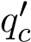 and q_{D}⁰ become:
(31)
qD0 = ν∆SD + (1 − ν)∆SD + qDS  Consequently, we can see that | (32)
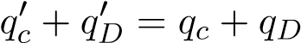 (33)
Consequently, the extended quantity of stocks consisting of the sum of cash plus delta one products is unchanged. We write them the equilibrium on the two respective markets consisting of cash and futures. The respective prices of cash and delta one products are derived by arbitrage.

2.3 Quotation Asymmetry and Consequences on the Mid-Price
It is well known that the possibility of placing limit orders, for an equity option market-maker, allows to mitigate a significant part of the transaction costs (usually the bid ask spreads of other market-makers). This is due to the relative asymmetry of option buyers and option sellers. Option sellers are negatively exposed to the variation of the underlying asset because of the term Γ∆S².
Under the hypothesis that σ is fixed and because Γ is always negative for option sellers, any variation of the underlying asset positive or negative, will be adverse to them. By the same token, option buyers will benefit from any variation of the underlying asset as they are ”Γ positive” or ”Long Γ” (The fact that the volatility is considered constant is key, here as results are not the same at all when this is not the case”).
Because of this particularity, according to Taleb (2005), when market-makers consider the delta hedging of their replication portfolio, they will use rather a ∆_{S} based rule than a ∆_{t} one, and they will place limit orders, when buying the underlying stock, to avoid part of the ask spread of their counterparts. In the case of the FTT, the market-maker which is ”Long Γ’ will place a limit order on the underlying equity inclusive of this tax. For instance, it will place a buy order at 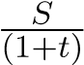 and a sell order at 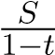. Because, of the specific nature of the limit order, the market will not move beyond those values without having the order executed.
In this condition and according to the market practice, in the presence of additional transaction costs whose expectation over the life time of the option is x, risk neutral market-makers will quote a bid-ask interval of [b-,a+x].
The new mid- price will then be:
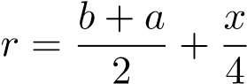
New bid-ask quotation spread will become:
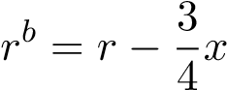
and
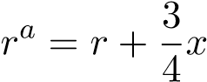

3 Application to the Quantitative Estimation of the FTT Impact on Implied Volatility in in Highly Liquid Markets

3.1 General Considerations on The Cash Equity and Futures Option Markets
As seen before, the market size impact term for the synthetic stock (and consequently , for both the ATM call and put) can be justified either by considering it is equivalent to the limit of the corresponding adverse term γ tends toward zero or by considering the direct impact of one additional trade whose size is α on the market, using equation (23).
We are also making the assumption that the trade size is not affected by the introduction of the FTT. Volumes traded on option marketsshould increase significantly, because of the substitution of Delta One (including synthetic stocks) to cash products. If we consider then that volumes on the option markets, are not going to be affected negatively, it implies the same for the intensity of trade arrivals, that the market’s maker is facing. Finally, we consider for the reasons explained above that the market impact will at least stay constant or decrease.
3.1.1 Equity Options and Tick Size
We consider now the case of equity option on futures . Those markets were, historically, options on index futures contracts. Those option contracts are generally specified with a direct reference to the level of the underlying future index expressed in points and a multiplier expressed in monetary units. The recent creation and expansion of Single Stock Futures in Europe Most of the index future contract specifications have been set up, a while ago, for index values around 1,000. Futures index options contract specifications have retained this level, too in such a way, that the ”theoretical” tick for option contracts, corresponds to 0.01 percent or 1 basis point (pip) of the notional value of the underlying future contract . However, because of the general drift of equity indices that occurred worldwide, since the inception of those contracts, this 1 basis point might be different, nowadays from the theoretical tick for option contracts which is still in the option contract specification.
One can see after reviewing the various contract specifications that 1 basis point of the index future contract value represents, nowadays, a multiple of the ”theoretical” or ”notional” option contract tick size. For instance, it is easy to figure that this multiplier is equal to the quotient between the current level of the index and 1,000.
This leads to multiplier values of approximately 5.5 for the NASDAQ 100 Option and the CAC 40 index option contracts. At the same time, the multiplier values amount to 2.5 for the DAX option exchange, whereas SP500 CME and SP500 CME Nasdaq evidence a 2.0 multiplier while, finally, the E-Mini SP500 contract retains a multiplier of 0.8.
Those various values are reflecting, the the ”effective” tick size in use on those exchange markets is a multiple of the original tick size which was set up at the inception of those contracts.
Consequently, in order to be able to formulate an opinion independent upon the current level of the Index markets considered, we propose to use a rule for the determination of the tick size, which is derived from the valuation rules prevailing in the equity OTC derivatives markets. This rule consist in quoting equity derivatives as a fraction of the notional amount of the underlying contract , expressed in basis points. Thus, the minimal and ”normalized” tick size to consider for index option contracts is, at least, 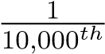 or 1 basis point (1 b.p) of the notional underlying contract.
3.1.2 Market-impact
We then consider the possible ”market impact” of the market-maker’s quotation on the bid-ask price. This term can be estimated for a risk neutral market-maker as equal to _{h}¹ by taking half the limit when γ tends toward zero in the asymptotic solution of the HJB equation described by equation (21).
Whatever is the quantitative estimation of this market effect, we will make the assumption that this term is going to decrease following the introduction of the FTT. Such move will be explained by an expected sharp increase in the volume of option transactions. This expected increase is due to the difference in taxation between cash equity products and derivatives which amounts to nearly 0.40 percent when both counterparts of an option trade are financial institutions. For a daily trade, this difference on a yearly basis amounts to 10 percent of the daily average notional value of the trades.
This very sharp difference, would justify, from all economic agents not interested in the physical detention of the cash stock, a massive switch from cash equity to delta one products, such as Single Stock Futures, CFDs and including as well synthetic stocks built up with call and put options. The Single Stock Futures as well as the CFDs market should expand very significantly.
This ”gravitational pull” or ”liquidity begets liquidity” effect should lead all economic agents not interested in the physical detention of the cash equity share to cluster as ”delta one” users. This situation would constitute an equilibrium as none of such agents would do the reverse move by going back to use cash equity products.
In conclusion, for those reasons we consider that in such highly liquid delta one markets, the market impact will stay at least constant and most likely will decrease. Consequently, the moves on the quoted market-spread will be explained by the two other factors discussed above.

3.2 Assumptions Made on the Highly Liquid Equity Option Markets
Assumptions:
In order to demonstrate some numerical results, we consider two hypothetical option markets respectively on futures and on cash equity options, which satisfy the following conditions:
a-The market-depth is such that the positions are unwound by the market in a reasonable time such that it can apply the ”Rule of Thumb” determination to assess its costs,
b- Market-maker is subject to a market risk limit expressed as an upper bound on MPL, its maximum daily potential loss.
This limit is set-up under predetermined assumptions on the possible move (∆S, ∆σ) of both underlying level and volatility. Those predetermined values are depending upon current market conditions. They are updated frequently.
Moreover, there are limits as well as on the greeks of its option market-making book (including hedges)such that:
with | MPL(S,∆S,σ,Γ,) <= L | (34)
(35)
and
Γ ≤ Γ₀ (36) ϑ ≤ ϑ₀ (37) δ ≤ δ₀ (38) θ ≤ θ₀ (39)
In this context, the market-maker considers other sources of income than facilitation revenues. It acts also as an ”informed trader”, as the limits above are in fact ”trading ” limits allowing it to take directional positions on both stock and volatility price level. For this reason, somehow, the two activities of market-maker and informed trader are commingled.
Consequently, the market-maker when facing the market flow has several activities, that it will exercise in the following ascending order:
- Acting as an agent matching orders from the client base with the market without acting as a principal
- Acting as a principal, netting orders from the client base with the market without taking any outright position
- Acting as a principal and taking outright positions bearing market risk within the trading limit
- Acting as a principal and hedging positions in excess of the trading limit with a replication portfolio and support the corresponding transaction costs
c- Consequently, there is only a proportion λ of the quoted options on the flow markets which will need a hedging replication portfolio at inception. The hedging will occur automatically when the MPL limit is reached, or it will happen when the market-maker decides to lower its exposure. Intuitively, the larger the MPL limit is the smaller the proportion options needing replication will be. A conservative assumption is to consider that, in such highly liquid markets, up to 20 percent of the option quoted for a given maturity and strike require a replication and hedging portfolio. Furthermore, if the option is replicated with futures whose maturity is beyond the option maturity, once the option is unwound in the market, there is no need to build an other replication portfolio. The existing portfolio can be used immediately at no additional transaction costs.

3.3 Quantitative Estimation of the FTT Impact on the Option Mid-price and the Bid-Ask Spread
3.3.1 Impact on Option Mid Price and Volatility
We now consider the Rule of Thumb. We know that the expected transaction costs TC(t,T,σ) are a fraction of the complete hedging costs.
Consequently they will write:
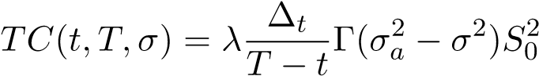
We have to consider in addition the total costs including inception costs.
Applying this to our particular case we find that the total costs x = x(t,T,σ) write:
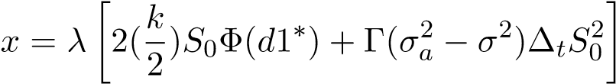 (40)
Indeed, the hedging costs will not only have an impact on the bid-ask spread but they will also have a lessened impact on the option mid-price and therefore the volatility. As we have seen that the increase in the reservation price is and the total bid-ask spread is 2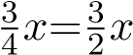it is easy to figure that in order to get the impact on the mid- price, we have to consider a fractionof the impact on the bid-ask spread.
3.3.2 Impact on Option Price and Volatility for Equity Options Hedged with Futures or Cash
We can then compute the impact on the option mid-price for both cash equity and (futures) Index options. We will make a distinction between those two categories.
a- Options Hedged with Futures We consider Option markets where the hedge consists either of cash stocks or Single Stock Futures or even Index Futures. The cash equity market associated is considered as highly liquid and the bid-ask spread is 2 b.p which is the magnitude of the roundtrip FTT rate on derivatives.
Option market-makers can either hedge with cash stocks or futures. The arbitrage condition between cash and futures holds. Following the FTT implementation, market-makers hedging with cash will switch to futures whose roundtrip transaction cost is more favorable.
We assume that because of the substitution between futures and cash products triggering an improved liquidity, the bid-ask spread on derivatives before the addition of the tax at 0.01 percent, will not increase. Provided that before the introduction of the tax, the derivatives and the cash prices were consistent with the arbitrage described in appendix B, the liquidity effect, should lower in fact the bid-ask spread on such products. We assume that it will not decrease.
Taking into account a one-day horizon for the maximization program of the market-maker’s utility function , we can see that for an option hedged with futures, the impact of the FTT roundtrip rate on the mid-price is going to be well within one basis point, which is ”within” one tick size.
This comes from the direct calculation of the quantity x in equation (38) above:
with parameters: S₀ = 100;σ = 0.25; ∆_{t} = 1 day; (T − t) = 1 day; Γ = 0,422162606; r=d=0.02 which yields a variation of the quantity in equation above equals to 0.6 b.p for the bid-ask spread and 0.1 b.p for the mid-price variation.
Table 7 below details the mid-price variation depending upon the maturity of the option when the time horizon of the market-maker is one day. The impact is maximal for the short dated options. It is close to nil for the other option maturities. One tick on the option price gives a nearly insignificant effect on the implied volatility. Using Black and Scholes formula, and using the parameters ( interest rate; dividends; strike and stock price) of the Table 7 below, 1 tick of option price gives an impact of 0,003-0,004 percent on the level of volatility, for ATM options whose maturities are between 1 day and 3 years. Because implied volatility is usually quoted with 2 decimals, we can consider that the impact on the volatility is close to nil. b-Options hedged with cash equity.
We consider here option market-makers which still use cash equity options even after the FTT implementation.
Table 8 below gives the same calculation for cash equity options hedged with cash equity.
Table 7: FTT Impact on the Option Mid-Price in b.p of the Notional Contract For ”At The Money” Futures Index, Equity Futures or Cash Equity Options (S = K) Hedged by Futures Contracts for various Option Tenors (in days) and a 1 Day Horizon Time for the market-maker σ=0.25)
Maturity | Gamma | Call price | Impact
5 | 0.08 | 1.9664 | 0.0
21 | 0.039 | 4.0274 | 0.0
63 | 0.0227 | 6.9639 | 0.0
126 | 0.0160 | 9.8236 | 0.0
252 | 0.0113 | 13.823 | 0.0
378 | 0.009 | 16.844 | 0.0
504 | 0.0079 | 19.352 | 0.0
756 | 0.0063 | 23.465 | 0.0
Table 8: FTT Impact on the Option Mid- Price in b.p of the Notional Contract For ”At The Money” Cash Equity Options Hedged with Cash Equity O(S = K) for various Tenors (in days) and Horizon Times (market depth-in fractional days and days; σ=0.35)
 |  |  | Market Maker Horizon in days
Maturity | Gamma | Call price | 1 | 0.75
1 | 0.1809 | 0.8785 | 1.1 | 0.8
5 | 0.08 | 1.9664 | 0.4 | 0.4
21 | 0.039 | 4.0274 | 0.2 | 0.1
63 | 0.0227 | 6.9639 | 0.1 | 0.0
126 | 0.0160 | 9.8236 | 0.1 | 0.0
252 | 0.0113 | 13.823 | 0.1 | 0.0
378 | 0.009 | 16.844 | 0.0 | 0.0
504 | 0.0079 | 19.352 | 0.0 | 0.0
756 | 0.0063 | 23.465 | 0.0 | 0.0
3.3.3 Impact of FTT Related Increase of Hedging Costs on the Derivatives Bid-Ask Spread
Table 9 evidences the impact of the FTT additional costs on the bid-ask spread in b.p of the notional amount under the assumptions stated above for such highly liquid market. The costs are computed according to a rule of thumb for various ∆_{t} times.
As we consider that an horizon ∆_{t} of 1 day, is realistic, we focus on the last column. We can see that the total costs are representing 0.1 bp of the notional value of the contract for ATM options. Taking a deep dive into the calculation, we see that the transaction costs borne at both the inception and the liquidation of the portfolio, amounts for 0.05 b.p.
This suggests additional reduction for institutions harboring option market-making desks coexisting with futures market-making desks. As the internal transactions between desks occur within the same legal entity, they are not subject to the FTT. Consequently, those costs at inception and liquidation could be further reduced to 0.025 bp for ATM options.
Table 9: FTT Impact on the Option Bid-Ask Spread in b.p of the Notional Contract For ”At The Money” Futures Index, Equity Futures or Cash Equity Options (S = K) Hedged by Futures Contracts for various Option Tenors (in days) and a 1 Day Horizon Time for the market-maker σ=0.35)
Maturity | Gamma | Call price | Impact
5 | 0.08 | 1.9664 | 0.6
21 | 0.039 | 4.0274 | 0.2
63 | 0.0227 | 6.9639 | 0.0
126 | 0.0160 | 9.8236 | 0.0
252 | 0.0113 | 13.823 | 0.0
378 | 0.009 | 16.844 | 0.0
504 | 0.0079 | 19.352 | 0.0
756 | 0.0063 | 23.465 | 0.0
For this same reason of initial and unsettling replication costs, we can see in Table 10, that equity option markets where hedging occurs with cash equity only will record a more significant increase of the transaction cost. Assuming that 20 percent of the quoted options have to be replicated, we see that from ATM options, the spread impact is already 2 bp of the notional value and 1.5 bp for OTM call options whose δ is below 0.25. However, for the reasons explained above, the impact on the reservation price is a fraction of those costs and is in fact still below 1 b.p. The impact is going to grow when the time ∆_{t} which measures the liquidity is increasing.
Consequently, it suggests that even for equity option markets which are already liquid, the impact of the FTT will be more significant than for future options or cash option hedged with futures, and that this impact will be inversely related to the liquidity of that market.
Table 10: Impact on the Bid-Ask Spread of the Hedging Costs generated by the FTT in b.p of the Notional Contract For ”At The Money” Cash Equity Options Hedged with Cash Equity O(S = K) for various Tenors (in days) and HorizonTimes (market depth-in fractional days and days; σ=0.35)
 |  |  | Market Maker Horizon in days
Maturity | Gamma | Call price | 1 | 0.75 | 0.25 | 0.16 | 0.08
1 | 0.1809 | 0.8795 | 6.3 | 4.7 | 1.6 | 1.0 | 0.5
5 | 0.08 | 1.9664 | 2.5 | 1.9 | 0.6 | 0.4 | 0.2
21 | 0.039 | 4.0274 | 1.1 | 0.9 | 0.3 | 0.2 | 0.1
63 | 0.0227 | 6.9639 | 0.7 | 0.5 | 0.2 | 0.1 | 0.0
126 | 0.0160 | 9.8236 | 0.5 | 0.4 | 0.1 | 0.1 | 0.0
252 | 0.0113 | 13.823 | 0.3 | 0.2 | 0.0 | 0.0 | 0.0
378 | 0.009 | 16.844 | 0.3 | 0.2 | 0.0 | 0.0 | 0.0
504 | 0.0079 | 19.352 | 0.3 | 0.2 | 0.1 | 0.0 | 0.0
756 | 0.0063 | 23.465 | 0.2 | 0.1 | 1.0 | 0.0 | 0.0
3.3.4 The Additional Impact of the FTT Tax at 0.01 percent on the Bid-Ask Spread for Derivatives Products
We consider the impact of the FTT tax at 0.01 percent of the notional value of derivative contracts on the bid-ask spread quoted by the cash equity option market-makers. This tax will not affect the mid reservation price and then the volatility in a highly liquid cash or futures option equity market
There ares several reasons, why this tax should not affect practically the bid-ask spreads quoted by the market-makers in highly liquid cash equity option markets. We think that while its initial ex-ante impact on the bid-ask spread is 2 b.p of the notional value of the contract, its final impact will be lessened for the following reasons:
- Under the monopolistic business model prevailing for market makers, an excise tax is partiallypassed through to the market to consumers, usually 50 percent (See as for example, Chamberlin (1949)). In our case, this means that only 1 b.p would be passed trough to the market.
- The increase in volumes traded on options, and the ”liquidity begets liquidity” effect optiondiscussed in paragraph 3, should increase the liquidity and the market depth and allow for in fact a reduction of the bid-ask spread for Delta one products and consequently synthetic stocks.
For instance, let’s consider a 5 days synthetic option based on two equity futures options based upon a position consisting of a long Call and short Put position. We assume that the horizon of the market-maker is 0.25 days. According to Table 7, the increase in the bid-ask spread due to hedging costs amounts to 1.4 b.p whereas the impact of the FTT is 2 b.p leading to a total impact of 3.4 b.p o the bid-ask spread.
This additional bid-ask spread (S₀ = K = 100 ; σ = 0.35; Γ = 0,080863587 will be offset by a reduction of approximately 0.9 days of the average time to unwind the position in the market. This is equivalent to an increase of roughly one third of the volumes.
Proof: we can try to compute what is the implicit value of ∆_{t} in fractional days.
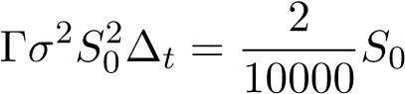
implies that
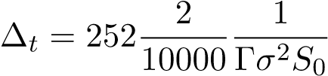
∆_{t} = 0,00012634 =0,03183671 Day.
Consequently, a reduction of 2 b.p would require that the time to unwind is reduced by approximately 0.03 days. This reduction can be realized by an increase in traded volumes for the one day option as it can be seen through the following consideration:
For a quote size of x, if we consider that a good ”estimation” of ∆_{t} could be:
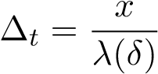
then using equation (10)
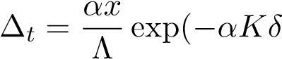) (41)
which further simplifies, (because the frequency is computed by dividing the average volume V₀ by the average size) into:
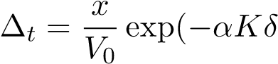) (42)
The above expression constitutes a possible ”proxy” (as it is obviously relies on several approximations).
- Today, internal deals within big institutions having several desks such as cash equity, delta one,and options are done at market price, with a bid-ask spread applied to transactions. By doing so, various desks get internal pricing which is competitive when compared to the market. A possible response to the introduction of the FTT, is that such institutions will merge their cash equity, delta one and option desks in one ”combined” desk, or allow internal transactions to be done at mid-price. Consequently, they will be able to reduce the transaction costs attached to the bid-ask spread.
In markets where the bid-ask spread is 2 b.p on the cash, we can see that Desks using this rule and switching to Futures instead of cash for hedging would be able to nearly offset the additional tax on option transactions whose roundtrip is also 2 b.p. This would come at a price of a reduction of the profitability of those desks, which would price at ”cost basis” the internal trades, in order to stay competitive on the external trades, on the combined desk.
In addition, for large financial institutions, several ”trading desks” can use and reuse the same internal cash or derivatives portfolio for various purposes (lending/borrowing stocks, hedging options, arbitrage) and proceed to internal transfers. Those transfers are FTT free as they occur within the same legal entity. This in turn lowers the transaction costs.
- The MIFID regulation requirement on the minimum tick size has been implemented on April1, 2018. The purpose of such regulation is to curb the competition between Exchanges competing to attract business by lowering the tick size and the bid-ask spread for transactions. The complete Grid is detailed in Appendix B. Minimum tick size is set up by underlying share or Exchange
Traded Fund (ETF) as a function of the daily trading volume and the price of the stock or the ETF. For liquid stocks, the minimum tick size is comprised between 1 and 2 b.p depending upon the stock price. Consequently, if we consider a stock whose bid-ask spread is 1 b.p and MIFID imposes a 2 b.p spread, the FTT would be responsible for only 1 b.p of additional bid-ask spread.
- Finally, we expect a reduction in the underlying asset price as evidenced in Chapter III. Theequity share cannot be considered as a pure commodity, and its in fact an instrument whose primary role is to raise capital for corporations. As shown in Chapter III, we should observe an increase in the volumes of shares issued on the primary market as well as a decrease in the equity share price. As the additional transaction costs generated by the FTT are proportional to the share price, any reduction should decrease the final amount of costs and the impact on the bid-ask spread.

4 Conclusion
In Section I, we have first explored the impact of the FTT on Implied Volatility using well known results on transaction cost introduced by Leland (1985), Leland et al. (2007) and Boyle and Vorst (1992), for a number of finite re-hedging trades through the life span of the option. We have completed both calculations by an additional volatility correction to accommodate the transactions costs to be borne by the market-maker, in case the European option is exercised at maturity, as well as original costs of building up a replication portfolio of equity shares at inception..
We have extended the Leland and Boyle and Vorst ”proxy” calculation for a number of finite re-hedging through the life span of the option, to the Variance swap market and concludes that the correction of the implied volatility to be considered, pursuant to the FTT, applies also on the expected realized variance of the underlying cash equity.
Furthermore, we have explored additional impact when the volatility is itself non constant. Such calculation requires first the calibration of volatility surface using option market prices then the Monte-Carlo simulation of the path dependent effects. We concluded on a sample of 5 corporate stocks that the impact of including volatility is significant but moderate (between 0.5 and 1.5 vega), and has to be added to the original estimations of both Leland and Boyle and Vorst. Going further, we have decided to keep the assumption of a constant volatility for simplicity sake.
We have used a well known result about the asymmetry between buyers and sellers of options, which favors option buyers to the detriment of option sellers when it comes to transaction costs. This effect is responsible for a theoretical increase in option mid-price and therefore volatility, whose magnitude and significancy have to be further estimated.
We find that in option markets with a low liquidity, and where market-makers are structurally short of options, the impact of the FTT on the volatility is going to be positive. A maximal effect will occur in ”insurance type” markets, when market-makers are the only sellers and face agents looking only for hedging and which maintain their positions until the option’s maturity.
In Section II, we have considered the liquidity of option markets as a variable explaining the intensity of the FTT impact on implied volatility quoted by either risk neutral or risk adverse market-makers. We have done numerical simulations using a theoretical and hypothetical cash equity option marked. We show that, if the liquidity is sufficient, the FTT would have no tangible impact on the option reservation-price quoted by the risk neutral market-maker. The computed impact, will be within one fraction of an effective quotation unit of the option. Therefore, there should be no tangible impact, too, on the implied volatility quoted by the market-maker.
Option markets such as Future Indices on the main market or cash equity option markets comparable to Apple’s, or Microsoft’s markets, seem as good candidate in terms of existing volumes and liquidity.
In Section III, we have conducted comparative statics for the effects of the FTT on the costs of hedging the replication portfolio as well as building this portfolio at option’s inception and liquidating it when the option is unwound.
Our results suggest that the final impact on volatility will depend upon the option market liquidity which will command the magnitude of the impact on the volatility mi-price. Results suggest an inverse relationship between the impact of the FTT and the option market liquidity prevailing at the time the FTT is introduced.
The difference in taxation between cash and derivatives should trigger a ”gravitational pull” for those agents, which should end clustering all in the delta one market. They should switch from cash stocks to ”delta one” derivatives products, including synthetic securities. As the latter is built up using a call and a put with the same strike and maturity it should generate a liquidity surge on the option market, most likely first on the strikes and maturities which are already liquid. Consequently, in existing option markets where the liquidity is sufficient for building up synthetic securities, or where the single stock futures market is already liquid, the liquidity should not decrease at all and is expected to increase significantly.
For the impact of the FTT on the bid-ask spread of derivatives we found that several possible factors such as the flight to derivatives taxed at a lesser rate, as well as a better management of order books, and also the implementation of MIFID II regulation on minimum tick size, could mitigate the ex-ante impact of 2 b.p of the notional value of the contract on the bid-ask spread, without completely offsetting it.
As a consequence, the bid-ask spread on the derivatives products such as Delta one derivatives (Single Stock Futures, Options, Contract for Difference-CFDs) should increase slightly, purely for tax reasons, in a context where the liquidity should improve very significantly.

Appendix A: The Impact of the FTT on the Option Demand from Economic Agents Acting as Hedgers
There are similarities between option pricing and insurance theory. In fact, an option can be seen at first glance as an insurance contract. For instance, a European call option can be seen as an insurance contract against the event of having:
S_{t} > K
The insurance contract pay-off is the difference between the value reached by the asset at expiration time and the strike price. By the same token, a European put option can be seen as an insurance contract whose pay-off is the difference between the strike price and the value reached by the underlying asset at expiration time. In both cases, the premium of the option corresponds to the premium of the insurance contract.
In fact, we will see below, that both call and put options can be considered as the combination of two insurance contracts.

5 European Call and Put Equity Options Markets seen as Insurance Exchanges
According to well-known properties of the Black-Scholes pricing framework, a European call option on an underlying asset S whose spot value at time t = 0 is S₀, with a strike K, a time to maturity T, a forward F can be seen as the sum of two exotic options. Recall the Black-Scholes formula, with the usual notations (for simplicity sake we consider a nil interest rate, thus that the forward value F is such that F = S₀).
C = S₀Φ(d1) − KΦ(d2)
The expression above can be seen itself as the difference of two exotic options:
- The first term consists of an ”Asset or Nothing” call option whose payoff at maturity is the value of the underlying asset.
- The second term consists of a ”Binary” call option whose payoff at maturity is a fixed amount of money equal to K the value of the call option strike.
The ”Asset or Nothing” call option value is the product of the Forward value and Φ(d1) where : Φ designates the cumulative distribution of a standard Gaussian random variable,
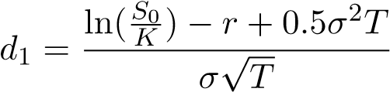
and E^{Q} designates the Risk-neutral modified probability.
Because C = E^{Q}(S_{T} − K;S_{T} > K), we get
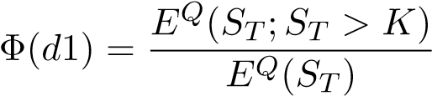
.
The ”Binary” call option value is the product of the strike price and Φ(d2). Φ(d2), according to Black-Scholes, is the ”modified probability” of the event (S_{T} > K). This probability writes
E^{Q}(S_{T} > K)
Proof
Assuming that S follows a geometric Black-Scholes process defined as ^{dS}_{S} = rdt+σdZ(t) with Z(t) standard brownian motion process.
By applying ITo’s lemma to Y_{t} = ln(S_{t}), it is well known that
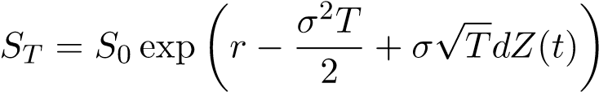
with Z(t) is a standardized gaussian distribution.
S_{T} > K is equivalent to ln(S_{T} ) > ln(K) which yields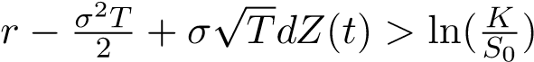
Thus,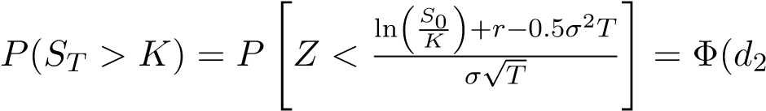) with the usual Black-Scholes notations.
The ”Asset or Nothing” call option appears then as an insurance contract whose premium per indemnity, in case of the event (S_{T} > K) occurence is exactly Φ(d1). The indemnity is variable and depends upon the value of the underlying asset S at maturity.
Consequently, because of the ”Asset or nothing” component, the buyer of a European call option is buying an insurance contract from the market against the event (S_{T} > K) whose occurence expectation is exactly Φ(d2). The pay-off , conditional to (S_{T} > K) is the asset value S_{T} .
On the other side, because of the Binary option component, the same buyer acts as an insurer against the event (S_{T} > K) whose occurrence expectation is measured by Φ(d2). The indemnity consist of a fixed amount of money equal to the value of the option strike price.The ”Binary” call option appears then as an insurance contract whose premium per indemnity, in case of the event (S_{T} > K) occurrence is exactly Φ(d2). The indemnity is fixed and does not depend upon the value of the underlying asset S at maturity.
Finally, we can consider that the equity option market, for European options, can be seen as an insurance ”Swap” Exchange. The two exotic options linked to a European Call or Put option are in fact two different insurance contracts, and the buyer of a call (respectively the seller) is acting both as an insurer and an insured agent for the same event, with different levels of indemnification, one being fixed (”The Binary”), the other being variable (”Asset or Nothing”).

6 Optimal Insurance for Call and Put Option Buyers in the absence of FTT

6.1 Optimal Insurance for Insured Agents
(i) For the Binary Option seen as an Insurance contract, the insured agent will consider from its perspective, its utility function which writes: U(w₁,w₂) where, at the end of the period, w₁ designates the agent’s wealth if not insured and w₂ is the agent’s wealth if insured. w is the wealth at origin. Z is the level of indemnification; q is the premium per unit of indemnification.
L is the level of loss.
π is the probability of occurrence of the event (S_{T} > K).
- For the Binary contract, the insured agent considers then the maximization program of itsutility function which writes as follows:
Max[(1 − π)U(w − qZ) + πU(w − qZ + Z − L)]  The first order condition writes: | (43)
q(1 − π)U⁰(w₁) = π(1 − q)U⁰(w₂) | (44)
It comes immediately that If q = π then Z=L . So we can see this optimum corresponds to a situation where the agent wealth stays the same regardless of the occurrence of the event.
Consequently, such a Binary option is an ”optimal Insurance contract”, because the premium paid KΦ(d₂) is the product of the indemnity and the probability of occurrence of the Insured event, such that the premium per indemnity is equal to the probability of occurrence Φ(d₂).
- For the Asset or Nothing, we can remark that:
-The premium S₀.Φ(d₁) corresponds to an ”optimal insurance contract”. We just need to check that such premium keeps the net wealth of the agent at a constant level regardless of the occurrence of the event.
- We can see also that the Asset or Nothing based contract corresponds to a maximization of the
Agent’s utility.
Proof
With the same assumptions, the insured agent will maximize its utility function and choose an ”Insurance level” αS with α positive and up to 1. The probability distribution is continuous, and we have to consider the modified measure E^{Q}.
MaxE^{Q}[U(w − αΦ(d₁)S₀) + (αS_{T} − S_{T} ){1_{ST} > K}]  implies a first order condition: | (45)
E^{Q}[U⁰(w − αΦ(d₁)S₀ + αS_{T} − S_{T} ][−Φ(d₁)S₀ + S_{T} {1_{ST} > K}] = 0 | (46)
Assuming α = 1 implies that E^{Q}[U⁰(w − Φ(d₁)S₀)] is the expectation of a constant variable.
The first order condition becomes then:
U⁰(w − Φ(d₁)S₀)]E^{Q}[−Φ(d₁)S₀ + S_{T} 1_{ST} > K] (47)
According to the definition of Φ(d₁), the right side of the expression above, writes:
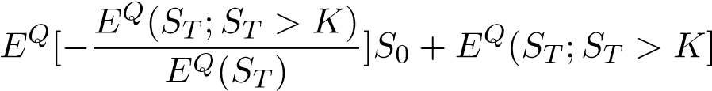
Because E^{Q}(S_{T} ) = S₀ (because r = 0), we find that the first order condition stands when α=1.

6.2 Optimal Insurance for Insurers
We consider now the perspective of the ’insurer” for both Binary and Asset or Nothing equity option.
6.2.1 Binary Call
The ”insurer” considers the following program:
Max[(1 − π)U(w + qZ + πU(w − qZ − L)] (48)
The first order (derivation toward Z) condition writes:
q(1 − π)U⁰(w₁) = π(1 − q)U⁰(w₂)
If q = π then Z=L. So we can see, in that case the insurer will be willing to provide coverage for the full extent of the loss as long as q = π. In fact, this optimum corresponds to a situation where the insurer wealth stays the same regardless of the occurrence of the event.
6.2.2 Asset or Nothing
For the ”Asset or Nothing”, the insurer (so, cashing in the premium, so selling the Asset or Nothing option) considers if wether or not it will provide full insurance to the insured agent.
The insurer agent will maximize its utility function and choose an ”Insurance level” αS with α positive and up to 1. The probability distribution is continuous, and we have to consider the modified measure E^{Q}.
MaxE^{Q} [U(w + αΦ(d₁)S₀ − αS_{T} {1_{ST} > K}] (49)
The solution for the first order solution is similar to the one discussed for equations (40) and (41) above. We find that α = 1.

7 Consequences of the FTT on the Demand for Options Issued by Hedgers

7.1 FTT Costs Embedded in the Volatility
- We see immediately that the option’s market-maker is going to pass through its costs by increasing the volatility on the sell side.
- The hedgers will add the tax amount of t⁰K with t⁰=0.01 percent of the notional value of the contract and which is certain to their costs.
- In terms of pay-off, the hedgers will record a decrease in their pay-off as the settlement willbe subject to taxation if we assume a physical settlement of the option with shares which is the common rule in cash equity option markets.
In case the option is exercised, for a call with strike K, they will buy at K(1 + τ) and sell at S_{T} (1 − τ) incurring a total cost of A = τ(S_{T} + K). The expectation of those costs are (with r=0). E^{Q}(τK;S_{T} > K) = τΦ(d2)K
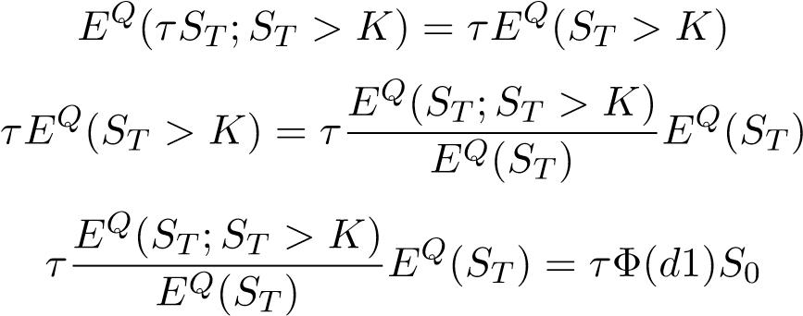
Consequently option buyers, face an increase of their premium, which is known at the time t = 0 where they buy the option. This amounts to:
t⁰K + τΦ(d2)K + τΦ(d1)S₀
This increase is equivalent to an increase in the volatility level (corresponding to an increase on the ”sell side” for market-makers ) which becomes:
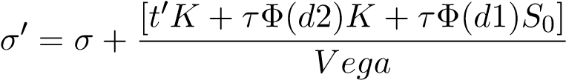

7.2 Consequences on the Expected Realized Variance
The expected realized variance on the period [0,T] is defined as:
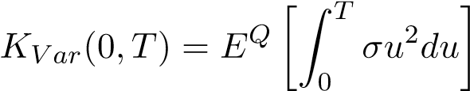
If we consider that following the introduction of the FTT, hedgers face an increase of the volatility such that the new volatility is:
σ_{A} = (1 + y)σ
Then this increase translates immediately in an increase of the expected realized variance:
K_{V arA}(0,T) = (1 + y)K_{V ar}(0,T)

7.3 Consequences on the Final Demand for Options
Hedgers (and other agents) looking for insurance are gauging their expected chances of realization of the event they are insured against (either S_{T} > K or S_{T} < K, depending of the option they buy) by reading the market expectations. Because of the increase in market-makers hedging costs the market expectations are up, as we saw above.
Based on the results of section 2 above, we have seen that, as long as the options are priced according to the Black and Scholes formula, both insurers and insured agents will consider that they are at the maximum of their utility function. Consequently, in such markets the demand for options is not going to be affected even if the pay-off and the volatility are increasing. Hedgers will consider, based on the increase in the expected realized variance that, the increase in the tax translates into an increase of the ”hazard rate”.
This results can appear as surprising. However, they are better understood if we think about that such option market would behave as a monopoly.

8 Appendix B: Delta One Products Definition and Types
Delta One Products are derivatives instruments which are mimicking the cash flows and the total return of either a long or a short position on a cash stock. Cash flows include dividends, corporate actions (such as stock splits), as well as financing costs. Total Return is defined as the variation of the stock price plus dividends. Those products are named after the option theory. Their ”delta”, defined as the variation of their marked-to-market value divided by the variation of the underlying equity, is exactly one. There are three different main kinds of delta one products.
8.1 Futures.
Futures or forward are delta one products. Assuming a stock price whose spot (mid) is S_{t} and forward value is F(t,T), then:
F(t,T) = S_{t} [exp(c_{f} − d)(T − t)] (50)
- with c_{f} is the average cost of:
- funding of the arbitrage cash and carry which consist of buying the stock, funding it and sellingthe future.
- borrowing the stock selling it, lending the cash proceeds, and buy the future (Reverse Cash andCarry).
d is the continuous dividend yield of the stock. Futures and forwards can have different bid-ask spread depending upon the credit worthiness of the two counterparts, which command the funding spreads of those instruments.

8.2 Equity Swaps or Contract for Differences
Equity Swaps (EQS) or contract for differences (CFDs) are derivatives contracts where the total return of the stock (including dividends) is exchanged against its funding cost. In an equity swap the counterpart which is ”long” will receive the positive performance, pay the negative performance as well as the funding of the position. Conversely a ”short” counterpart will pay the positive performance and the dividend to the other counterpart, it will receive the negative performance as well as the funding costs.
CFDs have been launched, a while ago, following the introduction of the British version of the FTT (called the Stamp Duty Tax). At the difference of the current EEC project, Stock brokers and market-makers are exempt from such tax, and this appeared as a way of avoiding the payment for the tax for the clients using usually cash. The FTT introduced by French authorities in 2012 at a rate of 0.2 percent and then increased to 0.3 percent does not apply to CFDs.
One can see that futures, forward, EQS and CFDs have a similar exposure toward the variations of the underlying cash equity. Market practice is to provide Direct Market Access (D.M.A) quotes for CFDs such that their bid-ask spread is identical to the cash equity bid-ask. Unlike the futures whose funding costs are embedded in the future price, CFDs see their funding treated and charged separately. Theoretically, CFDs ruled by the DMA quotation rule allow to take intra-day positions.

8.3 Synthetic Stocks
Long synthetic stock is defined as a combination of a long call and a short put positions with the same strike and maturity.
According to the Call-put parity relationship defined in the Black and Scholes framework:
C(S,K,t,T) − P(S,K,t,T) = exp[−(r − d)(T − t)][F(t,T) − K] = S_{t} − exp[−(r − d)(T − t)]K
(51) The delta one property is then immediate.As a consequence, we can see that any difference of two of the three instruments S, C(S,K,t,T),P(S,K,t,T) gives either a long or a short position on the third instrument.
Also, one can see that a synthetic stock issued using at the Money Forward options, (F(t,T) = K) will require no funding at trade inception. Furthermore, one can see directly using the equation above that the synthetic stock mimics exactly the total return performance of Single Stock Future.

8.4 Arbitrage and Substitutability between Cash and Delta One Products: the Delta One Property
- Products such as synthetic options or Single Stock Futures allow to replicate identically thereturn of the underlying cash instrument. This is because they can all be replicated by a long (respectively short) synthetic stock based on a combination of a long(respectively short) European call option and a short (respectively long) European put option. From the properties of the synthetic stock we get then the ”delta One property”:
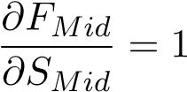
- Furthermore, Single Stock Futures prices are linked to the underlying cash prices by arbitragepricing.
- Finally, we can consider that cash products and delta ones can be substituted one to another.Within delta one products this is the same, provided that the funding costs are the same.
- In the particular case of day trading, and after the introduction of the FTT, there is a possibilityof arbitraging the cash stock against the CFD. Because operations, are in one day we will consider there is ni funding cost.
The arbitrage : buy the CFD sells the stock yields:
−F_{Bid}(1 + t⁰) + S_{Bid}(1 − t) = 0 (52)
Whereas buying the stock selling the CFDs yields:
F_{Ask}(1 − t⁰) − S_{ask}(1 + t) (53)
δ and δ⁰ designate the respective bid-ask interval for the cash and the CFD. t and t⁰ are the respective FTT tax rates. From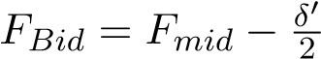 and 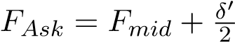 and
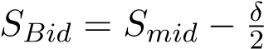 and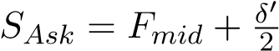
We get:
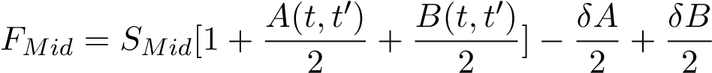 (54)
With:
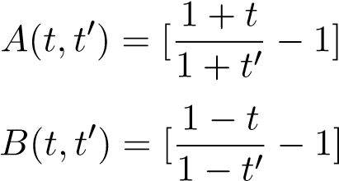

8.5 Overall Consequences on the Delta One and Derivatives Product Liquidity for Highly Liquid Option Markets
8.5.1 Quasi-Identity of volatility between cash and delta one products:
Because of the arbitrage relationship and the presence of two respective different FTT rates for cash and futures transactions, then the difference between the (normal) volatility of the future or delta one product and the the (normal) volatility of the cash product, can be considered as insignificant:
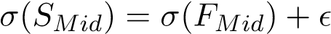
Proof:
In presence of respective FTT tax rates of t and t⁰ for cash and derivatives products, the cash and carry and reverse cash and carry relationships is an extension of the equation above, with a cost of funding the position, we designate by B. This yields:
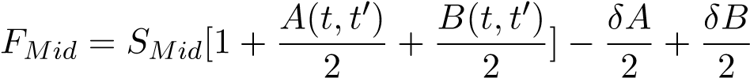 (55)
With:
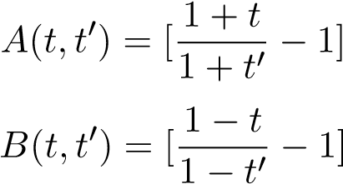
Consequently, by property of the standard deviation of a random variable, we see that the volatility of the future is slightly greater than the volatility of the cash.
Taking into account t = 0,01 andt⁰ = 0,001; an σ = 0,3, we find that the impact of the vol difference on the bid-ask spread is 0.5 b.p for a 1 year option and 0.04 b.p for a one day option. The impact of the basis reduction due to the substitution of futures to cash products should further lower this difference by decreasing the basis.
Going further, we will consider that:
σ(SMid) = σ(FMid)
8.5.2 Better bid-ask interval for derivative products and ”Gravitational Pull”
We consider first, the CFD position held one day versus the same position consisting of the cash instrument purchased and sold within the same day. Both positions do not require funding.
The market-maker quotes on both CFDs and cash market as it runs a unique book.
For the cash equity share, the market-maker will quote the interval:
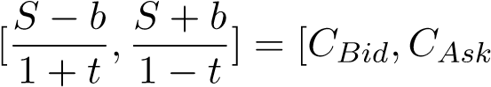] (56)
At the same time he will quote on the CFD the other interval:
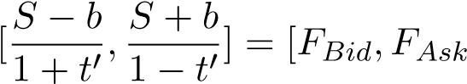] (57)
Using these two quotes we can see that the arbitrage consisting of selling the CFD and buying the cash, and conversely buying the CFD and selling the cash, yields the same cash-flow which is 2b. Furthermore one can see immediately that:
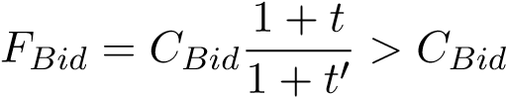
and
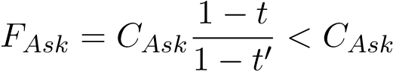
Consequently, this proves that the quotation interval, done by the market-maker is going to be narrower for the future than for the cash instrument.
The property extends to the futures with longer maturities. One has to consider in addition the cost of funding the cash position. There is a cost B in case the position is long.This carry cost corresponds to the difference between the cost of borrowing money to purchase the cash stock, and the revenue coming from lending the stock into the market with a Repo (repurchase agreement), plus any dividend paid by the stock.
By the same token, there is an other cost B⁰ when the position is short of the cash equity cash. This reverse carry cost is equal to the cost of borrowing the cash stock, selling it on the market, lending the proceeds, and paying any dividend.
If we consider that the difference (the basis) between the future and the cash prices is constant for a given future maturity.
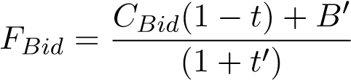
The substitution of futures to cash product for trading, should have a direct impact on the respective values of B and B⁰. Short sales of cash stock requiring the borrowing of cash stocks should be substituted with short sales of futures, instead. There should be then an excess of cash stocks to be lent, which should decrease both cost of borrowing and the lending rate of cash stocks. This should further reduce B and B⁰, and consequently narrows further the bid-ask spread for the delta one products.
We find an overall increase in the volumes of option traded because of the synthetic replication of the cash stock which allows a very large substitution of futures and delta one products to cash products. Assuming that before the introduction of the FTT, cash and delta one products quotes where priced at their theoretical values based on arbitrage, the increase in liquidity of futures products should, as seen above trigger a market-size effect allowing for a strong reduction of the before tax bid-ask spread for futures, synthetic stocks and other delta one products.
Consequently, we should observe a very large increase in the liquidity of all those products, following the introduction of the FTT.
At the same time, economic agents looking for insurance and using options will not decrease their demand for options, as seen before.
In addition, we have seen in section that any increase in the volumes traded on the future should further reduce the bid-ask spread. Moreover, substitution of futures to cash product for trading, should have a direct impact on the respective values of B and B⁰. Short sales of cash stock requiring the borrowing of cash stocks should be substituted with short sales of futures, instead. There should be then an excess of cash stocks to be lent, which should decrease both cost of borrowing and the lending rate of cash stocks. This should further reduce B and B⁰, and consequently narrows further the bid-ask spread for the delta one products.
We find an overall increase in the volumes of option traded because of the synthetic replication of the cash stock which allows a very large substitution of futures and delta one products to cash products. Assuming that before the introduction of the FTT, cash and delta one products quotes where priced at their theoretical values based on arbitrage, the increase in liquidity of futures products should, as seen above trigger a market-size effect allowing for a strong reduction of the bid-ask spread for futures, synthetic stocks and other delta one products.
Consequently, we should observe a very large increase in the liquidity of all those products, following the introduction of the FTT.
At the same time, economic agents looking for insurance and using options will not decrease their demand for options, as seen before.

8.6 Arbitrage and Substitutability Between Cash and Delta One Products
From the equations above, one can see directly that it is possible to arbitrage cash against delta one products. Furthermore, it is possible to arbitrage all delta one products one against an other. Depending upon the underlying cost of carry of the equity, bid-ask spreadS on the future or the synthetic can be narrower or larger than the corresponding spreadS for the cash instrument. Usually, the narrowing of the bid-ask will happen when the cost of carry will decrease. For instance, this is the case, when the continuous dividend yield of the stock increases more than the cost of funding the stock.
However, those bid-ask spreads are in fact equivalent. We can see the future or synthetic bid-ask spread as an ”all inclusive” spread taking into account the carrying costs. At the same time, the cash spread does not consider the funding costs, for instance on the repurchase agreement market.
Finally, we can consider that cash products and delta ones can be substituted one to another. Different kinds of delta one products can also be arbitraged one against an other. This is generally the case for the future and the synthetic stock, which are listed products cleared on Exchanges. EQS and CFDs are OTC (Over The Counter) products, and have different funding costs, which are generally less competitive.
Nowadays, the delta one trading has taken a very significant extent and is fully integrated within the business structure of main market-makers such as Investment Banks and Hedge Funds, as evidenced by the Table 1.
Barring’s Bank (1992) Societe Generale (2008) and UBS (2012) have experienced, on their delta one desk, huge fraud-related losses(between USD 2 and 5 Bio) leading to either bankruptcy (Barring’s) or recapitalization (SG). This underlines that this kind of trading has grown up to an enormous importance, as of today.

9 The AAPL Stock and Option Market Seen as an Example of Highly Liquid Market
We review the main characteristics for the AAPL stock on both cash and equity options for the month of May 2017.

9.1 Futures Markets on AAPL
Technically speaking, there is a single stock futures market dedicated to AAPL stock, which consists of a contract listed on the One Chicago exchange. However, the liquidity on such market is not comparable to the one on NASDAQ for the cash stock. The main market place consists of the option exchanges cleared through OCC, and accessible trough Smart Order Routing (SOR) system.

9.2 Respective Volumes on the Stock and the Option Market
We consider the volume of the cash stock traded on NASDAQ, which is a listed Exchange. We do not consider the volumes traded OTC (Over The Counter) through other ECN such as ”Dark Pools” which are in fact Exchanges organized by big players such as Banks in order to be able to trade big sized orders (”blocks”), or to preserve confidentiality.
a- Cash equity
The ”float” is defined as the number of outstanding shares available for trading and is 5.08 Bn. Float is generally affected by corporate actions such as stock splits, or new issues on the primary market. With an average price of USD 150 a share, the float for AAPL is worth USD 762 Bn.
The average daily volume in terms of number of stocks traded for May 2017 amounts to 31,926,657 shares which represents USD 4.79 Bn a day. Considering an average trade size of 100, we come to the conclusion, that the ”intensity” is such that, on an average basis, an executed trade occurs every 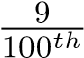 of a second. b- Option and Synthetic
We consider the volumes traded on option exchanges which are cleared through the OCC (”Option Clearing Corporation”), the US entity in charge of clearing options. Option contracts are traded on multiple option exchanges (15), where the execution can take place. The existence of SOR (Smart Order Routing system) guarantees that when a limit or a market order is entered through SOR, it will get executed at the best price among all competing exchanges. Consequently, we will consider that we have one unique option market for AAPL stock options, despite the fact that the option is traded on 15 different exchanges.
Our numbers do not include OTC trades on the interbank market or on ”Dark Pools”.
The Table 1, below, provided by the OCC details the breakdown between the various exchanges and the call and the put options.
The average daily volume in terms of option contracts (call and put options) is 476,226 contracts a day. Each contract is about 100 underlying shares. Trading is concentrated on the first two months, which represents around 75 percent of all transactions in volume.
We assume:
- A USD 150 stock price - That most of the option traded are ”At The Money” - That the
distribution of option’s strikes is symmetric around the spot rate
Consequently, the daily number of contracts represents a notional number of USD 7.14 Bn. One can see this is already 40 percent more than the average daily value of the trades on the cash equity market.
Considering a δ of 0.5, we get that the equivalent number of shares corresponding to the option traded, amounts 23.811 millions. This is approximately 75 percent of the average daily number of cash stocks traded on the NASDAQ.
Call and put options have different volumes. We do not have statistics on synthetics. Taking the minimum between the call and put traded on a month, would give an upper bound proxy . Using this calculation, we find a monthly total of 5.5 million of contracts correspond to synthetic stock, consequently 275,000*100= 27,500,000 shares on a daily basis. This amount represents approximately 90 percent of the average daily volume for cash equities.
Consequently, at first glance, the option market on AAPl appears as highly liquid.

9.3 Respective Bid-Ask Spreads and Market Intensity
- The average spread on the synthetic is computed as the average of the respective bid-ask spreadson the call and the put, weighted by the trading volumes. Using NASDAQ Exchange quotes, we computed as of 19 May 2017, for the first two nearby contracts, an average spread of 12 basis points for both May and June options (expiring within those two months). This situation on the synthetic encompasses generally narrower bid-ask spreads on one type of option (either call or put) depending upon the strike.
- The average spread on live quotations for the cash stock is frequently between 1 (0.65 b.p) and2 cents (1.3 b.p), and less frequently can reach (2 b.p) as of the 19 May 2017.
- As of the 19 May 2017, we computed some market intensity figures using NASDAQ statistics.NASDAQ represented in May 2017, 24 percent of the overall volumes traded on AAPL options. The market intensity appears very high for the short maturities options, on the first two nearby contracts, for strikes around the ”money”. For instance, we have that day 51,995 call options executed for strikes between 149 and 157.5 and 1 week maturity, whereas the corresponding volume of executed put trades amounts to 26,414. This represents approximately an execution rate of two option contracts per second for the call option, and a rate of one option contract per second for the put option.
For the one month maturity, the volume on the call amounts to 16,050 for strikes between 145 and 160, whereas for the 6 weeks maturity the volumes of executed call trades for strikes between 148 and 162.5 amounts to 30,606. At the same time, the corresponding number of put trades appears as relatively low at 424 trades for the day, for the same strikes.
Those figures suggest a high intensity market for options around at the money at least for option maturities up to 6 weeks. Such market intensity corresponds to the case seen in Chapter I, where the market depth is big enough to allow an impact of the FTT on the option price within the tick size.

9.4 Respective Market-Participants
The OCC summarizes the executed trades for options and considers three categories of agents: Market-makers, Clients, Firms.
- Market-makers are generally agents which commit to execute their bid-ask quotes for the quantities and the prices ”displayed on the screens”. Usually, they benefit from rebated from the exchange linked to the volumes they actually trade.
This category is not limited to real market-makers but includes informed and noise traders. According to the OCC the volume they represent is approximately 50 percent of the total volume. They can include small trading units, investment bank desks, or hedge-funds. Recall that the biggest market-maker on the world is Citadel, a Chicago based hedge fund.
- ”Clients” and ”Firms” represent the other half. This suggests those economic agents are not subject to the obligation of hedging their positions as the market-makers do. Consequently, potentially, they are taking directional positions, or conduct some sort of arbitrage.

9.5 Conclusion
We consider the option market for the corporate company Apple (AAPL) as a case study for measuring the effects of the introduction of a STET, similar to the EEC FTT.
The AAPL option market is highly liquid, especially for around ”At the Money” options with maturities up to two months. This option market represents the main market place where delta one products, such as synthetic stocks could be traded, following the introduction of a tax comparable to the FTT. Currently, the notional quantities already traded on AAPL option markets are sometimes Figure 1: Volumes Traded on AAPL Equity Option Markets: Source OCC
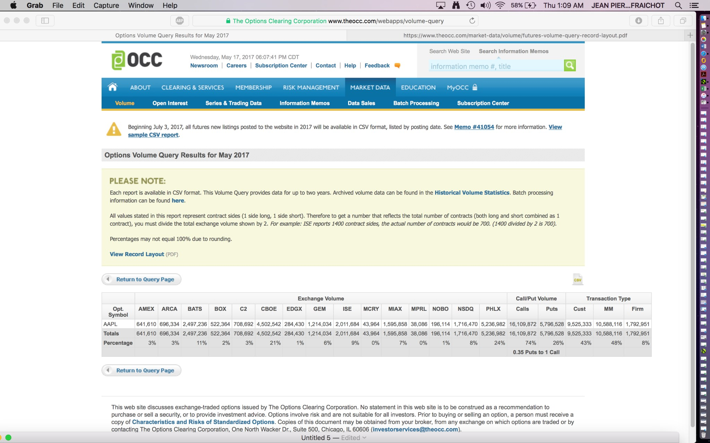
significantly larger than the notional quantities traded on the cash market.
We conclude this option market seems to present all characteristics enabling a possible transfer of cash transaction toward synthetic stocks. The situation appears very similar to the case where such tax would be introduced in only one country, and where a major portion of the trading business would migrate from this country to the countries free of such Tax.
As a consequence, we can expect that in such market, the synthetic trade volumes are going to increase, while the volatility is not going to increase. The existing average spread on the synthetic security should therefore be reduced. Most of the trading business should migrate to the derivatives market. All non market makers agents should cluster in this tax reduced financial market, while market-makers should systematically favor the hedging of cash products with derivatives.

References
Allen, P., Einchcomb, S., and Granger, N. (2006). Investment strategies. JP Morgan–European Equity Derivatives Research, (28).
Almgren, R. and Chriss, N. (2001). Optimal execution of portfolio transactions. Journal of Risk, 3:5–40.
Altman, E. I. (1968). Financial ratios, discriminant analysis and the prediction of corporate bankruptcy. The journal of finance, 23(4):589–609.
Amihud, Y. and Mendelson, H. (1986). Asset pricing and the bid-ask spread. Journal of financial Economics, 17(2):223–249.
Amihud, Y. and Mendelson, H. (1991). Liquidity, asset prices and financial policy. Financial Analysts Journal, 47(6):56–66.
Anthony, J., Bijlsma, M., Elbourne, A., Lever, M., and Zwart, G. (2012). Financial transaction tax: review and assessment. CPB Netherlands Bureau For Economic Policy Analysis. CPB Discussion Paper.
Avellaneda, M. and Stoikov, S. (2008). High-frequency trading in a limit order book. Quantitative Finance, 8(3):217–224.
Bessembinder, H. (2002). Trading costs and return volatility: evidence from exchange listings. Working paper.
Bjursell, C. J., Wang, G. H., and Yau, J. (2006). Transaction tax and market quality of us futures markets: An ex-ante analysisi. Journal of future markets, 26.
Black, F. and Cox, J. C. (1976). Valuing corporate securities: Some effects of bond indenture provisions. The Journal of Finance, 31(2):351–367.
Black, F. and Scholes, M. (1973). The pricing of options and corporate liabilities. Journal of political economy, 81(3):637–654.
Boyle, P. P. and Vorst, T. (1992). Option replication in discrete time with transaction costs. The Journal of Finance, 47(1):271–293.
Brennan, M. J. and Subrahmanyam, A. (1996). Market microstructure and asset pricing: On the compensation for illiquidity in stock returns. Journal of financial economics, 41(3):441–464.
Campbell, J. Y. and Froot, K. A. (1994). International experiences with securities transaction taxes. In The internationalization of equity markets, pages 277–308. University of Chicago Press.
Capelle-Blancard, G. and Havrylchyk, O. (2016). The impact of the french securities transaction tax on market liquidity and volatility. International Review of Financial Analysis, 47:166–178.
Chamberlin, E. H. (1949). Theory of monopolistic competition: A re-orientation of the theory of value. Oxford University Press, London.
Duffie, D. and Singleton, K. J. (1999). Modeling term structures of defaultable bonds. The review of financial studies, 12(4):687–720.
Elie, R. and L´epinette, E. (2015). Approximate hedging for nonlinear transaction costs on the volume of traded assets. Finance and Stochastics, 19(3):541–581.
Finkelstein, V. (2013). Assessing default probabilities from equity markets. Presentation, Credit Risk Summit.
Finkelstein, V. and Lardy, J. (2001). Assessing default probabilities from equity markets. simple closed-form solution. Presentation ICBI Global Derivatives and Risk Management, Credit Risk.
Finkelstein, V., Lardy, J., Pan, G., Ta, T., and Tierney, J. (2002). Credit grades technical document.
Habermeier, K. and Kirilenko, A. A. (2003). Securities transaction taxes and financial markets. IMF Staff Papers, Special Issue International Monetary Fund, 50(1):165–180.
Hakkio, C. S. et al. (1994). Should we throw sand in the gears of financial markets? Economic Review, 79:17–30.
Hau, H. (2006). The role of transaction costs for financial volatility: Evidence from the paris bourse. Journal of the European Economic Association, 4(4):862–890.
Hawkins, M. and McCrae, J. (2002). Stamp duty on share transactions: is there a case for change? Institute For Fiscal Studies.
Ho, T. and Stoll, H. R. (1980). On dealer markets under competition. The Journal of Finance, 35(2):259–267.
Ho, T. S. and Macris, R. G. (1984). Dealer bid-ask quotes and transaction prices: An empirical study of some amex options. The Journal of Finance, 39(1):23–45.
Jarrow, R. A. and Turnbull, S. M. (1995). Pricing derivatives on financial securities subject to credit risk. The journal of finance, 50(1):53–85.
Jones, C. M. and Seguin, P. J. (1997). Transaction costs and price volatility: evidence from commission deregulation. The American Economic Review, 87(4):728–737.
Keynes, J. (1936). The General Theory of Employment, Interest and Money. Harcourt Brace.
Kupiec, P. (June 1996). Noise traders, excess volatility, and a securities transaction tax. Journal of Financial Services Reseach, 10(2):115–129.
Lardy, J.-P. (2001). A simple closed-form formula to price credit. Presentation, Risk, Paris.
Leland, H. (1985). Option pricing and replication with transaction costs. The Journal of Finance, 40:1283–1301.
Leland, H. (1994a). Corporate debt value, bond covenants, and optimal capital structure. The Journal of Finance, 49:1213–1252.
Leland, H. (1994b). Optimal capital structure, endogenous bankruptcy, and the term structure of credit spreads. Finance working paper, (240). Haas School of Business, University of California, Berkeley, USA.
Leland, H. E. et al. (2007). Comments on ”hedging errors with leland’s option model in the presence of transactions costs”. Finance Research Letters, 4(3):200–202. Haas School of Business, University of California, Berkeley, USA.
Leland, H. E. and Toft, K. B. (1996). Optimal capital structure, endogenous bankruptcy, and the term structure of credit spreads. The Journal of Finance, 51(3):987–1019.
Lendvai J., Raciborski R., V. L. (2012). Securities transaction taxes: Macroeconomic implications in a general equilibrium model. European Economy: Economic Papers, (450).
Lo, A. W., Mamaysky, H., and Wang, J. (2004). Asset prices and trading volume under fixed transactions costs. Journal of Political Economy, 112(5):1054–1090.
Matheson, M. T. (2003). Taxing financial transactions: Issues and evidence, volume 3, Special Issue. IMF Staff Papers, International Monetary Fund.
Modigliani, F. and Miller, M. H. (1958). The cost of capital, corporation finance and the theory of investment. The American economic review, 48(3):261–297.
Mulherin, J. H. (1990). Regulation, trading volume and stock market volatility. Revue ´economique, pages 923–937.
Musiela, M. and Rutkowski, M. (1998). Martingale methods in financial modeling, 2nd edition. Stochastic Modelling and Applied Probability, 36.
Oxera (2007). Stamp duty: Its impact and the benefits of its abolition. Prepared for ABI, City of London Corporation, IMA and London Stock Exchange.
Oxera (2014). What could be the economic impact of the proposed financial transaction tax? a comprehensive assessment of the potential macroeconomic impact. Technical report, Oxera.
Roll, R. (1989). Price volatility, international market links, and their implications for regulatory policies. In Regulatory Reform of Stock and Futures Markets, pages 113–148. Springer.
Rubinstein, M. and Reiner, C. (1991). Breaking down the barriers. Risk, 4:28–35.
Saporta, V. and Kan, K. (1997). The effects of stamp duty on the level and volatility of equity prices.
Schwert, G. W. and Seguin, P. J. (1993). Securities transaction taxes: an overview of costs, benefits and unresolved questions. Financial Analysts Journal, 49(5):27–35.
Song, F. M. and Zhang, J. (2005). Securities transaction tax and market volatility. The Economic Journal, 115(506):1103–1120.
Stiglitz, J. E. (1989). Using tax policy to curb speculative short-term trading. Journal of financial services research, 3(2-3):101–115.
Summers, L. H. and Summers, V. P. (1989). When financial markets work too well: a cautious case for a securities transactions tax. Journal of financial services research, 3(2-3):261–286.
Taleb, N. (2005). Fooled by randomness: The hidden role of chance in life and in the markets, volume 1. Random House Incorporated.
Tobin, J. (1978). A proposal for international monetary reform. Eastern economic journal, 4(3/4):153–159.
Umlauf, S. R. (1993). Transaction taxes and the behavior of the swedish stock market. Journal of Financial Economics, 33(2):227–240.
Vasicek, O. KMV (Kealhofer, M. and Vasicek) (2012). Structural models in credit valuation. NYU Stern.
Wang, G. and Yau, J. (2012). Would a financial transaction tax affect financial market activity? insights from future markets. Policy Analysis, (702).
Westerholm, P. (2003). The impact of transaction costs on turnover, asset prices and volatility: the cases of sweden’s and finland’s security transaction tax reductions. Liiketaloudellinen Aikakauskirja, pages 213–241.
Chapter II: Study of The Effect of the EU Financial Transaction
Tax on The Corporate Cost of Capital and The Corporate Bond Market ∗
Jean Pierre Fraichot†
LEDa, U. Paris Dauphine, PSL Research University
November 13, 2018

Abstract
We study the impact of a Financial Transaction Tax (FTT) on the corporate cost of capital through the possible impact of the FTT on the corporate bond market. Our new approach which has not be considered so far, according to our review of the literature, considers the measure of the FTT impact using the concept of capital structure arbitrage at corporate firm level in the presence of transaction costs.
Corporate firms willing to raise capital by issuing corporate bonds on the primary market, have to compensate investors against the potential firm’s default on its credit obligations. This is usually done by issuing corporate bonds at a discount when compared to ”credit risk free” bonds (usually government bonds of the G-7 group of wealthiest countries). The discount is in fact equivalent, to the value of a Credit Default Swap (CDS) allowing the corporate bond investor to buy protection against the firm’s default. The CDS can itself be hedged by an American put equity option allowing to sell the share at a reservation price. As the share price will tend to zero in case of bankruptcy, bond holders can recover the amount of debt in excess of the assets by exercising this put. This put can also be replicated through a portfolio consisting of shares and cash. In both cases, the chain of those hedging operations constitutes a Capital Structure Arbitrage, where bond investors can buy equity derivatives or sell equity positions to hedge against the credit default.
Because the corporations are borrowing money, they have then to compensate bond holders by a premium allowing them to buy a put option from an option market-maker, or to replicate the put option with a hedging portfolio. Thus, corporate firms find themselves on the worst side of the bid-ask quotation interval. The market-maker selling the relevant option has to factor, in its selling price, the cascading effects of the FTT on its replication portfolio. Corporations will then support the possible increase in the asking price of the equity share price volatility, triggered by the introduction of the FTT.
Furthermore, because the bond maturities are generally greater than the option maturities, it happens that the option market to consider is quite illiquid. This is particularly the case for deep ”out of the money” put options which should be privileged by the investors because of their low costs. Then according to the results of chapter I, the impact on the implied volatility

∗
I thank Martine Carr´e-Tallon, Ren´e A¨ıd, Jeroˆme Mathis and participants to Doctorants Workshop (Paris Dauphine, June 2016) for useful comments.
†
Address: Universit´e Paris-Dauphine, PSL Research University, LEDa, Place du Mar´echal de Lattre de Tassigny,
75775 Paris Cedex 16, France. E-mail: fraichot@yahoo.com
of options sold, is maximal and corresponds to the case of the ”frozen inventory” described in chapter I.
In the worst case of illiquidity where no market-makers exist for such underlying cash instruments and maturities, the investor would have to improvise itself has an option market-maker, building up a replication portfolio and bearing the costs generated by the FTT, equivalent to the ones it would support for a ”frozen Inventory”.
Consequently, we derive the FTT impact on the Credit Derivatives market, by mimicking a capital structure arbitrage program which consists of hedging the credit risk by either a put option or selling shares. We consider a structural model of corporate’s default, based upon the results of the literature, and the practice of credit derivatives Capital markets. In this framework, the corporation default is triggered by the level of the assets falling below a predetermined threshold. This threshold is based upon the level of the outstanding debt. The corporation default probability increases with the asset volatility, which can be itself derived from the equity share price volatility.
We use the results of chapter I about the cascading effects of the FTT and the subsequent increase in the asking price of the implied volatility for options. We first consider an oversimplified structural model such as the Merton model, which belongs to the first generation of structural models. Sampling 3 European corporations, we first evidence that even the calibration to capital markets data of would predict an increase in the capital costs amounting to a multiple of what is currently considered by the EEC so far, as the real impact (9 bp).
We then consider, CreditGrades R the ”best of breed” structural model used extensively on today’s capital markets, and introduced by JP. MORGAN in 2002. This model is based on a version of the Black-Cox structural model which extends and completes the original Merton model. This model, now a market standard, has the advantage of being an ”Off-the-Shelf” product, and calculation engines are easily available.
We apply and calibrate this model to a sample of 6 European corporations which extends the sample of 3 corporations we used for the calibration of Merton model. The corporations sampled consist of 3 industrial and 3 financial companies.The calibration is done by observing, for each corporation, the implied volatility levels of the corporation’s assets and the implied volatility of the equity share price, which result from the inversion of the model using the credit spreads observed on the CDS market. The impact of hedging a replication portfolio is then assessed using the results of Chapter I. Then the initial asset volatility and the new asset volatility after the introduction of the FTT are derived from the equity share price volatility using the corporation’s capital structure (balance sheet). The reapplication of the model gives then the increased credit spread generated by the introduction of the FTT.
We show that the FTT introduction increases corporate credit spreads by up to 60 percent, and affects more the industrial sector than financial institutions. For an industrial corporation with a 5 year CDS initial spread of 343 basis points per annum, we find an increase of 174 basis points. On this sample, the impact we find is between 5 and 20 times higher than the one computed in a study realized for the EU authoritiesLendvai et al. (2012).
Credit Spread increase generates a price drop in corporate bond prices which is balance sheet specific and increases with the corporate bond tenor. For corporate bonds with a 15 year tenor, the price impact ranges between 3.8 and 45 percent.
From an economic policy standpoint, results evidence that the FTT effect will bear heavily on the high yield corporate bond market. The magnitude particularly heavy for industrial firms, suggests that even if the FTT is introduced in all EEC countries, at the same time, and targets financial institutions, its effects go well beyond the EEC borders. For instance, considering the case of ”Arcelor Mittal” corporation, a well known steel mill, the potential drop in its bond price would literally impeach this company to find competitive financing, and could even drive this company into default. This would create a strong distortion in competitiveness as the company’s main competitors are outside the EEC.
Keywords: Tax reform, options, volatility, liquidity, credit spread
JEL Classifications: G02,G11,G12,H22,H39

Introduction
There is a relatively large number of empirical contributions analyzing the effect of Standard Turnover Excise Tax (STET) on capital costs, however few theoretical studies (based on general equilibrium models or other theoretical tools) assess their impact on the real side of the economy. In general terms, the scarce existing literature considers that STET affect the behavior of the real economic variables through the transmission channel of capital costs (see EEC study by Lendvai et al. (2012), Anthony et al. (2012), and Oxera (2014)).
This existing literature draws on theoretical general equilibrium models, simulations and empirical analyses that try to determine the impact of STETs on the level and volatility of asset prices, capital costs and real investment. Focused on the experience of countries such as the United States (Amihud and Mendelson (1991); Hakkio et al. (1994); Matheson (2003), among others), United Kingdom (Saporta and Kan (1997), Hawkins and McCrae (2002), Oxera (2007)), or Sweden (Umlauf (1993); Westerholm (2003)), it concludes that financial transaction taxes would be associated with a decrease in the price of assets and an increase in the cost of capital.
Additionally, other relevant papers covering the same or similar topics would be Habermeier and Kirilenko (2003), Schwert and Seguin (1993), and Kupiec (1996).
However, among the literature, the various studies have focused on the corporate cost of capital through the impact on the stock market, and we did not find any specific review on the corporate bond market. This is not surprising as generally speaking the corporate bond market is atomized and often illiquid with a difficult price discovery process.
We consider here the impact of a STET on the corporate cost of capital in the particular case of the European Financial Transaction Tax (FTT). This FTT is in fact a standard turnover excise tax (STET) that would apply certain rates to the notional value of all transactions related to securities and derivatives. This STET would apply to all financial transactions taking place in the European Union (EU) or performed by financial institutions domiciled in the EU. The EU DG (the European Economic Research entity) has found, using a general equilibrium model Lendvai et al. (2012), that the FTT would increase the corporate cost of capital by 9 basis points per annum. Our study retains the exact specification of the FTT, as they are stated in the EU project.
Our approach is new and is based on micro-economics characteristics s at the corporate firm level. We consider the possibility that the specifics of a given corporate firm command directly the impact of the FTT in terms of capital costs. Therefore we study a framework where a uniform taxation disposition can induce heterogeneous responses at the micro-economic level.
Instead of choosing empirical studies or using general equilibrium models which consider indices or the corporate sector at the macro-economic level, we aim to find a quantitative framework which allows to compute the potential effects of any FTT or STET on the corporate cost of capital project at a micro-economic level. This quantitative evaluation is consistent and based on the current conditions of the credit and equity derivatives market prevailing at the time of the introduction of this new tax. In order to achieve this result, we focus on capital structure arbitrage between various financing instruments issued by the same corporate firm. In particular, we look after the interconnection between bond, credit and equity derivatives markets, for a given bond issuer.
Unlike other reviews, our analysis can be done nearly in real time and updated with the current market conditions prevailing on both equity option markets and credit derivatives markets.
When compared to other approaches based on general equilibrium models, our approach tends to capture the cascading effects of the FTT, especially on the hedging and transaction costs incurred by the economic agents involved in such arbitrage. The arbitrage we consider in particular consists of arbitraging for the same firm, the corporate bond against the equity share, under a risk neutral assumption. This arbitrage can be done either directly or through a put option, the two approaches being equivalent from a valuation standpoint.
Since the mid-1990’s, credit and equity derivatives markets have expanded at a fast pace and are largely used worldwide. The pricing methodology of such instruments is well known nowadays. It is a common practice know to arbitrage credit and equity derivatives in order to derive a possible profit in case of incorrect pricing. Both credit derivatives and equity derivatives instruments are related to the balance sheet structure of the corporate firm as well as the implied volatility observed in the relevant capital markets.
First, we consider the corporate bond market, through its connection to the credit default swap (CDS) and equity derivative markets. Credit default swaps and corporate bond markets can be arbitrated one against each other through basis arbitrage. This arbitrage consists in taking advantage of the possible differences between the values of the CDS embedded into the corporate bond price and the CDS traded in the CDS market. We estimate the impact of the FTT in terms of bond prices.
Second, we study the connection between the credit default swap (CDS) market and the equity option markets through capital structure arbitrage. This arbitrage consists in taking advantage of the relative value differences between different financing instruments of the same corporate firm, and finds its justification in the Modigliani-Miller proposition. However, our approach considers that this arbitrage is strongly dependent upon the presence of transaction costs. We evidence the possible static hedging of an agent selling credit default protection (short CDS) by an exotic put option.
We consider then a credit protection seller hedging its corporate credit risk either by a put or a dynamic replication of a put. This put for hedging costs consideration should be at a very low strike price, and consequently deeply ”out of the money”. It should also have a maturity equivalent to the corporate bond tenor and be specific to the corporate company. These characteristics suggest that such option market would be highly illiquid, or not existing at all leaving no other choice than to replicate the put and support the effects of the FTT. We then apply the results of Chapter I, measuring the impact of the FTT in terms of transaction costs on implied volatility. Those costs are equivalent to the costs that an option market-maker selling a put would factor in its quoted volatility, on the sell side. We derive the effects on the CDS markets and finally on the corporate bond markets.
We further review the effect of the FTT using structural models of the corporate firm. In such models, the bankruptcy occurs whenever the level of assets falls a predetermined threshold. Considering the diffusion process followed by the value of corporate assets, it is then possible to derive the probability of corporate default, and finally, under a given assumption for the recovery rate, the value of the CDS spread insuring bond holders against corporate default.
Using CreditGrades R , which is a standard structural models used oftenly in capital markets, we conclude that the response to the FTT is going to be indeed, heterogeneous and will depend mainly upon the corporate balance sheet structure, as well as initial conditions prevailing on the credit derivatives market. The impact will be lower on highly leveraged corporate firms than on corporates with a low leverage, and it will increase with corporate debt maturity. The impact will be higher for companies with a bad rating and high credit spreads. Numerically, the range of the possible responses to the FTT is very wide. It translates immediately in a wide range of price impacts on the corporate bond market. We forecast potential drops in the corporate bond market value comprised between 3 and 80 percent depending upon the corporate balance sheet structure and the bond maturity. Especially, the impact of the FTT on the high yield corporate bond market appears as huge and leading potentially to a turmoil of this market and a corresponding very high surge on the corporate costs of borrowing, for this sector.
Our results differ largely from the review done by the the European Union Research Entity which concludes to a 9 basis points per annum increase in the capital costs. Our study concludes to more radical effects in some particular cases than the other reviews based upon empirical or general equilibrium (Saporta and Kan (1997), Hawkins and McCrae (2002), Oxera (2007)).
The magnitude of the drawdown on the corporate bond market, would be particularly heavy for industrial firms. It suggests that even if the FTT is introduced in all the EU and targets financial institutions, its effects go well beyond the EU borders. For instance, considering the case of ”Arcelor Mittal” corporation, a well known steel mill, the potential drop in its bond price would literally impeach this company to find competitive financing. This would create a strong distortion in competitiveness, potentially threatening its existence as the company’s main competitors are outside the EU.
Our paper is organized as follows. Section 1 is devoted to the connection between bond, and credit derivatives markets. Section 2 considers simple capital structure arbitrage strategies and gives a possible estimation of the impact of a FTT on credit spreads. through the description of simple arbitrages. Section 3 considers the existence of structural models which link equity derivatives and credit derivatives, and review a possible calibration of such models in order to estimate the global effect of the FTT on the credit markets. The final impact on the corporate bond market taking into account both bond-credit and credit-equity derivative arbitrage, is then computed. Section 4 concludes.

1 Interconnection Between Bond and Credit Derivatives Markets

1.1 Credit Default Swaps and Corporate Bond prices
Credit Default Swaps (CDS) are instruments which have been introduced recently (about 2000) and which allow investors to mitigate the credit risk they bear when subscribing to corporate bonds. Alternatively, such instruments allow economic agents to take directional positions on the future evolution of the credit worthiness of such corporate bonds, in order to benefit from the right anticipation (increase or decrease) of the credit quality of such bonds.
By design, a CDS on a given corporate bond is an insurance contract which provides its buyer with protection against adverse credit default even such as bankruptcy, defaut on debt, debt restructuring, and others negative credit events. In other words, the price of the corporate bond plus the value of the CDS should be strictly equal to the value of a credit risk free bond.
This writes:
Pc = PRf − UFc (1)
Assuming the credit risk free and the corporate credit curve are both flat, and that both CDS and the corporate bond are issued at the same time, the value of the CDS contract is well known since the founding work of Hull and White or Duffie and Singleton Duffie and Singleton (1999). The CDS is valued as an insurance product where the net present value of premium effectively paid must be equal to the contingent payment to the insured party in case the credit default occurs.
Let’s designate this ”upfront” value (that the insured can choose to pay at the trade inception, hence its name) by UF_{c}. For a notional value of 1 dollar, the upfront value is given by (choosing the expression of the expectation of the contingent payment)
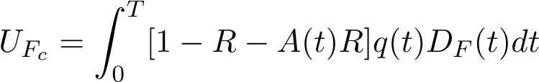 (2)
Where :
-D_{F}(t) designates the discount factor for 1 dollar received at time t
-q(t) designates the default probability density
-R designates the expectation of the recovery rate on debt in case of bankruptcy.
-A(t) designates the accrued interest on the bond at time t
Furthermore, Equation (1) can be extended when the yield curve is not flat.
Equation (1) means that any dollar variation of the upfront value of the CDS is going to increase or decrease by the same amount the market value of the corporate bond. In particular any increase in the credit spread is going to increase the upfront value of credit protection and decrease by the same amount the value of the corporate bond.

1.2 Bond Basis Arbitrage Against Credit Derivatives in the Context of the FTT Introduction
Equation (1) links the respective prices of the risk free rate bond, and the upfront value of the CDS and corporate bond. It allows the possible arbitrage between corporate bond and risk free bond prices as well as CDS prices. The possibility of an arbitrage occurs every time, the respective market prices or expected transaction prices observed on the market are such that equation (1) does not hold. It can happen, for instance, when the price of the corporate bond is below its theoretical price built up from the observation of the risk free bond price and the CDS price.
In the case of a floating rate bond, it happens when the spread of the corporate bond which includes in its spread an implicit credit default protection, does not correspond to the spread of the CDS, after deduction of possible transaction costs. Those costs consist generally of bid-ask spreads on the respective prices of both bonds and CDS. The difference between the bond credit spread and the CDS spread is called the ”basis”.
For instance, buying the corporate bond price, selling the government bond and selling protection trough a CDS would constitute such an arbitrage in the case where the bond price would be lower than its theoretical value. Assuming:
P_{Rfb} is the bid price of a risk free bond
U_{Fcb} is the corresponding bid upfront value of the CDS
P_{cb} is the bid price of the corporate bond observed on the secondary bond market.
We are interested in the bid price of the corporate bond
The arbitrage consists of buying a corporate bond, funding the purchase through a repo, buying credit default protection, and finally selling the risk free into the market. a- Before the introduction the FTT the cash flow (CF) of such arbitrage writes.
CF = PRfb − UFcb − Pcb
The corporate cash bond price insuring the breakeven (CF = 0) of the arbitrage is:
Pcb = PR_{fb} − UF_{cb}
After the FTT is introduced, additional transaction costs in the arbitrage have to be considered. The buyer of the corporate bond (counterpart A) executes 3 different transactions with opposing counterparts:
- 2 bond transactions consisting respectively in the purchase of the corporate bond and the sale of the risk free bond. - 1 transaction consisting of buying credit protection.
The opposing counterparts (counterpart B) mirror those trades and execute symmetrically the same kind of transactions, the sign being changed.
Under the FTT regime bond transactions are taxed for their amount at the rate of the 0.1 percent, whereas the CDS transaction, as a derivative, will be subject to a tax levied at a rate of 0.01 percent on its nominal amount N.
We assume that all counterparts are passing their transaction costs in their quoted price.
Consequently, the new bid-price quoted by counterpart B at which counterpart A sells the risk free bond is (1−t)P_{Rfb} and the sale is itself subject to the FTT rate of t leading to proceeds amounting to (1 − t)²P_{Rfb}.
The new asking price for the counterpart B is (1 + t)²P_{cb} The new breakeven price is:
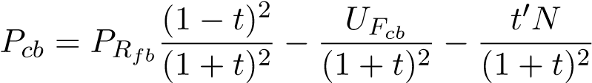 (3)
We can see immediately that the introduction of the FTT generates an additional cost of 0.4 percent. In order to be break-even, the basis arbitrage will then have to consider is going to increase the basis between the CDS upfront value and the corporate cash bond by 0.4 percent.
Finally, corporate firms on the secondary market will have to lower their offering price by 0.4 percent of the notional value to accommodate for the introduction of the FTT. This price impact will then be transmitted to the primary market. This price impact does not consider the possible reaction of the CDS spread and the upfront value of the CDS to the introduction of the FTT.

2 Arbitrage between Credit Derivatives and Equity Derivatives

2.1 Theoretical Static Hedging of a CDS with Put Equity Options
”Convertible arbitrage” strategies consist in trading a convertible bond, either against the equity or a discount bond of the same corporate issuer. This concept has been further extended into the concept of ”capital structure arbitrage”, now a market standard, which consists in arbitraging various financing instruments of the same corporation. The justification for this arbitrage is explicit in Modigliani-Miller’s work.
As a consequence of the developments of capital markets, and also because of the ModiglianiMiller’s justification, equity derivatives, credit derivatives and corporate bond markets are all interconnected. Equity volatility and corporate credit spreads can be arbitrated against each other. This arbitrage can be used for hedging purposes. For instance, economic agents insuring the credit risk on a specific issuer through a credit default swap (CDS), might hedge their exposure by buying a put on the corporate equity share. The put option will have to match exactly the CDS maturity. It is always possible to build up a natural or na¨ıve hedge against corporate Default by considering plain vanilla or exotic options such as binary or barrier options written directly on the corporate stock. Such exotic options are preferred because they are generally cheaper than plain vanilla options.
It is now a trend in today’s market that the CDS liquidity is dwindling down due to a tighter regulation. In this context, the hedging of CDS through equity options tends to develop at a fast pace.
It might happen, that there is not enough liquidity on the put option market for long dated maturities and out of the Money options. In this case, it is always possible to get the same protection level as the one provided by the put, by using a replicating portfolio consisting of short positions on the shares. By doing so, the agent willing to hedge will expose himself to the cascading effects of the FTT. He will support the transaction costs on the replicating portfolio, as well as the FTT on the replicating portfolio funding, as the FTT affects also the repurchase transactions.
Consequently, the occurrence of default and the fall of the firm’s stock value below a certain threshold are highly correlated.
Proposition 1: Existence of Self-Financed Hedging Strategies against Credit Risk using Equity Options.
Hypothesis
- Let us assume an economic agent A which sells credit protection against the default of a corporation F, through a credit default swap (CDS) for a notional amount of M, a spread of s∗. T the duration of the credit protection is expressed in years.
- The recovery rate of the debt R is assumed to be known and constant. The upfront value of the CDS is UF_{c}. The corporation is assumed to have issues equity shares which are traded actively. The value of the underlying equity at hedge inception is S₀.
- The credit protection applies to the non recoverable part of the debt, i.e the portion of debt inexcess of the liquidation value of corporate assets. This means that a corporate bond holder having bought credit protection will recover its capital and accrued interest by redeeming its bond to the credit protection seller.
- It is expected that in case of bankruptcy, the stock value will be ”close” to nil.
- The inception of the hedge is a a time where the company is not in bankruptcy.
Conclusion
- There exists a self-financed hedging strategy consisting of buying American binary put equityoptions to hedge against the cost of credit risk.
This means that NB = UF_{c}
- The pay-out B of each American option and the number N of options purchased are linked by the relationship:
NB = M(1 − R)
(vii) The strike price K∗ is:
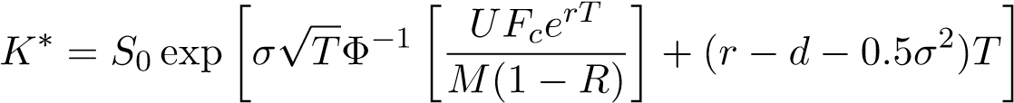 (4)
where Φ⁻¹ designates the inverse function of the cumulative distribution of the standardized gaussian distribution (mean=0; standard deviation=1)
Proof
Because we are ”far” from bankruptcy (S₀ >> K) we can consider that the difference in value between the binary American and the binary European option is insignificant. In any case, because the value of the American Put is in general more than the value of a European Put, using the European Put value as a proxy will lead to a lower bound of the credit protection. n designates the number of options. The self financing condition imposes that:
nP(K,B) = UF_{c}
whereas the static hedging at bankruptcy leads to:
nB = M(1 − R)
From Black-Scholes, Black and Scholes (1973) we know that the value of the Binary European put paying B and whose strike is K is
P(K,B) = exp^{−rT} BN(−d2)
with the usual notations such that :
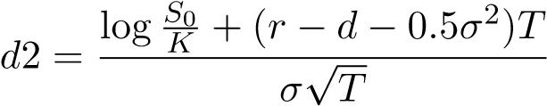
Combining the self-financing and hedging conditions, we eliminate n, apply the inverse function of the cumulative distribution and find that:
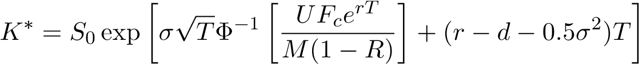
which is the expected result.

2.2 Static Hedging of a CDS with Put Equity Options: Theoretical Impact of the FTT
Once the hedge of the CDS with the binary put equity option is executed, the combined position consisting of selling protection on the CDS and buying the binary put, can be viewed as a contingent instrument, whose value is zero in case of bankruptcy, if we assume that the equity share price will be close to nil in that case. In other words, the purchase of the Put and the payment of the corresponding premium offsets the obligation to pay the portion of the debt in excess of the recoverable amount on the assets.
According to the pricing of CDS, the net Present Value of the premium paid must be equal to the contingent payment in case of bankruptcy.
This writes:
UF_{c}(σ⁰) + P(K,B,σ⁰) = 0  and | (5)
UF_{c}(σ) + P(K,B,σ) = 0  This leads to: | (6)
UF_{c}(σ⁰) − UF_{c}(σ) = −P(K,B,σ⁰) + P(K,B,σ) = 0 | (7)
We have then the following proposition
Proposition 2:
(i) Assuming that am agent sells credit protection on corporate debt for a notional amount M, and a recovery rate R hedges its risk by buying n units of a Binary American Put P(K,B) paying a fixed amount B and whose strike is K. such that:
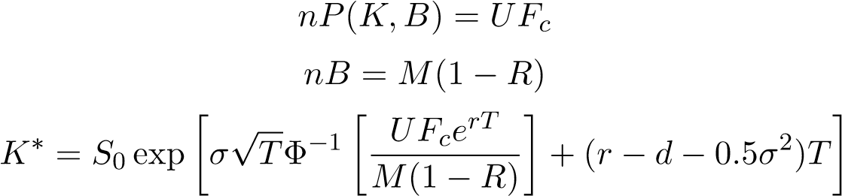
Then the CDS spread variation ∆S corresponding to an increase in the equity share price volatility σ can be approximated by ∆S∗ which is solution of the following equation:
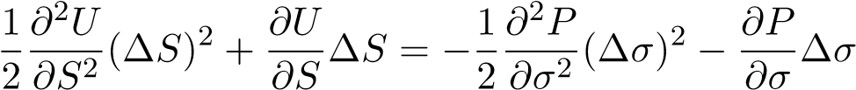 (8)
Proof:
The proof comes directly from equation (4) and a second order development of both ∆U and ∆P.
In equation (6), all terms but ∆S are known as they measure the sensitivities of respectively the CDS and the Option towards the credit spread and the volatility. Consequently, ∆S can be computed.

2.3 Numerical illustration of the FTT Impact when CDS is hedged with a Put
The following example illustrates the possible hedging of a CDS position by a put written directly on the stock. This is because, in case of a corporate default, the value of the stock will decrease sharply and tend to zero. Shareholders will only get the residual value remaining, if any, after all creditors have been paid.
Assumptions and Initial Hedge
- We consider AXA (Ticker CS. FP) a world known insurance company listed on the Paris Stock Exchange market
- On the 30/09/2016, the CDS-spread for a 5-year protection under standard default conditions, is 74.75 basis points per annum, for a 10 MM Euro notional amount.
- The sensitivity of the CDS value toward a 1 basis point variation is 4,915 Euro. Upfront cost for the CDS is 318,700 Euros assumed to be mid-value.
- Risk free yield rate is 0.5 percent.
- The stock spot price S₀ is 22 Euros constant dividend yield is assumed to be 6.5 percent
- A possible hedging consists of an American binary put option whose strike K is 4.0010276 Euros (rounded to 4 Euros) and whose cash pay-out is 4 Euros. In order to cover the part of the debt which is not recoverable in the case of the bankruptcy to 6 MM Euros (computed as (1 − 0.4) ∗ 10 MM), we need 6,000,000/4 = 1,500,000 binary put options.
As we consider to be reasonably far from bankruptcy, we assume that at most, the premium of the American option is going to be no more than the premium of the European put option which is considered then as an acceptable hedge. The European put option premium is 0.2125 Euros, for a volatility of 32.03 percent. The cost of buying those put options is then 318,700 Euros to be compared to the upfront CDS value of Euros 318,700 Euros.
Impact of the FTT
- We then consider the increase in volatility that the market-maker will have to consider if he applies a 2 percent ∆_{s} hedging rule.
- The volatility level is bumped to 37.984 percent. he put premium amounts to 0.42737197 and the total cost of hedging is now 641,058 Euros hence an increase of 322,358 Euros.
- Applying the sensitivity of the CDS toward a 1 basis point variation of 4,915 Euros, and ignoring the second order (convexity) effects, we find this is consistent with an increase of
65.58 basis points per annum of the credit spread.
Remark:
Such calculation constitutes a ”proxy” and a lower bound of the total impact of the FTT on the 5 years Credit Spread. This is because we have considered that the value of the American put was equal to the value of the European put, whereas generally European put options are cheaper than American ones.
However, such calculation of the volatility level allowing the arbitrage between the CDS and the put is still possible, for example using Monte-Carlo simulation. Such approach allow the possibility of factoring in a non constant volatility. Though this is possible, we will then jump, for simplicity reasons, to ”Off the Shelf” calculation models which are widely used by market practitioners.

3 Capital Structure Arbitrage Using Structural Models
Structural models of the Corporate firm have been pioneered by Modigliani and Miller (1958) and later, by Merton. Following the latter, such models derive the probability of default of the corporation from the level of assets relatively to the existing debt. They take into account the asset volatility which commands directly the probability of default. Using then assumptions on the recovery rate of the debt, it is then possible to derive the credit spread on the debt issued by the corporation.
Capital Markets are using extensively using such approach to conduct capital structure arbitrage between various financing instruments issued by the same corporate firm, such as equity and corporate bonds. An illustration of such arbitrage, is the convertible arbitrage, which takes advantage of the differences between the convertible bond price, (in which a call option for the issuer is embedded into the bond) and the equity,
Following the introduction of the Black-Scholes Option framework, Merton has introduced a quantitative model of the firm linking Credit Default, and Equity Derivatives. This framework has been completed later by Black and Cox and has known several adaptions.

3.1 Merton’s Original Structural Model
3.1.1 Theory
Merton Model Assumptions
- The firm’s asset value follows a geometric brownian motion process with drift.
dA_{t} = µA_{t}dt + σA_{t}dW_{t} A₀ > 0
where µ is the mean return of the assets and σ is the asset volatility.
- We assume there is no bankruptcy charges. We introduce a modification on the original work ofMerton by supposing the existence of friction costs such as transaction costs and the introduction of the FTT. According to chapter I, this can be taken into account by considering a modified volatility σ_{a}, computed for instance by applying Boyle and Vorst formula, in the case we consider a constant volatility or by Monte-Carlo simulation, as described in chapter I.
- Corporate firms whose shares are listed on main stock exchanges usually issue bonds with fixedmaturity or shares in order to raise capital from the market. We consider the debt consist of a representative zero coupon bond with a face value D and maturity T. At bond maturity, if A_{T} > D then the debt is repaid using the assets, otherwise in case A_{T} < D bond holders exercise a debt covenant allowing them the right to liquidate the firm.
In this case of a bankruptcy, shareholders, can ”walk away” from their debt by abandoning the assets to the bond holders (creditors).
Merton Model Results
- Shareholders They are detaining in fact a call option on the assets whose strike price is exactly the facial amount of the Debt D
This is explained, because of the debt covenant agreed upon at the time when the debt is issued. According to this covenant, in case of a bankruptcy, shareholders, can ”walk away” from their debt by abandoning the assets to the creditors. This possibility is equivalent in fact to being long of a put option on the corporate assets whose strike price is the facial debt value. Shareholders are then long of a put option written on the corporate firm assets and are owning the assets. According to the call-put parity relationship, this is equivalent to be long of a call on the assets whose strike price is the face value of the corporate debt.
- Bond holders
Conversely, corporate creditors are short of the put option on the assets described above, and are detaining a zero coupon bond. Consequently, for an amount of 1 dollar notional debt, the value of the debt D(t,T) at time t, writes:
D(t) = Ate−d(T−t)N(−d1∗) + De−r(T−t)N(d2∗) (9)
with
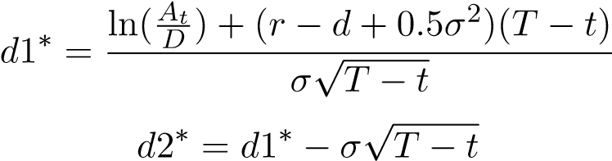
Merton considers that the spread of the corporate bond is such that it will pay for the premium of the put option sold to the shareholder. However, such interpretation considers only the amount of debt which is recoverable on the assets and not the unrecoverable amount of debt in excess of the assets at bankruptcy. For this reason, the credit spread computed using Merton’s framework, is not directly comparable to the spread of a CDS. This later one, considers in fact the amount of debt in excess of the assets (i.e in that case, (1 − R)D), in such a way that a bond holder buying protection will be made whole in case of bankruptcy by redeeming the bond to the agent selling credit protection. In usual cases where R is generally comprised between 0.25 and 0.40 this leads to underestimate the impact on the credit spread of an increase in the asset volatility. This difference is the reason for the abundance, in the literature, of the discussion around the ”credit spread puzzle” which designates the discrepancy between the calibrated spreads using Merton model and the CDS spreads observed in the market.
The Merton framework, considers the notion of the spread of a zero coupon bond over a risk free bond. This spread is designated as the Z-spread and is different from the notion of CDS spread we saw before. This Z-spread is the difference between the respective yield to maturity of the zero coupon corporate bond and the zero coupon risk free bond. According to Merton, (and with all the caveats discussed above) it is then given by:
D(t) = De−ρ(T−t)
and
s∗ = ρ − r
.
(10)
Remarks: In addition to the remark formulated above, Merton assumptions do not consider the possibility of an intermediate bankruptcy due to a shortfall in the assets, and occurring before bond debt maturity. This is an additional reason explaining why that the application of the Merton model will underestimate the impact of the FTT on credit spreads, because it omits an important case of possible bankruptcy.
3.1.2 Numerical Application: Merton Model Calibration and First estimation of the FTT impact on Credit Spreads
Using the equation above, we can conduct a calibration of the Merton model on Z- spreads and then derive the implied volatility of the assets which is consistent with Z-spread market values.
Applying chapter I, we can compute the impact on share price volatility of the introduction of the FTT. The difficulty lies into the fact that the asset volatility is not directly observable on the markets. One can see directly that the following relationship holds:
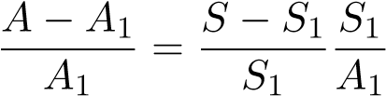
which writes:
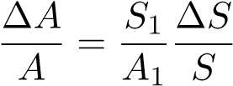
Because A_{t} = S_{t} + D_{t} at any time t we then derive a ”proxy” relation between asset volatility and stock volatility.
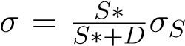 where S∗ is the average stock price to be retained which is also to be computed by
calibration. This means that there is for any value of σ a constant λ;λ < 1 such that σ = λσ_{S} . Consequently, we can apply the Boyle and Vorst rules to accommodate for transaction costs directly on the asset volatility obtained by calibration in order to get the new spread. The calculation displayed in the following table do consider the Merton’s formula for the Z-Spread.
Numerical results
Comments:
For the reason stated above, we consider that this calibration is going to underestimate the real impact of the FTT. Conversely, such Merton based calibration will give us a lower conservative bound of the overall effect of the FTT, we want to estimate.
Table 1: FTT Impact on the Z-spreads for a sample of Three European Corporate Firms Using the Calibrated Merton Model
Issuer | 5Y-Spread | σA | Modified σ_{A} | 5Y-∆ | 10Y-∆ | 15Y-∆ | 20Y-∆
Alsthom | 82.3 | 0.3603 | 0.4273 | 51.3 | 48.5 | 45.0 | 43.3
Arcelor-Mittal | 364.93 | 0.4044 | 0.4785 | 81.8 | 63.9 | 57.0 | 53.0
Michelin | 47.1 | 0.35 | 0.4063 | 34.0 | 37.8 | 36.5 | 34.9
Using this remark, one can see directly, that for those three corporations, the impact on the cost of capital is already between 4 and 7 times the impact computed by Lendvai et al. (2012).

3.2 Black and Cox Structural Model and Further Extensions: The CreditGrades R Model
Further developments of this structural model were introduced by Black and Cox (1976), developed later by Leland (1994), then by Vasicek and Vasicek) (2012). According to these authors, an additional event of corporate default can be considered when the asset value of a firm crosses a predetermined threshold (”default barrier”).This concept is largely used nowadays in the credit markets. For instance, some instruments such as collateralized debt obligations (CDOs) retain a notion of default for any given corporate risk, which is defined in terms of the corporate equity share value dropping below a predetermined threshold.
3.2.1 Black and Cox Structural Model
We still assume the fact that the value of assets follows a stochastic diffusion process:
dA_{t} = µ dt + σdW_{t}
Also, it is considered that the corporate debt is itself a zero-coupon based. We designate by K the face value of debt at maturity T. As per the Merton model, the Black-Cox model assumes that the default can occur at the maturity date of the debt, if the level of asset is insufficient to pay-off the debt. In addition, it considers that corporate default can be triggered, before the bond maturity, in case the value of assets falls below a predetermined level. We consider a time dependant barrier such that
Kt = K0ekt
with K₀ ≤ Ke^{−kT}. The default time is given by;
τ = inf [t > 0;A_{t} < K_{t}]
Consequently, the occurence of a corporate default can be directly related to the path followed by the corporate assets value. Then the default time is in fact given by the first passage time distribution of a Brownian motion process with drift.
- Probability of default:
One can see directly that:
At < Kt
is equivalent to:
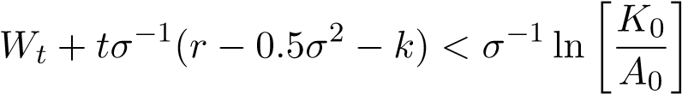
The risk neutral probability Q of having a default occurring before t with t < T is the probability for the asset value A_{t} of getting lower or equal to the barrier K_{t}: with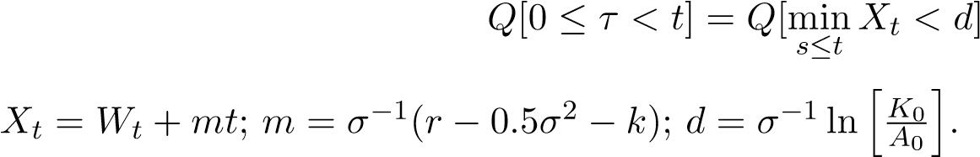
The formula can be expressed as:
Q[minX_{t} < d] = 1 − FP(−d,−m,t) s≤t
with
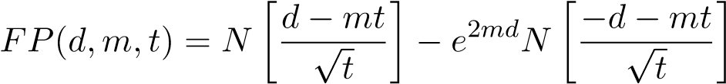
- Shareholder’s Value
Because shareholders get a payment at maturity only if there is no default in between and the amount of asset is sufficient to pay-off the debt, the payout at maturity is similar to the pay-off of a Down and Out call option on the capitalized initial asset price whose strike price is K. The value of the share can be then derived by using the well know calculation closed formula for such barrier option derived from Black and Scholes.
We designate the characteristic function which is is equal to 1 whenever there is no time value such that the barrier is touched before maturity (respectively zero whenever the barrier is touched before maturity) by:
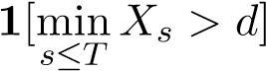
The value of the share then writes:
max[A_{T} − K,0]1[minX_{s} > d] s≤T  It can also be expressed as: | (11)
h  max A₀e^{kT}e^{σXT} − K,0^{i}1[minX_{s} > d] | (12)
s≤T
- Bond value
In case of default, the pay-off for bond holders is exactly A_{τ} = D(τ). Given the probability of default, this information allows to compute the CDS spread value insuring bond holders against the risk of corporate default. Alternatively to this ”Credit derivatives” based bond calculation, one can compute the value of the bond debt at any time by considering that the bond value will be the sum of:
- A recovery value in case of default RV
- A contingent pay-off at maturity CP
This writes:
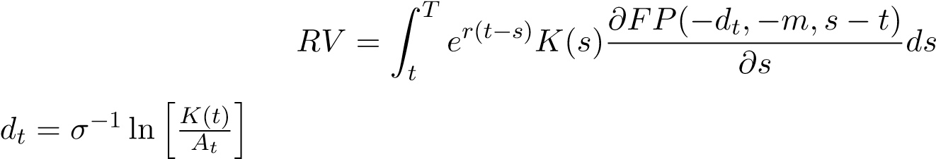
(13)
with
CP = EQ he−r(T−t)[AT − max(AT − K,0)]1(τ>T)i (14)
This last term appears as the difference of two barrier call options, of which one has a zero strike.
3.2.2 CreditGrades R Model Theory
J.P Morgan began to implement in 2002 a service called CreditGrades R (Finkelstein et al., 2002) and began using this approach, using a structural model of the corporation. As in the Black-cox model, Credit grades retains a corporate default, which occurs ever time the value of the assets is below a certain threshold. However, the credit grade models does not consider that the debt is compared at maturity to the level of assets. Consequently, the CreditGrades R model considers that the pay-off for the share holder is similar to holding the assets, paying the debt charges which include the premiums of the CDS built in the corporate bond price and hold an exotic equity derivative. This equity option is sold by the bond holders to the shareholders.
This model appears as the closest to the existing market practice of hedging a CDS with a Put Option, as discussed in paragraph 2.2. Unlike the arbitrage discussed in 2.2 the model captures the ”american feature” of having a corporate default as soon as the corporate asset value crosses a given level determined in reference to the level of facial debt.
Credit grades model uses abundantly former results established by Lardy (2001), Musiela and Rutkowski (1998), which detail the price of the CDS spread insuring the default of the firm defined as above. In a nutshell, this tool deducts corporate credit spreads for CDS for both the company’s asset volatility and leverage. Model assumptions below are quite standard . We use below the notation of the CreditGrades R technical document.
- The corporate asset value V_{t} evolves as a geometric Brownian motion process
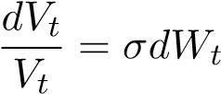
- W_{t} is a standard Brownian motion process, and σ is the asset volatility
- The recovery rate L follows a log-normal distribution with mean L¯ and standard deviation λ.
Corporate debt per share is D. Default does not occur as long as V_{t} > LD d Assumptions (b) and (c) imply that default does not occur as long as at t
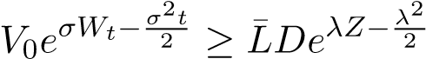 (15)
where Z is a standard normal distribution.
Because of the above equation, assessing the probability of a corporate default comes to evaluate the first hitting time of the Brownian motion process followed by the corporate assets value. By using this distribution it is possible to derive the survival probability of a corporation as in Musiela and Rutkowski (1998) and then compute the implied par spread value of the corresponding CDS as described in Rubinstein and Reiner (1991). The CreditGrades model uses those results by linking the Credit swap spread insuring against corporate default and the corporate asset volatility.
The formulation of the credit spread, s∗ is found in the work of Rubinstein and Reiner as well as in the technical documentation on CreditGrades R .
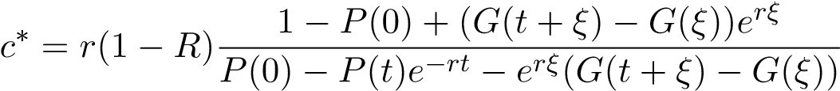 (16)
where
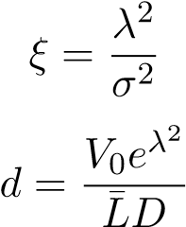
P(t) designates the survival probability at time t and Le designate the expectation of the random variable L.
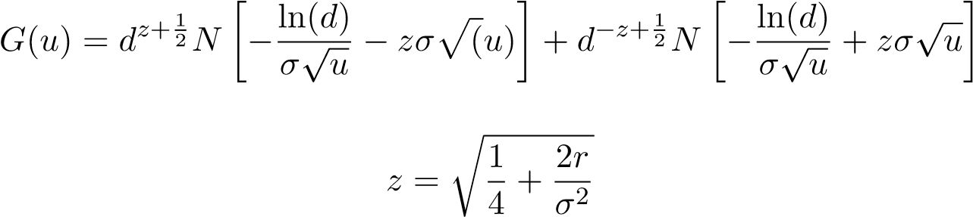
(17)
with
Remark: The formulation retains an origin of time which is 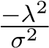. This explains why in the spread calculation above, we have to consider a possible value of P(0) different from 1.
Corporate asset volatility is not directly observable in the market. Therefore one must perform a necessary calibration, for example, to equity volatility. For a given corporate balance sheet structure, it is possible to derive from boundary conditions fulfilled by both equity and asset volatilities, a useful relationship between these two variables. This has been done by various authors such as KMVVasicek and Vasicek) (2012) or JP.MorganFinkelstein et al. (2002). It can be shown (Finkelstein et al. (2002)), that the relationship between asset volatility σ and equity volatility σ_{S} is as follows:
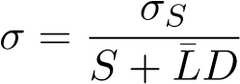 (18)

3.3 Generic Impact of the FTT on CDS Spreads Depending Upon Leverage: Comparative Statics
We consider a ”generic” corporation whose equity implied yearly volatility is 35 percent. We assess first the impact of the FTT on this volatility using our Boyle and Vorst framework. We apply the volatility level ”bump” on the sell side of options, having in mind that the agents selling credit default protection will hedge their positions by buying equity put options to market makers. We then derive, using CreditGrades R , the subsequent generic impact on the Credit Default Swap spread. Depending upon the corporation’s balance sheet structure, this volatility level leads to various credit spreads.
As discussed before, in case there are no existing market-makers, the economic agents will try to recreate a put by replicating a portfolio consisting of shares and cash. In that case, they will incur the same cascading cost effects linked to the FTT. The results are set forth in table 3 below.
Table 2: FTT impact on Corporate Debt cost in basis points per annum for Various Balance Sheet Structures, CDS Recovery Rate:0.4; Global Recovery rate: 0.5
TenorxDebt/Share | 0.5 | 1 | 2 | 3 | 4 | 5 | 10
5Y | 40 | 53.7 | 58.2 | 54 | 50.4 | 46.2 | 33.1
10Y | 50.9 | 57.7 | 57.1 | 53.1 | 58.8 | 54.9 | 32.8
15Y | 54.1 | 57.5 | 55.4 | 51.3 | 57.3 | 53.8 | 32.5
20Y | 54.6 | 56.4 | 55.4 | 49.8 | 46.1 | 42.8 | 32.3

3.4 Quantitative Impact of the FTT on CDS Spreads by Credit Model Calibration
We consider now a set of 6 corporations listed on European stock exchanges (Axa, Michelin, Arcelor Mittal, Alsthom, Commerzbank, Unicredit). Those companies are financial or industrial companies that have both an active credit default swap market and a liquid equity option market, till a maturity of three years. We observe the CDS spreads level for the 5-year tenor. Using the CreditGrades R model and a standard assumption on the recovery rate characteristics (average 0.5 and standard deviation 0.50), we derive the implied equity volatility which is consistent with the 5-year CDS spread levels. This gives us a starting point in terms of credit spreads.
Assuming that the equity option market for 5 to 20 years is illiquid, we apply our results about the FTT impact for non liquid option markets. We compute a theoretical impact on the ”asked price” of implied volatility quoted by option market-makers, for selling put equity options. We then assume a flat volatility forward curve for 5-years and beyond.
This effect is computed assuming a 2 percent based Delta_{s} rule. We use a favorable assumption on the repurchase agreement taxation which is that every operation would be taxed at 0.2 percent, even if the operation is rolled over on several days. Should this assumption fail, and for instance the repo operations be taxed every time they are rolled overnight, we would have to consider that Replication portfolio should be funded at an unsecured deposit rate which is generally higher. This would increase the impact of the FTT on volatility.
We do not consider any impact of stochastic volatility because of the difficulty of calibration of any stochastic volatility model, in the absence of available quotes on the option markets for the 5-years maturity.
Even in the case, where no option market-maker would willing to quote on that market, the calculation stays the same, as it is still possible to reproduce a put option using a replication portfolio consisting of selling shares, self-financed by the upfront value of the CDS.
For the two reasons mentioned above our calculation represents a minimum of the possible impact on quoted volatility and therefore on credit spreads.
We find (cf Table 4 below) that the FTT triggers a substantial increase in the cost of funding for these corporations. For the three financial institutions (Axa,Commerzbank, UniCredit) the impact seems to be much lower than for the three industrial companies (Alsthom, Arcelor-Mittal, Michelin). For the three financial institutions, the impact ranges between 27 and 47 basis points per annum, which represents between 20 and 50 percent of relative increase of the credit spread.
For the three industrial companies, the increase in the credit spreads ranges from 56 to 174 basis points, and for Michelin and Alsthom is consistent with a doubling of the credit spread at 5 years.
The results compare to the analysis performed by DGLendvai et al. (2012). This study uses a general equilibrium model and concludes that the introduction of the FTT would lead to an increase of 9 basis points per annum of the cost of capital for European corporations.
By contrast, we find an impact that is between 5 and 20 times more, and which depends upon the balance sheet of the corporation considered, as well as the implied volatility of its equity shares (recall that our calculation is based upon a lenient assumption on the final decision about the taxation of stock lending and borrowing).
Because of the connection between CDS and corporate bond markets through ”basis arbitrage” , this increase is likely to propagate to the bond market.
Table 3: FTT Impact on the CDS spreads for a sample of six European Corporate
Firms
Issuer | 5Y-Spread | σ | Modified σ | 5Y-∆ | 10Y-∆ | 15Y-∆ | 20Y-∆
Alsthom | 82.3 | 0.4058 | 0.4801 | 55.83 | 66.05 | 65.05 | 63.45
Arcelor-Mittal | 364.93 | 0.5502 | 0.6513 | 173.16 | 156.37 | 145.48 | 139.22
Axa | 73.62 | 0.28 | 0.3313 | 37.46 | 44.75 | 49.70 | 44.97
Commerzbank | 130.47 | 0.2 | 0.2366 | 26.39 | 27.42 | 27.24 | 26.61
Michelin | 47.01 | 0.41 | 0.4851 | 55.69 | 79.62 | 81.84 | 79.96
UniCredit | 188.9 | 0.228 | 0.2698 | 46.44 | 43.52 | 40.02 | 37.02

3.5 The Consequences on The Secondary Cash Corporate Bond Markets
The increase in the Credit Default Swap Spread generated by the increase in volatility as well as the increase in the corporate bond basis will translate directly into a decrease in the corporate bond prices due to the sensitivity of the bond price toward the Bond interest rate.
Table 4 evidences the bond price impact on the secondary bond market for the sample of - corporate companies considered before, for various bond maturities. One can note a wide range of price impact, which ranges from 3 percent to 80 percent, depending upon the corporate company initial rating, its balance sheet structure and the bond’s maturity.
Table 4: Corporate Bond Relative Value Variation in Percentage of Market prices for a sample of six European Corporate Firms Depending Upon Bond Maturity
Issuer | 5Y-Impact | 10Y-Impact | 15Y-Impact | 20Y-Impact
Alsthom | -3.99 | -8.3 | -12.38 | -16.98
Arcelor-Mittal | -11.82 | -26.55 | -45.34 | -81.46
Axa | -3.72 | -5.72 | -8.84 | -10.47
Commerzbank | -2.23 | -4.76 | -9.66 | -11.81
Michelin | -3.70 | -9.12 | -13.5 | -17.06
UniCredit | -3.41 | -6.14 | -8.76 | -11.38

4 Conclusion
In part I, we have reviewed the interconnection between bond, credit and equity derivatives markets through simple arbitrages aimed to take advantage of the differences between those financial instruments, or for hedging purposes. As an illustration, of the fact that more and more Credit Default Swap (CDS) market-makers rely on equity put options for hedging, we reviewed the specific case of AXA a well known financial institution and derived the rule of hedging for CDS.
In part II, we have considered structural models of the corporate firm, which give a theoretical framework for capital structure arbitrage (CSE) between the various funding instruments issued by the same corporate firm. Such arbitrage dates back to Modigliani-Miller proposition, whose corollary is that all debt related instruments issued by a corporate firm can be arbitrated one against another.
We have first considered voluntarily a stripped version based on Merton model that we calibrated using the CDS market as of 30/09/2016. We derived a maximum theoretical impact, which establish a lower bound fro the FTT impact, given the limitation of the Merton model. We found, that even using such model, the theoretical impact of the FTT could be a multiple of what is currently assessed by the EEC.
Second, we focused on Credit Grades which is an ”Off-the-Shelf” arbitrage model derived from the Black-Cox framework and which links equity derivatives volatility and credit spreads. This model is abundantly used in today’s markets and is based, too, on capital structure arbitrage. We have then used the fact, that the equity put option market for long dated maturities is quite illiquid. According to part I, the introduction of the FTT in such markets should have a maximum increasing effect on the implied volatility, for option buyers.
Using then the Credit Grades model, we derive the theoretical impact of the FTT introduction on Credit Default Swaps (CDS) spreads depending upon balance sheet term structure and implied volatility. We find a significant effect of the FTT on the CDS spreads.
Going further, we sample a group of six corporate companies and snap the corresponding CDS spreads on the Credit Default Swap markets as of 30/09/2016. For each company, using their balance sheet structure, we derive a theoretical ATM volatility consistent with those CDS spreads. We then apply a systematic shock on the implied volatility using Boyle and Vorst calculation and the FTT rates as they stand in the EEC project (Lendvai et al., 2012).
We finally derive the effect on the CDS spreads using again Credit Grades Model. As explained, in section 2.3, we find in one case, that the effect of the introduction of the FTT could be about 20 times the impact as it has been computed by the EEC.
Finally, using both the impact on the arbitrage between CDS and bonds and CDS and equity derivatives, we have derived the final impact of the FTT on the corporate bond market. As evidenced before, this impact is balance sheet dependent. We found that the potential impact on the corporate bond market can be very significant, especially for corporate firms with an unfavorable balance sheet structure. This potential impact might conduct to a very sharp decrease of the prices recorded on the corporate bond markets, leading in some cases to financial turmoil.
From an economic policy standpoint, results evidence that the FTT effect will bear heavily on the high yield corporate bond market. The magnitude particularly heavy for industrial firms, suggests that even if the FTT is introduced in all the EEC and targets financial institutions, its effects go well beyond the EEC borders. For instance, considering the case of ”Arcelor Mittal” corporation, a well known steel mill, the potential drop in its bond price would literally impeach this company to find competitive financing, and could even drive this company into default. This would create a strong distortion in competitiveness as the company’s main competitors are outside the EEC.

References
Allen, P., Einchcomb, S., and Granger, N. (2006). Investment strategies. JP Morgan–European Equity Derivatives Research, (28).
Almgren, R. and Chriss, N. (2001). Optimal execution of portfolio transactions. Journal of Risk, 3:5–40.
Altman, E. I. (1968). Financial ratios, discriminant analysis and the prediction of corporate bankruptcy. The journal of finance, 23(4):589–609.
Amihud, Y. and Mendelson, H. (1991). Liquidity, asset prices and financial policy. Financial Analysts Journal, 47(6):56–66.
Anthony, J., Bijlsma, M., Elbourne, A., Lever, M., and Zwart, G. (2012). Financial transaction tax: review and assessment. CPB Netherlands Bureau For Economic Policy Analysis. CPB Discussion Paper.
Avellaneda, M. and Stoikov, S. (2008). High-frequency trading in a limit order book. Quantitative Finance, 8(3):217–224.
Black, F. and Cox, J. C. (1976). Valuing corporate securities: Some effects of bond indenture provisions. The Journal of Finance, 31(2):351–367.
Black, F. and Scholes, M. (1973). The pricing of options and corporate liabilities. Journal of political economy, 81(3):637–654.
Boyle, P. P. and Vorst, T. (1992). Option replication in discrete time with transaction costs. The Journal of Finance, 47(1):271–293.
Duffie, D. and Singleton, K. J. (1999). Modeling term structures of defaultable bonds. The review of financial studies, 12(4):687–720.
Finkelstein, V. (2013). Assessing default probabilities from equity markets. Presentation, Credit Risk Summit.
Finkelstein, V. and Lardy, J. (2001). Assessing default probabilities from equity markets. simple closed-form solution. Presentation ICBI Global Derivatives and Risk Management, Credit Risk.
Finkelstein, V., Lardy, J., Pan, G., Ta, T., and Tierney, J. (2002). Credit grades technical document.
Habermeier, K. and Kirilenko, A. A. (2003). Securities transaction taxes and financial markets. IMF Staff Papers, Special Issue International Monetary Fund, 50(1):165–180.
Hakkio, C. S. et al. (1994). Should we throw sand in the gears of financial markets? Economic Review, 79:17–30.
Hawkins, M. and McCrae, J. (2002). Stamp duty on share transactions: is there a case for change? Institute For Fiscal Studies.
Ho, T. and Stoll, H. R. (1980). On dealer markets under competition. The Journal of Finance, 35(2):259–267.
Ho, T. S. and Macris, R. G. (1984). Dealer bid-ask quotes and transaction prices: An empirical study of some amex options. The Journal of Finance, 39(1):23–45.
Jarrow, R. A. and Turnbull, S. M. (1995). Pricing derivatives on financial securities subject to credit risk. The journal of finance, 50(1):53–85.
Kupiec, P. (June 1996). Noise traders, excess volatility, and a securities transaction tax. Journal of Financial Services Reseach, 10(2):115–129.
Lardy, J.-P. (2001). A simple closed-form formula to price credit. Presentation, Risk, Paris.
Leland, H. (1985). Option pricing and replication with transaction costs. The Journal of Finance, 40:1283–1301.
Leland, H. (1994). Corporate debt value, bond covenants, and optimal capital structure. The Journal of Finance, 49:1213–1252.
Leland, H. E. et al. (2007). Comments on ”hedging errors with leland’s option model in the presence of transactions costs”. Finance Research Letters, 4(3):200–202. Haas School of Business, University of California, Berkeley, USA.
Lendvai, J., Raciborski, R., and Vogel, L. (2012). Securities transaction taxes: Macroeconomic implications in a general equilibrium model. European Economy: Economic Papers, (450).
Matheson, M. T. (2003). Taxing financial transactions: Issues and evidence, volume 3, Special Issue. IMF Staff Papers, International Monetary Fund.
Modigliani, F. and Miller, M. H. (1958). The cost of capital, corporation finance and the theory of investment. The American economic review, 48(3):261–297.
Musiela, M. and Rutkowski, M. (1998). Martingale methods in financial modeling, 2nd edition. Stochastic Modelling and Applied Probability, 36.
Oxera (2007). Stamp duty: Its impact and the benefits of its abolition. Prepared for ABI, City of London Corporation, IMA and London Stock Exchange.
Oxera (2014). What could be the economic impact of the proposed financial transaction tax? a comprehensive assessment of the potential macroeconomic impact. Technical report, Oxera.
Rubinstein, M. and Reiner, C. (1991). Breaking down the barriers. Risk, 4:28–35.
Saporta, V. and Kan, K. (1997). The effects of stamp duty on the level and volatility of equity prices.
Schwert, G. W. and Seguin, P. J. (1993). Securities transaction taxes: an overview of costs, benefits and unresolved questions. Financial Analysts Journal, 49(5):27–35.
Taleb, N. (2005). Fooled by randomness: The hidden role of chance in life and in the markets, volume 1. Random House Incorporated.
Umlauf, S. R. (1993). Transaction taxes and the behavior of the swedish stock market. Journal of Financial Economics, 33(2):227–240.
Vasicek, O. KMV (Kealhofer, M. and Vasicek) (2012). Structural models in credit valuation. NYU Stern.
Wang, G. and Yau, J. (2012). Would a financial transaction tax affect financial market activity? insights from future markets. Policy Analysis, (702).
Westerholm, P. (2003). The impact of transaction costs on turnover, asset prices and volatility: the cases of sweden’s and finland’s security transaction tax reductions. Liiketaloudellinen Aikakauskirja, pages 213–241.
Chapter III: Study of The Effect of the EU Financial Transaction
Tax on Corporate Stock Markets Prices, Corporate Valuation and Volumes on the Primary Securities Markets ∗
Jean Pierre Fraichot†
LEDa, U. Paris Dauphine, PSL Research University
November 13, 2018

Abstract
We consider the EU project of implementing an FTT for all securities transactions. We study its short and long term impact on the expected theoretical values of corporate equity and debt, as well as corporate firm’s value, under a risk neutral assumption. The risk neutral measure is the one induced by the stochastic diffusion process followed by the corporate asset value.
We use the results of chapter I and II stating that the introduction of the FTT will raise both corporate asset volatility and credit spreads. Using corporate structure models, we find that it will lead to a decrease in both corporate debt and firm valuations. As a consequence, the value of preferred shares, subordinated notes and quasi-equity which all can be likened to perpetual debt will be negatively affected by the introduction of the FTT. We then focus on the impact of the FTT on the theoretical equity share price.
First, we review the case of corporations funded exclusively through equity, quasi-equity, preferred shares and perpetual debt. For such firms, we find that the immediate short term effect consists in an increase of the equity share price, whereas the prices of preferred shares and quasi-equity should drop, as well as the overall firm’s value. In the same time, corporations which are ”perpetual debt free” and are issuing new perpetual debt, would record a drop in the theoretical prices of equity, quasi-equity as well as preferred shares and firm’s value.
Second, we review the case of corporations funded through intermediate fixed term debt. This is the most common way for european corporations to raise debt. In general, we find an immediate price decrease in the equity share price, for intermediate debt maturities (up to 20 years). In this particular case, we find that corporations aiming to keep a constant ratio between the respective values of debt and assets, will record a significant decrease in their debt price. For corporations aiming to keep an optimal capital structure maximizing the corporation value, we find that the drop in equity price is generally greater, while the decrease in the debt price is less important than for fixed capital structure.
The only notable exception for this decrease in equity prices occurs for highly leveraged corporations, with important credit spreads, which are close to bankruptcy and are issuing ”junk-bonds”. In this case, we encounter an ”agency effect”, where the increase in the riskiness of the asset is beneficial for shareholders. Consequently, we find that the introduction of the FTT

∗
I thank Martine Carr´e-Tallon, Ren´e A¨ıd, Jeroˆme Mathis and participants to Doctorants Workshop (Paris Dauphine, June 2016) for useful comments.
†
Address: Universit´e Paris-Dauphine, PSL Research University, LEDa, Place du Mar´echal de Lattre de Tassigny,
75775 Paris Cedex 16, France. E-mail: fraichot@yahoo.com
would create an adverse selection bias, favouring highly leveraged and credit risky corporations issuing junk bonds.
In the long run, we find, that the reaction of corporations to the introduction of the FTT, would favor a drop in the equity share price. In general corporations looking for an optimal capital structure, maximizing the firm’s value, would tend to react by issuing more shares, and deleveraging their balance sheet by substituting equity to debt. This should lead to a negative impact on the equity price through equity dilution. Furthermore, the drop in equity price should increase the volumes issued on the primary markets, every time the corporation choose to issue new equity instead of debt. In the long run, corporate firms raising capital on the primary market will have no other choice than to issue more equity shares available for trading on financial exchanges to raise the same amount of capital. This will, in turn, increase the volumes of shares available for trading. Those findings are different from the literature which generally considers a negative impact on volumes traded by a classical effect of transaction cost increase. This difference is due to the fact that our approaches considers, through structural models, the fact that securities are instruments used for funding corporations, and that their supply is affected by the tax.
We then calibrate both models of perpetual and fixed term debt on a sample of 6 European corporations, funded either through intermediate or perpetual debt. We find a significant negative impact on the theoretical equity share price, as well as a substantial increasing effect on the corporate credit spread.
We find that the impact of the FTT on equity price is itself affected by the level of corporate tax. The drop in theoretical equity prices is stronger for higher risk-free rate levels. A higher corporate tax rate entails a slightly higher price decrease for low leveraged corporations. Conversely, highly leveraged coprorations domiciled in countries with low income tax rate, will record a more significant decrease than the ones located in countries having higher tax rates. Therefore, in order to avoid a competitive distortion, national corporate tax rates would have to be equalized throughout the EU prior to the introduction of the FTT.
Our results which are established on the use of theoretical models appear in line with the results from the existing literature, based on empirical reviews of the stock market prices, following the introduction of a STET in Sweden or the United Kingdom. The magnitude of the depressing effects on the equity share prices are comparable, though the specifics of the FTT in the European project are different from the respective specifics of the STET introduced in both countries.
In addition, we find that the introduction of the FTT conflicts with the goal of the new CRD IV (Basel III) regulation. This regulation requires a minimum capital structure, where the equity and quasi-equity must represent a portion of the asset value greater than a given threshold prescribed by the regulation. This requirement corresponds exactly to our framework consisting of a fixed capital structure. In order to fulfil capital requirements imposed by CRD IV, banks have engineered new types of securities, such as fixed term or perpetual debt, which are convertible in equity, should the equity value fall under a predetermined threshold. We find that the valuation of those securities, can be addressed with our valuation models. We find that the introduction of the FTT, would increase the volatility of shares and lower the value of those instruments having in fact a complete antagonistic effect to the new regulation.
Keywords: Tax reform, options, volatility, liquidity, credit spread
JEL Classifications: G02,G11,G12,H22,H39

Introduction
We consider here the impact of the European Financial Transaction Tax (FTT) on the theoretical prices of corporate equity and quasi-equity. The FTT is in fact a standard turnover excise tax (STET) that would apply certain rates to the notional value of all transactions related to securities and derivatives taking place in the European Union (EU) or performed by financial institutions domiciled in the EU.
The relatively large number of empirical contributions analysing the effect of a Standard Turnover Excise Tax (STET) on asset prices has focused mainly on the corporate stock market. The existing literature relies on theoretical general equilibrium models, simulations and empirical analyses to assess the impact of STETs on the level and volatility of asset prices, capital costs and real investment. Focused on the experience of countries such as the United States (Amihud and Mendelson (1991), Hakkio et al. (1994), Matheson (2011), among others), United Kingdom (Saporta and Kan (1997), Hawkins and McCrae (2002), Oxera (2007)), or Sweden (Umlauf (1993), Westerholm (2003)), it concludes that financial transaction taxes would be associated with a decrease in the price of assets, mainly corporate equity shares, and an increase in the cost of capital.
We follow the path we already took in chapter II, which considers that capital structure arbitrage may occur between the various instruments used by the same corporate firm for its funding. i.e. either equity or debt. Our approach is new and is based on micro-economic characteristics at the corporate level. We consider the possibility that the specifics of a given corporation directly determine the impact of the FTT in terms of capital costs. Therefore we study a framework where a uniform taxation disposition can induce heterogeneous responses at the micro-economic level. There is good reason to review the potential effects of the FTT on capital structure arbitrage between corporate debt and equity.
Modigliani and Miller (1958), postulate corporate indifference between issuing debt or equity, requires the absence of tax and transaction costs. This is not the case where the FTT applies. Second, the existing literature on structural models, such as Leland (1994a) and Leland and Toft (1996) or Black and Cox (1976), suggests that these two asset classes fare differently in the presence of taxation. A review of such models suggests that this is due to tax code provisions favoring financing through corporate debt, by way of a tax deduction for interest payments made to bondholders. Third, the liquidity of both markets is asymmetric, the stock market being generally more liquid than the corporate bond market. This suggests, in the vein of Chapter I, that the cascading effects of the FTT are split among a greater number of players in the stock market than in the corporate bond market.
There exists an abundant literature on structural models linking the default of corporate firms to the behavior of their asset value.Those structural models can be classified according to the maturity of the debt considered, as well as the manner in which the bankruptcy is triggered. First, the bankruptcy is due to exogenous causes and is introduced through the existence of positive net worth covenants attached to the debt. The bankruptcy may be triggered by bond holders as soon as the level of the asset value falls below a predetermined threshold, set as a fixed fraction of the face value of the debt issued by the firm. In the alternative, the bankruptcy may still be based on the asset value falling below a certain threshold, but this threshold is determined endogenously by the company in order to maximize its equity at bankruptcy time
Authors such as Black and Cox, generally assume that the bankruptcy is due to exogenous causes through positive net worth covenants attached to the debt. Leland and Leland and Toft consider both of those possible bankruptcy triggers based on the corporate firm’s asset level. However, in their discussion they mainly consider the endogenous determination of bankruptcy. They proceed to compute the equity value by subtracting the corporate debt from the company value. The above authors explore the possibility for the company to maximize its value by issuing an optimal amount of debt. They prove that the corporate value is inversely related to the asset volatility, and that in the case of an endogenous determination of bankruptcy, there is a natural limitation of the corporate debt capacity when the asset volatility increases. The original work of Leland, assumes, in the vein of Modigliani-Miller, that the debt is perpetual. Further works by Leland and Toft (1996) explore the case where the firm is continuously issuing and reimbursing fixed maturity debt. They find that, in the case of short to intermediate debt maturity, endogenous determination of bankruptcy and capital structure close to the optimal value, any increase in the riskiness of assets will lead to a decrease in equity value, except for very special situations where the corporate firm is on the brink of bankruptcy. However, the work of Leland and Toft was completed at a time when the credit derivatives market was not yet developed, and the main argument that the corporation can choose both the level of coupon paid and the time of bankruptcy suggests that this entity would act as a price maker on the credit derivatives market. This is not not generally the case, and, nowadays the credit derivative prices are set up by demand and supply on the credit default swap market.
We use two simple structural models inspired by Leland (Leland (1994b), and Leland and Toft (1996)). However instead of considering as those authors, an endogenous determination of bankruptcy by the firm itself, we are assuming an exogenous determination of corporate bankruptcy. The bankruptcy is triggered as soon as the value of assets falls below a predetermined threshold set up as a fixed proportion of the outstanding total debt. We assess the quantitative impact of the FTT on the theoretical expectations of equity, quasi-equity, debt and company value, computed under a risk-neutral assumption. The measure considered is the natural risk measure induced by the stochastic diffusion process followed by the corporate assets value. We derive a formulation of a stationary state of the corporate debt for a company funded through the issuance of both perpetual debt and fixed term debt. As a general result we find that both firm’s valuation and corporate debt values are negatively affected by the introduction of the FTT. We then focus on the possible FTT impact on the theoretical equity share price.
First, we compute the effect of the FTT for a corporation funded solely through the issuance of equity and perpetual debt. We find that in the short run the implementation of the FTT will raise the theoretical equity share price for corporations which are already carrying an inventory of perpetual debt on their balance sheet, whereas the prices of preferred shares and quasi-equity should be lower. Conversely, the issuance of new perpetual debt after the introduction of the FTT will tend to lower the equity share price.
Second we focus on companies funded through fixed term debt and find both immediate and long term impacts. The long term impact is computed after the adjustment of the corporation to its new target of principal amount of debt. This target is computed either through a fixed capital structure or an optimal capital structure, aiming to maximize the corporation’s value.
For highly leveraged or very risky entities, paying high credit spreads the increase in the asset volatility following the introduction of the FTT would increase, in fact, immediately, the equity theoretical price, for all debt maturities. This effect, known as the ”agency” effect, was first mentioned in the original work of Leland and Leland and Toft, in the particular case of endogenous determination of bankruptcy. By contrast, in this work, we consider an exogenous cause of bankruptcy. Consequently, the introduction of the FTT would generate an adverse selection bias.
For companies funded through intermediate fixed term debt(5 to 20 years), and under current market conditions, we compute the envelope of capital structure parameters such as leverage and return on equity (ROE), leading to a decrease of the equity share prices, for several debt durations.
We find that for common values of ROE and leverage, the impact will be negative for both short and long run. Using the models described above, we find, for companies funded through fixed term debt, that corporate values and equity share prices will generally be lower for intermediate debt maturity (5 to 20 years). For instance, we find that such is the case for most companies in the French CAC 40 index.
We demonstrate that this negative impact on the above values will increase with both the company’s leverage and the risk-free interest rate, for both fixed term and perpetual debt.
We find that the impact of the FTT will depend upon the combination of corporate tax rate and leverage. Highly leveraged corporations located in countries with low corporate tax rates will record a significantly more important equity price drop than corporations located in countries with higher tax rates. At the same time, corporations with a low leverage and located in countries with high tax rates will record a slightly more important drop in their equity price than the corporations with the same leverage and located in countries with lower tax rates.
We derive that the introduction of the FTT is likely to lead to an increase in the volume of equity shares issued by companies on the primary equity market. In the case of corporations aiming for the maximization of the firm’s value, this increase will lead, in the long run, to a further decrease of the equity share price through dilution. Consequently, we can project that in the long run, the introduction of the FTT will lead to an increase in the volumes traded.
We then calibrate our model on a sample of 6 European companies and find that the introduction of the FTT will lead to a significant decrease in theoretical corporate value and equity price, as well as a substantial increase in corporate credit spreads for those entities.
Generally speaking we find that our results, based on theoretical corporate structure models, are in line with empirical studies realized in the case of Sweden (Umlauf (1993), Westerholm (2003)) as well as for the United Kingdom (Saporta and Kan (1997),Hawkins and McCrae (2002)) and which are based on historical cases of the introduction of a STET for those countries. Though the specifics of the FTT European project are quite different, from the specifics of those two respective STET, we find a significant negative impact and somehow, the magnitude seems to be comparable.
Applying these results to the particular case of banks and financial institutions, in the context of the new CRD IV regulation, we find that the introduction of the FTT may conflict with the aims of CRD IV, as it requires in fact more capital because of the subsequent drop in equity prices.
Our paper is organized as follows: Section 1 is devoted to devising a structural model describing the valuation of equity and quasi-equity; Section 2 studies the impact of the FTT on the equity share price for companies raising capital through equity, perpetual debt and fixed term debt; Section 3 estimates the possible impact of the introduction of the FTT on the theoretical prices of equity for a sample of 6 European companies; Section 4 compares our finding to the results from the existing literature and considers also the FTT impact in the particular case of the banking sector in the CRD IV regulation context. Section 5 sets forth our conclusions.

1 Structural Models of the Corporate Firm Funded through the Issuance of Quasi-Equity, Equity and Debt

1.1 Assumptions on the Default Determination and the Debt Recovery Rate
We will consider that the corporation’s bankruptcy is triggered when the asset value falls below a predetermined threshold, K. At the difference of Leland and Toft, we will consider here an exogenous determination of K where the level of K is computed directly by reference to the level of outstanding debt. We will assume that K = LD where L designates the rate of recovery of the debt on the assets. This situation corresponds, in the absence of a Credit Default Swap market, where the credit risk can be insured, to the existence of Debt covenants allowing the creditors to trigger themselves the corporate bankruptcy, when the level of assets falls behind a fixed predetermined threshold.
In the presence of a Credit Default Swap market, the logic behind is that the coupons paid on the debt, encompass the credit spread premiums of a Credit Default Swap, which covers the non recoverable part of the debt. The recoverable part of the debt is paid directly on the assets. In this framework, corporate firms can run with negative equity for a while, as long as they respect the ”knock-out” barrier condition. Especially, they can further borrow or issue equity to fulfil their debt obligations till their net asset value falls below the level covering the recoverable part of the debt which is also the barrier level triggering the bankruptcy. At this point, they will not be able to borrow more debt or issue more equity.
This condition is quite different from the condition set up by Leland and Toft. Those authors determine a threshold K computed endogenously as a function of asset levels, volatility, risk free rates and credit spreads, which maximizes the equity value for shareholders at bankruptcy time. Thus, the shareholders can choose an optimal time to walk away with a positive equity left, once the company is liquidated and the creditors are paid.
We will consider that in the case the corporate debt is perpetual, its level of seniority is unspecified, provided that the debt issued has only one type of seniority (either junior or senior).
Finally, at the difference of the CreditGrades R model used in chapter II, we will assume that the recovery rate on the debt is constant and not anymore stochastic. This assumption is explained by the fact that, at the time CreditGrades R was released, the Credit default swap (CDS) market was just at its beginning. At this time, it was not possible to issue CDS with a fixed rate of recovery, and assuming a stochastic recovery rate was justified. However, since then, the CDS market has matured, and especially, new instruments such as Recovery Rate Swaps(RRS), allowing to exchange a fixed recovery rate against a variable one, are available on the market. Therefore, it is possible to trade CDS with a fixed recovery rate (Digital Credit Default Swaps or DCDS), by entering into a CDS with a variable rate of recovery and then locking the recovery rate by trading at the same time a recovery rate swap.

1.2 A Structural Model when the Corporate Firm Issues Perpetual Debt
We consider a joint determination of both the corporate debt and corporate equity values, taking into account the tax deductibility of corporate debt interest from the corporate taxable income. We assume that the corporate firm will satisfy its capital funding needs by issuing equity as well as perpetual debt either senior or junior. In this latter case, we will consider that this kind of debt can be deemed as quasi-equity.
We assume that the corporate asset value follows up the differential stochastic equation listed below:
dA_{t} = (r − d)dt + σA_{t}dW_{t} (1)
with A₀ > 0
σ designates the asset volatility and W_{t} designates a standard Wiener process.
r is the risk-free interest rate and d is the continuous yield of the cash dividend paid by the corporate assets.
We know from basic calculus that:
E^{Q}(A_{t}) = A₀ exp[(r − d)t]
where E^{Q} designates the expectation taking the ”natural measure” generated by the process W_{t}.
We then consider a ”perpetual” debt D(A₀,t), allowing a claim on the corporate assets that pays continuously a coupon C(t), as long as the firm is not in default. We assume that the debt reimbursement is subject either to the corporate bankruptcy or its dissolution. The coupon is funded by issuing additional equity either on the market or by ”collecting” the corporate profit.
According to Black and Cox (1976), the value of a ”perpetual” debt D(A₀,t), allowing a claim on the corporate assets that pays continuously a coupon C(t), and does not pay a dividend as long as the firm is not in default, must satisfies the following partial differential equation, pursuant to the application of Ito’s lemma.
∀t > 0
) = 0 (2)
According to Black and Cox, Equation (2) simplifies greatly if the debt does not depend upon time:
∀t > 0 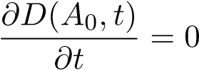
as it is the case for instance for a perpetual debt paying a constant coupon C(t) = C, ∀t > 0.
In this latter case, Black and Cox evidence that equation (2) becomes an ordinary differential equation:
∀t > 0
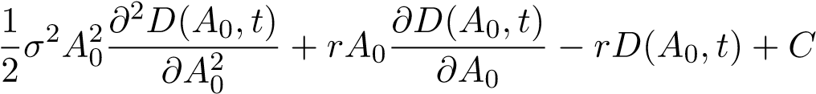= 0 (3)
The general solution of equation (3) is:
(4)
where
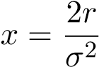
and X₀,X₁,X₂ values are determined by boundaries condition.
If we further assume that there is a cost, α for recovering the debt in case of bankruptcy and that the asset value at bankruptcy time is fixed and amounts to K, we can then explicit the boundary conditions and derive the values for X₀,X₁ and X₂.
Finally, it can be found that:
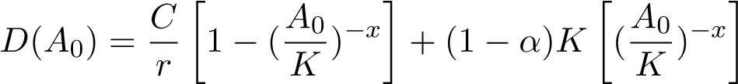 (5)
The first term of the second member of this equation on the right represents the risk neutral expectation of the coupon payment stream whereas the second term represents the expected value of the debt in case of bankruptcy. Then we can focus on the total value of the firm that we note V , and which is the sum of three terms:
- The firm’s asset value
- The future value of the deduction of coupon payments, in case the corporate firm earn enough profit or return from the assets to at least offset the debt coupon payments.
- The negative value of bankruptcy costs
We note ρ the corporate tax rate. This writes:
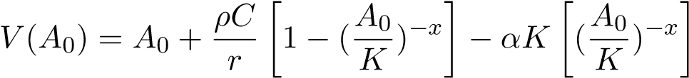 (6)
Finally, by subtracting the debt value to the corporate firm’s value we obtain the value of the equity which writes as follows:
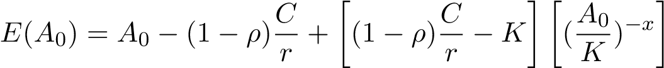 (7)
From equation (5) above, we can derive the coupon yield c of the perpetual debt and the corresponding credit spread s∗ over the risk free interest rate defined as:
s∗ = c − r
with
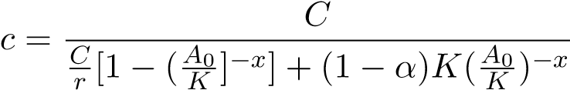
(i) First Alternate Equivalent Formulation The formulation done by Black-Cox and used by Leland and Toft uses a partial differential equation, and alternatively we can consider a valuation of both corporate equity and debt using martingale and risk neutral considerations. We suppose now the general case of a corporation whose assets are paying dividends as in equation (1).
Equation (1) implies the following process for A_{t}.
A_{t} = exp[lnA₀ + σW_{t} + (r − d − 0.5σ²)t] (8)
The bankruptcy condition comes to find the first hitting time τ_{K} defined as the the first hitting time where the process A(t) falls below the value K triggering the default:
τ_{K} = inf[t;A(t) < K]
If we designate by τ_{b} the ”stopping time” or first hitting time t of the Brownian motion W(t) with drift a(t) = (r − d − 0.5σ²)t and standard deviation σ such that:
τ_{b} = inf[t;W_{t} + at < b]
We know from the general properties of the brownian motion process that;
E^{Q}[exp(−ατ_{b})] = exp[b(a + ^{p}a² + 2α)] = L(α,b,a)
with L(α,b,a) being the Laplace transform Φ_{τb}(α)
We consider the particular case where α = r which comes to calculate:
E^{Q}[exp(−rτ_{b})]
which is the discount factor to apply at the time of default.
From equation (8) above, the bankruptcy condition can we written in terms of first hitting time:
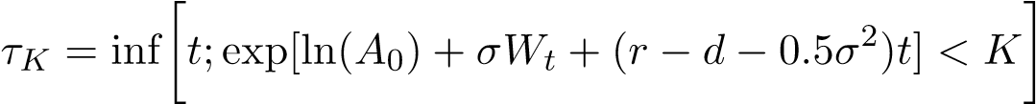
becomes
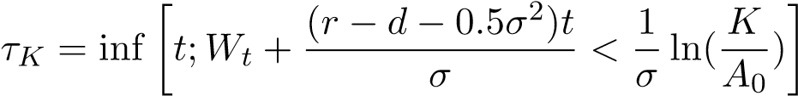
We recognise the first hitting time at:
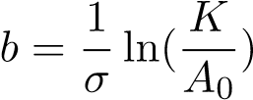
of the motion brownian process with drift coefficient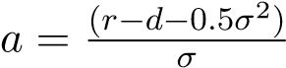 and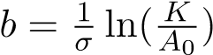
x is defined as:
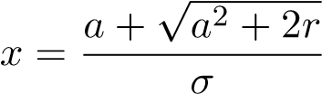 (9)
with a defined as:
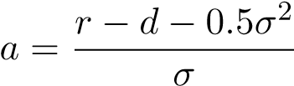 (10)
In the case, there is no dividend payment (d = 0), we find that x reduces to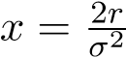.
In order to be consistent with the existing literature, we will consider in fact that we have a drift proportional to the volatility such that we consider a bankruptcy time
τ_{b} = inf[t;W_{t} + aσt ≤ b]
which leads without loss of generality to the new expressions
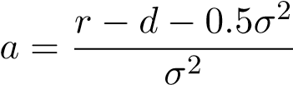 (11)
and
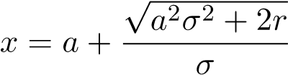 (12)
The expected value E^{Q}[exp(−rτ_{b})] writes:
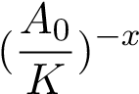
.
The value D₀ of the corporate debt at time t = 0 is the sum of:
- The expected ”recovery” debt value in case of bankruptcy occurring when A_{τb} ≤ K. This expected recovery value is:
(1 − α).E^{Q}[exp(−rτ_{b})]
- The expected discounted cash-flow payments on the corporate debt, either till the credit defaultevent time or the par bond maturity, whatever comes first.
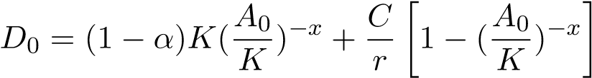 (13)
The value of the firm is:
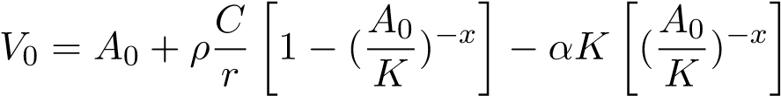 (14)
Consequently the value of the equity we find is:
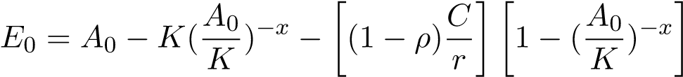 (15)
(ii) Second Alternate Formulation: Equity Value Seen as The Difference between Two Derivatives Instruments
Observing the terms in equation (15), one can remark that the term
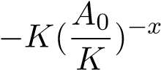
designates in fact the risk neutral expectation of a ”One Touch” perpetual put option written on the assets by the corporate shareholders in favor of the bondholders, and paying an amount K as soon as the strike price K is touched.
Furthermore, the term
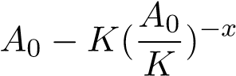
is in fact the premium value of a perpetual ”Down and Out” American call option whose barrier is K.
We can choose to write directly the expected value of the corporation’s equity as:
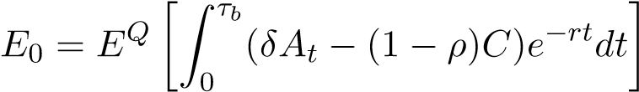 (16)
This leads to:
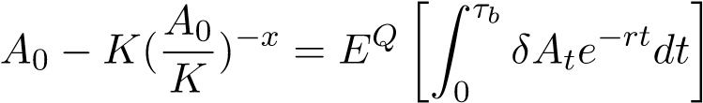 (17)
and
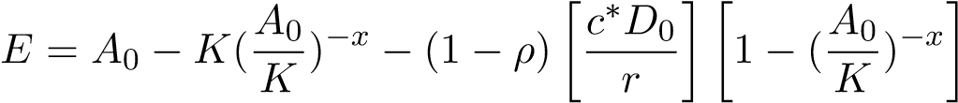
Finally we can split the coupon payment
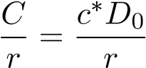
into two components.
c∗ = r + s∗
where s∗ is the spread over the risk free rate, such that the quantity:
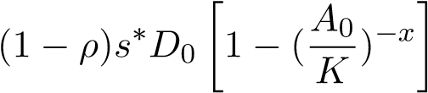
represents the after tax cost of a ”perpetual” credit default swap written for an amount of debt D₀.
Consequently we can see that corporate stockholders are:
- ”Long” of a perpetual ”American Down and Out” call; - ”Long” of a perpetual Credit Default Swap (paying the spread); - Borrowing from bond holders at the risk free rate.

1.3 Corporate Firms Funded through the Issuance of Equity and Fixed Term Intermediate Debt
We focus now on the particular case of corporations using fixed term intermediate debt for raising capital. This is the current standard for European corporations whose stocks are listed on main European exchanges.
As in section I, the firm has productive assets which follow a continuous geometric diffusion process with a a constant proportional volatility σ. As in section I, we have, with the same notations:
dA_{t} = (r − d)dt + σA_{t}dW_{t} (18)
with A₀ > 0.
As discussed previously, the bankruptcy is triggered when the asset value falls below a predetermined threshold, K. At the difference of Leland and Toft, we will consider here an exogenous determination of K as a fraction of the debt. We consider K = LD where L designates the rate of recovery of the debt on the assets and D is the principal amount of the outstanding debt.
Following Leland and Toft (1996), we consider a corporate firm which continuously sells a constant (principal)amount of new debt of fixed maturity T, which will reimburse, the outstanding principal P ”In Fine” at maturity T , and at par. The new bond principal is issued at rate p = (P/T), in such a way that the outstanding amount of debt is P and the distribution of principal maturities us uniform in the time interval [t,t + T] where the present time is t = 0.
The outstanding principal amount of debt pays an aggregated coupon C on the period of T years and a constant yearly coupon rate c = (C/T) such that the total debt service per year is equal to (C +P/T). In other words, on an aggregated basis, and in a stationary state, the outstanding debt pays yearly a linear amortisation of the outstanding principal plus the interest.
A bond issue with maturity t periods from present time τ = 0 and which continuously pays constant coupon flow c(t) and has principal p(t). Let’s consider α(t) the fraction of assets lost in the recovery process of the debt using the assets, such that the recovery rate on the debt if the bankruptcy occurs at time t is (1 − α(t))K.
with:
- F(t,A₀,K) is the cumulative distribution of the first (hitting) time the asset value A with a drift r∗ − d and starting from A₀ touches the bankruptcy level K.
- f(τ,A₀,K) is the corresponding density of the first (hitting) time the asset value A with a drift r∗ − d and starting from A₀ touches the bankruptcy level K.
The integration from the expression above is well known since the respective studies from Harrison and Rubinstein and Reiner (Rubinstein and Reiner, 1991). It is described in Leland and Toft
(1996).
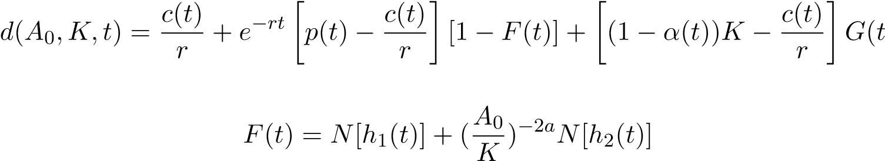) (19)
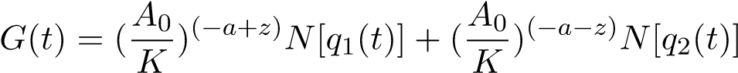
where
;
with:
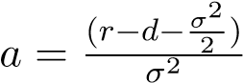; 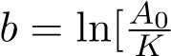]; 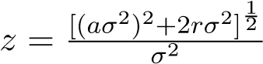
One can see that a has exactly the same expression as in equation (12).
One can further verify that x = z + a using the definition of x in equation (11).
The integration of equation (19) leads to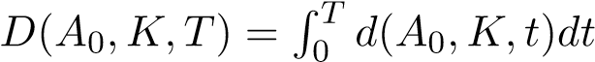which designates the value of all outstanding bonds with maturity T.
The computation has been done by Leland and Toft under the assumption that α(t) = α is constant which supposes that all debt issued on the interval [0,T] have the same seniority. We finally obtain the expected value under the risk neutral measure of the outstanding debt of the firm in a ”stationary state”.
) (20)
with
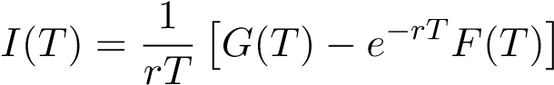
and
We then assume as in equation , that the firm value V (A₀,K,T) will depend upon the asset value A₀, the coupon tax benefit as well as the bankruptcy charges.
The value of corporate equity amounts then to:
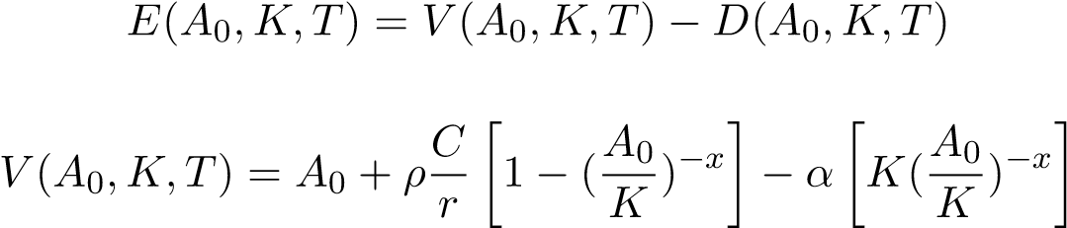
with
(21)
where x is defined as in equation (10) and (11) and where also x = z + a.
Remark: Optimal Capital Structure
It is possible to determine an optimal leverage in the case of an exogenous determination of bankruptcy. The optimal value of P∗ maximizes the firm value in equation (24). K the threshold is estimated at LP. The first order condition on V (P,K,T) derivatives leads to:
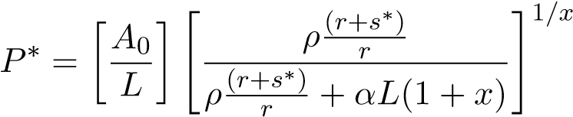 (22)
where s∗ is the corporate credit spread corresponding to the maturity T.
Equation (25) above can be written in terms of optimal leverage, as follows:
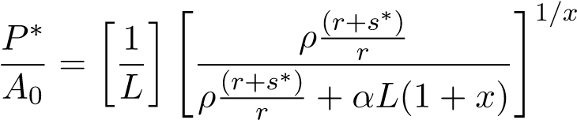 (23)
One can see directly on equation above, that the value of P∗ will be ”stationary” if the asset value has no drift. In the general case, this optimum value will change with A_{t} and P∗ can therefore be considered as a moving target.
However, in terms of capital structure, one can see directly on equation (23), that the optimal capital structure 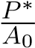 is constant as long as ρ,r,s∗,d,σ are fixed.

1.4 Addition, Superposition and Limit Case
It follows from equation (14) and (21), which are the same, that the corporate firm’s value depends of overall coupon paid on both fixed term debt and perpetual debt. Consequently, we can consider in equation (9) the sum of all coupon paid for all debt maturity classes, as long as we consider a threshold established on the total outstanding amount of principal debt and the same seniority for the debt considered.
In order to compute exactly the equity value, we need to consider the case of a corporation where debt of several maturities are issued. Practically, it comes to computing the respective values for each debt maturity according to equation (20). In some particular cases, where the corporation has issued hundreds of corporate bonds with various maturities, it can be burdensome.
As a proxy, we will consider the case of a corporation which issues continuously debt and is redeeming it at the same rate such that the outstanding amount of principal debt is constant, as well as the ”average maturity”. Because the debt newly issued can be issued at a different price than par, it means that any difference will be offset by the corporation through equity issuance or redemption. We will consider this model is an acceptable proxy.
The model which is described in Leland and Toft (1996) writes for the expectation of the debt’s value under the risk neutral assumption:
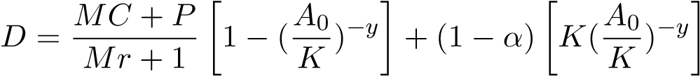 (24)
M designates the average maturity and m = _{M}¹ the ”average” rate at which the outstanding debt is renewed. P designates the outstanding principal amount of the corporation’s debt. δ designate the continuous ”dividend yield” paid out on the corporate assets.
We compute from equation (10) the quantity
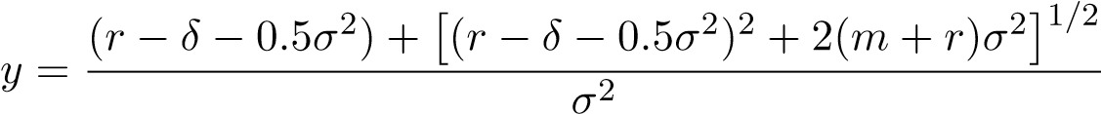
We compute from equation (11) the quantity x such that the corporation’s value is:
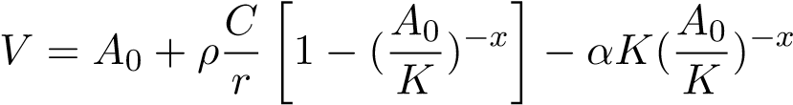
with
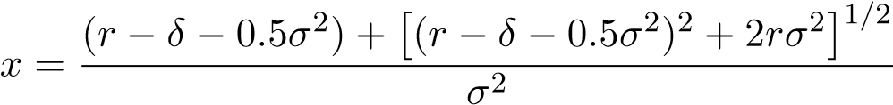
Under the assumption that all debts have the same recovery rate, it is possible to compute then the corporate equity value by subtracting the value of the cumulated debt from corporate value. By the same token as in equation (22) we can also find the optimal amount of debt which will maximize the corporation’s value.
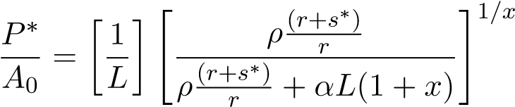 (25)
where s∗ is the corporate credit spread corresponding to the average maturity of the debt.

2 Consequences of the FTT introduction on the Theoretical Equity Share Price
In this section, we use the framework introduced and discussed in both chapter I and II. In order to raise capital on primary bond markets, corporations have to compensate the bond holders for the credit risk they support in case the corporation defaults on its debt. This is done through a credit spread embedded into the corporate bond price. This credit spread itself corresponds to a Credit Default Swap (CDS) which insures the bond holders against the part of the debt which cannot be recovered against the value of assets at bankruptcy time.
By way of capital structure arbitrage, as seen in chapter II, the value of the CDS is equivalent to the value of an equity put option on the stock, and is linked to the volatility level of the underlying equity. Consequently, the credit protection provided by the CDS is equivalent to the one provided by buying a put option.
Furthermore, the credit spread of the CDS can be linked to the volatility of the corporation’s asset value, which is itself linked to the corporation’s equity share price volatility. According to the results developed in Chapter I therefore the equity option market-makers will pass through the full impact of the additional transaction costs generated by the FTT to the end users, by increasing the implied volatility level, on the volatility asking price.
Because corporations are borrowing money on capital markets, they are on the wrong side of the volatility increase due to the introduction of the FTT, and they will have to pay the increase in the volatility asking price to compensate, through the CDS spread, the equity option market makers for the increased transaction costs generated by the FTT.
The numerical impact of the FTT is inversely related to the liquidity of such option markets. Equity Options with long dated maturities, will generally have very illiquid markets, consequently we will consider that equity option market makers are not able to find an offsetting trade. In the particular case of Credit Default swaps, for maturities matching the duration of corporate debt (from 5 years to 20 years) and hedged with out of the money put equity options, we will consider that at the time the FTT will be introduced, those markets will have this kind of restricted liquidity.
We consider comparative statics on the respective values of the firm, its debt and equity for the increased level of implied volatility, and considering the same level of asset value at time τ = 0. The readjustment rule followed by the market-maker is a 2 percent ∆_{s} rule. The theoretical equity share price is computed according to the results of section I as the expectation of the corporate equity value under a risk neutral assumption. The measure considered is the natural measure induced by by the corporate asset value diffusion process. The increase in the equity share price volatility is then transmitted to the asset value volatility, in the same way as in chapter 2, by the following equation:
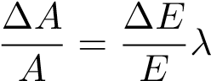 (26)
where λ is constant in the short run and is estimated through calibration and using the corporation balance sheet structure. This leads to:
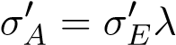
where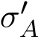 and 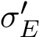 designate respectively the modified volatilities of corporation’s asset value and equity share price, following the introduction of the FTT, computed through Boyle and Vorst calculations.
The theoretical equity share price is computed according to the results of section I as the expectation of the corporate equity value under a risk neutral assumption. The measure considered is the natural measure induced by by the corporate asset value diffusion process.

2.1 Impact of the FTT for Corporate Firms Funded through Equity, and Perpetual Debt. Comparative Statics
2.1.1 The Theoretical Impact of the FTT Implementation when the Corporation is Funded Solely Through Equity and Perpetual Debt
Definition 1: A ”Valued Capital Structure” for a given corporate firm is the vector (A₀,D₀,V₀,K₀,σ₀),r where:
A₀ is the asset value;
D₀ is the market value of the outstanding debt whose outstanding principal amount is P and which is paying a fixed coupon C; This debt can be either perpetual, fixed term debt or the aggregation of the two types as seen in subsection above.
V₀ is the firm value as defined by equation (14);
K₀ is the threshold on asset level triggering the bankruptcy; σ₀ designates the asset volatility.
Definition 2: A ”Fixed Capital Structure” is a Valued Capital Structure where the outstanding amount of the debt principal is kept constant.
- Short Term Effects for Corporations Carrying an Inventory of Perpetual Debt atThe time of FTT Implementation.
According to equation (14), as well as the literature (see Black and Cox), when the debt is perpetual, the corporate equity value is a monotonous increasing function of the asset volatility. Consequently, corporate firms carrying an inventory of perpetual debt, and funded solely through perpetual debt and equity should see an immediate increase in their theoretical equity share price. At the same time, because preferred shares and quasi-equity are similar to perpetual debt, it results from the negative impact of the FTT on perpetual debt, that both preferred shares and quasi-equity should record immediately a decrease in their theoretical price.
- Short Term Effects for Debt Free Corporations Issuing Perpetual Debt After theIntroduction of the FTT
Conversely, if we consider that the corporation is ”perpetual debt free” at the time of the introduction of the FTT, and further assume that the corporation has to fulfil a fixed amount of funding on the debt capital markets, we can conclude that the possible issuances of perpetual debt after the introduction of the FTT will lead to a decrease in the theoretical equity share prices.
Proposition (1)
- Considering a corporate firm funding its capital requirements through the issuance of equity.
- Futures Corporate firm’s capital requirements are to be fulfilled partially through the issuanceof perpetual debt.
- The bankruptcy is triggered as soon as the asset value falls below a predetermined thresholdK, K being a fixed fraction of the debt.
- Corporation is aiming for a fixed amount of capital to raise from the primary corporate debtmarket.
Then:
- The theoretical expected values, of quasi-equity, equity and corporate value, under the naturalrisk measure associated to the corporate asset diffusion process values of quasi-equity, will be lower after the introduction of the FTT.
Proof
Let’s designate by K the predetermined threshold triggering the default in the case of protected debt.
Considering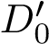 the value of outstanding debt following the introduction of the FTT and D₀ the value of outstanding debt without FTT. Because the FTT generates an increase in the volatility let’s consider x⁰ which is associated to the new volatility level σ⁰ using equation (11) and (12). We have 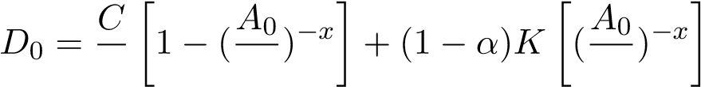
and 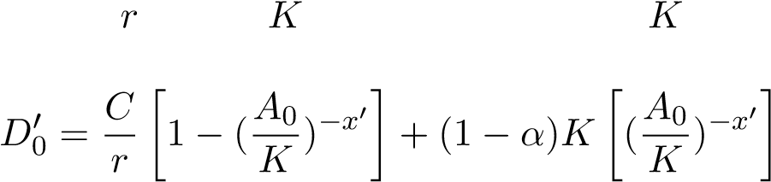
Let’s consider the new coupon C⁰ such that it offsets the negative impact on the debt value of the increase in the probability of default due of the increase in the asset volatility. Corporate firms will be willing to pay this increased coupon in order to raise the same amount of capital through debt.
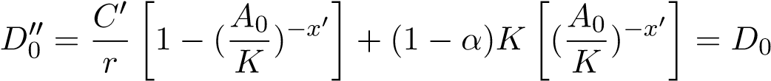
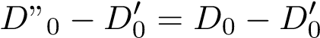
Replacing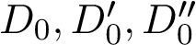by their respective values and after simplification we find:
(27)
We know that the new value of equity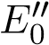 is such that:
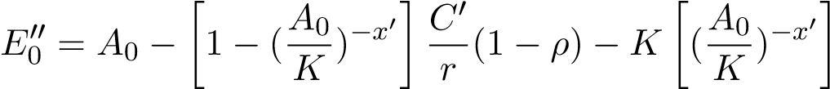
Using equation (15) we find then
Which writes:
(29)
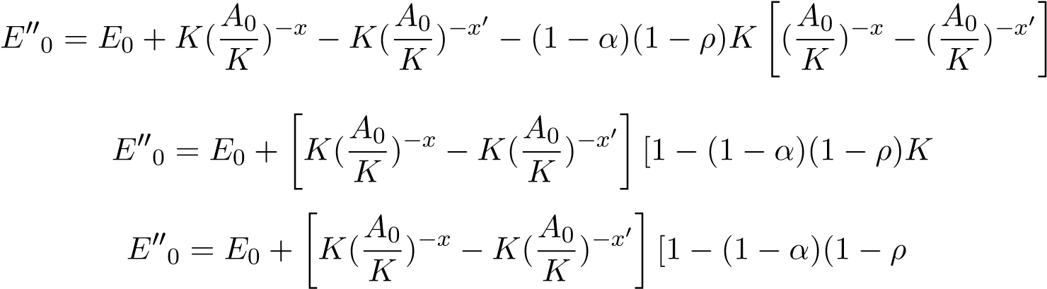
] (30)
)] (31)
-Let’s prove first that x is a monotonous decreasing function of sigma i.e
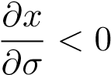
This is obvious if d = 0 as in this case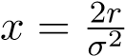 and consequently:
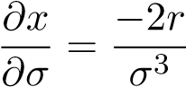
This is the case for any d. From equation (11) and (12) we know that:
x = a + B
with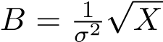 with X = δ² + 0.25σ⁴ + σ²(r + d) where δ = r − d.
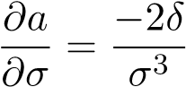
Equation (11) yields Finally :
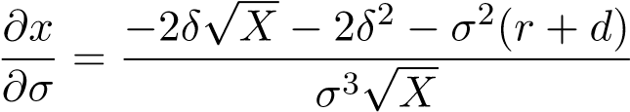
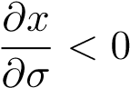
is equivalent to have (after simplification)
σ⁴(4dr) > 0
which is always true because d and r are positive.
-Because σ⁰ > σ, ^{A}_{K}⁰ > 1, α and ρ < 1, then we conclude that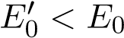.
Interpretation: Because there is a given funding requirement to fulfil in a fixed capital structure, corporate firms will tend to raise the coupon to compensate for the drop in unit debt price due to the increase in asset volatility. This will in turn lower the equity price level according to the equation above. The drop in equity price will be directly related to the issue size of the debt compared to the asset size as well as the aggregated side.
Corollary 2.1: The increase in the asset volatility following the introduction of the FTT leads to a decrease in the corporate firm’s valuation. This decrease in the corporation’s value occurs regardless of the maturity of the corporate debt.
Proof: This come from both equation (21) and the fact that x is a monotonous decreasing function of σ.
Proposition 2
We compare the two respective economies stated above, and we considers a given corporation aiming to raise a fixed amount of capital by issuing corporate debt on the primary market.
The magnitude of the drop in equity price due to the FTT and described above is:
(ii) Inversely related to the corporate tax rate
- Directly related to the credit spread of the corporate debt
- Directly related to the corporate debt leverage
- Directly related to the bankruptcy costsProof:
This is a direct consequence of equation (29).
The dependency towards α and ρ comes directly from the last term on the right in equation (29). The dependancy toward leverage comes from the fact that K = LP where P is the principal amount of the debt and 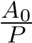 is inversely related to leverage.
The dependancy toward the credit spread comes from the fact that the credit spread is a monotonous increasing function of the volatility, and x is a decreasing function of σ.
Corollary 2.2:
Corporations located in different countries with different corporate tax rates will experience different price drops in the risk neutral expectation of their equity. Highly leveraged firms paying significant dividends and located in countries with a low corporate tax rate will incur the most significant drop in their equity prices.
2.1.2 Short Term effects for Corporations Carrying an Inventory of Perpetual Debt at the Time of FTT Introduction: Numerical Simulations
We consider the base case of a given corporate firm which carries an inventory of perpetual debt at the time the FTT is introduced, such that the model described in equation (13), section I, applies to this perpetual debt ”inventory”. The size of the outstanding principal amount (P) of perpetual debt commands directly the level of corporate leverage.
We assess the impact of the FTT on corporate equity, under risk neutral expectation, by first, computing the impact on the asset volatility, second deducing from the equations above the impact on the debt value. We consider a 2 percent ∆_{s} rule and a FTT round trip rate of 0.2 percent of the stock market value.
Corporations are confronted with an immediate drop in the value of the outstanding debt, which is due to the increase in the probability of default implied by the increased asset volatility. This drop in the debt value is more important than the drop in firm’s value and consequently this leads to a short term increase in the corporation equity.
Table 1 below describes the short term positive impact on the theoretical equity price. We assume that the corporation is funded solely through equity and perpetual debt and is carrying an existing inventory of perpetual debt at the time when the FTT is introduced. We compute this effect for several levels of corporate leverage, and credit spreads. Practically, perpetual debt amounts issued by corporations represents in general a small portion of their assets. Thus, we should expect that in the ”real life”, corporations will maintain low levels of leverage and this effect should be limited. The magnitude of this short term impact increases with the level of corporate assets volatility as evidenced in Table 2, below. Furthermore, this impact decreases with the level of corporate tax as evidenced in Table 3.
Table 1: Short Term Effect Variations of Equity Value Following the Introduction of the FTT when The Firm carries an Inventory of Perpetual Debt; as a function of Credit Spreads S and Corporate Leverage L(Variation in percentages; ρ = 0.35; α = 0.50; σ_{A} = 0.1; δ = 0.03; r = 0.01)
S | L=1.25 | L=1.67 | L=2 | L=2.5 | L=3.33 | L=5
0.007 | 0.47 | 1.01 | 1.3 | 1.6 | 1.9 | 2.2
0.015 | 0.95 | 2.18 | 2.9 | 3.7 | 4.6 | 5.62
0.025 | 1.65 | 4,3 | 6.1 | 8.45 | 11.54 | 15.8
0.035 | 2.53 | 7.74 | 12.53 | 20.9 | 38.8 | 104.73
Table 2: Short Term Effect Variations of Equity Value Following the Introduction of the FTT when The Firm carries an Inventory of Perpetual Debt; as a function of Corporate Leverage L for Various Volatility Levels(Variation in percentages; Spreads in percents. ρ = 0.35; α = 0.50; S = 0.007; δ = 0.03; r = 0.01)
σA | L=1.25 | L=1.67 | L=2 | L=2.5 | L=3.33 | L=5
0.1 | 0.47 | 1.01 | 1.3 | 1.6 | 1.9 | 2.2
0.2 | 0.75 | 1.41 | 1.74 | 2.05 | 2.36 | 2.66
Table 3: Short Term Effect Variations of Equity Value Following the Introduction of the FTT when The Firm carries an Inventory of Perpetual Debt as a function of Corporate Leverage L for Various Volatility Levels(Variation in percentages; Spreads in percents.ρ = 0.35; σ_{A} = 0.1; α = 0.50; S = 0.007; δ = 0.03; r = 0.01)
ρ | L=1.25 | L=1.67 | L=2 | L=2.5 | L=3,33 | L=5
0.35 | 0.47 | 1.01 | 1.3 | 1.6 | 1.9 | 2.2
0.15 | 0.77 | 1.74 | 2.28 | 2.86 | 3.50 | 4.18
2.1.3 Short Term Effects for a Debt Free Corporation Issuing New Perpetual Debt: Numerical Simulations
We review now the case of a corporation which is ”debt free” at the time the FTT is introduced and considers the issuance of new corporate perpetual debt. Equation (29) allows us to compute the comparative statics of the negative equity impact due to the introduction of the FTT. We conduct numerical simulations of this impact depending upon corporate leverage, corporate tax rate, bankruptcy costs and asset volatility. We compare two economies: one without FTT and the second featuring the FTT as it is described in the EU project.
We can then compute the impact of the FTT on Corporate equity, under risk neutral expectation, by first, computing the impact on the asset volatility, second deducing from the equations above the impact on the debt value. We assume a 2 percent ∆_{s} rule and a round trip FTT rate of 0.2 percent of the notional value of the stock.
Table 4 evidences the negative impact on equity value of the FTT depending upon the desired leverage and the corporate tax rate, spread, for an asset volatility of 10 percent per year, and bankruptcy cost of 50 percent. One can see that the impact is directly related to the leverage and inversely related to the corporate tax rate. Corporate firms which are tax domiciled in countries with low tax rates, will experience a higher decrease of the equity price than those located in countries with a higher tax rate.
Based on equation (15), the negative impact on the theoretical equity price increases with both bankruptcy costs and the risk free rate.
One can see that low corporate tax rates command a significant higher negative impact on the corporate debt value, especially for highly leveraged corporations. Corporations with the same characteristics, located in countries having different corporate tax rates will have different impact of the FTT on their corporate cost of fundings, creating potentially, competitive distortions.
This strongly suggests, that in case the FTT would be implemented at the same time, in all EU countries, it would harm the competitiveness of corporate firms located in countries having the lowest corporate tax rate. Consequently, in order to avoid such distortions, the EU should, prior to the introduction of the FTT, proceed to an harmonisation of the various corporate tax rates across the EU.
Table 4: Impact of the FTT In terms of Equity Value Variation in Percentages as a function of Leverage L and Corporate Tax Rate for a ”Debt free” Corporation Issuing New Perpetual Debt; (α = 0.50; σ_{A} = 0.20; δ = 0.05; r = 0.01 )
 | ρ = 0.15 | ρ = 0.20 | ρ = 0.25 | ρ = 0.30 | ρ = 0.35
L = 1.25 | -0.42 | -0.43 | -0.45 | -0.46 | -0.47
L = 1.67 | -0.90 | -0.91 | -0.92 | -0.93 | -0.95
L = 2.00 | -1.24 | -1.24 | -1.24 | -1.24 | -1.24
L = 2.5 | -1.75 | -1.71 | -1.67 | -1.64 | -1.61
L = 3.333 | -2.69 | -2.52 | -2.37 | -2.25 | -2.15
L = 4 | -3.59 | -3.21 | -2.93 | -2.71 | -2.54
L = 5 | -5.31 | -4.40 | -3.80 | -3.38 | -3.06
L = 10.00 | -91.79 | -15.89 | -9.02 | -6.45 | -5.10
The negative impact on equity share price is an increasing function of both corporate credit spreads and firm’s leverage as evidenced in Table 5.
Table 5: Short Term Effect Variations of Equity Value Following the Introduction of the FTT for a ”Debt free” Corporation Issuing New Perpetual Debt; as a function of Credit Spreads S and Corporate Leverage L(Variation in percentages; Spreads in percents ρ = 0.35; α = 0.50; σ_{A} = 0.1; δ = 0.03; r = 0.01)
 | L=1.25 | L=1.67 | L=2 | L=2.5 | L=3,33 | L=5 | L=6.67 | L=10
S=0.7 | -0.27 | -0.57 | -0.72 | -0.89 | -1.06 | -1.24 | -1.33 | -1.42
S=1.5 | -0.28 | -0.65 | -0.87 | -1.11 | -1.38 | -1.68 | -1.84 | -2.0
S=2.5 | -0.31 | -0.81 | -1.16 | -1.61 | -2.20 | -3.00 | -3.53 | -4.10
S=3.5 | -0.35 | -1.08 | -1.74 | -2.9 | -5.40 | -14.49 | -45.47 | NA
The magnitude of this negative impact on the equity share price increases slightly with the volatility level as it is shown in Table 6.
Table 6: Short Term Effect Variations of Equity Value Following the Introduction of the FTT for a ”Debt free” Corporation issuing New Perpetual Debt as a function of Volatility σ and Corporate Leverage L(Variation in percentages; ρ = 0.35; S = 0.007; α = 0.50; σ_{A} = 0.1; δ = 0.03; r = 0.01)
 | L=1.25 | L=1.67 | L=2 | L=2.5 | L=3,33 | L=5 | L=6.67 | L=10
σ = 0.1 | -0.27 | -0.57 | -0.72 | -0.89 | -1.06 | -1.24 | -1.33 | -1.42
σ = 0.2 | -0.42 | -0.79 | -0.97 | -1.14 | -1.32 | -1.48 | -1.57 | -1.65

2.2 Impact of the FTT for Corporate Firms Funded through Equity, and Fixed Term Debt Maturity in a Fixed Capital Structure: Comparative Statics for Leverage,Spread, Asset Volatility, Corporate Tax and Risk Free Rate
We consider now, corporate firms funded through fixed term maturity debt. We are still comparing the same corporate firm with the same capital structure in the two respective economies described above by doing a static comparison of its value, debt and equity theoretical prices.
We consider the instantaneous reaction of an economy to the Introduction of the FTT as well as its long term behavior under the assumption of a fixed capital structure..
2.2.1 Short term Impact
(i) Sensitivity of Theoretical Equity Price towards Leverage, Credit Spread, Volatility and Debt Maturity
Figures 1,2,3 show the instantaneous (short term) reaction of the expected theoretical share price, under the risk neutral measure associated to the asset value stochastic diffusion process, for various leverage and credit spreads. We consider two different assumptions on the yearly rate of return on assets, respectively 3 and 5 percent. Results are computed for two respective different level of asset volatility (10 and 20 percent) as well as two different maturities (5 and 10 years). The FTT roundtrip rate is assumed to be 0.2 percent. Option market-makers on the 5 year option are following a 2 percent based ∆s rule. Figure 3 evidences the impact of debt maturity on the short term equity price impact.
One can see that, the FTT introduction has a negative impact on the theoretical equity share price (computed according to equation (20), for an asset volatility of 10 percent a year). The negative impact magnitude is an increasing function of both corporate leverage and spreads. This negative dependancy is valid for respective debt maturities of 5, 10 and 15 years. The negative impact is slightly more significant for short term maturities and it decreases slightly when the debt maturity increases.
Conversely, for the asset level of volatility of 20 percent(pretty high), and a yearly return on assets of 5 percent, one can see that the equity share price can be up, for highly leveraged corporations with substantial credit spreads. This phenomenon is known as ”agency effect” and is well known in the corporate structure model literature., see for instance, Leland and Toft (1996) which discuss this effect in the case of endogenous bankruptcy determination. It corresponds to a situation where Figure 1: Short Term Reaction of the Expected Theoretical Share Price
-
30,000
-
25,000
-
20,000
-
15,000
-
10,000
-
5,000
0,000
25
1
,
1
,
43
67
,
1
,
00
2
50
2
,
3
,
33
4
,
00
5
,
00
6
67
,
10
Firms' leverage
Short term Equity price variation following the Introduction of the FTT for a firm funded
through fixed term debt maturity and equity(T=5 years;ROA=3%;r=1%;sigma=20%;Tax
rate=35%;FTT roundtrip rate=0,2%)
spread 1%
spread 1.5%
spread 2%
spread 2.5%
spread 3%
Equity
variation
in %

-
00
,
25
-
,
00
20
-
1
5
,
0
0
-
10
00
,
-
5
,
0
0
0
,
00
25
1
,
1
,
43
67
,
1
2
,
00
,
2
50
,
33
3
00
,
4
5
,
6
67
Short Term Equity Price variation in % as a function of corporate tax rate and leverage
ROA=3%;r=1%;T=5;sigma=10%;spread=2%;FTT roundtrip rate=0,2%)
(
Tx=15%
Tx=25%
Tx=35%
Firm's leverage
Figure 2: Short Term Reaction of the Expected Theoretical Share Price
-
1
8
,
0
0
-
1
6
,
0
0
-
1
4
,
0
0
-
1
2
,
0
0
-
,
00
10
-
8
,
0
0
-
6
,
0
0
-
4
,
0
0
-
2
,
0
0
00
0
,
00
,
2
1
25
,
43
,
1
67
,
1
00
,
2
50
,
2
33
,
3
4
,
00
5
67
,
6
10
Short term equity price variation in % as a function of leverage and spread
)
(
ROA=3%;r=1%;T=10;sigma=10%;FTT roundtriprate=0,2%
spread 1%
spread 1.5%
spread 2%
spread 2.5%
spread 3%
Firm's leverage

-
30,000
-
25,000
-
20,000
-
15,000
-
10,000
-
5,000
0,000
1
25
,
43
,
1
,
1
67
2
,
00
2
,
50
3
33
,
00
4
,
00
,
5
,
6
67
10
Short Term Equity price variation in percents as a function of leverage and Credit spread
)
(
ROA=5%;sigma=10%;T=5; r=1%; Tax=35%; FTT roundtrip rate=0,2%
spread 1%
spread 1.5%
spread 2%
spread 2.5%
spread 3%
Firm's leverage

Figure 3: Short Term Reaction of the Expected Theoretical Share Price
-
6
,
0
0
0
%
-
4
,
0
0
0
%
-
2
,
0
0
0
%
0
,000%
2
,000%
4
,000%
6
,000%
8
,000%
,000%
10
12
,000%
,000%
14
1
,
25
43
,
1
,
67
1
2
,
00
,
50
2
33
,
3
,
4
00
5
6
,
67
spread 1%
spread 1.5%
spread 2%
spread 2.5%
spread 3%
Short
term Equity price variation following the Introduction of the FTT for a firm funded through fixed
term debt maturity and equity(T=5 years;ROA=5%;r=1%;sigma=20%;Tax rate=35%;FTT roundtrip
rate=0,2%)
Firm's leverage
Short Term Impact of the FTT on Theoretical Equity Share Price Depending Upon Debt
Duration and Credit Spread (Rho=35%;r=1%;Delta=3%;!=10%)
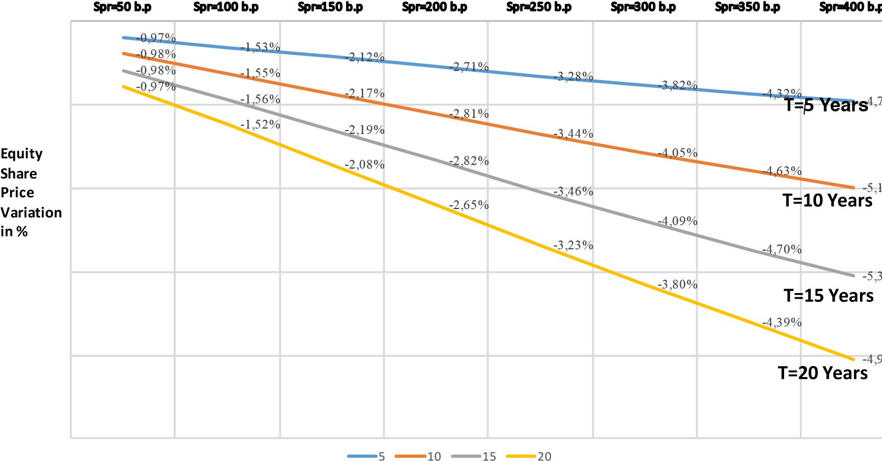
the increase in asset volatility (risk) will benefit the shareholder’s interest of highly leveraged companies issuing corporate debt paying higher credit spreads to investors (junk-bonds). It applies to an exogenous bankruptcy determination.
(i) Sensitivity of Theoretical Equity Price towards Corporate Tax and Risk free rates
Figure 1 , displays the negative impact on the theoretical equity share price for different levels of corporate tax rates and risk free rates. One can see that, countries having a lower corporate tax rate, will record a lesser drop in equity share price, than the countries with a higher corporate tax rate. This effect will occur for corporations with a low to average leverage. For highly leveraged corporations, the result will be the opposite. Higher drops will be recorded in countries having a lower corporate tax rate.
For the risk free rate, we find that the magnitude of the negative impact is a direct function of the level of risk free rates. Higher risk free rates level are generally commanding higher equity price drops, everything else being equal.
2.2.2 Short term Impact Negative Envelope.
Given leverage, and credit spreads, the return on assets determines the return on equity (ROE). Numerical simulations of equation [21] show that the impact of the increase in volatility of equity, on the equity share price, is inversely related to δ the rate of return on assets and consequently the return on equity (ROE). There is a maximum value for the ROE over which the percentage variation of the equity is going to be positive. Below this threshold, the impact on the equity share price of the volatility increase due to the FTT is going to be negative. One can remark, by doing numerical simulations that companies with a very high return on equity will experience in fact an increase in the share prices, if they finance through corporate debt with a 10 year maturity.
Such results are no surprise. All structural models used are considering in fact that the shareholders, in case of default, can walk away of their debt obligation by abandoning the assets to the bond holders. Such possibility is equivalent to be long of a (”knock-in”) Put option on the assets whose strike price is the amount of the outstanding debt. Such Put is ”activated” whenever the asset value falls below the barrier. The combination of owning both the assets and such ”Down and In” Put is equivalent to the ownership of a ”Down and Out” Call.
Finally, the equity is equal to the difference between a ”Down and Out” American call option on the assets (whose strike price is the amount of principal debt and the barrier is K) and a stream of cash-flows paying the risk free rate plus the credit spread on the amount of the principal debt.
The value of a ”Down and Out ” American call option is not a monotonous increasing function of the asset volatility, which explains the fact that the equity value can decrease when the volatility increases. Furthermore, when the return on dividends increases, the value of the call option tends to become ”stale” whereas the expected value of the cash flows tends to decrease, because of the increased probability of default. This explains, that the equity might increase, when the rate of return on assets is high.
We define the envelope of the FTT impact has the maximum return on equity level for which an increase of 5 percent of the asset volatility due to the implementation of the FTT provides a negative variation of the share equity price. We consider credit spreads ranging between 1 and 4 percent per annum. a base volatility of 20 percent, a risk free rate of 1 percent and a debt maturity of 5 years.
a base volatility of 20 percent, a risk free rate of 1 percent and a debt maturity of 5 years.
Table 7: Envelope of The Negative Equity Value Variation in Percentage for a 5 percent Increase in Asset Volatility due to the FTT (r = 0.01; ρ = 0.35; α = 0.50; σ_{A} = 0.20; 0.01 < s∗ < 0.04)
Maturity | Risk free rate | Leverage | Max ROE | 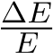
5 | 0.01 | 1.25 | 0.25 | < 0
5 | 0.01 | 1.43 | 0.25 | < 0
5 | 0.01 | 1.67 | 0.24 | < 0
5 | 0.01 | 2.00 | 0.23 | < 0
5 | 0.01 | 2.5 | 0.22 | < 0
5 | 0.01 | 3.33 | 0.21 | < 0
5 | 0.01 | 4 | 0.23 | < 0
5 | 0.01 | 5 | 0.26 | < 0
5 | 0.01 | 6.67 | 0.30 | < 0
5 | 0.01 | 10 | 0.32 | < 0
Table 8: Envelope of The Negative Equity Value Variation in Percentage for a 5 percent Increase in Asset Volatility due to the FTT (r = 0.05; ρ = 0.35; α = 0.50; σ_{A} = 0.20; 0.01 < s∗ < 0.04)
Maturity | Risk free rate | Leverage | Max ROE | 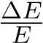
5 | 0.05 | 1.25 | 0.35 | < 0
5 | 0.05 | 1.43 | 0.34 | < 0
5 | 0.05 | 1.67 | 0.34 | < 0
5 | 0.05 | 2.00 | 0.34 | < 0
5 | 0.05 | 2.5 | 0.33 | < 0
5 | 0.05 | 3.33 | 0.32 | < 0
5 | 0.05 | 4 | 0.31 | < 0
5 | 0.05 | 5 | 0.34 | < 0
5 | 0.05 | 6.67 | 0.35 | < 0
5 | 0.05 | 10 | 0.38 | < 0
One can see in Table 7 that, for usual values of the ROE, the impact is going to be mainly negative for a 5 year maturity. The impact is going to be higher for a higher risk free rate. Table 8 evidences that if the risk free rate is 5 percent then the ROE to get a negative variation of the equity following a 5 percent increase in the asset volatility is higher. Table 9 and10 show the same results in the case of a 10 years maturity. One can see that for such maturities the impact is negative for return on equities values which are significantly lower.
Table 9 evidences that for a fixed maturity of 5 years, a risk free rate of 1 percent per year, a corporate tax rate of 35 percent, and per leverage, the maximum ROE for which a 5 percent Table 9: Envelope of The Negative Equity Value Variation in Percentage for a 5 percent Increase in Asset Volatility due to the FTT (r = 0.01; ρ = 0.35; α = 0.50; σ_{A} = 0.20; 0.01 < s∗ < 0.04)
Maturity | Risk free rate | Leverage | Max ROE
10 | 0.01 | 1.25 | 0.17 | < 0
10 | 0.01 | 1.43 | 0.127 | < 0
10 | 0.01 | 1.67 | 0.11 | < 0
10 | 0.01 | 2.00 | 0.09 | < 0
10 | 0.01 | 2.5 | 0.08 | < 0
10 | 0.01 | 3.33 | 0.065 | < 0
10 | 0.01 | 4 | 0.058 | < 0
10 | 0.01 | 5 | 0.042 | < 0
10 | 0.01 | 6.67 | 0.030 | < 0
10 | 0.01 | 10 | NA | > 0
Table 10: Envelope of The Negative Equity Value Variation in Percentage for a 5 percent Increase in Asset Volatility due to the FTT (r = 0.05; ρ = 0.35; α = 0.50; σ_{A} = 0.20; 0.01 < s∗ < 0.04)
Maturity | Risk free rate | Leverage | Max ROE
10 | 0.05 | 1.25 | 0.252 | < 0
10 | 0.05 | 1.43 | 0.227 | < 0
10 | 0.05 | 1.67 | 0.193 | < 0
10 | 0.05 | 2.00 | 0.184 | < 0
10 | 0.05 | 2.5 | 0.173 | < 0
10 | 0.05 | 3.33 | 0.150 | < 0
10 | 0.05 | 4 | 0.147 | < 0
10 | 0.05 | 5 | 0.139 | < 0
10 | 0.05 | 6.67 | 0.113 | < 0
10 | 0.05 | 10 | 0.043 | < 0
Table 11: Envelope of The Negative Equity Value Variation in Percentage for an Increase in Implied Share Price Volatility due to the FTT (r = 0.01; ρ = 0.35; α = 0.50; σ_{S} = 0.30; 0.01 < s∗ < 0.04)
Maturity | Risk free rate | Leverage | Max ROa | 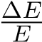
5 | 0.01 | 1.25 | 0.201 | < 0
5 | 0.01 | 1.43 | 0.172 | < 0
5 | 0.01 | 1.67 | 0.13 | < 0
5 | 0.01 | 2.00 | 0.12 | < 0
5 | 0.01 | 2.5 | 0.115 | < 0
5 | 0.01 | 3.33 | 0.11 | < 0
5 | 0.01 | 4 | 0.115 | < 0
5 | 0.01 | 5 | 0.118 | < 0
5 | 0.01 | 6.67 | 0.086 | < 0
5 | 0.01 | 10 | 0.05 | < 0
increase in the asset volatility leads to a negative variation of the corporate firm equity value, for credit spreads ranking from 1 percent to 4 percent per annum.
One can see that, for usual values of the ROE, the impact is going to be mainly negative for a 5 year maturity. The impact is going to be higher for a higher risk free rate. Table 8 evidences that if the risk free rate is 5 percent then the ROE to get a negative variation of the equity following a 5 percent increase in the asset volatility is higher.
Remark: Furthermore, for highly leveraged companies, the impact for a 10 year maturity debt will always be positive. This is in line, with previous results from Leland or Leland and Toft, though based on endogenous bankruptcy determination, which find that corporate companies issuing junkbonds are favoured by an increase in the risks on the assets. This is the classical agency effect, where because of the option nature of equity shareholders might increase their risk in order to increase the equity value.
Finally, Table 11 displays the envelope of return on assets leading to a decrease of the equity share value for a predetermined level of equity volatility of 30 percent. The asset volatility is then derived through the approximation of a fixed capital structure.
2.2.3 Long Term Impact in a Fixed Capital Structure
We consider now, corporate firms adjusting the level of their debt value by adjusting their credit spread, in order to raise the same amount of capital on the primary bond market. Because, in our model we consider a steady state corresponding to a continuous rate of issue for a fixed term debt maturity, we can conclude that this corresponds to a long term adjustment of this steady state, which is completed after the corporate debt has been completely renewed. Consequently, this happens after a number of years corresponding to the average tenor of the corporate debt.
Figure 4 evidences the instantaneous (long term) reaction of the expected theoretical share price under the risk neutral measure associated to the asset value stochastic diffusion process. As for the short-term impact review (see above), we consider two different assumptions on the yearly rate of return on assets, respectively 3 and 5 percent. Results are computed for two respective different level of asset volatility (10 and 20 percent) as well as two different maturities (5 and 10 years). The FTT roundtrip rate is assumed to be at 0.2 percent. Option market-makers on the 5 year option are following a 2 percent based ∆s rule.
One can see that, as for the short term impact, the level of asset volatility commands directly the magnitude and the sign of the long term impact on the theoretical price of corporate equity. For an asset volatility of 20 percent(pretty high), and a yearly return on assets of 5 percent, one can see that the equity share price can be up, for highly leveraged corporations with substantial credit spread. We encounter, again, the ”agency effect” described previously. The adjustment of credit spreads for highly leveraged corporations issuing high spread bonds (junk-bonds) will lead to an increase in the theoretical value of the corporate equity.
The magnitude of the negative impact on theoretical corporate equity price is an increasing function of both corporate leverage and spreads. This negative dependancy is valid for respective debt maturities of 5, 10 and 15 years. The negative impact is more significant for short term maturities and it tends generally to zero when the debt maturity increases.
The negative impact on the theoretical equity price decreases with the corporate debt maturity.

2.3 Consequences of the FTT Introduction on the Theoretical Equity Price for an Optimal Capital Structure and Fixed Intermediate Debt
2.3.1 Consequences of the FTT Introduction on the Corporation Optimal Capital Structure
We consider now the case of a corporation which choses to have an optimal capital structure in the case of an exogenous determination of bankruptcy.
We will focus on fixed term debt, considering the case of a corporation issuing fixed term debt for a given maturity. We can then figure what is going to be the reaction of the corporation to a change in asset volatility. We have the following proposition.
Proposition (3)
- Assuming that a given corporation determines its optimal capital structure by maximizing thecorporate value.
- Assuming that for a given corporation the variation of asset volatility parameters leads to anegative short term variation of the equity price.
(i) Assuming that the corporate default is triggered by an exogenous condition, based on a fraction of the outstanding principal amount.
Then
- Corporations will adjust to their new optimal capital structure, by reimbursing corporate debt,and funding this operation by issuing new equities.
- The equity price will record a drop due to the dilution effect generated by this adjustment ofthe optimal capital structure.
Figure 4: LongTerm Reaction of the Expected Theoretical Share Price
-
1
5
,
0
0
-
00
10
,
-
5
,
0
0
0
,
00
,
5
00
00
,
10
00
,
15
,
20
00
25
,
00
25
,
1
43
,
1
67
,
1
,
00
2
50
,
2
33
,
3
4
,
00
5
6
67
,
spread 1%
spread 1.5%
spread 2%
spread 2.5%
spread 3%
Long term Equity price variation following the Introduction of the FTT for a firm funded through fixed term debt
maturity and equity(T=5 years;ROA=3%;r=1%;sigma=20%;Tax rate=35%;FTT roundtrip rate=0,2%)
Firm's leverage
F
i
g
.
9
-
00
25
,
-
00
,
20
-
1
5
,
0
0
-
,
10
00
-
5
,
0
0
0
,
00
25
,
1
,
43
1
1
,
67
2
,
00
50
2
,
3
,
33
00
,
4
5
67
,
6
10

Long term Equity price variation following the introduction of the FTT for a firm funded
through fixed term debt maturity and equity (T=5 years;ROA=3%;r=1%;sigma=10%; Tax
rate=35%; FTT roundtrip=0,2%
spread 1%
spread 1.5%
spread 2%
spread 2.5%
spread 3%
Firm's leverage
Proof Considering equation (21) which defines the optimal value P∗ maximizing the corporate value. a- We first prove that 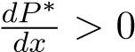
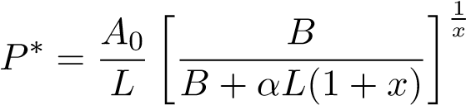
with 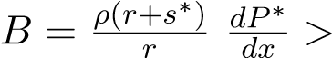= 0 and further develops into:
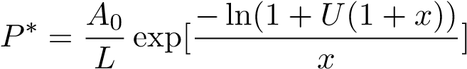
with U = ^{αL}_{B} The sign of the first order derivative toward x: 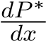 of this expression is the same as the sign of:
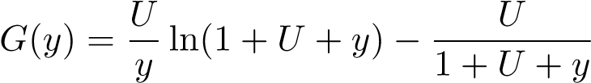
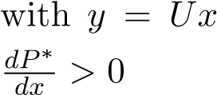 which is always positive when y > 0 because 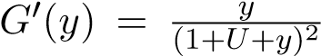 this proves that
b-We know from section 2.1.1 above that _{dσ}^{dx} <= 0 This leads to:
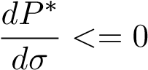
This implies that the optimal level of debt, following the introduction of the FTT, will decrease because of the increase in the volatility of corporation’s assets.
c-Let’s designate by P∗∗ this new optimal level of debt and by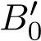 the new bond price. The new equity price is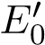 and the original equity price is E₀ . In order to reach the new optimum, the corporation will have to ”buy back” on the market the debt formerly issued at market price. Once the new level of debt is reached, the equity value is determined by equation (20).
Therefore the corporation has to issue a number ∆n of additional shares to fund the purchase of the corporate bonds on the secondary market. The issuance of shares and the bond ”buy-back” are done at the prevailing market prices on both bond and stock markets. This writes:
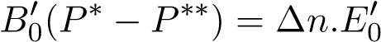
Pursuant to our hypothesis that we are within the ”envelope” leading to a decrease of the equity, following the introduction of the FTT, we have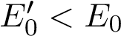. The price per share for the new issuance is 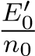 where n₀ designates the initial number of shares. The new number of shares is n₁ = n₀ +∆n.
Consequently, the firm is issuing additional shares at a lower share price which is characteristic of
dilution. The new equity value after issuance is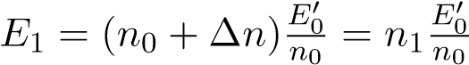 which implies
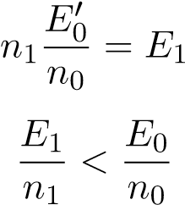
.
Figure 5: Short Term Reaction of the Expected Theoretical Share Price for an Optimal Capital Structure Depending Upon Spread and Leverage
-
6
-
5
-
4
-
3
-
2
-
1
0
Spr=50 b.p
Spr=100 b.p
Spr=150 b.p
Spr=200 b.p
Spr=250 b.p
Spr=300 b.p
Spr=350 b.p
Spr=400 b.p
Short Term Impact on Theoretical Equity Share Price for Optimum Leverage
Depending Upon Maturity and Credit Spread
T=5
T=10
T=15
T=20
2.3.2 The Short and Long Term Consequences of the FTT Introduction on The Theoretical Equity Share Price
We consider equation (23) with K = K∗ = LP∗ where P∗ is the outstanding amount of principal debt which maximizes the corporation value V in equation (21). We consider that the main parameters such as δ, r, s∗, and consequently ROE are within the envelope discussed previously which leads to a decrease of the equity share price. As the parameters are within this envelope, we can expect a decrease of the equity price for the value P∗.
We draw a distinction between the short and long term impact.
The short term impact consists in the immediate adjustment of the equity share price following the increase of the asset volatility. Table 12 evidences this drop in equity prices for the optimal leverage depending upon the credit spread for different values of debt maturity.
The long term impact consists in the adjustment of both the capital structure and the equity share price. The long run is reached once all the fixed term debt has been adjusted to its new principal amount. According to the model we are using, once the FTT is introduced, the number of years to reach the full long term effect of the FTT, is thus equal to the maturity of the debt. One can see on Table 12 as well as figures 5 and 6 that the magnitude of the negative impact on the equity price increases very slightly with the debt maturity.
Table 13 displays the short and long term values of the drop in the theoretical equity share price depending upon the corporate tax rate for average credit spreads comprised between 100 and 300 b.p.a and an average debt maturity of 5 years. One can see that corporations located within countries with a higher corporate tax rate will record a more important drop of the theoretical equity share price. This distorsion will increase with the level of the credit spread.
Both short term and long term impact of the FTT on the theoretical equity share price are increasing with the credit spread, whereas the influence of maturity is very little. as evidenced in figure 5..
As for the fixed capital structure, we can see on figures 7 and 8 that both short term and long term effects on the theoretical equity share price are strongly depending upon the corporate tax rate. For the same spread, and our base case, in terms of volatility, maturity and risk free rates, Table 12: Short and Long Term Impact (in percent) of the FTT at the Optimum Leverage for Various Credit Spreads (in b.p.a) Depending upon the maturity(r = 0.01; ρ = 0.35; α = 0.50; σ_{A} = 0.1;δ = 0.03)
Maturity | Credit Spread | Short Term Impact | Long Term Impact
5Y | 50 | −0.97 | -0.93
5Y | 100 | −1.53 | -1.49
5Y | 150 | −2.12 | -2.07
5Y | 200 | −2.71 | -2.66
5Y | 250 | −3.28 | -3.23
5Y | 300 | −3.82 | -3.76
5Y | 350 | −4.32 | -4.26
5Y | 400 | −4.78 | -4.72
10Y | 50 | −0.98 | -0.94
10Y | 100 | −1.55 | -1.51
10Y | 150 | −2.17 | -2.12
10Y | 200 | −2.81 | -2.75
10Y | 250 | −3.44 | -3.38
10Y | 300 | −4.05 | -3.90
10Y | 350 | −4.63 | -4.58
10Y | 400 | −5.19 | -5.13
15Y | 50 | −0.98 | -0.94
15Y | 100 | −1.56 | -1.51
15Y | 150 | −2.19 | -2.13
15Y | 200 | −2.82 | -2.77
15Y | 250 | −3.46 | -3.40
15Y | 300 | −4.09 | -4.03
15Y | 350 | −4.70 | -4.64
15Y | 400 | −5.30 | -5.24
Table 13: Short and Long Term Impact (in percent) of the FTT at the Optimum Leverage for Various Corporate Tax Rates (r = 0.01; ρ = 0.35; α = 0.50; σ_{A} = 0.1;δ = 0.03;T = 5Y ears)
Corporate tax rate | Credit Spread | Short Term Impact | Long Term Impact
0.15 | 100 | −0.36 | -0.33
0.20 | 100 | −0.61 | -0.58
0.25 | 100 | −0.90 | -0.86
0.30 | 100 | −1.21 | -1.17
0.35 | 100 | −1.53 | -1.49
0.15 | 200 | −0.76 | -0.72
0.20 | 200 | −1.22 | -1.18
0.25 | 200 | −1.72 | -1.67
0.30 | 200 | −2.33 | -2.17
0.35 | 200 | −2.71 | -2.66
0.15 | 300 | −1.24 | -1.19
0.20 | 300 | −1.92 | -1.87
0.25 | 300 | −2.60 | -2.55
0.30 | 300 | −3.24 | -3.19
0.35 | 300 | −3.82 | -3.76
Figure 6: Long Term Reaction of the Expected Theoretical Share Price for an Optimal Capital
Structure Depending Upon Spread and Leverage
-
6
-
5
-
4
-
3
-
2
-
1
0
Spr=50 b.p
Spr=100 b.p
Spr=150 b.p
Spr=200 b.p
Spr=250 b.p
Spr=300 b.p
Spr=350 b.p
Spr=400 b.p
Long Term Impact on Theoretical Equity Share Price for Optimum Leverage Depending Upon Maturity and Credit Spread
T=5
T=10
T=15
T=20
Figure 7: Short Term Reaction of the Expected Theoretical Share Price for an Optimal Capital Structure Depending Upon Spread and Corporate Tax rate
-
6
-
5
-
4
-
3
-
2
-
1
0
Spr=50 b.p
Spr=100 b.p
Spr=150 b.p
Spr=200 b.p
Spr=250 b.p
Spr=300 b.p
Spr=350 b.p
Spr=400 b.p
Short Term Impact on the Theoretical Equity Share price Depending Upon The Credit Spread and The
Corporate Tax Rate for a 5 Years Debt Maturity.
Rho=0,15
Rho=0,20
Rho=0,25
Rho=0,30
Rho=0,35
corporations located in countries with a higher tax rate will experience a higher drop in their theoretical equity share price than corporations located in countries with a lower tax rate. As for fixed capital structure, this should create some distortions in the competitiveness of corporations depending upon their tax domiciliation in Europe. This effect would be stronger than for fixed capital structure.

2.4 Consequences on The Volumes of Shares Available for Trading
As we saw previously, corporations aiming for an optimal capital structure and issuing fixed term corporate debt, should decrease their leverage ratio and issue more equity shares on the primary market at a lowered price.
Issuing debt is, in general the preferred way of raising capital for corporations as it is generally less expensive than issuing equity. Funding capital requirements through equity occurs in specific occasions, where the return on new equity issued is not guaranteed. Generally, this is the case for merger and acquisitions, or creation of new business lines.
In such occasions, because of the price drop in share prices due to the FTT, corporations will have to issue more shares on the primary market to raise the same amount of capital.
Consequently, as a whole, an economy featuring a FTT should record, in the long run, a higher volume of equity shares. Everything else being equal, the total amount of shares available for trading (”the Float”) should increase.
Figure 8: Long Term Reaction of the Expected Theoretical Share Price for an Optimal Capital Structure Depending Upon Spread and Corporate Tax Rate
-
5
-
4
,
5
-
4
-
3
,
5
-
3
-
2
,
5
-
2
-
1
,
5
-
1
-
0
,
5
0
Spr=50 b.p
Spr=100 b.p
Spr=150 b.p
Spr=200 b.p
Spr=250 b.p
Spr=300 b.p
Spr=350 b.p
Spr=400 b.p
Long Term Impact on the Theoretical Equity Share price Depending Upon The Credit Spread and The
Corporate Tax Rate for a 5 Years Debt Maturity.
Rho=0,15
Rho=0,20
Rho=0,25
Rho=0,30
Rho=0,35

3 Model Calibration and Application to a Sample of 5 Corporate Companies
We apply the two models described above to a sample of 5 corporate companies which includes three industrial corporate firms (Michelin, Arcelor Mittal, Alsthom) and two financial corporate firms (Axa, Commerzbank). We consider two valuation dates. The first date is the 30th of September 2016, in order to have a direct comparison with the calculations done on debt at Chapter II. The second is the 12th of January 2018.
The data we used consists of balance sheet, profit and loss statements, and credit spreads as well as the entire universe of bond issued which are still outstanding. The corporate short term debt is assumed to have a 1 month maturity.
Most of the corporate bonds, nowadays are featuring a call clause in favor of the issuer. This clause allows the issuer to buy back at a predetermined price (generally at par) the corporate debt which has been issued previously. This clause is useful, for instance, when the credit worthiness of the firm has improved since the bonds were issued and the current coupon served on outstanding corporate debt is above the current market price. It is then worth to buy back this debt and reissue new debt at a lower coupon price.
For simplicity’s sake, we will not consider the impact of such clause. The long call component for the shareholder is going to be negatively impacted by the introduction of the FTT, because the subsequent increase in volatility is going to increase the credit spread and the cost of corporate debt. For this reason, we can consider that our estimation constitutes a minimum evaluation of the FTT impact on corporate theoretical share prices.
We consider the credit spreads on the type of debt seniority prevailing on the Credit Default Swap market at valuation date. We consider the average duration of the corporate debt weighted by the amount of outstanding debt per maturity. We then calibrate an asset volatility such that the outstanding average corporate debt is valued at par using our model. Then we apply the Boyle and Vorst calculation for a 2 percent ∆_{S} rule and the FTT rate.
We conduct two different calculations:
- The first one consists of the computation of the short-term instantaneous effect, as described in previous sections.
- The second one consist of the computation of the stationary state impact, once the corporate firm has adjusted its capital structure, by replacing the corporate debt with bond issues featuring a higher coupon, in order to raise the same amount of capital.
We display the separate effects on both the expected theoretical value of Corporate equity, and corporate bond credit spreads.
Results are displayed in Table 14 and 15.
One can see that the impact is negative for most stocks of our corporate sample.
Table 14: FTT Impact on Theoretical Equity Prices and CDS spreads for a sample of five European Corporate Firms As of the 30/09/2016 (spreads in b.p, volatilities in percent)
Issuer | Spread | Duration | Short Term | Long Term | Spread Increase
Alsthom | 40 | 2.76 | -8.61 | -5.53 | 79
Arcelor-Mittal | 167 | 7.33 | -1.96 | 0.63 | 264
Axa | 201 | 20.77 | -8.98 | -11.78 | 145
Commerzbank | 120 | 4.45 | -1.44 | -2.05 | 160
Michelin | 47 | 6.6 | -1.06 | -1.0 | 62
Table 15: FTT Impact on Theoretical Equity Prices and CDS spreads for a sample of five European Corporate Firms As of the 12/01/2018 (spreads in b.p, volatilities in percent)
Issuer | Spread | Duration | Short Term | Long Term | Spread Increase
Alsthom | 15 | 2.76 | -9.12 | -7.14 | 50
Arcelor-Mittal | 138 | 6.05 | -2.71 | 0.20 | 148
Axa | 150 | 19.483 | -4.05 | -7.68 | 104
Commerzbank | 35 | 3.14 | -2.24 | -2.83 | 85
Michelin | 42 | 5.269 | -2.90 | -1.81 | 46

4 Comparison with the Existing Results from The Literature and FTT Impact in the Particular Case of the Banking Sector in the Basel III Context and the Need for Banks to Raise additional Capital

4.1 Comparison with the Existing Results from The Literature
We can now compare our conclusions with existing results from the literature. Existing empirical studies were done exclusively for the specific case of Sweden (Umlauf (1993), Westerholm (2003)) till 2003. At this time, similar reviews using the same methodology where done for the UK (Saporta and Kan (1997), Hawkins and McCrae (2002)). Those studies were considering the stock market only and were excluding the corporate bond market.
In the case of Sweden, Umlauf (1993) reports that the Swedish All-Equity Index fell by 2.2 percent on the day a 1 percent transaction tax was introduced and again by 0.8 percent on the day it was increased to 2 percent. This suggests a short-term elasticity of 2.2 and an additional 0.4 for the second increase. Westerholm (2003) concludes that the suppression of the two respective taxes of 1and 2 percent introduced respectively in 1983 and 1986 would lead to an increase of respectively 7.5 and 9.7 percent of the stock prices. This is consistent with an elasticity to the tax which is comprised between 4.85 and 7.5.
In the case of UK, which constitutes the only case for empirical reviews of the introduction of a STET, besides the Swedish case, Saporta and Kan (1997) by using the same methodology as Umlauf, found that a decrease of 1 percent of the ”stamp duty ” tax, would bring an expected index rise of 6.24 percent. Their study was based on observations of UK stock market prices from 1969 to 1996. Both Saporta, Umlauf and Westerholm do not consider the leverage as an explaining variable and do not disclose the average leverage of the sample of corporations they are reviewing. In the case of UK, Hawkins and McCrae (2002) explore the case of the suppression of the STET and find an elasticity which is comprised between 6.75 and 12.25 depending upon the assumptions done on the impact of the suppression on shares transaction turnover.
The STET considered in both the Swedish and the UK cases had different specifics than the FTT project. For instance, in both UK and Swedish cases, transactions initiated by f inancial institutions were exempt from the tax, whereas the European FTT would apply to all transactions with the EU. In addition, the Swedish review was done on a period where both the equity and credit derivatives markets were not developed significantly. In the UK case, the review was achieved in 2003, at a time where the credit derivatives markets were just beginning their development, while the equity derivatives market was already in place. In both cases, the possibility to conduct capital structure arbitrage between credit and equity derivatives, which is the justification of our analysis, was limited. Furthermore, in both cases of Sweden and UK reviews, the authors do not disclose or compute the average corporation leverage of the stock index they are considering.
Despite these differences, our results are comparable in terms of directions and magnitude to existing results from literature, based on empirical studies, for a reasonable assumption on corporation’s leverage. Our results displayed Table 4 evidence approximately the same short-term magnitude as Saporta and Kan (1997) or Westerholm (2003) and Umlauf (1993), and even Hawkins and McCrae (2002), if we consider an average leverage between 3 and 4, and a FTT roundtrip rate of 0.4 percent.

4.2 The Particular Case of the Banking Sector in the Basel III Context and the Need for Banks to Raise additional Capital
Results stated above are of particular importance for banks and financial institutions, especially in the European Union which are subject to the new capital requirements implemented by the CRD IV (”Basel III”) rules. According to those rules, banks must maintain enough capital to offset the risk they bear on their asset portfolio. Pursuant to the new requirements introduced by the CRD IV rule, banks have issued specific debt investment vehicles allowing them to fulfil this obligation in case their core equity defined as the Tier 1 falls below a predetermined fraction of their assets. Those instruments are in fact “quasi-equity” and are issued as convertible perpetual contingent debt(COCO), where generally the debt is converted into equity, once a specific event is triggered. This specific event consist of the equity value a poses then a fixed capital structure (and leverage) for banks and financial institutions falling under a predetermined threshold expressed as a fraction of the bank corporate assets. This debt is either at a fixed or floating rate. Additionally, banks have offered variants of COCOs which encompass a “wipe-off” clause where instead of a conversion into equity, the entire capital is lost for the investor, the rate of return of the instrument being priced accordingly.
Those instruments might encompass also a call clause where the issuer can buy back those instruments. In this case, there is an embedded call option which is sold by the investor to the issuer. From the investor’s standpoint, the introduction of the FTT which triggers an increase in both asset and stock price value, generates an additional cost which has to be compensated by the issuer, generally by increasing the principal amount of COCOs. This in turn creates an additional drop in the stock price. We will not consider this possible call clause, and therefore the impact we will compute is in fact the minimum possible effect.
Those new convertible instruments denominated as Contingent Convertible Bonds (”COCOs”) can be stripped into a perpetual debt issued either at a fixed or floating rate, and a ”call” option sold by the investors to the issuer. The issuer can then convert the debt into equity in the case the bank capital falls below a predetermined threshold. Practically, the computation of the price of a COCO uses the same framework as the one exposed previously in Section I. When the COCOS features a complete wipe-off possibility, instead, the calculation is then simplified as it consists solely of the expected value of the futures payment coupons, under the natural risk neutral measure attached to the diffusion process followed by the share price,
Let’s consider S(t) which designates the value of corporate equity at time t, and D(t) designates the total amount of corporate outstanding debt, excluding COCOs. We assume for simplicity’ sake that we have only one issue of COCO. We designate by DD(t) the market value of the COCO debt, corresponding to the facial value P(t) of the COCO issued.
We designate by r the “risk-free ” yearly interest rate, d is the continuous dividend yield paid by the stock, and σ designates the stock volatility.
dS_{t} = (r − d)dt + σdW_{t} (32)
S₀ > 0
Let’s compare two situations, one without FTT and one where the FTT has been introduced. We want to do a static comparison between the two values of the COCOs issued.
τ designates the first hitting time such that it triggers the conversion of one monetary unit of COCO into one monetary unit of corporate equity. This time is such that
τ = inf(t;B_{t} ≤ K)
. K designates the threshold on the equity value such that the conversion is triggered;
The risk neutral valuation of the COCO whose facial value is P and which pays a continuous coupon C encompasses the coupon payments till the debt is converted into corporate equity at the share price K.
The pricing of such COCO appears very similar to the pricing of the perpetual debt with an exogenous threshold triggering the bankruptcy, that we described in Section I.
By the same token as in Section I, the COCO’s coupon payment term writes:
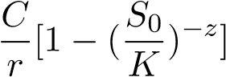
The payment at the date of exercice is PK. The expectation of such payment under the natural measure is
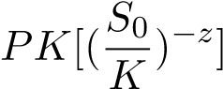
where z is computed accordingly to section 1, given that the process S(t) has a drift equal to r−d. The payment at the date of exercise is in fact similar to the pay-off of a perpetual one touch put paying PS_{c} in case the barrier K is touched by B(t).
We can therefore express the value DD of the COCO which writes:
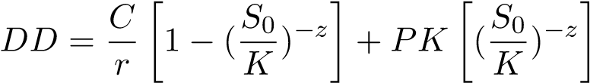 (33)
Equation above evidences that the increase in the stock price implied volatility due to the implementation of the FTT is going to have two antagonistic effects:
- The discounted value of future coupon payments is going to be negatively affected by the increase in the probability of exercising the COCO;
- The conversion option is going to be positively affected by the increase in the volatility.
This effect will not exist, of course, in a COCO featuring a complete wipe-off clause.
Equation (23) then allows to simulate the generic impact of the increase of the FTT on the corporate equity of banks, depending upon the capital requirements they have to abide by and the exact COCOs clauses.
In case of the introduction of the FTT, the value of the COCOs is going to decrease. Consequently, banks and financial institutions will have to adjust the coupon paid by the COCOs in order to raise the same amount of cap. Applying the reasoning of section 2.1.1 and equation (19), we find that the increase in the COCO coupon will lower both the theoretical bank’ value and its equity.
Consequently, the introduction of the FTT will conflict with the implementation of CRD IV. The FTT will lower the equity value of banks when, at the same time, CRD IV aims to increase the banks equity.

5 Conclusion
We have reviewed the possible impact of the European Union Financial Transaction Tax (FTT) on the theoretical values of corporations and the theoretical prices of their equity shares, as well as the corporate debt issued and to be issued. The FTT is a particular case of Standard Transaction Excise Tax (STET) that will apply to all financial transactions taking place within the EU or where at least one counterpart is domiciled within the EU.
Unlike other works, mostly based on practical surveys of equity prices following the introduction of a STET in various countries, our approach is micro-economic and based on theoretical models. We arrive at the conclusion that the introduction of a tax applying to all corporations will have different effects at the micro-economic level depending upon the capital structure of each corporation.
We assume the existence of capital structure arbitrage between the various cash instruments used to fund the corporate capital requirements, such as equity and debt. We also consider the existence of arbitrage between equity and credit derivatives written on corporate equity and debt.
We take into account standard available structural models found in the relevant literature. They assume a corporate default triggered by the value of corporate asset falling below a fraction of the outstanding corporate debt. This ”option-like” approach allows us to connect equity and asset volatility to the corporate credit spread and corporate debt value.
All theoretical prices or values of corporate debt or equity are then valued under the natural risk measure associated with the corporate asset diffusion process.
We rely upon the results of Chapters I and II to determine the FTT impact on equity share and corporate asset volatility. In particular the option market used to hedge the credit derivatives market is not liquid enough to amortize the impact of the FTT on equity share price volatility.
Under these circumstances, we describe the stationary state of a corporation funding its capital requirements through the issuance of perpetual debt, quasi-equity, equity and fixed-term debt. We then conduct comparative statics to estimate the effects of the introduction of the FTT, depending upon leverage, asset volatility, risk free rate, credit spread and corporate tax rate.
We find that the introduction of the FTT will generally tend to lower the corporation’s value, the price of corporate equity shares as well as the market value of the corporate debt. Those conclusions are in line with various practical studies, such as Umlauf (1993) and Saporta and Kan (1997), based upon the experience of the actual introduction of an FTT in Sweden and the United Kingdom. In addition, we find that the magnitude of the negative impact is going to increase with the level of the risk-free rate.
We further find that this impact is going to be affected by the corporate tax rate and the duration of corporate debt used to raise capital. For corporations raising capital through intermediate debt (1 to 15 years), the impact is going to be lower in countries with a lower corporate tax rate. However, corporations raising capital through perpetual debt in countries with a lower tax rate will experience a higher decrease of their theoretical equity share price than the ones located in countries with a higher tax rate. Consequently, even if the FTT is introduced at the same time in all European Union countries, the differences in country corporate tax rates will induce competitive distortions within the EU when it comes to the corporate cost of funding.
We also demonstrate that those corporations with the most volatile share prices will generally experience a stronger decrease of their corporate equity price and overall value. The negative impact will often increase with the corporation’s leverage. However, we find that for highly leveraged corporations with high asset volatility that issue debt with high credit spreads, the impact on corporate share price will be in fact positive, though the impact on overall firm’s value will still be negative. In fact, we reproduce the results found by Leland and Toft, evidencing an agency effect in that the shareholders of corporations issuing junk bonds benefit from an increase in the riskiness of the assets. We conclude that the introduction of the FTT will produce some adverse selection bias in favor of risky corporations and behavior.
We find also a dependency between the return on equity and the impact of the introduction of the FTT. In theory, for very high values of ROE, the impact on the equity share price might be positive. However, we find that for common values of ROE and leverage, the impact will be negative. We determine theoretically, an ”envelope” of parameters such as ROE, leverage, credit spreads, within which the introduction of the FTT will lead to lower equity share prices. For instance, we find that such is the case for most companies in the French CAC 40 benchmark.
We apply those theoretical results to a sample of 6 European Union corporations, from both financial and industrial sectors, and evaluate the magnitude of the drop in equity share price values and corporate debt.
We find that our results are in line with results taken from the existing literature, and based upon empirical reviews of stock market prices, following. for instance the introduction of a STET in Sweden or the United Kingdom. We find a negative impact on the stock prices, and the magnitude of this effect seems comparable to the ones measured respectively in Umlauf (1993), Westerholm (2003), Saporta and Kan (1997),Hawkins and McCrae (2002).
We then consider the possible interaction between the FTT and the new dispositions introduced by the new CRD IV regulation (Basel III) on minimum capital requirements for banks and financial institutions. As a consequence of these requirements, banks and financial institutions must issue debt convertible into equity or quasi-equity in case their equity falls below a predetermined threshold. Considering this debt is issued either as intermediate fixed-term bond or perpetual debt, we find that the introduction of the FTT will conflict, in this particular context, with the enforcement of the CRD IV regulation. In fact, the introduction of the FTT will lead to a decrease in the value of the banks equity at the same time the regulation seeks an increase in this same equity.
Finally, we find that the general decrease in corporate share prices following the introduction of an FTT will lead in the long run to an increase in the volumes of equity shares issued by corporations to raise capital.

References
Allen, P., Einchcomb, S., and Granger, N. (2006). JP Morgan–European Equity Derivatives Strategy.
Almgren, R. and Chriss, N. (2001). Optimal execution of portfolio transactions. Journal of Risk, 3:5–40.
Altman, E. I. (1968). Financial ratios, discriminant analysis and the prediction of corporate bankruptcy. The journal of finance, 23(4):589–609.
Amihud, Y. and Mendelson, H. (1986). Asset pricing and the bid-ask spread. Journal of financial Economics, 17(2):223–249.
Amihud, Y. and Mendelson, H. (1991). Liquidity, asset prices and financial policy. Financial Analysts Journal, 47(6):56–66.
Anthony, J., Bijlsma, M., Elbourne, A., Lever, M., and Zwart, G. (2012). Financial transaction tax: review and assessment. CPB Netherlands Bureau For Economic Policy Analysis. CPB Discussion Paper.
Avellaneda, M., Reed, J., and Stoikov, S. (2011). Forecasting prices from level-i quotes in the presence of hidden liquidity. Algorithmic Finance, 1(1):35–43.
Avellaneda, M. and Stoikov, S. (2008). High-frequency trading in a limit order book. Quantitative Finance, 8(3):217–224.
Bessembinder, H. (2002). Trading costs and return volatility: evidence from exchange listings. Working paper.
Bjursell, C. J., Wang, G. H., and Yau, J. (2006). Transaction tax and market quality of us futures markets: An ex-ante analysisi. Journal of future markets, 26.
Black, F. and Cox, J. C. (1976). Valuing corporate securities: Some effects of bond indenture provisions. The Journal of Finance, 31(2):351–367.
Black, F. and Scholes, M. (1973). The pricing of options and corporate liabilities. Journal of political economy, 81(3):637–654.
Boyle, P. P. and Vorst, T. (1992). Option replication in discrete time with transaction costs. The Journal of Finance, 47(1):271–293.
Brennan, M. J. and Subrahmanyam, A. (1996). Market microstructure and asset pricing: On the compensation for illiquidity in stock returns. Journal of financial economics, 41(3):441–464.
Campbell, J. Y. and Froot, K. A. (1994). International experiences with securities transaction taxes. In The internationalization of equity markets, pages 277–308. University of Chicago Press.
Capelle-Blancard, G. and Havrylchyk, O. (2016). The impact of the french securities transaction tax on market liquidity and volatility. International Review of Financial Analysis, 47:166–178.
Duffie, D. and Singleton, K. J. (1999). Modeling term structures of defaultable bonds. The review of financial studies, 12(4):687–720.
Finkelstein, V. and Lardy, J. (2001). Assessing default probabilities from equity markets. simple closed-form solution. Presentation ICBI Global Derivatives and Risk Management, Credit Risk.
Finkelstein, V., Lardy, J., Pan, G., Ta, T., and Tierney, J. (2002). Credit grades technical document.
Habermeier, K. and Kirilenko, A. A. (2003). Securities transaction taxes and financial markets. IMF Staff Papers, Special Issue International Monetary Fund, 50(1):165–180.
Hakkio, C. S. et al. (1994). Should we throw sand in the gears of financial markets? Economic Review, 79:17–30.
Hau, H. (2006). The role of transaction costs for financial volatility: Evidence from the paris bourse. Journal of the European Economic Association, 4(4):862–890.
Hawkins, M. and McCrae, J. (2002). Stamp duty on share transactions: is there a case for change? Institute For Fiscal Studies.
Ho, T. and Stoll, H. R. (1980). On dealer markets under competition. The Journal of Finance, 35(2):259–267.
Ho, T. S. and Macris, R. G. (1984). Dealer bid-ask quotes and transaction prices: An empirical study of some amex options. The Journal of Finance, 39(1):23–45.
Jarrow, R. A. and Turnbull, S. M. (1995). Pricing derivatives on financial securities subject to credit risk. The journal of finance, 50(1):53–85.
Jones, C. M. and Seguin, P. J. (1997). Transaction costs and price volatility: evidence from commission deregulation. The American Economic Review, 87(4):728–737.
Keynes, J. (1936). The General Theory of Employment, Interest and Money. Harcourt Brace.
Kupiec, P. (June 1996). Noise traders, excess volatility, and a securities transaction tax. Journal of Financial Services Reseach, 10(2):115–129.
Lardy, J.-P. (2001). A simple closed-form formula to price credit. Presentation, Risk, Paris.
Leland, H. (1985). Option pricing and replication with transaction costs. The Journal of Finance, 40:1283–1301.
Leland, H. (1994a). Corporate debt value, bond covenants, and optimal capital structure. The Journal of Finance, 49:1213–1252.
Leland, H. (1994b). Optimal capital structure, endogenous bankruptcy, and the term structure of credit spreads. Finance working paper, (240). Haas School of Business, University of California, Berkeley, USA.
Leland, H. E. et al. (2007). Comments on ”hedging errors with leland’s option model in the presence of transactions costs”. Finance Research Letters, 4(3):200–202. Haas School of Business, University of California, Berkeley, USA.
Leland, H. E. and Toft, K. B. (1996). Optimal capital structure, endogenous bankruptcy, and the term structure of credit spreads. The Journal of Finance, 51(3):987–1019.
Lendvai J., Raciborski R., V. L. (March 2012). Securities transaction taxes: Macroeconomic implications in a general equilibrium model. European Economy: Economic Papers, (450).
Lo, A. W., Mamaysky, H., and Wang, J. (2004). Asset prices and trading volume under fixed transactions costs. Journal of Political Economy, 112(5):1054–1090.
Matheson, M. T. (2011). Taxing financial transactions: Issues and evidence. Number 11-54. IMF Staff Papers, International Monetary Fund.
Modigliani, F. and Miller, M. H. (1958). The cost of capital, corporation finance and the theory of investment. The American economic review, 48(3):261–297.
Mulherin, J. H. (1990). Regulation, trading volume and stock market volatility. Revue ´economique, pages 923–937.
Musiela, M. and Rutkowski, M. (1998). Martingale methods in financial modeling, 2nd edition. Stochastic Modelling and Applied Probability, 36.
Oxera (2007). Stamp duty: Its impact and the benefits of its abolition. Technical report, Oxera.
Oxera (2014). What could be the economic impact of the proposed financial transaction tax? a comprehensive assessment of the potential macroeconomic impact. Technical report, Oxera.
Roll, R. (1989). Price volatility, international market links, and their implications for regulatory policies. In Regulatory Reform of Stock and Futures Markets, pages 113–148. Springer.
Rubinstein, M. and Reiner, C. (1991). Breaking down the barriers. Risk, 4:28–35.
Saporta, V. and Kan, K. (1997). The effects of stamp duty on the level and volatility of equity prices.
Schwert, G. W. and Seguin, P. J. (1993). Securities transaction taxes: an overview of costs, benefits and unresolved questions. Financial Analysts Journal, 49(5):27–35.
Song, F. M. and Zhang, J. (2005). Securities transaction tax and market volatility. The Economic Journal, 115(506):1103–1120.
Stiglitz, J. E. (1989). Using tax policy to curb speculative short-term trading. Journal of financial services research, 3(2-3):101–115.
Summers, L. H. and Summers, V. P. (1989). When financial markets work too well: a cautious case for a securities transactions tax. Journal of financial services research, 3(2-3):261–286.
Taleb, N. (2005). Fooled by randomness: The hidden role of chance in life and in the markets, volume 1. Random House Incorporated.
Tobin, J. (1978). A proposal for international monetary reform. Eastern economic journal, 4(3/4):153–159.
Umlauf, S. R. (1993). Transaction taxes and the behavior of the swedish stock market. Journal of Financial Economics, 33(2):227–240.
Vasicek, O. KMV (Kealhofer, M. and Vasicek) (2012). Structural models in credit valuation. NYU Stern.
Wang, G. and Yau, J. (2012). Would a financial transaction tax affect financial market activity? insights from future markets. Policy Analysis, (702).
Westerholm, P. (2003). The impact of transaction costs on turnover, asset prices and volatility: the cases of sweden’s and finland’s security transaction tax reductions. Liiketaloudellinen Aikakauskirja, pages 213–241.

Applied Economics
ISSN: 0003-6846 (Print) 1466-4283 (Online) Journal homepage:

http://www.tandfonline.com/loi/raec2
0
Study of the effect of a Financial Transaction Tax on the corporate cost of capital

Jean Pierre Fraichot
To cite this article: Jean Pierre Fraichot (2017): Study of the effect of a Financial Transaction Tax on the corporate cost of capital, Applied Economics, DOI: 10.1080/00036846.2017.1363864 To link to this article: http://dx.doi.org/10.1080/00036846.2017.1363864
Download by:
[Jean fraichot]
Date:
19 September 2017, At: 02:17
Published online: 21 Aug 2017.
Submit your article to this journal

Article views: 13
View related articles

View Crossmark dat
a
159

APPLIED ECONOMICS, 2017
https://doi.org/10.1080/00036846.2017.1363864
Study of the effect of a Financial Transaction Tax on the corporate cost of
capital
Jean Pierre Fraichot
LEDa, U. Paris Dauphine, PSL Research University, Paris, France
ABSTRACT
We study the impact of a Financial Transaction Tax (FTT or Tobin Tax) on the corporate cost of capital. We consider the results on the impact of transaction costs on implied volatility and then use the utility maximization of a market-maker and its asymptotic solution. The FTT impact on volatility, in highly liquid equity option markets, is within two decimals (‘the tick value’) and is insignificant. The volatility impact is considerable for illiquid option markets especially long-dated equity options, used for the hedging of credit default swaps (CDS). The credit spread increase is computed using a structural model, and amounts between 30 and 60 basis points (b.p). per annum, for 5– 20 year maturities, and a volatility level of 30%. The impact decreases with the corporation leverage ratio. We calibrate from the CDS market the implied volatility for six European corporations and find an increase in spreads by up to 60%. For a corporation with a 343 b.p. 5-year CDS spread, the increase amounts to 174 b.p. On the basis of this sample, the impact we find is between 5 and 20 times higher than the one computed in the study of Lendvai et al. which has been used by European Union authorities to assess the impact on the cost of capital.
KEYWORDS
Tax reform; options;
volatility; liquidity; credit spread
JEL CLASSIFICATION
G02; G11; G12; H22; H39

I. Introduction
In 1972, the Bretton-Woods agreement came to an end. Foreign currencies were allowed to float freely between one another, creating volatility on the foreign exchange markets. Observing this phenomenon, James Tobin introduced the concept of a tax on foreign exchange transactions to curb excessive speculation. The idea behind the proposal of such tax was that a transaction tax might reduce short-term speculative trading and excess volatility on the foreign exchange market. In fact, James Tobin was adapting an idea proposed by John Maynard Keynes during the Great Depression for securities markets, which consisted of a transaction tax, also designed to curb excessive speculation. In the years following the stock market crash of 1987, Stiglitz and Summers and Summers did revisit Keynes’s original idea and proposed the introduction of a low-rate broad-based ‘Securities Transaction Excise Tax’ (STET). They argued that the tax should apply to all financial instruments, including debt instruments and derivatives, as the exemption of such instruments would create strong distortions in the corporate capital structure. It should be levied, they reasoned, at a low rate as not to discourage arbitrageurs and long-term investors, which are useful to the economy.
Downloaded by [Jean fraichot] at 02:17 19 September 2017
We focus here on the particular case of the European Financial Transaction Tax (FTT) implementation project. Both securities and foreign exchange transaction taking place in the European Union (EU) or performed by financial institutions domiciled in the EU would be subject to this tax. Consequently, the FTT project appears as a hybrid between a STET of the type suggested by JM Keynes, J Stiglitz and Summers and Summers and the Tobin tax of the type suggested by J. Tobin in the early 1970s.
There are quite a few empirical contributions analysing the effect of a STET on capital costs. However, few theoretical studies (based on general equilibrium models or other theoretical tools) assess its impact on the real side of the economy. In general terms, the scarce existing literature finds that the STET affects economic variables through the transmission of capital costs. See Lendvai, Raciborski, and Vogel (2012), Anthony et al. (2012) and Oxera (Stamp Duty 2007).
CONTACT Jean Pierre Fraichot jean-pierre.fraichot@dauphine.fr LEDa, Université Paris-Dauphine, PSL Research University, Place du Maréchal de Lattre de Tassigny, Paris 75775, France
© 2017 Informa UK Limited, trading as Taylor & Francis Group
The effects on corporate capital costs of the introduction of a STET for US markets have been reviewed
2
(Amihud and Mendelson 1991, Hakkio 1994, Matheson 2003, among others). Amihud and Mendelson did conclude to a decrease in asset prices due to the fact that investors consider the net present value of future transaction costs when pricing financial assets. Empirical studies have focused on the experience of various countries that have tried and implemented different types of STET, such as the United Kingdom (Saporta and Kan 1997, Hawkins and McCrae 2002, Oxera (Stamp Duty 2007)) and Sweden (Umlauf 1993, Westerholm 2003). The literature concludes that taxes on securities transactions would be associated with a decrease in asset prices and an increase in the cost of capital.
For Sweden, Umlauf reports that the Swedish AllEquity Index fell by 2.2% on the day a 1% transaction tax was introduced in 1983 and again by 0.8% on the day it was increased to 2% in 1986. Westerholm concludes that the repeal of the tax would lead to an increase of respectively 7.5% and 9.7% in the stock prices. He further estimates the elasticity of asset prices to transaction costs, defined as bid-ask plus brokers fees and transaction taxes, and finds an elasticity of −0.20 for Sweden and −0.21 for Finland.
Studying the effects of the introduction of a stamp duty in the UK, Saporta and Kan find that on the day the stamp duty was increased from 1% to 2%, the stock market index declined by 3.3%. Hawkins and McCrae find that if the stamp duty was to be repealed, the stock price increase would be up to 12.5% and be directly related to the volumes and inversely related to the dividend yield of the stocks.
For the particular case of the FTT, a study by Lendvai et al. found, using a general equilibrium model (Lendvai, Raciborski, and Vogel 2012), that the FTT would increase the corporate cost of capital by 9 basis points per annum.
Our study retains the exact specifications of the FTT as stated in the EU project. We try, however, to gauge the quantitative impact of the FTT on the corporate cost of capital through a different approach. We consider the possible effects of the FTT on the corporate cost of capital by using the connection between credit default swaps (CDS) and equity derivative markets through capital structure arbitrage. This arbitrage consists in taking advantage of the value differences between different financing instruments of the same corporate entity, and finds its justification in the Modigliani– Miller proposition. Our approach aims at capturing the cascading effects of the FTT, especially on the hedging and transaction costs incurred by the economic agents involved in such arbitrage.
We consider that a uniform taxation disposition can induce heterogeneous responses at the micro-economic level, depending upon the specifics of any given corporate entity and its micro-economic characteristics.
We review the possible impact of the FTT on the prices quoted by option market-makers. Our aim is to derive a possible impact of the FTT on volatility that could propagate first to the credit derivatives market, as equity options can be arbitrated against CDS or used for hedging. We conclude that the response to the FTT will indeed be heterogeneous and depend mainly upon the corporate balance sheet structure, as well as the initial conditions prevailing on the credit derivatives market. The impact will be lower on highly leveraged corporate entities than on entities with low leverage, and it will increase with corporate debt maturity. The impact will be higher for companies with poor ratings and high credit spreads. Numerically the range of the possible responses to the FTT is very wide.
Our results differ widely from the review done by Lendvai et al. which has been used by the European Commission and which concludes to a 9 basis points per annum increase in capital costs.
Our study points to more radical effects in some particular cases than those found by empirical reviews (Saporta and Kan 1997, Hawkins and McCrae 2002, Oxera (Stamp Duty 2007)), all of which consider mainly stocks.
Our conclusions suggest that, even if the FTT were introduced in the EU and targeted financial institutions, its effects go well beyond the EU borders. For instance, considering the case of Arcelor Mittal, a well-known steel maker, the potential increase in its corporate cost of funding would literally prevent this entity from finding competitive financing. This would create a strong distortion in competitiveness, potentially threatening its very existence, since its main competitors are based outside the EU.
Consequently, the article is organized as follows: Section II is dedicated to measuring the effect on implied volatility of increased transaction costs, depending upon the liquidity of option markets considered. Section III, considers the impact of the implied volatility on the CDS market, include numerical simulations using the calibration of a credit structural model, then concludes.
II. Volatility
Replication and cost of hedging in the presence of transaction costs
The FTT is an additional transaction cost. According to Leland (1985) and Boyle and Vorst (1992), option market-makers have to bump the volatility of the options they are selling, to accommodate for the expected costs of future hedging transactions. These costs occur because option portfolios are (delta) hedged against the share price variations using a replicating portfolio consisting of shares and cash. This hedge is adjusted frequently, as the share price movements affect the number of shares to be either sold or purchased.
This adjustment exposes the market-maker to the cascading effects of the FTT assessed on transactions on the shares and therefore generates significant expenses. Furthermore, the FTT provisions include a taxation of stock lending and borrowing operations, repurchase agreements and reverse repurchase agreements which are necessary to fund the replicating portfolio. This disposition affects mainly cash equity options.
Because of the specific provisions of the FTT, we can expect that for index options, the impact will be significantly less. This is due to the fact that, in the case of Index options, the replicating portfolio consists of cash and Index futures contracts whose ‘round-trip’ FTT tax rate is 0.02% of the notional amount, instead of 0.2% for cash instruments. Furthermore, the funding of futures consists of funding initial margins and margin calls which represents only a fraction of the amount to fund for cash derivatives.
Leland (1985) finds an impact of transaction costs linked directly to the frequency of re-hedging of option replications portfolios. Boyle and Vorst (1992) find a different rule based on a threshold for the variation of the underlying asset. The replication portfolio is rebalanced every time the relative variation of the underlying asset, since the last rehedging, is over this threshold.
k designates the round trip transaction cost expressed in percentage of the underlying asset value. σ⁰ designates the modified volatility. The respective impact on implied volatility, depending upon the two different rules, is written as follows:
- In the Δt rule, which consists of systematic rehedging the portfolio when the Δt time elapsed since the last re-hedging equals Δt.
3
σ₀₂ ¼ σ₂"1 þ _{σ}pkpðffi _{π}ðffi 2_{Δ}Þ_{t}Þ#
- In the ν based Δs rule, where the systematic re-hedging occurs every time the variation of the underlying asset, Δsis greater or equal to a predetermined threshold ν.
σ₀2 ¼ σ21 þ k_{ν}
According to authors such as Taleb (2001), the Δs rule is more efficient than the Δt rule. Especially, it proves to be more conservative from a risk perspective and allows for better preservation of the market-maker’s capital and its impact on volatility is higher than for the Δs.
For a given level of volatility, this multiplier is constant. For instance, assuming a volatility level of 40% per year, the multiplier ratio between a daily re-hedging frequency and a 2%-based re-hedging strategy amounts to 1.56. For simplicity’s sake, we will use this multiplier going forward. This will allow us to minimize numerous calculations. We will then multiply the impact by the adequate number in order to get the impact on volatility using Δs rule.
The variables to consider are either the frequency of re-hedging (Leland 1985) or the underlying asset variation threshold (Boyle and Vorst 1992) triggering the rebalancing of the delta hedging portfolio. Both formulae consider the level of volatility as the other input. Assuming that the FTT generates an additional 0.2% roundtrip transaction cost on both sales and purchases of the underlying cash equity, the application of both formulae gives the following results in terms of volatility increase.
This volatility increase is computed under the assumption that the option position sold by the market-maker will be held until the option maturity. As a result, this effect as computed below is the maximum possible effect of the FTT that a market-maker will transmit to the market by an increase in the volatility of an option sold onto the market.
For index options, where we can assume a 0.02% roundtrip transaction cost, the magnitude of the impact will be 10 times lower as both the Leland and Boyle and Vorst formulae retain a volatility impact that is itself proportional to the rate of the roundtrip cost (Table 1). Table 1 shows the increase in the implied volatility traded on option markets expressed for a marketmaker selling an option on a cash equity, it will have
4
Table 1. Volatility increase for a short (cash) equity option position depending upon the re-hedging rules (initial volatility: 40%).
Hedging rule | No repo tax | Repo tax | Index options
ΔΔss ¼¼ 00::0102 | 7.32  3.82 | 14.5 7.5 | 0.732  0.382
ΔΔΔstt ¼¼ 11σ==p2522ðffi Δ; DailytÞ252 ; twice a day | 4.26  2.46  3.44 | 8.5  4.85  6.8 | 0.426  0.246  0.344
¼ ð Þ
to carry until maturity. According to both Leland and Boyle and Vorst, a market-maker buying an option on cash equity and carrying the position until maturity will have conversely to decrease the volatility it will quote to accommodate for the expected hedging costs.
FTT volatility impact depending upon market structure and liquidity
Low liquidity option markets: a rule of thumb
We consider here equity option markets with a low liquidity. Generally, such markets rely heavily upon a ‘human’ market-maker network. Those markets can be opposed to ‘auction exchange-based’ markets ruled by ‘automatic robot trading’.
Let us assume that the cost of carrying one unit of inventory until maturity (‘frozen inventory’) is X_{t} which can be computed according either to Leland or Boyle and Vorst rules if we assume a constant volatility. Let us assume as well that the market-maker has some knowledge of the market demand for options. In that case, it knows the function ðT t⁰ÞðqÞ which is the average expected time to unwind q units of short inventory.
A good ‘rule of thumb’ for the market-maker is to compute its total cost by discounting or averaging the total inventory cost on the time needed to unwind it into the market. Furthermore, the market-maker will seek to minimize its expected inventory costs by finding opposite interests in the market.
For doing so, the market-maker which carries a short inventory of q units will quote aggressively on the buy side. It will bump its reservation price for each unit of the inventory q by a quantity up to xt ¼ XtðT t0ÞðqÞ
T t
It will quote b_{t} ¼ r_{t} þ x_{t} for each unit of its inventory.
In other words, the market-maker will purchase insurance against being short by buying options at a competitive price up to b_{t} þ x_{t}. It will give immediately x_{t} to the market in exchange for offsetting the expectation of its inventory risk which is also x_{t}.
In such case where the market-maker is short inventory, it will quote the bid-ask interval ½b_{t} þ x_{t}; a_{t} þ x_{t}. By the same token, when it will carry a long inventory, it will quote the bid-ask interval:
½bt αt; at αt with αt ¼ YtðT t0ÞðqÞ
T t
Let us consider, now, the equity option markets dominated by market-makers. In a nutshell, those option markets are such that the market-makers are the main sellers against the rest of the market, and carry at all times, a short inventory. By applying the ‘rule of thumb’ described earlier, we can see that the increase in the FTT will generate an upward shift of the reservation price of the option, because the market-makers are structurally short and need to offset their inventory in the market. This increase in the mid (reservation) price of the option will be consistent with an increase of the implied volatility mid-price.
The FTT impact on liquid option markets
Let us consider now highly liquid markets which are generally based on ‘auction exchange’ based and animated by automated ‘robot’ trading, especially ‘highfrequency’ trading. Such markets are opposed to the broker-based markets discussed earlier which are ‘human-based’. They are characterized by a very high liquidity. This allows the presence of high-frequency traders as well as the possibility of placing ‘limit’ orders in the market. The market-making behaviour in such markets can be described by the Hamilton Jacobi Bellman (HJB) equation (see Ho and Stoll 1980) which describes the maximization of the market-makers’s utility function depending upon its terminal wealth. Such markets have been abundantly studied in the literature. According to the results established by Avellaneda and Stoikov (2008), it is possible to have a simple asymptotic expression of the prices quoted by the market-maker.
Asymptotic approximation of Hamilton Jacobi Bellman equation solution. We follow the steps of Avellaneda and Stoikov (2008) who have provided an asymptotic solution for the price quoted by any market maker in a highly liquid market. Assumptions. (a) dS_{t} ¼ σ W_{t} where W_{t} is a standard Wiener process and σ is the constant volatility.
- The market-maker maximises its expectedutility function:
vðx; s; q; tÞ ¼ E_{t}½expðγðx þ qTÞÞ
where x is the market-maker’s initial capital, and γ is the market-maker’s risk aversion coefficient (γ ¼ 0 meaning it is risk neutral). We note q the number of units in the market-maker’s inventory, and T is the time horizon on which the market-maker considers its maximization program.
- Trading intensity is defined as the Poisson process intensity λðδÞ at which a ‘limit’ order will be executed as a function of its distance δ to the midprice quoted by the market-maker. The frequency of market-orders is constant. In this model and in ‘real life’, the closer the ‘limit’ order is to the mid-price, the better is the chance to have this order executed.
d. The distribution of the size of market-orders
obeys a power law such that dP_{Q}ðxÞ ¼ K₁xð¹þ^{α}Þ where K₁ is a constant.
Δp ¼ K₂ logðQÞ
where Δp is the absolute price change following a market order of size Q.
Results. Then according to Avellaneda and Stoikov (2008), the solution of the market-maker’s optimization program at time t for the horizon T is as follows, in terms of bid-ask spread and reservation (mid) price.
- Reservation price is given by rðs; tÞ ¼ s qγσ2 ðT tÞ
- Bid-ask spread at time t is δa þ δb ¼ γσ2 ðT tÞ þ 2γ lnð1 þ γkÞ
with k ¼ Kα and σ²ðT tÞ is the cost incurred by the market-maker, if it carries the position until maturity. Clearly, this is an opportunity cost, as the market-maker is exposed to the market risk without having the opportunity to unwind its position.
the market-makerFinally,ðlnð1 ’þs quote on the market.^{γ}_{k}Þ measures the price impact of
Application to liquid option equity markets. Through these two equations, we can assess the impact of the introduction of the FTT on the prices
5
quoted by market-makers in order to derive any possible effect on the implied volatility. Synthetic stock market-making. Applying directly HJB to the option would prove difficult, as we would need to determine the volatility of the call option itself. Instead, we apply the HJB asymptotic solution described earlier to the long synthetic stock position consisting in buying a call and selling a put. From the definition of a synthetic stock, it follows immediately that the bid-ask spread on the synthetic is twice the bid-ask spread on each of the two options. We consider at the money forward options. The Black–Scholes volatility of the synthetic stock is equal to the volatility of the cash stock. We assume that the bid-ask spread is the same for the call and the put.
- Opportunity costs:
Consequently, the full opportunity costs after impact of the FTT on the synthetic stock, in the case the synthetic is held until maturity is 2γσ²_{A} ðT tÞ, where σ_{A} represents the modified ‘Normal’ volatility according to Boyle and Vorst. According to HJB framework, the term ðT tÞ represents the time horizon on which the market-maker maximizes its expected utility. We will consider that T t represents the time needed by the market-maker to find opposite interests in the market, and unwind its inventory position.
- Market price impact and fiscal arbitrage ðlnð1 þ ^{γ}_{k}Þ measures the price impact of the
quote on the market.
One can expect that because the synthetic is taxed at 0.04% of the notional (roundtrip), this will impact the demand for synthetic stocks and decrease the volumes. In that case, the impact of one additional unit will be less diluted because of the volume decrease. All things being equal, this should increase the price impact.
Conversely, we consider that the difference in tax rates between cash products (taxed at 0.4% roundtrip, if we consider the repo taxation) and the equivalent derivatives products (0.02%) should allow a fiscal arbitrage and a massive transfer from cash products to delta one products such as synthetic stocks or futures. As a consequence, delta one markets
6
including synthetic stocks should record a strong increase in the volumes. Therefore, the termðlnð1 þ ^{γ}_{k}Þ should be assumed to be constant or decreasing.
c. Fiscal arbitrage and delta one products
Because of the massive development of delta one products, especially synthetic securities and futures, we can expect in fact a further reduction of the bid-ask spread on synthetic securities. This reduction will occur because of the increased liquidity on the delta one markets and can be estimated using the asymptotic approximation of the HJB equation. The transfer of transaction from cash to delta one trades will not increase the overall volumes of transactions on the ‘whole’ equity market consisting of cash and delta one derivatives for the same product, because it will merely consist in a substitution.
Using the asymptotic HJP approximation,
we are looking for a reduction of (T − t), the time needed to unwind a synthetic position, which will offset the 0.02% tax effect on the Bid-ask price.
If σ^{N}_{A} is the normal volatility of the underlying asset after transaction costs, we proxy the corresponding log-normal volatility by σ_{A} ¼ σ^{N}_{A}=S₀. This is γσ²ΔðT tÞ S²₀ ¼ 2τS₀
We can see that a reduction of 1% of the time to unwind a synthetic security in the market would allow the offset of 0.02% increase on the bid-ask due to the FTT, for one monetary unit of underlying share. This reduction in bid-ask spreads should allow market-makers to quote option prices without adding the 0.01% increase in the bid-ask spread due to the FTT.
d. Consistency between the HJB approach and the ‘rule of thumb’
We can try to calibrate the ‘HJB’ equation, using the ‘boundary condition’ that the HJB solution must respect in case the inventory is held until maturity. In that case, we can compare the results to the Boyle and Vorst calculations.
From the bid-ask spread formulation, we get δª þ δ^{b} ¼ γσ² ðT tÞ.
If σ^{N}_{A} is the normal volatility of the underlying asset after transaction costs, we proxy the corresponding log-normal volatility by
σA ¼ σSN_{A}0
then
ΔσA ¼ ½γ σ½ 2aσ22ðTtÞS20 ¼ Vega Sð 0; K;σT; tÞðσA σÞ
Vega Sð 0; K;σT; tÞ ¼ S₀σðT tÞΓðS₀; K;σT; tÞ
then
ΓðS¼0;γK½σ;2aσT;σt2Þ2ðST20σðTtÞ St02ÞðσA σ Þ
This simplifies into:
2ΓðS0; K;σT; tÞσ γ ¼ ð_{σ} þ _{σ}AÞ
Interpretation. The preceding relationship is valid when σ_{A} tends towards σ then ΓðS₀; K;σT; tÞ ¼ γ, where γ designates the risk aversion of the marketmaker. Therefore, we find a very interesting proposition regarding the maximization of the option market-maker’s utility function.
Proposition 1. Let us consider
- an option market-maker on specific strikesand maturities for a given underlying asset
- this market-maker maximizes the followingutility function vðx;s; q; tÞ ¼ E_{t}½expðγðx þ qTÞÞ
- the asymptotic estimation from Avellanedaand Stoikov (2008) is valid in the option market considered
Then the risk aversion γ coefficient to consider in the market-maker’s utility function is exactly the corresponding Γ of the option.
Quantitative estimation of the FTT impact on market-maker’s quotations using the asymptotic approximation of HJB. We assert that the FTT has no significant effect on the quoted option price if the price modification of the option is within the ‘tick’
7
Table 2. Impact of the FTT in terms of bid-ask spreads on cash equity option prices for various tenors (in days) and unwinding times (market depth-in fractional days and days) using HJB framework.
Gamma 0.08 0.1 0.75
Maturity
0.25
0.5
1
2
5 | 0.10 | 0.0099 | 0.012 | 0.031 | 0.06 | 0.092 | 0.1234 | 0.2467
21 | 0.046 | 0.0047 | 0.0059 | 0.001500 | 0.0030 | 0.0045 | 0.06 | 0.1188
63 | 0.0265 | 0.0027 | 0.0034 | 0.0086 | 0.0171 | 0.0257 | 0.0342 | 0.068
126 | 0.0187 | 0.0002 | 0.0024 | 0.0060 | 0.0121 | 0.0180 | 0.0241 | 0.0482
252 | 0.0131 | 0.0014 | 0.0002 | 0.0042 | 0.0085 | 0.0127 | 0.01690 | 0.0338
378 | 0.011 | 0.0007 | 0.0009 | 0.0023 | 0.0046 | 0.0068 | 0.0091 | 0.0182
504 | 0.0091 | 0.0005 | 0.0006 | 0.0015 | 0.0029 | 0.0044 | 0.0059 | 0.012
756 | 0.0073 | 0.000251 | 0.0003 | 0.0008 | 0.0016 | 0.0024 | 0.0031 | 0.0063

size. Practically, this means that than the first two decimals of the option price are not affected.
For instance, let us consider a Black–Scholes volatility of 30% with FTT transaction costs driving the volatility up to 35% if the inventory is held until maturity. The synthetic stock stays the same (within two decimals), for example, if the time to unwind the position less than 1/6th of a trading day and if we have γ ¼ 0:09;S₀ ¼ 100; C ¼ 50;P ¼ 50.
Therefore, we find no significant impact on the bidask volatility spread for the options, if there is enough market depth. Practically, we can see in Table 2 that for options with short maturities the time to unwind the position has to be itself very short in order to have an insignificant FTT impact (within 2 decimals on the price of call or put options). For instance, for options with up to 6-month maturity, the time to unwind the market has to be less than a quarter of a day.
III. Structural models and equivalence between corporate financial instruments
‘Convertible arbitrage’ strategies consist in trading a convertible bond, either against the equity or a discount bond of the same corporate issuer. This concept has been further extended into the concept of ‘capital structure arbitrage’, now a market standard, which consists in arbitraging various financing instruments of the same corporation. The justification for this arbitrage is explicit in Modigliani–Miller’s work. As a consequence of the developments of capital markets, and also because of the Modigliani–Miller’s justification, equity derivatives, credit derivatives and corporate bond markets are all interconnected. Equity volatility and corporate credit spreads can be arbitraged against each other. This arbitrage can be used for hedging purposes. For instance, economic agents insuring the credit risk on a specific issuer through a CDS might hedge their exposure by buying a put on the corporate equity share. The put option will have to match exactly the CDS maturity.
Merton’s original structural model and further developments: option on corporate assets
In the Merton’s original model, the shareholders own the corporate entity and owe the corporate debt to the firm creditors. In case of a bankruptcy, they ‘walk away’ from their debt by abandoning the assets to the creditors. This possibility is in fact a put option on the corporate assets whose strike price is the facial debt value. The corporation’s debt value is the value of its assets in excess of the equity. Corporate shareholders are then long of a put option written on the corporate firm assets. According to the call put parity relationship, this is equivalent to be long of a call on the assets whose strike price is the face value of the corporate debt. Conversely, corporate creditors are short of the put option on the assets described above.
Further developments of this structural model were introduced by Black and Cox (1976), developed later by Leland (1994), then by KMV (Vasicek 2012). According to these authors, an event of corporate default occurs when the asset value of a firm crosses a predetermined threshold (‘default barrier’).
Assuming the asset value is A, the default of any given corporation will occur whenever the asset value A falls below an amount LD which is the product of the facial debt and the fraction L of debt which is recoverable by the creditors through the corporate liquidation process. Consequently, the occurrence of a corporate default can be directly related to the path followed by the corporate assets value and a barrier option written on the corporation assets (a put option). This put ‘asset’ option is in fact an ‘American Reverse Down and In Put Barrier option’ because it has a barrier feature and the barrier is less
8
that the strike, and it is activated when the stock value reaches a certain level consistent with LD.
We assume the fact that the value of assets follows a stochastic diffusion process:
dA_{t} ¼ μ dt þ σ_{a}dW_{a}^{t}
Then the default time is in fact the first hitting time of a Brownian motion process (hitting A = LD), whose computation is well established, once the drift and the volatility of the diffusion process are known.
This concept is largely used nowadays in the credit markets. For instance, some instruments such as collateralized debt obligations retain a notion of default for any given corporate risk, which is defined in terms of the corporate equity share value dropping below a predetermined threshold. However, the structural model and its further developments consider the asset volatility which is not directly observable on the market and which has to be derived from the equity volatility and the corporation’s balance sheet structure.
Impact of the FTT on the corporate credit spreads: mechanism at play
We can deem that economic agents selling protection on the credit default for any given corporation will try to hedge or arbitrage against this risk by buying a put option on the corporate equity. Because equity option markets are illiquid for maturities beyond 3 years, according to section II, we can expect an increase in the implied volatility of options sold by market-makers. This is indeed the sell side that matters because we are in fact considering the necessity to buy a Put option from a market-maker. Furthermore, it may happen, that there is no existing option market at all for the given maturities concerned. In that case, the economic agent selling protection will try to replicate the pay-off of a Put option by building a replicating portfolio consisting of going short of the adequate number of shares. The agent will then adjust the number of shares as a result of the underlying share price moves. Finally, the economic agent will incur the same costs generated by the FTT, which are computed according to Boyle and Vorst.
In order to assess the impact of the FTT on corporate credit spreads, using the option barrier framework set forth above, we will consider a standard model by the name of CreditGrades established initially by Finkelstein et al. (2002) and which is widely used in today’s markets.
The CreditGrades model
JP Morgan implemented in 1999 a service called CreditGrades (Finkelstein et al. 2002) and began using this approach, using a structural model of the corporation. In a nutshell, this tool deducts corporate credit spreads for CDS for both the company’s asset volatility and leverage, using a Black and Cox structural model approach, and results established by various authors (see Lardy 2001, Musiela and Rutkowski 1998).
Assumptions
The following assumptions are quite standard¹:
- The corporate asset value V_{t} evolves as a geometric Brownian motion process ^{d}_{V}^{V}t^{t} ¼ σ_{A}dW_{t}.
- W_{t} is a standard Brownian motion process σ_{A} is the asset volatility.
- The recovery rate L follows a log-normal distribution with mean L and standard deviation λ. Corporate debt is D_{t} default does not occur as long as V_{t} > LD_{t}
- Assumptions (b) and (c) imply that defaultdoes not occur as long as at the following condition holds:
V₀ exp W_{t}σ_{A} 12 σ²_{A}t > LD expðλ λ²t =2Þ

1 See Finkelstein et al. (2002).
Because of the preceding equation, assessing the probability of a corporate default comes to evaluate the first hitting time of the Brownian motion process followed by the corporate assets value. By using this distribution, it is possible to derive the survival probability of a corporation as in Musiela and Rutkowski (1998) and then compute the implied par spread value of the corresponding CDS as described in Rubinstein and Reiner (1991). The CreditGrades model uses those results by linking the Credit swap spread insuring against corporate default and the corporate asset volatility.
Credit and equity derivatives market: equivalence between asset and equity volatility
Corporate asset volatility is not directly observable in the market. Therefore, one must perform a necessary calibration, for example, to equity volatility. For a given corporate balance sheet structure, it is possible to derive from boundary conditions fulfilled by both equity and asset volatilities, a useful relationship between these two variables. This has been done by various authors such as KMV (Vasicek 2012) or JP Morgan (Finkelstein et al. 2002). It can be shown (see Finkelstein et al. 2002) that the relationship between asset volatility σ_{A} and equity volatility σ is as follows:
σS
σA ¼ ð þ Þ S LD
Generic impact of the FTT on CDS spreads depending upon corporate balance sheet structure
We consider a ‘generic’ corporation whose equity implied yearly volatility is 35%. We assess first the impact of the FTT on this volatility using our Boyle and Vorst framework. We apply the volatility level ‘bump’ on the sell side of options, having in mind that the agents selling credit default protection will hedge their positions by buying equity Put options to market makers. We then derive, using CreditGrades, the subsequent generic impact on the CDS spread. Depending upon the corporation’s balance sheet structure, this volatility level leads to various credit spreads.
As discussed earlier, in case there are no existing market-makers, the economic agents will try to recreate a put by replicating a portfolio consisting of shares and cash. In that case, they will incur the same cascading cost effects linked to the FTT, as the ones computed in the LBV framework. The results are set forth in Table 3.
9
Quantitative impact of the FTT on CDS spreads by credit model calibration
We consider, now, a set of six corporations listed on
European stock exchanges (Axa, Michelin, Arcelor Mittal, Alsthom,Commerzbank and Unicredit). These companies are financial or industrial companies that have both an active CDS market and a liquid equity option market, till a maturity of three years. We observe the CDS spreads level for the 5-year tenor. Using the CreditGrades model and a standard assumption on the recovery rate characteristics (average 0.5 and SD 0.50), we derive the implied equity volatility which is consistent with the 5-year CDS spread levels. This gives us a starting point in terms of credit spreads.
Assuming that the equity option market for 5– 20 years is illiquid, we apply our results about the FTT impact for nonliquid option markets. We compute a theoretical impact on the ‘asked price’ of implied volatility quoted by option market-makers, for selling Put equity options. We then assume a flat volatility forward curve for 5 years and beyond. This effect is computed according to a Boyle and Vorst (1992) calculation assuming a 1%-based Delta_{s} rule. We use a favourable, assumption on the repurchase agreement taxation which is that every operation would be taxed at 0.2%, even if the operation is rolled over on several days. Should this assumption fail, and for instance the repo operations be taxed every time they are rolled overnight, we would have to consider that
Replication portfolio should be funded at an unsecured deposit rate which is generally higher. This would increase the impact of the FTT on volatility.
We do not consider any impact of stochastic volatility because of the difficulty of calibration of any stochastic volatility model, in the absence of available quotes on the option markets for the 5-year maturity. For the two above-mentioned reasons, our calculation represents a minimum of the possible impact on quoted volatility and therefore on credit spreads.
We find (compare Table 4) that the FTT triggers a

Table 3. FTT impact on corporate debt cost in basis points per annum for various balance sheet structures, CDS recovery rate:0.4; global recovery rate: 0.5.
Tenor × debt/share | 0.5 | 1 | 2 | 3 | 4 | 5 | 10
5Y | 40 | 53.7 | 58.2 | 54 | 50.4 | 46.2 | 33.1
10Y | 50.9 | 57.7 | 57.1 | 53.1 | 58.8 | 54.9 | 32.8
15Y | 54.1 | 57.5 | 55.4 | 51.3 | 57.3 | 53.8 | 32.5
20Y | 54.6 | 56.4 | 55.4 | 49.8 | 46.1 | 42.8 | 32.3
substantial increase in the cost of funding for these corporations. For the three financial institutions (Axa., Commerzbank and UniCredit), the impact seems to be much lower than for the three industrial companies (Alsthom, Arcelor-Mittal and Michelin). For the three financial institutions, the impact ranges between 27 and 47 basis points per annum, which represents between
10
Table 4. FTT impact on the CDS spreads for a sample of six European corporate firms.
Issuer Modified σ 5Y-Δ 10Y-Δ 15Y-Δ
5
Y-Spread
σ
20
-
Y
Δ
63.45
Alsthom 82.3 0.4058 0.40802 55.83 66.05 65.05
Arcelor-Mittal | 364.93 | 0.5502 | 0.6513 | 173.16 | 156.37 | 145.48 | 139.22
Axa | 73.62 | 0.28 | 0.3313 | 37.46 | 44.75 | 49.70 | 44.97
Commerzbank | 130.47 | 0.2 | 0.2366 | 26.39 | 27.42 | 27.24 | 26.61
Michelin | 47.01 | 0.41 | 0.4851 | 55.69 | 79.62 | 81.84 | 79.96
UniCredit | 188.9 | 0.228 | 0.2698 | 26.39 | 27.42 | 27.24 | 26.61

20%and50%ofrelativeincreaseofthecreditspread.For the three industrial companies, the increase in the credit spreads ranges from 56 to 174 basis points, and for Michelin and Alsthom is consistent with a doubling of the credit spread at 5 years.
The results compare to the analysis performed by Lendvai, Raciborski, and Vogel (2012). This study uses a general equilibrium model and concludes that the introduction of the FTT would lead to an increase of 9 basis points per annum of the cost of capital for European corporations. By contrast, we find an impact that is between 5 and 20 times more, and which depends upon the balance sheet of the corporation considered, as well as the implied volatility of its equity shares (recall that our calculation is based upon a lenient assumption on the final decision about the taxation of stock lending and borrowing).
Because of the connection between CDS and corporate bond markets through ‘basis arbitrage’, this increase is likely to propagate to the bond market.
Acknowledgments
I thank Martine Carré-Tallon, René Aïd, Jerôme Mathis and participants of Doctorants Workshop (Paris Dauphine, June 2016) for useful comments.
Disclosure statement
No potential conflict of interest was reported by the author.
References
Amihud, Y., and H. Mendelson. 1991. “Liquidity, Asset Prices and Financial Policy.” Financial Analysts Journal 47 (6, nov, Dec.): 56–66.
Anthony, J., M. Bijlsma, A. Elbourne, M. Lever, and G. Zwart (2012) Financial Transaction Tax: Review and Assessment. CPB Netherlands Bureau For Economic Policy Analysis. CPB Discussion Paper.
Avellaneda, M., and S. Stoikov. 2008. “High Frequency Trading in a Limit Order Book.” Quantitative Finance 8 (3): 217–224.
Black, F., and J. Cox. 1976. “Valuing Corporate Securities: Some Effects of Bond Indenture Provisions.” The Journal of Finance 31: 351–367.
Boyle, P., and T. Vorst. 1992. “Option Replication in Discrete Time with Transaction Costs.” The Journal of Finance 47: 271–293.
Finkelstein, V., J. P. Lardy, G. Pan, T. Ta, and J. Tierney. 2002. Credit Grades Technical Document. RiskMetrics Group, Inc, Deutsche Bank.
Hakkio, C. 1994. “Should We Throw Sand in the Gears of Financial Markets?” Economic Review 79 (2): 17–30. issue Q II, No v.
Hawkins, M., and J. McCrae. 2002. “Stamp Duty on Share Transactions: Is There A Case for Change?.” In Institute For Fiscal Studies, Vol. 31.
Ho, T., and R. Macris. 1984. “Dealer Bid-Ask Quotes and Transaction Prices: An Empirical Study of Some AMEX Option s.” The Journal of Finance 39: 23–45. Ho, T., and H. Stoll. 1980. “On Dealer Markest under Competition.” The Journal of Finance 35: 259–267. Lardy, J.-P. 2001. A Simple Closed-Form Formula to Price Credit. Paris: Presentation, Risk.
Leland, H. 1985. “Option Pricing and Replication with Transaction Costs.” The Journal of Finance 40: 1283– 1301.
Leland, H. 1994. “Corporate Debt Value, Bond Covenants, and Optimal Capital Structure.” The Journal of Finance 49: 1213–1252.
Lendvai, J., R. Raciborski, and L. Vogel. 2012. “Securities
Transaction Taxes: Macroeconomic Implications in a General Equilibrium Model.” European Economy: Economic Papers 450 (March 2012), European Commission.
Matheson, T. Taxing Financial Transactions: Issues and Evidence. IMF Staff papers. Vol. 50, Special issue 2003 International Monetary Fund.
Musiela, M., and M. Rutkowski. 1998. Martingales Methods in Financial Modeling. 2nd ed. Berlin: Springer Verlag. Rubinstein, M., and C. Reiner. 1991. “Breaking down the Barriers.” Risk, 4(8): 28–35.
Saporta, V., and K. Kan. 1997. “Stamp Duty on Share Transactions: Is There a Case for Change?.” Bank of England Working Paper, No. 71.
Schwert, G., and S. P. Securities Transaction. 1993. “Taxes: An Overview of Costs, Benefits and Unresolved Questions.” Financial Analysts Journal. September-October.
Stamp Duty: Its Impact and the Benefits of Its Abolition. Prepared for ABI, City of London Corporation, IMA and
London Stock Exchange. Oxera. May 2007
Taleb, N. 2001. Fooled by Randomness: The Hidden Role of Chance in Life and in the Markets, Random House.
Umlauf, S. 1993. “Transaction Taxes and the Behavior of the Swedish Stock Market.” Journal of Financial Economics 33 (issue 2): pages 227–240.
Vasicek, O. 2012. KMV (Kealhofer, McQuown and Vasicek). Structural Models in Credit Valuation, Presentation, NYU Stern.
11
Wang, G., and J. Yau. 2012. “Would a Financial Transaction Tax Affect Financial Market Activity?.” Insights from Futures Markets Em Policy Analysis 702.
Westerholm, J. 2003. “The Impact of Transaction Costs on Turnover, Asset Prices and Volatility: The Cases of Sweden and Finland’s Security Transaction Tax Reductions.” Lta 2 /03p. 213–241.

One must also pay attention to the long term increase in the stock volumes (see Chapter III) linked to the influence of the FTT on the optimal capital structure of the business, which will further increase liquidity.
This hypothesis can be justified by the general practice and the competitive pressure observed in capital markets
See Finkelstein et al. (2002).

