MICROSOFT POWERPOINT BASICS

Microsoft PowerPoint is part of the Microsoft Office suite of programs. It can be one of your most powerful tools for communicating ideas and information during presentations. In PowerPoint, you are able to place your content into a series of "slides" which can then be projected for your audiences, printed and distributed as handouts, or published online using different file formats.

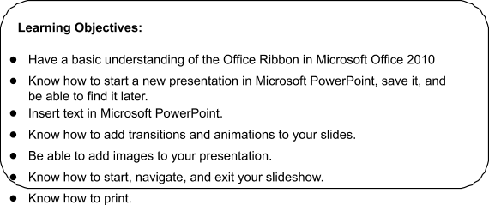
Benefits:
- Allows users to become more confident, efficient and effective in using a presentation application.
- Proves mastery of the application.
- Enables users to plan and design more effective presentations.
- Improves user’s productivity.
- Developed with input from computer users, subject matter experts, and practising computer professionals from all over the world. This process ensures the relevance and range of module content.

The Powerpoint Window

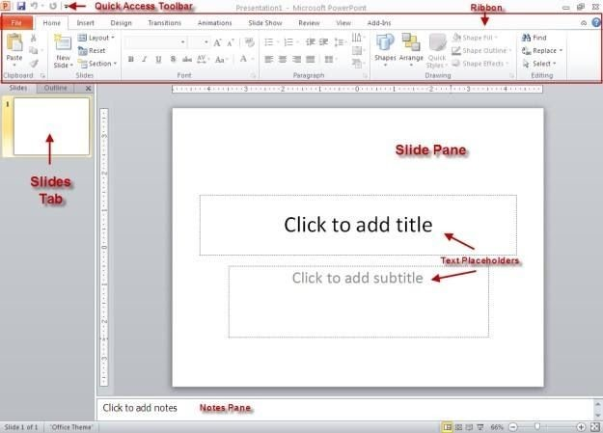

Ribbon
The ribbon, which spans across the top of the PowerPoint screen, replaces the old Menu Bar and toolbars used in Microsoft
Office programs up through version 2003.

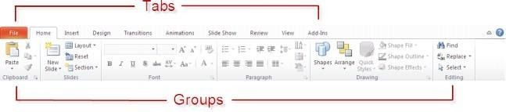
It organizes related functions into tabs. Those related functions are further organized into groups. The Home tab, for instance, has a Font group that contains formatting options for adjusting font, font size, bold face, underline and italics. The Paragraph group contains icons that control margins, spacing and indentation, among other things.

Zoom Slider
On the bottom right of the window you will find the Zoom Slider. Clicking or dragging the slider arrow or + /- icons with your mouse will enlarge or shrink the size of the slide in your window.

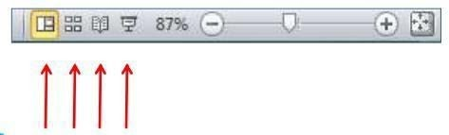
Viewing Pane
Also notice the four icons to the left of the slider. These are shortcuts to the normal, sorter, slideshow, or reading pane view of your presentation.

Quick Access Toolbar:
- This is a customizable toolbar that provides access to commonly used functions such as Save or Undo Last Action.
- Clicking on the down arrow gives you access to other common functions that you can add to the toolbar
Contextual Command Tabs:
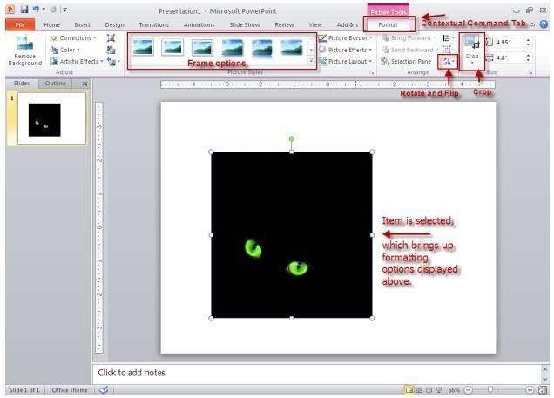

- Tools appear directly above a tab and provide access to options that pertain to a just completed action. For instance, if you click once on an image to select it, the Format tab appears, offering you ways to adjust the selected image. You can crop, frame and rotate the image, among other things.)

Slide Pane:
- The large white typing area that features “Click to add…” text prompts.
- This is the area where you’ll type your slide text.
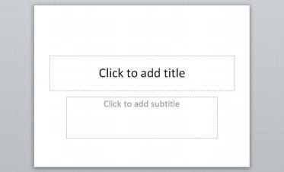

Slides Tab
- Located to the left of the slide pane.
- Displays thumbnail versions of slides in your presentation.
- Clicking and dragging a thumbnail allows you to rearrange the slides in your presentation.
- You can also click on a thumbnail to advance your presentation to that slide.

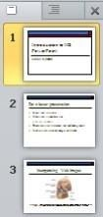
Notes Pane:
- Located beneath the slide pane.
- Lets you type speaker notes for each slide.
- When printed out, the slide image and notes for that slide appear together on the same page.

Text Placeholders:
- Located inside the slide. (Look for "Click to add..." prompts)
- When you click inside the placeholder, a blinking text insertion point--or cursor-- appears, and you can enter text


The Pointer/Cursor:
- It moves on-screen in the direction you move your mouse.
- When pointed at text, the pointer becomes a cursor, assuming the shape of an I- beam.
- When pointed outside of the text area, the pointer becomes an arrow.
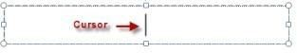

The Title Bar:
- Located at the very top of the screen.
- Displays the program title as well as the filename you assign your presentation upon saving it.

The Task Bar:
- Located at the bottom of the screen.
- The Task bar displays the number of the current slide in the presentation (e.g., Slide
1 of 1, Slide 2 of 2, etc.).
- It also allows you to zoom in and out of your current slide (note the magnification slider on the right side of the Status Bar), and to change your slide view from the normal editing screen to multiple slide view (the Slide Sorter) and Slide Show view.

The Vertical and Horizontal Scroll Bars:
- Located to the right of and beneath the slide pane.
- The vertical scroll bar allows you to scroll through your slides.
-Dragging the elevator (the button located between the up and down arrows) moves you quickly through the presentation. A slide indicator box to the left indicates each slide number as you pass by it.
- The horizontal scroll bar appears when you zoom in on part of the slide so that the entire slide doesn't fit within the viewable area. This scroll bar lets you see parts of the slide not currently displaying on-screen.
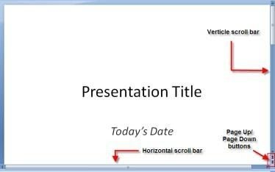

The Page Up/Page Down Buttons:
- Located beneath the vertical scroll bar. (Look for the buttons that display double- arrows, one set facing up [page up] and the other facing down [page down].) ● Moves you slide-by-slide in either direction.

Create a Title Slide
When you open PowerPoint, the program takes you by default to a Title Slide screen. ● Follow PowerPoint's on-screen prompts to enter text ("Click to add...").

NOTE: All "Click to add..." prompts are optional. If you don't type a sub-title, for instance, the Click to add… sub-title prompt won't appear when you present your slide.
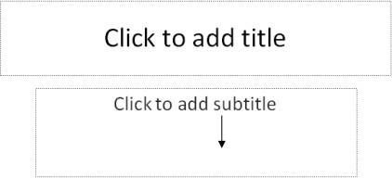
Save Your Presentation
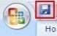

- Choose Save from the Quick Access toolbar.
- Use the Save in window to locate where you plan to save your file.
- Enter a filename in the Filename window for the presentation and press Save.

NOTE: To save your presentation in a previous version of PowerPoint ● Click on the down arrow by the Save as type window.
- Select the version in which you'd like to save the presentation.
- Click Save.
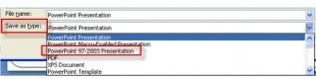

Create a New Slide
- Click on New Slide from the Home tab.
- A list of thumbnails appears, outlining your various slide content options to choose from.
- Click once on the appropriate thumbnail to bring up the next slide.

NOTE: Selecting Title and Content allows you to create the most common slide types such as bullet lists, tables, and charts.
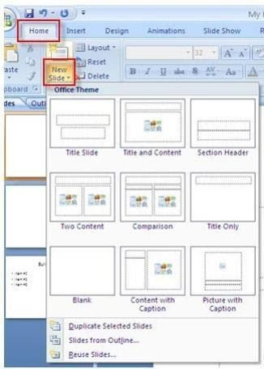

Create a Bullet List
- Click on Title and Content
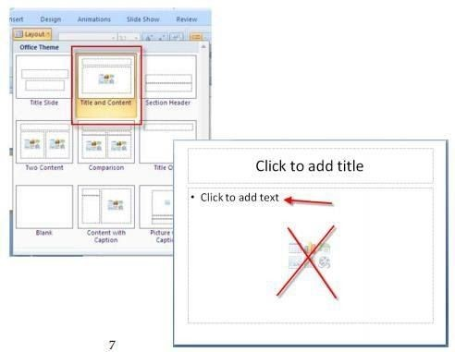

Follow PowerPoint's on-screen prompts to enter text o Ignore​ the thumbnails that appear in the center of the screen, unless you plan to add additional content to the slide. As you begin typing your bullet list, they will disappear automatically.
NOTE: Those thumbnails offer you content options in addition to the default bullet list. You can create a table, chart, SmartArt graphic, or you can insert a saved picture, clip art, or media clip. (See illustration below for thumbnail descriptions.)

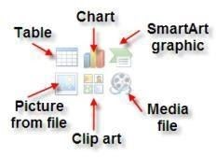
About entering bullets:

●
Bullets appear automatically on each line.

- Pressing Enter brings up the next bullet.
- To erase an unwanted bullet, click next to that bullet and press the Backspace key.
- To indent a bullet (to make a sub-point), press Tab.
- To undo an indent, press Shift together with the Tab key.

Animate the Bulleted List
You can display the bulleted list one bullet point at a time rather than all at once.

- If the bullet list doesn't have a selection box (a box bounded by dashed lines) around it, click anywhere inside it.
- Click on the Animations tab.
- Choose Custom Animation from the Animations group.
- The Custom Animation window appears to the right of your slide.
- Click on the Add Effects tab.
- Select Entrance.
- Choose More Effects… to see a complete list of effects.
- By default, your slide should run a preview the chosen animation as you click on it once.
- Click OK.
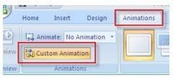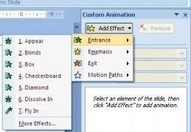
To dim previous bulleted points, while still in the Custom Animation
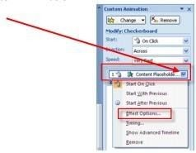
- Click on the down arrow by the animation listing
- Choose Effect Options…
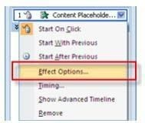
- Click on the down arrow by the After animation window.
- Click on a color choice for dimming the previous bullets.
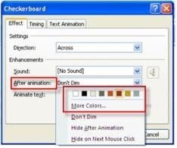
- Click OK.

Create a Chart
- Click on Title and Content from the list of layout options displayed.
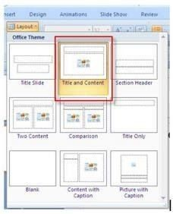
- Click on the Chart icon in the center of the slide.
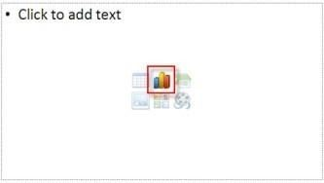
Select a chart type from the list on the left side of the Insert Chart dialog box. ● Next, choose a sub-type from the icons to the right and click OK.

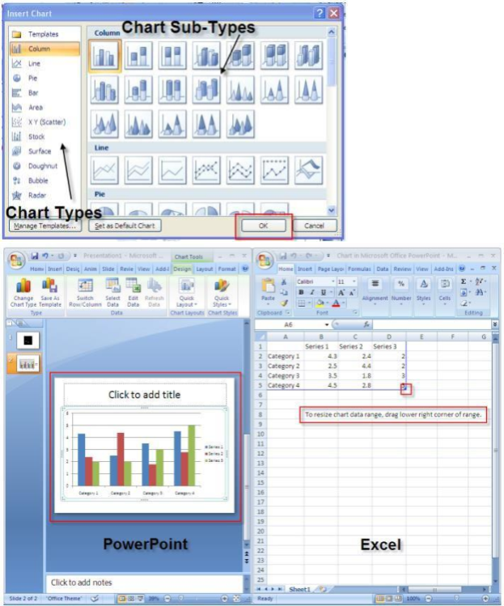

You’ll now see a split screen; PowerPoint is on the left and Microsoft Excel has just launched and appears to the right, with sample chart data displayed. Data for PowerPoint charts is actually entered in Excel. As you enter your own data in place of the sample data, PowerPoint automatically updates the chart displaying on the PowerPoint side of the split screen.

You’ll notice a blue boundary line at the right and bottom edges of the sample data.

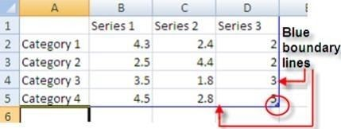
If you have more columns/rows in your chart than are filled in by sample data, simply click on the lower right corner where the blue lines meet and drag the mouse down/to the right until you see displayed the correct number of columns and rows. You may only drag in one direction at a time (either horizontally to expand the number of columns or vertically to expand the number of rows). To expand both columns and rows, release the mouse after having dragged it in one direction and then repeat the process in the other direction.

If your chart has fewer columns/rows than are displayed in the sample datasheet, click on the lower right corner and drag the mouse up/to the left to eliminate any extraneous columns/rows. Again, you may only drag in one direction at a time. So if you want to decrease the number of columns and rows, you’ll have to do it in one direction at a time.

To replace sample data with your own data, click on a cell in the worksheet and type over your own data. The sample data disappears as soon as you begin typing over it.

Entering data labels (categories):
- Enter the categories you are measuring in the column labeled A. Start entering data in Row 2.
NOTE: As you begin typing data in each cell, the sample data from the next cell disappears automatically
- Press the down arrow key to move row by row, or click on the next cell down using the mouse.
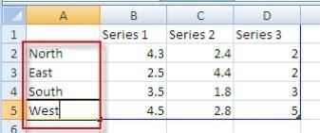
Entering legend headings (series):
- Enter legend headings directly beneath the cells labeled B, C, D and so on. Start entering legend headings in Column B.
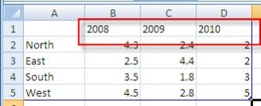
- Sample legend headings will disappear in each cell as you begin typing your own. Don't worry if some of your text appears cut-off; it should display!
Use the right arrow key to move from cell to cell, or click on the next cell over using the mouse.

About legends:
You only need to include a legend when you are plotting sets of values for more than one group. A bar chart with different color bars, for instance, would need a legend to state what series each bar color represents. If you don’t require a legend and try to delete the sample legend headings, the cells will read Column 1, Column 2, and Column 3. The legend cannot be deleted here. You’ll be shown how to delete the legend over in PowerPoint.

Entering values (numeric data):
Before entering values, you can specify the kind of values you are entering (percentage, dollar amounts, etc.).
- Click on the upper left blue cell of the spreadsheet. (This highlights the info in your spreadsheet.)
- Click with the right mouse button on the same cell.
- Choose Format Cells… with the left mouse button.
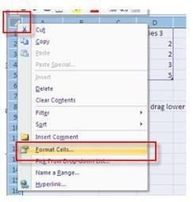
- Choose Number from the pop-up menu.
- Choose the type of values being represented from the Category listing at left.
- Click OK.
NOTE: If you choose Percentage, you will need to enter your values in the datasheet using decimal points in front of the numbers (e.g. for 23%, enter .23 [not 23]).
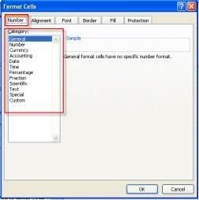

Entering your values:
- Enter values (numbers only--don't include %, $, etc,) in the rows located beneath
those in which you entered your series (legend headings). Sample values appear in

each cell, but will disappear as you begin typing over them. Pressing the arrow keys moves the cursor horizontally cell-by-cell. Pressing the up and down arrow keys moves the cursor vertically cell-by-cell. (Or you can simply click in each new cell using the mouse.)

When done entering data:
- Click on the x in the upper right corner of the Excel window.
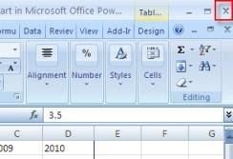

Returning to the Excel spreadsheet to edit data (if necessary):
- Click once anywhere inside the chart to select it. This launches a Chart Tools contextual command tab that doesn’t appear on the normal editing screen.
- Make sure the Design tab under Chart Tools is selected and then click on Edit Data from the Data group.
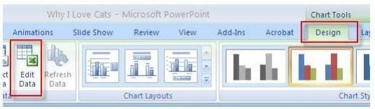

When done editing data:
- Click on the x in the upper right corner of the Excel window.

Change the chart type (to a line chart, area chart, etc.):
- If your chart is not currently selected, click once in the white space above or below the legend to select it. This launches a Chart Tools contextual tab that doesn’t appear on the normal editing screen. If the chart is already selected (has a blue bounding box around it), the Chart Tools tab will display.
- Make sure the Design tab under Chart Tools is selected and then click on Change Chart Type from the Type group.

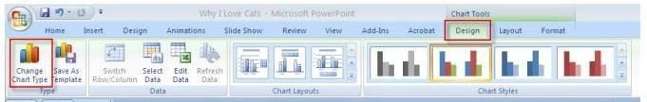
- Select a new chart type and sub-type and click OK.

Relocating or deleting the legend:
- If your chart is not currently selected, click once in the white space above or below the legend to select it. This launches a Chart Tools contextual tab that doesn’t
appear on the normal editing screen. If the chart is already selected (has a blue bounding box around it), the Chart Tools tab will display.
- Make sure the Layout tab under Chart Tools is selected and then click on Legend from the Labels group.
- Select an alternate location on the slide for the legend, or select None to delete it.

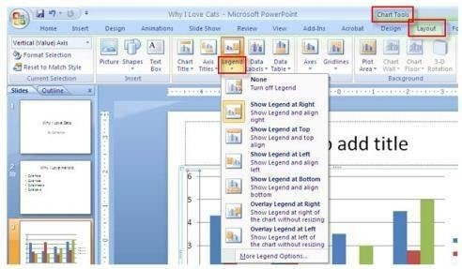

Resize the chart:
- If a light blue selection box doesn't currently frame your chart, click in the white space beyond the chart itself to make the box appear.
- Click on any of the four corners of the selection box (position the pointer tip directly on the 3 dots; the pointer will change from a 4-sided to a double-sided arrow).
- Drag the mouse button diagonally to stretch or shrink the chart area.
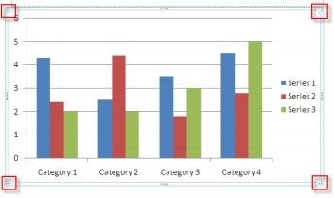

Apply a contrasting color to the chart’s background:
- If a light blue selection box doesn't currently frame your chart, click in the white space beyond the chart itself to make the box appear.
- Position the mouse pointer tip in a blank area of the chart until the Chart Area indicator appears beneath the arrow.
- Click once with the RIGHT mouse button. A pop-up menu should appear.
- Select Fill, if it isn’t already, and then choose Solid fill. Click on the down arrow by the paint bucket next to where it reads: Color.
- Choose a color for your background that contrasts adequately with your other chart elements.
- Click Close when done

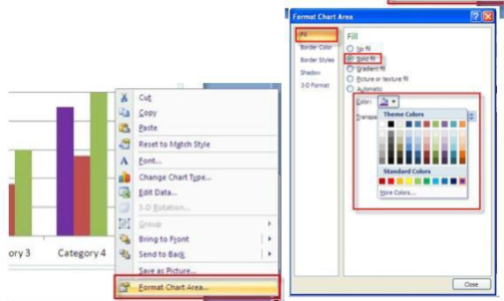

Change the color of the line in a line chart:
- If a light blue selection box doesn't currently frame your chart, click in the white space beyond the chart itself to make the box appear.
- Position the mouse pointer tip directly over the line (anywhere except where it intersects a gridline) and click once to select it.
- Choose Format beneath the Chart Tools tab and click on Shape Outline. Choose a color for your chart line that contrasts adequately with the chart’s background color.
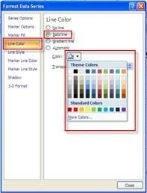
NOTE: You may also change the width of the line by choosing Line Style and then adjusting the default weight.

- Click Close when done.

Add Shapes to Your Slide
- Click on the Insert tab and choose Shapes from the Illustrations group.
- Click on the desired shape.

The mouse pointer changes shape to that of a crosshair.
- Position the crosshair where you want to begin drawing the shape.
- Click and hold down the mouse button as you drag to create the shape.
- Let go of the mouse when done.

Relocate/resize/recolor the shape as you wish.
To relocate:
- Click and hold down the mouse button anywhere inside the shape. ● Drag it to a different location and let go of the mouse button.
To resize:
- Position the mouse pointer tip directly over any of the corner handles (the tip changes to a double-headed arrow). ● Click and hold down the mouse.
- Drag the mouse in a diagonal direction to shrink or expand the shape, and let go of the mouse button.
NOTE: Holding down the Shift key while dragging the mouse preserves the shape’s proportions as you resize.
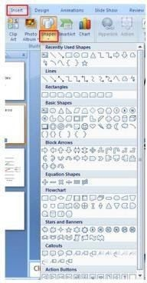

To recolor:
- Click anywhere inside the shape.
- Click on the Home tab.
A contextual tab called Drawing Tools (Format) appears.
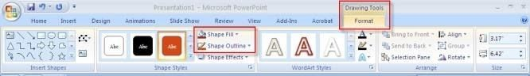
- Change the color and/or outline of the shape by selecting Shape Fill and/or Shape Outline.
- You may also click on the Home tab and select Quick Styles from the Drawing group to select from some preset designs offered by PowerPoint.

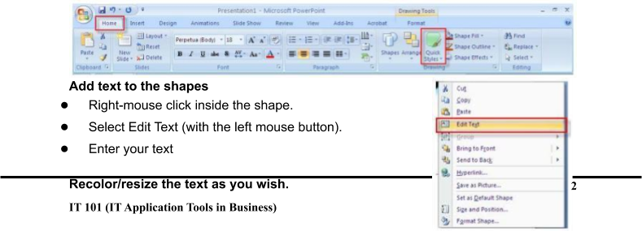

- Highlight the text using the mouse.
- Click on the Home tab.
- Use the tools in the Font group to make changes to the text.

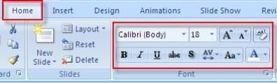

Add Additional Text to Your Slide
You may want to insert additional text on your slide besides that which goes in the text placeholders.
- Click on the Insert tab and select Text Box from the Text group.

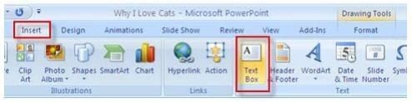
The mouse pointer changes shape to a cursor.
- Position the cursor where you want to insert the text box.
- Hold down the left mouse button (the pointer changes to a crosshair shape) and drag the crosshair to create a text box.
- Type text inside the box.

Recolor/resize the text as you wish. ● Highlight the text using the mouse.
- Click on the Home tab.
- Use the tools in the Font group to make changes to the text.
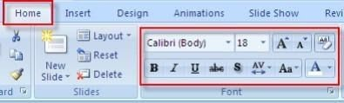

Add Clip-Art to a Slide
- Click on the Insert tab and choose Clip Art from the Illustrations group.
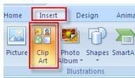

A Clip Art task pane appears on the right side of the screen.
- Enter word or phrase that describes the image you are looking for in the Search for:
window and click on Go.

Scroll through the list of images that match your description and click once on the thumbnail of the image you wish to insert.

The image will appear on your slide with "handles" around it.

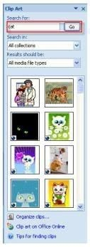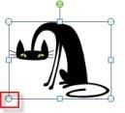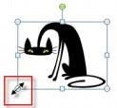

Relocate/resize/recolor the image as you wish.
To relocate:
- Click and hold down the mouse button anywhere inside the image.
- Drag it to a different location and let go of the mouse button.

To resize:
- Position the mouse pointer tip directly over any of the corner handles (the tip changes to a double-headed arrow). ● Click and hold down the mouse.
- Drag the mouse in a diagonal direction to shrink or expand the image, and let go of the mouse button.

Import an Image from the World-Wide Web
If you find an image on the Web that you want to include in your PowerPoint presentation,

At the website:
- Position the mouse on the image and click on it with the right mouse button.
- Choose Save Image As… from the pop-up menu. (Use your left mouse button this time!)
- Choose where on your computer you wish to save the image from the Save In window.
- If you wish, you can overwrite the given filename listed in the File name window, or you can stick with the given file name already assigned to the image.
- Click on Save.

In PowerPoint:
- Click on the Insert tab and choose Picture from the Illustrations group.
Find the location of the image on your computer using the Look in: window. ● Click on the image thumbnail and click Insert.

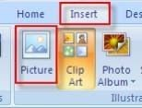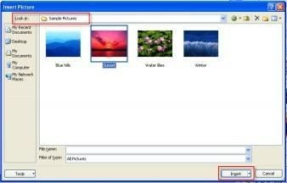

Relocate/resize/recolor the image as you wish.
To relocate:
- Click and hold down the mouse button anywhere inside the image.
- Drag it to a different location and let go of the mouse button.

To resize:
- Position the mouse pointer tip directly over any of the corner handles (the tip changes to a double-headed arrow). ● Click and hold down the mouse.
- Drag the mouse in a diagonal direction to shrink or expand the image, and let go of the mouse button.

Adjust Images Using Picture Tools
- The Picture Tools (Format) tab appears when an image is selected (has handles around it). Click once inside the image if no handles appear.
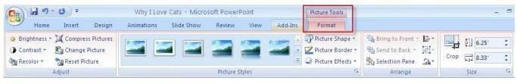 The Picture Tools tab allows you to crop your image, add a frame, and adjust image contrast, brightness, etc.
- Place the mouse pointer tip over the various icons (without clicking) and a description box appears, identifying what each one does. (Most are self- explanatory.)

To crop the image:

- Click on the Crop icon on the Picture Tools tab.

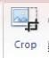

The handles surrounding your image change shape.
Position the mouse pointer tip over any of the handles. The mouse pointer changes
to the shape of a crop tool​ as it nears a handle, and then assumes the same shape as the handle when positioned directly over it.
- Hold down the mouse and drag it. An outline of your image changes as you slide the mouse, so that you can see what portion is being cropped. ● Release the mouse button when finished cropping.
- To turn off the Crop tool, click again on the Crop icon
NOTE: If you over crop your image, you can “uncrop” by clicking on the same handle and dragging it outward. Cropped portions of your image will return to view.

Online Image Attribution
Create a text box beneath or next to your image and add the source information.
- Always cite the source of your online image. Use the following formula for proper attribution:
o Author. (Year). Title. [Online image]. Retrieved Date from URL​

Insert a Scanned Image
If you’ve scanned and saved an image such as a family photo from a page that you’d like to include in your presentation,

In PowerPoint:
- Click on the Insert tab and choose Picture from the Illustrations group.
- Find the location of the image on your computer using the Look in: window.
- Click on the image thumbnail and click Insert.
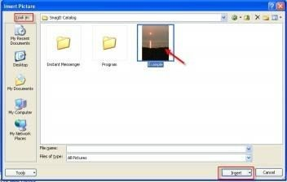
Relocate/resize/recolor the image as you wish. To relocate:
- Click and hold down the mouse button anywhere inside the image.
- Drag it to a different location and let go of the mouse button.

To resize:
- Position the mouse pointer tip directly over any of the corner handles (the tip changes to a double-headed arrow). ● Click and hold down the mouse.
- Drag the mouse in a diagonal direction to shrink or expand the image, and let go of the mouse button.

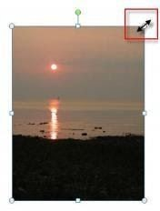
Adjust Images Using Picture Tools
- The Picture Tools tab appears when an image is selected (has handles around it). Click once on the image if no handles appear.
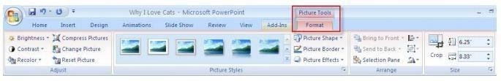
The Picture Tools tab allows you to crop your image, add a frame, and adjust image contrast, brightness, etc.
- Place the mouse pointer tip over the various icons (without clicking) and a description box appears, identifying what each one does. (Most are self- explanatory.)

To crop the image:
- Click on the Crop icon on the Picture Tools tab.
- Position the mouse pointer tip over any of the handles. The mouse pointer changes
to the shape of a crop tool as it nears a handle, and then assumes the same​ shape as the handle when positioned directly over it.
- Hold down the mouse and drag it. An outline of your image changes as you slide the mouse, so that you can see what portion is being cropped. ● Release the mouse button when finished cropping.
- To turn off the Crop tool, click again on the Crop icon.

Hyperlink to a Web Site Containing a Video Clip
A hyperlink allows you to move seamlessly between your slide and another slide in your presentation, another PowerPoint presentation, a program file such as a Word document, a website, etc. A hyperlink is created using a designated object such as a text box or an image on your slide that you’ll click on to initiate the hyperlink. If hyperlinking to a website containing a video clip, clicking on that object launches your internet browser and takes you directly to the website containing the video clip. (You’ll probably want to copy the web address using Ctrl-C so you can paste it into the Address field in PowerPoint’s Hyperlink

Click once directly on an object, or highlight a segment of text, that will serve as the link to the web page containing the video clip
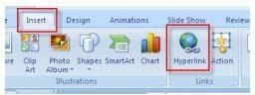
- Click on the Insert tab and choose Hyperlink from the Links group.
- Click on Existing File or Web Page under Link to:
- Enter the web address in the Address field and click
- OK. 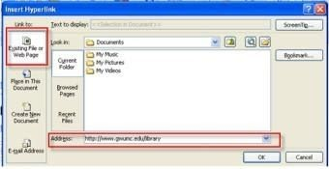
To see the video clip:
You must be in Slide Show view and not the editing screen.
- Click on the Slide Show tab and choose either From Beginning or From Current Slide from the Start Slide Show group.
- Glide the mouse over the object or text you’ve used to hyperlink from and the pointer will change to a hand with a pointing index finger.
- Click once on the object or text to launch your internet browser. Your page will display and you can run the clip.
- When done, close the browser to return to the slide show.
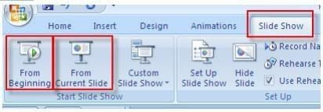

Re-arrange Slides in Your Presentation Using the Slide Sorter
- Click on the View tab and choose Slide Sorter from the Presentation Views group.
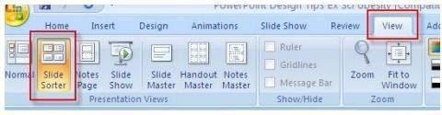
The Slide Sorter displays the slides of your presentation side-by-side in miniature. Depending on the number of slides in your presentation, some or many of the slides may be out of view. (If so, you’ll notice the vertical scroll bar on the right, which you can use to navigate through the presentation.)
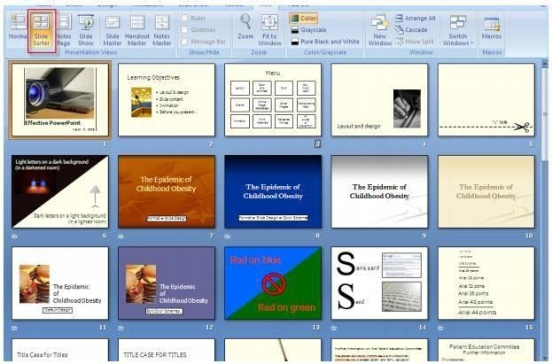
- Position the mouse pointer over the slide you wish to relocate, and then click and hold down the mouse.
As you drag the mouse around the screen, a thin vertical line follows, moving between the slides.
- When the thin line is in the location you wish to move the slide to, let go of the mouse button.

To restore single slide view:
- Double-click on a slide to restore single slide view.
The slide you double-click on will appear in single slide view.

Create Slide Transitions ● Click on the Animations tab.
- Glide your mouse over each of the transition effects located in the Transition to This Slide group to preview them on your slide.
o Note the vertical scroll bar to the right; there are more effects to preview than​ are currently in view.

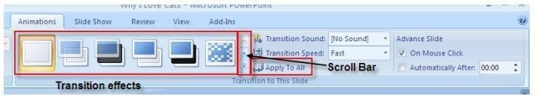
- Click once on an effect to select it.
- To apply the transition to the entire presentation, click on Apply To All.

View Your Presentation
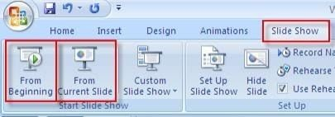
Click on the Slide Show tab.
- Click on From Beginning to view the entire presentation or From Current Slide to view from the current slide onward.
- Click on the left mouse button to advance from slide to slide.
- If you have animated your bullet list, clicking on the mouse brings up each successive bullet.
- At the end of your presentation, a black screen appears, with the message: End of slide show, click to exit.
- Click once more to return to the editing screen.

NOTE: To move backwards in your presentation, simply press the Backspace key. NOTE: You can press Escape on the keyboard at any time to exit the presentation. The slide currently being displayed in

Slide Show view will appear on the editing screen.

Print Your Presentation
- Click on the Microsoft Office button and choose Print.
- Select your printer, the number of copies, etc.
- If you are using a black and white printer, select the Grayscale option in the lower left corner of the print menu.
- Click OK.
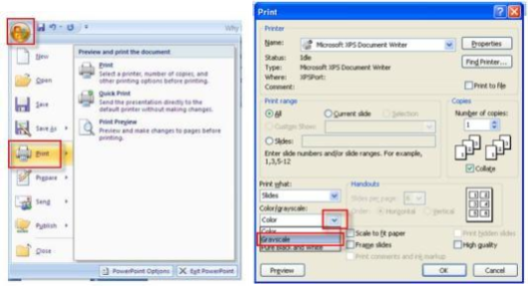

Print Audience Handouts
PowerPoint allows you to print handouts of your slides for your audience. The handouts include reductions of your slides; you can choose to display 2, 3, 4, 6 or 9 slides per page.
- Click on the Microsoft Office button and choose Print.
- Click on the down arrow by the Print What window.
- Choose Handouts.
- Click on the down arrow by the Slides per page window.
- Select the number of slides you want to appear on each page.
- Below the Slides per page window, you can select whether you want the slides to be ordered horizontally or vertically.
- Click OK.

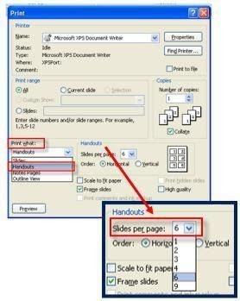

Create/Print Speaker Notes To create Speaker Notes:
- Click in the Click to add notes pane directly beneath your slides to add notes.

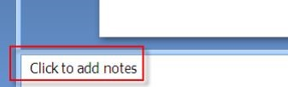
To print Speaker Notes:
- Click on the Microsoft Office button and choose Print.
- Click on the down arrow by the window labeled Print What.
- Choose Notes Pages.
- Click OK.
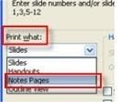
A reduction of your slide appears at the top of the printed Notes Page and your typed speaker notes appear underneath.

Spell-Check Your Presentation
- Click on the Review tab and choose Spelling from the Proofing group.
- MS PowerPoint stops at the first misspelled (or unrecognized) word, if any. Here, you can:
  - Scroll through the Suggestions list and click on the correct spelling​
OR o Type your own correction in the Change To window.
  - Then click on Change or Change All
(instances of that misspelling). The
OR: word's spelling is automatically corrected.
  - Choose Ignore or Ignore All (instances of that spelling) if the word is​ correctly spelled.
- When the Spell-check is complete, you are prompted to 'Click OK'.
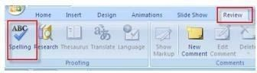

Get Online Help
To look up a topic:
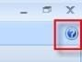
- Click the Help icon, located directly beneath the x in the upper right corner of the screen.
- Type a topic (no need to click anywhere first).
- Choose Search.
- Click on an item from the list of topics that Online Help displays.
- Read the information in the description box and click on the x in the upper right corner of the description box when done.

Exit PowerPoint
- Click on the Microsoft Office button and choose Exit PowerPoint.

NOTE: If your most recent changes to the presentation have not been saved, you'll first be asked if you want to resave.

Close Your Presentation, without Exiting PowerPoint
- Click on the Microsoft Office button and choose Close.

NOTE: If your most recent changes to the presentation have not been saved, you'll first be asked if you want to resave.

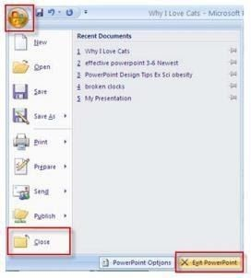

Open a Saved Presentation
- Click on the Microsoft Office button and choose Open.
- Click on the down arrow by the Look In window.
- Scroll until you find the location of your file and click on it. ● Click on the file in the window below.

- Click Open.
