“PERCEIVED IMPORTANCE OF PREPARING AND UTILIZING
FINANCIAL STATEMENT IN DECISION MAKING
FOR SMALL AND MEDIUM ENTERPRISES"
This study examines the perceived importance of preparing and utilizing financial statements and, it’s possible effect in decision making. The respondents of this research are the managers of SME located in Lipa City, Batangas. The study analyze if there is a significant difference between the importance of preparing and utilizing financial statements, and the importance in decision making when respondents are grouped according to profile. The statistical tools that were used include Frequency percentage distribution, mean, and ANOVA. The result showed that there is no significant difference between the demographic variables and financial decision making in terms of highest educational attainment, hence, there is a significant difference between the demographic variables and financial decision making in terms of the type of business, primary activity of the business, and source of knowledge about financial statements, and practice of the SMEs in preparing financial statements.

TABLE OF CONTENTS
Title Page……………………………………………………………………………i
Abstract……………………………………………………………………..………ii
Table of Contents…………………………………..………………………………iii
List of Tables…………………………………..…………...……………………….v
Table of Figures……………………………………………………………….…...vii

CHAPTER 1 Introduction
Introduction…………....................................................................................1
Statement of the Research Problem................................................................2
Conceptual Framework...................................................................................4
Operational Framework..................................................................................5
Hypotheses......................................................................................................7 Objectives of the Study...................................................................................7
Significance of the study.................................................................................8
Scope and Limitation.......................................................................................9
Operational definition.....................................................................................10

CHAPTER 2 Review of Literature
Review of Related Literature..........................................................................12
Related Studies................................................................................................20
Synthesis..........................................................................................................23

CHAPTER 3 Research Methodology
Research Design..............................................................................................24
Sampling Design.............................................................................................24
Respondents of the Study...............................................................................25
Locale of the Study........................................................................................25
Research Tools and Instrument......................................................................25
Data Gathering Procedure..............................................................................28
Data Analysis and Interpretation....................................................................29
CHAPTER 4 Discussion of Results………………………………...………...…...32

CHAPTER 5 Summary, Conclusions and Recommendations
Summary……………………………………………………...………...…...46
Conclusions…………………………………………………...………...…...48
Recommendations…………………………………………...………..……..49
References
Appendices
LIST OF TABLES

Table Page
1.1 Distribution of respondents according to highest educational
attainment………………………………………………………………..….32
1.2 Distribution of respondents according to source of knowledge about
financial statements……………….…………………………………….…..33
2.1 Distribution of respondents according to primary activity of the
business………………………………………………………………….….33
2.2 Distribution of respondents according to type of
business………………………………………………………………….….34
3.1 Distribution of respondents according to the Practice of the SMEs in
preparing financial statements……………………………………...……....34
3.2 Frequency of Financial Statements preparation……………………..….......35
- Perceived level of importance of preparing and utilizing financial
statements…………………………………………………………..………..36
- Percevied level of importance in decision making…..………………...……...
……........................................................37
  - Difference in importance of preparing and utilizing Financial Statements when respondents are grouped according
to profile …………………...……………………………...………….……38
  - Difference in importance in decision making when respondents
are grouped according to profile …………………………………………...42
LIST OF FIGURES

Figure Page
- Conceptual Framework………………………………………………………….4
- Operational Framework…………………………….……………………………6

CHAPTER 1

INTRODUCTION
Nowadays, the majority of the people are encouraged to start up a business in a small industry which is called Small and Medium Enterprises. According to the Republic Act 9501 also known as the “Magna Carta for Micro, Small and Medium Enterprises”, Small and Medium Enterprises are defined as any business activity or enterprise engaged in industry, agribusiness and/or services. SMEs play an important role in a country’s economic development with the potential to contribute in the creation of wealth, employment and income generation for both rural and urban areas. This type of businesses is also benefiting the economy by giving a continuous supply of skills, idea, and innovation necessary to stimulate competition and efficient allocation of scarce resources.
Considering the importance of SMEs for the economy of the Philippines, SMEs’ owners need to improve their management by using reliable and qualified information to be their basis of decision making. In building up a business, financial statements are at all time present. These financial statements are the basic tool designed to summarize financial activities for specific periods which gives information about an account of a company’s past performance, a portrait of its current financial strength and a sight into the future potential of a firm. Financial statements provide a huge benefit to the internal and external users. It is important that the business has all the documents that record, report, and used for evaluating economic events and transactions that affects the operation of the enterprise, to allow stakeholders to gain a better understanding in monitoring the performance of their firms. These financial statements may have the ability to assess the owner in decision making. But often, owners of small firms have poor finance skill in order to use financial statements efficiently and eventually may not fully recognize the effect of their decisions. In this instance, if the user doesn’t know how to interpret and utilize it well, even the reliable and timely financial statements can be insufficient in decision making process of the firm. Having the most current and accurate financial statements can help the owner to come up with better decision that can help the performance of the businesses which can lead to its success. Effectively using the current financial statements can lead the management improve their financial management and can avoid financial stress and business failure. It is the reason why the owner must have the right knowledge, skill, and confidence in the reliability in preparing and using financial statements in decision making.
This study aims to determine the perceived importance of preparing and utilizing financial statements and, its possible effect in decision making. The respondents of this research are the managers of SME located in Lipa City, Batangas.

Statement of the Research Problems
The research intended to explain the Perceived Importance of Preparing and Utilizing Financial Statement in Decision Making for Small and Medium Enterprises.
Specifically, this study sought to answer the following questions:
- What is the profile of the SME managers in terms of:
  - Highest Educational Attainment; and
  - Source of knowledge about Financial Statements?
- What is the profile of the SME in terms of:
  - Primary activity of the business; and
  - Type of Business?
- How are the financial statements prepared in terms of:
  - Practice of the SMEs in preparing financial statements; and
  - Frequency?
- What is the perceived level of importance of preparing and utilizing financial statements?
- What is the perceived level of importance in decision making?
- Is there a significant difference among the following, when respondents are grouped according to profile?
  - Importance of preparing and utilizing of financial statements; and
  - Importance in decision making?

RESEARCH FRAMEWORK
The research framework of this study included the conceptual framework from the study entitled “The Practice of Preparing and Using Financial Information in Financial Decisions: A Survey of SMEs in Tanzania” (2013) of Joshua Mwakujonga and Kembo M. Bwana. Moreover, included in this segment is the operational framework which acknowledged the financial statements preparation and utilization of SMEs manager in decision making.

Conceptual Framework
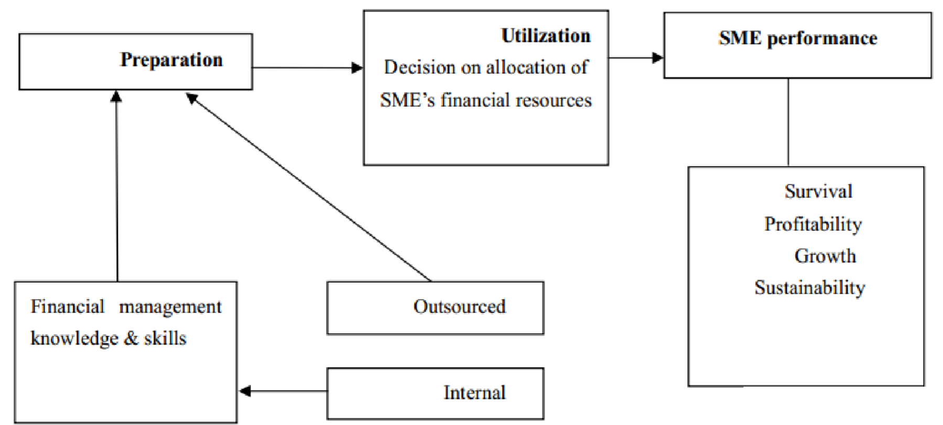

Figure 1: Conceptual Framework
The conceptual framework was based on the study conducted by Joshua Mwakujonga and Kembo M. Bwana entitled “The Practice of Preparing and Using Financial Information in Financial Decisions: A Survey of SMEs in Tanzania” (2013). They focused their study on analyzing the purpose and practice of preparing financial information, its utilization and, perceived importance in the day-to-day management of SMEs. This study used both primary and secondary information. They used 140 SMEs as their respondents who were randomly selected from different service industry (i.e. tourism, marketing and advertising, transportation, health and insurance). The researchers used statistics and descriptive analysis to analyze what they gathered. Based on the result the study shows that very few SMEs internally prepare and utilize financial information; most these information are prepared purposely to meet the requirements of financiers, business registration and revenue authorities. Moreover, most of SMEs prepare financial information by using external financial experts and they also don’t have enough internal resources.
This paper also uses the concept of Carrahera and Van Auken. (2013). “The Use of Financial Statements for Decision Making By Small Firms” where in the researchers use a sample of 312 small firms to examine the use of financial statements by analyzing factors that affect the use of financial statements and owners' comfort in interpreting financial statements. Financial statements give important information that can be used to decide for a better decision. The findings presented that owner comfort in using financial statements to make decisions was inversely associated with frequency of preparing and directly associated with level of revenues. Additionally, the results showed that whether the owner uses financial statements when making decisions was indirectly associated with education level and having the statements prepared externally was directly associated with owner comfort in interpreting the information in financial statements. The results should be useful and effective for the owners of SMEs and providers of services to SMEs to better understand which influences affect the use of financial statements and the process by which financial statements get incorporated into decisions.

Operational Framework
Illustrated below is the operational framework of the study. The framework illustrates the two variables being independent and dependent. The independent variable is the demographic variable and financial decision making while there are two dependent variables which are the importance of preparing and utilizing financial statements, and importance in decision making.
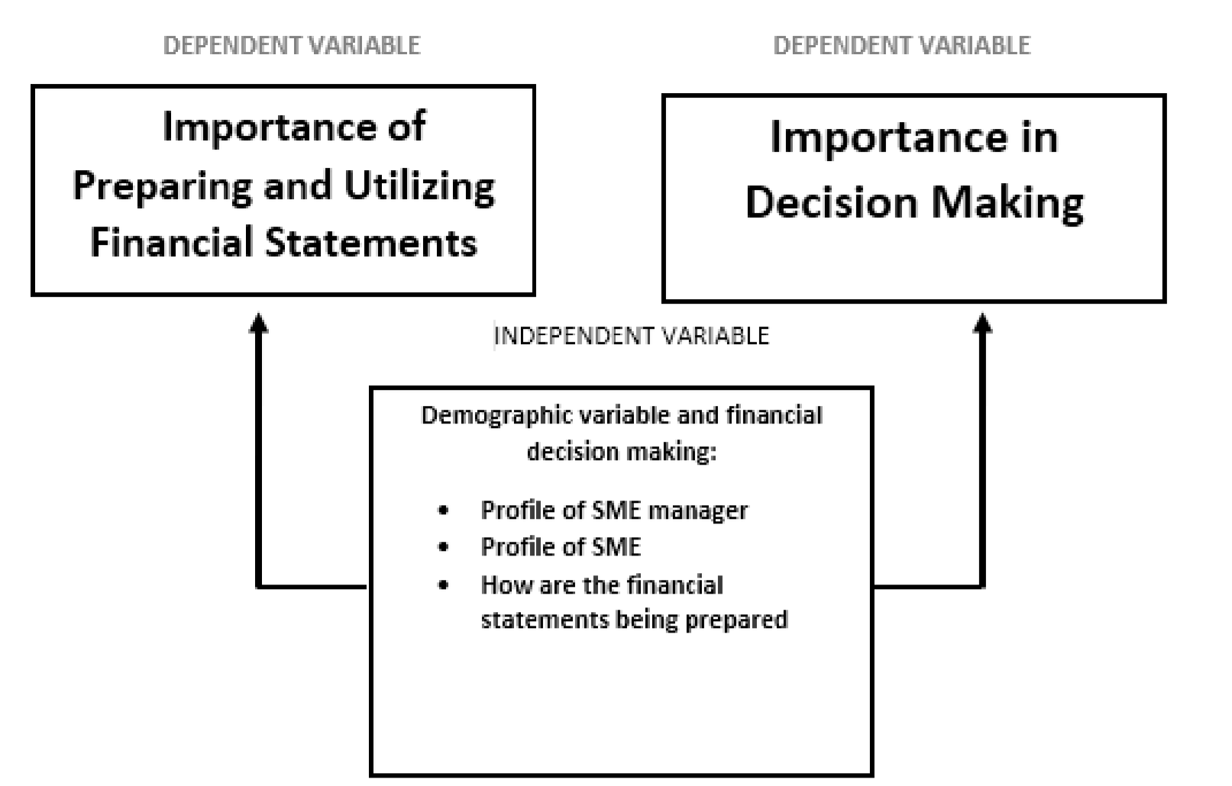

Figure 2: Operational Framework
Attached in the research study of Joshua Mwakujonga and Kembo M. Bwana
(2013) entitled “The Practice of Preparing and Using Financial Information in Financial Decisions: A Survey of SMEs in Tanzania” and “The Use of Financial Statements for Decision Making By Small Firms” by Shawn Carrahera and Howard Van Auken, the present study compact with the demographic variable and financial decision making (independent variable) and importance of preparing and utilizing financial statements, and importance in decision making (dependent variables).
The dependent variables will be hypothesized if it has difference when respondents are grouped according to profile. The independent variable is the demographic variable and financial decision making which shows why the independent variable affects the dependent variables.
The importance of preparing and utilizing financial statements, and the importance in decision making depends on the profile of the SME managers in terms of: highest educational attainment and source of knowledge about financial statements, profile of SME in terms of: type of business and primary activity of the business, and how are the financial statements being prepared in terms of: practice of the SMEs in preparing financial statements and frequency.

Hypothesis
Ho1: There is no significant difference among the following, when respondents are grouped according to profile
- Importance of preparing and utilizing of financial statements; and
- Importance in decision making

Objectives of the Study
The researchers aimed to determine the following:
- To determine the profile of the SME managers in terms of:
  - Highest Educational Attainment; and
  - Source of knowledge about Financial Statements
- To determine the profile of the SME in terms of:
  - Primary activity of the business; and
  - Type of Business
- To determine the financial statements prepared in terms of:
  - Practice of the SMEs in preparing financial statements; and
  - Frequency
- To determine the perceived level of importance of preparing and utilizing financial statements.
- To determine the perceived level importance in decision making.
- To determine if there is a significant difference among the following, when respondents are grouped according to profile.
  - Importance of preparing and utilization of financial statements; and
  - Importance in decision making

Significance
The results of this research paper will benefit more particularly to the Small and Medium Enterprise Managers, the researchers and future researchers, the professors, the stakeholders of the small and medium enterprise, and the Government.

For Small and Medium Enterprise Managers
The direct recipient of the output of the research is the small and medium enterprise managers who may help them to be familiar with the importance and purpose of financial statements that can lead them to a good management and decision making to their business. The research may aid them to steer in a right direction and avoid financial distress or costly breakdowns.
For the Researchers and Future Researchers.
The outcome of the study is beneficial to either present or future researchers. Given the fact that the researchers are financial management students, the research will assist them to improve their skills or knowledge about the usefulness of financial statements in decision making. Also, this study may be one of the basis of a new theory of learning.
For the Professors.
The research study will help college professors, especially those handling subjects related to financial statements, to have a deeper understanding of the usefulness of financial statements in decision making. By this study, they will purposely discover an easier way to merely discuss or explain to their students, the purpose of preparing and utilizing financial statements in decision making.

For the stakeholders of the small and medium enterprise
The research of the study aims to help dissimilar kind of stakeholders, including: prospective investors that may need financial statements to review the capability of investing in a company. Furthermore, financial statements may provide a foundation for the investment decisions of potential investors to measure risks connected with the investment. Another is the financial institutions that may use financial statements to decide whether to grant a loan or credit to a business. In addition, suppliers may also need financial statements to evaluate the creditworthiness of a business and determine whether to supply goods on credit. This may also help out suppliers for them to know if their customers can repay them back. Customers, on the other hand, may use financial statements to appraise whether a supplier will have the resources to make sure the stable good available in the future. Employees too, may utilize financial statements for assessing the company’s productivity and its effect in their predicted compensation and employment sanctuary. Lastly, will be the competitors who may contrast their presentation with rival firms to be skilled and build up strategies to progress their competitiveness.

Scope and Limitations
The study area of this research work is concerned with the purpose and practice of preparing financial statements in decision making, its utilization and, recognizes importance in the daily management of Small and Medium Enterprises.
The study chiefly focused on the importance of preparing and utilizing of financial statements and the importance in decision making. The demographic variables and financial decision making was determined according to on the profile of the SME managers in terms of: highest educational attainment and source of knowledge about financial statements, profile of SME in terms of: type of business and primary activity of the business, and how are the financial statements being prepared in terms of: practice of the SMEs in preparing financial statements and frequency. Furthermore, this research focuses on the significant differences of the variables presented on the study.
The researchers used purposive sampling technique to conduct field surveys to 140 randomly selected managers of Small and Medium Enterprises located in Lipa City, Batangas that use financial statements in decision making. Hence, the researchers did not conduct the study to all managers of Small and Medium Enterprises around the City of Lipa. The researchers base the respondents according to RA 9501 or the Magna Carta’s definition that Small and Medium Enterprises must have value falling under P 3,000,001 – P 100,000,000 and the number of employees that may vary for each category and the business activity or enterprise.
In order to achieve the objectives of the research study, the researchers gathered data by conducting surveys. It sought to evaluate the practice of preparing financial statements in decision making, its utilization and, recognizes importance in the daily management of Small and Medium Enterprises.

Operational Definition
The following terms are operationally defined as used in the study:
Decision making – means to select a course of action from two or more alternatives. It is done to achieve a specific objective or to solve a specific problem.
Financial Statements – formal record of the financial activities and position of a business, person, or other entity. Financial statements include: Balance Sheet, Income statement, Cost of goods sold table, Cash flow statement, Statement of retained earnings, and Statement of working capital.
Frequency – number of times something occurs within a specified period of time. Managers – a person responsible for planning and directing the work of a group of individuals, monitoring their work, and taking corrective actions if necessary.
Practice – a customary way of operation or behavior. It is a systematic training by multiple repetitions.
Preparing – making ready beforehand for a specific purpose, as for an event or occasion.
Small and medium enterprise - can either be single, proprietorship, cooperative, partnership or corporation that must have value falling P3,000,001 - P 15,000,000 for Small, and P15,000,001 - P100,000,000 for Medium Enterprises.
Utilizing - is the act of putting something into use, especially to make profitable or effective use of.
CHAPTER 2

REVIEW OF RELATED LITERATURE
The review of literature is significant to the researchers to acquaint themselves with the history and other related facts about the topic under study. Readings from various journals, related studies and internet serve as bases in conceptualizing the research.

Demographic Variable and Financial Decision Making
There was a study by Smirat (2013) that examined the level of awareness of the importance of financial management of the preparation of accounting reports and its usage in the business. The research design was adopted by the systematically selected SMEs throughout the south districts of Jordan with the target population composed of
136 SMEs—operating retail shops, manufacturing firms and suppliers of various services —all over the south of the country. The result revealed that the single entry accounting system was used by many small enterprises because of its simplicity and it was concluded that good accounting practices could develop the actions and operations of small and medium scale enterprises and even sole proprietors.
Zager and Zager (2006) studied the significance of accounting information or financial statements in making decisions. In the setting of those financial statements as a tool for decision-making, it is important for the different users to be familiar with those statements or must know how to “read” that financial information. “Reading” the contents of those, financial statements deliver different mechanisms and analyses for understanding the business. As a result, they found out that financial statements and financial may create a stable system of a management. Therefore, accounting information system formulates different data that may help different operators and with the help of that information, we can measure and observe the quality of business in the entire company.
Rathnasiri’s (2013) study revealed that preparing and monitoring the cash flows of the business has the highest importance since it is critical to the success and survival of SMEs. However, most of the SMEs have the informal accounting systems and have the lack of financial literacy when it comes to financial reports. The result of the study emphasized that better financial information means having the higher chance of success and good record keeping. Aside from that, the types of records practiced and the management’s understanding in the information could be associated with the success of the business on one hand or the struggle to fail on the other. Therefore, wise financial management practices and reporting skills are critical for the health of an SME.
According to Shawn and Howard (2013), educational attainment is significant in preparing financial statement and using it for decision-making. Those who prepare financial statement with a high level of education can have a better understanding and can interpret it well, than those with lower level of education. In addition, Amoako (2013) found in his study that that the level of educational attainment has an impact on the owner's’ understanding of the importance of maintaining proper books of accounts. Business owners who have rational level of education can irrefutably undeniably affect its decision making and necessary implementation in accounting and control system of the business. And in regards,Carter et al. (2003); Cassar (2009); Hanlon and Saunders (2007) explain that education can contribute to the firm's’ success by conducting better interpretation and utilization of Financial statement in decision making.
Madray (2009) stated in his study that the type of business can affect the preparation of Financial Statement. The preparing and utilizing financial statement for decision-making varies in Sole Proprietor, Partnership, and Corporation. The financial information that sole proprietorship firms prepare are mostly limited than partnership and corporation that requires comprehensive and in accordance to GAAP. Type of business also has a significant to the decision making of the owners, which depends on the corresponding action appropriate to the firm’s size.
According to Needles and Crosson (2014) the operation of service, retail, and manufacturing organizations differ from each other. Moreover, their financial statement preparation and relevance of it in decision making also differs. Mostly of service organizations doesn’t prepare inventory accounts on its balance sheet, while retail organization maintains only a merchandise inventory account. Lastly, three inventory accounts are prepared by a manufacturing organization, which are materials, work in process and finished goods inventory. These financial statements were used for operation, product or service unit costs to formulate budgets, pricing and other decisions. In Addition, Barton and Waymire (2004) shows that regulated industries may be less likely to produce and use financial statements than other firms. Preparation of financial statements can benefit facilitating regulatory process and may increase the importance of high-quality financial information.
Alle and Yohn’s (2009) study found that it is more efficient to prepare and utilize financial statement if the owner is more experienced and educated. This implies to the study of James (2006) that concludes that educators should influence the student to have a better understanding in preparing and analyzing financial statement that results in having a high reliable and relevant financial reports.
Hussein (1983) stated that meeting the information needs of both internal and external decision-makers makes a good accounting system. Clute and Gitman (1980) a qualified accountant must avoid failing to provide information needed by decisionmakers and make sure to keep records up to date. However, in the journal of Jayabalan and Dorasamy (2009) relegated management of accounting information was due to the high cost of contracting professional accountants. In the perspective of Gooderham et al. (2004) stated that small firms tend not to seek external financial advice than those other firms. Instead, they depend and give confidence on accountants as financial advisor. Alle and Yohn’s (2009) study stated that professional accountant who pile up, reviewed, and/or audited financial statement are likely to be more sophisticated or has a highly degree of complexity, than those that are not. Using computer can help reduce the relative cost that can positively affect to the preparation and use of financial statement. In the study of Bushman and Smith (2001) explains that there is a difference between internally and externally prepared financial statements.

Frequency of Preparing FS
The study of Auken’s (2010) examined several factors that affect the frequency of financial statement preparation. His study was among a sample of 312 SMEs. Specifically, the study examines the relationship between the frequency of preparing financial statements and (1) whether they are used in decision-making and (2) owners’ confidence in the reliability of their financial statements. Aside from that, he stated that using financial statements provide important information that may help the SME’s owners or managers in their decision-making. The findings presented that the frequency of preparing financial statement was associated with whether the financial statements were used in the management’s decision-making and inversely related with owners’ assurance in the efficiency of their financial statements. The results are useful for SMEs’ owners and their providers of services to better understand which factors affect how often financial statements are prepared in order to help them provide the assistance in the growth of their business.

Importance of Preparing Financial Statement
In Yström’s (2013) study entitled “Financial Reporting In Entrepreneurial SMEs”, she stated that financial reporting data are likely to be of significance to managers of entrepreneurial SMEs in their setting up of information to users. Based on the results of the study, financial capital’s continuous high demand is a great challenge to managers of entrepreneurial SMEs in their efforts to make their entities improve and develop. In this context, financial reports are reliable most especially when assessing the prospects of the business.

Financial Statement in Decision-Making
There are previous studies about the effect of financial statement utilization in decision-making. One of this is the study of Katarina Zager and Lajos Zager (2012). They stated that using accounting information is relevant especially in measuring and examining the business quality of the entire company. By defining the current business quality rate, the company may be able to make some significant presumptions for the company’s development and existence of the company on the market. They conclude that financial information can be very beneficial in creating assumption for more successful business in the future.
Collis et.al (2013) study stated the value of financial statements of small and medium enterprise to trade creditors and trade credit intermediaries.

Evaluating Financial Risk
According to Auken and Carraher’s (2013) study, it is very essential to understand what issues may affect the frequency of financial statement preparation for the reason of the information assessment of financial statements. Aside from that, firms decisions can lead to success or else lead to failure. As stated by Auken and Carraher, financial risk is important to evaluate and can be evaluated using financial statements. Through more current and valid financial statements, better financial information is possible. Moreover, improved financial information can lead to better quality decisions.

Finding and obtaining financing
With the study of Farcane et.al (2012), finding and obtaining financing is one of the objective or main purpose that is served by cash flow statements. In addition, they consider that using cash-flow statements is necessary for the transactions with clients and suppliers.

Evaluating and generating investment opportunities
According to the study of Blessing and Onoja (2004), financial statements range from the fact that it should disclose truthful information about its profitability and financial position of a business. The information provided should also understood easily and be critically evaluated by the different parties such as investors, creditors, lender and bankers, etc. Therefore, it can be seen that financial information is very effective and essential in making investment decisions in an organization.

Useful for making a wide range economic business decision
Dumitras (2015) stated that financial statements are important for the reason that it provides information about an enterprise’s financial position and performance that is useful for making a wide range of economic business decision. It is significant to the point that they influence the economic decisions of users, having a confirming role in historical accounting information or a predictive role in forecasting financial statements. In order to overcome the current hyperinflationary environment that raises difficult issues in accounting methods, there must be a proper method or procedure under the situations of radical economic and regulatory changes that ensure compatibility and conversion of information.

Predicting of proficient financial decision
According to Berheci and Cuza’s research, impact in settling financial decisions is because of financial statements. Financial statements, being the company’s control instrument, encourages the exact estimation of a company’s taxes and fees owed to various public bodies, as well as the satisfaction of the agreement finished up by the company and various business accomplices.

Assessing market needs
A research done by Kurniawati et.al (2013), sales report, as a part of financial statement, can be used to determine what price should be marked up in each product or services. It can also be beneficial in recording customers order, and in analysis of what innovation can the firm offer to the market. The records that a business keeps can be used for planning and production schedule especially in service and manufacturing industries.

Forecasting sales
According to Chen (2008), sales forecasting is an essential component for a corporation’s planning and controlling activities. In addition, his study reveals that financial statement indicators could be significant to foresee the sales of project-based firms in the construction industry.

Expenses control
Maguire (2004) stated in his study that preparing a detailed financial statement could be beneficial for the corporation to help them monitor their income and expense over a period of time. It can be also used to favorable for the company cut down the costs, reveal its annual income and identify its net savings or net loss by recording the sources of expenses.

Determining Selling Price
According to the study done by Kurniawati et.al (2013), in determining selling price, the SME managers usually use mark-up pricing method, especially for merchandising business they use market price or cost-plus pricing method. They use written information in the form highest retail price determined by the supplier, price list, and record of sales, and unwritten information in the form percentage of the expected profit margin (usually 10-20%) and estimated of market prices to determine selling price.

Determining optimal inventories
In Ibicioglu et.al (2010) study, in order to improve the SME’s operation, it is efficient to use financial information as a helpful tool. Besides that, they anticipated that it helps the managers to foresee and keep away from the conceivable business disappointments. Along these lines, in dealing with their business, they presumed that utilizing financial statements is a useful instrument.

Planning and management of future financial commitments
Farcane et.al (2012) found in their study that cash flow statement that is needed for arranging and administration of future financial commitments is significantly related to the cash flow statement’s usefulness in decision-making process.

Assessing the future stability of the company
Based on Berheci and Cuza’s study, the twofold part of accounting is to know the data with respect to company’s financial status, and furthermore for decision-making support. Moreover, utilizing financial information as a part of terms of surveying the future security of the organization may help the association settle on some conceivable choices or conclusions with respect to its long haul understandings.

Anticipate the goods and services that the customer’s demand
In the study of Kurniawati et.al (2013), it was found that in order for the SMEs to foresee their salary, recognize what sort of item is requested by the client, and plan to purchase more items that is demanded, sales records are utilized. For the most part, SMEs have accounts receivable records, when they offer merchandise or administrations in credit. After they give their products and complete their administrations, they will record the upfront installment from their client and will get the rest.

Foreseeing probable Liquidity and Financial Crisis
A study done by Ibicioglu et.al (2010), those as indicated by their survey, that financial statements are typically significant to foresee the liquidity and financial crisis of a company, since Turkish and European managers assert that financial information is not an effective measurement to understand if the advertisements or advancements are profitable or not. For the most part, Turkish and European managers distinguish utilizing financial statements as a supportive instrument in dealing with their associations on the grounds. In addition, with the help of financial statements, it serves as a tool to clear the mind of the SME managers during the process of decision-making.

Related Studies
Trimisiu Tunj Siyanbola (2012), studies the analysis of accounting information as an aid to management’s decision-making. A survey research design was adopted in fifty workers of a typical manufacturing company and data were collected using questionnaire. On the said study, their hypotheses revealed that accounting information has effects on management’s decision and performance; while the demographic information of the respondents were analyzed using simple percentage, t-test statistic was used to examine their hypotheses at a significant level of 5%. Based on the study, it was suggested that companies should employ a personal accountant in order to provide valuable information and keep accurate record of their accounts.
In a study conducted on Malaysia, many reports had showed that micro enterprise always dealing with many challenges as they are not skilled and knowledgeable enough even been guided with numerous governments' bodies. There is almost 99% of business entity, which is micro enterprise. However, it does not constitute any progress or development to the Malaysian economy. For that reason, they must have to provide an efficient way in terms of financial management that may lead to the success of their business. (Nurulhasanah, Zulnaidi, & Rafisah, 2014).
Another study concentrated mostly on the influences on owner-managers’ education and prior experience. Using a survey questionnaire, data were gathered from ownermanagers of some small metalworking firm located in Sheffield, UK. Owner-managers that are using business plan were around half of the sample. The factors that influences the owner-managers including the level of education, work experience before setting up their firm and running firms in sectors outside their preceding experience showing a significant relationship with the possession of a business plan. Therefore, firms that possess a business plan showed a positive relationship with a growth orientation with those owner-managers. In the study, it is concluded that owner-managers’ characteristics can be an important factor in explaining the existence/absence of a business plan within a small firm. (Richbell, H.D. Watts and Wardle, 2009).
In Japan, there was a study regarding the practice of regional financial institutions in their decision-making process and the use of qualitative information in these processes. Their study was based upon the data gathered by using survey questionnaire on financial institutions. With the dataset, they also conducted a statistical examination of the hypothesis, which predicts a positive relationship between the delegation of loan decision-making authorities and the use of soft information. Based on the statistical analysis, they found out that there is a relationship, which supports their hypothesis although the statistical significance is not so high. The study shows that the results of the previous empirical studies, which were intended upon the intuitive postulation that financial organizations with larger total assets have a more consolidated decision-making method and their use of soft information is lower, should be construed with carefulness.
Vasile Dumitras (2015) study stated that financial statements are an important tool to provide information about the financial status of an enterprise. The financial statements also present the cash flow and results of the company’s resources. For this reason, financial statements that were prepared by organizations are important to different range of users. Experience has revealed clearly that there is a conflict of interest between those who collect, process and aggregate accounting information and the information users. Frequently, users show an absence of confidence in using accounting information, because the users who produce this information usually are dependent from the processes and the situations presented.
In Jordan, small and medium enterprises (SMEs) have been very important especially on its role in their country’s economic growth. Smirat (2013) studied the importance of preparing financial statements and its information usage to support the SMEs in managing their finances. The research design of the study is based on a survey using a sample of selected SMEs throughout the south of country. 136 SMEs in the said location including companies under retail, manufacturing and suppliers of different services was the target population. Smirat concluded that because of the simplicity of financial statements, significant number of small-scale enterprises use the single entry accounting system. The study recommended that good accounting practices would improve the effective operations of SMEs and even sole proprietors.
A study conducted in Indonesia provides preliminary evidence on the effect of accounting information in an SME’s decision-making process. The objects of the research study are the SMEs as users of the services of rural banks and the rural banks that channel funds in the form of investments in SMEs. The result of the study showed that the information concerning to the business situations of SMEs would be a consideration for investors in deciding the filing of an investment whether to accept it or reject it. In addition, information obtained from financial statements is also beneficial as a basis in investment decisions.

Synthesis
This analysis aims to review different articles regarding the importance of preparing and utilizing financial statements in small and medium enterprises (SMEs). It was revealed that financial statements are significant in setting up information to users most especially in evaluating financial risk, finding and obtaining financing, evaluating & generating investment opportunities, making a wide range economic business decision, and predicting of proficient financial decision. It was clearly mentioned in the articles that financial statements can identify the financial risks and is essential tool in making investment decisions. Aside from that, it is necessary for the transactions with clients and suppliers.
The review of literature has also indicated the use of financial statements in decision-making particularly in assessing market needs, expenses controls, determining selling price, determining optimal inventories, planning & management of future financial commitments, assessing the future stability of the company, anticipating the goods & services that the customer’s demand, and foreseeing probable liquidity & financial crisis of an SME. It was revealed that using financial statements can help especially in examining and evaluating the business quality of the entire company. By determining the quality rate of the business, they may be able to make some corrective actions or improvement that may support the company in its operation and development. Moreover, the records that the company keeps are reliable for an organization’s strategic planning and better quality decisions.
CHAPTER 3

RESEARCH METHODOLOGY
This chapter covers the research design and sampling design, the respondents and locale of the study, the research tools and instrument also used, and also the data analysis and procedures of data gathering used in studying the importance of preparing and utilizing financial statements, the importance in decision making, and its difference when grouped according to profile of SMEs located in Lipa City, Batangas.

Research Design
The researchers used descriptive research design in order to describe the SME managers' demographic variable and financial decision making, and their practice of preparing and utilizing financial statements.

Sampling Design
Purposive sampling design was used in this study. Purposive sampling is best used when samples are chosen based on predetermined criteria. Respondents were chosen based on RA 9501 or the Magna Carta’s definition that Small and Medium Enterprises must have value falling under P3, 000,001 - P100, 000,000 and the number of employees that may vary for each category and the business activity or enterprise. Based on the records of business permits and licensing office, there are 3,000 SMEs in Lipa City. Out of this number, the researchers analyzed and determined which among them prepare and use financial statements in decision making and arrived with the end result of 1,500 SMEs. Based on G-power analysis, the minimum number of respondents is 111. The researchers were able to survey 140 managers in Lipa City, Batangas.

Respondents of the study
The respondents of this study are the managers of SMEs located in Lipa City, Batangas. The respondents were chosen because they have the criteria that the researchers needed in the study. The respondents should be a manager of SME and should be located in Lipa City, Batangas that use financial statements in decision making.

Locale of the Study
The researchers performed their survey of the said topic in different SMEs located in Lipa City, Batangas.

Research Tools and Instrument
The researchers adapted the survey questionnaire from the two studies: entitled “The Practice of Preparing and Using Financial Information in Financial Decisions: A Survey of SMEs in Tanzania” by Joshua Mwakujonga1 and Kembo M. Bwana, and "The
Use of Financial Statements for Decision Making By Small Firms" by Hasan İBİcİoĞlu, Turan Kocabiyik, and Hüseyinwhich DalĞar. However, minor revisions were made to highlight the focus of the study. The questionnaire contains two sections. The first section was about the demographic variable and financial decision making of the respondents which consist of the profile of the SME managers in terms of highest educational attainment and source of knowledge about financial statements, profile of SME in terms of type of business and primary activity of the business, and how are the financial statements being prepared in terms of practice of the SMEs in preparing financial statements and frequency. The second section contains information about the Small and Medium Enterprise Manager’s importance of preparing and utilizing Financial Statements and importance in decision making.
The instrument underwent reliability test. The variables of the importance of preparing and utilizing financial statements, and the importance in decision making have statistically loadings of Cronbach’ s alpha as shown below:
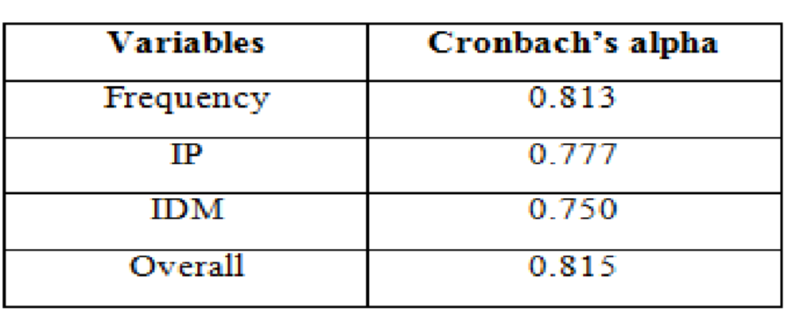
Overall, the instrument passed resulting to Cronbach’s alpha of 0.815. Cronbach’s
Alpha reliability co-efficient normally ranges between 0 and 1 however; there are actually no lower limit to the co-efficient. The closer Cronbach’s Alpha co-efficient is to
1.00 the greater the internal consistency of the items in the scale. George & Mallory
(2003 cited by Matkar, 2012) provides the following techniques: a) ≥ 0.90 = Excellent; b) 0.80 - 0.89 = Good; c) 0.70 - 0.79 = Acceptable; d) 0.60 - 0.69 = Questionable; e) 0.50 -
0.59 = Poor; and f) ≤ 0.50 = Unacceptable.
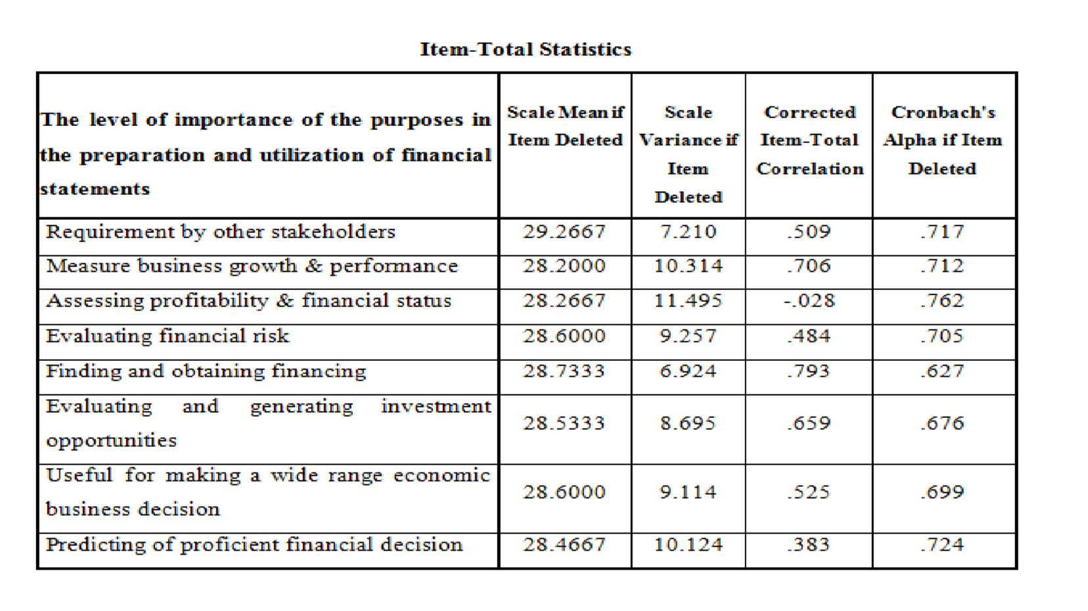
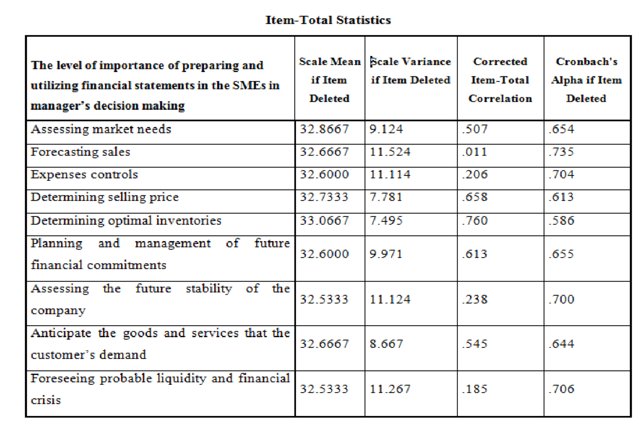
A 4-point Likert scale was used in determining the responses of the managers in the sixth to eighth part of the survey questionnaire:
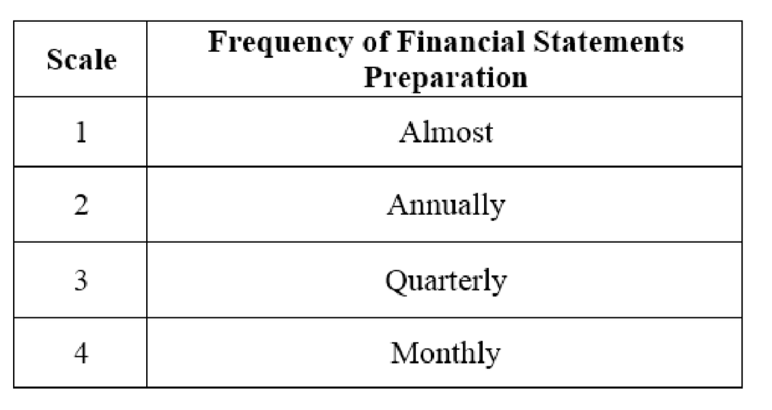
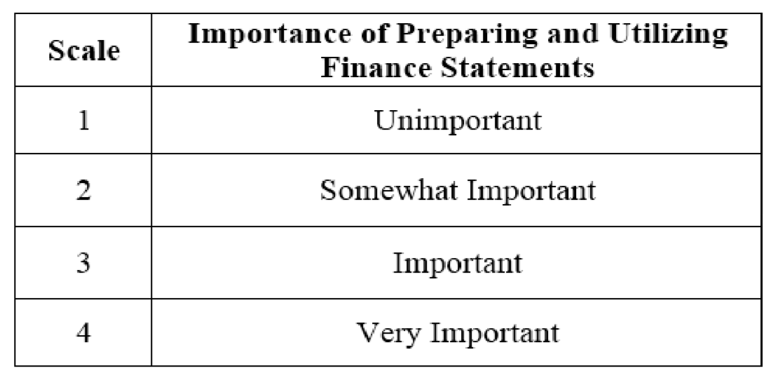
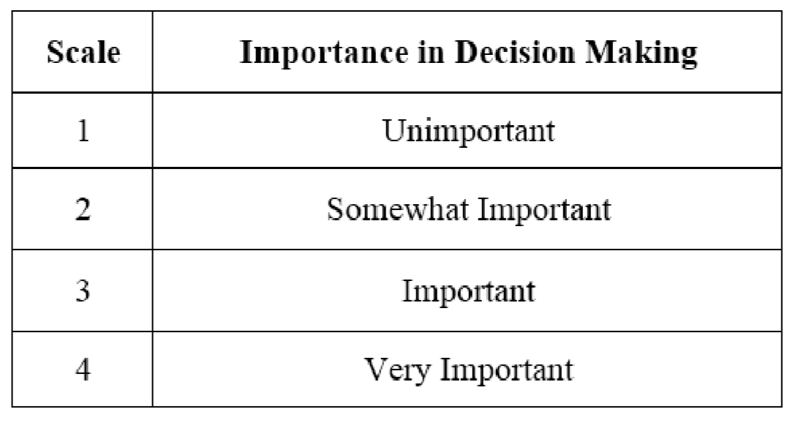

Data Gathering Procedure
The data gathered from this research were collected using a survey questionnaire.
The researchers gathered data from managers of SMEs located in Lipa City, Batangas.
The researchers performed the following steps in gathering the primary data:
- The researchers gave letters to the managers of the SMEs requesting for permission to conduct a survey about our research topic.
- The researchers distributed the survey questionnaires to the managers of the SMEs.
- After that, the researchers gathered and tallied the answered questionnaires and submitted it for data analysis.

Data Analysis and Interpretation
For data analysis and interpretation, the following statistical tools were used by the researchers:

Frequency Percentage Distribution
Percentage = (f/T) x 100%
Where: f = frequency
T = total number of respondents
This was used to know the distribution of age, highest educational attainment, type of business, the primary activity of the business, and the source of knowledge about financial statements of the respondents.

Mean
This was used to determine the frequency of preparation of the Balance Sheet, Income Statement, Cost of goods sold, Cash flow statement, Statement of retained earnings and Statement of working capital, perceived level of importance of preparing and utilizing financial statements, and perceived level of importance in decision making.
It was interpreted as follows:

Interpretation
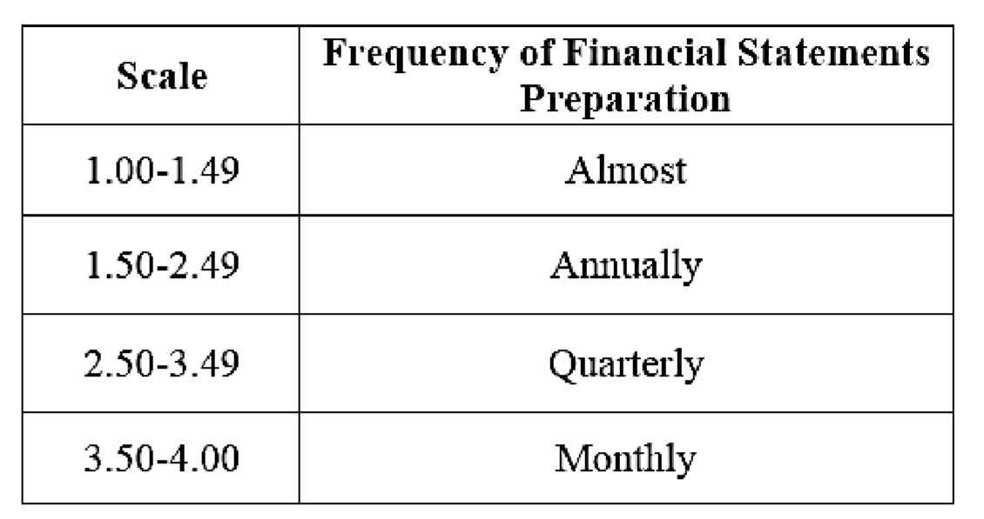
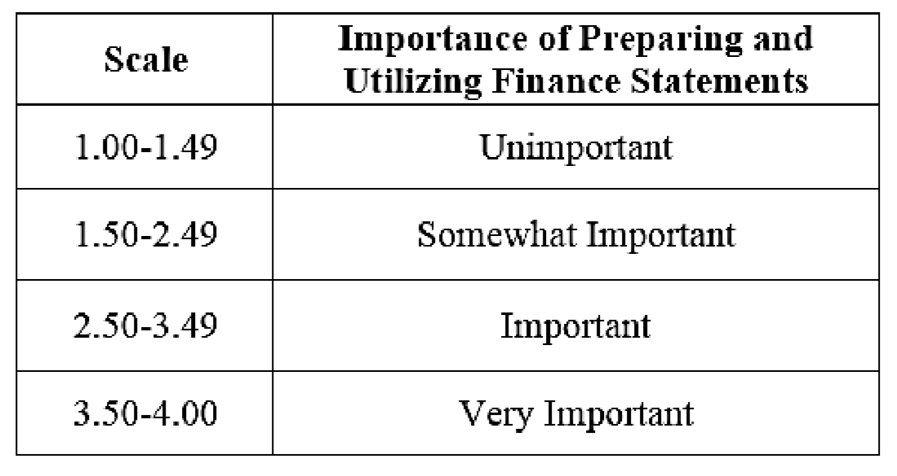
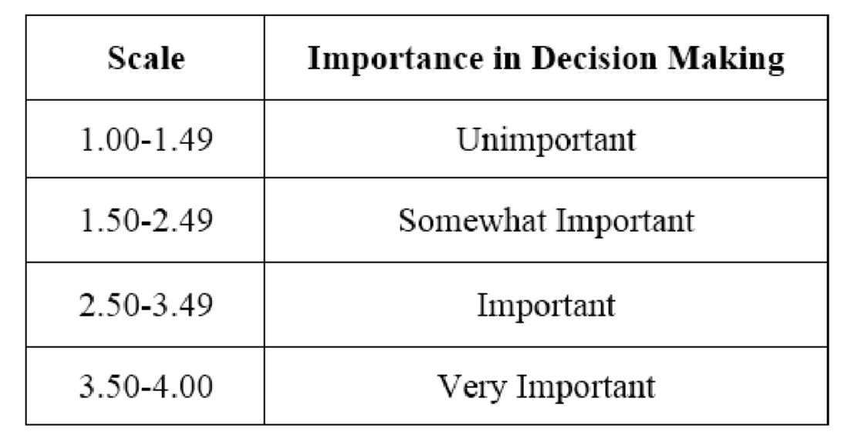

ANOVA
This was used to determine if a significant difference exist in the importance of preparing and utilizing of financial statements and the importance in decision making when respondents are grouped according to profile.
CHAPTER 4

DISCUSSION OF RESULTS
This chapter presents the discussion of results of the data gathered. This explains the presentation, analysis and interpretation of the quantitative data gathered in the study
DEMOGRAPHIC VARIABLE AND FINANCIAL DECISION MAKING

Table 1.1: Distribution of respondents according to Highest Educational attainment
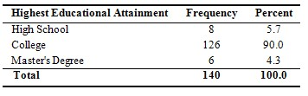
Table 1.1 shows the distribution of respondents according to highest educational attainment. Results revealed that the majority of the respondents were college graduates (90%). Least number of respondents earned Master’s Degree (4.3%).

Table 1.2: Distribution of respondents according to Source of Knowledge about Financial Statements
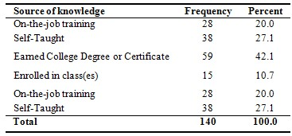
Table 1.2 shows the distribution of respondents according to source of knowledge about financial statements. It shows that the majority of the respondents consisting of 59 respondents, which is equivalent to 42.1%, earned College Degree or Certificate to get their knowledge about Financial Statements while only 15 respondents, which is equivalent to 10.7% enrolled in class(es).

Table 2.1: Distribution of respondents according to Primary Activity of the Business
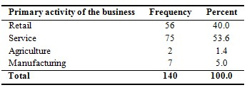
Table 2.1 shows the distribution of respondents according to type of business. Majority of the respondents belong to Service Industry consisting of 75 respondents, which is equivalent to 53.6%, while only 2 respondents, which is equivalent to 1.4% belongs to Agriculture.

Table 2.2: Distribution of respondents according to Type of Business
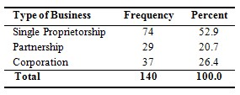
Table 2.2 shows the distribution of respondents according to type of business. On the questions pertaining to the type of business, most respondents (74) which is equivalent to 52.9% answered that the type of their business is Single Proprietorship and the least (29) which is equivalent to 20.7% answered that their business are Partnership.

Table 3.1: Distribution of respondents according to the Practice of the SMEs in preparing financial statements
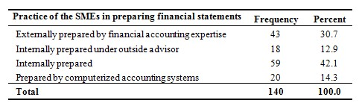
Table 3.1 shows the distribution of respondents according to the practice of the SMEs in preparing financial statement. It shows that the majority of the respondents consisting of 59 respondents, which is equivalent to 42.1%, internally prepared the financial statement, while only 18 respondents, which is equivalent to 12.9%, internally prepared the financial statement under an outside advisor. This implies that most of the respondents prepared financial statements internally. The result supports the view of Ekwe (2013) that when a company prepare internally they can organize it in their own and interpret it appropriately which they don’t seek advice for outside advisor or some financial experts. This study contradicts to the study of Mwakujonga and Bwana (2013), their study resulted that most SMEs do not prepare their financial statements internally instead they prepare their financial statements with the help of external financial experts in order for them to interpret well the substance of financial statements.

Table 3.2: Frequency of Financial Statements preparation
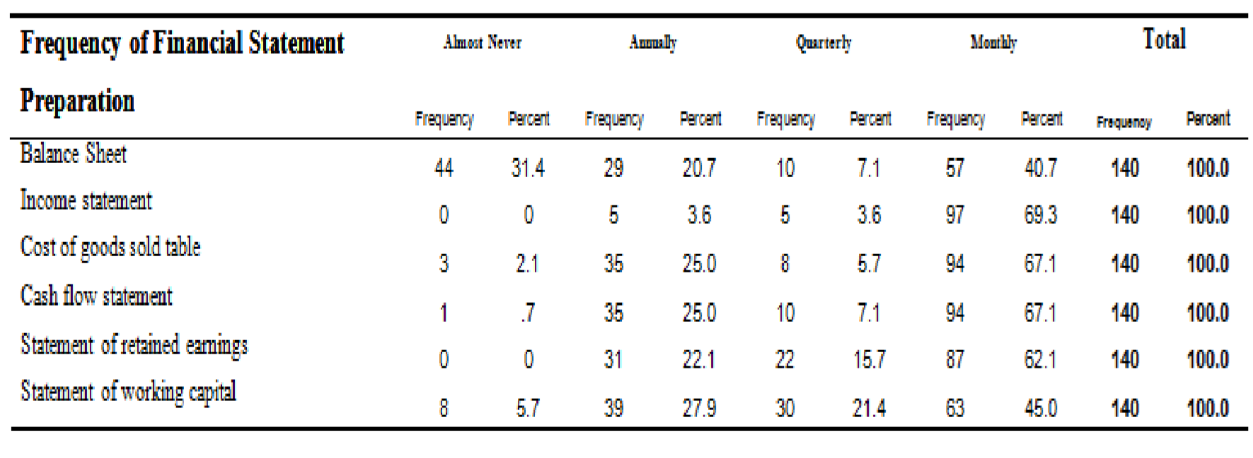
Table 3.2 presents the frequency of financial statements preparation. It shows that the majority of the respondents prepare their balance sheet monthly consisting of 57 respondents which is equivalent to 40.7%, while only 10 which is equivalent to 7.1% prepare their balance sheet quarterly. In preparing Income Statement, the majority of the respondents consisting of 97 respondents, which is equivalent to 69.3%, answered they prepare it monthly. While only 5 or 3.6% of the respondents answered that they prepare their income statement quarterly. In preparing Cost of goods sold, 94 respondents, which is equivalent to 67.1%, answered that it was being prepared monthly, while only 3 respondents, which is equivalent to 2.1% almost never prepare Cost of goods sold. Majority of the respondents answered that their Cash Flow were being prepared monthly consisting of 94 respondents which is equivalent to 67.1%, while only 1 which is equivalent to .7% almost never prepare cash flow. In preparing Statement of retained earnings, the majority of the respondents consisting of 87 respondents, which is equivalent to 62.1%, answered they prepare it monthly. While only 22 or 15.7% of the respondents answered that they prepare their income statement quarterly. And lastly, majority of the respondents answered that their Statement of working capital was being prepared monthly consisting of 63 respondents which is equivalent to 45.0 %, while only 8 which is equivalent to 5.7% almost never prepare Statement of working capital.

Table 4: Level of Perceived Importance of Preparing and Utilizing Financial Statements
Items | Mean | Interpretation
Requirement by other stakeholders | 2.850  0 | Important
Measure business growth & performance | 3.850  0 | Very Important
Assessing profitability & Financial Status | 3.857  1 | Very Important
Evaluating Financial Risk | 3.528  6 | Very Important
Finding and Obtaining Financing | 3.335  7 | Important
Evaluating and generating investment opportunities | 3.571  4 | Very Important
Useful for making a wide range economic business decision | 3.507  1 | Very Important
Predicting of proficient financial decision | 3.635  7 | Very Important
Perceived Importance of preparing and utilizing financial statements Composite Mean | 3.517  0 | Very Important
Table 4 shows the level of perceived importance of the different purposes in preparing and utilizing financial statements. Assessing profitability & financial status got the highest mean of 3.8571 followed by measure business growth & performance with a mean of 3.8500 while the lowest mean is the requirement by other stakeholders (M= 2.8500). The composite mean of all the items in preparing and utilizing financial statements is 3.5170, which mean that these were generally considered as very important.

Table 5: Level of Perceived Importance in Decision Making
Items | Mean | Interpretation
Assessing Market Needs | 3.4357 | Important
Forecasting Sales | 3.6000 | Very Important
Expenses Controls | 3.6786 | Very Important
Determining Selling Price | 3.5143 | Very Important
Determining Optimal Inventories | 3.2286 | Important
Planning and management of future Financial  Commitments | 3.7286 | Very Important
Assessing the future stability of the company | 3.7500 | Very Important
Anticipate the goods and services that the customer’s demand | 3.6071 | Very Important
Foreseeing probable Liquidity and Financial Crisis | 3.7714 | Very Important
Perceived Importance in decision making Composite  Mean | 3.6098 | Very Important
Table 5 presents of perceived importance in decision-making. Foreseeing probable liquidity and financial crisis got the highest mean of 3.7714 while determining optimal inventories earned the lowest mean of 3.2286. Results showed that the managers

consider preparing and utilizing financial statements in the SMEs in their decisionmaking as very important. (M=3.6098).

Table 6.1. Difference in importance of preparing and utilizing financial statements when respondents are grouped according to profile
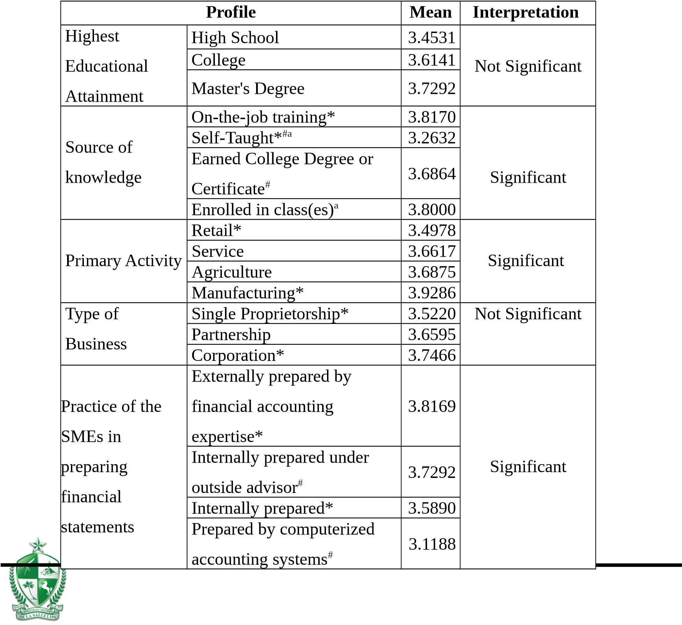
Significantly different based on post hoc test tukey at .05 level
Table 6.1 shows the difference in the importance of preparing and utilizing financial statement when respondents are grouped according to profile of SME managers in terms of highest educational attainment and source of knowledge about financial statements, according to profile of SME in terms of primary activity of business and type of business, and how are the financial statements being prepared in terms of practice of the SMEs in preparing financial statements. Results revealed that the importance of the purposes of preparing financial statement were not significantly different when respondents are grouped according to profile of SME managers in terms of highest educational attainment and according to profile of SME in terms of type of business. Moreover, importance of the preparing and utilizing financial statements when respondents are grouped according to profile of SME managers in terms of source of knowledge, profile of SME in terms of primary activity of the business, and how are the financial statements being prepared in terms of practice of preparing financial statements were significant. (p-values < 0.05).
The result that educational attainment has no significant in preparing financial statements contradicts to the study of Shawn and Howard (2013) that explains those owners who have high education are more efficient in using financial statements than those owners with lower level of education. The author also indicate that with a higher level of education owners will have clear understanding information that contained in the financial statements and also in the awareness on how important is financial statements. In addition, the result of the study of Amoako (2013) assumes that the level of educational fulfillment can change the perspective of understanding the importance of using financial statements. The result in source of knowledge implies to the study of James (2006) that concludes that accounting profession have a wide range of knowledge in analyzing and preparing financial statements. Accounting profession has a formal core and broad comprehension of basic accounting concepts and principles, general reporting rules, as well as having many details in accounting rules that essentially allow them to prepare or analyze highly reliable and relevant financial reports. Another study about the source of knowledge implies to Allee and Yohn (2009) study which stated that firms with a lot of experienced and intellectual owners within the firm are more productive in producing and using financial statements. Accounting majors must not only pertain to the multitude of accounting rules they also should also be connected to the overall reporting requirements that is required in preparing financial statements.
In addition, result in the primary activity of the business implies to the study of Needles and Crosson (2014) the operation of service, retail, and manufacturing organizations is significantly different. Their financial statements also differ to one another. In the preparation of financial statements a service activity keeps no inventory accounts on its balance sheet. The cost of sales on its income statement reflects the net cost of the services sold. While a retail organization, which purchases products ready for resale, maintains only a merchandise inventory account. And lastly, in a manufacturing organization maintains three inventory accounts namely Materials Inventory, Work in Process Inventory and Finished Goods Inventory. While, result in type of business was studied by Madray (2009). He implies that sole proprietorship’s financial statements are supported on the declaration of the law that existence of financial statements in reference to preparation is in accordance with GAAP or OCBOA. The financial statement for sole proprietorship may be not as good as others due to its some inefficient process of financial statements. The financial statements in sole proprietorship showed to be applicable in form and free from obvious material errors. In the financial statements of the partnership business type the information contained in the records must be sufficient to the preparation of financial statements in accordance to GAAP or OCBOA. In partnership type the financial statements was often used by the stakeholders especially through compilation and reviewing of financial records. A financial statement of a corporation is presented on an accrual and comprehensive basis of accounting. Corporation has no wide list of notes that should be comprised in the financial statements and as an alternative it should state that the notes are in integral part of the financial statements. It also may be presented on an accrual basis; however may be presented on other comprehensive basis of accounting (OCBOA).
Lastly, result on how are the financial statements being prepared in terms of practice of preparing financial statements was studied by Hussein (1983). He determines how well the financial records are by having a good accounting system which pertains to the external and internal users that prepare the financial statements. Clute and Gitman (1980) supports the study of Hussein that a qualified accountants a well organize in keeping records up to date but sometimes fail to provide information needed by decisionmakers. However, in the journal of Jayabalan and Dorasamy (2009) others claim that contracting professional accountants with a higher cost has left SME owners with no better option but to downgrade management of accounting information. In the perspective of Yet Gooderham et al. (2004) report that small firms pay attention in avoiding to seek external financial advice because they mostly rely on accountants of their own firms as financial advisors because they are confident in the financial advice according to the quality of the services they rendered.
Table 6.2. Difference in importance in decisin making when respondents are grouped according to profile

Profile Mean Interpretation
Highest High School 3.5469
Educational College 3.5089 Not Significant
Attainment Master's Degree 3.6458
On-the-job training*^{#a} 3.0268
Source of Self-Taught*# 3.7105 Significant
Earned College Degree or
knowledge ^{#a} 3.5487
Certificate
Enrolled in class(es) ^{#a} 3.8167
Retail* 3.3438
Primary Activity Service* 3.6100 Significant
Agriculture 3.6875
Manufacturing* 3.8571
Type of Single Proprietorship 3.4426
Business Partnership 3.6293 Not Significant Corporation 3.5777
Externally prepared by
financial accounting 3.6279
Practice of the expertise*
SMEs in Internally prepared under 3.5556 Not Significant
preparing outside advisor#
Internally prepared* 3.4428
financial Prepared by computerized
3.4625
statements accounting systems#
Table 6.2 shows the difference in the importance of preparing and utilizing financial statement in decision making when respondents are grouped according to profile of SME managers in terms of highest educational attainment and source of knowledge about financial statements, according to profile of SME in terms of primary activity of business and type of business, and how are the financial statements being prepared in terms of practice of the SMEs in preparing financial statements. Results revealed that the importance of the purposes of preparing financial statements in decision making were not significantly different when respondents are grouped according to profile of SME managers in terms of highest educational attainment, according to profile of SME in terms of type of business, and how are the financial statements being prepared in terms of practice of preparing financial statements. Moreover, importance of the preparing and utilizing financial statements when respondents are grouped according to profile of SME managers in terms of source of knowledge and profile of SME in terms of primary activity of the business were significant. (p-values < 0.05).
The result in educational attainment that has no significant in preparing financial statements in decision making contradicts to the study of Shawn and Howard (2013) that explains those owners who have high education are more efficient in using financial statements in decision making than those owners with lower level of education. The author also indicate that with a higher level of education owners will have clear understanding information that contained in the financial statements and also in the awareness on how important is financial statements are when it comes in decision making. In addition, the result of the study of Amoako (2013) assumes that the level of educational fulfillment can change the perspective of understanding the importance of using financial statements when it comes to decision making. Also, it is probable that if a business owner has a reasonable level of education it will indisputably affect his influence on implementing the necessary accounting and control systems in the business. The result contradicts to the study of Carter et al. (2003); Cassar (2009); Hanlon and Saunders (2007) found a direct association between using financial statements and educational levels. They conclude that high educated owners seem to appreciate the importance of financial statements in decision making in different aspects whereas less educated owners does not found the importance of financial statements in decision making due to lack of knowledge about preparing financial statements. In source of knowledge, according to the book of Madray (2009) he implies that sole proprietorship’s financial statements are supported on the declaration of the law that existence of financial statements in reference to preparation is in accordance with GAAP or OCBOA. The financial statement for sole proprietorship may be not as good as others due to its some inefficient process of financial statements. The financial statements in sole proprietorship showed to be applicable in form and free from obvious material errors. In the financial statements of the partnership business type the information contained in the records must be sufficient to the preparation of financial statements in accordance to GAAP or OCBOA. In partnership type the financial statements was often used by the stakeholders especially through compilation and reviewing of financial records. A financial statement of a corporation is presented on an accrual and comprehensive basis of accounting. Corporation has no wide list of notes that should be comprised in the financial statements and as an alternative it should state that the notes are in integral part of the financial statements. It also may be presented on an accrual basis; however may be presented on other comprehensive basis of accounting (OCBOA).
While the result in the primary activity of the business was studied by Needles and Crosson (2014) which the operation of service, retail, and manufacturing organizations is significantly different. Their financial statements also differ to one another. In the preparation of financial statements a service activity keeps no inventory accounts on its balance sheet. The cost of sales on its income statement reflects the net cost of the services sold. While a retail organization, which purchases products ready for resale, maintains only a merchandise inventory account. And lastly, in a manufacturing organization maintains three inventory accounts namely Materials Inventory, Work in Process Inventory and Finished Goods Inventory.The result in type of business implies to the study of James (2006) that concludes that source of knowledge can be found in enrolling to a class when educators help their students prepare challenging accounting profession in order to have a better understanding when it comes to analyzing financial statements that will be used in decision making. With this they will be engage in the overall accounting and reporting concepts, principles and rules that can be used in analyzing financial statements that can be apply for decision making process. The study of Allee and Yohn (2009) stated that those who have gain their experienced through working within the firm are more likely to evaluate, produce and use financial statements when it comes to decision making.
Lastly, the result in how are the financial statements being prepared in terms of practice of preparing financial statements implies in the study of Alle and Yohn (2009) that financial statements that are documented, examined and or audited by professionals are likely to be more sophisticated because it can give a better decision than those that are not. The use of a computer might lessen the cost of preparing financial statements and therefore be more accurate than other type of preparing financial statements because it is systematically made. In the study of Bushman and Smith (2001) about the difference between internally and externally prepared that more sophisticated financial statements may be desired by management for decision making needs when the firm becomes more complicated. This also became the wants of older firms that they are more likely to have their means in hiring professionals in compiling, reviewing and auditing the firm’s financial statements in order to have a better decision to have a better outcome.
CHAPTER 5

SUMMARY, CONCLUSIONS AND RECOMMENDATIONS
This chapter provides the summary of findings, which the data were collected and evaluated by the researchers throughout the study. Recommendations were also presented for the improvement of some areas in the study.
Summary

Demographic Variable and Financial Decision Making
The study revealed that among the 140 respondents, majority of it are college graduates. Most of the respondents got their knowledge by earning a college degree or certificates. In terms SME profile, most respondents who answered the survey questionnaires are Sole Proprietorship. Majority of these businesses belongs to Service Industry. Furthermore, 42.1% of these SMEs prepare their financial statements internally.
According to the data gathered, all financial statements were prepared quarterly.

Perceived Level of Importance of Preparing and Utilizing Financial Statements
From SMEs managers’ perspective, the study revealed that the perceived level of importance of Preparing and Utilizing of Financial Statements in Assessing Profitability & Financial Status got the highest mean and measures business growth & performance follows this. Requirement by other stakeholders has the lowest mean.

Perceived Level of Importance in Decision Making
The SMEs managers find Preparing and Utilizing Financial Statements in Decision Making to Foreseeing probable liquidity and financial crisis got the highest mean, followed by assessing the future stability of the company, while Determining Optimal Inventories has the lowest mean.

Difference in the Importance of Preparing and Utilizing Financial Statements when respondents are grouped according to profile
The ANOVA revealed that the importance of preparing and utilizing financial statements was significantly different when respondents are grouped according to primary activity of the business, source of knowledge, and practice of SMEs in preparing financial statement, while there is no significant difference in importance of the purposes of preparing and utilizing financial statement, when respondents are grouped according to highest educational attainment, and type of business.

Difference in the Importance in Decision Making when respondents are grouped according to profile
The ANOVA revealed that the Importance in Decision Making was significantly different when respondents are grouped according type of business, primary activity of the business, source of knowledge, and to practice of preparing financial statements. Moreover, only the highest educational attainment has no significant difference in importance of the purposes of preparing and utilizing financial statement.

Conclusions
From the findings, the following conclusions were drawn:
1. Significant difference between profile and the following:
a. Level of Importance of Preparing and Utilizing Financial Statements
The result showed that there is no significant difference between the demographic variable and financial decision making of the respondents in terms of highest educational attainment, type of business and practice of the SMEs in preparing financial statements, hence, there is a significant difference between the demographic variable and financial decision making in terms of primary activity of the business, and source of knowledge about financial statements. Therefore, out of the 5 demographic variable and financial decision making, 3 of them, which is the; highest educational attainment, type of business and practice of the SMEs in preparing financial statements were found to be accepted on the second hypothesis while the other 2 which is the; primary activity of the business, and source of knowledge about financial statements were rejected on the hypothesis stated.

b. Level of Importance in Decision Making
The result showed that there is no significant difference between the demographic variable and financial decision making of the respondents in terms of highest educational attainment, hence, there is a significant difference between the demographic variable and financial decision making in terms of the type of business, primary activity of the business, and source of knowledge about financial statements, and practice of the SMEs in preparing financial statements. For that reason, out of the 5 demographic variable and financial decision making, only highest educational attainment was found to be accepted on the second hypothesis while that rest of the demographic variable and financial decision making, namely; the type of business, primary activity of the business, and source of knowledge about financial statements, and practice of the SMEs in preparing financial statements were rejected on the hypothesis stated.

Recommendations
The researchers recommend the managers of SMEs to consider the result of this paper as a tool and guide for future decision making. The findings in the study could give the managers additional knowledge about the importance of preparing and utilizing financial statement in decision making that could be applied in operating their small and medium enterprises.
For the future researchers, the researchers recommend that they may perceive new ideas and explore more about the importance of preparing and utilizing financial statements that may benefit the readers especially the managers of SME. There are a number of additional areas for further research that could have been highlighted by the studies undertaken for this research. This includes gathering data from different respondents, not only for small and medium enterprises. Furthermore, the researchers’ study focuses only to the small and medium enterprises located in Lipa City, Batangas.
Hence, the researchers recommend to choose other locale to conduct the study.

REFERENCES
Allee, K.D., & Yohn, T.L. (2009). The Demand for Financial Statements in an
Unregulated Environment: An Examination of the Production and Use of
Financial Statements by Privately Held Small Businesses. The Accounting Review:
January 2009,Vol. 84, No. 1, pp. 1-25. doi: http://dx.doi.org/10.2308/accr.2009.84.1.1
Amoako, G.K. (2013) Accounting Practices of SMEs: A Case Study of Kumasi
Metropolis in Ghana International Journal of Business and Management; Canadian
Center of Science and Education Vol. 8, No. 24; 2013ISSN1833-3850E-ISSN 1833-
8119 Retrieved from http://search.proquest.com/docview/1491098828/24B583ECE64B4A5DPQ/1? accountid=28547
Berheci, M., & Cuza, A.I., (2007) THE ANNUAL REPORTS AND FINANCIAL
DECISION. Annales Universitatis Apulensis Series Oeconomica 01/2008; 1(10):17-
17Available at http://www.oeconomica.uab.ro/upload/lucrari/1020081/17.pdf
Briciu, S., Capusneanu, S., & Farcane, N. (2012) Preparation of Financial Statements for Sme’s in Romania. Interest for Cash-Flow Statement. Theoretical and Applied Economics Volume XIX (2012), No. 5(570), pp. 77-92 Available at
http://store.ectap.ro/articole /722.pdf
Bushman, R. & A. Smith. (2001). Financial accounting information and corporate governance. Journal of Accounting and Economics 32, 237-333.

Clute, R. C., & Gitman, G. B. (1980). A Factor Analytic Study of the Causes of Small Business Failure. Journal of Small Business Management, 30(2).
Crosson, S., & Neddles, B. (2014). Managerial Accounting 10th Edition. South-
Western, Cengage Learning. 10th Edition, 27-28
Dalgar, H., Ibicioglu, H., & Kocabiyik, T. (2010) Financial Statement Utilization
During Decision Making Process in SMEs A Comparative Study on European and
Turkish Managers. Marmara University Journal of the Faculty of Economic & Administ; Jun2010, Vol. 28 Issue 1. 209-226 Available at
http://dosya.marmara.edu.tr/ikf/iib-dergi/2010-1/12-ibicioglu-kocabiyik-dalgar.pdf
Døving, E., Gooderham, P. N., Morrison, A., & Nordhaug, O. (2004) Small firm accountants as business advisers: accounting for the differences in their provision of business advisory services in Norway and Scotland. EAA Conference, Prague. April. Available at http://brage.bibsys.no/xmlui/handle/11250/166462
Døving, E., Gooderham, P. N., Morrison, A., Nordhaug, O., & Tobiassen, A.(2004).
Accountants and Sources of Business Advice for Small Firms. International Small Business Journal, 22 (1): 5–22. Available at http://isb.sagepub.com/content/22/1/5.short
Dumitras, V. (2011). THE ROLE OF AUDIT IN IMPROVING THE QUALITY OF
INFORMATION PRESENTED IN THE FINANCIAL STATEMENTS. Romanian
Economic and Business Review, 6(3), 7-19. Retrieved from http://search.proquest.com/docview/1130504167?accountid=28547
Hussein, M. E. I. M. (1983). Accounting and Control Systems for Small Business.
Touché Ross Foundation
James, M.L (2006). Accounting Majors’ financial reporting knowledge and their ability to identify and correct financial statement errors and omissions. Academy of Educational Leadership Journal 10(3). 3-6. Retrieved from http://search.proquest.com/docview/214232501/D66672FDF2754D10PQ/1? accountid=28547
Jayabalan J, Dorasamy M (2009). Outsourcing of Accounting Functions among SME companies in Malaysia: An Exploratory Study. J. Acc.Bus. Pub. Interest., 8(2): 96114. Available at http://citeseerx.ist.psu.edu/viewdoc/download?
doi=10.1.1.506.8182&rep=rep1&ty=pdf
Kurniawati, E.P., Kurniawan, E.Y., & Kristiani M. (2013) Accounting Information for Business Decision Making and Performance Assessment in Small and Medium Enterprises (SMEs). The Journal of Social Science 76. 77-82 Available at http://ci.nii.ac.jp/naid/120005416036/
Madray, J. R. (2008). Compilations & Reviews 2008-2009. Cch.
Matkar, A. (2012). Cronbach’s Alpha Reliability Co-efficient for standard of customer services in Maharashtra State Co-operative Bank. National Monthly Refereed Journal of Research In Commerce & Management. 1 (3) pp. 67 – 74.
Nemoto, T., Ogura, Y., & Watanabe, W. (2013). The Decision-Making Mechanism of
Regional Financial Institutions and the Utilization of Soft Information. Policy Research Institute, Ministry of Finance, Japan, Public Policy Review, 9. Available at https://www.mof.go.jp/english/pri/publication/pp_review/ppr020/ppr020e.pdf
Nurulhasanah, A. R., Rafisah, M. R & Yaacob, Z. (2014). Determinants of successful financial management among micro entrepreneur in malaysia. Journal of Asian Scientific Research, 4(11), 631-639. Retrieved from http://search.proquest.com/docview/1624944683?accountid=28547
Purwati, A. S., Putri, N. K. & Suparlinah, I., (2014). The Use Of Accounting
Information In The Business Decision Making Process On Small And Medium
Enterprises In Banyumas Region, Indonesia. Economy Transdisciplinarity Cognition, 17(2), 63-75. Retrieved from
http://search.proquest.com/docview/1644447235?accountid=28547
Richbell, S. M., Watts, H. D., & Wardle, P. (2006). Owner-managers and business planning in the small firm. International Small Business Journal, 24(5), 496-514. Available at http://isb.sagepub.com/content/24/5/496.short
Siyanbola, T. T. (2012). Accounting Information as an aid to Management Decision
Making. International Journal of Management and Social Sciences Research
(IJMSSR) ISSN, 2319-4421. Available at http://www.irjcjournals.org/ijmssr/Dec2012/5.pdf
Smirat, B. Y. A. (2013). The Use of Accounting Information by Small and Medium
Enterprises in South District of Jordan,(An empirical study). Research Journal of Finance and Accounting, 4(6), 169-175. Available at http://www.iiste.org/Journals/index.php/RJFA/article/view/5661
Zager, K., & Zager, L. (2006). The Role of financial information in decision making Process. Special Edition on Consumer satisfaction,—Global Perspective. Available at http://businessperspectives.org/journals_free/im/2006/im_en_2006_03_Zager.pdf Appendices

