TMA 01 assignment

Introduction

This TMA counts for 33% of the continuous assessment on TM129. The weightings of the other assignments are listed in the Module guide. Each TMA is marked out of 100.

Submitting your TMA
This module uses the online TMA/EMA (eTMA) service for submission of TMAs. To submit your TMA go to your StudentHome page and follow the link provided.

Give your name, your personal identifier, the module code and the assignment number at the start of the assignment. It will help your tutor if you save your TMA document with a file name that includes your name, the module code and the TMA identifier — for example ChrisSmith TM129 TMA01.doc.

You should create two files for this TMA. One file should contain answers to all TMA questions except the ePortfolio question. The other file should contain your completed ePortfolio templates as specified in the TMA ePortfolio question. The eTMA system will only accept one file and this must be less than 10Mb, so combine these files into a single zip file for submission.

If you foresee any difficulty with submitting your assignment on time, contact your tutor well in advance of the date it is due.

For further information about policy, procedure and general submission of assignments please refer to the Assessment Handbook, which can be accessed via your StudentHome page.

Checklist before submission
Check the following before you submit your assignment:

- Have you followed good academic practice in clearly identifying material from other authors, for example by enclosing quotes in quotation marks?
- Have you given references to your sources in OU Harvard style?
- Have you complied with the word limits?
- Are your screenshots legible? Are they cropped to show just important material?
- Are your documents in an acceptable file format, such as .doc or .docx?
- Have you zipped your assignment into a single file ready for upload? Is the file size smaller than the limit?

See the Module guide for further guidance on these issues.

Question 1 (20 marks)
This question tests your knowledge of the history and key principles of robotics.
- The terms ’robot' and ‘robotics' have been used for many years.

Who coined the term ‘robot’ and in what context was it first used? Who coined the term ‘robotics’ and in what context was it first used? iii. How would you define the term ‘robot’ as it is likely to be used in academic and industrial research today?
(5 marks)

- Robotics and AI research have developed side-by-side over the past 50 years. Characterise the positions of researchers who believe in strong AI and weak AI, referring to their views on whether robots may one day become conscious. What position do you take?

(5 marks)

- One model of behaviour is the sense-act model. What subsystems does it contain and how are these connected? What types of behaviour can it describe? How does this model differ from the sense-think-act model in terms of:
  - architecture? ii. behavioural capability? (5 marks)
- What do the terms ‘telepresence’ and ‘teleoperation’ mean? What is the relevance of these techniques to robotics? (5 marks)

Question 2 (20 marks)
This question tests your general knowledge and understanding of robotics.

- Identify four different types of sensor that can be used in the design of a mobile robot. For each one, give an example of a task in which the sensor could be used.

(8 marks)

- Automated decision making is an important part of many robot control programs. One such approach is to use game theory.

  - In the context of robotics and artificial intelligence, in what sorts of situation might game theory be used?

  - The prisoner’s dilemma is a widely analysed game in game theory. Briefly describe how this game works. In the terms of the game, what do cooperate and defect mean?

  - Suppose a game is defined using the following payoff matrix.

 | You defect | You cooperate
Partner defects | You score 0, partner scores 2 | You score 2, partner scores 4
Partner cooperates | Both score 2 | Both score 3

A. If you think that your partner will defect, what strategy should you take? What payoff would you each receive?

09/04/2018B. If you wanted to minimise any payoff your partner receives from defecting, what strategy should you use?
WhyTutor-marked assignment TMA 01: View as single page might this be bad for you?
C. What should you do if you don’t know what your partner will do and why? (8 marks)
- Several different types of Braitenberg vehicle can be constructed around the idea of phototaxis. i. What is phototaxis?
- Explain how a Braitenberg vehicle would be constructed so that it behaves as if:
  - it is repulsed by a light source

  - it is attracted to a light source. (4 marks)

Question 3 (25 marks)
This question tests your understanding of robot control programming.

Figure 1 is a RobotLab program intended to make the robot, Simon, search rooms looking for a casualty. Each room has a different shade of floor colouring. Use this program to illustrate your answers to parts a and b. Below Figure 1 the code is repeated with line numbers added for ease of reference. You can find the background image file rooms-and-body.bmp in the Assessment section of the module website.

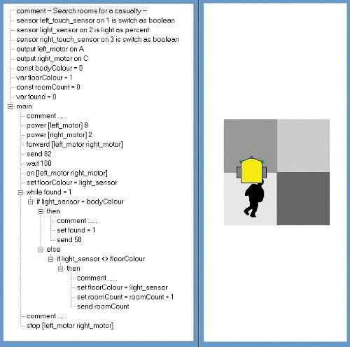

Figure 1

- comment -- Search rooms for a casualty --

sensor left_touch_sensor on 1 is switch as boolean

- sensor light_sensor on 2 is light as percent4 sensor right_touch_sensor on 3 is switch as boolean
- output left_motor on A

- output right_motor on C

- const bodyColour = 0

- var floorColour = 1

- const roomCount = 0 10 var found = 0
11 main12 comment ......

- power [left_motor] 8

- power [right_motor] 2 15 forward [left_motor right_motor]
- send 82

- wait 100

- on [left_motor right_motor]

- set floorColour = light_sensor

- while found = 1 21 if light_sensor

= bodyColour

22 then 23

comment ......

- set found = 1

- send 58

- else27 if light_sensor <> floorColour
28 then 29

comment ......

- set floorColour =
light_sensor

09/04/2018 Tutor-marked assignment TMA 01: View as single page
- set roomCount =

roomCount + 1 32

send roomCount 33 comment ......

34 stop [left_motor right_motor]

- There are three errors in the program that will prevent it from running as intended. For each error, state which line contains the error and give the correct RobotLab statement.

(6 marks)

- What is a ‘comment’ in a computer program? For each of the four empty comments in the program above, provide a meaningful comment that describes the action of the program.

(5 marks)

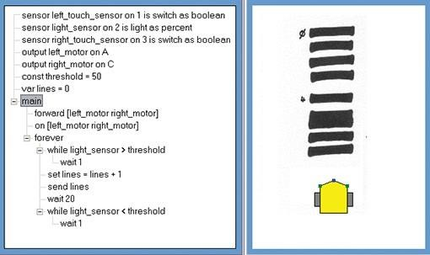
- Figure 2 shows another RobotLab program. Below Figure 2 the code is repeated with line numbers added for ease of reference. You can download the background image file greyLines.bmp from the Assessment section of the module website.

Figure 2

  - sensor left_touch_sensor on 1 is switch as boolean

  - sensor light_sensor on 2 is light as percent3 sensor right_touch_sensor on 3 is switch as boolean
4 output left_motor on A 5 output right_motor on C

09/04/2018 Tutor-marked assignment TMA 01: View as single page
- const threshold = 50

- var lines = 0

- main

- forward [left_motor right_motor] 10 on [left_motor right_motor]
- forever

- while light_sensor > threshold

- wait 1 14 set lines = lines

+ 1

- send lines

- wait 20 17 while light_sensor < threshold
18 wait 1

- If you were to run this program, describe in one or two sentences what you would observe Simon do. ii. By referring to the program line numbers, explain how the program determines Simon’s behaviour.
(6 marks)

- Start a new program in RobotLab. Write a program to make Simon trace out regular octagon. Your program should use named constants where appropriate and include comments to explain how your program operates.

Submit a screenshot showing your program and the trace of the robot’s movement. See the study note below.

How could you make use of constants in your program so that you could easily modify it to plot a regular hexagon? (You do not need to show a screenshot of this.)

(8 marks)

Study note
Your screenshot should show:

your program, with the text displayed at a readable size the behaviour of Simon, as recorded by running your program with the Show Trail function selected.
If you cannot capture the screenshot, you should submit:

the text of your program, containing appropriate comments
a short, written description of what Simon did when you ran your program and of the trace produced by the Show Trail function.

09/04/2018 Tutor-marked assignment TMA 01: View as single page

Question 4 (25 marks)
This question tests your understanding of the wider social and cultural issues of robotics.

Suppose that you work for a technology research and consultancy company that is regularly approached to produce short articles on advances in modern technology. These may be published in a technology magazine or on a website as a blog post.

You are asked to write a short article about the use of robots in the agricultural or farming industry. Your article should be based on the following plan:

Give three examples of robots that can be used in an agricultural or farming industry setting. (3 marks)

09/04/2018Demonstrate that each example can be considered a robot by giving a brief description that refers to concepts andTutor-marked assignment TMA 01: View as single page topics discussed in the Block, such as autonomy, intelligence, sensors and actuators.
(9 marks)

Briefly identify and discuss health and safety issues associated with the use of these robots, as well as any other social or ethical concerns regarding the use of such robots to replace human workers.

(4 marks)

To what extent, if any, may these robots be identified as collaborative robots? What design features might identify them as such?

(3 marks)

Give full references, either to the module materials or to other sources you use. Use OU Harvard style and follow the guidance at Referencing and plagiarism.

(3 marks)

Marks will be awarded for the overall quality of your writing, in particular for clarity, structure, spelling, punctuation and grammar.

(3 marks)

Your article should be no more than 400 words, excluding references.

Question 5 (10 marks)
This question tests your engagement with your ePortfolio.

During this block you will have carried out a number of ePortfolio activities. If you have not already done so, you should complete a TM129 ePortfolio template for each activity. You can download a document containing templates for this block from the TM129 ePortfolio page.

For each ePortfolio activity, use the template to record your work on the activity and to comment on the knowledge and skills you demonstrated. You should insert up to three screenshots (with a brief description or explanation) or other evidence for each activity. As far as possible all evidence should be inserted into the template. If you need to include additional evidence in other files, you must make sure these files are appropriately named and referred to by name in the template.

Your tutor will provide some overview feedback and will allocate marks for:

- the evidence you provide of your work for the ePortfolio activities (5 marks)
- your comments on the knowledge and skills you have demonstrated (5 marks)

Your ePortfolio will be marked by reference to the grid given in ‘Further guidance on the ePortfolio’.

You will have an opportunity to review and improve your work on the ePortfolio activities as part of the end-of-module assessment. The feedback your tutor provides for this TMA question should help you with this.

