THE IMPRESSIONIST ERA
In the following pages, you will find a comparison of three
Different art forms from the same time and era but by different
Artists. These artworks depict the same type of art form known as Impressionist style.
Claude Monet grew up in Le Havre, France. This is where he developed a reputation for drawing caricatures.
A local picture framer placed them for view in his shop where they caught the eye of the famous painter, Eugène Boudin.
Boudin convinced him to pursue his artistic abilities. This began Monet’s career as an artist which brought him to continue his studies of artistry in Paris where he met the controversial painters Courbet and Manet as well as another art student known as Renoir who shared his passion for painting nature and modern life, (as cited in Prebles’ Artforms: An
Introduction to the Visual Arts, chapter 20, pgs 339-343.) Monet and Renoir would quickly find themselves leading a group known as the “Impressionists”. In 1874, this group had been denied the right to show artwork in the Salon of 1873, which brought forth the “Impressionists”. Monet and his colleagues were labeled Impressionists by critics. These Impressionists, which included Monet, opposed academic doctrines and Romantic ideals, began creating artwork that depicted a portrait of contemporary life.
Landscape and ordinary scenes painted outdoors in various atmospheres and conditions of day were some subjects of these artists. In 1877, Claude Monet took his easel to the St. Lazare railroad station and painted a series of paintings. Among them was the following piece known as “Arrival of the Normandy Train, Gare St. Lazare.” This was for reasons of his fascination of the light in the steam as well as the clouds showing through the glass roof.
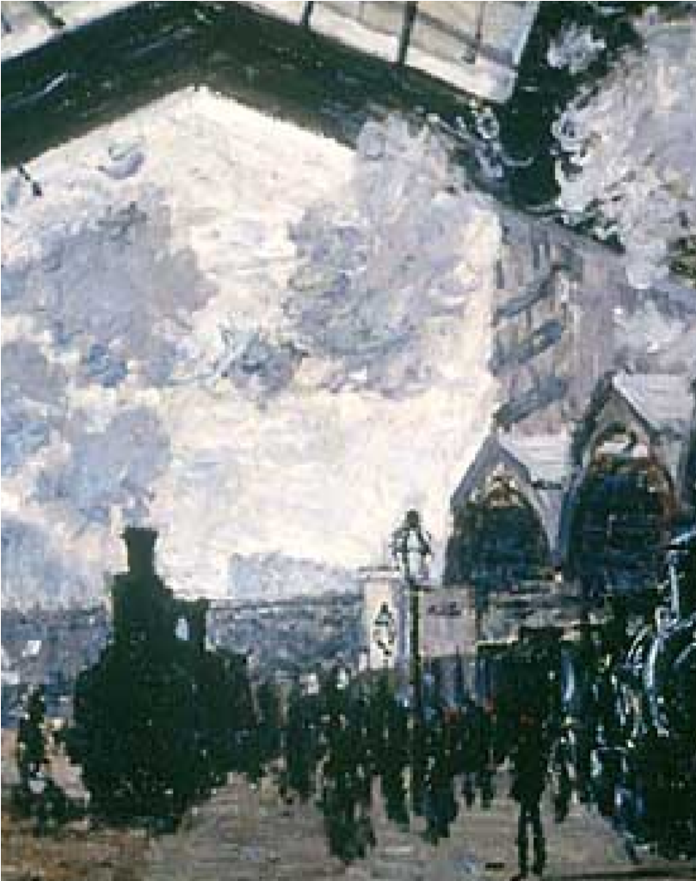
This is the photo known as the “Arrival of the Normandy Train, Gare St. Lazare” by Claude Monet in 1877 as an oil on canvas. It can be found in the Mr. and Mrs. Martin A.
Ryerson Collection located at The Art Institute of Chicago Monet had seen the paintings of Turner and utilized his techniques but in a different concept. However, this Impressionist, learned that we see light in the form of reflections received by the eye and then reassembled by the mind through the process of perception.
This gave him the idea of using small dabs of color in a way as to appear as separate strokes of paint when seen close up, yet become depictions of subjects seen at a distance. The effect was startling to the virgin eyes only exposed to the tones of academic painting. This explained why the Impressionists viewed the world as gifts and nature’s forces as aids to human progress.
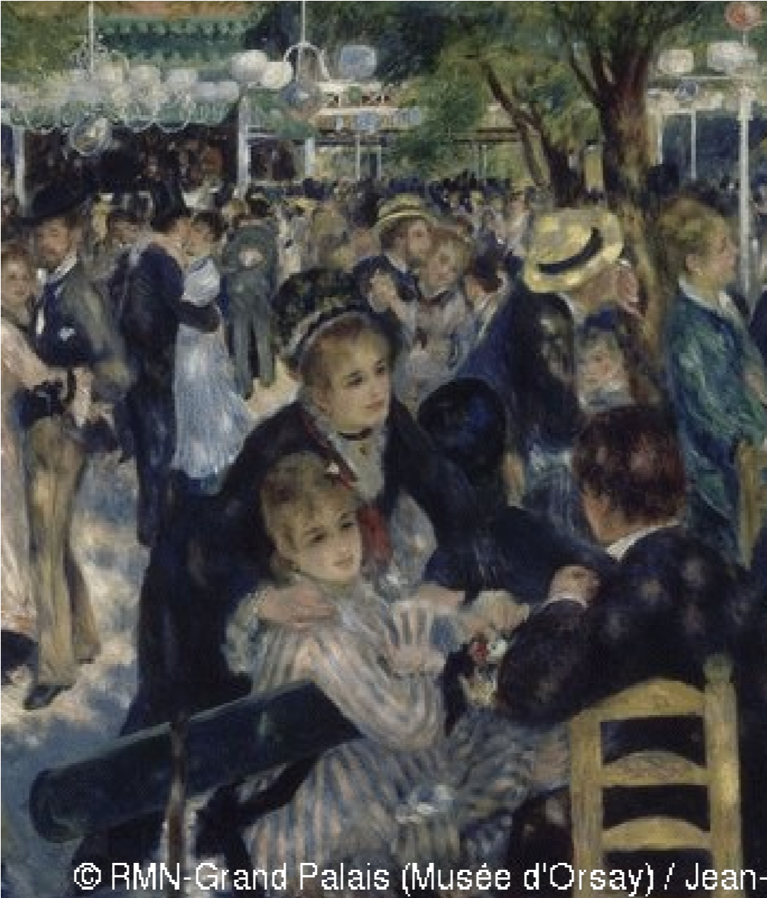
Above is a depiction of the popular oil on canvas by PierreAuguste Renoir titled “Le Moulin de la Galette” which can also be interpreted as “The Pancake Mill.” This artwork depicts a popular Impressionist theme: contemporary middle-class people enjoying outdoor leisure activities. The young men and women depicted are conversing, sipping wine, and generally enjoying the moment at the popular outdoor café that served up pancakes and dance music with equal liberality. The painting depicts a typical Sunday afternoon at Moulin de la Galette in the district of Montmartre in Paris. In the late 19th century, working class Parisians would dress up and spend time there dancing, drinking, and eating galettes into the evening. The Industrial Revolution had created an urban middle class with leisure and the Impressionists chronicled their lives. This painting is doubtless Renoir's most important work of the mid 1870's. Though some of his friends appear in the picture, Renoir's main aim was to convey the joyful atmosphere of this popular dance garden on the Butte Montmartre. The study of the moving crowd, bathed in natural and artificial light, is handled using vibrant, brightly coloured brushstrokes. The somewhat blurred impression of the scene prompted negative reactions from contemporary critics. This portrayal of popular Parisian life, with its innovative style and imposing format, a sign of Renoir's artistic ambition, is one of the masterpieces of early Impressionism.
Renoir was interested in the human drama than Monet.
However, he was also veryinterested in how the light, filtered by leaves, hits the bodies and clothing in the crowd.
From 1879 to 1894 the painting was in the collection of the French painter Gustave Caillebotte.
When he died it became the property of the French Republic as payment for death duties.
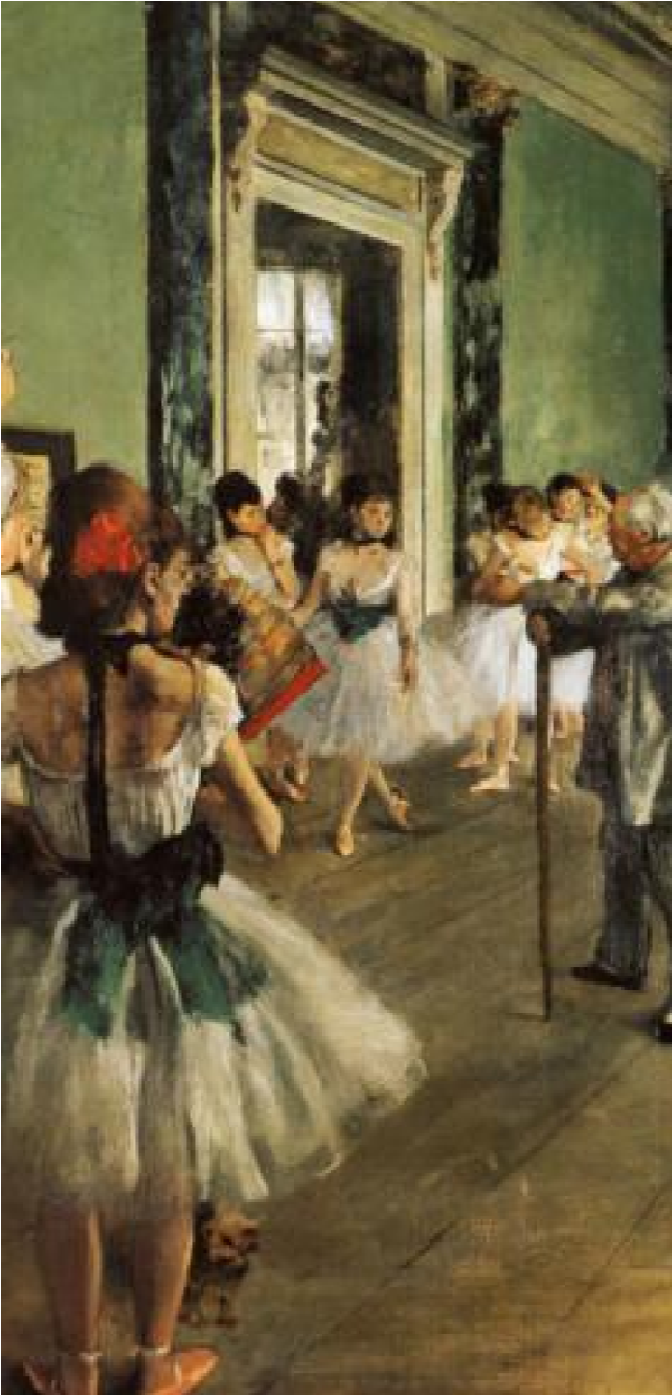
Above is a picture of Edgar Degas’s “The Ballet Class”. Edgar Degas created this art as an oil on canvas in 1879 that exhibited with the Impressionists. Degas’s approach differed somewhat from Renoir and Monet.
He shared with the Impressionists a directness of expression and an interest in portraying contemporary life, but he combined the immediacy of Impressionism with a highly inventive approach to pictorial composition. Degas’s artwork “The Ballet Class “and its variant in the Musée d'Orsay, Paris, represent the most ambitious paintings Degas devoted to the theme of the dance. Some twentyfour women, ballerinas and their mothers, wait while a dancer executes an "attitude" for her examination, (as cited in
By autumn of 1874, he temporarily abandoned the Orsay picture and executed this version, which was delivered to Faure 1874, Jules Perrot, a famous ballet master, conducts the class. The imaginary scene is set in a rehearsal room in the old Paris Opéra, which had recently burned to the ground. On the wall beside the mirror, a poster for Rossini’s Guillaume Tell pays tribute to the singer Jean-Baptiste Faure, who commissioned the picture and lent it to the 1876 Impressionist exhibit.
“The Dance Class” shows us two dancers waiting to be assessed by ballet master Jules Perrot. Degas prepared assiduously by making numerous drawings of dancers posing for him in his studio. His lively brushwork and light, bright colors were typical of the Impressionist movement. Their use of color was partly influenced by Japanese prints, in what it was called in France by Japonism which also made dramatic use of the “cut-off” composition – where the subject is chopped off at the frame – that Degas deploys so cleverly here and throughout his work. Degas, was also heavily influenced by the early years of photography and by overturning traditional compositional rules. This work looks like a snapshot but it is meticulously planned, with the eye drowned instantly to the arresting foreground group of two dancers before being taken into the picture by the receding floor planks. Degas admired the Dutch School and here shows the same ability to combine both traditional and modern approaches giving a new status to everyday life.
All three works of art exhibited were epic of their time period, and still remain famous works to this day in age. The three artworks are remarkable examples for their time period of the artistic capabilities of these three amazing artists.
References:
Course Smart, Prebles’ Artforms: An Introduction to the Visual
Arts, Tenth Edition, chapter 20, pgs 339-343.
Dance at Le Moulin de la Galette, Musée d'Orsay Bal du moulin de la Galette, as cited on www.musee-orsay.com
The Metropolitan Museum of Art - The Dance Class, as cited as www.metmuseum.org/collections.com

