“The Role of E – Marketing: A Study Towards the Structure of UK Online Market”

ABSTRACT
Until recently and in the last decade, an incredible numbers of organizations significantly started operating their operation online and have been increased their proportion of revenue successfully generated from online. The comprehensive usage of internet created a mixture of both positive as well as negative effect on the traditional market structures increased the market competition by establishing alternate market structures. All these new market structures have decided the failure or success for many organizations. Additionally, how the consumers approach to a business and handle financial transaction has also affected by electronic trading medium. In the field of business and strategic management traditional market structures are well defined as well as well studied but the structure of e – market have not achieved the same amount of satisfaction due to their comparative innovation and involvement of some temporary technologies.
This comprehensive study will highlight the role of E-marketing and targeted to be approachable to the group of computer consultants, business analysts, management personals, decision makers or managers and possibly to general audience as well apart from the mentioned groups. A variety collection of measurement methods as well as statistical models are implemented to gather raw data from internet research companies. The results from the raw data then linked with appropriate models and related theories to show online trends synthesis as well as any theoretical developments based on numerous selected UK wed industries. The chapter two objectives are to develop a theoretical framework for the research and indicate roughly appropriate investigation thoughts of concern. The questions developed for the research will tailor and displayed allowing to analyze those research thoughts or themes.

TABLE OF CONTENTS
List of Figures ...................................................................................................................... ii
List of Tables........................................................................................................................ ii
Acknowledgement ............................................................................................................. iii
Glossary................................................................................................................................ iv
Chapter I: Introduction ...................................................................................................... 1
Description of Terms .................................................................................................. 2
Purpose of Study .......................................................................................................... 4
Chapter II: The Reviews of Literature ............................................................................ 5
Electronic Market & Hierarchies .............................................................................. 9
Research of Electronic Marketplace ....................................................................... 11
Networked Market ..................................................................................................... 16
Assessments of Industry Dynamic ......................................................................... 21
Key points ................................................................................................................... 24
Chapter III: Research Problems .................................................................................... 26
Research Questions ................................................................................................... 28
Vertical Markets .......................................................................................................... 29
Chapter IV: Methodology of the Research .................................................................. 30
Description of Data Sources .................................................................................... 31
Methodologies for Web Measurements Judgments ............................................ 35
Chapter Outline .......................................................................................................... 37
HHI .............................................................................................................................. 43
Data Analysis Framework ........................................................................................ 44
Chapter V: Data Analysis ................................................................................................. 46 UK Airlines Power Curve ........................................................................................ 50
UK Insurance Companies ........................................................................................ 51
UK Consultancy Firms ............................................................................................. 55
UK Social Networking Sites .................................................................................... 59
UK Top Search Engines .......................................................................................... 63
Chapter VI: Findings and Discussion ........................................................................... 66
Discussion of UK Airlines ...................................................................................... 66
Discussion of UK Insurance Companies .............................................................. 68
Discussion of UK Consultancy Firms ................................................................... 69
Discussion of UK Social Networking Sites .......................................................... 70
Discussion of UK Top Search Engines ................................................................. 71
Summary of Industry Characteristics ..................................................................... 73
Chapter VII: Conclusions ................................................................................................ 75
Recommendations .................................................................................................... 76
Appendix 1: Consumer Behaviors ................................................................................. 77
Appendix 2: Buying Process ........................................................................................... 78
References ......................................................................................................................... 80
LIST OF FIGURES
Number of Figures Page
1 .................................................................................................................................. 6 2 .................................................................................................................................. 7 3 .................................................................................................................................. 8
4 ................................................................................................................................ 15 5 ................................................................................................................................ 23 6 ................................................................................................................................ 34 7 ................................................................................................................................ 36 8 ................................................................................................................................ 39 9 ................................................................................................................................ 41
10 ................................................................................................................................ 49 11 ................................................................................................................................ 50 12 ................................................................................................................................ 53 13 ................................................................................................................................ 54 14 ................................................................................................................................ 57 15 ................................................................................................................................ 58 16 ................................................................................................................................ 61 17 ................................................................................................................................ 62 18 ................................................................................................................................ 64 19 ................................................................................................................................ 65
Number of Tables Page
1 ................................................................................................................................ 19 2 ................................................................................................................................ 48 3 ................................................................................................................................ 52 4 ................................................................................................................................ 56 5 ................................................................................................................................ 60 6 ................................................................................................................................ 63 ACKNOWLEDGEMENT
The author wishes to express sincere appreciation to Professors Paul Reynolds and Dr. Rajendra Kumar for their assistance in the preparation of this manuscript. In addition, special thanks to Mr. Roger Telfer whose familiarity with the needs and ideas of the class was helpful during the early research phase of this undertaking. Many thanks also to the members of the school council for their valuable input.

GLOSSARY
‘B2B’. ‘Business to Business’.
‘B2C’. ‘Business to Customers’.
‘C2B’. ‘Consumer to Business’.
‘C2C’. ‘Consumer to Consumer’.
‘CERN’. ‘The European Council for Nuclear Research’.
‘Dot - Com bubble’. ‘IT disaster history’.
‘E-commerce’. ‘Electronic based transaction’.
SMEs. ‘Small and Medium Enterprises’.
‘WWW’. ‘World Wide Web’.

Chapter 1

THE INTRODUCTION
The European Council for Nuclear Research (CERN) and it’s scientists were understating one of the most challenging, inspired and complex projects that human civilizations had ever think of: the LHC or the Large Hardon Collider in 1980’s. The LHC project was finally finalized its journey in 2008 but the project had to shut down for a risky helium leakage (Rincon, 2008). Meanwhile, to collect many different data about LHC project across the Europe, and to find out specific solution for any problem related to project LHC; in 1989 Sir Tim Barners - Lee proposed the magical idea of “ World Wide Web” or in short “WWW”. The idea of “WWW” have changed the entire world dramatically and converted web technologies far more remarkably effective, user friendly, complex, beneficial than Tim Barners - Lee ever wondered (Seattle, 2014).
In recent technological world internet became more familiar than ever and expanded its operation not only for scientists as the only group to use but also benefiting normal people too. Students, lawyers, engineers business consultants also using the internet in their day to daily life as a communication medium with each other’s. In 1990s, the internet has gained more popularity and become more feasible worldwide. This revolution was assessed by numerous Techs - Buddha and accepted it as a compartment for business sectors. The tendency of making easy money was also obvious. Numerous internet organizations has commenced in a competitive business world. Mostly, these internet companies followed the traditional business standard or structure and started offering services on the web portals for free of cost. Initially, these free activities and services were generated to get some credit from advertising. However, this in the long run prompted the
“Dot - Com bubble” synergy (Galbraith, 2003). In 2003, a remarkable technical and specialized IT writer; Nicholas Carr accomplished sound contention and inspired business sectors to slash their spending on IT sectors. The highly debatable documentation known as “IT Doesn’t Matter” illustrated that companies will not gain any competitive advantages even if they increase their annual budget for their IT sectors (Carr, 2003). The low levels of speculation were undermining the eventual fate of the web abs IT budget/spending.
Nevertheless, in 2004 the posting of Google’s stock exchange or market, a new form of bubble was magnified. Google’s innovation and the way of targeting keywords as well placing text next to search results or advertisements have changed the advertising game. Many different business models were validated after the “Dot - Com bubble” since Google’s success. The marketplaces began recapturing their vanished hope. Due to less number of broadband connectivity and connection the idea did not work according to the plan. The “Eyeball” hunting started its journey again while internet services such as Facebook, YouTube, Twitter, and Myspace appeared and started offering exclusive as well as interesting free online services. These not only fascinated a large amount of audience but also attracted some good numbers of high profiled companies for their advertisement. It was then predicted that at some pick point in the near future the amount of revenue from the advertisement will be also very fascinated. After All, it had met all the expectations of Google’s (The Economist, 2009).
Internet has its own detailed history of presence. It has discovered a path in the most perspective of human lifestyle. Even with its simple level of functionality, internet system nowadays opened the door to collect information, easy communication methods, across the globe. Internet has extended many areas of science and technologies with its simplicity. From any commercial online transaction to any online research or communication, today human can perform various online activities with in a blink of eye without compromising time and security. The enormous presence of internet easily can feel when it is disconnected from us temporality. It feels like the making the decision on “Who should we vote in any election” for instant life with internet or life without internet. In reality nowadays, internet is actually connected with the political activities. History says, in 2008 approximately 74% of online users were actively involved to online US general election which basically represents an approximate of 55% adult population (Aaron, 2009). Statistics from the same source (PewResearch Center) also showed that 38% online users were highly interested to carry out online political conversation with each other’s whereas 58% of online users were using many internet services to receive and send political related messages.
According to Internet World Stats, currently an estimated number of 3,035,749,340 (80.8%) people are using internet around the world whereas in the Europe alone the number of users are 582,441,059(19.2%) approximately and growing (M.M.G, 2014). National statistic of UK showed in 2014, 84% of the UK households were successfully connected to the internet and the internet accesses using a mobile device were doubled from 24% to 58% between the year of 2010 and 2014 respectively (National Statistic,2014). Currently the proportion and speed of fibre optic broadband in the UK has also increased for business as well as home use from less than 2Mbps to mighty 100Mbps or more (National Statistic,2014). With a recently confirmed 0.5% UK GDP growth and the increased level of internet broadband consumption, its clearly present that the implication of internet has the exclusive opportunities for business sectors and marketers (T.Economics,2015). A survey based on many marketers around world were associated with McKinsey back in 2007 predicted that, 2010 will be the year when most of the consumers in major industries may find new online products and services as well as most of them are expected to do online shopping too. In another survey conducted by Centre for Retail Research 2015 has studied and forecast that the rate of UK online sales growth were 15.8% in 2014 which may increase by 16.2% in the year of 2015, regardless of the bankruptcy, it seems the rate is increasing as same as the broadband connections.
Until recently and in the last decade, an incredible numbers of organizations significantly started operating their operation online and have been increased their proportion of revenue successfully generated from online. The comprehensive usage of internet created a mixture of both positive as well as negative effect on the traditional market structures increased the market competition by establishing alternate market structures. All these new market structures have decided the failure or success for many organizations. Additionally, how the consumers approach to a business and handle financial transaction has also affected by electronic trading medium. In the field of business and strategic management traditional market structures are well defined as well as well studied but the structure of e – market have not achieved the same amount of satisfaction due to their comparative innovation and involvement of some temporary technologies. This comprehensive study will highlight the role of E-marketing and targeted to be approachable to the group of computer consultants, business analysts, management personals, decision makers or managers and possibly to general audience as well apart from the mentioned groups. A variety collection of measurement methods as well as statistical models are implemented to gather raw data from internet research companies. The results from the raw data then linked with appropriate models and related theories to show online trends synthesis as well as any theoretical developments based on numerous selected UK wed industries. The chapter two objectives are to develop a theoretical framework for the research and indicate roughly appropriate investigation thoughts of concern. The questions developed for the research will tailor and displayed allowing analyzing those research thoughts or themes.

Chapter 2

2. THE REVIEWS OF LITERATURE
In this chapter the report is targeting to provide an overall view of the related literature reviews needed to understand major key elements of this study. The main purpose in this section is to provide a detailed summary of some related affairs or topics, relevant approaches, and theoretical implications, in consideration of establishing the whole project into an expanded research subject. A wider selection of topics and citation are chosen not only from a wider range of both academic and business literature sources, but also from numerous internet sources. It is important to note that, numerous relevant topics such as “consumer behavior model” were investigated and exposed for this study that occurred at an early stage. Be that as it may, in light of a legitimate concern for quickness, some of these areas ought to remain discarded according to principle group of the current study. Appendixes are highly recommended to have a look for more details regarding those discarded discussions.

2.1. E – MARKETING & CURRENT TRENDS
“Electronic based transaction (E-commerce) refers to business transaction in which the parties involved interact electronically to exchanges information (MK, 2008)”. However, a definition like this is not complete enough to highlight current business structure and revolutionary development. A comprehensive meaning like: “E-commerce is the use of electronic communications and digital information processing technology in business transactions to create, transform, and redefine relationships for value creation between or among organizations, and between organizations and individuals (Zoryada, 2003)”. Both the sellers and buyers can be benefitted from the factor of E – marketing and E – commerce in case of selling as well as buying respectively. Online market place is a very secure, convenient, faster, connected and comparative shopping platform. Buyers can choose a wider range of product without physically visiting the shop or dealing with the sales assistant. In terms of seller, they also can enjoy faster and secure payment procedure in a convenient lower transaction fees. Additionally, sellers may also get the advantages of using a numbers of modern tools that are suitable to build effective customer relationship.
According to an article from CIO (2007), e – marketing and e – commerce are approximately 6% less compare to the all other retail sales. However, very recently ComScore has finalized their Q2 e – commerce and m – commerce statistic where in the second quarter the growth of e – commerce (+10%) outpaced the ordinary retail growth (+3%)(Lipsman,2014). It is therefore, significantly proven from the prediction of CIO article that the growth of e – commerce is much more established and a mainstream over the traditional local shopping mall (CIO, 2007).
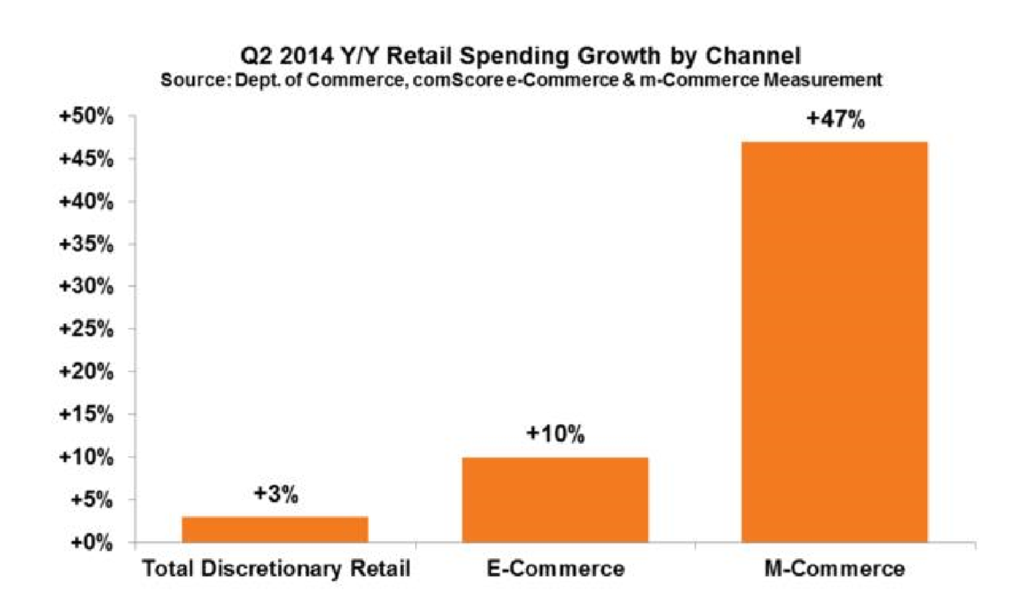

Figure 1: The Growth of E – Commerce (adapted from comScore, 2014)
The terms “click – only” and “click – and – mortar” can be related with the terms of E – Marketing (Investopedia, 2015). If any company is based on “click – only” that means there are no physical presence of the companies as well as no physical trace of financial transaction. Mostly, transaction occurred online when it’s a “click – only” company. Companies like eBay, Amazon, Google Play, Apple, Play.com etc. are the suitable examples of “click – only” companies. However, all these “click – and – mortar” companies are as essential as traditional “brick – and – mortar” companies growing and extending their functions by including E – Marketing((Investopedia, 2015). There are mainly four major e – marketing domains available and they are Business to Business B2B or Business to Business, C2C or Consumer to Consumer, C2B or Consumer to Business. The figures of four major E – Marketing domains are given below –
 |  |  |  |  | Targeted to Consumers |  |  |  | Targeted to Business
 | Initiated by Business |  |  |  | B2C [Business to |  |  |  | B2B [Business to
 |  |  |  |  | Consumer] |  |  |  | Business]
 | Initiated by Consumer |  |  |  | C2C [Consumer to |  |  |  | C2B [Consumer to
 |  |  |  |  | Consumer] |  |  |  | Business]

Figure 2: E –Marketing Domain (adapted from Kotler, 2007)
In the McKinsey quarterly survey (2007), four major areas were analyzed out of five to understand the importance of using digital tools. It seems, spending on computerized promoting appears set to increment fundamentally. The results were simply astonishing. In today’s world at least one third of the organization spending at least more than 10% of their advertising or marketing budgets online (McKinsey, 2007). Around 93% of business officials for administration and 40% for evaluating asserted that online or digital tools were in any event somewhat imperative for organizations inside their commercial ventures. Evidence shows, most of the high profiled companies in Europe and in the field of High Tech Industries are using online digital tools for their marketing very frequently. However, the usage level of these digital tools and their importance may vary from company to company. Here in figure 3 showing the results from Mckinsey survey –
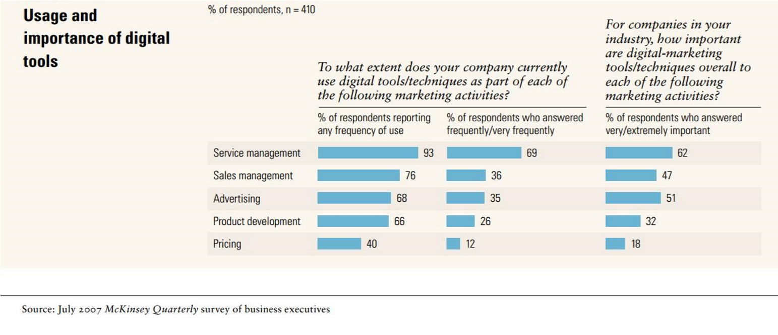

Figure 3: Usage and Importance of Digital Tools (adopted from McKinsey)
Considerably, the same survey report also identified that the efficiency of these online digital tools are much more higher compare to the traditional marketing techniques and therefore, it seems the role of these digital tools are extremely more important in every aspects of marketing activities. The survey concludes by pointing the lack of capabilities to work online by many companies due to lack of super-fast broadband connectivity in their organizations. Some of the other trends and interests were highlighted for this research are given below –
- Many growing companies are spending incredible amount of their budget for online advertising. In particular, investments on search advertisement increased significantly. Investing rapidly on paid keyword searches, sponsorship by brands and social networking are also not far away in the field of digital marketing.
- Investing on modern technologies like web 2.0 is comparatively cheaper which may help to adopt digital tools in a lower price of cost. Features like RSS, podcasts, blogs, forums, P2P sharing/networking, mash – up, social networking applications are vastly supported by web 2.0. All these features are very effective to optimize any web based services (Jonathan, 2007).
2.2. HIERARCHIES OF ELECTRONIC MARKETS
According to to Neoclassical Economics, perfect competition a market where the characteristic should be present as following (Stigler, 1957) –
- A massive number of buyers as well sellers,
- No entry or exit barriers,
- Excellent factor of mobility,
- Perfect knowledge or information,
- Free of cost transaction method,
- Profit increment,
- Homogeneous products
In 1987, the prediction from Malone at al showed the emergence of digital market and the conditions under digital market will likely take place everywhere.
This debatable article argued that the “electronic communication effect” will spread if information technologies usage extends its operation. Therefore, the price tag for communication medium will reduce and it will be possible to transmit massive amount of data at the same time. This will create the trend of perfect information conditions.
Considering the “electronic brokerage effect” for B2B marketplace can enhance the usage of centralized database system to connect numerous buyers and suppliers under the same hood (Malone, 1987). This is also suggested to minimize price tag for alternative products and services in “computer based market” (Aurthur, 1996).
After all the tendency of traditional market’s converting to electronic markets, may have the tendency of facing the term “electronic integration effect” by employing IT(Schmitz,2000). This happens when the methodology of data administration in associations is changed, for instance by interfacing in the middle of suppliers and producers in the production network which because of data just being entered once aides stay away from human lapses and protects stage.
The compelling learning brings numerous impacts of using information technologies and in what way automated marketplaces can fulfill various impeccable rivalry conditions, to be specific immaculate data, various purchasers and suppliers, close cost less exchanges, and bringing down passage and way out obstructions (Schmid, 1998). As the study move towards flawless data, brought about by cost less exchanges and quests on the web, the notoriety, and thus number of exchanges occurring on a site begin to end up directed by the cost of merchandise and administrations, and the accessibility of choices introduced.
Malone at al. finished up saying “On the off chance that our expectations are right, we cannot expect to have the automatically unified universe of tomorrow to be essentially a quicker and more productive form of the world know today. To expect essential changes in how firms and markets sort out the stream of merchandise and administrations in our economy. Unmistakably more efficient observational study also more clearly formal examinations are expected to affirm these expectations.”The thoughts introduced overhead, give an insignificant specimen of the contentions put forward in this paper; an all the more top to bottom examination of which is past the extension of this study. Interested reader may read further in “Electronic Markets and Electronic Hierarchies” by Malone.

2.3. RESEARCH OF ELECTRONIC MARKETPLACE
A comprehensive review of literature for the online trade investigation included one hundred nine papers from nineteen different periodicals was conducted by Shan “A literature review of electronic marketplace research: Themes, theories and Information System Frontiers”. Eight research themes, five research methodologies and six different types of categories on “Electronic Marketplace” or in short EM were highlighted to review from this literature review. The research then proposes a parallel structure of EM which finishes up EM exploration is principally approached from three major points: data frameworks, authoritative/social structures, and administration. This segment introduces some of their findings. All of the eight research themes that were rectified during the progress of this paper are given below –

The Success of Electronic Market
Creating explanations for the achievement and disappointment of different Electronic Markets is by a long shot the most investigated theme in Electronic Markets research. A portion of the explanations for Electronic Market accomplishment, as distinguished by this paper, given below –
- Electronic Markets claimed according to settled brand names and organizations that are more liable to succeed than those possessed by money related organizations and financial speculators.
- Another research was carried out by Murcus at el showed around 248 European EMs and close to those with better banding together aptitudes are more prone to enhance their focused positions than others.
- A slow extension of administration procurement has been recognized as a suitable technique. As it were, business administrators ought to core interest on their center skills before giving a more extensive scope of administrations.
- Product as well as service separation in light of value has been recognized as a benefit amplification system for some EMs.
- Further critical components adding to EM achievement incorporate interior capacities, for example, IT abilities, monetary backing behind EMs, and key control (advantages of moving early).

Adoption of Electronic Market
A few purposes behind fostering different EMs by people and organizations found in examination writing have been introduced, with the most shares of these falling into the accompanying four classifications:
- Expectancy or performance: The degree to which the EMs supports users ‘career improvement and work performance or productivity.
- Expectancy of effort: The client's apparent level of simplicity with regards to using and exploring the EMs. Suitable EMs outlines may prompt lower exertion expediencies.
- Expectancy of institution: Even if remarkably respected people accept the client ought to receive the new framework.
- Encouraging Conditions: The apparent level of help gave by associations or innovation to the EMs.

Designing Electronic Market
Electronic Market designing can be divided in to 2 different categories –
- Suggested plans aims at innovative sorts of internet markets, specifically commercial business.
- Suggested plans how to enhance current e-markets, for instance by giving better security as well as better privacy emphasizes in existing frameworks.

Impact of Electronic Market
The literature investigation found that studies on acknowledged effects of Electronic Markets are regularly experimentally built, while those with respect to potential effects have a tendency to be more enlightening. Some of these impacts are showing below –
- Monetary profits: Exchange and stock expense diminished, an increment in the client base, and so forth.
- Higher rivalry levels: Because of lower expenses and higher effectiveness, in any case, advantages purchasers more than sellers.
- Impacts on adverse: Agreement, data over-burden.
- Alterations of market structure: This was talked about in the past segment, is an illustration examination paper found around (Malone at all).

Trustworthy and Electronic Market
The levels of trustworthiness of clients of Electronic Market, is an essential variable adding to their prosperity and reception rates. Various studies have been done to make methods for measuring, building, and improving trust by Electronic Markets (Belanger, 2002).

Small & Medium sized Enterprise and Electronic Markets
A few numbers of researches has been coordinated at Small and medium sized organizations (SMEs), and their connection to Electronic Markets. SMEs appear to charge vastly improved in divided markets, than in concentrated ones, generally because of the high specialized venture levels needed in much focused commercial enterprises (Moen, 2002).

Electronic Market Specialist
Wise specialists endeavor to hunt down exchanging accomplices and arrange costs on the web, and along these lines can supplant or assuage concentrated Electronic Markets. This exploration subject falls into a more extensive Electronic Market plan class, yet has been singled out because of its apparent significance.

Electronic Market Overview
Research papers with a more expanded scope of points fall into this examination subject class. These studies are regularly found to fail to possess an exact base and have a tendency to be more spellbinding and general in nature. The following figures are showing the quantity of examination papers in every distinguished exploration topic, assembled by research strategy.
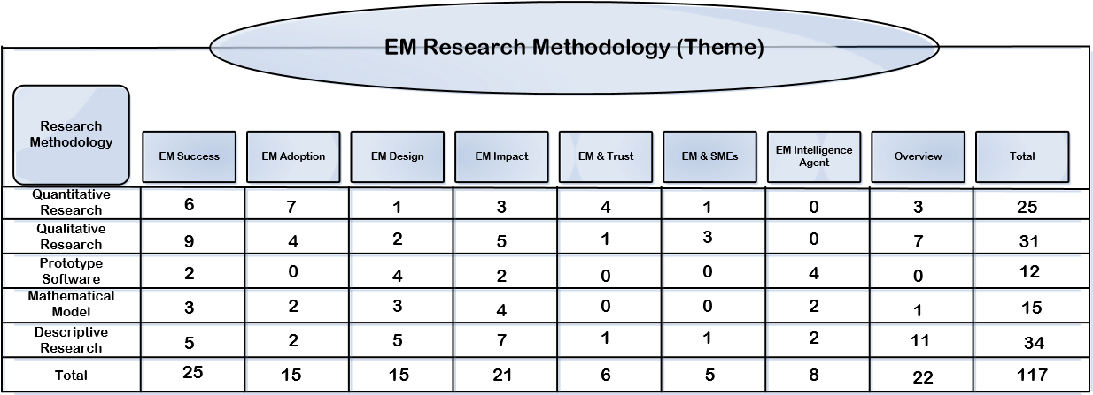

Figure 4: EM Research Methodologies [Theme] (adopted from Shan at el)
The findings as well as proposals for extra learning will conduct further experimental exploration in the end. Therefore, in any case, that these endeavors may be controlled due to the difficulties of gathering information. One likely arrangement is the utilization of electronic information, despite the fact that peruses are admonished that using such information may bring up issues of legitimacy. The way of such information sources will be talked about in the accompanying sections. The creators of this literature review of Electronic Market research make the conclusion despite numerous examines about EMs have showed up as of late, they are still not develop. Numerous different issues are still not completely investigated, and request consideration from future examination. In entirety, the future exploration of EM ought to be led in a manner that is grounded in both hypotheses and field information.

2.4. THE CONCEPT OF “NETWORKED MARKETS”
Crucial rivalry is the standard in the majority of the arranged economy, yet a solitary supplier has commanded the businesses for desktop programming, web inquiry and online barters very nearly from the beginning. How did champs like Microsoft, Google and eBay oversee to take for all intents and purposes all the prizes as well as to clutch them (Kieran, 2010)? An article from The Harvard Business School in 2007 written by Eisenmann known as “Winner – Take – All in Networked Markets” highlighted the dominated concept of “Networked Market”. A stage incorporates the segments and principles utilized by clients crosswise over the majority of their system exchanges. Two stages are a piece of the same organized business; if changing the expense to clients affiliating with one stage, impacts the volume of exchanges interceded by the second platform. Each stage encourages client association on one, and one and only, organizes. Each stage interceded system has one, and one and only, stage at its center.
Opposing stages utilize non-perfect advancements. Due to the explanations American Express, Visa, MasterCard are three separate systems, every assisted by a unique stage. All these three systems together include an arranged business sector: the U.S. Visa industry (Eisenmann, 2007).
At the beginning it is important to discuss about the principle thoughts displayed, it is also important and serious issue on two-sided paper which is organized or networked markets, which happen to be the most widely recognized sort; put in an unexpected way, arranged markets with two different clients bunches who dependably continue the same parts. Cases in point the PDF systems are per users and reporters (report inventors). Additionally, Windows desktop O/S system is personal computer based clients and request designers. An alternate significant truth is that the fundamental accentuation here is on stage structures, which is identified with the quantity of contending stages in a given arranged business sector.
The networked market platform structure can be identified according to following factors –
- Including multi – homing: in a market in which most clients on no less than one side utilization numerous stages. For instance in the Online Music Subscription industry, like Napster, iTunes, and so on all music organizations have a tendency to backing different stages, to achieve the full scope of buyers (Lewis,2009).
- Including monaural-approach: in a market where clients are networked and on at minimum single sided, utilize one and simply stage. Purchasers included feature diversions manufacturing have a tendency to choose one or more accessible stages, be it the PS or Play-Stations, console like Xbox,), or whatever further accessible stages.
- Including blended approach: in a market where clients are networked has an extensive client’s amount (mono – home) as well as multi-home. Visas give an appropriate case for the issue, while a noteworthy parcel of buyers stick with standout Visa, while others decide to make utilization of numerous.
Obviously, these stage structure results are display without a ‘Winners-Takes-All’ or in short WTA stage construction, whereas characterized as one in which a sol itary stage catches more than 90% of the significant organized market (Eisenmann, 2007). At the end of the day, there are not that numerous huge opponent stages for clients to pick from in any case. In such cases, it can be said that WTA results have predominated. The table beneath, extricated from this article, gives various illustrations to different stage structure results.
Network | Side 1 Users | Side 1 Structure | Side 2 Structure | Side 2 Users
Fax | Senders/Receiver | WTA |  | One sided network
DVDs | Consumers | WTA |  | Movie Studios
Mobile FeliCa | Phone User | WTA |  | Retails Stores
Real Estate MLS | Home Buyers | WTA |  | Home Sellers
Windows O/S | PC Users | WTA |  | Application Provider
Online Auction | Buyers | WTA |  | Sellers
PDF | Readers | WTA |  | Document Creators
Instant Messaging | Senders/Receiver | Mixed Mode |  | One sided network
Credit Cards | Consumers | Mixed Mode | Mixed Mode | Merchants
Yellow Pages | Consumers | Mixed Mode | Mixed Mode | Marketers
Recruitment Sites | Job Seekers | Mixed Mode | Mixed Mode | Recruiters
Video games | Consumers | Mono | Mixed Mode | Game Developers
Shopping mall | Consumers | Mono | Multi | Stores
Music Subscription | Consumers | Mono | Multi | Artist/label
Multi-channel TV | Consumers | Mono | Multi | Programming network

Table 1: Outcomes from Platform Network (Adopted from Eisenmann, 2007).
Eisenmann proceeds with his evaluation of netwoked markets, and their stage structures, by distinguishing four variables which impact the shots of another organized business being overwhelmed by a solitary stage. These are:
- Monopolies that is natural.
- Cost of Multi Homing
- Net effects
- Distinguished platform of functionality
Numerous organizations exploit the scale of finances, to minimize the budget for the unit. This is commonly, just attempts to the opinion whereas profits may balance according to dis-economies of balance that ordinarily brought about by substantial overheads. MES or in short Minimum Efficient Scale is the most minimal level of yield at which it is conceivable to minimize an organization's unit fetched (Eisenmann, 2007). Certain businesses have an especially expansive MES in connection to the level of yield or the extent of their experienced business sector. In fact, keeping in mind the end goal to amplify economies of scale, and thus, perform with greatest proficiency; especially large amounts of yield are needed. These are called common imposing business models. The railroads, postal conveyance, and phone administrations are all illustrations of characteristic imposing business models. This condition alone can focus WTA results. The other three major elements are said to have a joint impact on deciding WTA results:
Multi-homing expenses allude to the costs continued by clients, both in a money related sense, and in a less substantial sense, (for example, burdens), when they choose to subsidiary with numerous stages. Case in point in the feature amusements industry, a client may wish to utilize both an Xbox and a PS3, and consequently brings about expenses connected with both stages. The chances for a system being served by a solitary stage have a tendency to increment, when the (apparent) expenses of multi-homing increment. Nevertheless multi-vary from exchanging expenses, which are connected with abandoning one stage to utilize an alternate. Despite, much of the time, a positive relationship between the two has been observed homing expenses.
System impacts are said to be solid when clients give high priority to the capacity to communication method and partner with numerous different clients of the same stage. Despite, clients of a stage exist on both sides, and needing to associate with numerous different clients can essentially demonstrate needing to have various exchange accomplices. For instance, PC clients might profoundly give priority to the capacity to communicate with numerous application suppliers. Solid system impacts are recognized as a component adding to WTA results.
Clients are ordinarily offered various diverse functionalists and specialized peculiarities by contending stages. The Play Station for instance, has separated its stage (PS3) from different reassures, for example, The Nintendo Wii and Xbox 360, by offering blue-ray. This is an exchange particular purpose of separation. Competing stage Wii, then again, has set a bland purpose of separation with its movement distinguishing remote controllers. The probability of WTA conditions overarching in an arranged business are said to increment when clients have homogeneous needs and think less about stage separation (Horowitz, 2012). For further study interested readers are highly recommended to read the article of Eisenmann, 2007.

2.5 ASSESSMENT OF INDUSTRY DYNAMIC USING POWER CURVES
Another article published by Mckinsey Journal explained that the inclination of expanding disparity in a long run can saw in the size and execution of vast organizations (Michele, 2009). These perceptions have been made on the premise of results assembled from plotting the appropriation of different markers of size and execution (e.g. net wage, business sector esteem, and accessible resources), among the top enterprises in various businesses. The outcomes from these appropriation formats, imply the vicinity of a force bend, rather than a typical conveyance or ringer bend, which show a moderately even spread of qualities around a mean.
Certain curve like this is described by a short "head," involving a little set of organizations with to a great degree extensive wages, and drops off rapidly to a long "tail" of organizations with an altogether littler earnings. This example, like those representing the conveyance of riches among ultra-rich people, is depicted by a numerical relationship called an influence law. To explain more about such type curve the article also highlighted few more factors on the behavior of power law. Any industry's focused power is an imperative consider expanding imbalance amongst its players. Good number of competitors and then some customer decision, (out of the blue) builds disparity, and the crevice between the top rank and the average spot, rather than bringing about a compliment curve.
The existence of volatile resources (e.g. trademarks, licenses, ability, systems, and so on.) is likewise said to propel force curves. Volatile resources support customers in performing worth suggestions, and make economies of extension, which among numerous different profits, permit firms to advance a more extensive scope of items. Volatile resources additionally realize expanding comes back proportional; put in an unexpected way, immaterial resources permit firms to keep developing their net revenues as the firm develops. Despite, most firms just appreciate consistent comes back proportional.
Figure 5 displays the distribution examples of business sector values in positioning request, over five tagged commercial ventures. The ranking dispersions under is highlight the distinctions in the nature and size of driving players in these commercial enterprises. As can be seen, capital-escalated commercial ventures, for example, Chemicals and Machinery have a much "compliment" influence curve, contrasted with elusive rich businesses like Software and Biotech.
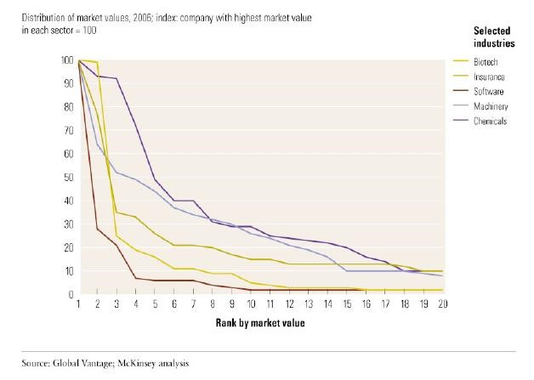
Figure 5: Power Curve by industries (Adopted from Michele, 2009)
These explanations propose that organizations, with a specific end goal to enhance their position along the force bend, need to focus on a "key push", rather than an "incremental method". The field of Mergers and Acquisitions (M&A) gives various suitable cases of vital pushes, when organizations fuse with or secure an alternate. Exploiting system impacts (talked about in the past segment), has likewise been distinguished as a component in charge of driving force bends.
Because of their (power curve) pervasive and reliable nature, can be used as a precious device to foresee and break down an industry's development, and helping us benchmark an industry's execution. Michele closes the article with the comments such as not at all like the physics, power curves aren't permanent. Yet their omnipresence and consistency propose that organizations are by and large contending against each other as well as against an industry structure that gets to be continuously more unequal. For most organizations, this probability makes force bends an essential bit of the vital connection. Senior officials must comprehend them and appreciation their suggestions (Michele, 2009).

2.5 KEY POINTS /SYNOPSIS
The increment of E-Marketing or E-commerce, with online organizations anticipated to passage better than different organizations in the wake of the current monetary emergency. Various advancements which will assume a noteworthy part in the further development of digitalization, within a reasonable time-frame, have been distinguished. Numerous organizations, not simply web organizations, make utilization of Web 2.0 advances. All through this task, we hope to experience numerous instances of the use of this innovation, which will provide for us better knowledge into this rising IT drift.
The analyzing of research theme and the reasons for EM achievement, effect, and selection rates may end up being especially important in building up a structure and displaying procedures to enhance site availability. The studies completed by Lenz et al. (on the impacts of associations), because of their attention on European EMs, and the quantity of mulled over business sectors, are liable to be of noteworthy enthusiasm here.
The thoughts examined in Eisenmann’s article are especially important to online markets, and this study will plan to focus the availability of the components adding to WTA results in the business sectors concentrated on, and evaluate their precision. Despite the principle contributing impacts to these results which are required to be experienced are multi-homing expenses, system impacts, and separated stage usefulness, as characteristic restraining infrastructures have a tendency to happen in exceptionally uncommon circumstances.
Various established plus modern speculations as well as prototypes regarding digital marketplace were introduced in the part of business sector. Approximately measurable prototypes deployed for customary business sector structures survey (e.g. Power curves) have additionally discussed.
The traditional contentions set onward by Malone anticipate that computerized marketplaces resolve basically prompt immaculate data, took after by different impacts which will fulfill flawless rivalry conditions. These conditions achieve the rise of industry structures with vast quantities of more or less similarly measured organizations. On the opposite side of the range, the contentions seen in Michele’s article, in view of customary business sector structures, appear to a degree negate these expectations. The impacts created by the vicinity of countless, and more buyer decision, are supposed to expand disparity between companies. Evaluating of implication and ease of use of the declarations, and setting e-markets, should cause a region of concentrate in this undertaking. Possible impacts of unclear elements may remain imbalance (i.e. ability, network/associations, goodwill, experience, and so forth.), and also some financial elements will likewise be assessed.

Chapter 3

3. RESEARCH PROBLEMS & QUESTIONS
Illustrating any research issue is the fuel that drives the exploratory process, and is the establishment of any exploration technique and test plan, from genuine trial to case study. It is one of the first explanations made in any examination paper and, and also characterizing the examination territory, ought to incorporate a fast summary of how the speculation was touched base at. Operationalization is then used to provide for some sign of the careful meanings of the variables, and the sort of experimental estimations utilized (Martyn, 2015).
The chapter two highlighted the regularly developing significance, and relative curiosity of the web. In the last ten to twenty years, numbers of developing organizations continuously was shifting their operation on the web, expanding extent of incomes presence produced there. Regardless various infrastructures were created to clarify as well as to investigate electronic business arrangements results. A genuinely new zone in investigation has emerged, separating space to improve the structures and prototypes to deliver suitable computer-generated business sector constructions.
Topic for this research as well as speculations displayed at last section focus the degree whereas different regions of e- trade were significantly investigated. In light of this data, it can be reasoned that various traditional models, for example, impeccable rivalry, were initially proposed trying to make a structure to dissect and anticipate electronic business sector structures and online conduct. Then again, a more contemporary set of speculations and models, for example, the ones seen in Eisenmann’s article and Michele’s article, show that the ideal rivalry model, does not so much have as critical an effect, on account of online markets.
Through the years, numerous parts of digital/electronic markets have been concentrated on via researchers in numerous fields. The achievement and disappointment of digital/electronic markets, for the most part through the utilization of contextual analyses and subjective examination, has gotten a considerable measure of consideration. Expressive research strategies have additionally been utilized to study the potential effects of such markets. As of late, web investigation as well; have been investigated to an extraordinary degree, both via researchers, and organizations expecting to enhance their online execution.
Numerous portions of the research papers and other writing reviews mulled over, have distinguished the requirement for more indisputable, observational, and orderly methodologies in electronic statistical surveying, as most of the examination completed up to this point have a tendency which is independent. While absence are solid plus agent wellsprings of online information is mentioned as essential element adding into fracture of learning stage. Therefore, it may prompt possibility of examination stranded in hypotheses as well as the pitch of information confirmed.
The structures of virtual business and between hierarchical rivalries in online business are generally understudied ranges in electronic showcasing exploration, and given their criticalness (as pointed out by in Eisenmann’s article and Michele’s article), ought to be examined profundity. However, the distraction can occur because of virtual oddity speculations talked about, but the inaccessibility meanwhile are suitable network manufacturing standard measurements to quantify the execution and size of online associations and commercial ventures.
A moderate amount of studies which utilize quantitative research procedure and mathematical models in electronic statistical surveying, and the obliviousness towards virtual business structures and their levels of concentration have persuaded this study (Merriam, 2002). The synthesis of thesis writing in this field is utilized to infer the accompanying questions addresses behind this study.
- Web traffic and Web execution measurement, how to do it?
- How the overall industry characterized as in the computer-generated domain?
- In what sense the legitimacy plus dependability of online information from web showcasing organizations decided?
- How do distinctive online commercial enterprises contrast with one another?
- Focus levels in these businesses can be measured and how?
- Are implications possible for this assumed e-business's fixation or awareness stages?
- Which type of numerical models can be utilized to show web execution?
At last, which techniques organizations can accept and recruit people to utilize their online execution experience according to site traffic? This examination venture intends to reveal insight into the responses to these inquiries.
Numerous various companies, utilizing different estimation systems so as to give devices to precisely "measure the web". ‘Hitwise’ and ‘comScore’ are two such associations. However, both ‘Hitwise’ and comScore are paid service therefore to save project expenses this study will use ‘Alexa’ (an amazon company) and ‘similerweb’ to measure the online services. A percentage of the devices and systems utilized by these associations will be examined in more detail in the accompanying section. This research has made far reaching utilization of Alexa, as its primary origin of essential information. Alexa gives a to a great degree rich dataset, be that as it may, there are sure confinements in regards to the information which may be gotten to. Specifically the district while information is accessible in order to constrained to the UK, and restricted for minimum one year. More insights in regards to the way of the information source and its limits will be given in the following section of this research.
In the process of this study, an observational normality in the example of visits to sites has been watched. These exact research and their applicable consequences have been displayed and talked about, in an offer to reveal insight into a few parts of virtual business sector structures. Because of the substantial number of firms and commercial ventures introduce on the web, various vertical markets have been picked, with a specific end goal to thin down the extent of this examination. A vertical business sector is a specific industry or gathering of undertakings in which comparative items or administrations are created and showcased utilizing comparable techniques and to whom products and administrations can be sold (Margaret, 2007). These picked vertical markets are given underneath:


Aviation/Airlines
Commercial
)
(

Insurance

Search Engines

Social Networking

Consultancies

Chapter 4

4. METHODOLOGY OF THE RESEACH
Most research reading material speaks to research as a multistage handle that must follow to attempt and complete the research process. The exact number of stages changes, yet they generally incorporate defining and elucidating a subject, surveying the writing, outlining the examination, gathering information, dissecting information and reviewing. In the greater part of these the research process, although gave excused samples, is depicted as a progression of stages through which must pass too. Articles that have perused may additionally propose that the examination procedure is judicious and direct. Disappointingly, this is once in a while genuine, and the truth is extensively messier, with what at first show up as extraordinary thoughts now and then having next to zero pertinence (Saunders and Lewis 2007).
This section gives a review of the methodology of research and the way of the information assembled. Various models have been investigated to clarify and foresee customary and online business sector structures. These models have been utilized to backing the advancement and transforming of another structure in internet promoting; with the destination to enhance advertising endeavors did in these territories.
The following segment analyzes the way of the information sources. This is conveyed forward by an exchange of measurable models and measures of industry focus which have been utilized as a part of the advancement of the thoughts displayed. In the end, a finishing up segment sets the scene for the information examination did in the accompanying section.

4.1. DATA SOURCES & NATURE OF DATA
The primary sources of information are assembled via researchers keeping in mind the end goal to address ebb and flow research issue nearby. Acquiring primary data/ information can be a hard task and time intensive methodology. Primary research typically gives more prominent control and more particular solutions for marketers/advertisers' inquiries, however because of high expenses and the time it takes to complete, is not generally an achievable arrangement. The primary research that required to be done in this task for the most part falls inside a class known as "quantitative information/data gathering". This includes the utilization of numerical figures and measurements to survey data. Luckily, this sort of e -research can be outsourced to advertising think-tanks that have practical experience in information gathering and can offer full and incomplete backing in producing essential information. As already demonstrated, information from one of the main web research organizations, Alexa, has been utilized broadly as a part of the advancement of the thoughts talked about in this paper. This area intends to represent the systems used to complete online statistical surveying by organizations, for example, Alexa, and giving a correlation between portions of the main web investigation device suppliers.

4.1.1. METHODOLOGIES FOR WEB/ONLINE MESUREMENT
There are three major stages to measure the online/web such as user – centric, website – centric and network – centric. A board of clients can be measured at their PCs with introduced programming (client driven), advertisers can screen how guests connect with a particular (site-driven), or information can be gathered specifically from ISP systems (system driven) (Carlos, 2007). A brief description of these methodologies are given below –
User – Centric/Driven: The user driven/centric, or board based system, utilized by organizations, for example, comScore, includes staying informed regarding an expansive number of clients who have beforehand consented to participate in an online system. This is attained to by introducing uncommon checking programming on these clients' PCs. This kind of programming measure client exercises in the advanced environment, by enlisting and reporting back clients' web searching propensities and ecommerce buy conduct. This incorporates client exercises in protected method, like ‘HTTPS’ or ‘Hypertext Transfer Protocol Secure’, which is ordinarily utilized in place of planned installment exchanges plus exchange delicate information on the web. These sorts of information are caught without specifically distinguishing clients. Illustrations of use data which are accumulated incorporate site visits, time spent saw promotions, and inquiry questions directed (Carlos, 2007).
There are various issues in regards to the precision and the demonstration level of the user-centric/driven strategy. Generally, primary worries are the cosmetics clients on the boards. However, produced information is accumulated after clients eager to do registration, also not so much different people with higher protection concerns. Associations which decline to unveil such data, paying little respect to the protection understandings set up are additionally prohibited. Alexa, in their own particular words, depict a portion of the fundamental motivating forces being offered to members as:
- Security programming applications, for example, server-based infection insurance, remote information stockpiling, encoded neighborhood stockpiling, Internet history evacuation,
- Appealing sweepstakes prizes,
- Chance to effect and enhance the Internet (Orelind,2014)
These motivations, while they may engage a considerable number of clients, do not so much give confirmations in regards to the assorted qualities and representativeness of the chose demographic examples.
Web – Centric/Driven: Webpage driven estimation is made conceivable through participation with sites and their individual holders who consent to introduce web examination programming on their website pages.
This is normally done utilizing web server log documents, or by adding page following code to site joins. The free administration gave by Google Analytics (Google, 2015) is a sample utilization of such page labels.
One of the principle reactions of this estimation method is like that of board based systems, in that site managers need to consent to partake and convey such programming on their locales in any case. This can possibly confine the assorted qualities and scope of information which is gathered.
Network – Centric/Driven: The system driven or ISP-based strategy utilized by Alexa is a novel method, including the utilization of programming to record site use logs created by Internet Service Providers (ISPs). This is carried out by capturing data in the middle of clients and locales at the system level. A portion of the measurements noted during incorporate website browsing, browsing time, as well as additional trade customary measurements. Figure 6 shows straightforward representation of this sharp technique. Despite, linking curve showed to represent stream data structure one data supply or an alternate.


Com
p
uter
Web
Server
ISP
Internet
Website’s Usage information
to Alexa

Figure 6: Alexa Blueprint
Keeping in mind the end goal to survey the viability of this strategy, the inspecting procedures connected need to be looked into. At the end of the day we have to know which ISPs are imparting their utilization logs and what client demographic they speak to?
Alexa, in their own particular words, gather total utilization insights from a geologically different scope of ISP systems in metropolitan and provincial regions, speaking to a wide range of web use including home, work, instructive and free. To guarantee the ISP and pick in information is precise and delegate, it is weighted to universe appraises in every business (Kyle, 2003).

4.1.2. METHODOLOGIES FOR WEB/ONLINE MESUREMENT JUDGMENTS
One of the major methods for social occasion online aggressive brainpower is by measuring sites' amount of one of kind visits. The extraordinary guest tally is the quantity of induced distinctive individuals (separated for insects and robots), inside an assigned reporting time period, with movement comprising browsing many websites. Every single one included just after remarkable guest amount for the reporting period (Jason, 2007). The techniques to define quantity of a site's actual crowd (like "range"). Accordingly it needs to figure out if the information sources utilized measure remarkable visits. Despite all the approaches talked about produce negligible evaluations of the number of extraordinary guests, as it is for all intents and purposes difficult to quantify each and every visit to any site in the unfathomable space of the web. Similarly as with any assessment, there will be a sure level of instability, as figures may be downplayed or overestimated.
A clear method for checking the quantity of one of a kind visits is by enrolling clients, so every time a specific client gets to a site, the system can figure out if that is an interesting visit or not. Board/Panel based systems can secure this without lifting a finger, as they stay informed concerning enrolled clients when they get to different sites. ‘comScore’ has built up a licensed Session Task/Assignment Technology that distinguishes the individual utilizing the PC anytime taking into account a distinguishing proof of the singular's console keystroke designs. This implies that comScore can recognize the individual utilizing the PC without obliging a meddlesome pop-up study every time the panelist starts a client session (comScore, 2015). Site-driven/centric measures, regardless of depicting remarkable guest tallies no sweat, have notable confinements as well. One issue influencing the precision of this measure is the point at which a share of the clients going by a site originate from a zone, association, or segment which has not been spoken to. This will result in the one of a kind guests' check to be disparaged.
Alexa as well, measures novel visits, however this is exhibited regarding shares of exceptional visits on a positioned rundown. Figure 8 is an illustration screenshot of such a rundown, for the UK Aviation sites in March 2015. System driven routines may confront a comparable issue to that of board/panel based information regarding how illustrative an assessment they are. Despite the fact that, too much lesser than degree. This is brought on by the absence of access to all ISPs and their information, as a few suppliers won't consent to impart their information.
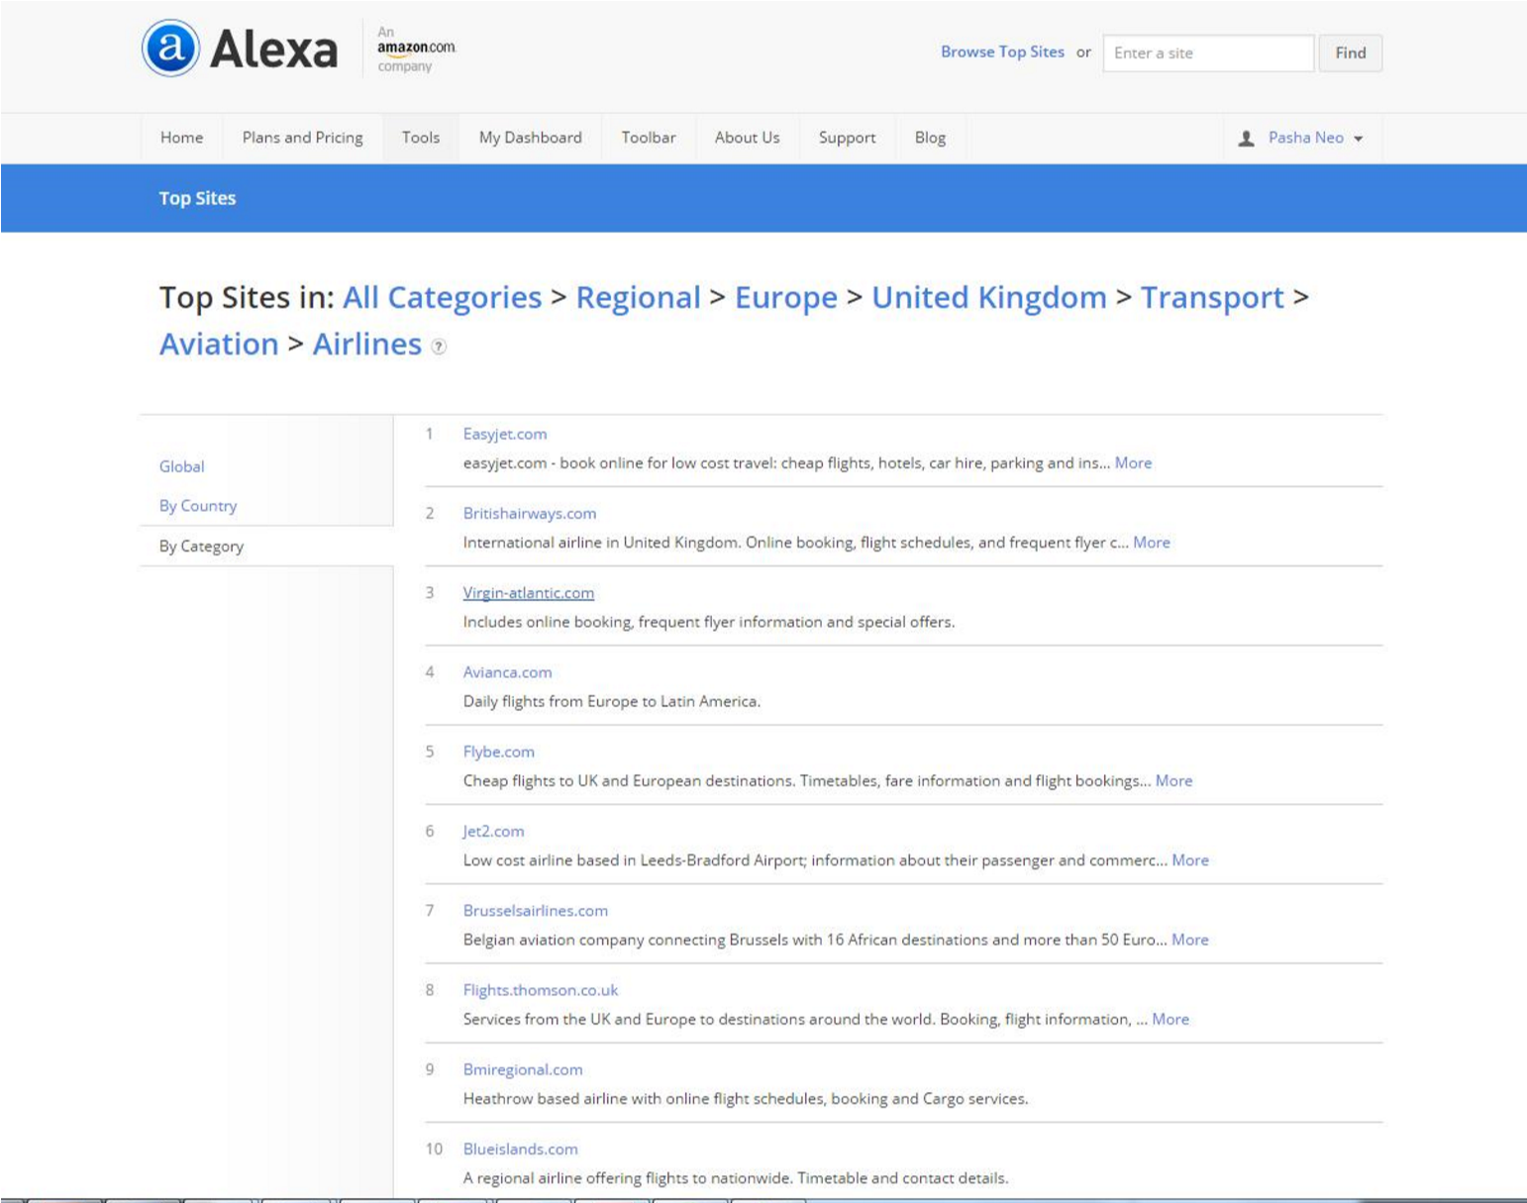

Figure 7: Top 10 UK airlines in March, 2015 (Adopted from Alexa.)
Site-driven/centric estimation systems experience the hostile effects of an alternate class of issues. Some webpage driven strategies make utilization of web treats and IP delivers keeping in mind the end goal to focus the character of clients. Dynamic IP designation has brought about the utilization of static IPs to focus the quantity of one of kind visits to turn into an outdated idea. Utilizing IP locations can prompt disparaging the genuine number of novel visits (Keller, 2007). Threats don't give the premise to an altogether sound estimation framework either, because of numerous clients erasing their treats, either physically or consequently. An alternate inconvenience here is brought on by extraordinary visits being tallied a few times when a few programs are utilized. Nevertheless the process of calculating online traffic may sometimes highly difficult to control. Numerous profits plus confinements connected along utilizing some of these procedures. Alexa's approach implies a more various scope of members will be checked, which gives wealthier activity information than any other strategy accessible, and the specimen size is various times bigger than that of comScore. Be that as it may, ISP-based information, not at all like board based routines, cannot generally gather secure (HTTPS) data. comScore, on the other hand, gets a decent profundity of information from their panelists and is perfect for marketing tenacity, whereas Alexa consider as a marketing tools too.

4.1.3. CHAPTER OUTLINE
This segment has depicted the distinctive routines utilized by different web measurement information suppliers. An examination of these systems was moreover exhibited. As previously demonstrated, in this undertaking Alexa has been utilized as the principle wellspring of essential information. The Alexa approach is by and large more illustrative and different, in light of the fact that it screens all web activity, and not only a picked toward oneself gathering of clients. Therefore, the automatic way of the information accumulated settles on both Alexa and Hitwise are perfect decision. However Hitwise is a paid service, plus entrance stages conceded are constrained to the UK, and inside a year time allotment. Like Hitwise, Alexa also is not a fully free service. That’s why data will be collected manually and individually to finalize this project.
There are numerous different associations giving comparable instruments and administrations which in light of a legitimate concern for curtness was not examined. Intrigued peruses may allude to, ‘Compete: (www.compete.com)’, and ‘Quantcast: (www.quantcast.com)’ for additional data on some of these web research organizations and their systems.

4.2. NUMERICAL MODELS
Various measurable methods were utilized and focused carefully on appropriation of web traffics/visits between clients of sites in the picked virtual sections. Therefore, the segment gives bases to dissemination examples saw in the quantity of site visits. Likelihood is a measure connected with an occasion and indicated by Pr (A) which takes a worth such that 0≤Pr (A) ≤1. Basically the quantitative interpretation of the chance in that occasion will arise (Everitt and Skrondal 2010).
Numerous casual variables showing up in characteristic and man-made phantasm are circulated in a certain manner. In the event that a variable can tackle any worth between two pointed out qualities, it is known as a constant variable; else, it is known as a ‘separate variable’. According to this, the share rate of visits to sites remain ceaseless inconstant, regardless quality somewhere around “0/100”. In the event that a casual variable is a nonstop variable, its likelihood is known as ceaseless likelihood dispersion. Once in a while, it is referred to as a depth capacity, or a Probability Density Function (PDF) (StatTrek, 2015).

4.2.1 BELL CURVE MODEL
An extensive variety of likelihood circulations have been utilized to portray the conveyance of numerous elements of investment. Standouts amongst the most essential and broadly examined likelihood circulations are Normal Distributions (otherwise called the Bell curve) (Herrnstien, 2012). The ordinary conveyance bend is most suited to a scope of variables with a high number of qualities near to the mean. Case in point, Figure 8 outlines the ordinary ring shape a typical dissemination takes.

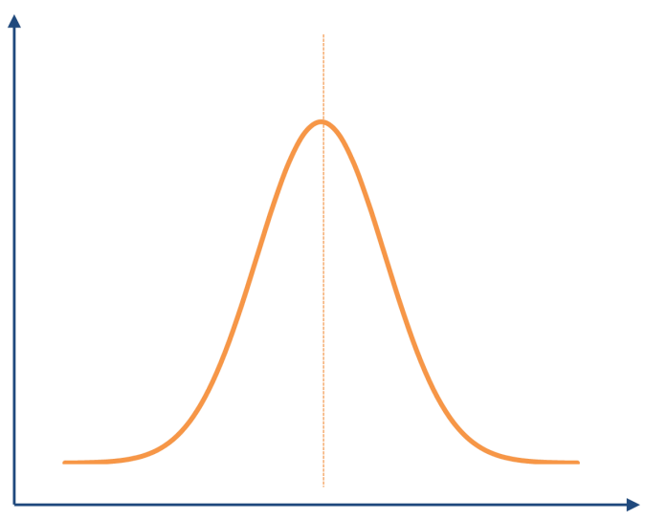

Figure 8: Bell Curve (Adopted from Restore, 2011)
Statisticians have recognized various measurable appropriations which seem as often as possible in a differing scope of physical phenomena. The accompanying segment portrays a certain sort of dissemination recognized by that known as a force law.

4.2.2 EQUATION OF POWER LAWS
The definitions have been given to present 'power law equation' statements, and to give a scientific structure which has been utilized to decipher power curves in the phase of data analysis. At the point when the likelihood of measuring a specific estimation of some amount fluctuates contrarily as a force of that esteem, the amount is said to take after a force law (Kleinberg, 2010). The expressions power law, Pareto's standard, and Zipf's law are here and there utilized conversely as a part of the writing this dissertation (Adamic & Huberman, 2002).
A non-negative irregular variable X is said to have a force law appropriation if
P[X > x] ~ cx^{-k}. (c>0 & k>0)
If X has a force law conveyance, then in a log-log plot of Pr [X ≥ x], otherwise called the correlative total conveyance capacity, asymptotically the conduct will be a straight line. This gives a straightforward exact test for whether an irregular variable has a force law given a proper exempt (Adamic & Huberman, 2002). A standout amongst the most generally utilized instances of the force law, which will be utilized broadly as a part of the accompanying sections, has the streamlined structure –
𝒇(𝒙) = cx-k
Where C is a (non-vital) standardization consistent and k is a steady parameter known as the example. The type k is characterized as the angle of the force bend; put in an unexpected way, k is the measure of how steep the bend is, with higher estimations of k demonstrating more extreme bends. Figure 9 delineates an average force/power law diagram.
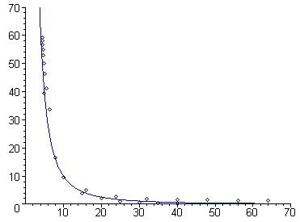

Figure 9: Power curve (adopted from Marianne, 2007)
It has long been realized that numerous experimentally watched phenomena showcase power law conduct. Cases incorporate word recurrence measures, abundance of wealthiest Americans, populaces of urban communities, phone calls, extent of tremors, power of wars, and so forth. In this paper, the information under thought is positioned by the fame of sites as per their offer of extraordinary visits, and in some unique cases their offer of online deals opportunities. This is now and again alluded to as a rank-recurrence appropriation. A more itemized portrayal of the force laws, Pareto's rule, and Zipf's law are past the extent of this record. Intrigued peruses can counsel (Adamic and Huberman, 2002).

4.3. INDUSTRY CONCENTRATION MEASUREMENTS
The concentration refers to the degree to which a little number of firms or ventures represents a vast extent of financial movement, for example, complete deals, resources or employment. Industry or market focus (additionally regularly alluded to as vendor fixation/concentration) measures the relative position of extensive ventures in the procurement of particular products or services. Various techniques are utilized to gauge industry fixation to survey business sector structure. Some of these routines, which have been utilized as a part of this study are given below (Shughart, 2008) –

4.3.1. CR OR CONCENTRATION RATIO
The CR or 'concentration ratio' is the rate of aggregate industry yield (or other such measure of monetary movement, e.g., deals income, job) which a given number of vast firms represent. The four-firm concentration/fixation degree (CR4) measures the relative offer of aggregate industry yield represented by the four biggest firms. The formula is given below –

∁𝑅_{𝑚}= 𝑠₁+𝑠₂+𝑠₃+𝑠₄+…………+𝑠_{𝑚}
Where 𝑠_{𝑚} highlight to the rate piece of the pie held by the 𝑚^{𝑡ℎ} organization. This offers a basic measure of industry concentration, and levels of rivalry, and in addition highlighting the degree accessible for economies of scale. In this paper, a four-organization measure (CR4) has been utilized to focus concentration degrees crosswise over distinguished (online) markets of premium.
Case in point in an industry comprising of seven organizations, where pieces of the pie (in sliding request) are 15%, 25%, 20%, 30%, 9%, 1%, 10%, the four organization fixation degree is 90% ( CR4 = 15% + 25% + 20% + 30% =90%).
All through the information investigation exhibited in the accompanying part, CR4 results have been joined by diagrams portraying the rate offer held by the main four sites more than a time of twelve months. This is conveyed out trying to handle the issue expressed above, and to show market offer progress and variances amongst the top organizations in each industry (QuickMBA, 2010).
4.3.1. HHI OR THE HERFINDHAL – HIRSCHMAN INDEX
HHI is a measure of business focus. The file is ascertained by squaring the % piece of the pie of every firm in the business sector and summing these numbers.
The formula for HHI is given below –

𝐻𝐻𝐼= 𝑠₁²+𝑠₂²+𝑠₃²+…………+
For instance in a business sector comprising of just four organizations with shares of 10%, 20%, 30% and 40% the Herfindahl Index would be 3000 (100 + 400+ 900+ 1600)( Riley,2012).
The Herfindahl Index has particular focal points over CR, in that it gives more weight to bigger firms, and in this way is frequently a decent pointer of levels of rivalry amongst firms. The US utilizes HHI to control mergers and to choose whether an organization takeover may bring about monopolistic conduct. The accompanying arrangements for diverse estimations of the HHI have been separated from the U.S. Bureau of Justice and the Federal Trade Commission's
Merger rules (U.S. Department of Justice, 1997) –
- HHI below 1000 = Unconcentrated
- HHI between 1000 and 1800 = Moderately Concentrated
- HHI above 1800 = Highly Concentrated

4.4. DATA ANALYSIS FRAMEWORK
In this sections a few confinements set on the assembled information, and additionally portraying how various confusions were tended to give equivalent datasets over the different distinguished online markets. Alexa information for site rankings are accommodated an expansive number of commercial enterprises, gathered by orders.
The vertical markets distinguished with the end goal of this task, in any case, expected to be renamed as indicated by classes and datasets characterized by the creator. For instance, to study online long range informal communication administrations, social systems administration locales' rankings expected to be differentiated from the "person to person communication & discussions" classification, as characterized by Alexa. The "long range interpersonal communication & gatherings" classification gives back almost 7000 sites, a large number of which are sites whose essential capacity is distinctive to that of plain informal communication (e.g. YouTube). Thus, sites with non-unimportant shares of visits fitting in with every online business were chosen, and their rate shares of visits were balanced appropriately. As the rate offer of visits for every site draws near to 1%, it gets to be irrelevant. The majority of the information has been confined to sites with visit shares of no under 1% of their separate business sector. The rate shares of special visits have been changed in accordance with speak to the offer of every site among the top n chose sites in every area, as there are various (ordinarily 500+) sites in every class, the lion's share of which hold immaterial rate shares of visits. The creator recognizes that this will reject sites with little imparts of visits, and then again, this is not thought to have influenced the examinations and finalization of this study.
Remarkable online visitors checks are constantly distinguished inside a certain time allotment (regularly no more than a month), and are non-added substance measurements. This suggests that interesting visits can't be included more than a period, or over gatherings of substance, as including extraordinary guest numbers over diverse time periods or sites may bring about over-representation (Jason, 2007). The way that remarkable visits are non-added substance causes a few middling in regards to the information examination in this study. With a specific end goal to precisely speak to each site's novel visits offer, to perform a static investigation of every part, a sufficiently long time period must be relegated. Thus, the choice was made to run with quarterly periods, notwithstanding, the longest period for which visit shares were accessible on Alexa was a month. Therefore, sites' shares of one of kind visits in three successive months were arrived at the midpoint of to touch base at their normal offer of extraordinary visits for a given quarter. An alternate confusion originating from the non-added substance nature of special visits, was on account of specific sites basically being a territorial form or a piece of an alternate (e.g. Google and Google UK, Microsoft and Microsoft Windows). In cases like these the remarkable visit offers for diverse sites were included, and indicated to as their "offer of online deals opportunities”. The utilization of online deals open doors as a metric like the offer of the online business has been shown in the accompanying section. Notwithstanding, auxiliary organizations and their separate guardian organizations working in the same division (e.g. bmibaby) have not been assembled, as they work as two different, unique, legitimate substances.

Chapter 5

5. DATA ANALYSIS
This section plans to report the discoveries and perceptions made in each vertical business. A portrayal of every web business sector section is given, taken after by a dialog of the figures, business sector structures, and their particular power curve/bends. Despite to make the created force bends equivalent, the most obvious rank was altered at 100%, and the other sites' visit shares were balanced appropriately. This was carried out by partitioning the rate visit offers for each site by the top positioning site's visit offer rate, and increasing the outcome by 100. Peruses are by and by helped that the notoriety to remember sites talked about in this part are built exclusively with respect to their offer of (special) guest tallies from inside the UK; put in an unexpected way, just ISPs inside the UK have added to this information (got to by means of Alexa).

5.1. UK AVIATION/AIRLINES (COMMERCIAL)
This classification incorporates any sites offering air-travel bookings and contract flight administrations. In view of the figures on shares of visits in the initial few month of 2015 (see Table 1), Easyjet has the main site in this class UK rank wise (28.9% visits offer), took after 2nd position by British Airways (38.4% visits offer). The dominant part (very nearly over 75%) of visits are coordinated with ease carriers (e.g. jet2, bmibaby, and so on.) , which is very nearly three times the same number of as conventional or full-benefit aerial shuttles (e.g. BA, KLM, Flybe, and so on.). Subsequently it is vital to recognize the two, and the administrations they offer.
Minimal effort carriers, as the name recommends, contend predominantly on cost. They figure out how to cut their expenses, and work all the more effectively, mostly by prior certain traveler administrations offered by the vast majority of their conventional partners. One of the principle routes in which plan carriers figure out how to cut their costs is by removing the center man, for this situation the travel operators. They urge their clients to make direct bookings, particularly over the web, by publicizing exceptional offers and less expensive admissions for the individuals who go on the web. This permits them to keep away from intemperate paper-work and superfluous staff wages, while clients appreciate quicker and less expensive exchanges. The web and the utilization of electronic frameworks permit these organizations to practice element evaluating procedures, which are urgent to any minimal effort aerial shuttle's yearning to stay focused. Plan aerial transports likewise attempt to amplify their auxiliary incomes; these are those incomes produced from non-ticket sources (Sorense, 2006). Auxiliary incomes fall in the accompanying classes:
- Offering commission-based administrations, (for example, protection, lodging reservations, and auto contracting administrations) outside their center competency zone.
- Adopting individually estimating methodologies; this is, putting forth a different sticker for different administrations excluded in the publicized cost, for example, the buy of nourishment, snacks, and refreshments on board, abundance things charges, and better seating choices for the individuals who are ready to pay additional expenses.
- Long standing customer projects, which are reasonably like reliability cards, have likewise been recognized as a rising wellspring of auxiliary incomes. Aerial shuttles have the capacity to create incomes by cooperating with various organizations in different businesses, offering a scope of (free and reduced) items and administrations to travelers wishing to part-take in such program (McDermott, 2014).
An imperative certainty is that because of the fruitful vocation of these procedures, aerial shuttles around the world (counting conventional ones) are receiving comparable methodologies. In any case, auxiliary incomes remain a critical money related part of plan aerial transports.
Domain | UK Ranking | % of visitors | Daily% per  visitors
easyjet.com | 163 | 28.9% | 4.01 | 0.50%
britishairways.com | 169 | 34.8% | 6.19 | 1.10%
virgin-atlantic.com | 652 | 13.3% | 3.84 | 5.88%
flyebe.com | 886 | 65.2% | 4.09 | 0.97%
jet2.com | 936 | 84.3% | 3.76 | 14.00%
flysn.com | 12,533 | 7.9% | 3.70 | 6.33%
thompson.co.uk | 208 | 86.0% | 6.28 | 9.00%
bmiregional.com | 20,867 | 51.2% | 1.70 | 4.00%
blueislands.com | 38,420 | 55.3% | 1.50 | 7.00%
auringy.com | 62,469 | 57.6% | 1.50 | 7.32%

Source: Manually extracted Alexa data, for illustration purposes only

Table 2: Top UK commercial airline website’s Alexa data 2015
The qualities for the focus/concentration degree of the main four sites, (CR4=142.2%), and the Herfindahl measure (HHI =0.11) in this part, in light of their offer of visits, show a reasonably thought industry, with generally large amounts of rivalry amongst firms. The comparative way of the administrations offered, i.e. flights, specifically with plan carriers which experience the ill effects of absence of separation, can drive rivalry and lead to value wars.
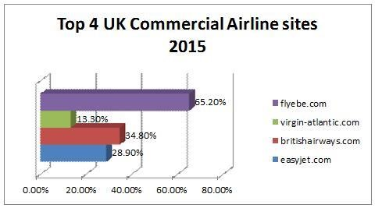

Figure 10: UK top 4 Commercial Airlines
Figure 10 demonstrates the offer of visits amongst the main four organizations in this classification: Flybe.com, BA, Easyjet and Virgin-atlantic. Over the time of a year (2014/2015), the top four’s online pieces of the overall industry with respect to one another stay pretty much the same, with low levels of variety (for every site) from the normal visit imparts over the same period. This demonstrates the absence of any critical patterns in business sector fixation in this classification over the given period. Then again, Figure 5.1 recommends large amounts of rivalry amongst the main two adversaries, BA, and flybe.
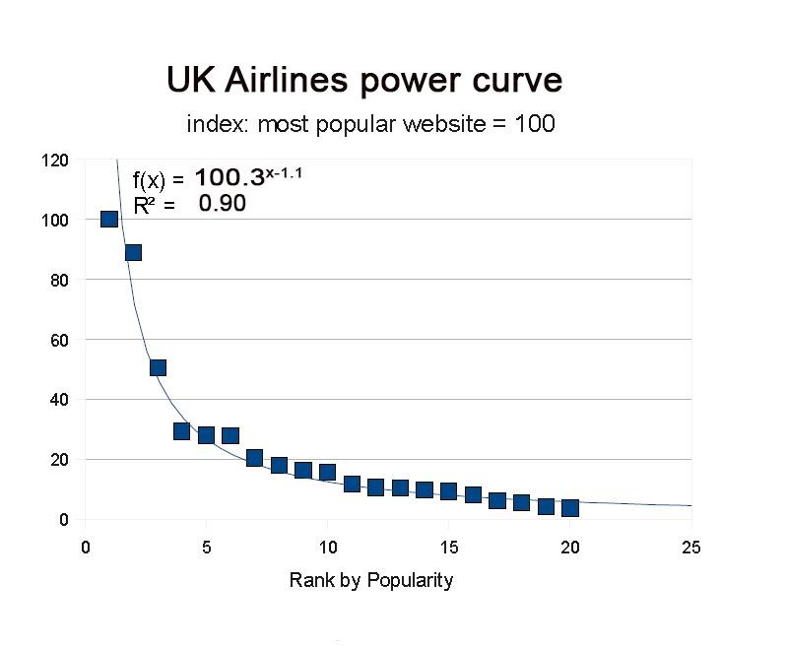

Figure 11: Top 2 UK airlines Power curve for 2015 (till March)
The power curve above demonstrates the power curve for progressively positioned exceptional visit shares to air transport sites, more than a time of three months, in March, 2015. The Likelihood Density Function (PDF) for the bend is depicted by the taking after mathematical statement:
𝒇(𝒙) = 100.3^{-.1.1} & R2=0.90
This force bend demonstrates the main two positions getting an impressively bigger parcel of visits to their sites than different sites in this classification. R2 is the extent of fluctuation clarified by relapse. The high estimation of R2 demonstrates the information is portrayed by the force law to a striking level of precision. Reviewing the comparison of a power bend (𝒇(𝒙) = cx^{-k)}, the type ^{k} is characterized as the angle of the force bend. ^{K}, on account of business aerial shuttles, takes the estimation of 1.1, demonstrating a fairly level bend for this online industry. A few consequences (taking into account the inclination and shape) of this force bend, and others, will be highlighted.

5.1. UK INSURANCE COMPANIES
This class comprises of any sites offering insurance/protection administrations. This incorporates protection approaches on home, pets, car/automobile, and travel so on. Despite, the correlation sites (e.g. comparethermarket.com, gocompare.com) have not been incorporated; nonetheless, a few parts of such correlation sites and their effects will be examined in later areas.
A percentage of the main sites in this class offer money related activities, for example, personal or business loans, mortgage or credit card services, and online banking, notwithstanding insurance or protection (e.g. Tesco Personal Finance, The AA, Virgin Money UK), while others concentrate on protection benefits specifically ranges, for example, wellbeing (e.g. BUPA) or auto protection (e.g. RAC). Be that as it may, the share of sites offers a scope of insurance administrations including auto, home, and travel protection. An alternate vital part of the way of sites in this class is that numerous insurance agencies are auxiliaries or associates of banks, building social orders, and different associations (e.g. Direct Line is a service of RBS, Virgin Money is belongs to the Virgin, Tesco Personal Finance is claimed by Tesco).
It is imperative to recognize individual protection or care plan policy and policy obtained by organizations. People are urged to perform protection exchanges web, exploiting better arrangements and faster exchanges, while this methodology is much more confounded for organizations. Subsequently the fundamental target group of onlookers for the sites in this class is people, rather than organizations. All sites in this classification offer online query method. The greater part permit clients to buy individual care plan on their sites, while others perform whatever is left of the methodology (once the query has been provided online) physically.
Domain | UK Ranking | % of visitors | Daily% per  visitors
tesco.com | 33 | 86.9% | 10.33 | 3.90%
aviva.com | 1,069 | 84.6% | 5.00 | 8.00%
bupa.co.uk | 1,802 | 65.6% | 2.38 | 5.00%
admiral.com | 1,860 | 95.5% | 3.65 | 4.00%
hastingdirects.com | 3,256 | 94.6% | 3.50 | 10.00%
morethan.com | 3,900 | 86.3% | 3.60 | 3.72%
scottishwidows.com | 5,193 | 92.0% | 4.00 | 0.75%
winton.co.uk | 5,256 | 86.0% | 3.30 | 21.00%
esure.com | 6,254 | 93.3% | 5.10 | 25.00%
hiscox.co.uk | 9,386 | 65.0% | 2.10 | 5.00%

Source: Manually extracted Alexa data, for illustration purposes only

Table 3: Top UK Insurance website’s Alexa data 2015
The table above demonstrates the offer of visits in March, 20015. Tesco is the business sector pioneer in this class with top UK rank (86.9%) of the online piece of the pie, took after by Aviva with 84.6%, and Bupa with 65.6% online piece of the overall industry.
The qualities for the focus/concentration degree of the main four sites, (CR4=332.6%), and the Herfindahl measure (HHI =281.32) in this part, in light of their offer of visits, show a reasonably thought industry, with generally large amounts of rivalry amongst firms.
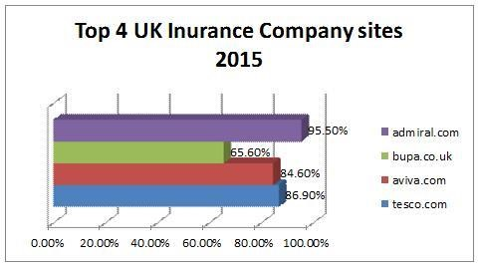

Figure 12: UK top 4 Insurance Companies
Tesco Personal Finance's offer of visits has increased by 3.90%, with the staying two demonstrating no huge changes in their online piece of the pie levels. The Admiral's online piece of the pie picks up since the begin of 2015 propose a quick increment in levels of industry focus, notwithstanding, a period of six months is expecting to be sufficiently long to make firm expectations in regards to the structure of this apparently aggressive business sector.
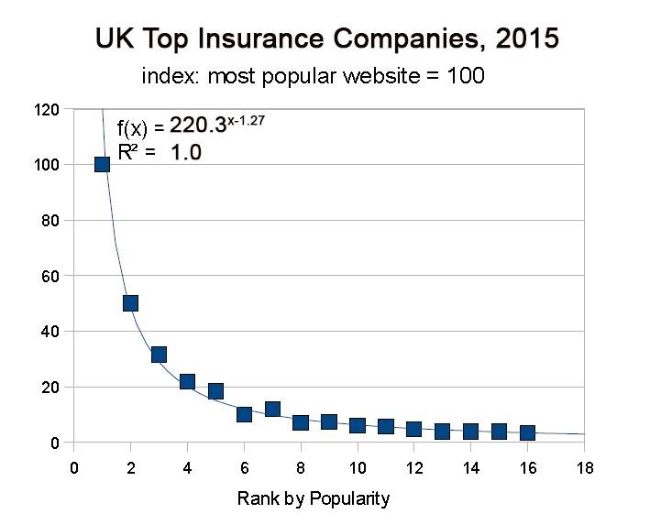

Figure 13: Top 2 UK Insurance Companies Power curve for 2015 (till March)
The power curve above demonstrates the power curve for progressively positioned exceptional visit shares to insurance company sites, more than a time of three months, in March, 2015. The Likelihood Density Function (PDF) for the bend is depicted by the taking after mathematical statement:

𝒇(𝒙) = 220.3^{-.1.17} & R2=1.0
The high estimation of the R2 coefficient demonstrates the information is a surprisingly solid match. This is the most astounding estimation of R2 over all concentrated on segments. The type ^{K} takes the estimation of 1.27, demonstrating a moderately level.

5.3. UK CONSULTANCY FIRMS
This classification incorporates any organizations offering help and exhortation to associations, went for advancing their business execution and enhancing their proficiency. This is accomplished by taking advantage of an incomprehensible pool of learning, methodology philosophies, and industry best-rehearse rules which consultancy firms have entry to. By offering master exhortation and expertise to organizations looking for development, consultancies have possessed the capacity to build themselves as an essential instrument for boosting organizations' focused stance in their individual businesses.
There are consultancy firms that can have practical experience in. The dominant part offer administration counseling administrations, took after by IT counseling, bookkeeping, Human Resources (HR), outsourcing administrations, and so on. There is some perplexity as to how different these forte zones may be. This is brought on by the covering way of such administrations. For example, to enhance organization's execution, a consultancy firm may need to enhance the organization's present business courses of action, exploit important innovations, and outsource certain errands outside the organization's center competency territory. Bigger counseling firms have a tendency to fuse a significant number of these strength zones in the scope of administrations they offer, nonetheless, medium and little measured organizations in this class may offer a more restricted scope of administrations.
An imperative truth is that a percentage of the real organizations considered in this class, exhibit a system of firms, possessed and oversaw autonomously, while being facilitated by one different substance. These, offer a more various scope of expert administrations, particularly in the fields of monetary examining and bookkeeping, which separates them from littler organizations simply offering administration and/or innovation counseling administrations. The "Big Four Auditors" are, PWC, Deloitte, Ernst & Young, and KPMG. Numerous substantial open and privately owned businesses have made a "Big four" review an important prerequisite for their fiscal reviews.
Domain | UK Ranking | % of visitors | Daily% per  visitors
deloitte.com | 5,208 | 3.0% | 3.18 |  | 4.79%
ey.com | 6,640 | 4.0% | 3.27 |  | 1.51%
pwc.co.uk | 6,755 | 47.6% | 2.13 |  | 4.48%
apegemini.com | 6,755 | 5.9% | 3.52 |  | 7.85%
kpmg.com | 8,252 | 3.6% | 2.56 | 12.00%
isgplc.co.uk | 48,509 | 72.0% | 2.80 |  | 0.72%
plainenglish.co.uk | 50,802 | 45.1% | 3.30 | 100.00%
srg.co.uk | 57,517 | 53.4% | 2.40 | 36.60%
wspgroup.com | 5,193 | 7.1% | 8.60 | 18.00%
wuwu.com | 140,364 | 49.8% | 2.20 | 30.00%

Source: Manually extracted Alexa data, for illustration purposes only

Table 4: Top UK Consultancy Firms website’s Alexa data 2015
The table above demonstrates the offer of visits to UK consultancy firms' sites in March, 2015. The figures show PWC obviously driving with a 47.6% offer, took after by IsgPlc, with a 72.0% offer of the online business sector amid this period. IsgPlc, which is not a noteworthy consultancy firm, offers a scope of administrations which are to a degree distinctive to different consultancies talked about, with the principle accentuation being on measuring site effects on building organizations. A few results of this will be examined in the following part.
The qualities for the focus/concentration degree of the main four sites, (CR4=60.6%), and the Herfindahl measure (HHI =1.55) in this part, in light of their offer of visits, show a reasonably thought industry, with generally large amounts of rivalry amongst firms.
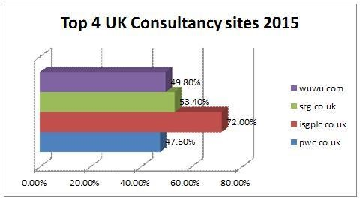

Figure 14: UK top 4 Consultancy Firms
The Figures above (main four as indicated by most visited in 2015: Wuwu, Srg, Isgplc, and Pwc) and main four with most elevated normal visit compare to: KPMG, Ey, and Deloitte) demonstrate the offer of visits among the main four organizations in this class, over the time of 2015. Both figures recommend a continuous increment in the fixation levels among the main four sites in this online business section, with the main two positioning firms expanding their individual pieces of the overall industry.
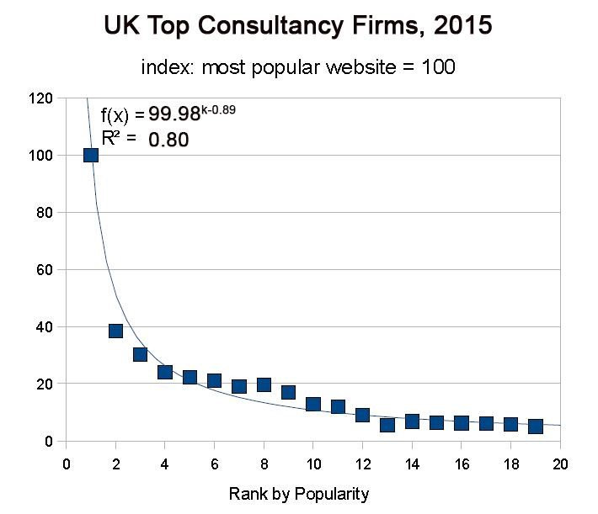

Figure 15: Top UK Consultancy Firm Power curve for 2015 (till March)
The power curve above demonstrates the power curve for progressively positioned exceptional visit shares to consulting firms, more than a time of three months, in March, 2015. The Likelihood Density Function (PDF) for the bend is depicted by the taking after mathematical statement:
𝒇(𝒙) = 99^{-.0.89} & R2=0.80
The high estimation of the R2 coefficient demonstrates the information is a surprisingly solid match. This is the most astounding estimation of R2 over all concentrated on segments. The type ^{K} takes the estimation of 0.89, demonstrating a moderately level.

5.4. UK SOCIAL NETWORKING SITES
This class incorporates sites which empower clients to take part in long range informal communication exercises, through the utilization of their profile pages. This incorporates numerous online systems; in any case, discussions have not been incorporated in this classification. One explanation behind this is the fundamental usefulness of some prominent sites which offer gatherings being other than plain informal communication (e.g. YouTube, which is chiefly utilized for offering features, additionally offers gatherings). Long range informal communication sites permit clients to impart data and convey to one another through an assortment of systems, for example, email and texting, and empowering site like passages, photograph imparting, gathering participations, and lately applications and devices which can be included onto a client’s profile.
Despites for the reasons of this study, interpersonal interaction groups shut to the general population (referred to as Internal Social Networking or ISNs sites) has not been considered (Scott,2012). The interpersonal interaction destinations considered in this class, because of the confinement set on the base offer of visits, are bigger, blander locales emphasizing a large number of clients from varying backgrounds. This classification does not emphasize specialty market long range informal communication destinations for clients imparting one or few particular premiums just. As of late different interpersonal interaction sites have sprung up and the ubiquity of such administrations are expanding by the day. Various organizations (especially bigger organizations) are likewise utilizing long range informal communication sites as intends to raise brand mindfulness inside online groups, and for enrollment purposes. None of the person to person communication locales distinguished in this class obliges a membership expense. Most long range informal communication sites create the dominant part of their incomes through publicizing.
Domain | UK Ranking | % of visitors | Daily% per  visitors
google.co.uk(plus) | 1 | 87.7% | 18.89 | 4.50%
facebook.com | 2 | 3.7% | 11.59 | 9.59%
Twitter.com | 10 | 4.3% | 4.97 | 1.97%
linkedin.com | 13 | 4.2% | 6.05 | 1.30%
instagram.com | 26 | 3.4% | 5.55 | 16.10%

Source: Manually extracted Alexa data, for illustration purposes only

Table 5: Top UK Social Networking website’s Alexa data 2015
The table above demonstrates the offer of visits to UK consultancy firms' sites in March, 2015. The figures show Google+ obviously driving with 87.7% traffic, are domination among all other competitors.
The qualities for the focus/concentration degree of the main four sites, (CR4=99.9%), and the Herfindahl measure (HHI =77.44) in this part, in light of their offer of visits, show a reasonably thought industry, with generally large amounts of rivalry amongst firms.
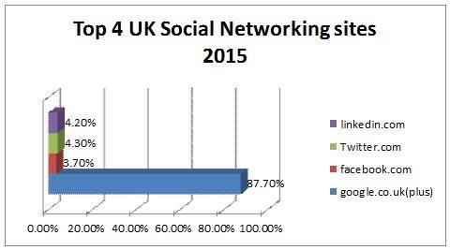
Figure 16: UK top 4 Social Networking Sites
The figure above shows the percentage of visits among the main four organizations (Google+, Facebook, Twitter and LinkedIn) in this classification, over the time of March, 2015. This figure demonstrates an enduring pattern in the rate of development of Facebook's offer of visits (9.59% decrease in online piece of the overall industry). Over the same period, an increment in the quantity of visits to LinkedIn (by 1.30%) and Instagram (by 16.10%) can be watched, while Twitter decline increment (by 1.97%) in imparted of visits.
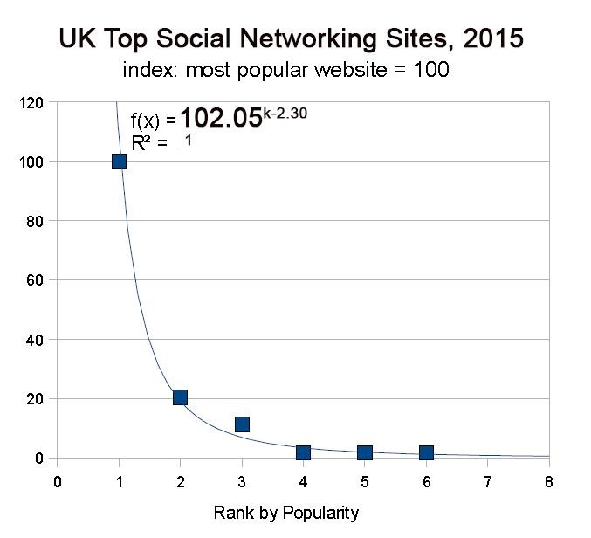

Figure 17: Top UK Social networking Sites Power curve for 2015 (till March)
The power curve above demonstrates the power curve for progressively positioned exceptional visit shares to social networking sites, more than a time of three months, in March, 2015. The Likelihood Density Function (PDF) for the bend is depicted by the taking after mathematical statement:

𝒇(𝒙) = 102.05^{-.2.30} & R2=1
The high estimation of the R2 coefficient demonstrates the information is a surprisingly solid match. This is the most astounding estimation of R2 over all concentrated on segments. The type ^{K} takes the estimation of 2.30, demonstrating a moderately level.

5.4. UK TOP SEARCH ENGINES
This classification incorporates sites whose fundamental capacity is to give brings about the type of connections to different sites, taking into account the entered set of pivotal words.
Domain | UK Ranking | % of visitors | Daily% per  visitors
google.co.uk | 1 | 87.7% | 18.89 | 4.50%
bing.com | 17 | 4.2% | 5.28 | 6.50%
excite.co.uk | 36,145 | 17.3% | 1.90 | 3.00%
yahoo.co.uk | 47.546 | 56.9% | 1.00 | 1.96%

Source: Manually extracted Alexa data, for illustration purposes only

Table 6: Top UK Search Engines website’s Alexa data 2015
The table above demonstrates the offer of visits to UK search engines' sites in March, 2015. The figures show Google obviously driving with 87.7% traffic, are domination among all other competitors. Since just four (gatherings of) web searchers are being considered in this classification (because of the unimportant pieces of the pie of others), it might be plain to see the subsequent focus proportion (CR4 =100%). A fixation proportion of close to 100% in customary markets means the presence of syndication. The Herfindahl measure (HHI = 114), which is the most elevated measured over all concentrated on online business sector portions) in this part, shows a much focused online industry.
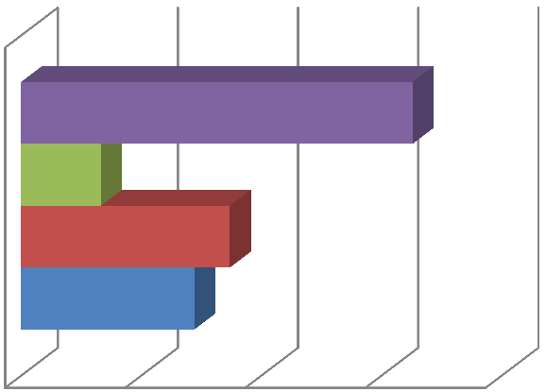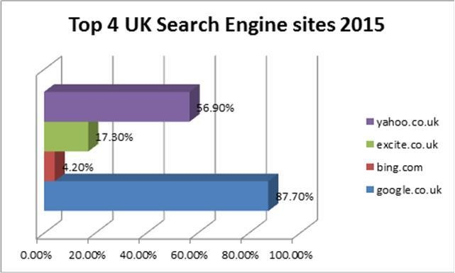

%
0.00
%
20.00
%
40.00
%
60.00
80.00
%
%
28.90

%
34.80

13.30
%

%
65.20

Top 4 UK Search Engine sites 2015

flyebe.com
virgin-atlantic.com
britishairways.com
easyjet.com

Figure 18: UK top Search Engine Sites
The predictable importance and exactness of Google (87.7%) list items have added to this internet searcher building a prevailing position in the online pursuit market. A more discourse of the philosophies utilized by different internet searchers is past the extent of this record. Intrigued researches can counsel Google's website admin rules for more data on a percentage of the variables affecting the apparent importance of different connections (Google, 2015). Note that the particular points of interest on pursuit calculations, specifically with online hunt giants, for example, Google, are nearly monitored competitive innovations, and stay outside the general population space.
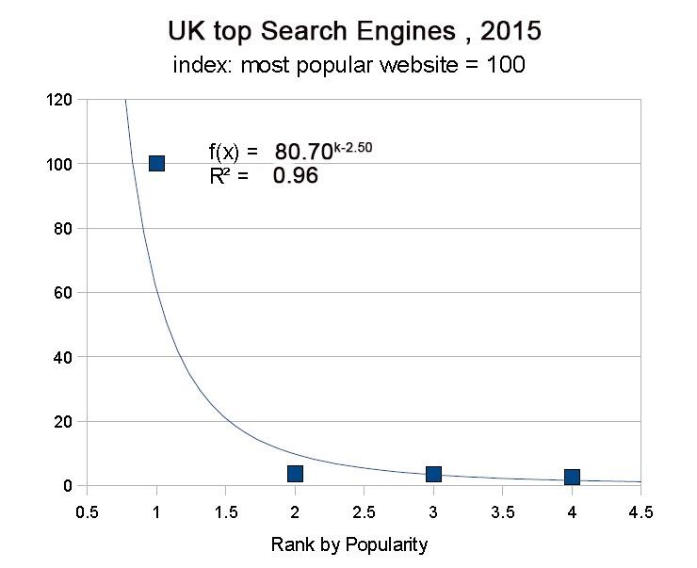

Figure 19: Top UK Search Engines Sites Power curve for 2015 (till March)
The power curve above demonstrates the power curve for progressively positioned exceptional visit shares to search sites, more than a time of three months, in March, 2015. The Likelihood Density Function (PDF) for the bend is depicted by the taking after mathematical statement:
𝒇(𝒙) = 80.70^{-.2.50} & R2=0.96
The high estimation of the R2 coefficient demonstrates the information is a surprisingly solid match. This is the most astounding estimation of R2 over all concentrated on segments. The type ^{K} takes the estimation of 2.50, demonstrating a moderately level for Google.

Chapter 6

6. DISCUSSION OF THE RESULTS
The outcomes of the data investigation exhibited in the past part demonstrate the diverse way of the picked vertical markets. Various variables in charge of affecting online business structures have been recognized by the writing review. In this part, by drawing on those impacts, and the watched examples in online business structures, a correlation of the outcomes with the writing is given. The fundamental powerful perspectives in every watched business structure are given independently to start. This examination is conveyed forward by a cross-industry investigation, where all the online markets are contrasted with one another and various conclusions are drawn taking into account their business sector potentials.

6.1.1. DISCUSSION OF THE COMMERCIAL AIRLINES SECTOR
The E-Market sector structure which business/commercial airlines work inside, has been recognized as one with moderate levels of focus, and high seen hazard. The effect of digital online markets on the business flights industry has brought about larger amounts of rivalry amongst carriers. This has profit shoppers more than the carriers. These elevated amounts of rivalry especially influence ease transporters, which utilize cost as their extraordinary offering point. Such carriers, which by nature experience the ill effects of an absence of administration separation are compelled to cut expenses and create incomes from sources other than ticket deals (auxiliary incomes) keeping in mind the end goal to stay gainful. Collaborating with different associations empowers ease transporters to give (and create incomes from) various administrations outside their center competency zone (flights). This serves as a critical benefit expansion technique. Easyjet, and Flybe, BA the business sector pioneers in this class, have both step by step extended their administrations in the course of recent years to incorporate inn bookings, auto rentals, and travel protection, by banding together with different associations (Easyjet, Flybe & BA, 2015). By utilizing the web as a medium for deals, aerial shuttles have possessed the capacity to fuse the different administrations they offer on one site, taking into account such organizations to wind up practical, while shoppers have the capacity to get to the different capacities offered in a more advantageous way.
So as to offer low costs and stay aggressive, plan carriers need to cut their own spending also. Using the web as a medium for deals, whilst as a result diminishing work expenses, has ended up being an effective expense cutting strategy. Dropping costs infers higher volumes of offers are obliged to achieve make back the initial investment focuses. Hence, airborne shuttles need to concentrate on client maintenance, while attempting to draw in new clients. Making utilization of decently outlined and simple to-explore sites is restricted of diminishing clients' exertion anticipations and urging them to return to their site. Be that as it may, value astute clients may wish to contrast costs and have entry with a huge number of carrier tolls before buying tickets. This can permit a flight-examination site to snatch some piece of the pie. It appears unlikely on the other hand, for any of the created sites having a place with aerial transports to offer such an administration, as it would be irrational. Logistical issues coming from specific aerial transports working in specific courses might likewise hose the effect of any such examination sites. Most of the sites offering comparative peculiarities pretty much rules out stage separation. Considering the variables expressed above, Winner-Take-All impacts are not liable to win in this online business. In view of the investigation completed as such, and the force bend figures, the structure of this B2C-centered business is liable to continue as before for the not so distant with no predominant players rising. IT organization like ‘SITA ’having some expertise in Aviation IT arrangements, has distributed a report highlighting innovative advances which may change the way of air go throughout in 2015 and the following 5 years (Kable, 2013). Web 2.0 and Software Oriented Architecture (SOA) are among the innovations examined. These advancements may empower destinations to separate their stage from others and addition a game changer. A discourse of the particular nature and profits of such peculiarities is past the extent of this record. Interested researchers can take a look the article by Jim Peters the CEO of SITA (Peters, 2013).

6.1.2. DISCUSSION OF THE INSURANCE SECTOR
The online protection industry has been distinguished as one which is essentially centered on B2C administrations. The sites in this class, and additionally serving as a data point for clients, offer a scope of e-administrations. This suggests the quantity of visits to these sites can have an effect on their business figures. Insurance agencies urge shoppers to buy protection approaches online by offering them better arrangements and rebates. The vast overheads ordinarily seen in this industry (particularly for specific sorts of protection strategies, for example, travel protection) can be diminished fundamentally, and fruitful sites have the capacity to exploit economies of scale as the unit cost for every protection approach sold is decreased.
'Tesco Personal Finance’ and 'Virgin Money UK' have received a comparative methodology, in that they give a scope of fiscal administrations, for example, advances, Visas, and bank accounts, notwithstanding their protection benefits on their site. One of the primary contributing components to the gainful procurement of such administrations are cross-industry associations like Tesco Personal Finance, until 2008, was half possessed by the Royal Bank of Scotland until 2008 (BBC, 2008).
The ascent of correlation sites, for example, ‘Gocompare’, ‘Moneysupermarket’ and ‘Confused.com’, which have not been incorporated in this class (with piece of the overall industry levels similar to the main sites in this classification), flags the significance of value separation and the moderately abnormal state of trust among (typically careful) online customers, as they hunt down the least expensive protection strategies on the web. At present, there are unpretentious signs of Winner-Take-All impacts in this business; however this may not be the situation later on. The late increment in the fame of examination sites flags purchasers' yearning to have admittance to, and think about diverse protection.

6.1.3. DISCUSSION OF THE CONSULTANCY SECTOR
A nearby review of the sites in this classification demonstrates these destinations are principally used to raise brand mindfulness and give data about the administrations their individual organizations offer. This, to some degree varies from the other (B2C-centered) markets broke down amid the course of this study. Consequently it is essential to recognize that visits to destinations in this class don't fundamentally have a direct relationship with their particular organizations' incomes. The instructive way of such sites is likewise halfway in charge of the moderately "level" influence bend saw in this "impalpable rich" online business.
The main sites in this segment, except for ISg, have a place with substantial (three of the main four organizations are a piece of the huge four reviewers), secured consultancy firms, with numerous years involvement in the field. This highlights the significance of organization size, and built brand names in the level of utilization amongst clients of these sites. Fit in with vast (three of the main four organizations are a piece of the enormous four examiners), created consultancy firms, with numerous years involvement in the field. This highlights the significance of organization size, and secured brand names in the level of utilization amongst clients of these sites.
There are no solid indications of components adding to Winner-Take-All results in this business sector. Notwithstanding the steady increment in piece of the overall industry levels by the main two sites, the focused way of this business make it troublesome for one single site to outflank others and addition a prevailing position soon. The elements deciding the accomplishment of different sites having a place with consultancy firms appear to be riding primarily on their size, notoriety, and to collaborating abilities. Notwithstanding, the adroit utilization of web advertising systems can permit much littler organizations propel in such markets too. ISg's effective piece of the pie snatch is demonstration of this.

6.1.4. DISCUSSION OF THE SOCIAL NETWORKING SITES
This intensely focused business sector is ruled by Google+ and Facebook. Google+'s normal offer of visits in the course of recent months, over all classifications of sites (got to from inside the UK), are second just to that of Facebook. Over the same period, the offer of visits for Google and Facebook in the long range informal communication sites class have expanded, while both fundamental opponents which give a comparative administration have endured extensive piece of the pie misfortunes. To start with, and early mover focal points are for the most part examined from a key administration stance, and in connection to conventional markets. Lately, in any case, the idea has been acquired and reached out to clarify electronic business sector results too.
Considering the way of long range interpersonal communication administrations, it can be seen why the clients of such administrations may profoundly esteem the capacity to get to other potential clients of such administrations. Nonetheless, in the connection of interpersonal organizations, system impacts are said to happen once a site achieves minimum amount. Subsequently, early movers in this business sector don't essentially increase a game changer until they achieve minimum amount. This is seen as a contributing element to Facebook's capacity to make up for lost time with more established adversaries, for example, MySpace. A mix of the variables expressed, and the sharp increment in focus levels in this business sector, demonstrates the likelihood of WTA results overall in this business, with Facebook and Google+ rising as the overwhelming player. The impalpable way of the administrations offered in this class (most innovation related commercial ventures are thought to be immaterial, because of high dependence on the ability of people included) support its moderately steep power curve, flagging abnormal amounts of imbalance amongst firms.

6.1.5. DISCUSSION OF THE SEARCH ENGINES SITES
This business sector is plainly commanded by one noteworthy player: Google. Google is not just the top positioning site amongst web indexes, however the most went to site out of all sites went to from inside the UK (in light of information from Alexa). The web crawlers (search engines) organized business sector has three sides: the "clients" who look for data and substance on the web, the "substance suppliers" (site managers) who give the substance looked to, and an alternate gathering of substance suppliers which will be alluded to as the "sponsors". The recent additionally comprises of sites/site managers, however with the distinction that they pay to have their substance made accessible on
"supported connections" records or in positive positions on the natural results list. Internet searcher clients esteem the capacity to have admittance to a substantial number of pertinent sites (content suppliers) when they complete a hunt. Publicists appreciate having entry to however many clients as could reasonably be expected, because of bigger measures of incomes being produced from more visits. Content suppliers likewise, esteem the capacity to cooperate with huge quantities of clients, as they increase more presentation to give their data, produce incomes, and/or offer their items/administrations. Then again, it is vital to note that substance suppliers have almost no say in their sites showing up on the rundown of results returned by a web crawler. These variables have made the pursuit motors advertise one with solid system impacts. The Google stages (google.com, google.co.uk, and so forth.) have possessed the capacity to separate themselves from other web crawlers in view of their usefulness and the nature of administration that they give. This is primarily because of their complex pursuit calculations, and their unexampled disseminated registering stages.
A blend of solid system impacts and separated stage usefulness have made a Winner-Take-All stage structure in this business sector, with Google catching pretty nearly 90% of the piece of the overall industry. The web crawlers business structure before this study shows up exceptionally steady, with Google keeping up its high impart of the business sector. Hence, it is hard to anticipate any significant changes to this business sector structure within a reasonable timeframe. The slope of the force bend connected with this business demonstrates the enormous measure of disparity between the top rank and lower positions. This meets desires because of quality of system impacts and the elusive way of this business. The structure of this online business sector is liable to continue as before within a reasonable time-frame (Plaza, 2011).

6.2. SUMMARY OF INDUSTRY CHARACTERISTICS
The table below is representing a quick summary of industry characteristic and their measurement for the online markets –
Online  Vertical  Markets | Characteristic of the Online markets | K | R2 | CR | HHI
Airline Sector | Low-Moderate focus, click-and-mortar, B2C-centered, site guests intrigued by buying tickets and inquiring about costs, rivalry principally on value, e-trade critical to stay aggressive (especially with ease bearers), joining forces ailities imperative, powerless WTA impacts, unmistakable resources, cutting edge: Web 2.0, SOA | 1.10 | 0.90 | 142.2% | 0.11
Insurance | Modestly thought, click-and-mortar, B2Cfocused, site guests intrigued by obtaining administrations and looking at costs, high client trust so contending for the most part on value, bigger destinations giving more extensive scope of administrations are more mainstream, money related sponsorship and collaborating aptitudes critical because of high dangers, inconspicuous WTA impacts, ecommerce vital expense cutting device, unmistakable resources, best in class: Web2.0 | 1.27 | 1.0 | 332.6% | 281.32
Consultancy | Low-Moderate concentration, click-and-mortar, B2B-centered, site guests keen on examining and utilizing as data source, size, experience, and notoriety vital, feeble WTA impacts, immaterial resources, cutting edge:  intuitive advertising systems | 0.89 | 0.80 | 60.6% | 1.55
Social Networking | Profoundly focused, click-just, general (B2C and B2B), site guests inspired by long range informal communication, WTA result likely because of  solid system impacts (passed minimum amount), impalpable resources,  state-of the- workmanship: Web 2.0, Micro-informing | 2.30 | 0.96 | 99.9% | 77.44
Search Engines | Exceptionally thought, click-just, general (B2C and B2B),site guests inspired by getting the most enlightening indexed lists, solid WTA  impacts for the most part because of separated stage usefulness what's  more system impacts, elusive resources, condition of-the workmanship:  propelled inquiry calculations, conveyed processing stages | 2.50 | 0.96 | 100% | 114.0

Table 7: Industry Characteristics

Chapter 7

7. CONCLUSIONS
Finalizing an efficient analysis of the picked vertical markets has empowered the creator to reach inferences about online markets of comparative nature. The business sector fixation levels in all commercial ventures showing solid WTA impacts have turned out to be high, with the overwhelming site being various times bigger than the following mainstream site. The utilization of 'Winner- TakeAll' impacts for online markets has given astoundingly precise depictions of all the concentrated on segments. This gives specific significance to the utilization of such models in surveying online business structures. Additionally, all through this venture, the figures created from HHI, force/power curves (rises), and to a lesser degree CR, have ended up being steady in connection to the watched structure of the online markets. An experimental normality in the offer of visits appreciated by different sites was watched. These watched examples (of one of kind visits to sites) are precisely spoken to by the force law. Consequently, power curves can give a novel way to evaluating online industry structures. This contention has been substantiated both by the accumulated information, and by the business focus levels seen in different online markets. Review the standard test for figuring out if a factual appropriation takes after the power law (by re-plotting it utilizing logarithmic scales) talked about in the Research Methodology section. Despites, high varieties from the straight line, i.e. lower R2 qualities, are primarily brought about by the little sample size. Power curves or bends can likewise be used as a critical instrument to benchmark an online industry's business sector structure. This can help focus a site's current remaining in connection to different sites and to gauge deviations from the normal standard. Contending on cost in tolerably focused online markets obliges the fitting use of e-trade and advanced frameworks to diminish overheads and build benefit levels. Organizations with better inward capacities and more elevated amounts of IT competency are liable to be more effective at leading business over the web. This procedure can drive rivalry in online markets experiencing low levels of separation, in view of the way of their center items. Online markets comprising of sites whose fundamental usefulness is to advance brand mindfulness and serve as a data point for intrigued organizations and people (e.g. consultancies), are liable to be overwhelmed by trustworthy locales having a place with bigger associations which are high in experience levels. Notwithstanding, the utilization of cutting edge internet showcasing systems in these apparently aggressive markets (with weaker WTA impacts) may permit locales having a place with much littler associations to progress and increase extensive pieces of the pie. The past part highlighted how early mover favorable circumstances in informal communities on the web can be acknowledged once a webpage has ended up self-maintaining (arrived at minimum amount). The Google web search tool's strength in its separate classification gives a suitable case supporting this contention. Organizations in all mulled over segments are liable to profit from fusing best in class innovations on their locales. Most quite Web 2.0 advances. Spearheading sites which exploit these innovations are prone to increase a game changer and build their online pieces of the pie.

7.1. RECOMMENDATIONS
The recommendations for further study are given below –
- One primary feedback of the ISP system is that it can't catch the full scope of client exercises on the web, especially after the client has gotten to a site and has begun utilizing the different peculiarities gave on the webpage. This calls for making utilization of ISPs & Panel information together trying to both catch the entire scope of online client exercises, and have a dataset that is illustrative and differing in nature (MA,2012).
- The essentialness of examination sites were highlighted in this paper. These administrations are particularly essential in businesses which contend chiefly on cost, for example, protection and avionics. Examination sites can have compelling effects on these business sector structures and can further build rivalry levels.
- The criticalness and effect of the web and e - trade can really be acknowledged when it is considered all inclusive. The different shares of visits for sites were restricted to the UK district.
- In the cases where clickstream figures have been utilized, they have given significant clarifications in regards to online client conduct, and the wellspring of sites' visits.
- In the end, so as to completely investigate click - and -mortar sites, information catching the execution and size of organizations in the physical world need be used.

Appendix 1

CONSUMER BEHAVIOURS
Behaviors of consumer is characterized as exercises individuals embrace when getting, devouring, and discarding items and services (Blackwell,2006). Consumer behavior is affected by various social, social, and individual components. Society is the key determinant of a man's needs and conduct. The developing kid procures an arrangement of qualities, discernments, inclination, and practices through his or her family and other key institutions (Kotler, 2006). Cultural elements have been part into littler subcultural components to create a more exact meaning of social impacts on the shopper. These subcultures help consider the purchasing conduct connected with race, nationality, religions, and topographical ranges. Grouping taking into account social class is an alternate method for deciding customer conduct. This is on the grounds that the presumption may be made that individuals from a certain social class hold comparative values, conduct, and diversions.
Social components like family, reference gatherings, and social parts and statuses likewise influence client conduct. Reference gatherings have immediate or aberrant impact on the purchaser's conduct. These gatherings incorporate the purchaser's family, companions, colleagues, neighbors, and so on. Individuals resume different parts in the public arena and at times a purchaser will make a buy in light of or affected by their societal position. Case in point a supervisor who purchases a games auto may have made that by taking into account the impact of societal position. Mental variables are an alternate significant impact in the purchasing choice process. These incorporate convictions, learning, inspiration, and discernment (Solomon, 2012).

Appendix 2

DECISION PROCESS OF BUYING
The Internet has changed the methodology of data inquiry. Today's commercial center is comprised of conventional customers (who don't shop online), digital purchasers (who for the most part shop online), and cross breed customers (who do both). Most customers are hybrid (Kotler, 2006). There are five stages purchasers experience when settling on a buy choice. This is the five-stage model grew by showcasing researchers to depict the purchasing choice methodology.
- Issue Recognition: An occasion or manner of thinking triggers the requirement for an item or administration. By concentrating on shoppers, advertisers attempt to recognize circumstances that trigger a specific need/want.
- Data look: Now mindful of the specific need, the client is it might be said of "elevated consideration" and has gotten to be more responsive to data about distinctive sorts of the item or administration of investment.
- Assessment of options: In this stage, buyers by and large structure their choice on an objective premise and are liable to attempt and assess and select from different items. Convictions and state of mind assume a noteworthy part in impacting individuals' purchasing conduct too.
- Buy choices: The shopper has now experienced an assessment stage and at this point may have settled on a brand to buy. Buyers can make five sub-choices when choosing a buy: brand, merchant, amount, timing, and installment system.
- Post Purchase conduct: The following phase of shopper choice making is postutilization assessment, in which buyers encounter a feeling of either fulfillment or disappointment. Fulfillment happens when shoppers' desires are coordinated by seen execution. At the point when encounters and exhibitions miss the mark concerning desires, disappointment happens. These results are critical on the grounds that customers store their assessment in memory and allude to them in future choices (Blackwell, 2006).

References
Airways, B., 2015. About BA | British Airways. British Airways. Available at: http://www.britishairways.com/en-gb/information/about-ba [Accessed March 3, 2015].

Alexa Internet, I., 2015. Alexa - Top Sites by Category: Regional/Europe/United Kingdom/Transport/Aviation/Airlines. Alexa Internet, Inc. Available at: http://www.alexa.com/topsites/category/Top/Regional/Europe/United_King dom/Transport/Aviation/Airlines [Accessed March 9, 2015].

Arthur, W. Brian, et al. "Asset pricing under endogenous expectations in an artificial stock market." Available at SSRN 2252 (1996).

BBC, 2008. BBC NEWS | Business | Tesco planning big financial push. BBC News. Available at: http://news.bbc.co.uk/1/hi/business/7529544.stm [Accessed March 2, 2015].

Belanger, France, Janine S. Hiller, and Wanda J. Smith. "Trustworthiness in electronic commerce: the role of privacy, security, and site attributes." The Journal of Strategic Information Systems 11.3 (2002): 245-270.

Blackwell, D. R., W. P. Miniard, and F. J. Engel. "Consumer behaviour Southwestern." Mason. (2006).

Carlos, S., 2007. Web Statistics: Understanding Alexa, comScore, Hitwise, Nielsen, Quantcast and the others. Available at: http://antezeta.com/news/webstatistics-suppliers [Accessed February 7, 2015].

Carr, Nicholas G. "IT doesn't matter." Educause Review 38 (2003): 24-38.
Available at:
http://www.simoes.com.br/mba/material/ebusiness/ITDOESNTMATTER.pd f [Accessed February 1, 2015].

CIO Staff, 2007. E-Commerce Definition and Solutions | CIO. Available at:
http://www.cio.com/article/2439503/internet/e-commerce-definition-andsolutions.html [Accessed February 2, 2015].

ComScore, 2015. Enterprise Analytics - comScore, Inc. Available at: https://www.comscore.com/Products/Enterprise-Analytics [Accessed March 8, 2015].
EasyJet, 2015. easyJet plc. Available at:
http://corporate.easyjet.com/default.aspx.utm_source=ej_CMS&utm_medium= en_Homepage&utm_term=CompanyInfo&utm_content=StaticLink_AEJ1&ut m_campaign=Footer [Accessed March 3, 2015].

ECONOMICS, T., 2015. United Kingdom GDP Growth Rate | 1955-2015 |
Data | Chart | Calendar. Available at: http://www.tradingeconomics.com/united-kingdom/gdp-growth [Accessed February 1, 2015].

Economist, T., 2009. Internet companies: The end of the free lunch—again | The Economist. The Economist Newspaper Limited 2015. Available at: http://www.economist.com/node/13326158 [Accessed February 1, 2015].

Eisenmann, Thomas. "Winner-take-all in networked markets." Harvard Business
School Note (2007): 806-131. Available at: https://www.pitt.edu/~ckemerer/Kemerer-Liu-Smith--Submitted.pdf [Accessed
February 4, 2015]

EVERITT, B.S.& A.S., 2010. THE CAMBRIDGE DICT IONARY OF STAT IST ICS FOURTH EDIT ION. Cambridge University Press, p.338. Available at: http://www.stewartschultz.com/statistics/books/Cambridge Dictionary Statistics 4th.pdf [Accessed March 5, 2015].

Flybe, 2014. About Flybe - Corporate | Flybe UK. Flybe. Available at: http://www.flybe.com/corporate/about-flybe/ [Accessed March 3, 2015].
G.F. SEATTLE, 2014. Tim Berners-Lee. The Economist Newspaper Limited 2015.Availableat:
http://www.economist.com/blogs/bab?bage/2014/03/internet-history [Accessed February 1, 2015].

Galbraith, James K., and Travis Hale. "Income distribution and the information technology bubble." Presented at the Association of Public Policy Analysis and Management Fall Conference. 2003.

Google Analytics, Google Analytics Analysis Tools – Google Analytics. Google
Analytics site. Available at:
http://www.google.co.uk/intl/en_uk/analytics/features/analysis-tools.html [Accessed February 8, 2015].

Google, 2015. Webmaster Guidelines - Webmaster Tools Help. Available at: https://support.google.com/webmasters/answer/35769 [Accessed March 7, 2015].
Herrnstein, Richard J., and Charles Murray. Bell curve: Intelligence and class structure in American life. Simon and Schuster, 2010.

Horowitz, John K., and Kenneth E. McConnell. "A review of WTA/WTP studies." Journal of Environmental Economics and Management 44.3 (2002).

Investopedia, P., 2015. Brick and Mortar Definition | Investopedia. Investopedia, LLC. Available at: http://www.investopedia.com/terms/b/brickandmortar.asp [Accessed February 2, 2015].

Investopedia, P., 2015. Click And Mortar Definition | Investopedia.
Investopedia, LLC. Available at:
http://www.investopedia.com/terms/c/click_and_mortar.asp [Accessed February 2, 2015].

Jason Burby, A.B.& W.S.C., 2007. Web Analytics Definitions. Web Analytics Definitions. Available at:
http://www.digitalanalyticsassociation.org/Files/PDF_standards/WebAnalytics DefinitionsVol1.pdf [Accessed March 2, 2015].

Keller, Walter. "Method and arrangement for the improved exploitation of technical resources between telecommunications networks and IP-networks." U.S. Patent No. 7,206,318. 17 Apr. 2007.

Kieran Levis, 2010. Winner takes all in the networked economy | Market Leader Articles - Spring 2010. The Marketing Society. Available at:
https://www.marketingsociety.com/the-library/winner-takes-allnetworkedeconomy [Accessed February 4, 2015].

Kleinberg., D.E. and J., 2010. Power Laws and Rich-Get-Richer Phenomena. Cambridge University Press, pp.545 – 547. Available at:
http://www.cs.cornell.edu/home/kleinber/networks-book/networks-bookch18.pdf [Accessed March 9, 2015].

Kotler, Philip, and Kevin Lane Keller. Marketing management. Prentice Hall*, 2006.

Kyle, 2013. How Does Alexa Track Traffic – Do They Really Have a Grasp of
Your Traffic? - Ways to Avoid SCAMS Online. Available
at:http://waystoavoidscamsonline.com/how-does-alexa-track-traffic-do-theyreally-have-a-grasp-of-your-traffic [Accessed March 8, 2015].

L.A. Adamic and B.A. Huberman, 2002. Zipf, Power-law, Pareto - a ranking tutorial. Information Dynamics Lab. Available at: http://www.hpl.hp.com/research/idl/papers/ranking/ranking.html [Accessed March 2, 2015].

Lewis, L., 2009. Napster 10 Years On - Did File-Sharing Destroy The Music Industry, Or Save It? | NME.COM. NME, Time Inc. (UK). Available at: http://www.nme.com/blogs/nme-blogs/napster-10-years-on-did-file-sharingdestroy-the-music-industry-or-save-it [Accessed March 7, 2015].

Lipsman, A., 2014. Q2 M-Commerce Explodes to 47% Y/Y Gain: What it Means for the Growth of Mobile - comScore, Inc. comScore, Inc. Available at: http://www.comscore.com/Insights/Blog/Q2-M-Commerce-Explodes-to-47YY-Gain-What-it-Means-for-the-Growth-of-Mobile [Accessed February 2, 2015].

Ma, Richard TB, et al. "Internet Economics: The use of Shapley value for ISP settlement." IEEE/ACM Transactions on Networking (TON) 18.3 (2010): 775787.

Malone, Thomas W., Joanne Yates, and Robert I. Benjamin. "Electronic markets and electronic hierarchies." Communications of the ACM 30.6 (1987): 484-497.

Margaret Rouse, 2007. What is vertical market? - Definition from WhatIs.com. TechTarget. Available at: http://searchcio.techtarget.com/definition/verticalmarket [Accessed February 10, 2015].

Marianne Freiberger, 2007. Network news | plus.maths.org. plus.maths.org. Available at: https://plus.maths.org/content/network-news [Accessed March 2, 2015].

Martyn Shuttleworth, 2015. Defining a Research Problem - What exactly should
you investigate? Explorable.com. Available at: https://explorable.com/defininga-research-problem [Accessed March 12, 2015].

Merriam, Sharan B. Case study research in education: A qualitative approach. Jossey-Bass, 1988.

McDermott, A., 2014. Airline Frequent Flyer Programs - How They Work |
FareCompare. FareCompare.com. Available at:
http://www.farecompare.com/travel-advice/frequent-flyer-mileage-programshow-do-they-work/ [Accessed March 3, 2015].
McKinsey & Company, 2007. How Companies are marketing online: A McKinsey Global Survey. Available at: http://ai.kaist.ac.kr/~jkim/cs5912007/resources/MarketingOnline.pdf [Accessed February 2, 2015].

Michele Zanini, 2009. Using “Power Curves” To Assess Industry Dynamics.
McKinsey & Company. Available at:
http://www.slideshare.net/Venugopa/using-power-curves-to-assess-industrydynamics [Accessed February 4, 2015].

MK, Euro Info Correspondence Centre(Belgrade, Serbia), ?E commerce-Factor of Economic 2008Zorayda, Ruth Andam. "e-commerce e-business."(2003). Available at:http://dl.is.vnu.edu.vn/bitstream/123456789/233/1/eprimerecom[1].pdf [Accessed February 1, 2015].

Moen, Øystein, and Per Servais. "Born global or gradual global? Examining the export behavior of small and medium-sized enterprises." Journal of international marketing 10.3 (2002): 49-72.

Office for National Statistic, 2014. E-commerce and ICT Activity, 2013. Available at: http://www.ons.gov.uk/ons/rel/rdit2/ict-activity-of-ukbusinesses/2013/stb-ecom-2013.html#tab-Internet-Connection-Speeds [Accessed February 1, 2015].

Office for National Statistic, 2014. Internet Access 2014 - Households and Individuals. Available at: http://www.ons.gov.uk/ons/rel/rdit2/internet-access--households-and-individuals/2014/sty-ia-2014.html [Accessed February 1, 2015]. Plaza, Beatriz. "Google Analytics for measuring website performance." Tourism Management 32.3 (2011): 477-481.

Peters, J., 2013. Ten technology advances that will change air travel | SITA.aero. SITA. Available at: http://www.sita.aero/content/ten-technology-advances-willchange-air-travel [Accessed March 3, 2015].

Phillip Kotler, 2007. Principles of Marketing. Prentice Hall, p.Chapter 18.
Available at: https://comstudies.files.wordpress.com/2007/04/digital-age.pdf [Accessed February 2, 2015].

Press, M.M.G., 2014. Europe Internet Usage Stats Facebook Subscribers and Population Statistics. Miniwatts Marketing Group. Available at: http://www.internetworldstats.com/stats4.htm [Accessed February 1, 2015].
Quick MBA, 2010. Industry Concentration. Quick MBA. Available at: http://www.quickmba.com/econ/micro/indcon.shtml [Accessed March 1,
2015].
Restore, 2011. 1.8 The Normal Distribution. Available at: http://www.restore.ac.uk/srme/www/fac/soc/wie/researchnew/srme/modules /mod1/8/ [Accessed March 5, 2015].

Riley, G., 2012. Measuring Market Concentration. tutor2u. Available at:
http://tutor2u.net/economics/revision-notes/a2-micro-measuring-marketconcentration.html [Accessed March 1, 2015].

Rincon, P., 2008. BBC News - What happened to the Big Bang machine? BBC News. Available at: http://news.bbc.co.uk/1/hi/sci/tech/7627631.stm [Accessed February 1, 2015].

Saunders, M., Lewis, P. & Thornhill, A., 2007. Research methods for business students. Prentice Hall. Available at: http://doha.ac.mu/ebooks/Research Methods/ResearchMethodsForBusinessStudents_Saunders.pdf [Accessed March 8,2015].

Schmid, Beat F., and Markus A. Lindemann. "Elements of a reference model for electronic markets." System Sciences, 1998., Proceedings of the Thirty-First Hawaii International Conference on. Vol. 4. IEEE, 1998.

Schmitz, Stefan W. "The effects of electronic commerce on the structure of intermediation." Journal of Computer-Mediated Communication 5.3 (2000) Available at: http://onlinelibrary.wiley.com/doi/10.1111/j.1083
6101.2000.tb00343.x/full[Accessed February 2, 2015].

Shughart, W.F., 2008. Industrial Concentration: The Concise Encyclopedia of Economics | Library of Economics and Liberty. Liberty Fund, Inc. Available at: http://www.econlib.org/library/Enc/IndustrialConcentration.html [Accessed March 2, 2015].

SMITH, A., 2009. The Internet’s Role in Campaign 2008 | Pew Research Center's Internet & American Life Project. Pew Research Center. Available at: http://www.pewinternet.org/2009/04/15/the-internets-role-in-campaign-2008/ [Accessed February 1, 2015].

Scott, John. Social network analysis. Sage, 2012.

Solomon, Michael, Rebekah Russell-Bennett, and Josephine Previte.Consumer behaviour. Pearson Higher Education AU, 2012.

Sorensen, J., Europe’s Top 4 Low Cost Carriers Generated 470 Million Euros (US$593 Million) From Non-Ticket Sources in 2005.
IdeaWorksCompany.com, p.2006. Available at:
http://www.ideaworkscompany.com/wp-
content/uploads/2012/05/AnalysisAncillaryRevenue2006B.pdf [Accessed March 3, 2015].

StatTrek, 2015. Discrete vs Continuous. StatTrek.com. Available at: http://stattrek.com/probability-distributions/discrete-continuous.aspx [Accessed March 95, 2015].

Stigler, George J. "Perfect competition, historically contemplated." The Journal of Political Economy (1957): 1-17.
Strickland, Jonathan. "How Web 2.0 Works" 28 December 2007. HowStuffWorks.com. Available at: http://computer.howstuffworks.com/web20.htm> [Accessed February 2, 2015].

Tesco planning big financial push. BBC News. Available at: http://news.bbc.co.uk/1/hi/business/7529544.stm [Accessed March 3, 2015]. The Centre for Retail Research, 2015. Online Retailing Research - Centre for Retail Research, Nottingham UK. Available at: http://www.retailresearch.org/onlineretailing.php [Accessed February 1, 2015].

U.S. Department of Justice and the Federal Trade Commission, 1997. 1.5 Concentration and Market Shares. U.S. Department of Justice and the Federal
Trade Commission. Available at: http://www.justice.gov/atr/public/guidelines/horiz_book/15.html [Accessed March 3, 2015].

Wang, S. et al., 2008. A literature review of electronic marketplace research: Themes, theories and an integrative framework. Information Systems Frontiers, 10(5), pp.555–571. Available at: http://link.springer.com/10.1007/s10796-0089115-2 [Accessed January 17, 2015].

Websites Frequently Used:
https://scholar.google.co.uk/schhp?hl=en&as_sdt=0,5

http://www.mendeley.com/dashboard/

http://web.b.ebscohost.com/ehost/search/selectdb?sid=ce8a3a8d-
7e6c-4a04-9c2e-4c39beb524af%40sessionmgr115&vid=0&hid=118

