Chapter 1: Introduction

1.1. Problem Statement
The constant changes in the external environment and disruptive innovation trends have severely undermined the relevance of such theories as Lewin’s 3-Stage Model of Change (Hossan, 2015, p.53). While these classical concepts assume that organisational transformations occur in a planned and predictable manner, the majority of challenges faced by modern businesses are emergent and urgent in their nature. This problem is especially evident in the UK context where the outcomes of the Brexit referendum create high levels of uncertainty forcing all country organisations to get ready for both ‘soft’ and ‘hard’ regulatory paths (Bratton and Gold, 2017, p.32). It was noted by Viswanathan and Lal (2018, p.222) that XXI century businesses experience the need for a transformational culture rather than transformational changes. As the external environment cannot guarantee long-term stability anymore, the readiness for constant transformation becomes a valuable competitive advantage. The proponents of this approach are Google, Facebook, Apple, and other highly innovative businesses that largely defined the ideas of a transformational organisation. However, a large part of their success may be attributed to the leadership styles and practices utilised by their leaders.

1.2. Rationale for the Research
Leadership theories have been in development since the early days of humanity with the first of them being based on military leaders and the traits used by them to govern their troops (Kovach, 2018, p.4). At the same time, many of these concepts such as the Great Man idea and other traits-based frameworks were later discarded by researchers. Transformational changes could be viewed as one of the reasons for this new vision because modern leaders have to face highly diverse challenges and contingency situations (Uzohue et al., 2016, p.18). Hence, a single skill or set of skills is insufficient for these problems and leadership is viewed as a developmental transformation of its own. However, leaders skilled in multiple styles are usually found in large and well-known organisations such as the ones mentioned earlier (Vidal et al., 2017, p.3). While they were clearly capable of guiding them through major transformational changes, it is not evident if these practices can be used by small and medium organisations (SMEs) with equal effectiveness. This dissertation seeks to address this research gap and explore the impact of leadership practices utilised by UK-based SMEs on the transformational changes of these companies.

1.3. Research Background
According to the CIPD (2015, p.1) report on transformational change, UK companies often struggle to adapt to new customer needs and technological changes. This report included organisations from a variety of industries, which indicates that transformational changes are a modern day reality for the majority of modern companies. Besides technological and customer-based incentives for change, there also exist economic reasons caused by Brexit that may be hard to predict (Gordon, 2016, p.1). Small and medium enterprises were reported to suffer from uncertainty and experience greater stress than major and international enterprises. This stress is associated with the unclarified status of non-British employees from the EU, unpredictable outcomes of leaving the ‘single market’ and other economic and political issues (Gordon, 2016, p.1). This situation creates ambiguity and suggests that a lot of organisations can face the need for substantial change in their organisations to address the arising challenges in the external environment. Therefore, British SMEs can benefit from practical recommendations on improving the outcomes of future transformational changes that are almost inevitable in the current economic and political situation.

1.4. Aim and Objectives
The aim of this dissertation is to explore how leadership can aid British SMEs in improving the efficiency of transformational changes.
- To identify how leadership roles are defined by the key leadership theories.
- To examine how leadership styles are matched with specific leadership practices.
- To analyse the impact of leadership practices implemented in UK-based SMEs on transformational change within these organisations.
- To develop practical recommendations to SMEs concerning the effective use of leadership practices in a changing environment.

1.5. Relevance and Potential Contribution
It is expected that this dissertation will provide valuable recommendations to small and medium UK businesses that will improve the effectiveness of their transformational change management. Recommendations on improving transformational change outcomes through effective leadership practices will be valuable to organisational leaders who want to improve their change management skills. This study will also contribute to the body of theoretical literature on leadership practices and organisational change management by providing the evidence on leadership practices and their influence on transformational change outcomes and the development of a ‘transformational culture’ in the studied organisations. The findings will be especially valuable to practitioners in the UK context due to the current economic situation that can require substantial transformational changes in UK SMEs.

1.6. Expected Findings and Limitations
It is expected that this dissertation study will uncover the relevance of specific leadership practices in the UK context and will formulate practical recommendations for leaders in UK SMEs. Its findings may be different from the findings of other researchers due to the uniqueness of the current economic situation and the focus on small and medium companies that usually have moderate resources. However, this can also limit the generalisability of the findings and the applicability of recommendations in this study to companies with larger sizes or companies located in different geographical regions.
1.7. Dissertation Structure
Leadership theories and styles, leadership practices, transformational change in organisations and contemporary evidence on the association of leadership practices and transformational change will be analysed at the Literature Review level. The need to analyse primary data from the UK context to address the formulated aim and research objectives, substantiated the need to analyse available methodological instruments such as approaches, strategies, and philosophies. The most effective data collection and analysis practices will be identified in the Methodology section. Afterwards, the collected questionnaire survey forms studying leadership practices in UK SMEs and their impact on transformational changes will be explored in-depth at the level of the Analysis chapter. Finally, actual results of the graphical and statistical analyses will be discussed, summarised and presented in the final section. It will also contain practical recommendations to small and medium UK businesses on how to develop their transformational cultures through leadership practices.

Chapter 2: Literature Review

2.1. Leadership Theories and Styles
The necessity to analyse the role of leadership in stimulating and sustaining transformational change in organisations suggests that leadership and organisational change should be analysed in isolation in this chapter. It is necessary to establish specific practices that constitute leadership and the characteristics that identify organisational change as transformational. These variables will be linked and analysed further in this dissertation. Leadership theories can be subdivided into four primary categories, namely trait theories, behavioural theories, contingency theories and power and influence theories (Lussier and Achua, 2015, p.16). Trait theories suggest that leadership qualities are innate and leaders possess specific and unique characteristics that directly influence the quality of their leadership and cannot be developed. However, this approach does not suggest any potential research other than observation of ‘natural born’ and non-imitable leaders and does not allow leaders to add new instruments to their ‘leadership portfolio’ (Morse and Buss, 2014, p.286). Behavioural theories attributed leadership effectiveness to specific behavioural patterns giving researchers and practitioners the capability to ‘emulate’ specific practices to improve leadership efficiency (Harvey, 2014, p.107).
Contingency theories act as a holistic approach rationalising the choice of a specific leadership behaviour depending on a particular business and organisational situation. Contingency theories are often discarded by modern researchers due to the great degree of competence and adaptability required from a leader (Caroll et al., 2015, p.45). However, they are extremely powerful from the point of view of organisational culture and transformational change. Modern business environment is associated with frequent changes (Lindsey, 2013, p.28) that require good organisational adaptability and lead to the emergence of transformational cultures in organisations. On the other hand, while transformational organisations are much more powerful in terms of sustainability and market ‘durability’ (Pech, 2013, p.23), the development of such organisations can require a multi-faceted leadership approach and the development of both the leader and the team, which requires the extensive acquisition of new leadership skills. Finally, power and influence theories emphasise the sources of personal power like professional expertise or industry connections as key leadership instruments (Jex and Britt, 2014, p.398).
Leadership styles are associated with primary patterns of practices and approaches selected by a specific leader. That said, the contingency theory suggests that modern leaders can be selective in their choice of practices and avoid adhering to a single style (Nitin and Khurana, 2013, p.411). Kurt Lewin identified autocratic, democratic and laissez-faire leadership styles (Harvey, 2014, p.91). However, this differentiation is based on decision-making patterns primarily, which can limit the generalisability of this approach to modern multi-faceted leadership backgrounds. Autocratic leaders ignore the input of their team members in decision-making, democratic leaders consult them to make better and more balanced decisions while laissez-faire leaders empower their team members giving them greater control over individual decision-making and work planning. The laissez-faire leadership style is often reported to improve organisational cohesion, functioning and self-discipline through employee empowerment (Mann, 2013, p.204). Finally, researchers identify such leadership styles as charismatic leadership, transformational leadership and transactional leadership (Roe, 2014, p.11). These styles can be attributed to the previously discussed leadership theories where charismatic qualities are a prerequisite for effective autocratic leadership and transactional leadership is based on some sources of power and influence to negotiate with team members (Allwood and Selart, 2013, p.215).
Transformational leadership is perceived as an ‘integrative’ leadership style that pursues the contingency-based approach to team building and motivation. It is considered one of the most effective leadership styles by Arslan et al. (2014, p.344). That said, Allwood and Selart (2013, p.215) mentioned that it requires a greater level of awareness, competence and professionalism from the leader; which could limit its applicability in some cases of transformational changes in organisations. Modern research studies mainly focus on laissez-faire, transformational and transactional leadership styles due to the fact that these styles shift the focus from some innate traits towards specific practices or stimuli that can be analysed and emulated (Hicks, 2013, p.2). This substantiates the consideration of these practices in this research study that aims to provide practical recommendations and suggestions on improving transformational change outcomes to all British SMEs. The findings of Khan and Nawaz (2016, p.144) further supported the significance of these two styles in the modern context. According to these researchers, the majority of employee resistance problems could be addressed through properly utilised motivators or the gradual development of a transformational culture.
At the same time, the majority of the above-mentioned studies emphasised the problem of long-term and short-term planning perspective. In many cases, the pressure to achieve the desired change outcomes does not allow leaders to adhere to the transformational style or utilise the practices that do not have an instant impact on the challenging situation (Al-Malki and Juan, 2018, p.44). This forces leaders to use autocratic leadership for addressing the most pressing issues. Unfortunately, this quick success frequently convinces them that this style is sustainable and makes them ignore the adverse consequences of its application in the strategic perspective. These controversies further support the suggestions of Roe (2014, p.11) regarding the need for a multi-faceted contingency approach. While this strategy may be highly difficult to realise, the knowledge of multiple leadership styles and practices can make a leader substantially more flexible and knowledgeable. For transformational changes, this may provide for maximal productivity where the main strategic vision can be based on transformational leadership with temporary inclusions of autocratic or transactional instruments for issues with short deadlines.

2.2. Leadership Practices
Modern leaders often act as the driving force behind transformational changes in contemporary organisations (Lindsey, 2013, p.62). To initiate and support these changes, they often rely on such leadership practices as delegation, vision, strategic thinking, communication and networking. Vision is a highly important leadership practice that can determine goal-setting, decision-making and prioritisation. These activities can be perceived as strategic thinking and communication. At the same time, delegation can be perceived as a form of shared leadership (Douglas, 2014, p.53). It can manifest itself in the form of specific tasks and specific roles assigned to several leaders responsible for different areas. This practice can also support contingency-based and transformational leadership by avoiding over-reliance on a unique leader figure with a vast range of ‘innate’ skills and replacing it with several specialised leaders with different approaches and methods (Hicks, 2013, p.2). Such practice can be highly effective in large organisations that often span over several countries and industries and cannot be effectively controlled by a single leader.
Hazy and Uhl-Bien (2014, p.3) suggested that all leadership practices could be subdivided into generative practices, administrative practices, community-building practices, information gathering and information using practices. Generative practices were aimed at developing the vision of the desired outcome. Administrative and community-building practices were focused on developing, sustaining and administrating the organisational state that was most suitable for the change and the future state of involved organisations. Finally, information gathering and information using practices dealt with developing a ‘learning organisation’ and obtaining a good amount of knowledge generation and transfer to support the change. The significance of developing a learning organisation for facilitating transformational changes was also confirmed by Burns et al. (2015, p.135). These researchers paid special attention to the significance of charismatic leadership and being a ‘role model for change’. Leaders who wanted to develop a good level of knowledge-sharing had to demonstrate the ‘proper’ attitude of a constantly learning specialist who is open to sharing his or her findings instead of hiding them. Otherwise, community-building could be ineffective (Burns et al., 2015, p.135).
An important leadership practice mentioned by Chreim (2015, p.518) is adaptive leadership or redistribution of leadership roles in each situation. In many cases, organisational configurations could change with time and leaders could be granted more or less power in organisations. They can also be replaced or retire. Therefore, leadership must be sustainable and adaptive in terms of creating a set of principles for organisational functioning and avoiding over-reliance on a single person, like in the case of autocratic leadership. This point of view was supported by Raelin (2011, p.197) who discovered that leadership-as-practice should avoid the strict separation between the leader and its followers and shift the focus towards a specific set of leadership processes rather than individual traits, which could assist organisations in achieving greater self-management efficiency. The findings of Noor and Dzulkifli (2013, p.129) also indicated that innovative behaviour of employees and good organisational climate could be influenced by employee empowerment and feedback collection. However, this qualitative study was focused on the agricultural sector of Malaysia, which can limit its generalisability to other contexts.
One more leadership practice from the educational context was suggested by Naicker et al. (2013, p.137). Instructional leadership involved defining the mission, promoting positive organisational climate, observing organisational activities and assessing them. This practice could be effectively applied to organisations taking into account the ideas of Hazy and Uhl-Bien (2014, p.3) and the general necessity to replace individual-centred leadership with leadership practices or instructions. Therefore, developing clearly outlined instructions can assist organisations in managing and sustaining transformational changes. Sustainable leadership practices were further analysed by Suriyankietkaew and Avery (2016, p.9). Their analysis included such practices as personnel development, staff retention, succession planning, long-term vision, supporting ethical behaviour, supporting organisational change processes, self-management promotion, team empowerment, knowledge-sharing, developing trust-based organisational climate and promoting organisational values at employee- and team-level. It was discovered that these leadership practices have a positive influence on organisational financial performance (Suriyankietkaew and Avery, 2016, p.9). However, the above-discussed studies did not analyse the impact of these practices on transformational change effectiveness, which creates a research gap that will be closed by this dissertation.
Pech (2013, p.23) analysed the practices of being adaptive to crisis situations, leaving a legacy in the form of an improved organisational culture, direction development, vision development, staff alignment, staff motivation and staff inspiration. This supports the sustainable leadership practices analysed by Hazy and Uhl-Bien (2014, p.3) and Naicker et al. (2013, p.144). It can be suggested that being a ‘role model’ to inspire staff and developing their vision and team coherence can lead to the development of a ‘transformational’ organisational culture. However, this suggestion needs to be verified in the practical part of this research study. Additionally, effective crisis situation management is highly significant for transformational changes considering the ideas of Cran (2015, p.1) on the ever-going transformational change in organisations and the necessity to perceive change as a constant companion of organisations rather than a one-time event. However, Belias and Koustelios (2014, p.465) suggested that the shift towards transformational culture should be initiated by structural changes. They also emphasised the role of vision as the most powerful leadership practice for transformational change management.
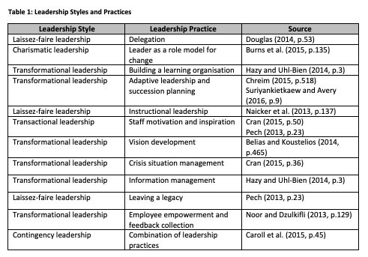

2.3. Transformational Change in Organisations
Zhu and Jones (2014, p.2) identified four specific types of organisational change that vary in the degree of change voluntariness and scope. Proactive and reactive qualities describe the voluntary or involuntary nature of a change while re-orientation or re-creation are responsible for outlining the degree of organisational change. That said, only two types of change were perceived by Zhu and Jones (2014, p.2) as transformational. Breaking the frame can be viewed as making fundamental changes in organisational structure or market orientation. Bending the frame can involve extending the product range or changing it to adapt newly emerging technologies or market conditions. Therefore, these researchers identified two types of transformational change depending on voluntary or involuntary character of change activities (Zhu and Jones, 2014, p.2). While proactive re-orientation change could be perceived as potentially more effective due to the capability to plan change activities beforehand and allocate time and resources, not all changes can be predicted and planned. Hence, frame breaking re-creation changes can occur to any enterprises and may, in turn, suggest the application of transactional, autocratic or other ‘non-transformational’ leadership styles and practices to withstand the organisational stress associated with these changes.
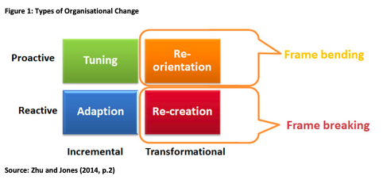
Fischer et al. (2013, p.1) supported the ideas of Hodges and Gill (2014, p.113) that internal transformational changes were a reaction to changes in the external business environment. These researchers suggested that the degree of ‘dissonance’ between the internal and external environments characterised the scope of the necessary change. The rate and scope of changes inside the organisation had to address the rate or scope of external changes, otherwise the organisation could find itself at a substantial competitive disadvantage. That said, Hutchins (2013, p.5) argued that the inability to match internal and external ‘change rates’ was largely caused by organisational inertia and the lack of change leadership, which confirms the significance of leadership practices for transformational change management. This researcher reported that leaders had to possess both the vision and the power to implement it. Therefore, an effective leader also depends on the scope of power obtained from stakeholders in order to be able to use transactional instruments or adhere to the power and influence theory (Pech, 2013, p.23).
It was noted by Hodges and Gill (2014, p.113) that rapid changes in business environments force organisations to rely primarily on the transformational changes involving a change in strategic directions, goals, cultural identities and paradigms. Such transformational changes are revolutionary rather than evolutionary and are often initiated by technological changes in various industries that require quick adaptation to benefit from the first-mover advantage. This substantiates the importance of selecting effective leadership practices to initiate, sustain and speed up change processes in organisations. Jones and Recardo (2013, p.58) additionally emphasised that sustainable and rapid transformations require a thorough horizontal and vertical integration and a good degree of team motivation to accept and resolve emerging difficulties. Hence, the role of a leader as a consolidating force becomes highly significant for the success of a transformational change. This confirms the ideas described in the classical John Kotter’s Eight-Step Model of Organisational Change (Petersen et al., 2014, p.57) that laid emphasis on developing a sense of urgency, a consolidated change team, a clear vision of the change and team-empowering practices.
Cran (2015, p.20) confirmed the relevance of this approach by analysing such transformational companies as Apple and Google. It was discovered that these companies used incentives and value-adding to motivate its employees and ‘sell’ the idea of an innovative culture aimed at frequent and rapid transformations. Parallels can be established with Kotter’s model described by Petersen et al. (2014, p.57) in terms of ‘selling’ change ideas to employees and using the transactional leadership style. At the same time, the ‘dissonance’ between internal and external change situations described earlier by Fischer et al. (2013, p.1) suggests that modern organisations have to constantly be in the state of transformational change to some degree. The evidence on such transformational change leaders as Apple and Google provided by Cran (2015, p.20) further suggests that this problem could be addressed by developing a change culture to implement the desired practices and behaviours into organisations. Furthermore, the findings of Pech (2013, p.23) on sustainable leadership and ‘leaders’ legacy’ in the form of organisational practices that support established organisational processes also confirm the significance of building a change culture. This dissertation aims to identify effective practices capable of developing and sustaining a transformational change culture to close this research gap.

2.4. Empirical Evidence from Contemporary Organisations
The analysis of public organisations by Voet (2013, p.8) revealed that change planning did not have any superior effectiveness as compared to the emergent approach. This could be attributed to the fact that major changes in the environment can require several adaptations and transformations as opposed to Lewin’s single 3-step cycle. Therefore, transformational change demands that the leader should possess both vision and the capability to quickly update organisational policies and change approaches to address emerging market trends. At the same time, transformational leadership was found to be more effective in non-bureaucratic organisations, which raises substantiated concerns over the ‘one-size-fits-all’ approach to selecting leadership styles and practices without taking into account a specific organisation. This confirms the ideas of Zhu and Jones (2014, p.2) and Cran (2015, p.20) on the importance of developing a transformational culture rather than a fixed plan for transforming an organisation. Additionally, this emphasises the role of the crisis management practice of leadership (Pech, 2013, p.23) as a method of dealing with unexpected and unpredictable crisis situations.
The analysis of Ikinci (2014, p.127) confirmed that transformational leadership, empowerment of employees and employee involvement into the decision-making process were almost mandatory for the effective functioning of modern organisations. This researcher argued that the process of transformational change should be perceived as a ‘normal’ state of contemporary organisations rather than a ‘stressful’ and temporary condition reflected in classical works on change management. The constant need for change and the broad scope of modern knowledge lead to the development of information societies and learning organisations. These structures are much more complicated than organisations from the XX century and emphasise the importance of developing individual expertise, stimulating participative approach, creating an environment of trust and other transformational practices. This suggests that such activities as the external monitoring of the ‘dissonance degree’ (Fischer et al., 2013, p.1) can assist leaders in developing knowledge-intensive organisational structures. This also substantiates the ideas of Suriyankietkaew and Avery (2016, p.9) on the significance of building supportive and knowledge-sharing environments as a method of developing sustainable transformational cultures in organisations.
The analysis of Cekuls (2015, p.253) was aimed to reveal the significance of leadership values for transforming organisations and building the culture of trust. It was discovered that successful change management was highly dependent on the learning organisation concept and the atmosphere of trust between team members and the leader described by Suriyankietkaew and Avery (2016, p.9). The failure to establish the kind of organisational culture stimulating knowledge-sharing and mutual assistance could result in poor information transfer and other hindrances to the change process. Therefore, a significant degree of trust must be developed by the leader to effectively manage the team and lead the organisation through transformational changes. This is in line with the findings of Jones and Recardo (2013, p.58) on the significance of horizontal and vertical organisational integration for proper change management. Good integration can support the development of trust and create a transformational culture necessary for improving change outcomes. That said, this research study was focused on a single country in the European Union, which can limit its generalisability to other cultural and geographical contexts.
The qualitative study of Al-Quraan (2015, p.6) analysed the correlation between leadership and change management in a large banking organisation. The results demonstrated a medium positive correlation between transformational leadership and structural and technological changes and a strong correlation between transformational leadership and people-associated changes. This clearly indicates that transformational leadership can be effective in managing organisational changes at multiple levels. At the same time, this research study was focused on a single organisation in Jordan and its findings can have limited generalisability. A broader perspective was provided by Latham (2013, p.13) who studied 14 CEOs who had been awarded for successful organisational transformations. According to this author, as much as 70-80% of organisational transformation attempts fail, which confirms the complexity of change management and leadership. It was discovered that role modelling, communication, personal and organisational learning, strategic thinking, team empowerment and behaviour reinforcement contributed to the success of transformational changes. The variety of identified practices were subdivided into five categories, namely change facilitators and stimuli, approaches to leadership, leadership behaviours, individual characteristics of a leader and characteristics of an organisational culture (Latham, 2013, p.13).
This division can be applied to the analysis of leadership practices in organisations within the scope of this dissertation. However, it should be stated that Latham (2013, p.13) substantiated the concerns of Pech (2013, p.23) on the holistic nature of successful transformational changes. Positive outcomes were usually achieved by combining several practices simultaneously rather than relying on one specific practice or leadership style. Therefore, contingency leadership could be perceived as the most effective leadership style. That said, the holistic nature of transformational change leadership makes it resource-dependent (Allwood and Selart, 2013, p.215) and can limit the applicability of this approach in crisis situations. The development of a transformational culture suggested by Cran (2015, p.20) can assist organisations in overcoming this dependence and building sustainable transformational organisations. In order to achieve this purpose, the practices identified earlier will be analysed in terms of their effectiveness in the consequent chapters of this dissertation paper.

Chapter 3: Methodology

3.1. Methodologies

3.1.1. Philosophy
The primary methodological choice preceding data collection refers to research philosophy (Saunders et al., 2016, p.127). This study adheres to epistemology because the researcher seeks to appraise the primary evidence on the leadership practices of UK SMEs in distant and objective manner to minimise bias. This prevented the use of ontology focused on the exploration of multiple perceptions of reality or axiology prioritising individual ethics and values (O’Reilly and Kiyimba, 2015, p.19). The role of separate respondents is deemed as insignificant as this study explores major industry trends to produce generalisable findings.
This direction further suggested the application of positivism as the main philosophical paradigm (Halperin and Heath, 2016, p.26). The experiences of the respondents from UK-based SMEs will be studied in a quantitative manner through standardised data collection. This approach is frequently utilised in natural sciences to avoid bias and ensure that the findings represent real-world trends rather than the perceptions of specific individuals. While interpretivism could produce interesting results by expanding the study perspective with the experience of SME managers and leaders skilled in leadership through transformational change, the access to this population group was limited, which suggested the exclusion of this philosophical stance.

3.1.2. Approach
Deduction is the research approach that starts with the choice of research hypotheses and theories that are tested against new research environments afterwards (Pruzan, 2016, p.99). This simplifies the research process due to the clarity of the researched areas and the possibility to confirm or discard clearly outlined hypotheses or theories. However, this approach also limits the scope of the researcher in terms of focusing on specific theories and ignoring any data that does not fall within the narrowly specified analysis limits. Induction suggests that theories should be drawn on the basis of data analysis to explain actually observed facts (Newsome, 2015, p.159). Induction allows researchers to analyse completely new fields and arrive at genuine hypotheses and theories. However, inductive research projects usually have a broader scope and are less predictable in terms of their outcomes and overall effectiveness. This research project aims to confirm or discard several pre-determined hypotheses, which makes deduction the optimal research approach for this dissertation.

3.2. Methods

3.2.1. Data Collection Strategy
Qualitative and quantitative research strategies vary in their approach to data samples sizes and data analysis procedures (Leavy, 2017, p.197). This dissertation adheres to the quantitative method due to a number of factors. First, the research questions did not require in-depth expertise in the studied topic that is possessed by a small number of practitioners. Second, the good availability of the respondents allowed the researcher to collect the sample size of 100 respondents providing for good generalisability and supporting the use of statistical analysis instruments (Jason and Glenwick, 2016, p.121). Hence, the study was organised on the basis of the quantitative design. Six hypotheses were formulated at the Methodology section level and were confirmed or discarded by analysis results. While the alternative qualitative strategy could expand the perspective by adding the insights of UK businesses’ leaders in an unstructured format, time constraints and limited accessibility of these busy individuals prevented the researcher from utilising the mixed methods research strategy. This limitation can be addressed by further studies.

3.2.2. Sampling
The questionnaire survey method (see Appendix) provides for administering a large number of questionnaire forms to obtain substantial samples of data. It is faster and more cost-efficient than interviews and other intepretivist data collection methods (Saunders et al., 2016, p.416). That said, it also has such limitations as the inability to ask additional questions, a lower degree of control over the respondents and the limited capability to verify respondents’ qualifications (Bryman and Bell, 2015, p.241). Questionnaire surveys usually have lower response rates, which substantiates the necessity to administer 300 questionnaire forms to obtain the sample of 100 respondents and guarantee good generalisability of the findings. This research study applies the non-probability convenience sampling method. Specific entry criteria are used to select the research respondents possessing the required knowledge and expertise while convenience sampling provides for easier access to research participants and general costs reduction (Sekaran and Bougie, 2016, p.247). That said, the haphazard selection of participants can introduce some inconsistency and non-homogeneity into research data (Saunders et al., 2016, p.416). This effect was mitigated by the large size of the sample.
To collect the targeted sample, the researcher sent direct emails and messages to 214 UK organisations found via online directories and social media pages. This decision was substantiated by the relatively low response rate in the case of the ‘cold’ contacts approach (Saunders et al., 2016, p.210). To improve data collection results and combine ‘push’ and ‘pull’ approaches to respondents’ engagement, the multiple channels strategy was applied (Neelankavil, 2015, p.160). Specifically, survey links were posted in social communities and on the personal page of the researcher. The author of this study also used the network of friends to create reposts and published the study description on several resources on entrepreneurship in the UK as well as the r/SampleSize community on Reddit. These activities resulted in the collection of 115 responses. It should also be noted that 13 questionnaires were not completed fully, which suggested their exclusion. The study sample size was limited to 100 respondents to facilitate the processing of data and ensure that several ‘backup’ survey forms were available if some respondents decided to withdraw their consent for participation before the completion of this dissertation.

3.2.3. Analysis
Statistical analysis is the most appropriate method of analysing structured quantitative data to identify correlations and confirm or discard research hypotheses (Myers et al., 2013, p.3). It facilitates the processing of homogenous data and allows to identify potential errors and inconsistencies that can undermine the quality of the research, which makes it highly valuable for data analysis. The following variables will be used in statistical analysis within the scope of this dissertation.
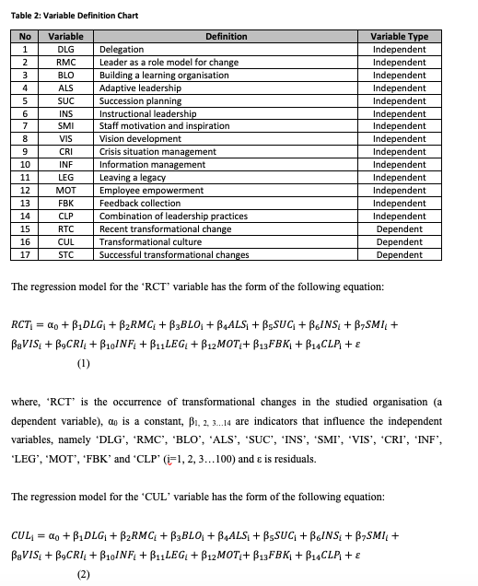
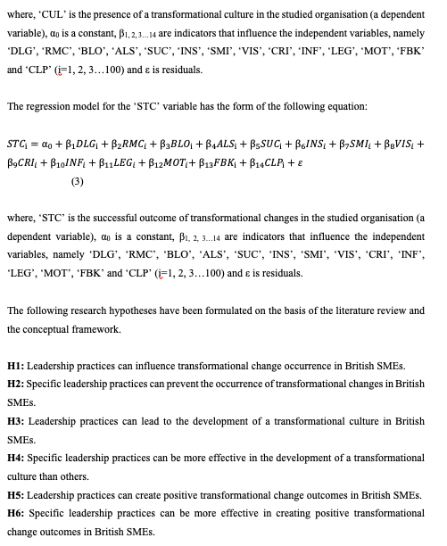
3.3. Ethics and Limitations
Research ethics are an inherent element of any contemporary research project (Woodfield, 2017, p.8). Respondents’ anonymity and confidentiality will be maintained throughout all research stages. Their consent for processing the collected data will be obtained at questionnaire administration and all personal data will be coded to avoid disclosure. This research study will be focused on the SMEs context and one country exclusively, which limits its generalisability to other contexts and countries.

Chapter 4: Analysis

4.1. Respondents Background
The majority of research respondents belong to the age groups of 18-25, 26-30 and 31-40. The group of employees aged between 25 and 30 is the largest group, which can have both positive and negative outcomes on transformational change effectiveness. Employees above 35 years of age are highly resistant to organisational changes (Felix et al., 2013, p.391) and can negatively impact the effectiveness and outcomes of transformational change. They are also less open to accepting technological innovations (Fallik, 2013, p.5). That said, older employees can have unique experience or knowledge in a specific industry that is critical for the functioning of their organisations.
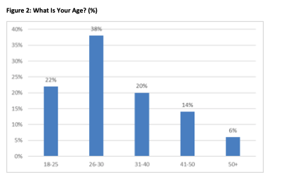
The following figure demonstrates that 92% of research respondents were employed for less than 4 years. This can indicate that small and medium enterprises in the UK have higher turnover rates than large ones or short terms of existence. In combination with the fact that 85% of respondents’ organisations experienced transformational changes during their employment period, it can also signify the fact that transformational changes in the UK context often involve staff reduction or company termination. This factor can be negative in terms of developing a transformational culture. High turnover rates can lead to the inability to implement and consolidate the features of a transformational culture in the organisation (Latessa et al., 2014, p.221).
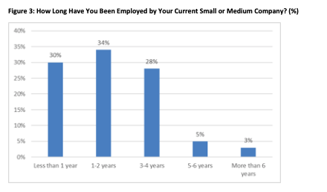
75% of respondents stated that their companies employed less than 50 employees. This corresponds the statistics of Gov.uk (2015, p.1) on the staff composition of British small and medium companies. The small number of employees and comparatively short employment terms can change the leader-employees distance and the portfolio of leadership practices in comparison with larger companies. At the same time, it can limit the number of leaders in an organisation to a single leader represented by the owner. This can also mean that some leadership practices like legacy-building and succession planning can be omitted or considered less relevant than in large corporations. However, organisational learning and the speed of communication can be different in small and large organisations (Farhanghi et al., 2012, p.606), which can influence the speed of implementation of leadership practices, the development of a transformational culture and the resulting effectiveness of transformational change management.
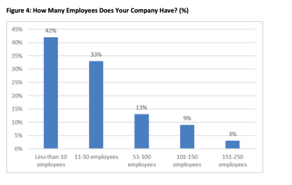
It can be concluded that the majority of research respondents are aged 18-40, have been employed by their companies for no longer than 4 years and work in the companies with less than 50 employees.

4.2. Leadership Practices in British SMEs
The number of employees confirming the use of delegation as a leadership practice and discarding it was approximately the same. This can indicate that delegation as a leadership practice is used by some of the researched organisations and neglected by others. While leaders in small and medium organisations can be reluctant to delegate some of their functions to employees, the inability to do so creates a viable bottleneck in both decision-making and organisational work load. It also makes the leader non-replaceable, which undermines the stability and survival of organisations in the cases when the leader cannot perform his or her functions (Byham et al., 2015, p.193). On the other hand, not all tasks can be delegated and the lack of delegation can be associated with the unique know-how or skills that leaders do not want to share with other employees. A further analysis of delegation impact on transformational change can reveal more information about the significance of this controversial practice for transformational change management.
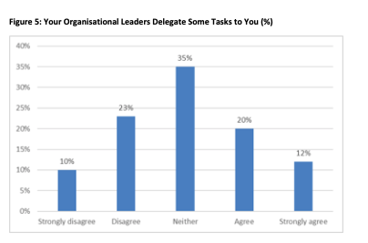
Similar information has been obtained from the research respondents on the use of the adaptive leadership approach to practices selection. This signifies that almost half of the leaders in the researched organisations prefer to adhere to some selected leadership practices and are reluctant to change their views when situations demand a different set of practices. This can also indicate that some organisations constantly face similar challenges and have no need to develop adaptive mechanisms of leadership. However, the significance of adaptive leadership for improving transformation change outcomes established further in this section suggests that these organisations can get substantial benefits by shifting towards a more adaptive approach during crisis periods. Besides that, major changes in the economy can create new kinds of problems that cannot be resolved through a small number of traditional practices (Olmedo, 2012, p.88). Therefore, the extension of adaptability can be considered a strategic move towards preparing for potential future threats.
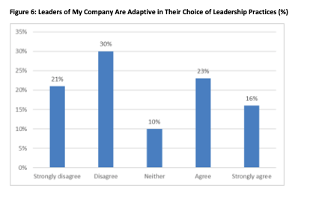
The obtained data on the use of succession planning indicates that as much as 46% of companies do not use succession planning, as opposed to the 23% of organisations that adhere to this practice. Considering the earlier indicated fact that 75% of the respondents’ companies employed less than 50 people, this can indicate that the leader is often the owner of the small and medium company. Therefore, he or she does not plan any successors before achieving senior age, which can create a problem in the case of sudden illness or accident. The unforeseeable development of the current situation in the economy suggests that succession planning should be implemented as a safety mechanism to some degree to mitigate the risks associated with the inability of a leader to continue performing his or her organisational duties. New successors must be trained in advance and taught all the required skills before some emergency situation arises (Mutunga and Gachunga, 2013, p.298)
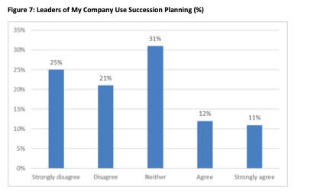
Motivation and inspiration were cited by 66% of employees, which indicates that these practices are widely used in small and medium UK organisations. However, it is not clear if they are capable of developing a sustainable transformational change culture and preparing the organisation for substantial fluctuations of a business environment. That said, the high percentage of leaders with strong change vision identified further in this work suggests that motivation is associated with clearly defined short- and long-term goals, which is critical for leadership effectiveness and cost-efficient motivation (Kerestesova, 2012, p.128).
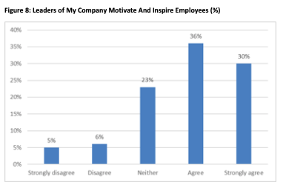
61% of the respondents stated that the leaders of their organisations possessed a strong change vision. However, this fact does not directly suggest that such vision is effective and guarantees a positive transformational change outcome. The good degree of vision-sharing in the researched organisations suggests that the necessity for change is clearly communicated to employees and they understand the plans of the change implementation. However, it can be possible that some leaders use purely autocratic style and lose the opportunity to use the professional judgement of their employees (Ejimabo, 2015, p.19). In this case, a shift towards a more democratic or laissez-faire approach can significantly improve the effectiveness of vision development due to the use of multiple expert opinions.
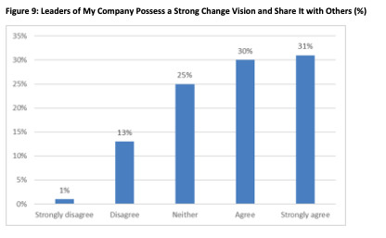
It should be noted that the majority of the research respondents considered their leaders incapable of effectively managing changes in crisis situations. This indicates a serious problem for the periods of unpredictable fluctuations discussed earlier. The ability to quickly react to a rapidly changing market environment can be critical when some change plans require a rapid alteration (Olawale, 2014, p.79). Therefore, this leadership practice is highly significant for the survival of organisations in the short-term perspective during transformational changes and can be more prominent than practices developing a transformational culture in the long perspective.
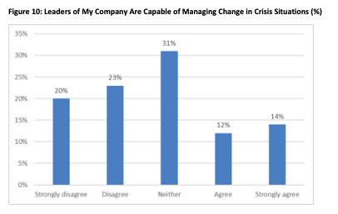
71% of respondents disagree that their leaders are building a legacy of organisational practices. This can be associated with the lack of succession planning identified earlier and explained by similar reasons. As leaders in small companies are unlikely to be replaced due to some unexpected reasons, they do not focus on preparing their organisations for functioning without them. While this situation can be explained, it is not clear if it has any negative impact on the functioning of small and medium organisations.
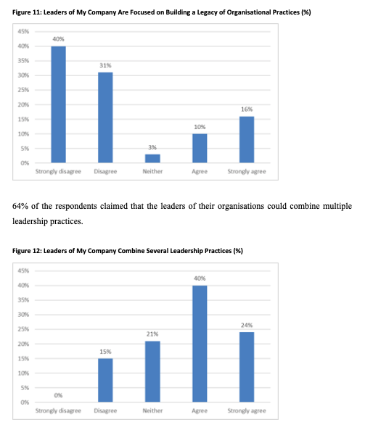
Similar figures were obtained for the capability to select proper leadership practices for specific situations. This indicates that the leaders of small and medium enterprises are proficient in multiple leadership practices and are capable of selecting the most appropriate practices from their leadership practices portfolio. However, this skill can be mitigated by accidental exclusion of leaders from the leadership process. Considering the previously identified lack of organisational practices legacy, this creates a dangerous ‘organisational bottleneck’ where organisations cannot maintain effective functioning through transformational changes without the constant presence of their leaders.
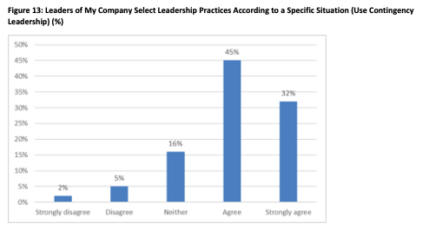

4.3. Transformational Change in British SMEs
This chapter establishes the correlation between independent variables in the form of organisational parameters and leadership practices and dependent variables in the form of transformational change occurrence, the development of a transformational culture and the positive outcomes of transformational changes. Linear regression was used to process the collected questionnaire data. The analysis of leadership practices and transformational change occurrence has revealed that there exists no statistically significant correlation between the leadership practices used in respondents’ organisations and the occurrence of transformational changes. This indicates that transformational changes are caused by both internal and external factors in business environment. (Burke and Noumair, 2015, p.149). Therefore, their occurrence cannot be avoided or prevented through the use of internal organisational practices exclusively.
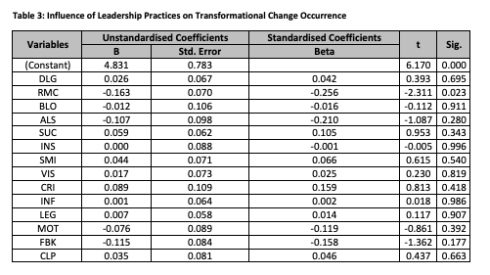
The following table represents the correlation between the leadership practices implemented by the studied British SMEs and the existence of transformational culture in their organisations. It has been revealed that such leadership practices as instructional leadership, information management and preparing organisational legacy of leadership practices were influencing the development of a transformational culture. The degree of correlation was highly significant from the statistical viewpoint, which suggests that the concentration on these practices can lead to the development of a transformational culture. However, the analysis of leadership practices and the development of a transformational has discarded such practices as succession planning and managing change in crisis situations. Although these practices do not lead to the development of a transformational culture, they can be critical for managing organisational changes in the short-term perspective. Therefore, they must not be omitted. It can be suggested that organisations should focus on resolving the short-term problems in the first place while implementing the practices that lead to the development of a transformational culture in the longer perspective.
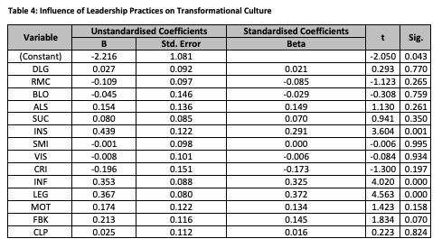
The following table demonstrates the influence of leadership practices on the successfulness of transformational changes in the analysed organisations. It has been discovered that implementing the mechanisms of a learning organisation, adaptive leadership, crisis situation management and employee empowerment were capable of leading organisations through transformational changes successfully. All of these practices had a high degree of statistical significance, which indicates that they are highly important for organisations that need to conduct their business activities in unstable environments with frequent transformational changes. The unpredictable outcomes of Brexit can emphasise this leadership practice and make it critical in adjusting British SMEs to the changing market conditions. It should be noted that the analysis of crisis situation management earlier in this chapter revealed that organisations do not implement this practice in general, which puts them at a substantial disadvantage in the periods of financial crises. Therefore, leaders in these organisations should focus on developing this practice to guarantee the success of their transformational change efforts.
The positive correlation between a relatively small number of organisations implementing this leadership practice and positive outcomes of transformational changes signifies that this practice is highly effective and can be considered one of the most valuable ones of all leadership practices analysed in this study. A similar situation exists with building a legacy of organisational practices. Combined with the lack of succession planning, this creates a substantial threat to surviving major transformational changes. While 64% of leaders were capable of combining multiple practices and using contingency leadership, this does not indicate that their employees are capable of sustaining these organisational processes without their supervision or presence. Therefore, the identified significance of building a legacy of organisational practices for successfully passing transformational changes suggests the inclusion of this practice into the set of most important leadership practices.
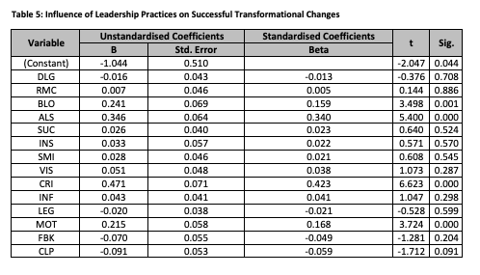

Chapter 5: Discussion, Conclusion and Recommendations

5.1. Discussion
This dissertation study aimed to reveal the impact of leadership on transformational change in organisations. A number of objectives and hypotheses were established in earlier sections to approach this problem from several aspects. Objective 1 was to identify how leadership roles are defined by the key leadership theories. The analysis has revealed that contemporary leaders cannot rely on a single leadership style or practice and have to be capable of both combining several leadership practices and adapting their leadership style to a specific situation (Lussier and Achua, 2015, p.16). The majority of modern theories consider leadership skills to be developed rather than innate. Therefore, contemporary leaders must develop and expand their portfolio of available leadership instruments to be ready for a variety of challenges (Caroll et al., 2015, p.45). A broader scope of available instruments and a more adaptive approach contribute to greater efficiency and better leadership results. Besides that, leaders can also initiate, sustain and consolidate change processes, which makes leadership effectiveness one of the key elements of successful transformational change.
Objective 2 was to examine how leadership styles are matched with specific leadership practices. It has been discovered that the majority of leadership practices belong to the transformational leadership style. Additionally, charismatic leadership and transactional leadership are used for building learning organisations and putting leaders into the role of a ‘model for change’ (Roe, 2014, p.11). Finally, contingency leadership suggests an all-inclusive approach to the selection of practices and promotes adaptability and a wide array of instruments to address leadership challenges arising in modern organisations (Allwood and Selart, 2013, p.215). The analysis of leadership practices revealed 12 specific practices that could be used to support transformational change in organisations. These practices have been included into the questionnaire survey to identify the degree of their integration into the functioning of British SMEs. Additionally, the impact of some practices on transformational change occurrence and outcome was tested in the analysis section. It was revealed that the analysed practices did not contribute to the development of transformational culture while transformational changes can occur in any organisations at any moment. However, the two analysed practices did contribute to positive transformational change outcomes, which indicates their significance for change management through leadership.
Objective 3 was to analyse the impact of leadership practices implemented in UK-based SMEs on transformational change within these organisations. It was discovered that leaders in British SMEs were capable of using staff motivation and inspiration, developing and communicating a change vision and using several leadership practices in combination. They were also reported to use contingency leadership or adapting leadership practices to a particular situation, which confirmed the suggestions of Lussier and Achua (2015, p.16). That said, the majority of leaders in the researched organisations failed to build a legacy of organisational practices and demonstrated a limited capability to deal with transformational changes in crisis situations. Besides that, the ability to adapt their choice of leadership practices to a particular situation was found in less than half of the companies. This indicates a substantial problem that is even more prominent considering the fact that good adaptability and crisis management skills were directly associated with positive change outcomes in the statistical analysis performed in this study (Pech, 2013, p.23)
Objective 4 was to develop practical recommendations to SMEs concerning the effective use of leadership practices in a changing environment. This objective is achieved in the recommendations section of this dissertation.
Hypothesis 1 on the association of employees’ greater length of employment and the probability to encounter transformational changes in their organisations has been discarded. This indicates that organisations face transformational changes irrespective of their period of existence, which confirms the significance of preparing for transformational changes in British SMEs (Pech, 2013, p.23). Combined with the fact that 85% of research respondents have encountered transformational changes, this confirms the necessity of preparing for changes and developing transformational change culture. Hypothesis 2 on the correlation between the number of employees and transformational change occurrence has also been discarded. Transformational changes occur in any organisations and their frequency and scope are defined by the market environment rather than some internal parameters like size and length of existence (Lindsey, 2013, p.28). However, it can be suggested that smaller organisations are less protected from negative change outcomes than major corporations due to limited resources and concentration on a single geographical environment. They cannot redistribute expenses between international subsidiaries in the case of a crisis, which emphasises the importance of effective transformational change management in SMEs.
Hypothesis 3 on the positive influence of instructional leadership practice on the development of a transformational culture and Hypothesis 4 on the positive impact of the combination of several leadership practices on the development of a transformational culture have been discarded. While transformational culture is an important organisational element that involves a number of practices that are structurally implemented into business operations to support the constant readiness for transformational changes, the analysed leadership practices did not have a correlation with the development of such culture (Arslan et al., 2014, p.344). However, it should be noted that as much as 48% of the respondents claimed that their organisations did not have a transformational culture, which indicates that this element is not present in almost half of organisations. It can be suggested that this such culture can be developed by combining leadership practices with the experience of successfully passing several transformational changes, which means that the impact of such practices is realised in the long perspective (Hicks, 2013, p.2). That said, 71% of the respondents stated that no efforts are made by their leaders to develop and sustain such culture while 85% of the researched organisations have faced transformational changes previously. This indicates that organisational leaders have a poor understanding of the importance of developing a transformational culture to withstand future changes.
Hypothesis 5 on the association of the adaptive leadership practice and positive transformational change outcomes has been confirmed as well as Hypothesis 6 on the significance of the crisis situation management practice for obtaining positive transformational change outcomes. This indicates that these two practices are highly important for improving the effectiveness of transformational changes and are especially significant for managing change in crisis periods (Roe, 2014, p.11). High market volatility requires both being able to adapt leadership practices to newly arising challenges and the capability to manage transformational changes through crises. Therefore, these two practices are a prerequisite for surviving transformational changes and should be implemented on a first-priority basis (Allwood and Selart, 2013, p.215).

5.2. Conclusion
It can be concluded that UK-based SMEs generally demonstrate a medium degree of awareness in terms of effective leadership practices. While the leadership legacy and leadership succession practices can have limited significance for organisations with a single leader, the inability to lead transformational changes in crisis periods and to adapt to a specific situation are highly dangerous for the predicted periods of market instability (Jex and Britt, 2014, p.398). British SMEs demonstrate medium levels of delegation, leading by example, adaptability and information management. This corresponds the general lack of transformational culture in almost half of the researched organisations. It can be assumed that the lack of established organisational practices in terms of leadership and the lack of succession planning and leadership legacy development can contribute to the underdevelopment of transformational culture in British organisations. While this situation can be tolerable for the periods of stable economy, the current situation can require greater sustainability and persistency from British organisations (Pech, 2013, p.23). Therefore, leaders should focus on remedying the problems with adaptability and crisis change management and continue towards developing transformational cultures in their organisations.

5.3. Recommendations and Limitations
It can be recommended that the leaders of British SMEs should concentrate on developing the capabilities to manage transformational changes in crisis conditions, to extend their portfolio of available leadership practices and to improve their adaptability to different situations (Caroll et al., 2015, p.45). While the lack of transformational culture in the majority of researched organisations is a negative indicator for their sustainability in the rapidly changing environment, the inability to manage changes in crisis periods and the lack of adaptability can be much more dangerous to British companies in the short-term perspective. After these drawbacks have been remedied, it can be suggested that leaders should focus on developing sustainable transformational cultures to implement the readiness for changes into their organisations (Pech, 2013, p.23). Finally, succession planning and leaving a legacy of organisational practices can remove the over-dependence on a single leader in small organisations. Although these practices can be partially compensated by delegation and empowerment, clearly outlined rules for managing change can be valuable for shifting the focus from individuals towards leadership roles.
This study was limited to a single geographical context and was exclusively focused on small and medium companies. It can be suggested that its findings may have limited applicability to non-British companies. Besides that, the lack of industry-based segmentation of companies can conceal some specific differences in leadership practices application that can vary between different industries (Qiu et al., 2017, p.84). That said, the large sample of the study and the findings suggest that transformational changes occur in all companies and the findings of this study can be beneficial to any company with less than 250 employees that seeks to improve the outcomes of its transformational changes through implementing more effective leadership practices.

References
Allwood, C. and Selart, M. (2013) Decision Making: Social and Creative Dimensions, Berlin: Springer Science & Business Media.
Al-Malki, M. and Juan, W. (2018) “Leadership Styles and Job Performance: A Literature Review”, Journal of International Business Research and Marketing, 3 (3), pp. 40-49.
Al-Quraan, A. (2015) “The Impact of Transformational Leadership on Organizational Change Management: Case Study at Jordan Ahli Bank”, IOSR Journal of Business and Management, 17 (12), pp. 1-7.
Arslan, H., Rata, G. and Kocayoruk, E. (2014) Multidisciplinary Perspectives on Education, Cambridge: Cambridge Scholars Publishing.
Belias, D. and Koustelios, A. (2014) “The Impact of Leadership and Change Management Strategy on Organizational Culture”, European Scientific Journal, 10 (7), pp. 451-470.
Bratton, J. and Gold, J. (2017) Human resource management: theory and practice, New York: Palgrave.
Bryman, A. and Bell, E. (2015) Business Research Methods, Oxford: Oxford University Press.
Burke, W. and Noumair, D. (2015) Organization Development: A Process of Learning and Changing, 3rd ed., Upper Saddle River: FT Press.
Burns, H., Vaught, H. and Bauman, K. (2015) “Leadership for Sustainability: Theoretical Foundations and Pedagogical Practices That Foster Change”, International Journal of Leadership Studies, 9 (1), pp. 131-143.
Byham, T., Wellins, R. and Thomas, B. (2015) Your First Leadership Job: How Catalyst Leaders Bring Out the Best in Others, Hoboken: John Wiley & Sons.
Caroll, B., Ford, J. and Taylor, S. (2015) Leadership: Contemporary Critical Perspectives, London: SAGE.
Cekuls, A. (2015) “Leadership Values in Transformation of Organizational Culture to Implement Competitive Intelligence Management: The Trust Building Through Organizational Culture”, European Integration Studies, 9 (1), pp. 244-256.
Chreim, S. (2015) “The (non)distribution of leadership roles: Considering leadership practices and configurations”, Human Relations, 68 (4), pp. 517-543.
CIPD (2015) “Landing transformational change: Closing the gap between theory and practice”, [online] Available at:http://www.cipd.co.uk/binaries/landing-transformation-change_2015-gap-theory-practice.pdf [Accessed on 26 October 2016].
Cran, C. (2015) The Art of Change Leadership: Driving Transformation in a Fast-Paced World, Hoboken: John Wiley & Sons.
Douglas, E. (2014) The Leadership Equation: 10 Practices That Build Trust, Spark Innovation, and Create High Performing Organizations, Austin: Greenleaf Book Group.
Ejimabo, N. (2015) “An Approach to Understanding Leadership Decision-Making in Organization”, European Scientific Journal, 11 (11), pp. 1-24.
Fallik, F. (2013) Managing organizational change, London: Routledge.
Farhanghi, A., Abbaspour, A. and Ghassemi, R. (2012) “Examining the Structural Relationships of New Communication and Information Technologies, Organizational Structure and Firm Performance: An Analysis of Consultant Engineers Firms (CEF) in Iran”, World Applied Sciences Journal, 20 (4), pp. 605-614.
Felix, C., Vhuramayi, C., Martin, C. and Nyasha, M. (2013) “Impact of Age on Employee Resistance to Change. A Case Study Cotton Company (COTTCO) in Zimbabwe”, Greener Journal of Business and Management Studies, 3 (9), pp. 386-392.
Fischer, B., Lago, U. and Liu, F. (2013) Reinventing Giants: How Chinese Global Competitor Haier Has Changed the Way Big Companies Transform, Hoboken: John Wiley & Sons.
Gordon, S. (2016) “Brexit uncertainty starts to affect small British businesses”, Available at:https://www.ft.com/content/c5782176-436d-11e6-b22f-79eb4891c97d [Accessed on 26 October 2016].
Halperin, S. and Heath, O. (2016) Political research: methods and practical skills, Oxford: Oxford University Press.
Gov.uk (2015) “Business Population Estimates for the UK and Regions 2015”, [online] Available at: https://www.gov.uk/government/uploads/system/uploads/attachment_data/file/467443/bpe_2015_statistical_release.pdf [Accessed on 28 October 2016].
Harvey, M. (2014) Interactional Leadership and How to Coach It: The Art of the Choice-focused Leader, London: Routledge.
Hazy, J. and Uhl-Bien, M. (2014) “Towards operationalizing complexity leadership: How generative, administrative and community-building leadership practices enact organizational outcomes”, Leadership, 11 (1), pp. 79-104.
Hicks, R. (2013) Coaching as a Leadership Style: The Art and Science of Coaching Conversations for Healthcare Professionals, London: Routledge.
Hodges, J. and Gill, R. (2014) Sustaining Change in Organizations, London: SAGE.
Hossan, C. (2015) “Applicability of Lewin’s change management theory in Australian local government”, International Journal of Business and Management, 10 (6), pp. 53-65.
Hutchins, G. (2013) The Nature of Business: Redesign for Resilience, Gabriola Island: New Society Publishers.
Ikinci, S. (2014) “Organizational Change: Importance of Leadership Style and Training”, Management and Organizational Studies, 1 (2), pp. 122-128.
Jason, L. and Glenwick, D. (2016) Handbook of methodological approaches to community-based research: Qualitative, quantitative, and mixed methods, Oxford: Oxford University Press.
Jex, S. and Britt, T. (2014) Organizational Psychology: A Scientist-Practitioner Approach, Hoboken: John Wiley & Sons.
Jones, D. and Recardo, R. (2013) Leading and Implementing Business Change Management: Making Change Stick in the Contemporary Organization, London: Routledge.
Kerestesova, M. (2012) “The Model of Motivating Planning and Planning Motivation”, Human Resources Management & Ergonomics, 6 (1), pp. 115-129.
Khan, N. and Nawaz, A. (2016) “The Leadership Styles and the Employees Performance: A Review”, Gomal University Journal of Research [GUJR], 32 (2), pp. 144-150.
Kovach, M. (2018) “An Examination of Leadership Theories in Business and Sport Achievement Contexts”, The Journal of Values-Based Leadership, 11 (2), pp. 1-17.
Latessa, E., Listwan, S. and Koetzle, D. (2014) What Works (and Doesn’t) in Reducing Recidivism, London: Routledge.
Latham, J. (2013) “A Framework for Leading the Transformation to Performance Excellence Part I: CEO Perspectives on Forces, Facilitators, and Strategic Leadership Systems”, Quality Management Journal, 20 (2), pp. 19-40.
Leavy, P. (2017) Research design: Quantitative, qualitative, mixed methods, arts-based, and community-based participatory research approaches, New York: Guilford Publications.
Lindsey, K. (2013) Leadership Breakthrough: Leadership Practices that Help Executives and Their Organizations Achieve Breakthrough Growth, Bloomington: AuthorHouse.
Lussier, R. and Achua, C. (2015) Leadership: Theory, Application, & Skill Development, Boston: Cengage Learning.
Mann, R. (2013) The Measure of a Leader: A Review of Theories About Leadership and a Methodology for Appraising Leader Effectiveness, Bloomington: iUniverse.
Morse, R. and Buss, T. (2014) Innovations in Public Leadership Development, London: Routledge.
Mutunga, F. and Gachunga, H. (2013) “Factors affecting Succession Planning in Small and Medium Enterprises in Kenya”, International Journal of Academic Research in Business and Social Sciences, 3 (8), pp. 285-300.
Myers, J., Well, A. and Lorch, R. (2013) Research Design and Statistical Analysis, 3rd ed., London: Routledge.
Naicker, I. Chikoko, V. and Mthiyane, S. (2013) “Instructional leadership practices in challenging school contexts”, Education as Change, 17 (1), pp. 137-150.
Neelankavil, J. (2015) International Business Research, New York: M.E. Sharpe.
Newsome, B. (2015) An introduction to research, analysis, and writing: Practical skills for social science students, London: SAGE.
Nitin, N. and Khurana, R. (2013) Handbook of Leadership Theory and Practice: An HBS Centennial Colloquium on Advancing Leadership, Boston: Harvard Business Press.
Noor, H. and Dzulkifli, B. (2013) “Assessing Leadership Practices, Organizational Climate and Its Effect towards Innovative Work Behaviour in R&D”, International Journal of Social Science and Humanity, 3 (2), pp. 129-133.
O’Reilly, M. and Kiyimba, N. (2015) Advanced Qualitative Research: A Guide to Using Theory, London: SAGE.
Olawale, S. (2014) “Crisis Management Strategy and its Effects on Organizational Performance of Multinational Corporations in Nigeria: Empirical Evidence from Promassidor Ltd.”, European Journal of Business and Management, 6 (23), pp. 79-87.
Olmedo, E. (2012) “The Future of Leadership: The New Complex Leaders’ Skills”, Academic Research Journals (India), 1 (1), pp. 79-90.
Pech, M. (2013) The Financial Times Guide to Leadership: How to lead effectively and get results, London: Pearson UK.
Petersen, L., Person, R. and Nash, C. (2014) Connect: How to Use Data and Experience Marketing to Create Lifetime Customers, Hoboken: John Wiley & Sons.
Pruzan, P. (2016) Research Methodology: The Aims, Practices and Ethics of Science, Berlin: Springer Science & Business Media.
Qiu, J., Zhao, R., Yang, S. and Dong, K. (2017) Informetrics: Theory, Methods and Applications, Berlin: Springer Science & Business Media.
Raelin, J. (2011) “From leadership-as-practice to leaderful practice”, Leadership, 7 (2), pp. 195-211.
Roe, K. (2014) Leadership: Practice and Perspectives, Oxford: Oxford University Press.
Saunders, M., Lewis, P. and Thornhill, A. (2016) Research Methods for Business Students, 6th ed., New York: Pearson Publishing.
Sekaran, U. and Bougie, R. (2016) Research methods for business: A skill building approach, Hoboken: John Wiley & Sons.
Suriyankietkaew, S. and Avery, G. (2016) “Sustainable Leadership Practices Driving Financial Performance: Empirical Evidence from Thai SMEs”, Sustainability, 8 (327), pp. 1-14.
Uzohue, C., Yaya, J. and Akintayo, O. (2016) “A review of leadership theories, principles, styles and their relevance to management of health science libraries in Nigeria”, Journal of Educational Leadership and Policy, 1 (1), pp. 17-26.
Vidal, G., Campdesuner, R., Rodríguez, A. and Vivar, R. (2017) “Contingency theory to study leadership styles of small businesses owner-managers at Santo Domingo, Ecuador”, International Journal of Engineering Business Management, 9 (1), pp. 1-11.
Viswanathan, R. and Lal, S. (2018) “The influence of Organizational Culture on Team Cohesion in ITES Sectors”, International Journal of Scientific Research, 6 (8), pp. 222-225.
Voet, J. (2013) “The effectiveness and specificity of change management in a public organization: Transformational leadership and a bureaucratic organizational structure”, European Management Journal, 32 (3), pp. 373-382.
Woodfield, K. (2017) The Ethics of Online Research, New York: Emerald Group Publishing.
Zhu, H. and Jones, M. (2014) “Huawei: An Exemplar for Organizational Change in a Modern Environment”, Journal of Information Technology Education: Discussion Cases, 3 (1), pp. 1-13.

